**Documentation**

1. **Setting up the environment**
2. **Automated test cases to be written**
3. **Cross-Browser Testing**
4. **Documentation**

**A. Setting up the environment**

1. Visit node.js side from where you can download the installer.

2. Install Visual Studio Code.

3. In Visual Studio Code open “Terminal”.

4. In terminal we are going to install “Testcafe” by command – “ npm install testcafe”

**B. Automated test cases to be written**

1. Test successful login with valid credentials.

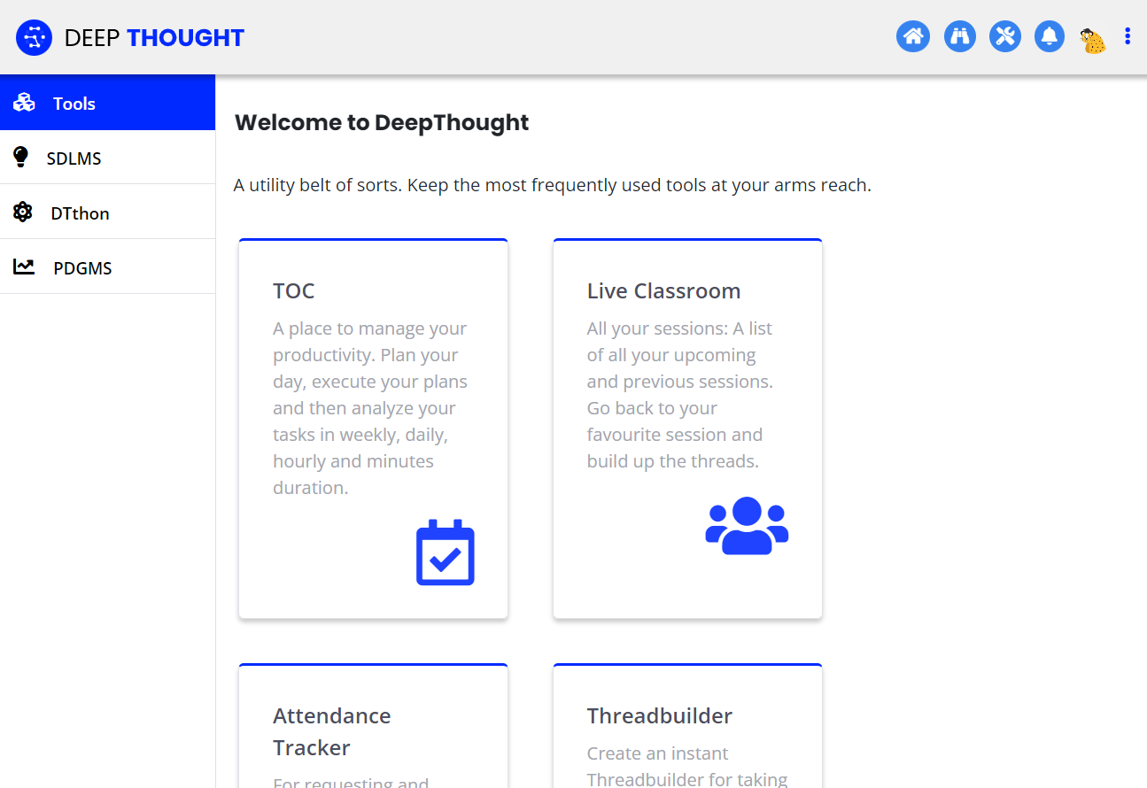

2. Test unsuccessful login attempts with invalid credentials.

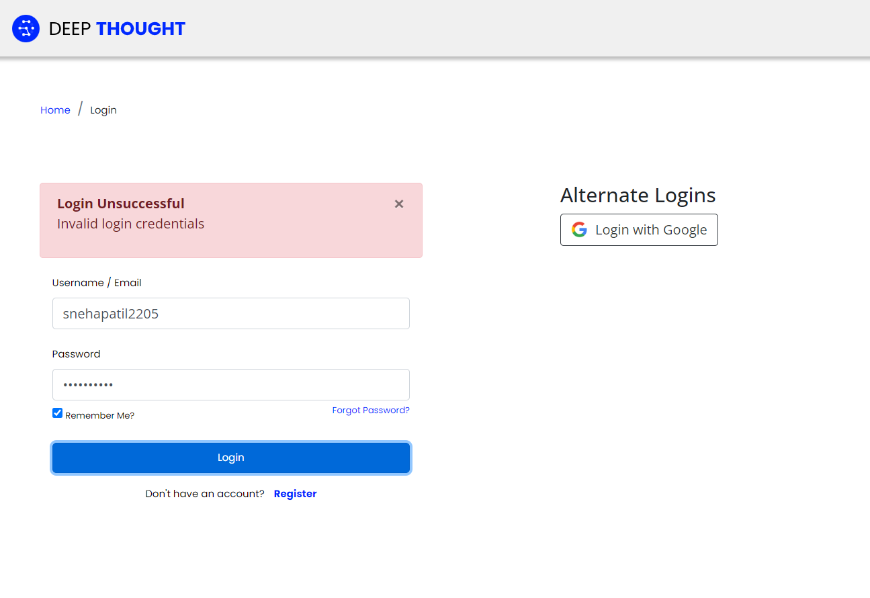

3. Validate that appropriate error messages are displayed for invalid login attempts.



4. On successful login, validate that the user is redirected to the dashboard screen.



1. **Cross-Browser Testing**
2. Configure the TestCafe tests to run on at least two different browsers (e.g., Chrome and Firefox)-

* Testcafe supports Cross platform and cross browser testing, so we can run test on multiple browsers.
* While running the test you can choose browser whichever you want.
* E.g. – “npx testcafe chrome .\testcafe\login.js ” OR “ npx testcafe firefox .\testcafe\login.js ”