**DAY-2(20.06.2023)**

**Task given:**

**1 .Create a dataset(Binary or Multiclass) and upload it in drive**

I have chosen Flower classification- a binary classification consisting of 2 classes - Rose and Jasmine (above 300 images for each class)

Images were collected from Google, downloaded using relevant extensions as zip folder and extracted. The images were analysed and uploaded into drive.

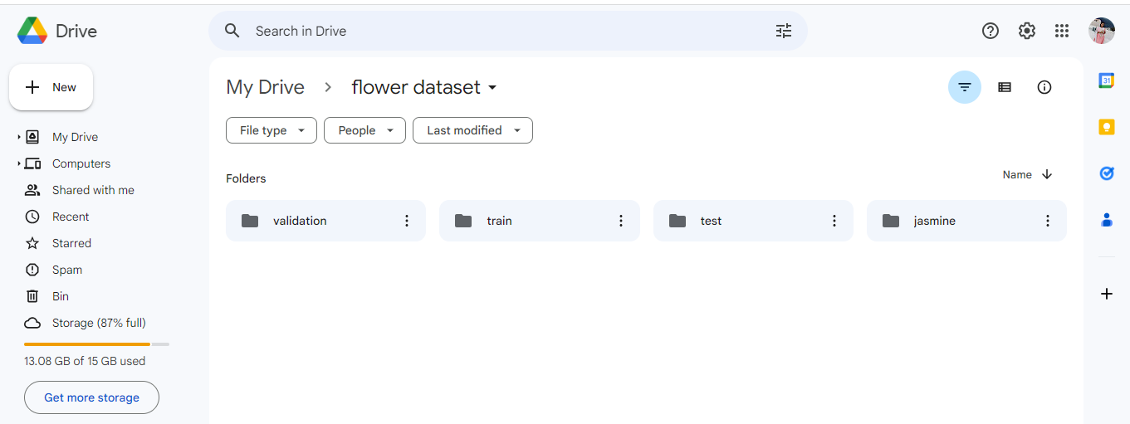

* The images were partitioned into validation, test and train.
* Basic CNN code was shared and we worked on it with our own dataset in colab.
* Code ran in Colab has successfully run with 20 epochs and plotted graph for the training loss, validation loss, Training accuracy and validation accuracy

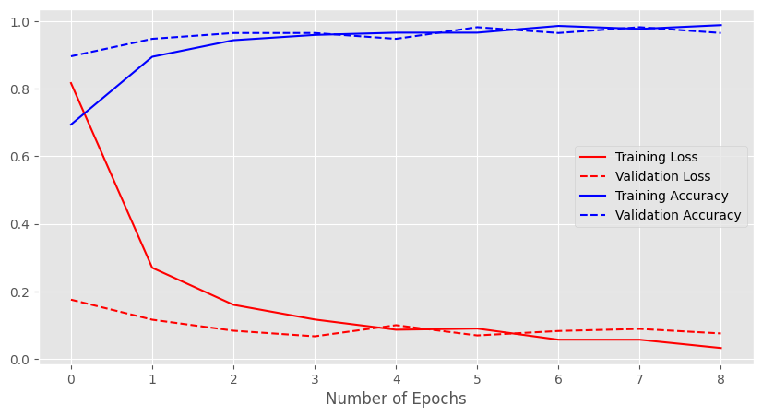

**Doubts :**

* Loading packages and the functionality of each package seemed to be unknown
* Changes to be made for a binary and multiclass classification was taught.
* Common errors that we encounter as a beginner in colab environment was cleared.

Eg: Package installation errors

Code has been run and predicted correctly.

