**DAY-3(21.06.2023)**

**TASK ASSIGNED:**

1. **To find CNN code for a given dataset**

* A dataset named exam dataset was provided
* It contained around 4000 images under 5 labels to predict forgery during examinations.
* The dataset was downloaded and uploaded into our google drive
* Basic CNN code had to be found,by surfing through Kaggle or github along with the code provided in previous sessions.
* The code was run for 20 epochs initially and accuracy-loss graph was plotted.

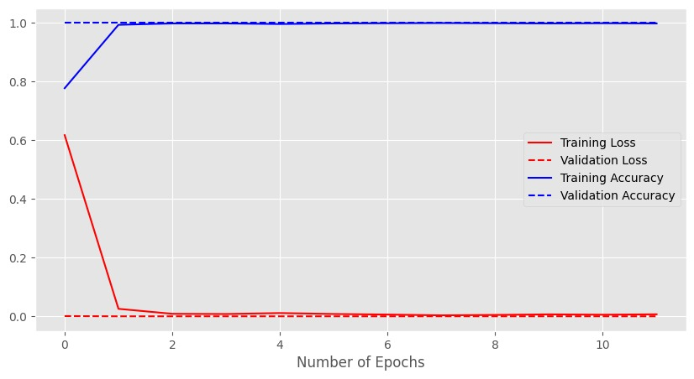

**2.Plot confusion matrix for the algorithm**

After running 20 epochs, code for confusion matrix was found and has been plotted.

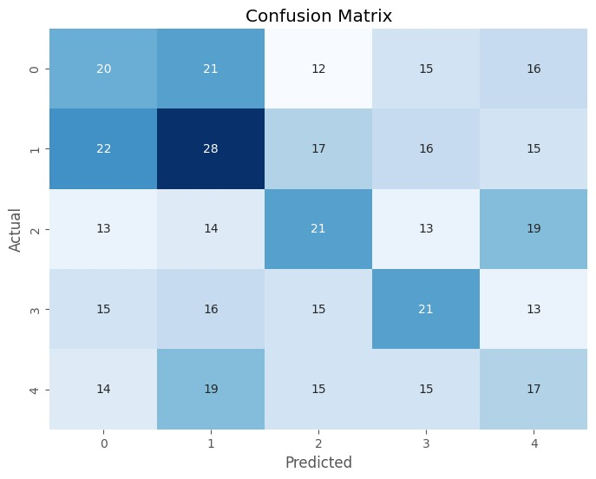

**Doubts:**

* Epochs took too long to run which was a tedious task.
* Code had many paramters like dropout,learning rate,batch size etc. which were unknown.
* Confusion matrix was plotted, but the concept was not clear.
* All the clarifications were provided in the meeting and many concepts were taught.