**DAY-4(22.06.2023)**

**TASK ASSIGNED:**

1. **To run the code in system using Anaconda/VS Code etc.**

* The same code run on the previous day in colab had to be run in the system.
* Initially, Anaconda and Visual Studio Code was downloaded.
* I used VS Code to run the algorithm for 20 epochs.
* Variations were found in the results by running same code in Colab and VS code.

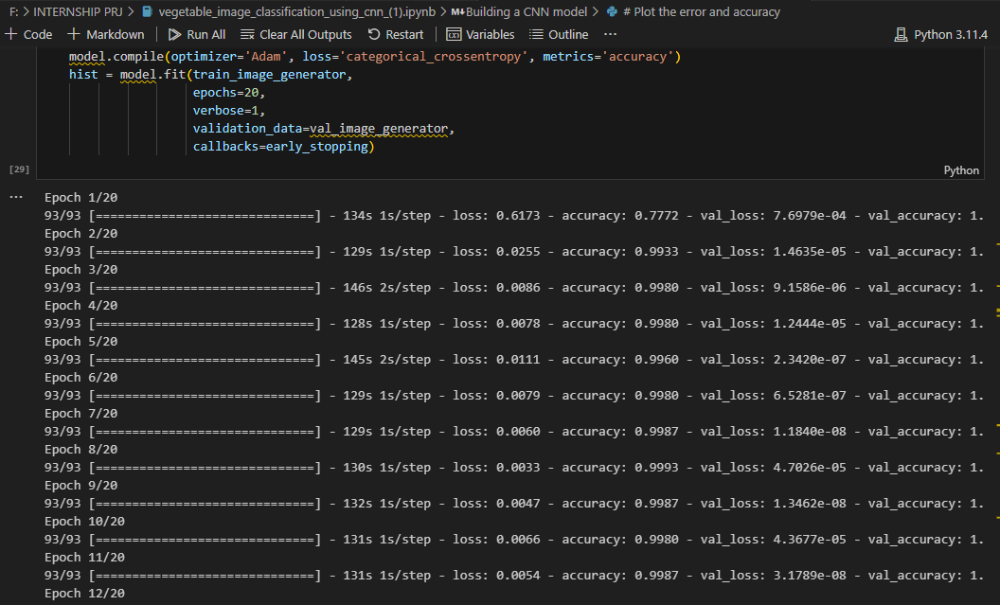

* Successfully run until 20 epochs and accuracy-loss has been studied.
* The model also predicted the images belonging to each labels correctly.

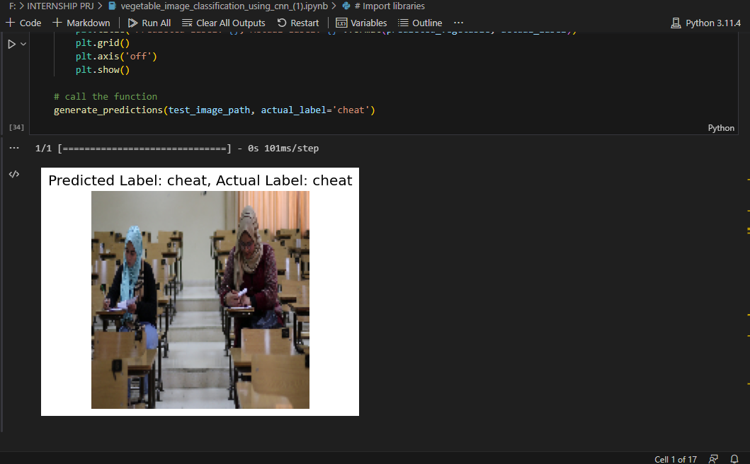

Similarly, confusion matrix and accuracy-loss graph was plotted and studied.

A clear view about the learnings of the model could be figured out by analysing the confusion matrix.

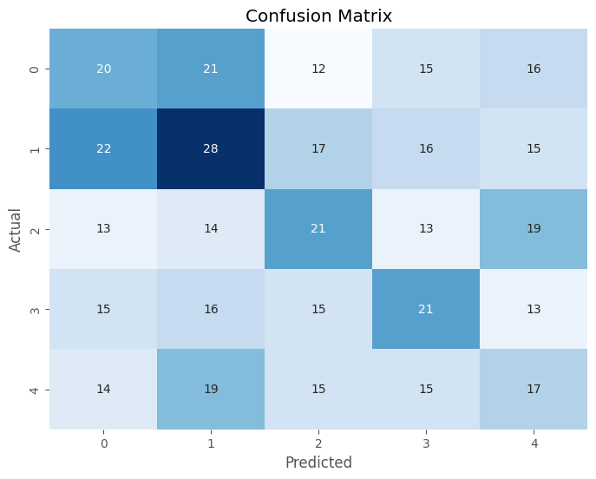

**Doubts:**

* Encountered errors in installing packages such as tensorflow, numpy etc.
* Faced issue with plotting confusion matrix since seaborn package was not installed with the latest update. It was rectified by searching in stack overflow.
* Epochs took much longer time to run, but accuracy did not show a steady growth.

