**DAY-5(23.06.2023)**

**TASKS GIVEN:**

**1.Run various CNN architecture code for a given data set.**

* An architecture dataset was provided which consisted of 10 classes
* The multiclass dataset contained about 11,000 images
* Code for Densenet121 algorithm was attached along with the dataset
* Densenet algorithm was run for 100 epochs
* Confusion matrix and accuracy-loss graph was plotted

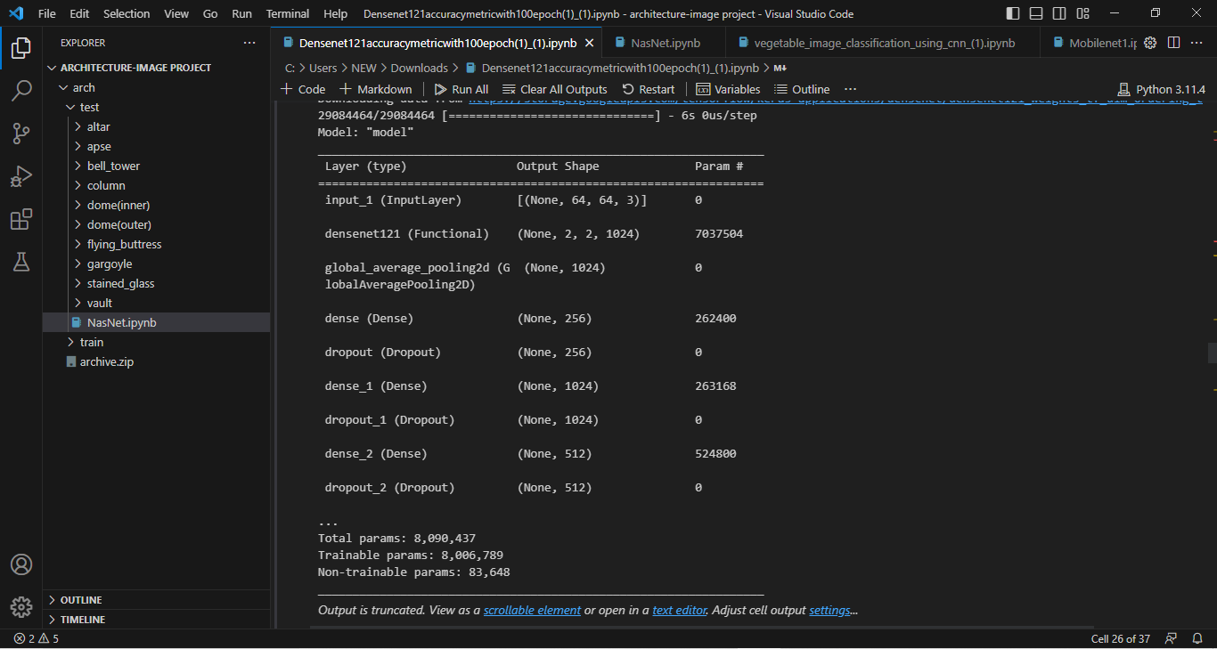

Densenet algorithm was run successfully for 100 epochs and an accuracy of 0.857558 was obtained.

Precision: 0.869083

Recall: 0.840506

F1 score: 0.848991

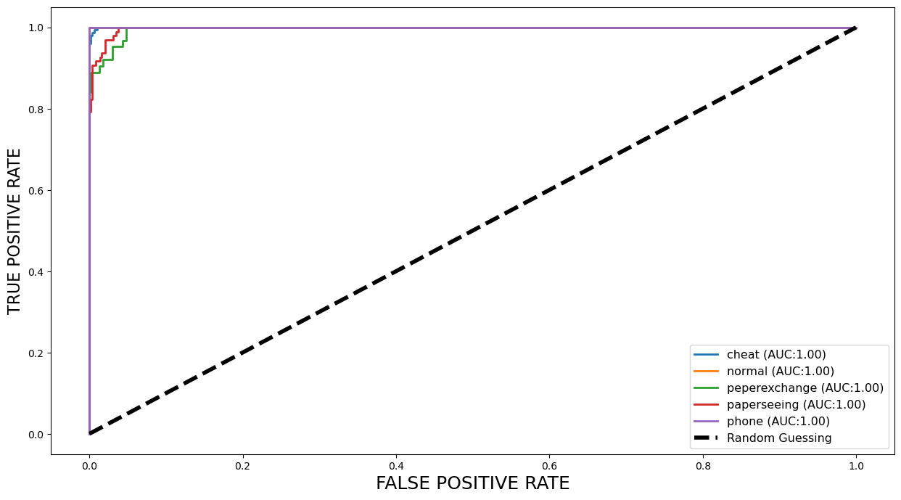

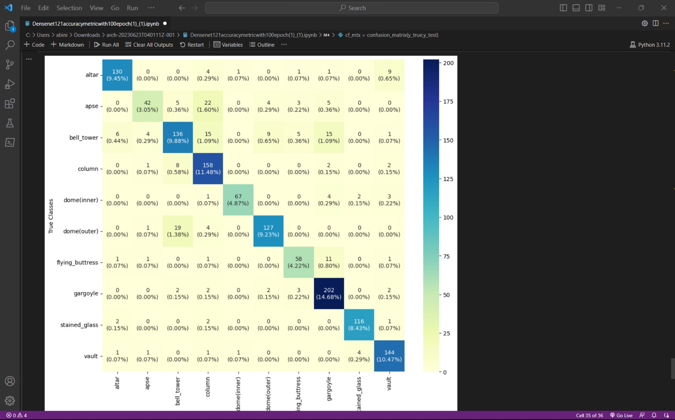

**Doubts:**

* Graph execution error was encountered
* It was cleared by referring stack overflow.