**DAY-06(24.06.2023)**

**TASK ASSIGNED:**

1. **To find better architectures for the given dataset and record the details in a table format.**

* Previously, Densenet121 algorithm was used which gave an accuracy of 0.857558
* The algorithm took almost 7-8 hours to execute 100 epochs at learning rate of 0.1 and batch size 64
* Next, I have chosen Mobilenet architecture.
* The code for the pretrained model was gathered from Kaggle and was run for a learning rate of 0.01 for batch size 128
* It took about 9 hours to execute 100 epochs
* Confusion matrix was plotted for the architecture.

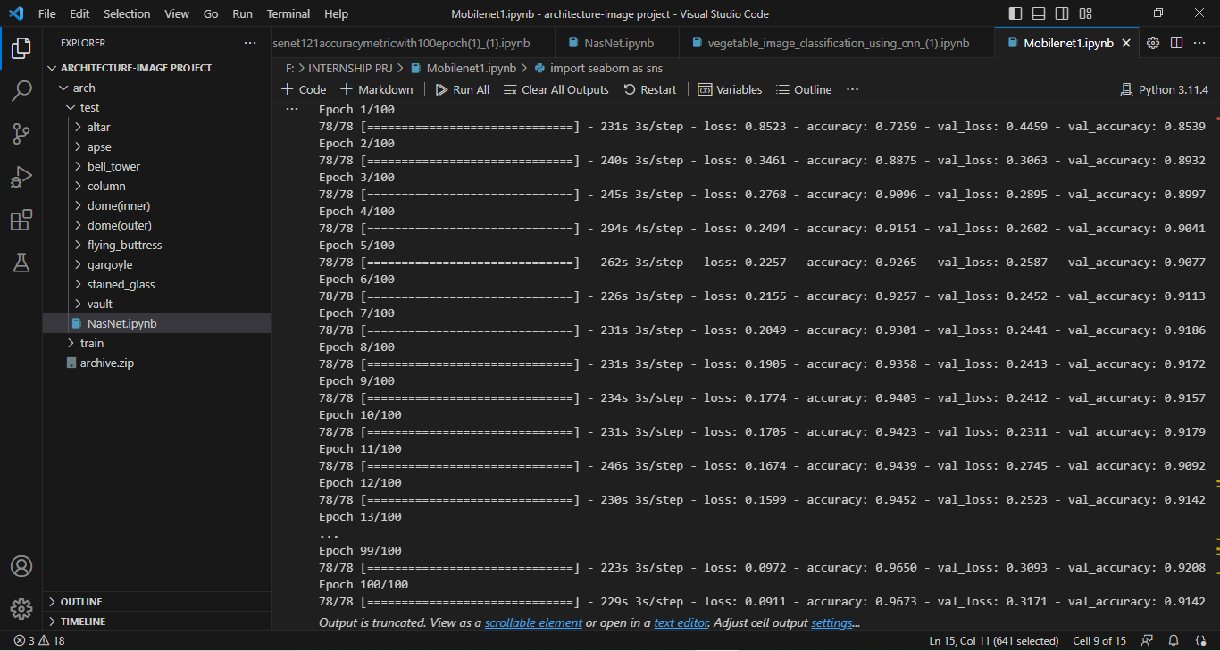

***Classification report:***

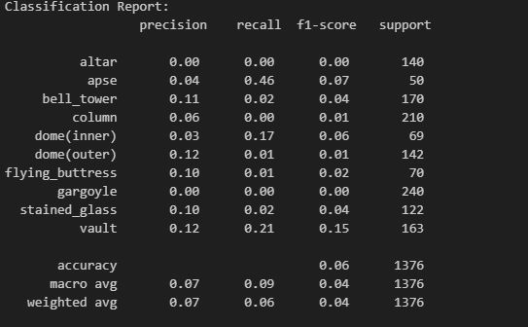

***Confusion matri***x:

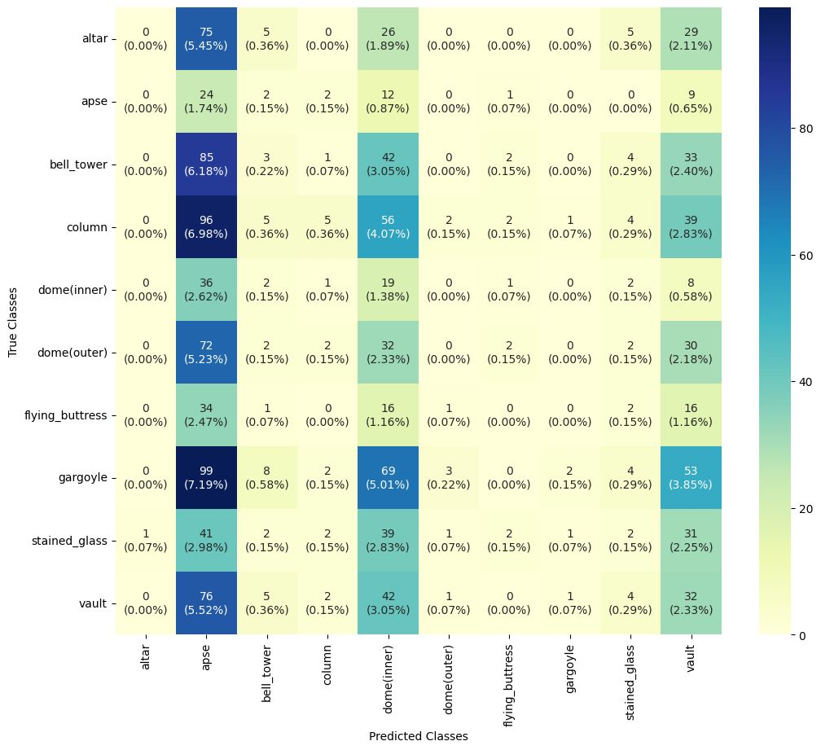

**Doubts:**

1.Epochs took longer time to run.

2.Confusion matrix plotted did not infer the obtained accuracy for the architecture, which were later discuused in the meeting.