**DAY-07(25.06.2023)**

**TASKS ASSIGNED:**

1. **To e**x**ecute the code for few more CNN pretrained architectures**

Until now, we have executed two algorithms – Densenet121 and MobileNet each 100 epochs

The accuracy and loss percentages were analysed and confusion matrix was plotted.

Now, we have been executing NasNet algorithm at learning rate of 0.01 and batch size 128 and VGG 16 at learning rate of 0.1 and batch size 64, each for 100 epochs

***VGG-16 Architecture:***

***Confusion matrix:***

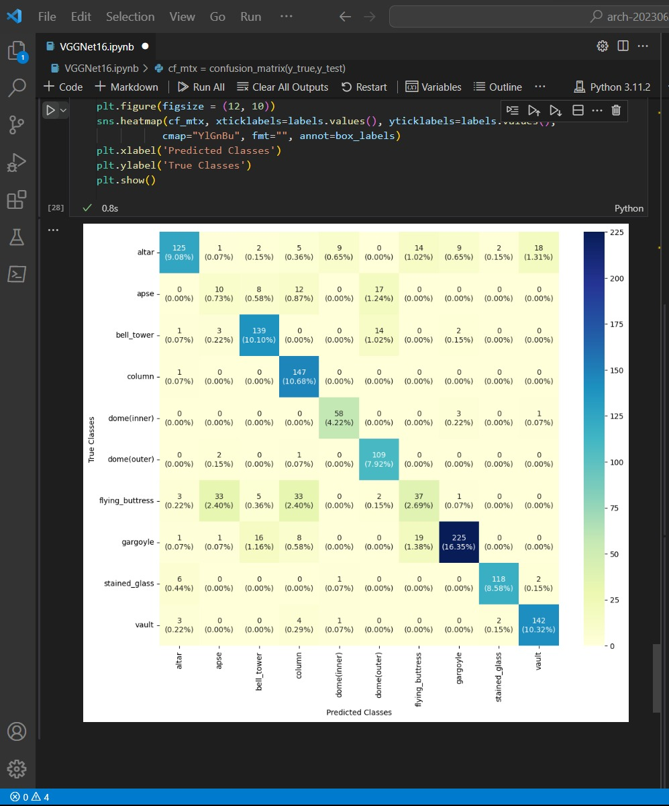

***Classification Report:***

Accuracy: 0.806686

Precision: 0.752314

Recall: 0.768584

F1 score: 0.751930

VGG-16 algorithm was completely executed for 100 epochs and graph was plotted.

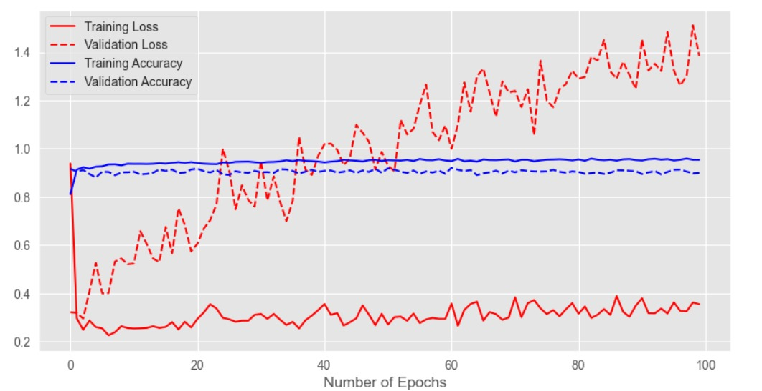

NasNet architecture is still executing at epoch-7 since each epoch takes around 7 hours to run.

**CONCLUSION:**

Training the models for a image dataset was taught with various datasets

Gained more knowledge about the execution of code in a pretrained model and its parameters

Concept of Confusion matrix and its vitality in inferring the results for a model was made clear.