**DEEP2NEURONS-INTERNSHIP**

**DAY-1(19.06.2023)**

Initially, we discussed about the area of interest and about the mini-project we have done during our semester-IV.

The areas I would like to gain knowledge about are data analytics and image processing.

**Tasks given:**

**1.To have a basic knowledge about CNN and algorithms underlying that**

Convolutional Neural Network is an algorithm that is used widely in all applications especially in image processing and segmentation. There are various algorithms that lie under CNN. Some of them are:

1. VGGNet
2. GoogLeNet
3. MobileNet
4. ResNet
5. DenseNet
6. Inception Resnet etc.

**2.Identify a project related to image processing**

I have chosen Fashion MNIST project which uses basic CNN architecture. The Fashion MNIST is a dataset  of Zalando's article images consisting of a training set of 60,000 examples and a test set of 10,000 examples. It has 10 labels such as T-shirt/top,Trouser,Pullover,Dress,Coat,Sandals etc.

**3.Identify the code for respective project and run it**

Fashion MNIST Project:

<https://www.kaggle.com/code/sneha2003/fashion-mnist-91-cnn-beginner-code/edit>

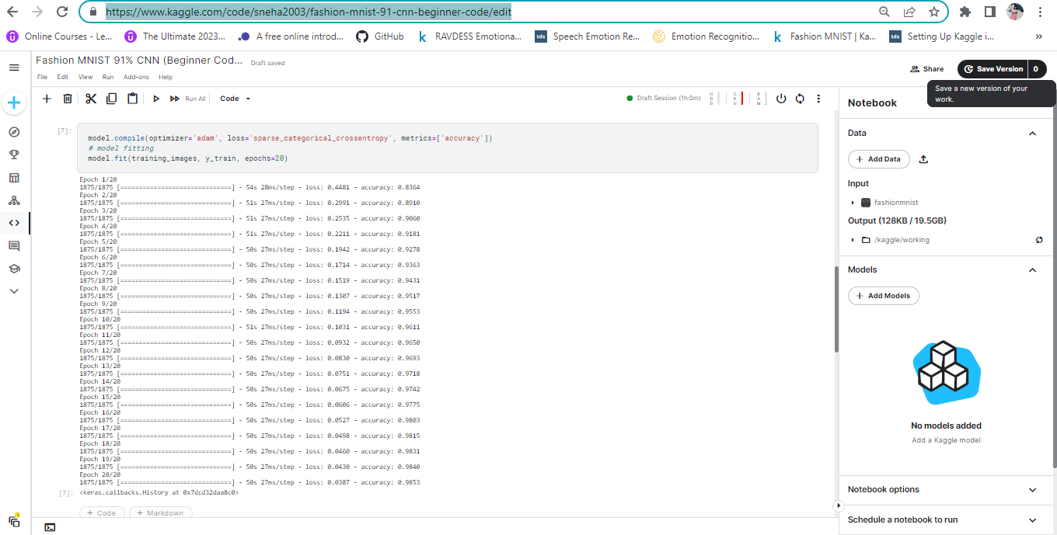

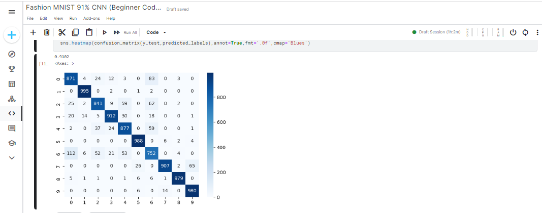

Reference:https://www.kaggle.com/datasets/zalando-research/fashionmnist

**Doubts:**

Faced difficulty in running the code in Kaggle initially.

Errors were discussd later in the meeting and have been cleared.