**Steps for processing documents:**

1. We open the official Howard County portal <https://data.howardcountymd.gov/>

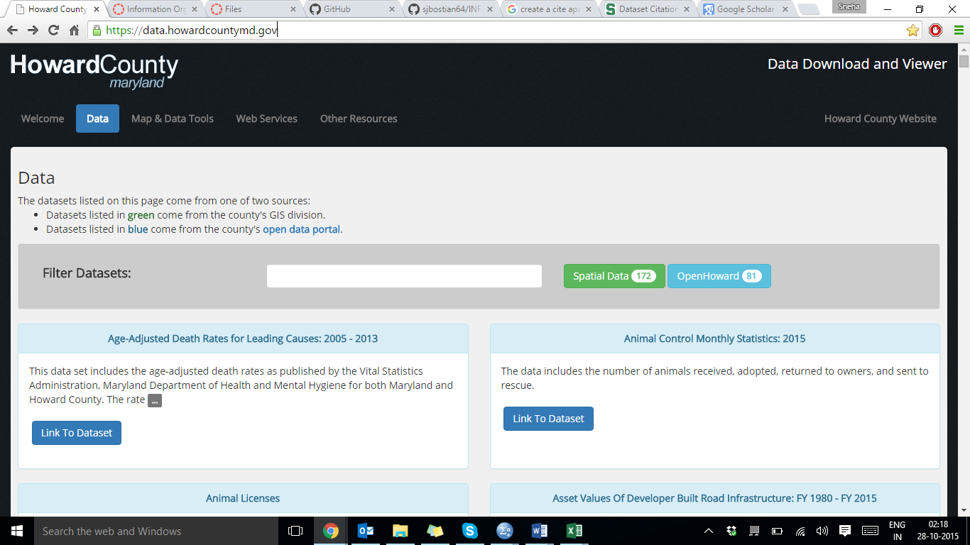

1. We scroll down until we reach the section “Residential Site Development Plans” which is our focal dataset.

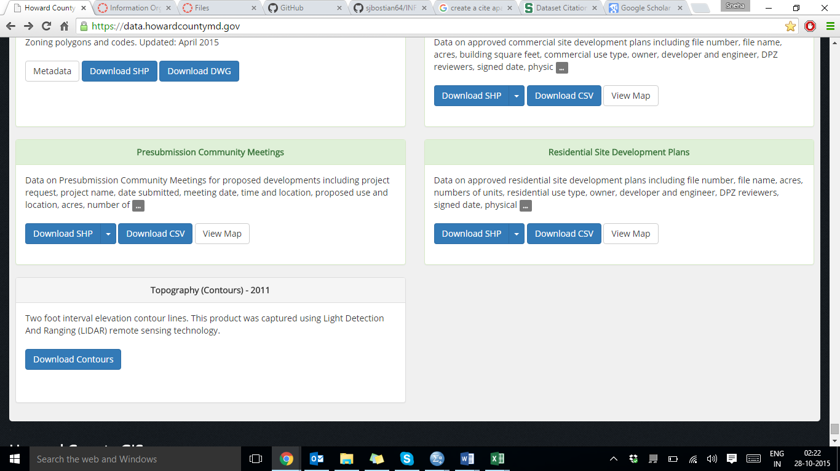

1. We click on “Download CSV” button. The csv file gets downloaded.
2. We rename the file to “Residence.csv”.
3. We open the file.

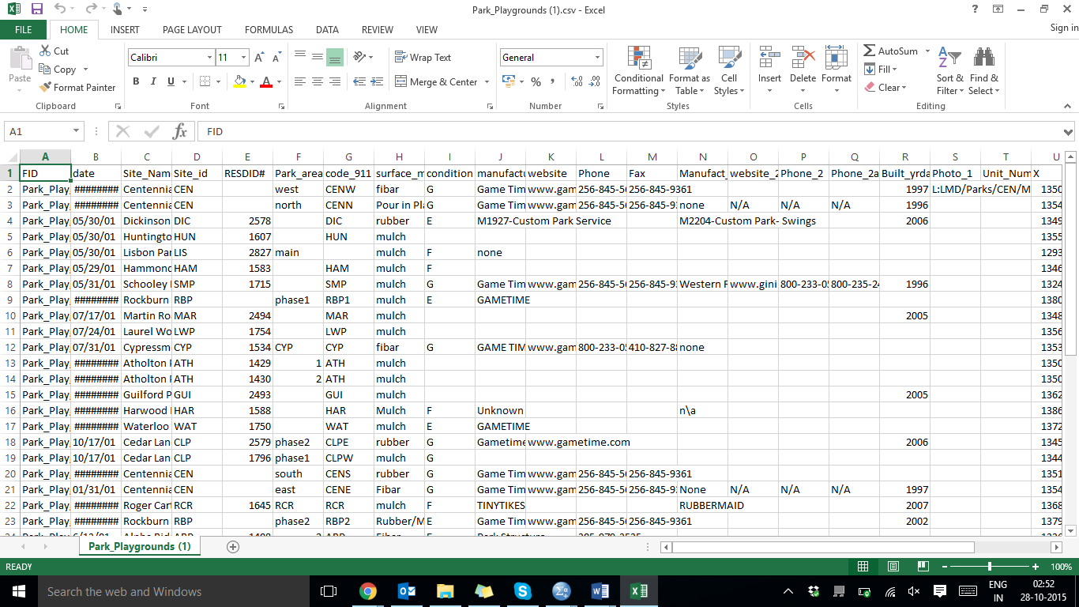

1. We remove the attributes unnecessary to the assignment. In this case, we have removed 13 attributes.
2. We bring the “geom” attribute to the front such that it becomes the first column in our file.
3. We save the edited file.

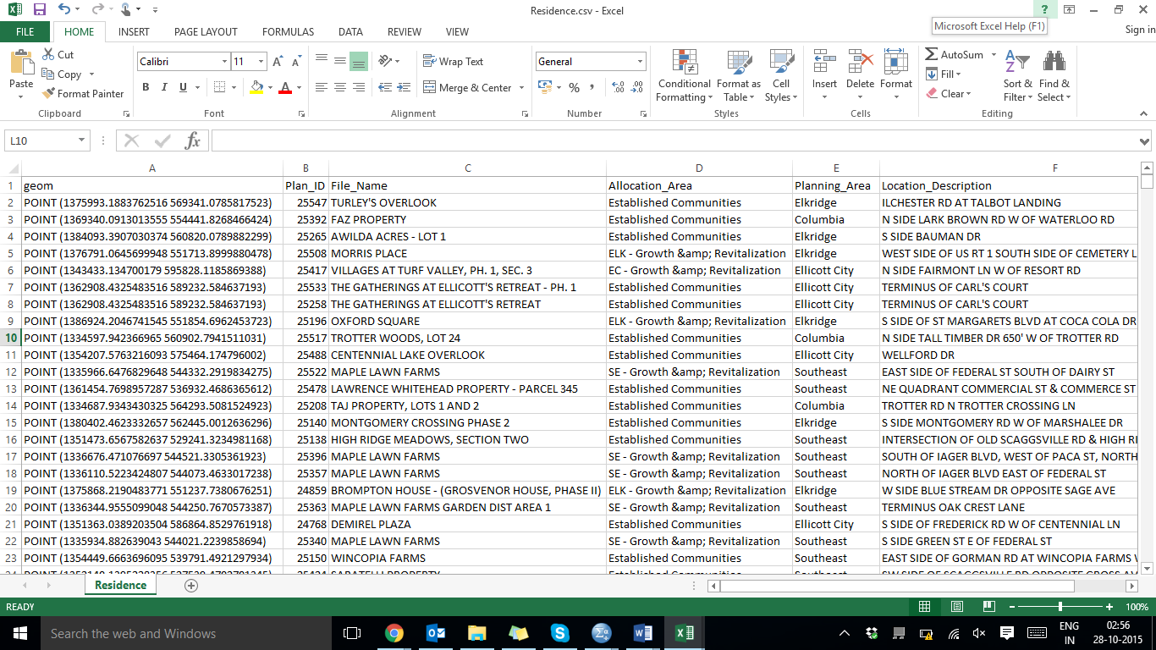

1. We download the second dataset named Park_Playgrounds and save it.
2. We open the file.

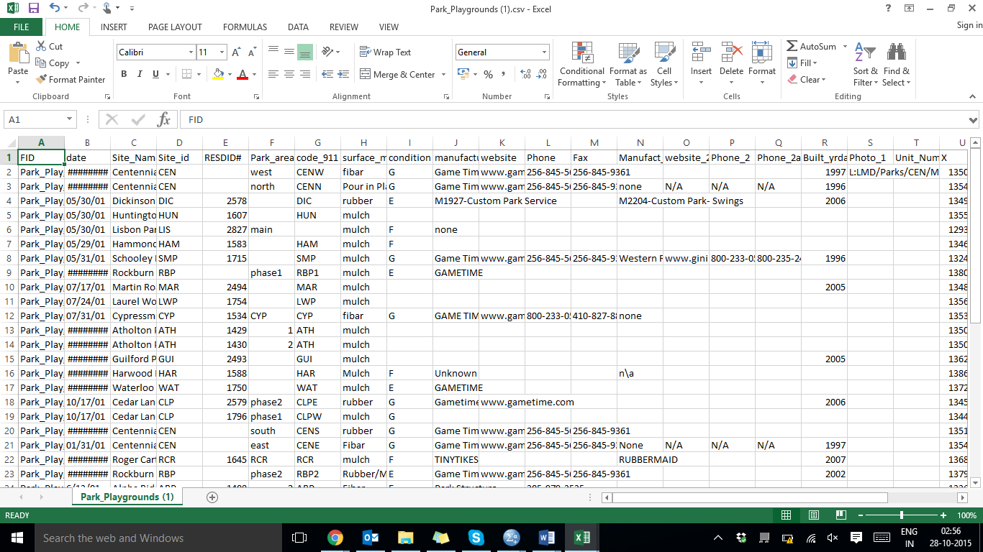

1. We remove the unnecessary attributes from the dataset. In this case, we have removed 13 attributes. We also rearrange the attributes such that “geom” comes in the front.

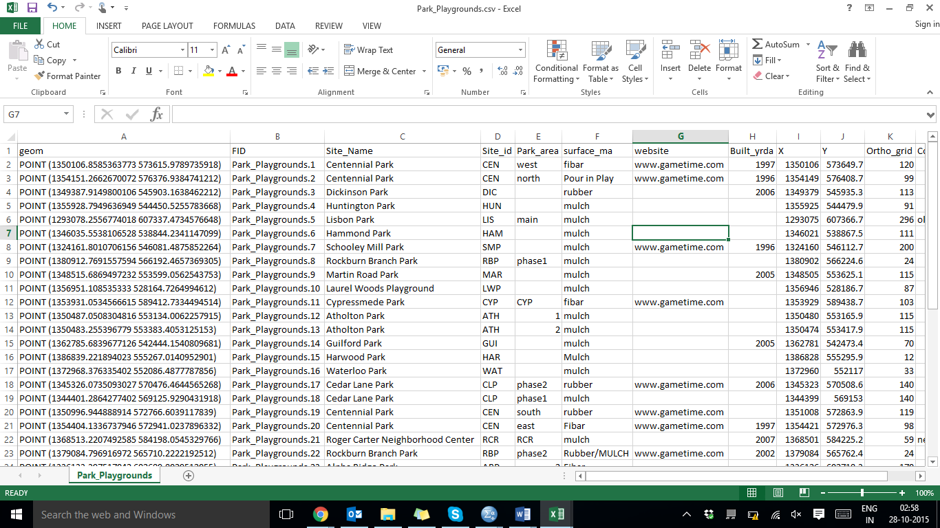

1. We save the csv file.