Practical No:7

Aim:Create forensic images of digital devices from volatile data such as memory using Imager for Computer System

Open Access FTK Imager

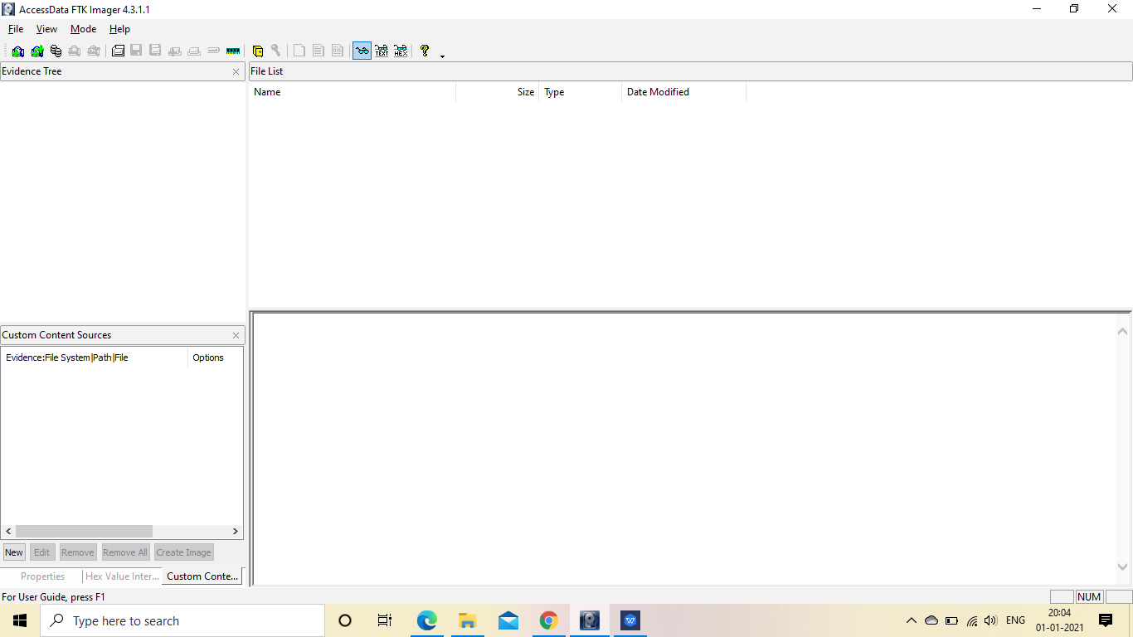

Click on File and select Create Disk Image

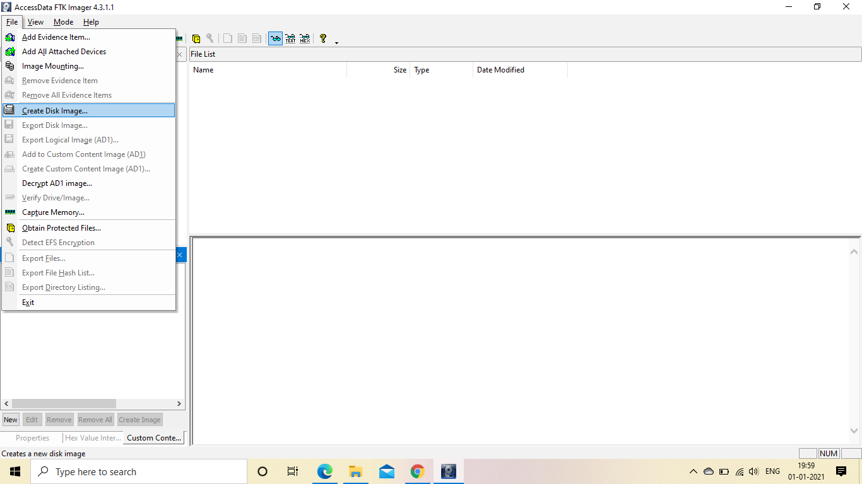

A popup window will appear and select source as Contents of Folder

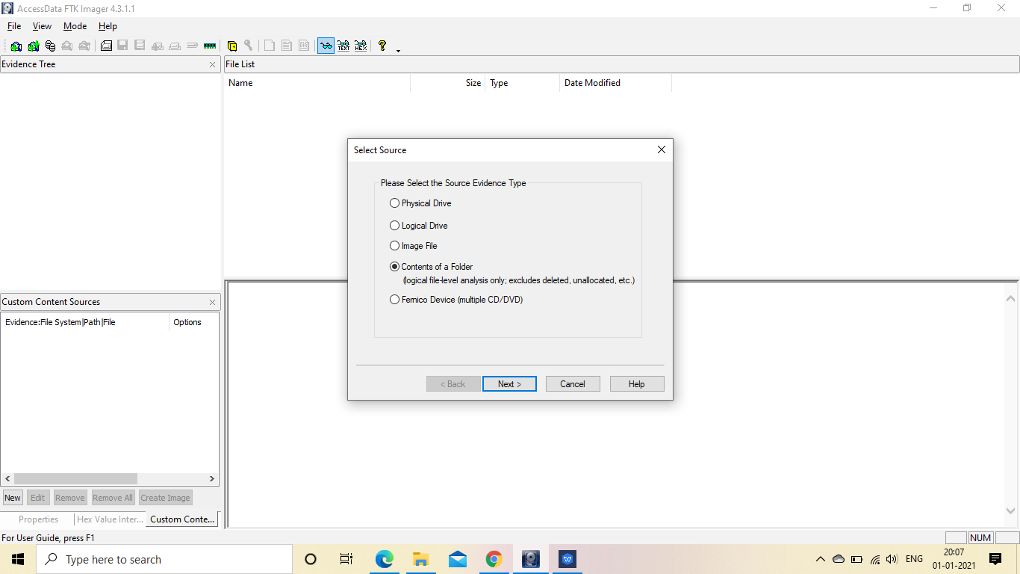

Click on Next and Click Yes

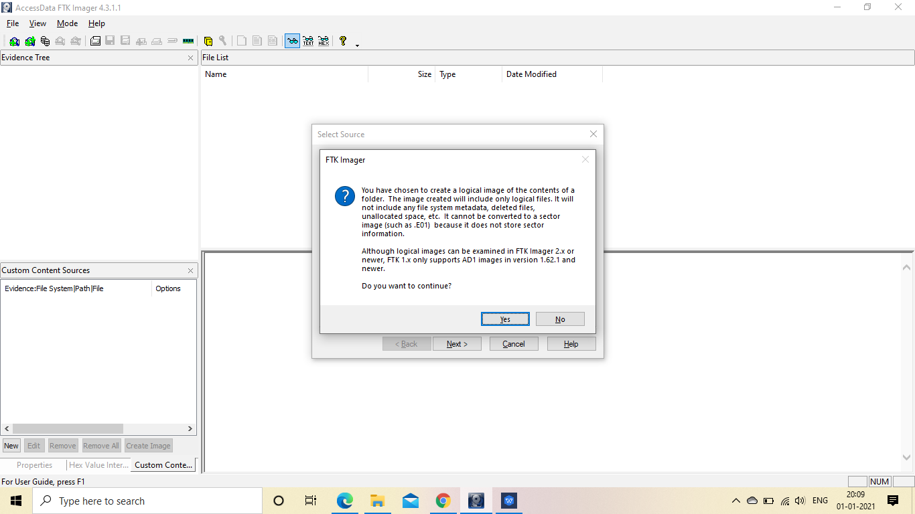

Select the File and Click on Finish

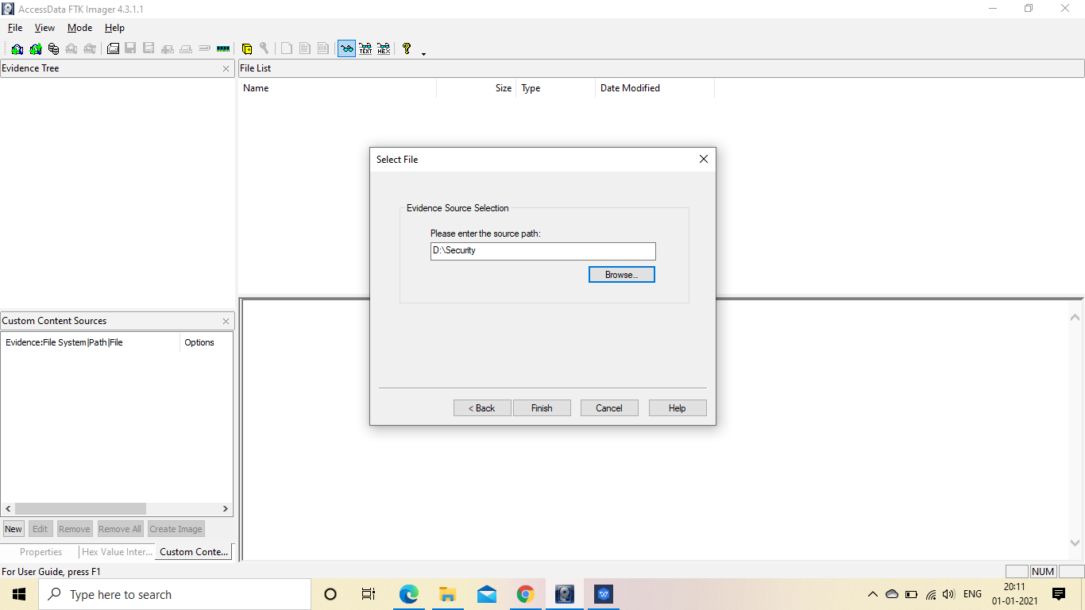

Add the Evidence Information and click on next

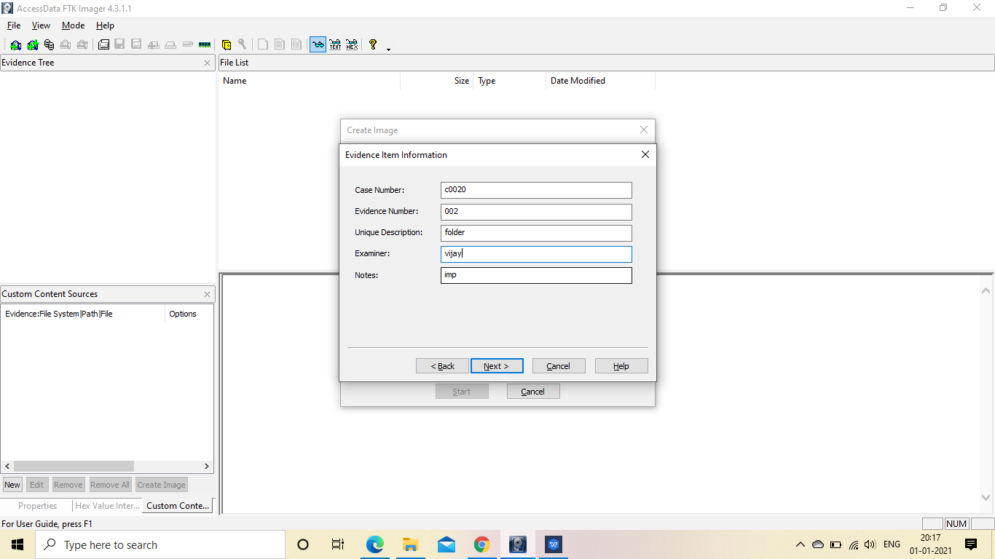

Select the Image Destination and Click on Finish

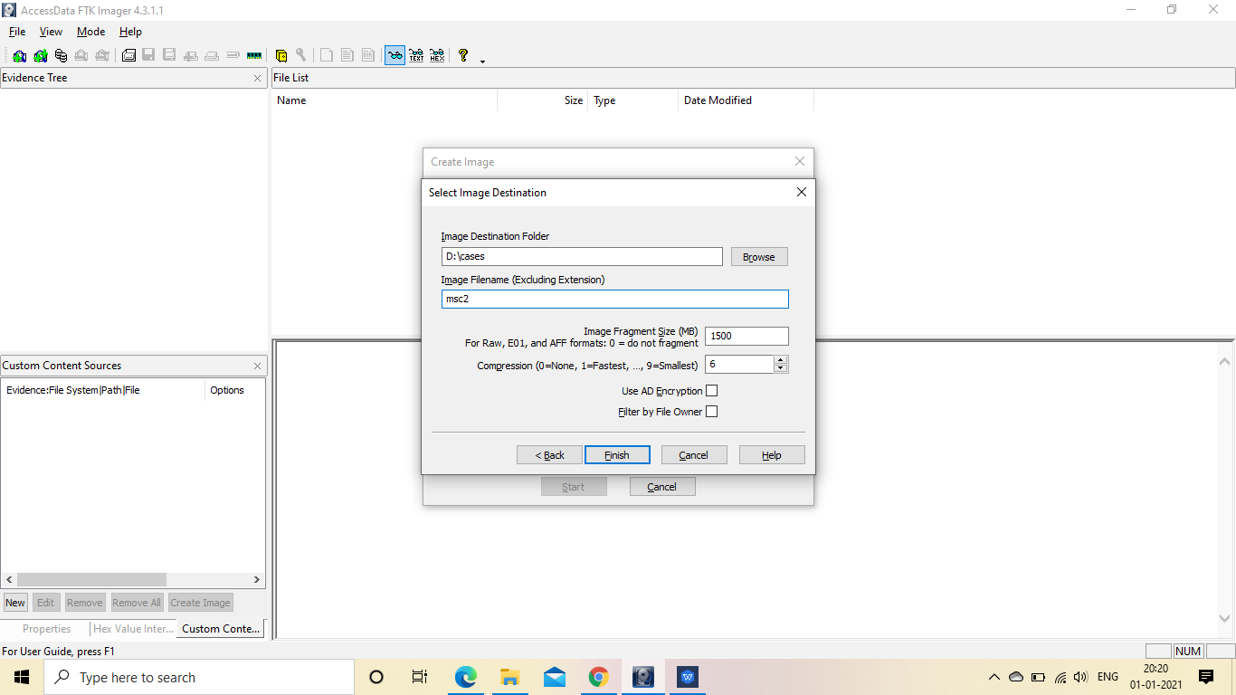

We can see that the Image Source and Destination has been created, just click on Add button

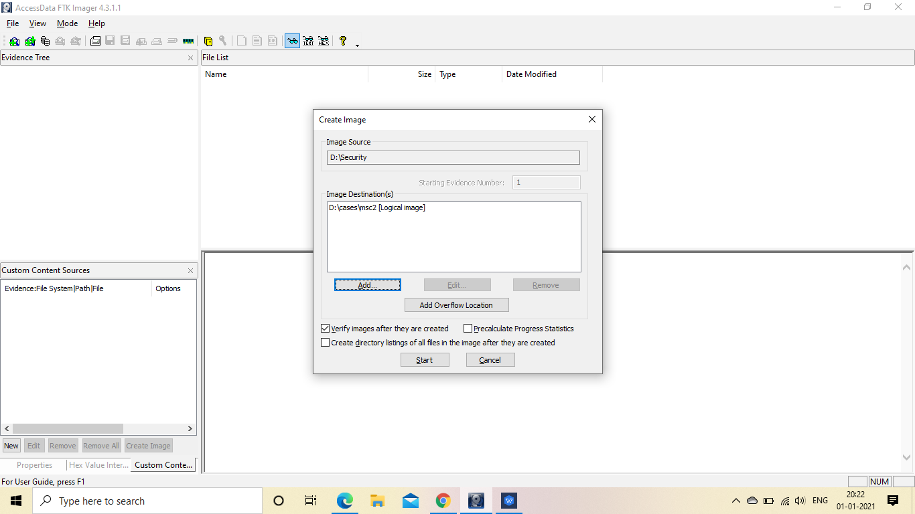

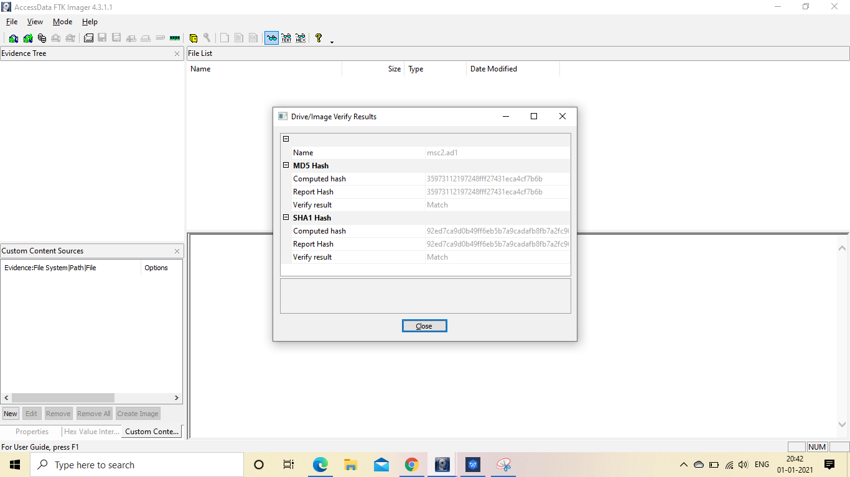

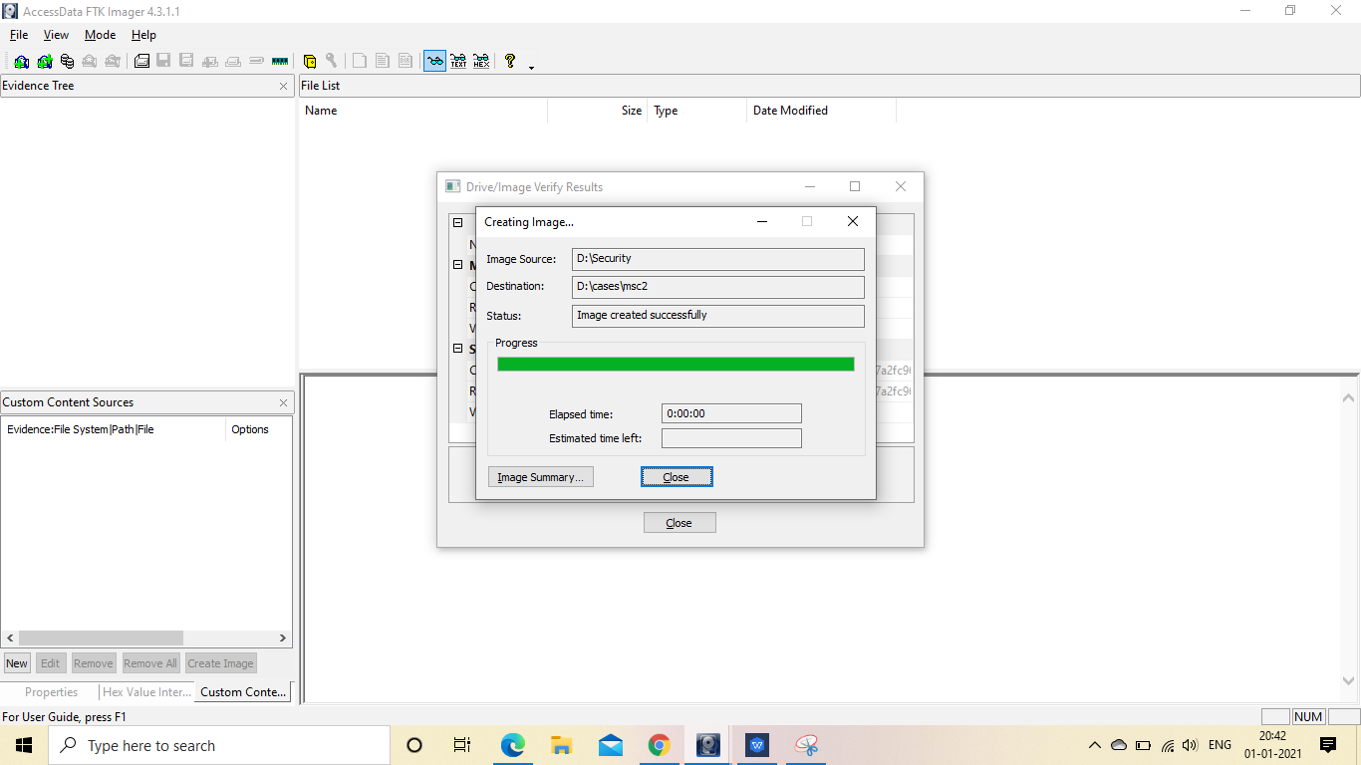

Click on Image Summary and Close

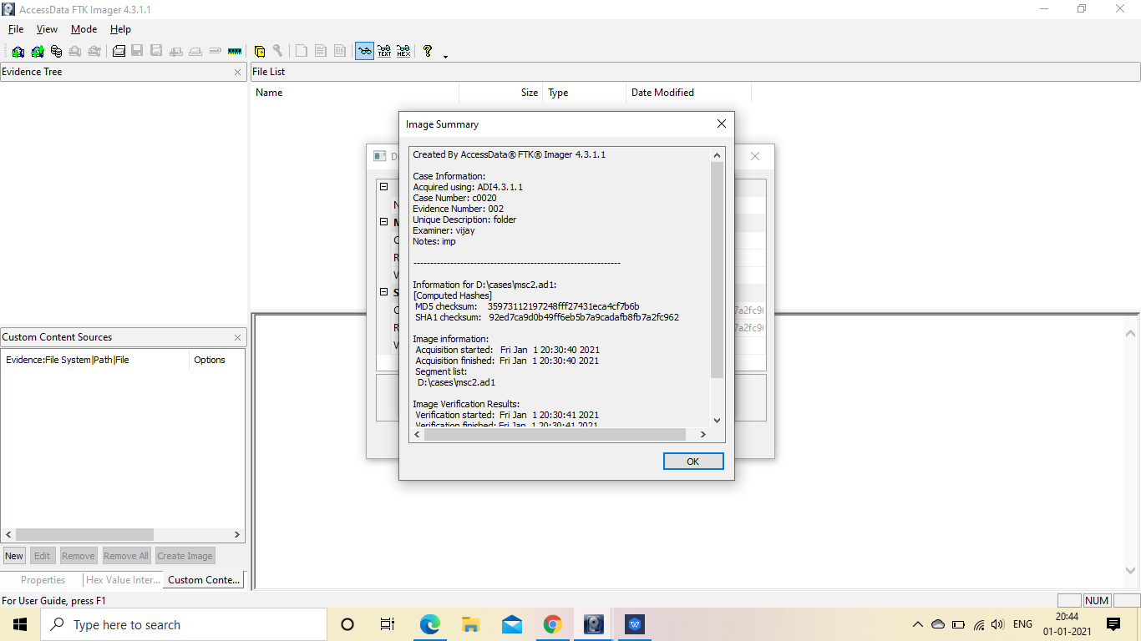

Click again on File and Select Add Evidence Item

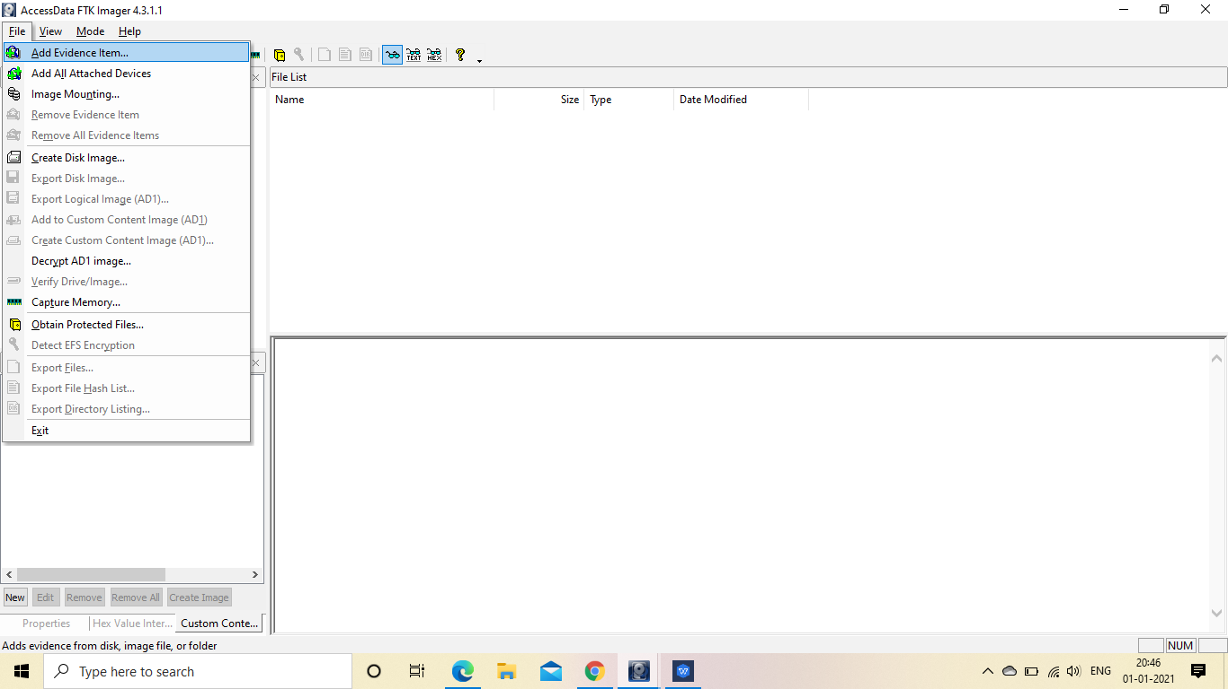

Select the Source as Image File and click Next

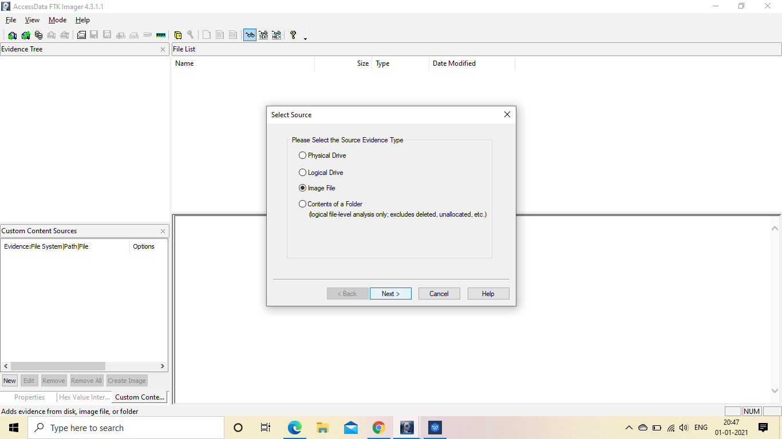

Browse the file

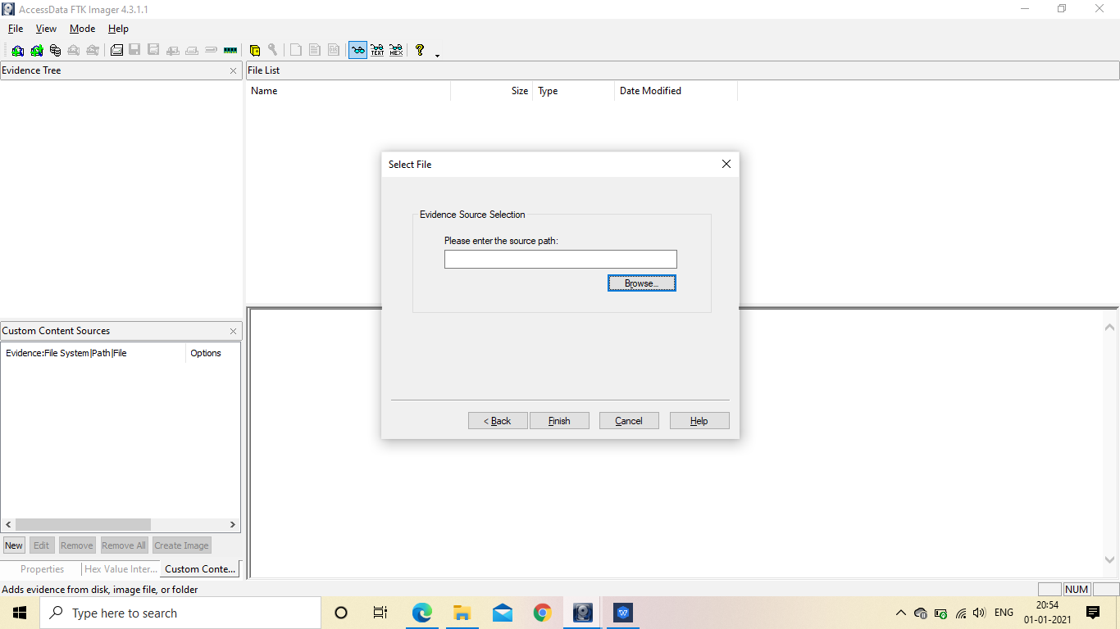

Select any one file and click on Open and Finish

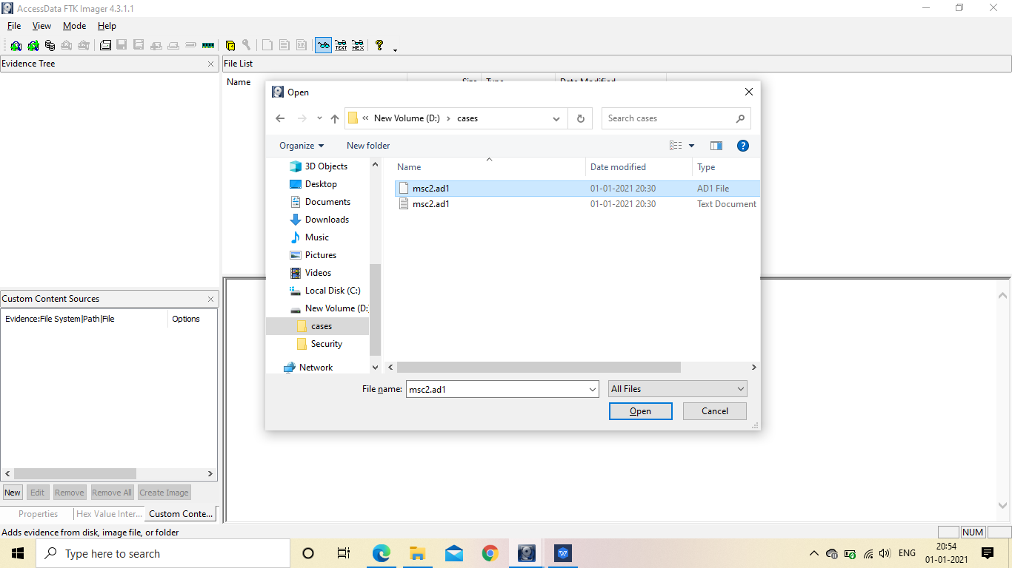

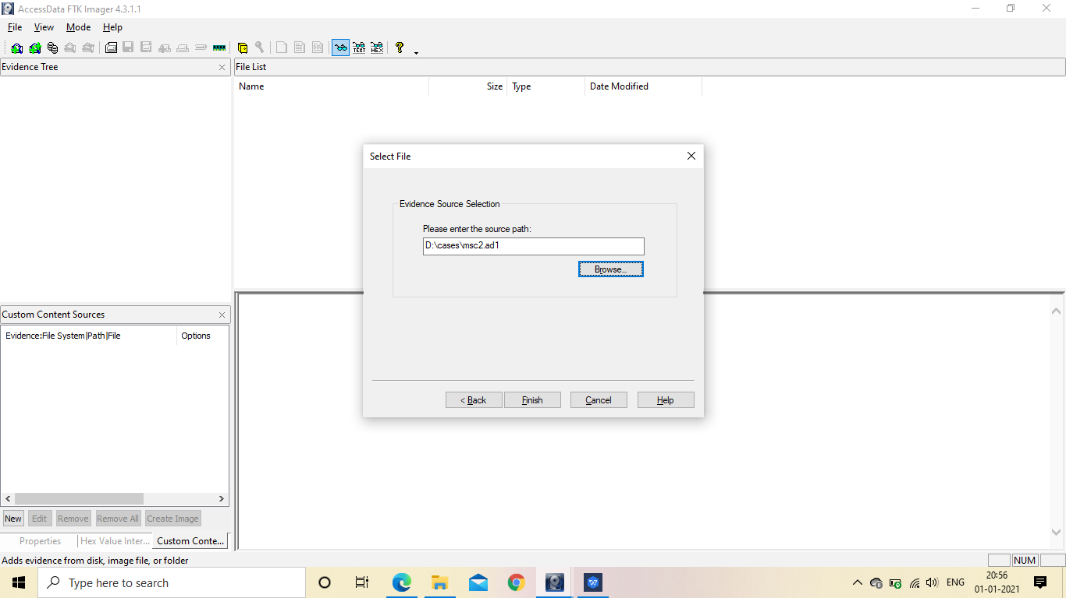

In the Evidence Tree we will see that the tree with the directory has bee created and click on any one file.

