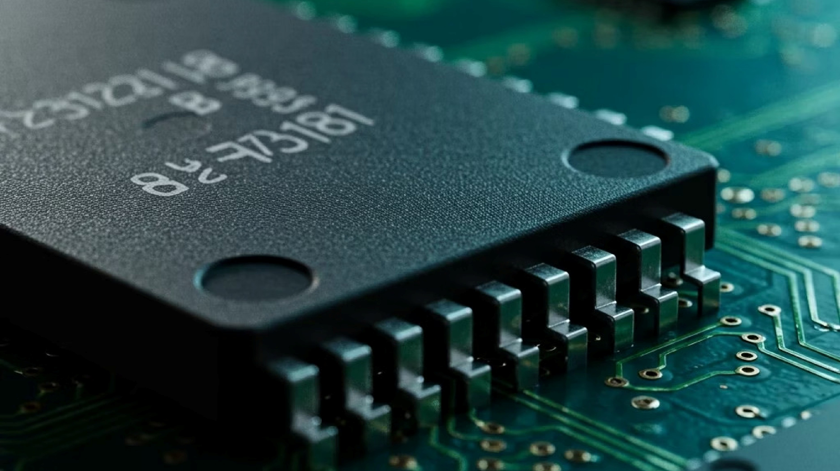
Experiment 8: Interrupt-Driven Systems with
Semaphores
This experiment explores the integration of
hardware interrupts
and
semaphores
in embedded real-time systems. You
will learn how interrupts signal events from hardware to software, and how semaphores coordinate safe data sharing
between an Interrupt Service Routine (ISR) and the main application thread — a foundational pattern in RTOS-based
embedded design.
EMBEDDED SYSTEMS LAB
EXPERIMENT 8
Aim
The objective of this experiment is to design and implement an interrupt-driven embedded system that uses a
binary

semaphore
to synchronise an ISR with the main program loop. By the end of this experiment, you should be able to:
1
Understand Interrupts
Explain how hardware interrupts work and how an ISR

is triggered and executed on an embedded processor.
2
Apply Semaphores
Use a binary semaphore to safely pass event signals

from an ISR to the main task without data corruption.
3
Implement in Code
Write and test interrupt + semaphore code on a target

microcontroller using an RTOS or bare-metal

approach.
4
Observe Behaviour
Record and analyse timing, latency, and correctness of

event handling under real hardware conditions.
The Interrupt Concept
An
interrupt
is a hardware or software signal that temporarily pauses the CPU's current execution and redirects it to a

dedicated handler called the
Interrupt Service Routine (ISR)
. This allows the processor to respond to real-world events

— such as a button press, timer overflow, or UART data arrival — immediately and without continuous polling.
Without Interrupts (Polling)
The CPU continuously checks peripheral status registers

in a loop. This wastes CPU cycles and increases

response latency, especially when events are infrequent.
With Interrupts
The CPU executes its main task freely. When an event

occurs, hardware asserts an interrupt line, the CPU saves

its state, executes the ISR, then resumes — achieving

near-instant response.

ISR Limitations
While ISRs enable fast hardware response, they operate under strict constraints. Violating these rules leads to
system

crashes, race conditions, and unpredictable behaviour
. Every embedded engineer must internalise these limitations.
Must Be Short
ISRs should execute in microseconds. Long ISRs block

other interrupts and degrade system responsiveness.
No Blocking Calls
Never call blocking functions like
delay()
,
printf()
, or

RTOS
pend
inside an ISR — these can deadlock the

system.
Shared Data Risks
Variables shared between an ISR and main code must

be declared
volatile
and protected against concurrent

access.
Limited Stack
ISRs use the main stack. Deep nesting or large local

variables risk stack overflow on memory-constrained

devices.
The golden rule:
ISR signals the event; the main task handles the work.
Keep ISRs minimal and delegate

processing to the application layer.

The Role of Semaphores
A
semaphore
is a synchronisation primitive used to signal between concurrent execution contexts — in this case,

between an ISR and the main task. A
binary semaphore
acts like a flag: the ISR
g
i
v
e
s
(posts) it upon detecting an event,

and the main task
t
a
k
e
s
(pends) it to begin processing.
Main Task

Pends
ISR Posts

Semaphore
Hardware

Event
This pattern cleanly separates
detection
(ISR) from
processing
(main task), keeping the ISR short while allowing the

main loop to perform complex operations safely. In an RTOS environment, the semaphore
give
may also unblock a

waiting task, enabling priority-based scheduling.
Binary Semaphore
Value: 0 (unavailable) or 1 (available)
Single event signalling
ISR gives; task takes
Counting Semaphore
Value: 0 to N (tracks multiple events)
Queues multiple occurrences
Used when ISR fires repeatedly

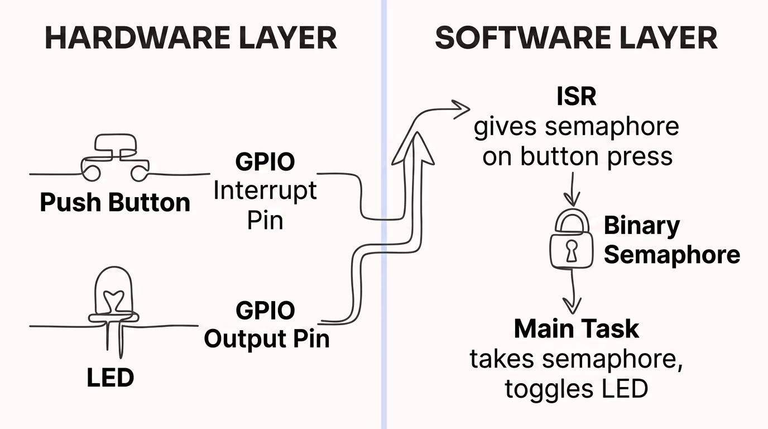
System Design
The experiment system consists of a microcontroller (e.g., STM32 or Arduino) connected to an external push-button
(
interrupt source) and an LED (output indicator). The design follows a clean two-layer architecture separating interrupt
detection from application logic.
The
hardware layer
generates a GPIO falling-edge interrupt on button press. The
software layer
uses a binary
semaphore to bridge the ISR and the main application task, which toggles the LED as a visible confirmation of the
handled event.

How It Works — Step by Step
1
Initialisation
Configure the GPIO pin as input with interrupt on falling edge. Create and initialise the binary semaphore to 0

(
empty). Enable the NVIC interrupt channel.
2
Main Loop Blocks
The main task calls
semaphoreTake()
with a timeout or indefinite wait. It blocks here, consuming zero CPU

cycles until the semaphore is signalled.
3
Button Pressed
The user presses the button. Hardware detects the falling edge on the GPIO pin and raises the interrupt

request to the CPU.
4
ISR Executes
CPU saves context and jumps to the ISR. The ISR calls
semaphoreGiveFromISR()
to post the semaphore, then

returns immediately.
5
Task Unblocks
The semaphore give unblocks the main task. It takes the semaphore, toggles the LED, and loops back to block

again — ready for the next event.

Implementation
Below is a representative bare-metal C implementation for an STM32-class microcontroller using CMSIS and a simple

binary semaphore modelled with a
volatile
flag. In an RTOS context (e.g., FreeRTOS), replace the flag with
xSemaphoreGiveFromISR()
and
xSemaphoreTake()
.
/* --- Global semaphore flag --- */
volatile uint8_t semaphore =
0
;
/* --- GPIO Interrupt ISR --- */
void
EXTI0_IRQHandler
(
void)
{

if (EXTI->PR & EXTI_PR_PR0) {

EXTI->PR |= EXTI_PR_PR0;
/* Clear pending flag */

semaphore =
1
;
/* Give semaphore */

}
}
/* --- Main Task --- */
int
main
(
void)
{

HAL_Init
()
;

GPIO_Init
;
()
/* Configure button (PA0) + LED (PA5) */

NVIC_EnableIRQ
EXTI0_IRQn);
(

while (
1

{
)

/* Take semaphore (spin-wait; use RTOS pend in production) */

if (semaphore ==
1

{
)

semaphore =
0
;

HAL_GPIO_TogglePin
(
GPIOA, GPIO_PIN_5);
/* Toggle LED */

}

}
}
In FreeRTOS, replace the
volatile
flag with
xSemaphoreHandle
and use
xSemaphoreGiveFromISR()
in the ISR and
xSemaphoreTake(sem, portMAX_DELAY)
in the task to enable true blocking without CPU spin.

Observations
During lab execution, record the following measurements and verify system behaviour against expected results. Use an

oscilloscope or logic analyser to capture interrupt latency and LED toggle timing.
Parameter
Expected
Observation Notes
Interrupt latency (button
→
ISR entry)
<
1 µs (hardware
)
Measure with logic analyser on ISR

GPIO toggle
Semaphore give
→
task unblock delay
)
<
10 µs (bare-metal
Time from ISR exit to LED toggle start
LED toggles per button press
Exactly 1
Verify no missed or double events
CPU load during idle (no button)
Spin: ~100% / RTOS: ~0%
Compare bare-metal vs. RTOS

implementation
Bounce events (mechanical button)
Multiple edges possible
Check if debounce logic is needed
If multiple LED toggles occur per press, the button is
bouncing
. Add a software debounce delay or hardware RC

filter (10 k
Ω
+ 100 nF) and re-observe.

Conclusion
This experiment demonstrated a core embedded systems pattern: using a
hardware interrupt to detect events
and a
binary semaphore to synchronise
the ISR with the main application task. This separation of concerns is critical to

building responsive, reliable, and maintainable embedded software.
🔌
Interrupts
Enable immediate hardware

response without CPU polling,

reducing latency and power

consumption significantly.
🚦
Semaphores
Provide a safe, structured

mechanism to signal between ISR

and task contexts without shared-
variable race conditions.
⚡
ISR Discipline
Keeping ISRs short and

delegating work to tasks is

essential for predictable timing in

real-time systems.
The interrupt + semaphore pattern is the backbone of event-driven embedded firmware — mastering it prepares you

for professional RTOS development on any platform.
EXPERIMENT COMPLETE
RTOS READY

