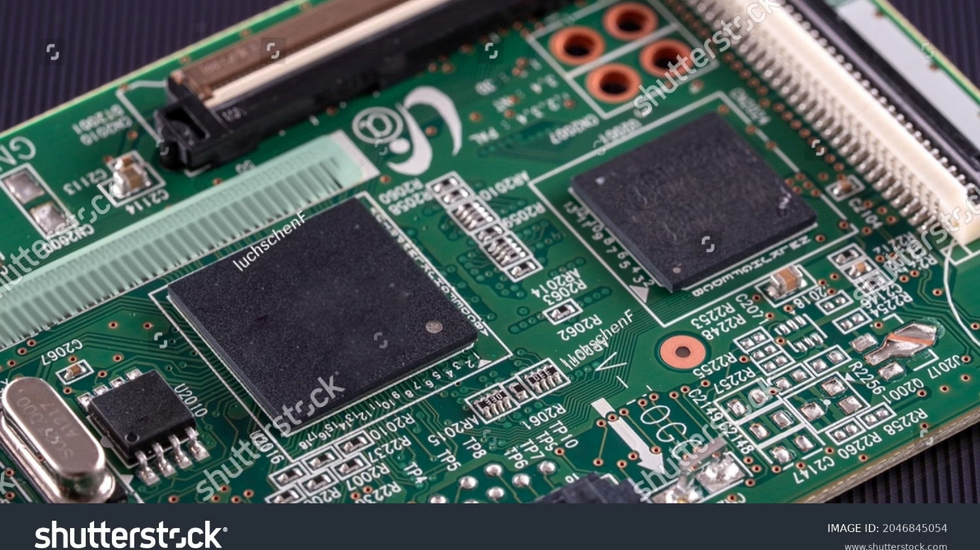
Experiment 5: Super Loop Based Embedded
System
A practical exploration of bare-metal embedded programming using the super loop architecture — implementing
multiple concurrent tasks on a microcontroller without an RTOS.
EMBEDDED SYSTEMS
BARE-METAL PROGRAMMING
STM32 / HAL
Aim
Primary Objective
Implement a
super loop architecture
on an embedded

microcontroller platform using STM32 HAL libraries and

a bare-metal programming approach.
Secondary Objective
Perform
multiple tasks sequentially
within a single

infinite loop — including LED control, button polling,

and sensor reading — without any operating system

overhead.
This experiment demonstrates how real-world embedded systems can manage multiple peripherals using only

a structured main loop and timing counters.
Introduction
The
super loop
(also called a bare-metal loop or foreground/background system) is one of the most fundamental

architectures in embedded software design. At its core, it uses a single
while(1)
construct that runs indefinitely from

power-on until the system is reset.
Each iteration of the loop executes a set of tasks in sequence. Because the loop never exits, tasks are repeatedly

serviced — giving the illusion of simultaneous execution. This approach is ideal for
resource-constrained

microcontrollers
where the complexity and overhead of an RTOS are not justified.
Core Principle
Uses an infinite
while(1)
loop to execute tasks

repeatedly in a deterministic sequence.
Key Advantage
Minimal memory footprint — no kernel stack, no

scheduler, no context switching overhead.
Theory
Foreground — Interrupt Context
The
SysTick timer
fires at a regular interval (typically

every 1 ms). Its ISR increments the HAL tick counter,

providing a global time reference. This is the

"foreground" layer that services time-critical hardware

events asynchronously.
SysTick interrupt at 1 ms period
Increments
uwTick
counter
Serves as system heartbeat
Background — Main Loop
The
main loop
runs continuously in the background. It

reads the tick counter via
HAL_GetTick()
and compares

against stored timestamps to decide whether each task

is due for execution.
Polls
HAL_GetTick()
each iteration
Compares elapsed time per task
Executes task if interval has passed
HAL_GetTick()
returns the number of milliseconds elapsed since system startup, sourced from the SysTick-
driven counter — enabling non-blocking time management in the background loop.

Concept: Cooperative Task Scheduling
No Blocking Delays
Cooperative Tasks
No RTOS
The super loop concept is built on three pillars: operating without an RTOS kernel, using cooperative (non-preemptive)

task execution, and completely avoiding blocking delays. Each task checks the tick count and runs only when its time

slice arrives — then immediately returns control to the loop.
No RTOS
No scheduler, no task priorities, no

kernel — just bare hardware and your

code.
Cooperative
Tasks voluntarily yield after

completion. No preemption occurs

between tasks.
Non-Blocking
Replace
HAL_Delay()
with tick

comparison — the loop never stalls.

System Tasks
Three peripheral tasks are managed within the super loop, each with its own timing requirement and hardware interface.
1
LED Blinking
Toggles an onboard or external

LED at a defined interval.

Validates that the timing

mechanism is functioning

correctly — the most basic system

health indicator.
2
Button Reading
Polls the state of a digital push-
button input. Polled frequently to

capture brief presses reliably.

State changes can trigger actions

or log events.
3
IR Sensor Reading
Reads the output of an infrared

proximity or distance sensor.

Sampled at a moderate rate

sufficient for detecting

environmental changes in real

time.

Working Principle
Software Counter-Based Timing
Each task maintains its own
last-execution timestamp
stored

in a
uint32_t
variable. On every loop iteration, the current tick

value is fetched via
HAL_GetTick()
and compared against the

stored value. If the difference meets or exceeds the task's

interval, the task runs and the timestamp is updated.
This pattern ensures tasks are
time-multiplexed
without

blocking each other — the loop continues iterating freely

regardless of whether any task executed.
This approach handles
tick counter overflow

gracefully when using unsigned arithmetic —

subtraction wraps correctly after ~49.7 days at 1 ms

resolution.
Pseudo-Code Structure
uint32_t t_led =
0
;
uint32_t t_btn =
0
;
uint32_t t_ir =
0
;
while
(
1
)

{

uint32_t now =
HAL_GetTick
;
()

if
(
now - t_led >=
500
)

{

LED_Toggle
()
;

t_led = now;

}

if
(
now - t_btn >=
50
)

{

Button_Read
()
;

t_btn = now;

}

if
(
now - t_ir >=
200
)

{

IR_Read
()
;

t_ir = now;

}
}

Implementation: Task Timing Configuration
Each peripheral task is assigned a fixed execution interval tuned to its functional requirements. Faster tasks consume

marginally more CPU cycles per second but remain negligible in a bare-metal loop.
ms
500
LED Blink
Toggle period — 1 Hz visible blink rate,

suitable for visual status indication.
ms
50
Button Poll
Hz sampling — fast enough to
20

reliably detect short button presses

without debounce loss.
200
ms
IR Sensor
5
Hz read rate — adequate for

detecting proximity changes in

typical test scenarios.
Task
Interval
Frequency
Priority
LED Toggle
500
ms
2
Hz
Low
Button Read
50
ms
20
Hz
High
IR Sensor Read
200
ms
5
Hz
Medium

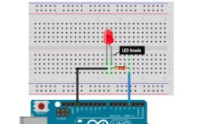
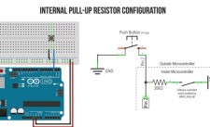
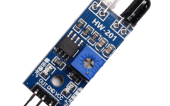
Observations
LED Blinked
Correctly
The onboard LED toggled
at the expected 500 ms
interval throughout the
experiment. No missed
cycles or timing drift were
observed during the test
duration, confirming
accurate tick-based
scheduling.
Button Detected
Properly
Press and release events
were reliably captured at
the 50 ms polling rate.
Short presses as brief as
~80 ms were consistently
registered without
debounce-related false
triggers.
Sensor Values
Changed with
Distance
The IR sensor output varied
predictably as an object
was moved toward and
away from the sensor.
Values updated smoothly
every 200 ms, with no stale
readings observed in the
serial output.
Conclusion
Multitasking Without

RTOS
The super loop architecture

successfully demonstrates

cooperative multitasking. Multiple

peripherals were managed

concurrently using only a single

loop and tick-based counters.
Bare-Metal Efficiency
The system operates entirely

without OS overhead — no kernel,

no scheduler. This results in

deterministic, lightweight

execution ideal for resource-
constrained MCUs.
Suitable for Simple

Systems
For applications with a small, well-
defined task set and no hard real-
time constraints, the super loop

remains a practical, maintainable,

and highly reliable design choice.
Key Takeaway:
The super loop pattern is a foundational technique every embedded engineer should master

before advancing to RTOS-based designs. Its simplicity is its strength.

