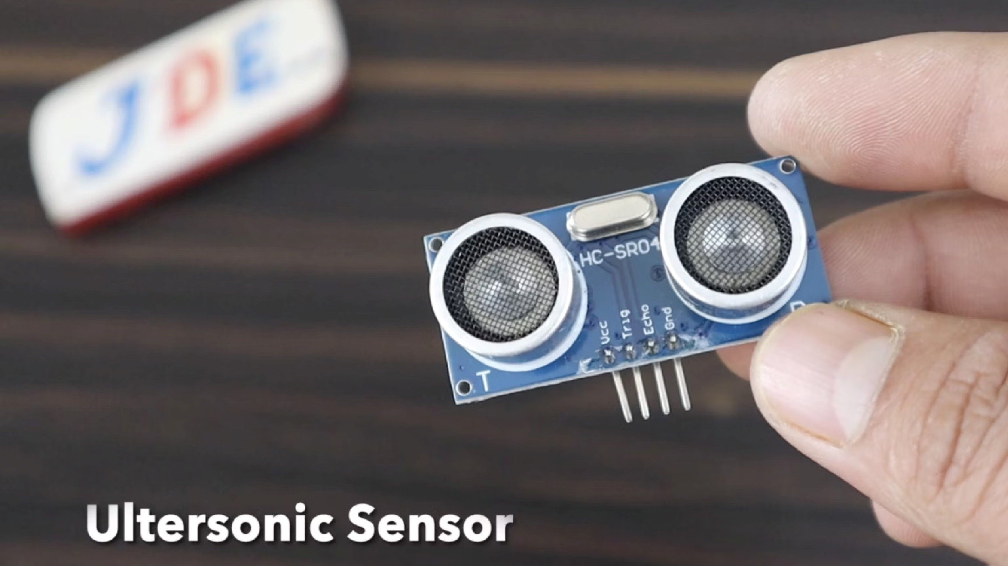
Ultrasonic Sensor Interfacing with STM32
EMBEDDED SYSTEMS LAB
STM32F446RE
A hands-on experiment to interface the HC-SR04 ultrasonic sensor with the STM32F446RE microcontroller, measure
real-time distance, and indicate proximity using an LED.
Aim
Objective
To interface an
HC-SR04 ultrasonic sensor
with the

STM32F446RE microcontroller and measure distance using

LED indication as a visual output mechanism.
Configure GPIO and Timer peripherals on STM32
Measure time-of-flight of ultrasonic pulses
Indicate proximity via LED ON/OFF logic
Apparatus Required
STM32 Nucleo-F446RE
ARM Cortex-M4 based development board with onboard

ST-LINK debugger and abundant GPIO peripherals.
HC-SR04 Sensor
Ultrasonic distance sensor with TRIG and ECHO pins,

measuring distances from 2 cm to 400 cm.
Jumper Wires & USB Cable
Male-to-female jumper wires for connections and a USB

cable for programming and power supply.
STM32CubeIDE & CubeMX
STMicroelectronics' official IDE and configuration tool for

project setup, code generation, and debugging.
Introduction
Ultrasonic sensors are non-contact distance measurement devices that operate on the principle of
sound wave

propagation
. They are widely used in robotics, automation, and safety systems for reliable proximity sensing.
Trigger Pulse
The microcontroller sends a

short 10 µs HIGH pulse on the

TRIG pin to initiate a

measurement cycle.
Echo Signal
The sensor emits 8 ultrasonic

bursts at 40 kHz and waits for the

reflected echo to return on the

ECHO pin.
Distance Calculation
The time elapsed between the

trigger and echo is used to

compute the distance to the

object in front of the sensor.

Theory
Time-of-Flight Principle
The HC-SR04 sensor uses the
time-of-flight (ToF)

technique. The TRIG pin is driven HIGH for 10 µs, causing

the sensor to emit an ultrasonic burst. The ECHO pin

goes HIGH for a duration proportional to the travel time

of sound.
Speed of sound in air
≈

m/s
343
at room

temperature (25°C).
Distance Formula
Since the sound travels
t
o
the object and
b
a
c
k
, the total

path is divided by 2:
d = (v ×
Δ
t) / 2
where v = speed of sound,
Δ
t = echo pulse width
TRIG Pin
Sends a 10 µs HIGH

pulse to start

measurement
ECHO Pin
Returns HIGH pulse

proportional to

distance
v = 343 m/s
Speed of sound used in

the formula
÷ 2 Factor
Accounts for round-
trip travel of sound

Working Principle
Measure

ECHO
Echo

Reflection
Ultrasonic

Burst
MCU

Trigger
The working cycle is deterministic and repeatable. The STM32 timer peripheral captures the rising and falling edges of

the ECHO pin, giving a precise pulse width in microseconds. This value is then converted to centimetres using the

distance formula.
System Design
Pin Configuration
TRIG

→
GPIO Output pin (e.g., PA5)
ECHO

→
Timer Input Capture pin (e.g., PA6)
LED

→
GPIO Output pin for indication
GND & VCC

→
5V power from Nucleo board
Peripheral Usage
TIM2 / TIM3
used for microsecond-level timing
Input Capture mode captures ECHO edges
Timer prescaler set to achieve 1 µs resolution
LED threshold set (e.g., object within 20 cm)
Implementation
01
GPIO Configuration
In STM32CubeMX, configure the TRIG pin as
GPIO Output

and the ECHO pin as
Timer Input Capture
. Set LED pin as

GPIO Output.
02
Timer Initialisation
Initialise a timer (e.g., TIM2) with a
1
MHz clock
(prescaler =

SystemClock/1MHz − 1). Enable Input Capture on the ECHO

channel.
03
Distance Calculation
Capture timestamps on the rising and falling edges of

ECHO. Compute
Δ
t
in microseconds and apply:
d
i
s
t
a
n
c
e

=

(
3
4
3

×

Δ
t
)

/

(
2

×

1
0
0
0
0
)
cm.
04
LED Indication Logic
Compare computed distance against a threshold (e.g., 20

cm). Turn
LED ON
if object is closer, turn
LED OFF
if farther

away.
Generate project code using STM32CubeMX and complete the distance logic inside the
while(1)
loop in
main.c
.

Observations
Results Recorded
Distance Range
LED State
Accuracy
0
– 20 cm
ON (Close)
cm
±1
21
– 100 cm
OFF (Far)
±2
cm
>
100 cm
OFF
±4
cm
Accurate distance readings were consistently observed during

testing. Minor errors were noted due to ambient temperature

variations and acoustic reflections from nearby surfaces.
Environmental factors such as temperature, humidity, and

surface texture can affect the speed of sound and introduce

measurement errors.
✅
LED ON
Triggered for objects closer than 20 cm
⚪
LED OFF
Remains off for objects beyond

threshold
⚠
Minor Errors
Due to temperature and surface

reflections

Conclusion
The experiment successfully demonstrated interfacing of the
HC-SR04 ultrasonic sensor
with the STM32F446RE

microcontroller. Real-time distance measurement was achieved with good accuracy using the
time-of-flight principle

and timer-based pulse capture.
Interfacing Achieved
Sensor successfully integrated with STM32 GPIO and

Timer peripherals
Time-of-Flight Used
Precise distance measured from echo pulse width via

hardware timer
Accurate Results
Timer provided high resolution timing at 1 µs granularity
Real-World Applications
Applicable in obstacle detection, parking sensors, and

robotic navigation

