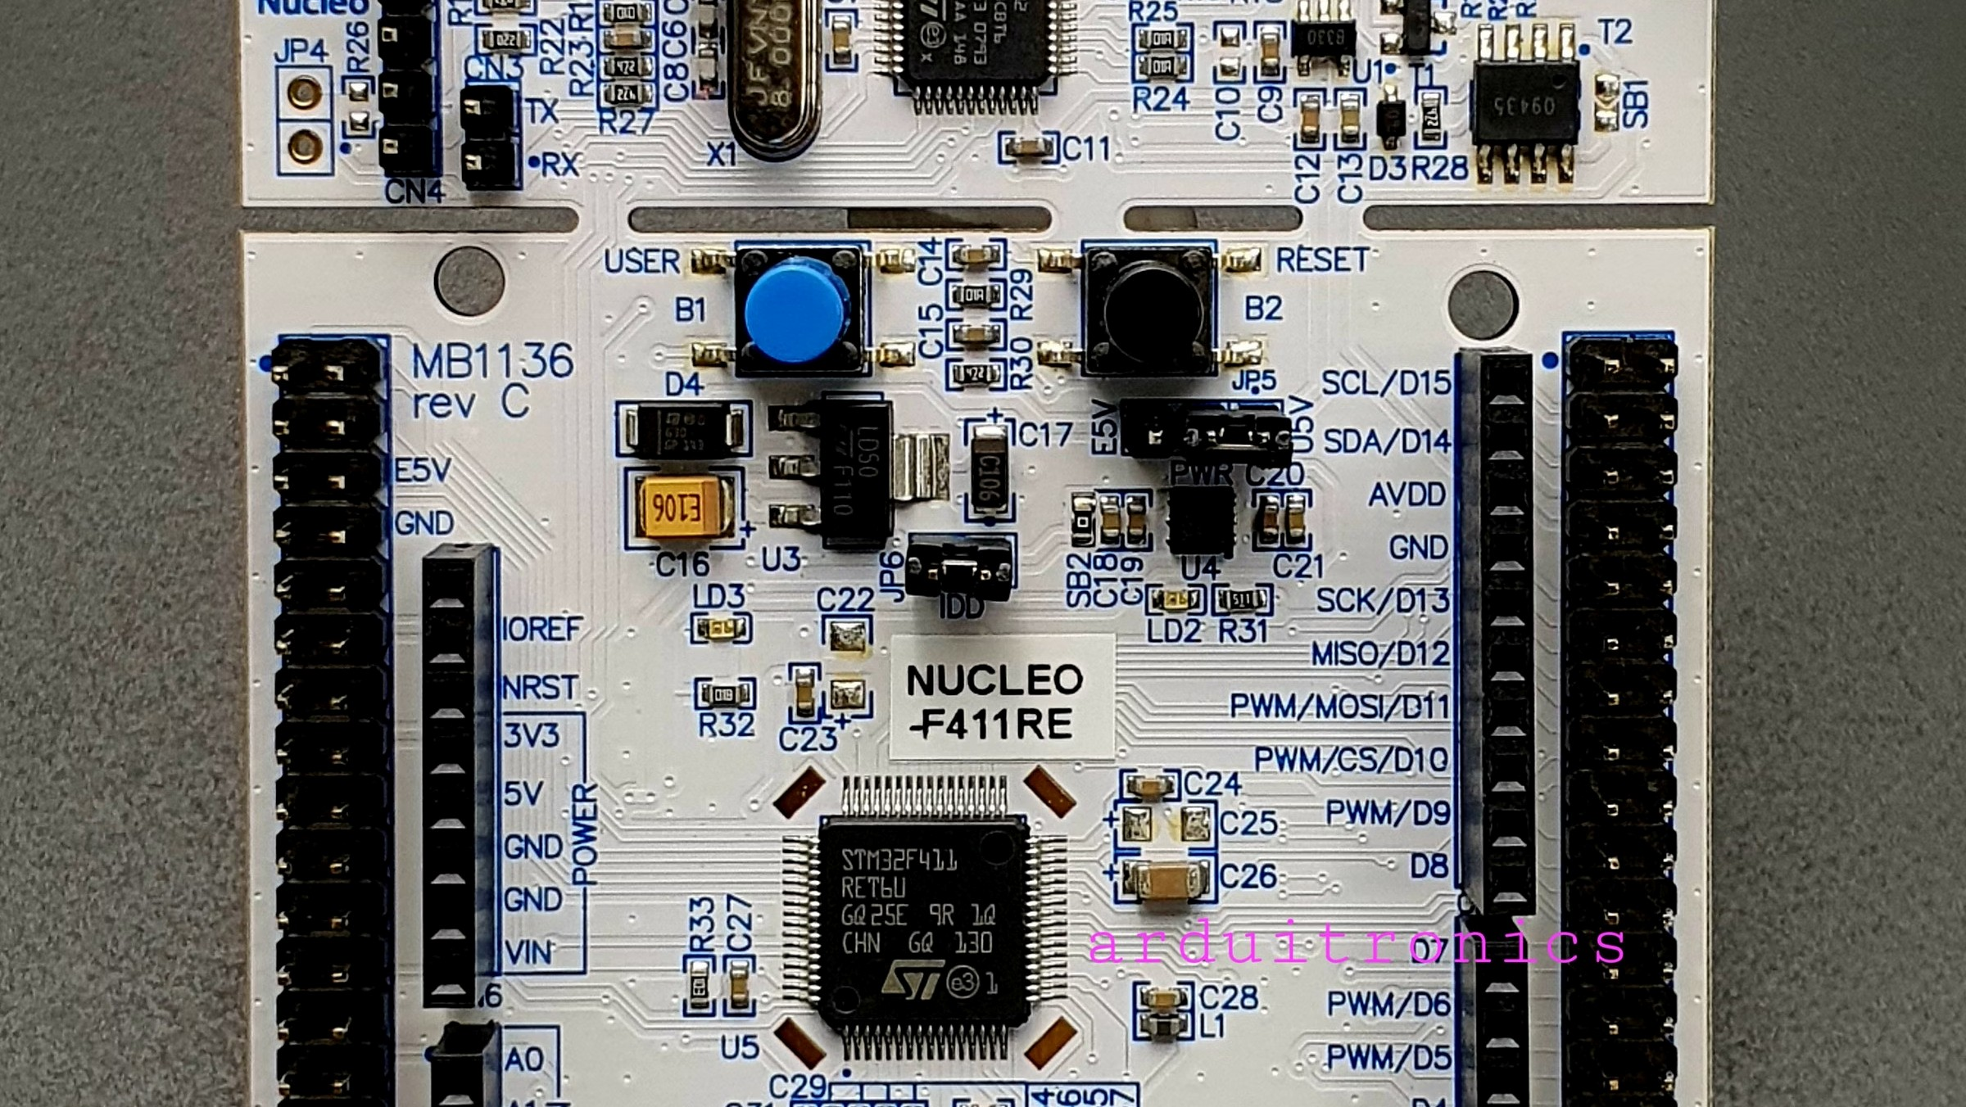
PWM Signal Generation using STM32
EMBEDDED SYSTEMS EXPERIMENT
A hands-on laboratory experiment demonstrating Pulse Width Modulation signal generation using the STM32F446RE
microcontroller, with LED brightness control through variable duty cycle configuration.
Aim
Objective
Generate a PWM signal using the
STM32F446RE

microcontroller and control LED brightness by varying the

duty cycle of the output signal.
Configure hardware timer for PWM output
Adjust duty cycle values in firmware
Observe corresponding LED brightness levels
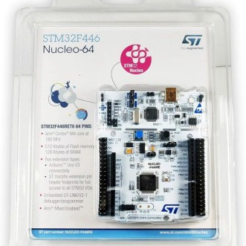
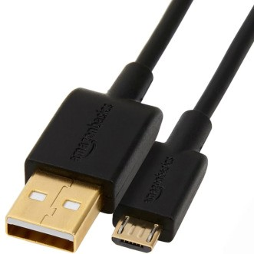


Apparatus Required
The following hardware and software tools are required to complete this experiment successfully.
STM32 Nucleo-
F446RE
The primary microcontroller
development board
featuring the ARM Cortex-
M4 core with onboard ST-
LINK debugger.
USB Cable
Used for powering the
Nucleo board and
establishing a serial
communication link with
the host PC.
STM32CubeIDE
Eclipse-based integrated
development environment
for writing, compiling, and
flashing firmware to the
target device.
STM32CubeMX
Graphical initialisation tool
for configuring peripherals,
clock trees, and generating
initialisation code
automatically.
Introduction to PWM
Pulse Width Modulation (PWM) is a widely used technique in embedded systems that enables control of analog devices

through digital signals. By rapidly switching a digital output between HIGH and LOW states, PWM effectively simulates

varying voltage levels.
The core principle lies in varying the
ON time
and
OFF time
of a periodic signal. A longer ON period results in a higher

effective voltage at the output, while a shorter ON period reduces it — all while the signal frequency remains constant.
PWM is commonly used for motor speed control, LED dimming, servo positioning, and audio signal generation

in embedded applications.
Theory
Understanding the key parameters of a PWM signal is essential before implementation. These parameters determine the

behaviour and effectiveness of the output signal.
Duty Cycle
The percentage of time the signal remains HIGH

within one complete period. A
50
% duty cycle
means

the signal is ON for half the period and OFF for the

other half.
Frequency
The number of complete PWM cycles per second,

measured in Hz. Higher frequencies produce

smoother output but may impose constraints on

timer configuration.
Output Voltage
The effective (average) output voltage is directly

proportional to the duty cycle. A higher duty cycle

produces a higher average voltage at the output pin.
LED Brightness Relationship
Since LED brightness depends on average current, a
higher duty cycle
results in greater perceived

brightness, while lower duty cycles dim the LED

proportionally.

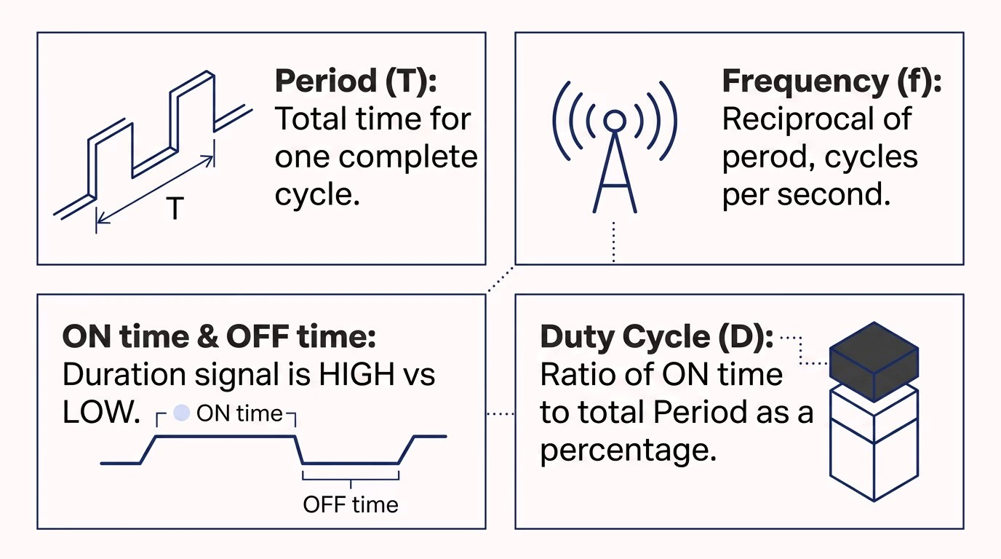
PWM Parameters
Four fundamental parameters define any PWM waveform. Together, they fully characterise the signal behaviour on the
STM32 timer output.
On the STM32,
Period
is set via the Auto-Reload Register (ARR), and
Duty Cycle
is controlled by the
Capture/Compare Register (CCR).

Working Principle
The STM32 hardware timer generates PWM by continuously comparing its internal counter value against a threshold

register. This comparison logic directly drives the output pin state.
Square

Wave
Output

LOW
Output

HIGH
Timer

Counts
The
ARR (Auto-Reload Register)
defines the period of the waveform, while the
CCR (Capture/Compare Register)
sets

the duty cycle threshold. Adjusting CCR dynamically changes the pulse width without affecting the overall frequency.
CNT < CCR → HIGH
The output pin is driven HIGH while the counter value is

below the CCR threshold, forming the ON portion of the

pulse.
CNT ≥ CCR → LOW
Once the counter reaches or exceeds CCR, the output is

driven LOW until the counter resets at ARR, completing

the cycle.

Implementation
The experiment uses
TIM2
on the STM32F446RE, configured in PWM Generation mode. STM32CubeMX is used to set up

the timer, and the generated code is modified to vary the CCR value for duty cycle control.
Configure TIM2 in STM32CubeMX
Select TIM2, set the channel to PWM Generation CH1, and

assign the output pin.
Set Prescaler and ARR
Calculate and enter Prescaler and Auto-Reload Register

values to achieve the desired PWM frequency.
Control Duty Cycle via CCR
In the generated code, modify the CCR value using
__HAL_TIM_SET_COMPARE()
to vary the duty cycle.
Observe LED Brightness
Flash the firmware and observe how LED brightness

changes proportionally as the CCR value is varied.

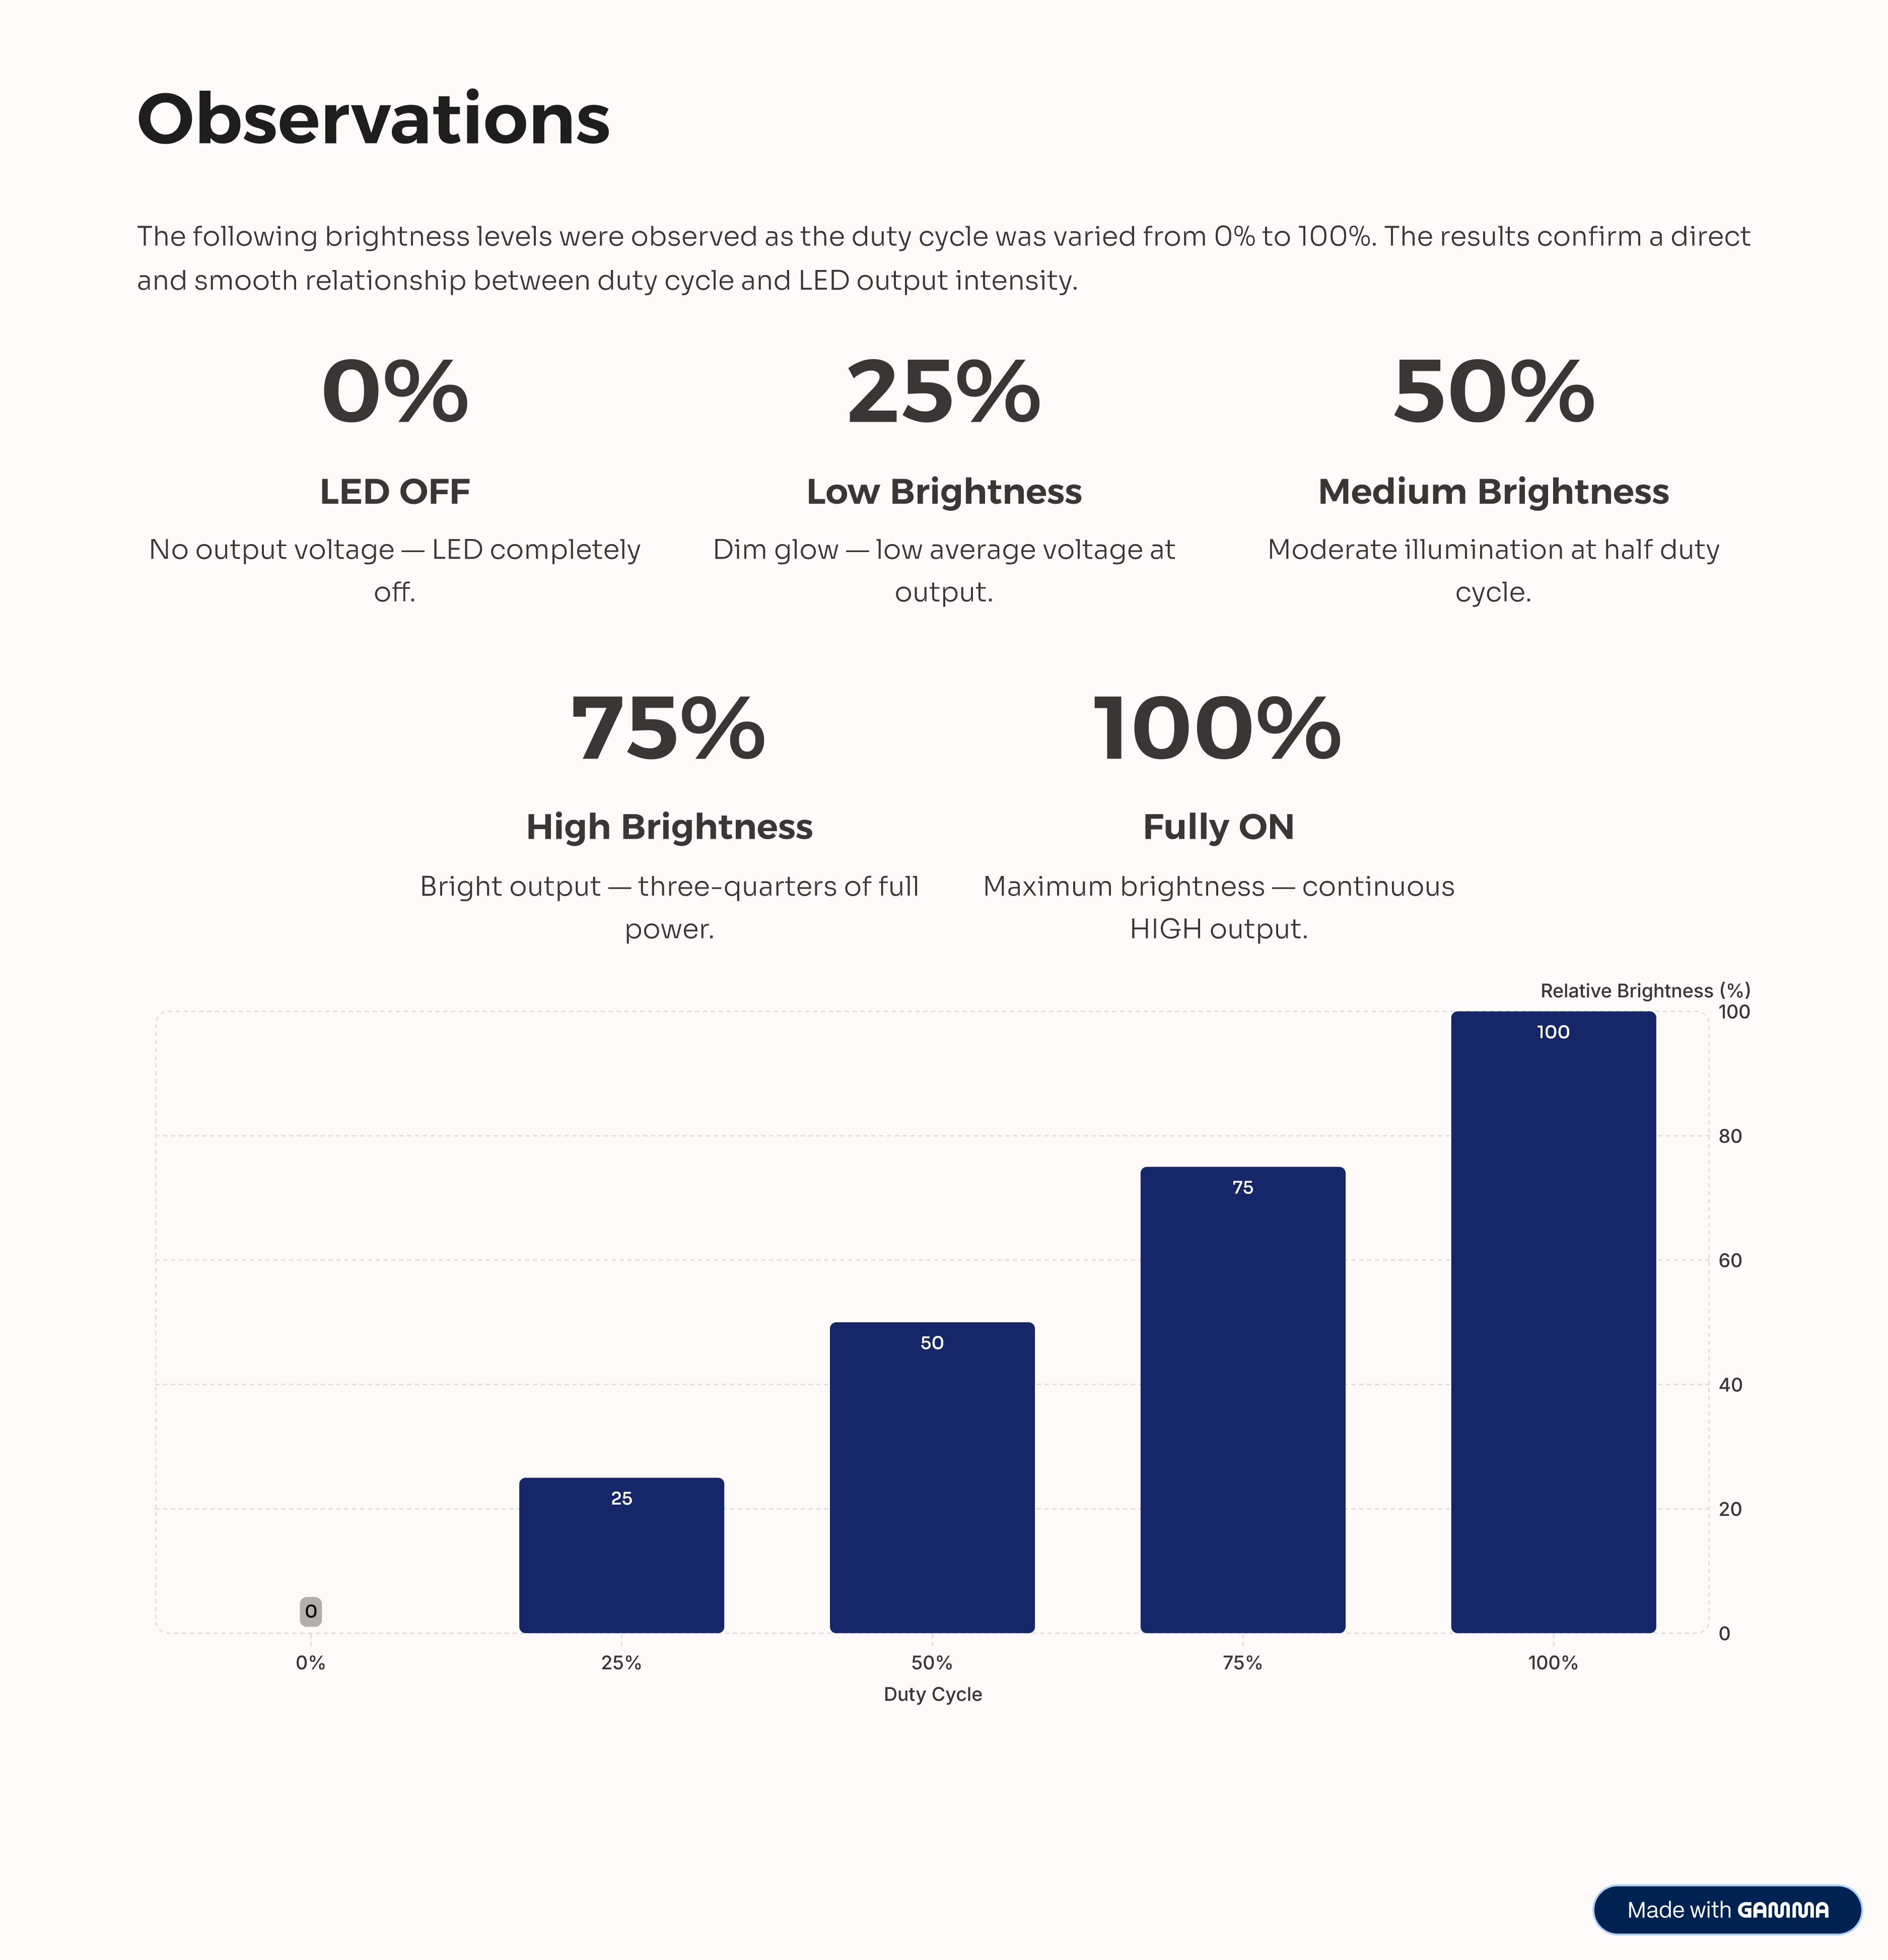

Conclusion
This experiment successfully demonstrated the generation of a PWM signal using the STM32F446RE and validated the

control of LED brightness through duty cycle variation.
✅
PWM Successfully

Generated
TIM2 was correctly configured to

produce a stable PWM output at

the desired frequency using

STM32CubeIDE and CubeMX.
💡
Smooth Brightness

Control
LED brightness varied smoothly

and proportionally across all

tested duty cycle values, from fully

off to fully on.
📐
Duty Cycle

Relationship Confirmed
Results clearly demonstrate the

linear relationship between duty

cycle percentage and effective

output voltage at the GPIO pin.
The experiment confirms that PWM is an effective and efficient method for analog-level control using digital

hardware — a foundational skill in embedded systems development.

