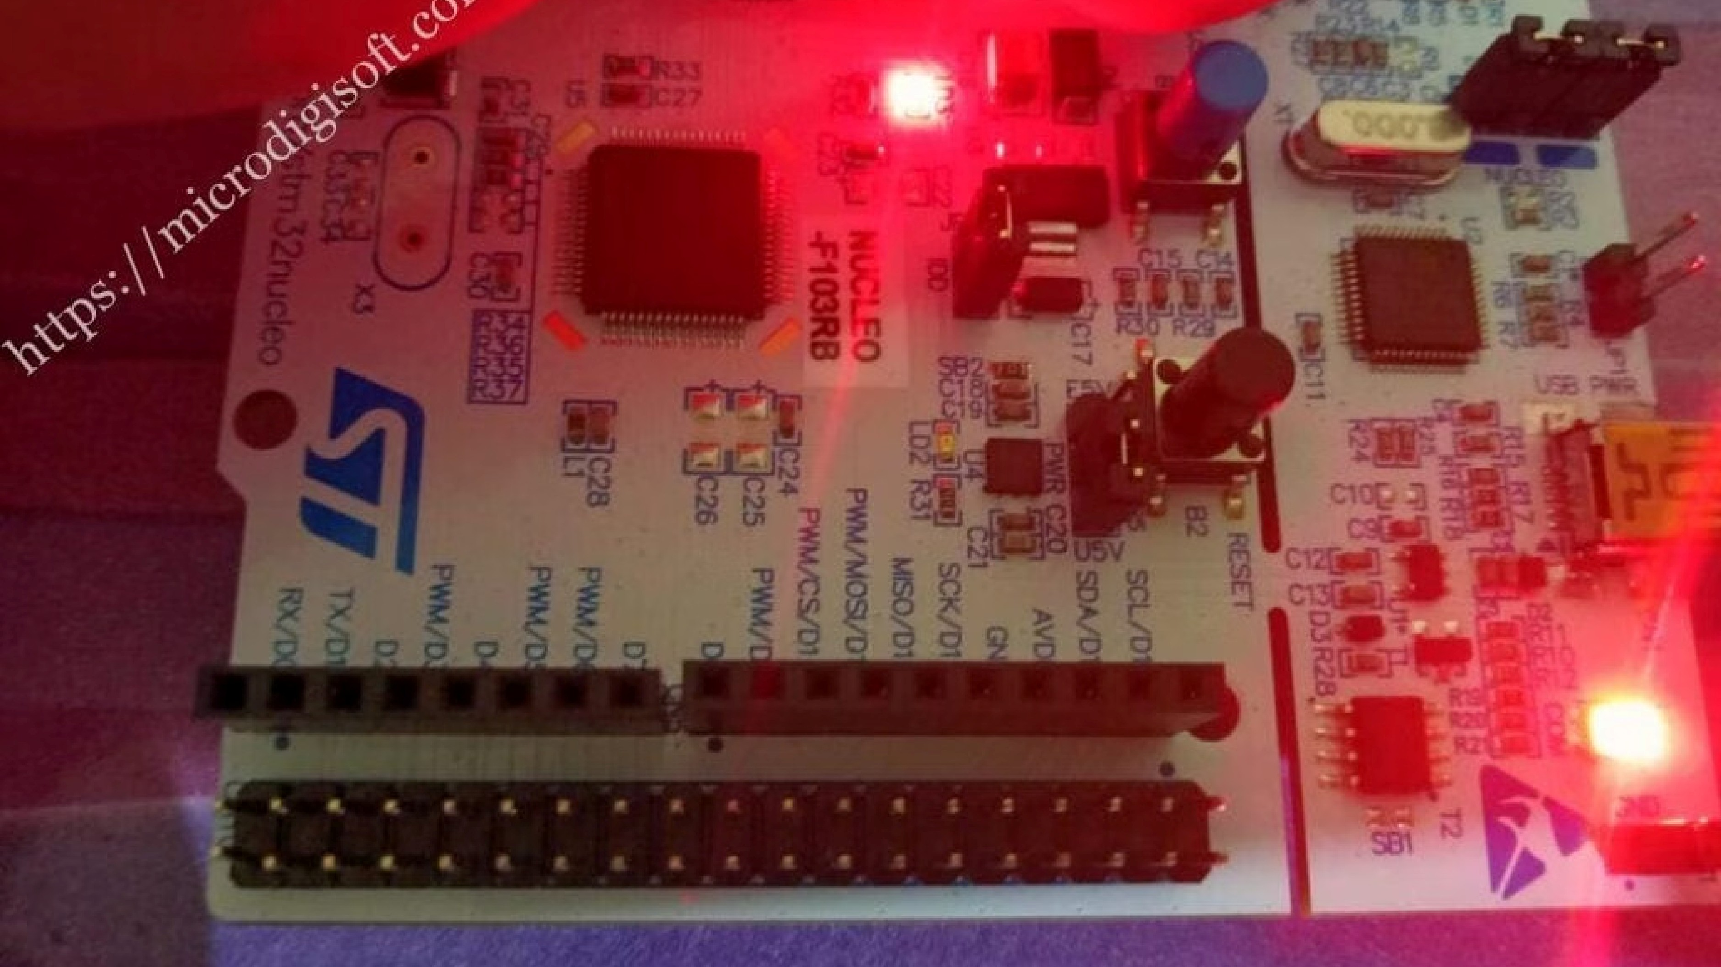
RTOS Lab Experiment 2
Push Button Controlled LED
using STM32
This lab experiment introduces the fundamentals of Real-Time Operating Systems (RTOS) through hands-on embedded
programming on the STM32 Nucleo-F446RE platform. Students will learn GPIO interfacing, input-output control, and
the basics of embedded system design using industry-standard tools.
RTOS
STM32
EMBEDDED SYSTEMS
GPIO
Introduction
Embedded systems form the backbone of modern electronics — from consumer devices to industrial controllers. This

experiment provides a practical entry point into that world by combining hardware interfacing with software logic on a

real microcontroller platform.
What We Are Building
A simple but complete

embedded system where a push

button controls an LED. Though

straightforward, this exercise

demonstrates the full signal

chain — from physical input,

through microcontroller

processing, to physical output —

which is the foundation of all

embedded design.
Tools of the Trade
We use
STM32CubeMX
to

configure the microcontroller

peripherals visually, and
STM32CubeIDE
to write,

compile, and debug the

firmware. These are the official

STMicroelectronics tools used by

professional embedded

engineers worldwide.
Why RTOS Matters
While this experiment uses a

simple polling loop, it introduces

the execution model that RTOS

builds upon — deterministic,

event-driven behaviour where

the system responds to inputs in

real time. Understanding this

model is essential before moving

to multi-tasking RTOS

environments.

Experiment Objectives
By completing this experiment, you will gain hands-on experience with the core skills every embedded systems

engineer needs. Each objective builds on the previous one, creating a clear learning progression from hardware setup to

functional firmware.
1
GPIO Input Interface
Configure and read a push button connected to pin

PC13 as a digital GPIO input. You will learn how to set

pin modes, read electrical states, and interpret them

in software.
2
GPIO Output Control
Drive an onboard LED connected to pin PA5 as a

digital GPIO output. This covers output pin

configuration and how to switch a pin between high

and low states.
3
Toggle Logic Implementation
Write firmware that toggles the LED state on each

valid button press. This introduces conditional logic

and state management in an embedded context.
4
RTOS-Style Execution
Understand how a continuous polling loop mimics

basic RTOS task behaviour — constantly monitoring

inputs and responding deterministically.

Components Used
This experiment requires minimal hardware — the STM32 Nucleo board provides most of what you need onboard. Below

is a complete list of components and tools required to complete the lab successfully.
Hardware
STM32 Nucleo-F446RE development board
USB cable (for power and programming)
Onboard LED — connected to pin
PA5
Onboard Push Button — connected to pin
PC13
Software Tools
STM32CubeMX
— graphical configuration tool for

setting up GPIO pins, clocks, and peripherals without

manual register manipulation
STM32CubeIDE
— integrated development

environment for writing C firmware, building projects,

and flashing the microcontroller
The Nucleo-F446RE features an ARM Cortex-
M4F core running at up to 180 MHz, with 512 KB

flash and 128 KB SRAM — ample resources for

this and many advanced experiments.

System Architecture
The experiment follows a classic embedded system architecture: an input device sends a signal, the microcontroller

processes it, and an output device responds. This simple three-stage pipeline is the same pattern used in far more

complex real-time systems.
Three-
stage

Embedde
d System
Processing:

STM32 MCU
Reads state and

executes logic
Output: LED

Toggle
LED on PA5 is

toggled
Input: Push

Button
Button on PC13

provides signal
The microcontroller continuously monitors the button pin. When a press is detected, it executes the toggle routine and

updates the LED pin. This entire cycle happens in milliseconds, demonstrating the real-time nature of embedded

firmware — there is no operating system overhead, just direct hardware control.
Signal Flow
Button press pulls PC13 from HIGH to LOW
MCU polls PC13 in the main loop
Logic decides to toggle PA5
LED state changes immediately
Why This Matters
Real-time embedded systems must respond to events

within predictable time bounds. Even this simple

example demonstrates deterministic behaviour — the

LED always responds to a button press, and the response

time is consistent and measurable.

Working Principle
Understanding how the hardware and software interact is key to writing reliable embedded firmware. The sequence

below describes exactly what happens from the moment a finger presses the button to the moment the LED changes

state.
Button Pressed
Mechanical contact closes, pulling the PC13 pin voltage

from HIGH (3.3V) to LOW (GND). The microcontroller

sees this as a logic 0.
HAL_GPIO_ReadPin()
The firmware calls
HAL_GPIO_ReadPin(GPIOC,

GPIO_PIN_13)
which returns
GPIO_PIN_RESET
when the

button is pressed.
HAL_GPIO_TogglePin()
If the button state is confirmed,
HAL_GPIO_TogglePin(GPIOA, GPIO_PIN_5)
flips the LED —

ON becomes OFF and vice versa.
HAL_Delay()
A software delay of 200 ms is inserted to allow the

button to settle, preventing multiple toggles from a

single press.
HAL Library:
The Hardware Abstraction Layer (HAL) provided by STMicroelectronics simplifies peripheral

access. Instead of manipulating registers directly, you call readable functions like
HAL_GPIO_ReadPin()
— making

code portable and easier to maintain.

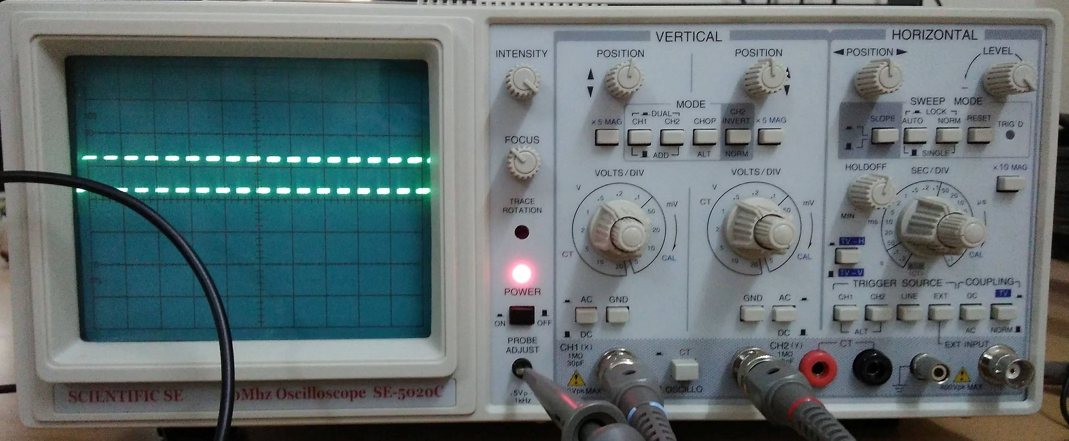
Debouncing Concept
Mechanical push buttons are not perfect switches. When
pressed or released, the metal contacts physically bounce
against each other multiple times before settling. This creates a
rapid series of HIGH-LOW-HIGH transitions that the
microcontroller interprets as multiple button presses.
Without debouncing, a single press could toggle the LED two or
three times — a frustrating and incorrect behaviour. The
solution is a
software debounce delay
after detecting a press,
:
the firmware waits 200 ms before checking again, allowing all
mechanical bouncing to settle.
Problem
Contact bounce causes 5–
20
ms of electrical noise,
triggering false events
Solution
Insert
HAL_Delay(200)

after each detected press
to ignore bounce
Advanced Note:
For production systems, hardware debouncing (using an RC filter circuit) or more
sophisticated software algorithms (state-machine based) are preferred over simple delays, as delays block the
processor from doing other work.

Step-by-Step Procedure
Follow these steps carefully to set up, configure, and run the experiment. Each step builds on the previous one — do not

skip ahead until the current step is complete.
01
Open STM32CubeMX
Launch the configuration tool and create a new project.
02
Select STM32F446RE
Search and select the exact microcontroller used on the

Nucleo board.
03
Configure GPIO Pins
Set
PA5
to
G
P
I
O
_
O
u
t
p
u
t
and
PC13
to
G
P
I
O
_
I
n
p
u
t
mode in

the Pinout view.
04
Generate Code
Click
P
r
o
j
e
c
t

→

G
e
n
e
r
a
t
e

C
o
d
e
to create the initialisation

files and Makefile.
05
Open in STM32CubeIDE
The IDE opens automatically. Navigate to
main.c
in the

project explorer.
06
Write Toggle Logic
Inside the
while(1)
loop in
main.c
, add the button-read and

LED-toggle code.
07
Build and Flash
Click the hammer icon to build, then the play icon to flash

firmware to the board.
08
Test with Push Button
Press the onboard button — the LED should toggle reliably

with each press.

Code Logic
The firmware logic resides entirely within the infinite
while(1)
loop in
main.c
. This loop runs continuously after

initialisation, polling the button and responding to presses. Below is the conceptual structure of the code.
Core Loop Structure
while (
1
)
{

if (HAL_GPIO_ReadPin(

GPIOC, GPIO_PIN_13)

)
GPIO_PIN_RESET
==

{

HAL_GPIO_TogglePin
(

GPIOA, GPIO_PIN_5);

HAL_Delay
(
200
)
;

}
}
Function Reference
HAL_GPIO_ReadPin()
Returns
GPIO_PIN_SET
(HIGH) or
GPIO_PIN_RESET

(
LOW) for the specified pin. Used here to detect

button press on PC13.
HAL_GPIO_TogglePin()
Automatically flips the output state of a pin — no

need to track current state manually. Ideal for LED

toggle applications.
HAL_Delay()
Blocking delay in milliseconds. Called with
200
to

debounce the button and prevent multiple toggles

per press.

Results & Conclusion
✅
Observed Results
Correct Toggle
LED toggles exactly

once per button press

— no missed or extra

toggles observed

during testing.
No False

Triggering
The 200 ms debounce

delay successfully

eliminated contact

bounce effects,

ensuring clean

detection.
State Retained
LED state is preserved after button release,

demonstrating correct memory-less toggle

behaviour.
🎯
Key Takeaways
GPIO Interfacing:
Learned to configure and control

microcontroller pins as digital inputs and outputs

using the HAL library.
Input-Output Control:
Understood how physical

signals are read, processed, and acted upon in

embedded firmware.
RTOS Foundation:
The polling loop model introduced

here is the basis for understanding RTOS task

scheduling and event-driven design.
Platform Readiness:
With STM32CubeMX and

STM32CubeIDE configured, you are ready to tackle

more advanced peripherals and RTOS features.
Next Steps:
Extend this experiment by adding

multiple buttons, implementing interrupt-driven

input, or porting the logic to FreeRTOS tasks for

true multi-threaded behaviour.

