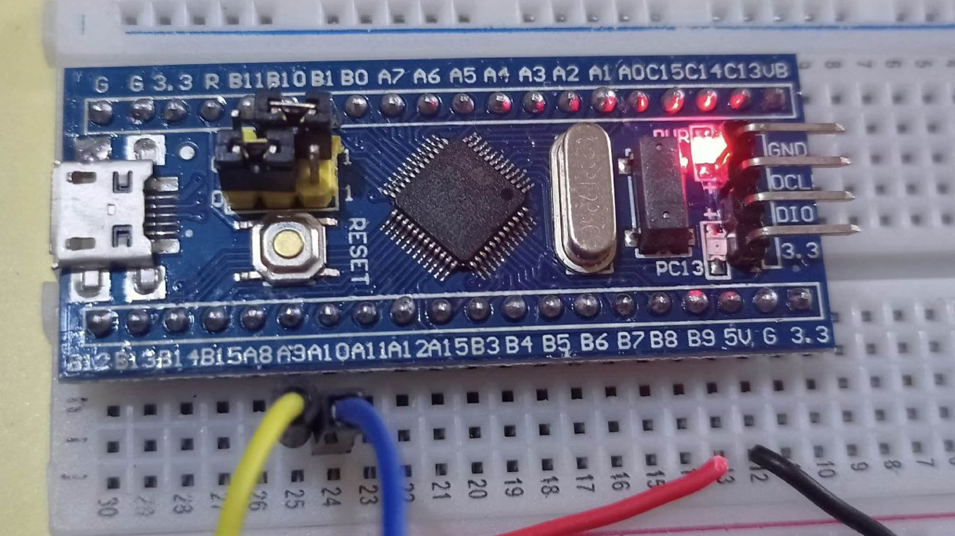
Experiment 6: FreeRTOS Task
Implementation
A hands-on exploration of real-time operating system concepts using FreeRTOS on STM32, demonstrating task
scheduling, LED control, and efficient CPU utilisation through CMSIS-RTOS v2.
EMBEDDED SYSTEMS
FREERTOS
STM32
Aim
This experiment focuses on two core objectives that introduce the foundational concepts of real-time task

management on embedded hardware.
Implement FreeRTOS Task
Create and register a FreeRTOS task using the

CMSIS-RTOS v2 API on an STM32 microcontroller,

understanding task structure and lifecycle.
Control LED Using Scheduler
Demonstrate the FreeRTOS scheduler's role by

toggling an onboard LED at precise intervals,

validating real-time task execution behaviour.
Introduction
The Super Loop Problem
Traditional embedded firmware relies on a bare-metal

super loop — a single
while(1)
that executes tasks

sequentially. This approach blocks execution, wastes

CPU cycles during delays, and scales poorly with

complexity.
RTOS to the Rescue
A Real-Time Operating System replaces the super loop

with a
preemptive scheduler
. Each functional unit

becomes an independent task. The scheduler decides

which task runs, for how long, and when to yield —

enabling concurrent-like execution on a single core.
Theory
Understanding FreeRTOS requires familiarity with three core concepts that govern how tasks are created, managed, and

executed.
1
Task Stack
Every FreeRTOS task is allocated

its
own private stack
in RAM.

Local variables, function call

frames, and CPU register context

are stored here. Stack size must

be carefully configured to avoid

overflow.
2
Scheduler
The FreeRTOS scheduler uses a
priority-based preemptive

algorithm. It context-switches

between tasks, saving and

restoring CPU state. The highest-
priority ready task always runs

first.
3
CMSIS-RTOS v2
CMSIS-RTOS v2 is a standardised

API layer over FreeRTOS. It

abstracts vendor-specific RTOS

calls, making code portable

across ARM Cortex-M devices

and compatible with

STM32CubeIDE middleware.

Key Concepts
Creating a Task —
os
T
hre
adN
ew()
Tasks are registered with the RTOS kernel using
osThreadNew()
.

This function accepts a pointer to the task function, an optional

argument, and a set of thread attributes (name, stack size,

priority).
osThreadNew
LedTask, NULL, &led_attr);
(
Once created, the task enters the
Ready
state and waits for the

scheduler to give it CPU time.
Yielding with
os
D
el
a
y()
Inside a task, calling
osDelay(ms)
places the task in the
Blocked

state for the specified duration. This immediately hands the

CPU back to the scheduler, allowing other tasks or the idle task

to run — a key advantage over a busy-wait delay.
Task States
Running
— Currently executing
Ready
— Waiting for CPU
Blocked
— Waiting on delay/event
Suspended
— Explicitly paused

How It Works
Scheduler

Resume
Call osDelay
Toggle LED
The LED blink task operates in an infinite loop. On each iteration, it toggles the LED GPIO pin and then calls
osDelay(500)
.

During the 500 ms blocked period, the CPU is free — the FreeRTOS idle task runs, or other higher-priority tasks can

execute. This is fundamentally more efficient than a blocking
HAL_Delay()
in a super loop.
Implementation Steps
The experiment is set up using STM32CubeIDE with the following configuration pipeline.
GPIO Configuration
Configure the onboard LED pin

(
e.g., PA5 on Nucleo-F446RE) as
GPIO Output
in STM32CubeMX.

Set default output level to Low.
Enable FreeRTOS

Middleware
In CubeMX, navigate to
Middleware
→
FreeRTOS
and

enable it with CMSIS-RTOS v2

interface. Set the timebase source

to a timer other than SysTick (e.g.,

TIM1).
Create Task
Add a new task in the FreeRTOS

configuration tab. Generate code,

then implement the task function

body — toggle LED and call
osDelay(500)
inside
while(1)
.
Debugging with SWV ITM Console
SWV ITM Data Console
Serial Wire Viewer (SWV) with ITM

(
Instrumentation Trace Macrocell) provides a low
-
overhead
printf-style debug channel
over the

SWD interface — no UART required.
Enable SWV in the debug configuration and set

the core clock frequency correctly to receive

output.
Implementing
_write()
To redirect
printf
output to the ITM console, override the
_write()

syscall in your project:
int
_write(
int
file, char *ptr,
int

len
)

{

for
(
int
i =
0
; i <
len
; i++)

ITM_SendChar(*ptr++);

return

len
;
}
Once configured,
printf("Task running\n")
inside the FreeRTOS

task will print timestamped output to the SWV ITM Data

Console in STM32CubeIDE.
Observations
LED Blink Behaviour
The onboard LED toggled at a consistent
500
ms

interval
, producing a visible 1 Hz blink pattern. The

timing was accurate and stable, confirming correct

FreeRTOS scheduler operation and
osDelay()

resolution.
ITM Console Output
The SWV ITM Data Console displayed repeated print

messages (e.g.,
"LED Task Running"
)
at each task

activation cycle. This confirmed that the task was

being scheduled, executed, and released correctly by

the FreeRTOS kernel without any missed executions

or crashes.
Conclusion
This experiment successfully demonstrated the fundamentals of FreeRTOS task management on an STM32

microcontroller, highlighting the practical advantages of an RTOS over traditional bare-metal approaches.
RTOS Enables

Multitasking
Independent tasks can execute

concurrently, making complex

embedded applications

manageable and modular.
Efficient CPU Usage
osDelay()
blocks the task and frees

the CPU, unlike
HAL_Delay()
which

wastes cycles in a busy wait.
Superior to Super Loop
RTOS-based design scales

gracefully — adding new tasks

does not break existing timing

behaviour, unlike a monolithic

super loop.
FreeRTOS with CMSIS-RTOS v2 provides a portable, industry-standard foundation for building reliable, real-
time embedded applications on ARM Cortex-M devices.

