
Queue Communication
Experiment-9
A deep dive into inter-process communication using queues — exploring the theory, mechanics, and real-world
patterns that underpin modern concurrent systems.
OPERATING SYSTEMS
IPC
CONCURRENCY
Aim
This document is designed to build a clear, structured understanding of queue-based communication between

processes. By the end, you will be able to:
1
Understand the Need
Identify why processes require structured

communication channels in concurrent environments.
2
Grasp Queue Theory
Comprehend the foundational principles of queues

and how they govern data flow between processes.
3
Analyse Producer-Consumer
Understand the roles, responsibilities, and

coordination of producer and consumer tasks.
4
Apply & Observe
Study the working mechanism and draw meaningful

conclusions from observed behaviour.
Need for Communication
Why Do Processes Need to Communicate?
Modern operating systems run multiple processes

simultaneously. These processes are often

interdependent — one generates data while another

consumes it. Without a structured communication

mechanism, data sharing becomes unsafe and

unpredictable.
Key Challenges Without IPC
Race Conditions:
Multiple processes accessing

shared memory simultaneously without coordination
Data Inconsistency:
Partial reads/writes causing

corrupted state
Synchronisation Loss:
Producer outpacing consumer

or vice versa
Deadlocks:
Processes waiting indefinitely for

resources
Queue-based IPC solves all of these by providing

an ordered, buffered, and thread-safe channel.
Queue Theory
A
queue
is a linear data structure that follows a strict ordering discipline. It serves as the backbone of inter-process

communication by providing a safe, predictable buffer between a sender and a receiver.
Buffer / Storage
A queue temporarily stores messages or data items

produced by one process until another process is ready to

consume them.
Mutual Exclusion
Access to the queue is controlled using locks or

semaphores to prevent simultaneous read-write conflicts.
Ordered Delivery
Messages are delivered in the exact order they were

enqueued, preserving causality and data integrity across

processes.
Blocking & Signalling
When the queue is full or empty, processes are blocked

and signalled upon state change, enabling efficient CPU

usage.

FIFO Concept
First In, First Out (FIFO)
is the fundamental ordering principle of a queue. The element enqueued first is always the first

to be dequeued — ensuring fairness and predictability in communication.
Enqueue
Queue Buffer
Dequeue
Process
Real-World Analogies
A line at a ticket counter — first person in line is served

first
Print spooler — documents printed in submission

order
Network packet queues — packets forwarded in arrival

order
Key Properties
Rear pointer:
Tracks where the next item will be

inserted
Front pointer:
Tracks where the next item will be

removed
Bounded queue:
Has a maximum capacity; blocks on

overflow

Producer Task
The
producer
is the process (or thread) responsible for generating data items and placing them into the shared queue.

It must respect the queue's capacity constraints to avoid overflow.
01
Generate Data
The producer creates a data item — this could be a

message, a job request, a sensor reading, or any unit of

work.
02
Acquire Lock
Before accessing the queue, the producer acquires a

mutex lock to ensure exclusive access and prevent race

conditions.
03
Check Queue Capacity
If the queue is full, the producer waits (blocks) on a

condition variable — it is signalled when space becomes

available.
04
Enqueue & Signal
The item is added to the rear of the queue. The producer

then releases the lock and signals the consumer that new

data is available.


Consumer Task
The
consumer
is the process (or thread) that retrieves and processes items from the shared queue. It mirrors the
producer's locking discipline to maintain safe access.
Acquire Lock
The consumer requests the mutex lock before
interacting with the queue.
Check if Queue is Empty
If the queue has no items, the consumer blocks
and waits for the producer to signal availability.
Dequeue Item
The consumer removes the front item from the
queue following FIFO order.
Release Lock & Process
The lock is released, the consumer signals the
producer, and then processes the retrieved item
independently.
Key Design Insight:
The consumer should
release the lock
before
processing the item to
maximise concurrency. Holding the lock during
processing unnecessarily blocks the producer.

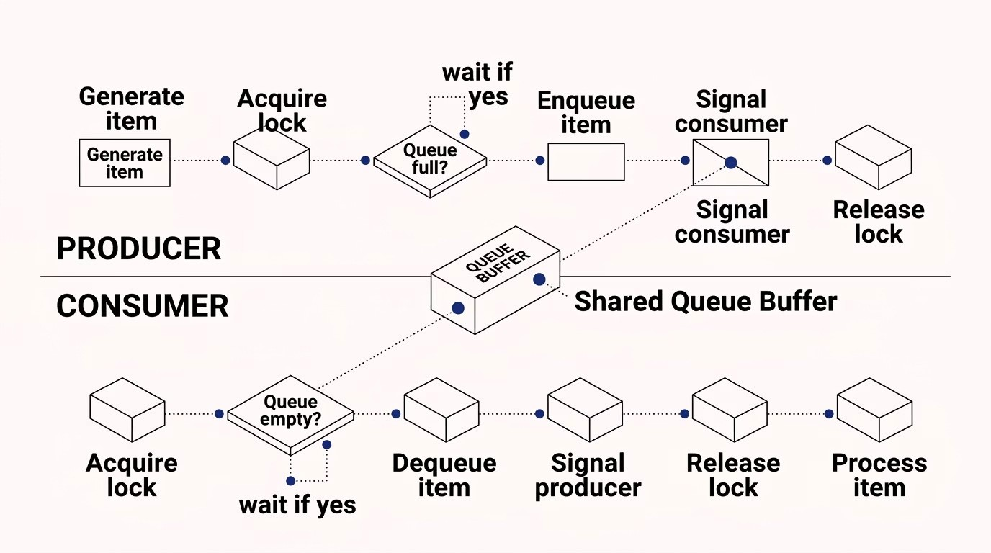
Working Mechanism
The producer and consumer operate
concurrently
, coordinated through shared queue state, mutex locks, and condition
variables. The interaction is governed by a tight synchronisation protocol.
Synchronisation Primitives Used
Mutex:
Ensures only one process accesses the queue
at a time
Condition Variables:
Allow processes to sleep and be
woken up efficiently
Bounded Buffer Problem
This classical OS problem directly models queue
communication. The queue has a fixed size
N
, and both
producer and consumer must handle full and empty
states gracefully.

Observations
After studying and simulating queue communication between producer and consumer processes, several important

behavioural patterns and edge cases are consistently observed.
Blocking Behaviour
When the queue is full, the producer blocks

predictably. When empty, the consumer blocks. No

busy-waiting occurs — CPU cycles are not wasted,

which is a sign of well-designed synchronisation.
Order Preservation
Items are always consumed in the exact order they

were produced. FIFO integrity is maintained even

under high concurrency with multiple producers or

consumers.
Throughput Sensitivity
Queue size significantly impacts system throughput.

A very small buffer causes frequent blocking; an

oversized buffer may increase memory pressure and

latency for time-sensitive items.
Deadlock Risk
Improper lock acquisition order or failing to signal

condition variables after enqueue/dequeue can lead

to deadlock. Careful programming discipline is

essential.
Conclusion
Queue-based communication is a foundational pattern in operating systems and concurrent programming. It elegantly

solves the challenges of safe data sharing between asynchronous processes through a combination of structured

ordering and synchronisation primitives.
🔑
Core Takeaway
Queues provide a thread-safe,

ordered buffer that decouples

producers from consumers,

enabling independent operation

at different speeds.
⚙
Mechanism
Mutex locks and condition

variables are the essential

primitives that make queue

communication correct and

efficient in a concurrent

environment.
📐
Design Principle
Choosing the right queue size and

minimising lock-hold duration are

critical engineering decisions that

directly affect system

performance.
Queue communication is not just a data structure pattern — it is a contract of orderly cooperation between

processes in a shared world.

