

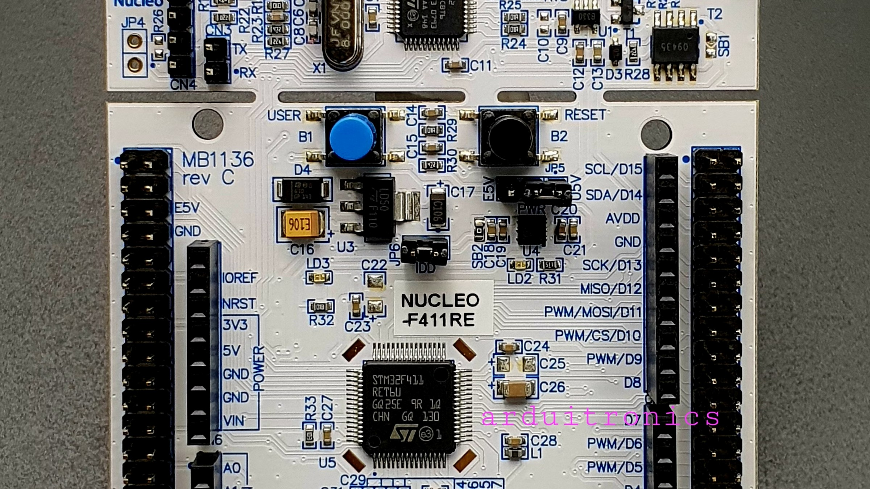
Introduction to GPIO with STM32
This experiment focuses on configuring and controlling
GPIO (General Purpose Input/Output)
pins using an STM32
microcontroller. GPIO pins act as the primary interface between the microcontroller and external hardware
components, making them the fundamental building block of embedded systems development.
In this practical, we control a simple LED connected to the
STM32 Nucleo-F446RE
board. By writing a basic
embedded C program and using STM32 development tools, we make the LED blink at a fixed interval 4 a classic "Hello,
World!" for embedded engineers.
This experiment serves as a foundation for embedded systems development, as GPIO operations are essential in
almost every hardware-based application, from blinking an LED to driving complex motor controllers.
EMBEDDED SYSTEMS LAB
STM32
GPIO



Objectives
By the end of this experiment, students will be able to interface simple hardware components like LEDs using software
control. The following five objectives guide the learning journey, taking you from conceptual understanding to hands-
on implementation with industry-standard tools.
1
Understand GPIO Pins
Learn the concept of GPIO pins in STM32 microcontrollers and how they serve as the bridge between
software and hardware.
2
Configure with CubeMX
Learn how to configure GPIO pins using STM32CubeMX, a graphical tool that simplifies peripheral setup
and code generation.
3
Write LED Blinking Code
Write a program for LED blinking using HAL libraries, gaining practical experience with embedded C
programming.
4
Master Timing Control
Understand timing control using software delays and observe how delay values affect the blinking rate.
5
Use STM32CubeIDE
Gain hands-on experience with STM32CubeIDE, the integrated development environment used for coding,
compiling, and debugging.



Apparatus and Requirements
The following components and tools are required to perform this experiment. Each item plays a specific role in the
development and testing process.
Hardware Required
STM32 Nucleo-F446RE
— Development board with
onboard LED on pin PA5
USB Cable
(Type A to Mini B) — For powering the
board and uploading code
Computer/Laptop
— To run the development tools
Software Required
STM32CubeIDE
— Integrated development
environment for coding, compiling, and debugging
embedded applications
STM32CubeMX
— Graphical configuration tool to set
up peripherals and generate initialization code
automatically
Both STM32CubeIDE and STM32CubeMX are
free downloads from STMicroelectronics.


Understanding GPIO
GPIO
stands for
General Purpose Input/Output
. These pins allow the microcontroller to interact with the outside
world — reading signals from sensors or sending control signals to actuators. GPIO pins are the most basic yet most
frequently used peripheral in any embedded system.
Input Mode
Input pins read signals from
external components such as
sensors, switches, or buttons.
The microcontroller samples
the voltage level on the pin
and interprets it as a logic
HIGH or LOW.
Output Mode
Output pins control external
devices like LEDs, motors, or
displays. In this experiment,
we configure a GPIO pin as an
output to drive the onboard
LED.
Alternate Functions
GPIO pins in STM32 are highly
flexible and can also support
multiple alternate functions
like communication protocols
(
UART, SPI, I2C), making
them versatile for complex
designs.



GPIO in STM32 Microcontrollers
In STM32 microcontrollers, GPIO pins are organized into
ports
— GPIOA, GPIOB, GPIOC, and so on. Each port contains
up to 16 pins (P0 to P15). For this experiment, we use
Pin PA5
, which is internally connected to the onboard LED on the
Nucleo board.
GPIO Configuration Parameters
Pin Mode
Select Input or Output direction
Output Type
Push-Pull or Open-Drain
Speed Setting
Low, Medium, High, or Very High
Pull-up / Pull-down
Internal resistor configuration
Our Configuration: PA5
For the LED blinking experiment, PA5 is configured as:
Mode:
GPIO Output
Type:
Push-Pull
Speed:
Low Speed
Pull-up/down:
None
These settings ensure correct electrical behavior of the
pin and safe operation of the onboard LED.



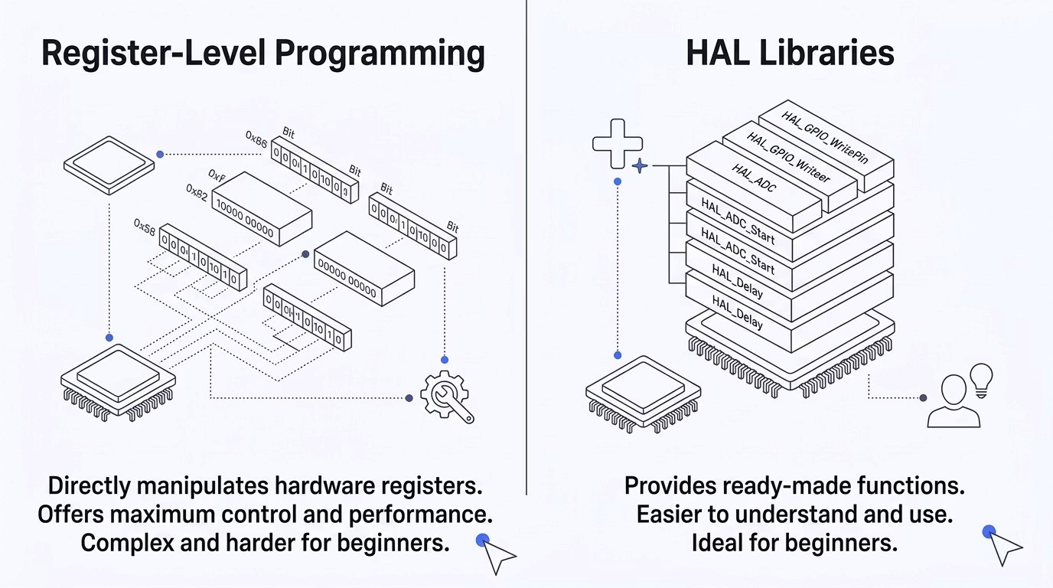
Register Programming vs HAL Libraries
There are two main approaches to control GPIO in STM32 microcontrollers. Each has its own advantages depending on
the project requirements and the developer's experience level.
In this experiment, we use
HAL (Hardware Abstraction Layer) libraries
to simplify the implementation. HAL
functions wrap the low-level register operations into easy-to-use API calls, allowing beginners to focus on application
logic rather than hardware details.



Development Workflow
The complete workflow of this experiment follows a structured process that ensures smooth integration between
hardware configuration and software development. Each step builds on the previous one, guiding you from initial setup
to a working LED blink program.
01
Open STM32CubeMX
Launch the graphical configuration tool to begin setting
up the microcontroller.
02
Select the Board
Choose STM32 Nucleo-F446RE from the board selector.
03
Configure PA5 as GPIO Output
Set pin PA5 to GPIO_Output mode with Push-Pull output
type.
04
Generate Initialization Code
Let CubeMX generate the project files and HAL
initialization code.
05
Open Project in STM32CubeIDE
Import the generated project into the IDE for coding.
06
Write LED Blinking Logic
Add HAL_GPIO_TogglePin() and HAL_Delay() calls in the
main loop.
07
Compile and Upload
Build the project and flash the firmware onto the Nucleo
board.
08
Observe LED Behavior
Verify that the onboard LED blinks at the expected
interval.
This workflow ensures smooth integration between configuration and coding, reducing manual setup errors and
accelerating development time.



Program Explanation
The LED blinking program is based on a simple
infinite loop
that continuously toggles the LED state with a fixed delay
between each toggle. This is the embedded equivalent of "Hello, World!"
Core Logic
Toggle the LED state (ON
→
OFF or OFF
→
1.
ON)
2.
Wait for a fixed delay (500 ms)
Repeat continuously inside
while(1)
3.
Key HAL Functions
HAL_GPIO_Togg
lePin()
Changes the state of
the specified pin — if
the LED is ON, it turns
OFF, and vice versa.
HAL_Delay()
Pauses program
execution for the
specified time in
milliseconds using the
SysTick timer.
Working Sequence:
LED turns ON
→
Wait 500 ms
→
LED turns OFF
→
Wait 500 ms
→
Repeat. This creates a
continuous blinking effect with a 1-second full cycle.



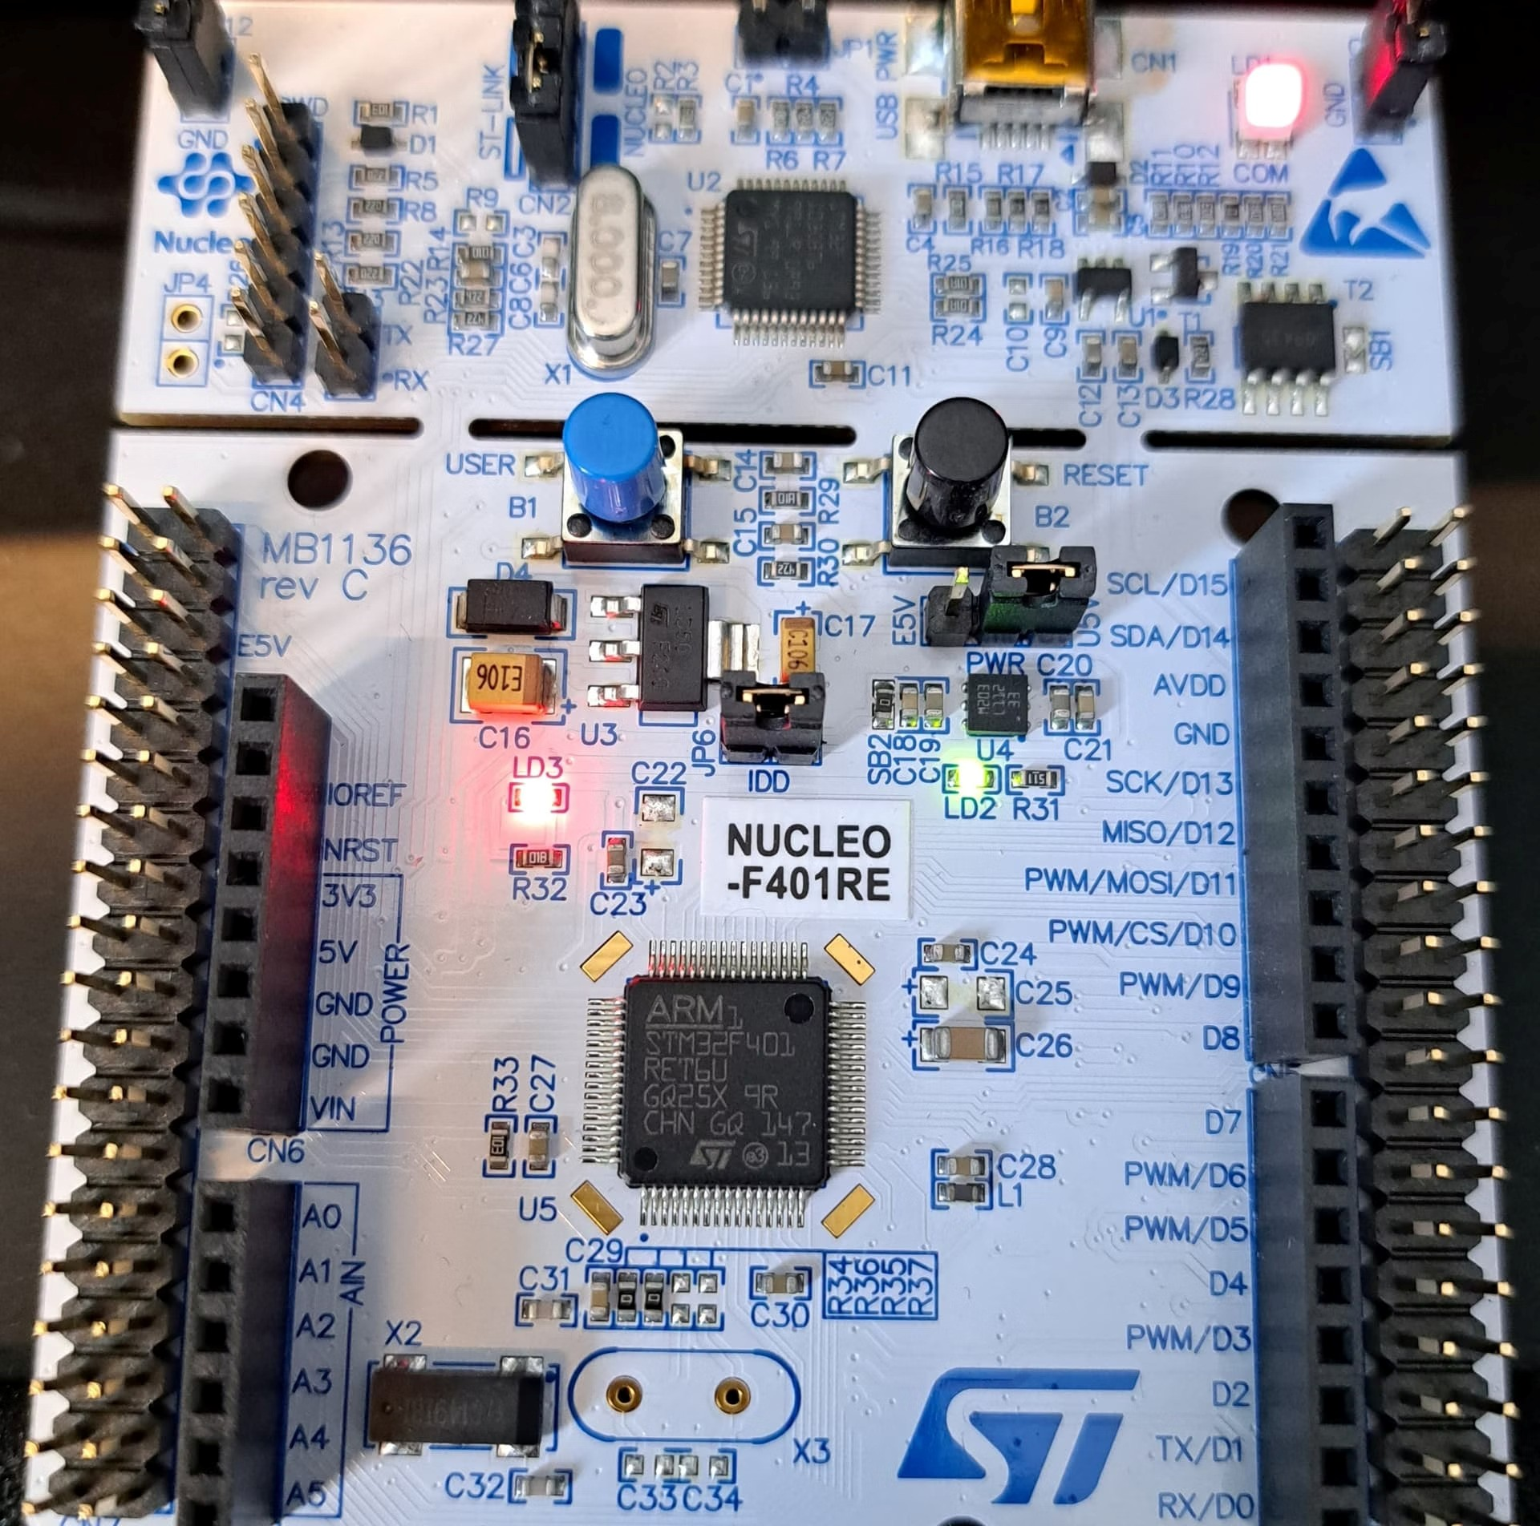
' D ó
Results and Observations
After successfully compiling and uploading the program to the STM32 Nucleo board, the following results were
observed, confirming correct hardware and software integration.
Pin Configured
GPIO pin PA5 was configured
correctly as a digital output in
Push-Pull mode.
LED Blinking
The onboard LED started blinking
continuously at the programmed
interval.
Delay Verified
Different delay values were
tested and the blinking rate
changed accordingly.
Observation: Delay vs Blink Rate
Increasing Delay
³
Slower Blinking
Longer HAL_Delay() values result in a slower blink
frequency.
Decreasing Delay
³
Faster Blinking
Shorter HAL_Delay() values produce a faster blink
frequency.



Conclusion and Learning Outcomes
This experiment successfully demonstrated how to configure and control GPIO pins in STM32 microcontrollers. By using STM32CubeMX and HAL libraries, the complexity of embedded programming was significantly reduced, making it accessible for beginners.

GPIO Configuration CubeMX & CubeIDE Workflow
Understood how to configure GPIO pins for Gained familiarity with the complete development output mode and control hardware directly workflow from graphical configuration to code through software. deployment.

HAL Function Usage Timing-Based Operations
Learned to use HAL library functions like Implemented software delays to control real-time HAL_GPIO_TogglePin() and HAL_Delay() for behavior, forming a strong foundation for hardware control. advanced embedded applications.
Mastering GPIO is the first step toward building complex embedded systems — from simple LEDs to full sensor networks and motor controllers.

