### 5. GIT-HOL

### Step 1: Verify if `master` is in a clean state

check the status:

If it says "working tree clean", proceed. If not, commit or stash your changes:

### Step 2: List out all the available branches

Run the command:

### Step 3: Pull the remote Git repository to `master`

Ensure you are on master:

Command:git push origin master

### Step 4: Push the changes from “Git-T03-HOL_002” to the remote repository

Run the following command if you are on master:

Command:git push origin master

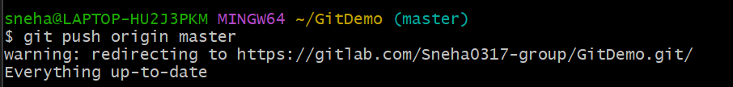

### Step 5: Observe if the changes are reflected in the remote repository

Go to your GitHub repository.  
Check Commits, Files Changed, or the branch name to verify the push.

