Sneha Patra D20A 43

Blockchain Experiment 9

AIM: Implement the Private Ethereum Blockchain using Geth

THEORY:

Q1: What is Geth?
Geth (Go-Ethereum) is one of the most widely used Ethereum clients, written in the Go programming language. It allows users to run an Ethereum node, mine Ether, and interact with the blockchain through JSON-RPC, command-line, or JavaScript consoles.

Q2: Significance of a Private Ethereum Network
Setting up a Private Ethereum Network involves creating a customized blockchain environment isolated from the public Ethereum network. It enables developers to test smart contracts, consensus mechanisms, and network behavior without incurring gas costs or depending on public validators.

Q3: Steps for creating a Private Ethereum Network
Steps Involved:

Choosing a Network ID:
Each private blockchain must have a unique network ID to differentiate it from public or other private networks.

Choosing a Consensus Algorithm:
Ethereum supports different consensus mechanisms such as Proof of Work (PoW) and Proof of Authority (PoA). In private networks, Clique (PoA) is often used for faster block confirmation.

Creating a Genesis Block:
The genesis block is the first block of the blockchain, defining network parameters such as difficulty, gas limit, initial account balances, and consensus settings.

Initializing the Geth Database:
The Geth init command initializes the blockchain using the genesis.json file, preparing the data directory for node operation.

Setting up Networking:
Nodes communicate using enodes (Ethereum Node URLs) that contain IP addresses and public keys for peer discovery and connection.

Running the Member Nodes:
Each participant runs a Geth node that connects to the private network and participates in block validation and transaction processing.

Running a Signer (in Clique):
In the Clique consensus, designated signers validate and sign blocks. These accounts are pre-configured in the genesis file to ensure trusted block production.
NOTE: Download the genesis file and edit the account details, including the public keys of all participating peers in the network.

PROCEDURE

Step 1: Install Geth
wget https://gethstore.blob.core.windows.net/builds/geth-linux-amd64-1.13.14-2bd6bd01.tar.gz tar -xvf geth-linux-amd64-1.13.14-2bd6bd01.tar.gz
mkdir -p ~/bin
cp geth-linux-amd64-1.13.14-2bd6bd01/geth ~/bin/geth113 export PATH="$HOME/bin:$PATH"
geth113 version
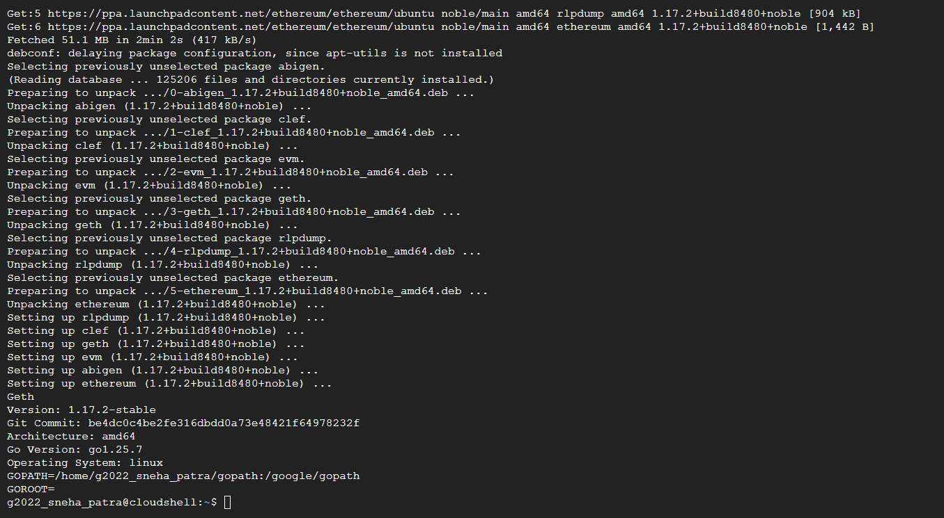

Step 2: Create folders and accounts for both nodes

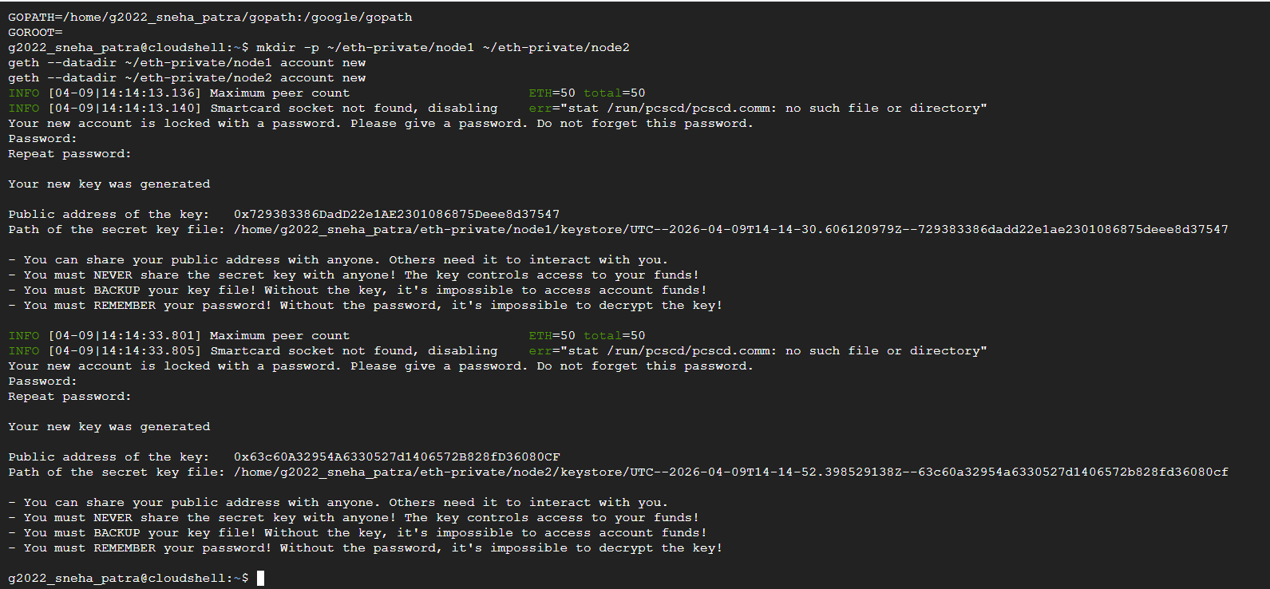

Step 3: Create password files

Step 4: Create genesis.json and verify it looks correct NODE1="PASTE_NODE1_ADDRESS_WITHOUT_0x_HERE" NODE2="PASTE_NODE2_ADDRESS_WITHOUT_0x_HERE"

cat > ~/eth-private/genesis.json << EOF
{
"config": { "chainId": 1234,
"homesteadBlock": 0,
"eip150Block": 0,
"eip155Block": 0,
"eip158Block": 0,
"byzantiumBlock": 0,
"constantinopleBlock": 0,
"petersburgBlock": 0, "clique": {
"period": 5,
"epoch": 30000
}
},
"difficulty": "1",
"gasLimit": "8000000", "extradata":
"0x0000000000000000000000000000000000000000000000000000000000000000${NODE1
}0000000000000000000000000000000000000000000000000000000000000000000000000
000000000000000000000000000000000000000000000000000000000",
"alloc": {
"0x${NODE1}": { "balance": "100000000000000000000" }, "0x${NODE2}": { "balance": "100000000000000000000" }
}
}
EOF

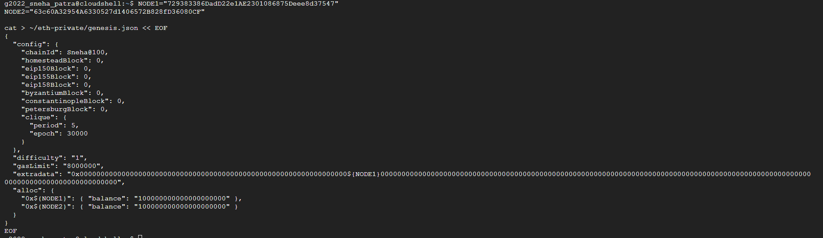

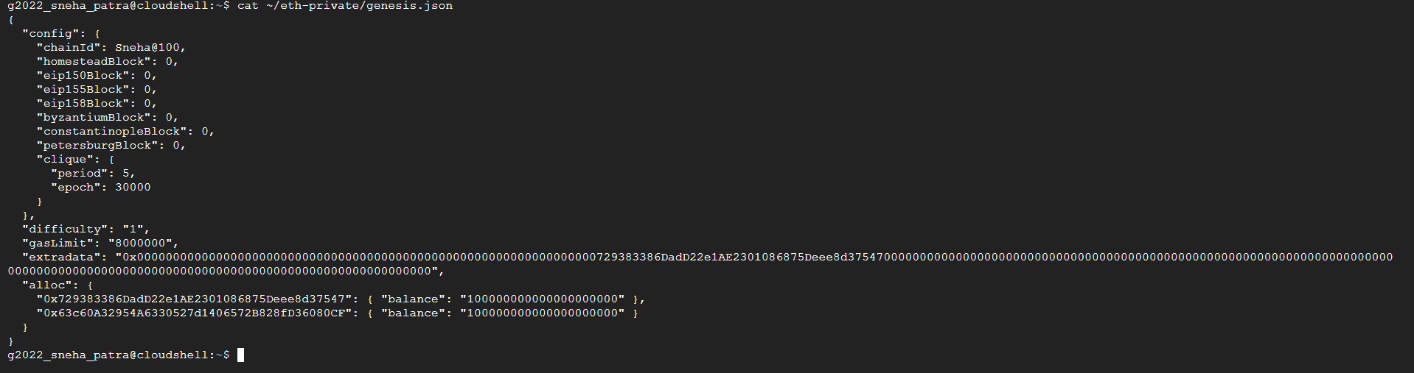

Step 5: Initialize both nodes

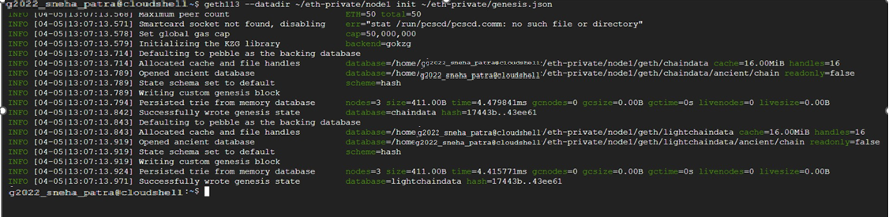



Step 6: Run Node 1 (signer)

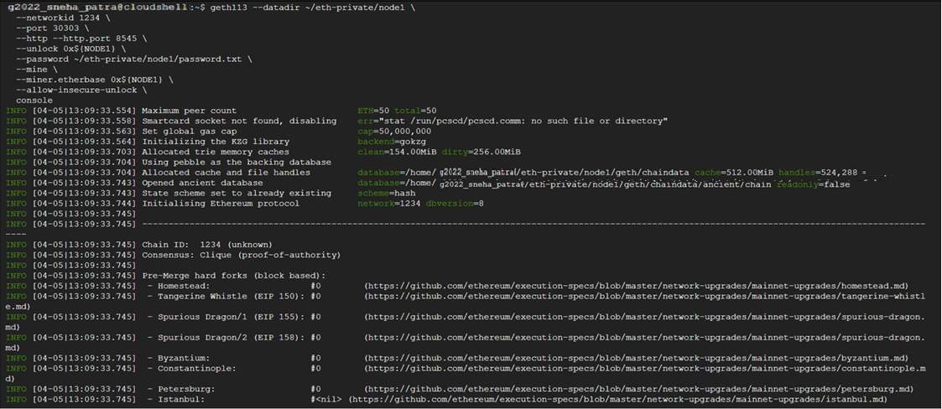

Step 7: Open new terminal tab and run Node 2 (member)
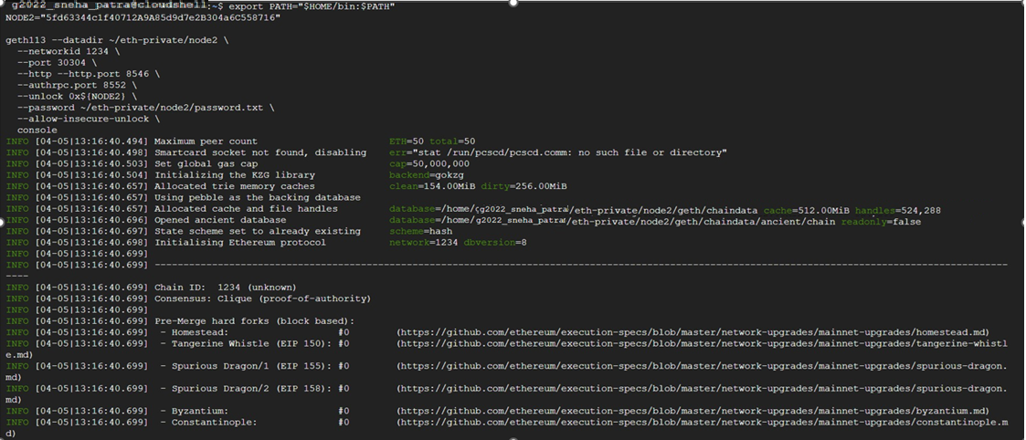

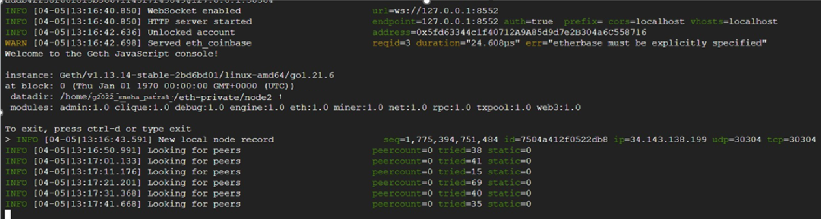

Step 8: Connect the two nodes
In Node 1 console, get its enode

Now, switch to Node 2 console and paste the Node 1 enode

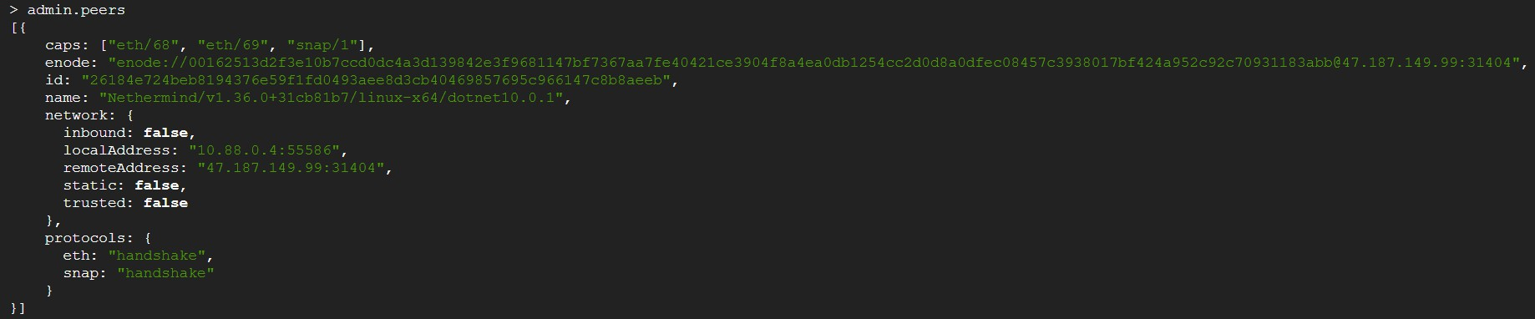
In Node 2 console, check they are connected

Step 9: Send a transaction
In Node 1 console, send transaction to Node 2

and check the balance of Node 2

CONCLUSION:

Through this experiment, two smart contracts - OrderRecord and ReviewVerification, were successfully created and deployed on the Ethereum Sepolia test network using Solidity and Remix IDE. The experiment demonstrated how blockchain technology can be integrated into a full-stack web application to permanently and transparently record order transactions and product reviews. The use of the Sepolia test network and MetaMask allowed safe testing without real funds. Overall, this experiment provided practical understanding of designing

