**DA ASSIGNMENT PART(I)**

NAME: SNEHA SAVARKAR Subject code: OEIT6 UID: 2019120055

Shark Tank India :

Shark Tank India is a Hindi-language business reality show broadcast on Sony Entertainment Television in India. The show is an Indian franchise of the popular American reality show Shark Tank. It shows entrepreneurs giving pitches to a panel of investors or sharks who determine whether or not to invest in their company.

The show features a panel of "Sharks," or possible investors, who listen to entrepreneurs propose ideas for new businesses or products.  These self-made multi-millionaires evaluate the business plans and products presented before deciding whether or not to invest their own money in marketing and mentoring each contestant.

Sharks

At least five of the following seven sharks are present in each episode

* Ashneer Grover Co-founder of BharatPe
* Aman Gupta Co-founder and Chief Marketing Officer of boAt
* Anupam Mittal Founder and CEO of Shaadi.com and People Group
* Ghazal Alagh Co-founder and Chief Mama of MamaEarth
* Namita Thapar Executive Director of Emcure Pharmaceuticals
* Peyush Bansal Co-founder and CEO of Lenskart
* Vineeta Singh CEO and co-founder of SUGAR Cosmetics

Report:

There are 36 total Episodes in Season one of the show.

There are total 121 pitches in the First Season

* Number of pitches per Episode

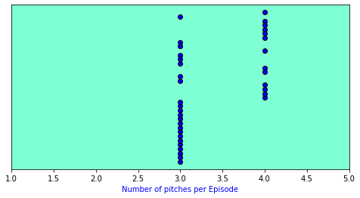

As per the above graph the number of pitches per episode are about 3-4.

* Total Number of Pitches per Industry

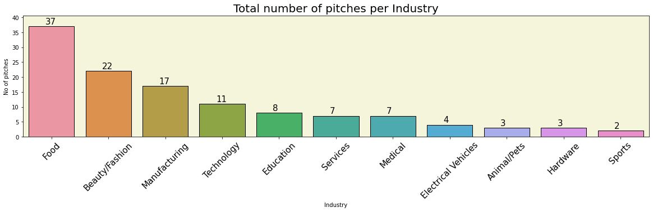

We can see the industries that came for investment as a result of the graph. The food industry has the most startups/companies that have attended the show, with the beauty/fashion industry coming in second. The sports industry has the least businesses. The average number of companies is in the technology, education, services, and medical sectors.

* Pitches

Number of presenters per pitch total pitches

0 2 56

1 1 33

2 3 23

3 4 8

4 6 1

------------------------------------------------------------

Total female presenters : 75.0

Total male presenters : 177.0

Couple presenters : 25

* Offers

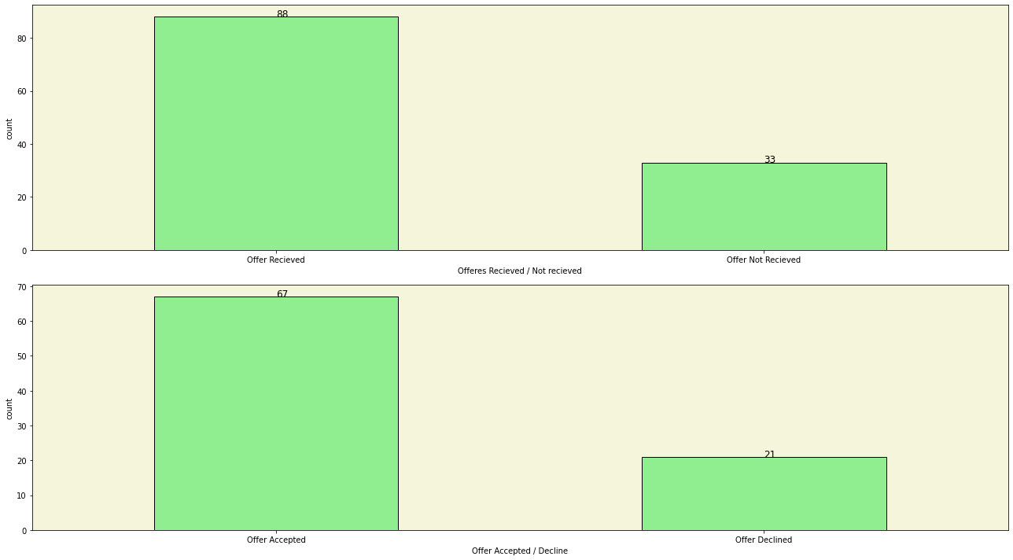

According to the graph above, 88 presenters got an offer for a stake or equity in the company out of 121 pitches. Out of 88 companies 67 companies accepted the proposal offered by the investers and 21 declined it. This gives us a number of entrepreneurs who got an offer and how many of does not found satisfaction in the offer

* Negotiation

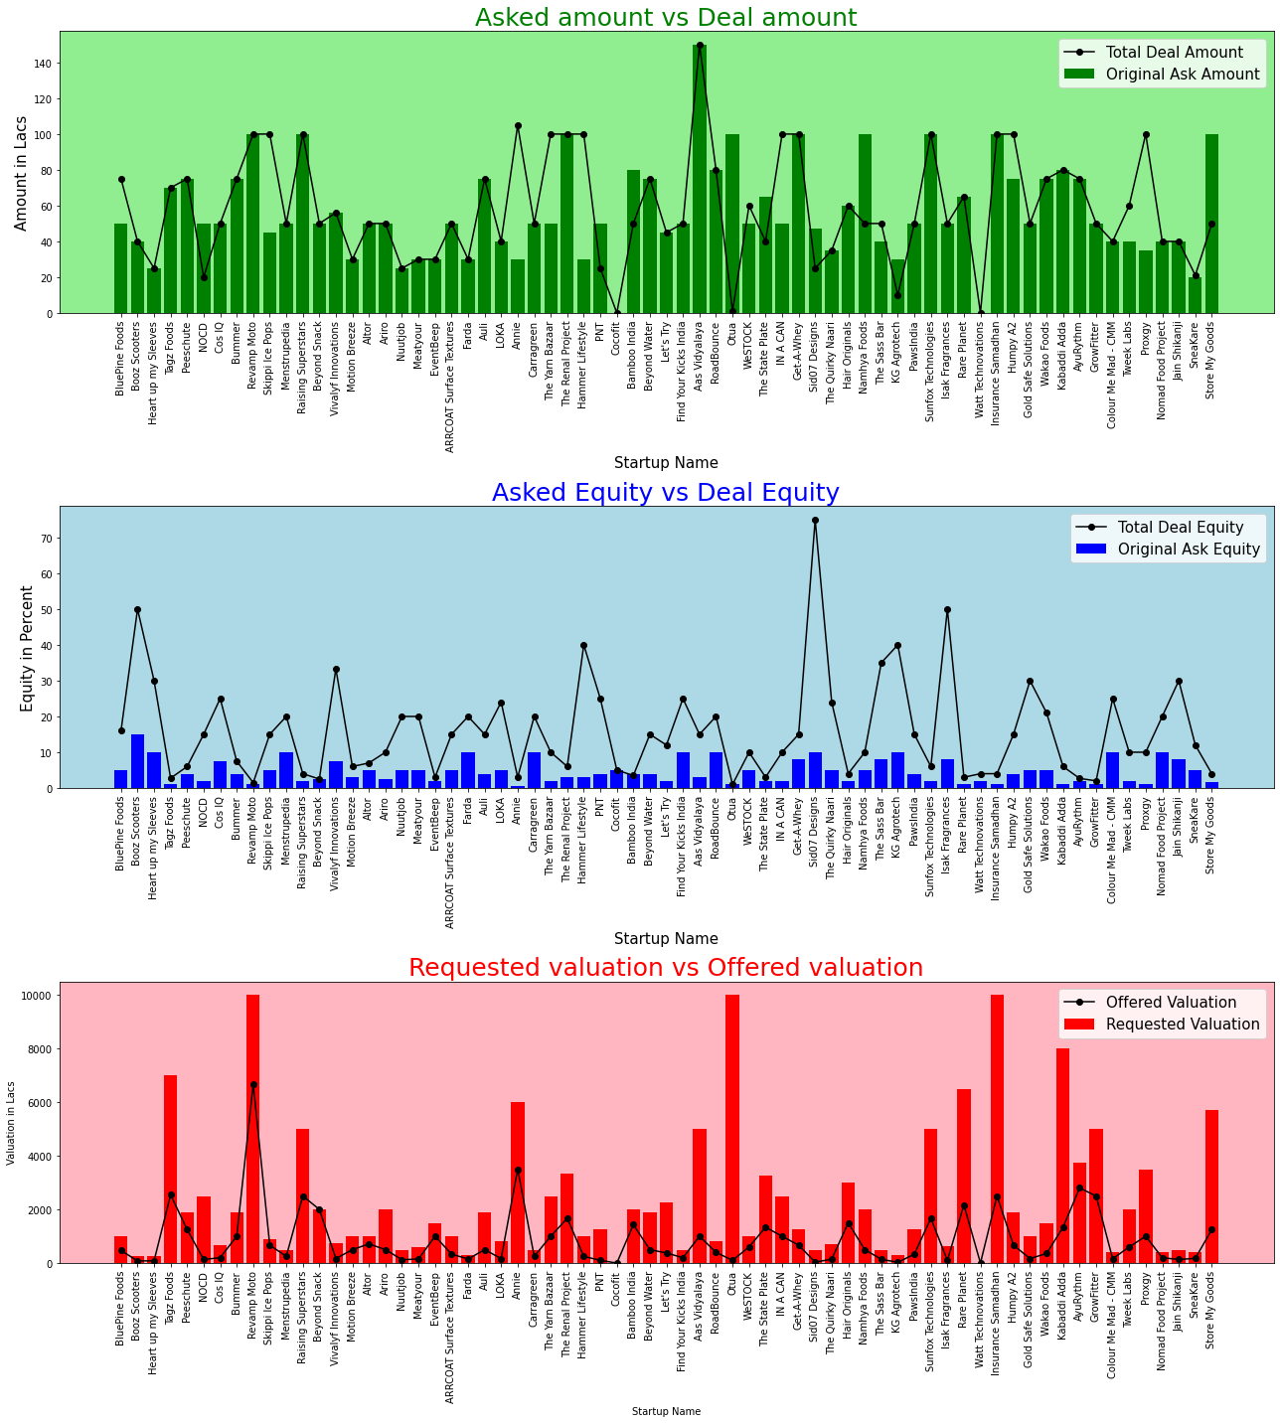

The first part bars reflect the amount requested/asked by entrepreneurs, while the line plot represents the amount offered by investors/sharks. The second section is about the amount of equity offered by the entrepreneurs and the overall amount of equity delivered to the sharks when the deal is completed. The final section displays the requested valuation as well as the sharks' offer of valuation.

We may conclude from the graph above that the majority of businesses have gotten the amount requested, although the equity rate varies on a larger scale. We can see that the valuation has also effected a lot by the sharks.

* **Who received the same deal as requested?**

Startup Name Valuation Requested Valuation Offered

Beyond Snack 2000 2000

The start up name Beyong Snack received the same valuation,which was requested by them.

* **Number of Investments done by Individual Shark:**

Ashneer invested in 21 businesses in the first season.

Namita invested in 24 businesses in the first season.

Anupam invested in 24 businesses in the first season.

Vineeta invested in 16 businesses in the first season.

Aman invested in 29 businesses in the first season.

Peyush invested in 28 businesses in the first season.

Ghazal invested in 7 businesses in the first season.

According to this shark Aman has invested in most number of companies. And shark Ghazal has invested in least number of companies.

* **Number of sharks involved in the deal**

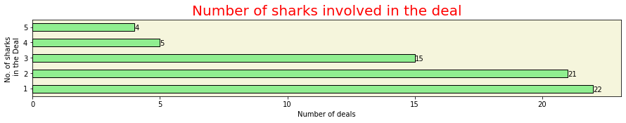

According to the graph above, all five sharks have invested in four companies, whereas just one shark has invested in 22 startups.

Deals in which 5 sharks invested combinedly :

----------------------------------------------------------------------

Startup Name Total Deal Amount Total Deal Equity

15 Skippi Ice Pops 100.0 15.0

49 Find Your Kicks India 50.0 25.0

63 IN A CAN 100.0 10.0

79 Sunfox Technologies 100.0 6.0

* **Which shark has invested most amount of money?**

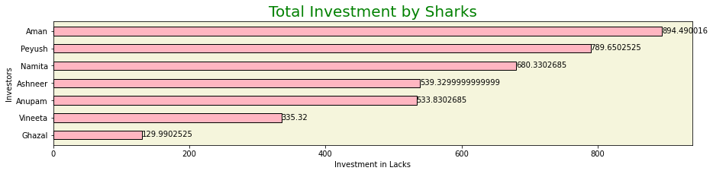

According to the above graph Shark Aman has invested most amount money followed by Shark Peyush and Shark namisha. Whereas shark ghazal has made least amount of investment.

* **Debt**

Total Debt offerred by the sharks in Lacks :

------------------------------------------------------------

Ashneer : 114.0

Namita : 25.0

Anupam : 15.0

Vineeta : 30.0

Aman : 50.0

Peyush : 117.0

Ghazal : 0.0

------------------------------------------------------------

Deals in which debt accepted :

---------------------------------------------------------------------------

Startup Name Total Deal Amount Total Deal Equity Total Deal Debt

8 NOCD 20.0 15.0 30.0

43 PNT 25.0 25.0 25.0

45 Bamboo India 50.0 3.5 30.0

55 Otua 1.0 1.0 99.0

61 The State Plate 40.0 3.0 25.0

65 Sid07 Designs 25.0 75.0 22.0

71 Namhya Foods 50.0 10.0 50.0

76 KG Agrotech 10.0 40.0 20.0

119 Store My Goods 50.0 4.0 50.0

Shark Peyush has offered most amount of debt followed by shark Ashneer. In which startup Name Otua received the most amount of debt. Where as shark Ghazal has offered no debt.

* Top Deals

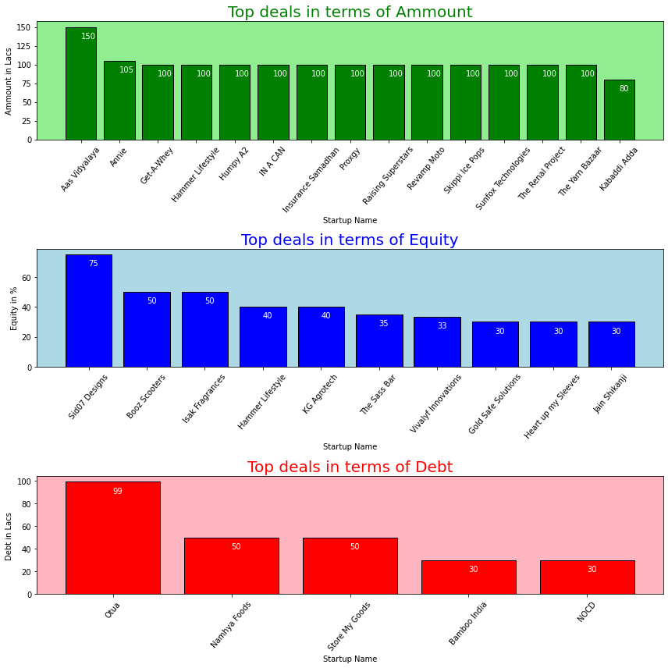

The above graphs displays the top deal received in terms amount, equity and debt. Aas vidyalaya secures the first position for the best deal received in terms of amount, followed by annie. Sid07 Designs would be the best deal in terms of equity for sharks as it gives them the 75% equity of the company. Otua has received the best deal in terms of debt.

Conclusion:

From the above report answers different questions such as which shark has invested in which company, Which company has most number of sharks invested in, what is initial amount requested, how much difference is there in the amount at the end of the deal, how many entrepreneurs has taken debt, which shark has invested most amount of money, and many more. It also tells us on what aspect the show is based on and how it went.