Flickr30k Text Embedding Baseline
  - Group 9
Xiaoxiao Song : Coding
Sneha Mishra : Coding
Ching-Chieh Lin : Coding
Che-Wei Lee : Coding

Objective and proposed model
We propose to study text conditioning and dataset adaptation with Stable Diffusion 1.5. The executed baseline combines the paired CLIP encoder (77 x 768 token embeddings), a latent-space U-Net and a VAE. A later experiment will compare the pretrained model with rank-4 attention LoRA while freezing CLIP, VAE and original U-Net weights.

Dataset and completed preparation
We selected 1,000 unique Flickr30k image-caption pairs from a 5,500-image candidate pool. The standalone notebook normalizes captions, removes empty and duplicate descriptions, checks decoding and pixel hashes, corrects EXIF orientation, and saves 512 x 512 RGB center crops. Five duplicate descriptions were removed from 27,500 source captions. With one caption per image and seed 42, the custom image-disjoint split is 800 training, 100 validation and 100 test pairs.

Executed environment and sample tests
The notebook ran on CPU with PyTorch 2.6.0+cpu, Diffusers 0.35.1 and Transformers 4.49.0. All 1,000 captions were encoded and saved as float32 77 x 768 sequences; no dataset caption was truncated. Five additional prompts below were each used to generate a new image from the pretrained model.
Five prompt to image tests use 512 x 512 pixels, DDIM with 30 steps, CFG 7.5 and seeds 42-46. The pretrained safety checker is enabled; individual inference times appear below.
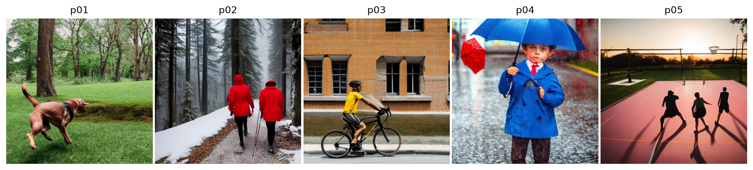
Prompt | Seed | Seconds
p01 A brown dog jumps over a fallen log in a green park. | 42 | 114.3
p02 Two people in red jackets walk along a snowy mountain trail. | 43 | 112.8
p03 A cyclist in a yellow shirt rides past a brick building. | 44 | 173.0
p04 A child in a blue coat holds a red umbrella on a rainy street. | 45 | 164.8
p05 Three people play basketball on an outdoor court at sunset. | 46 | 117.9
18/18 checks passed, including split isolation, finite and repeatable embeddings, empty and long prompts, tensor reload, five saved RGB 512 x 512 images, and correct prompt-seed mapping. No LoRA training was performed.

Observations and next experiment
p02 depicts two red-jacket walkers and p03 a yellow-shirt cyclist beside brickwork. In p04, the child holds a blue umbrella instead of the requested red one, revealing an attribute-binding error. Next, compare guidance and samplers on validation prompts, then compare the baseline with LoRA on locked test prompts using FID, IS and CLIP alignment. Five illustrative outputs do not establish population-level generation quality.

