PROJECT 5

**Scheduling a basic job in Jenkins**

* Creating a remote repository named Jenkins in GitHub and then creating a new java file named vowels with respective code.
* Copy the http code link.

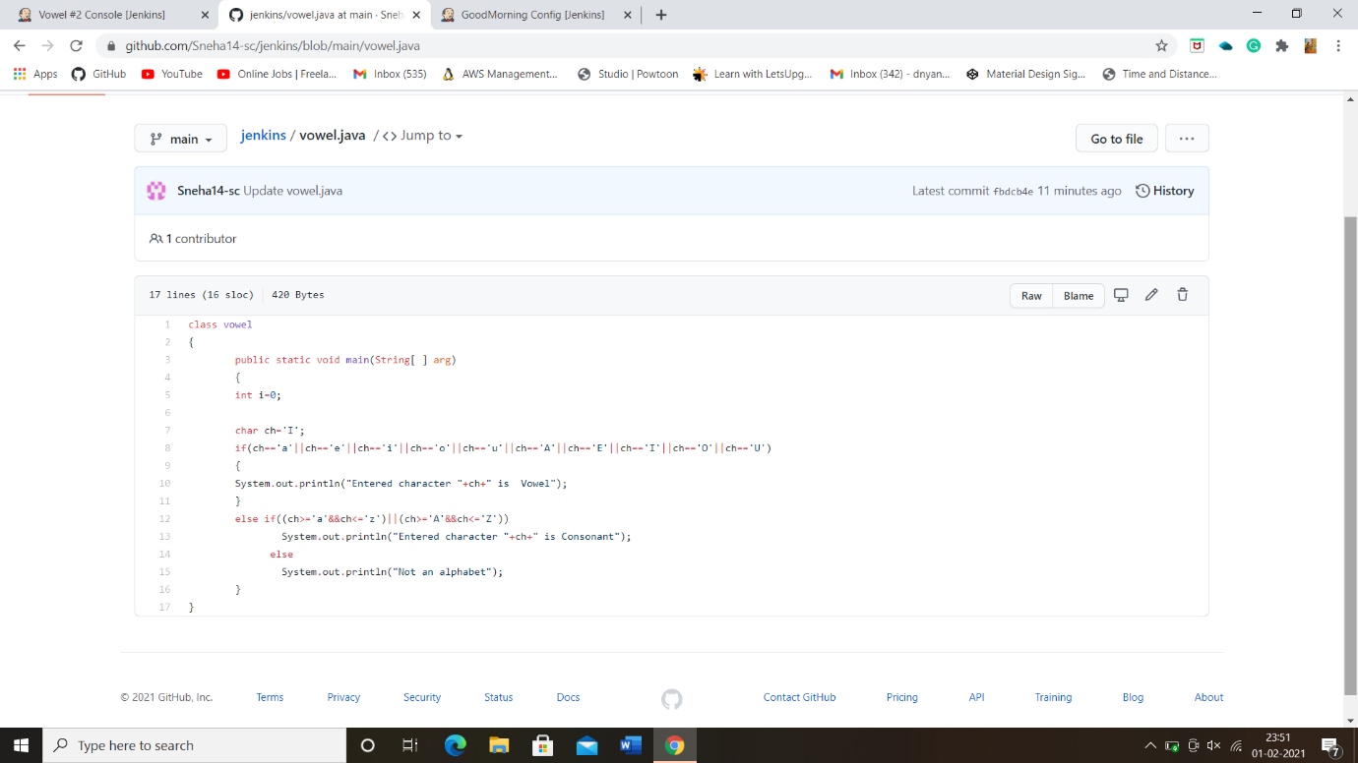

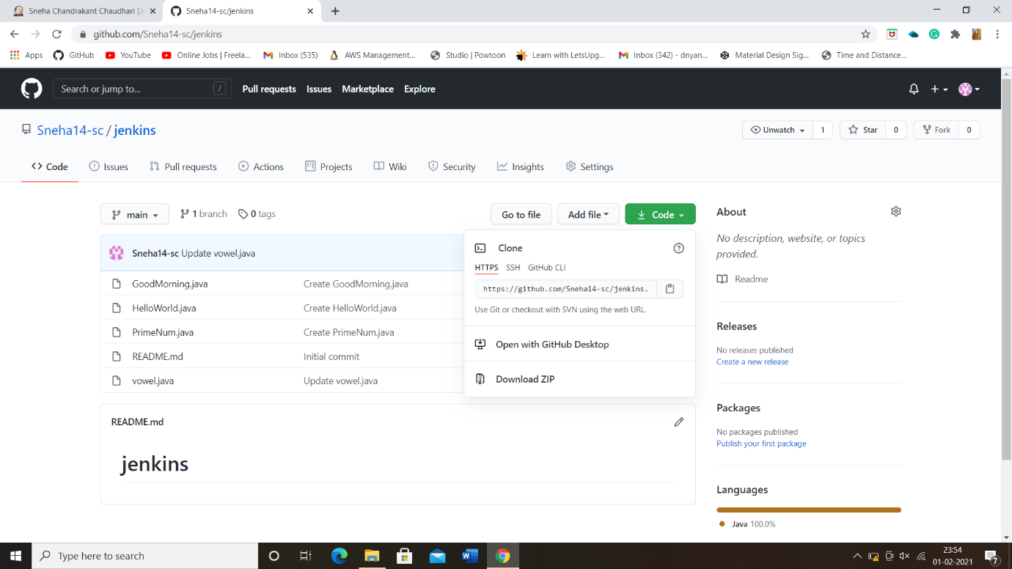

Task 1: - Creating a free style project in Jenkins.

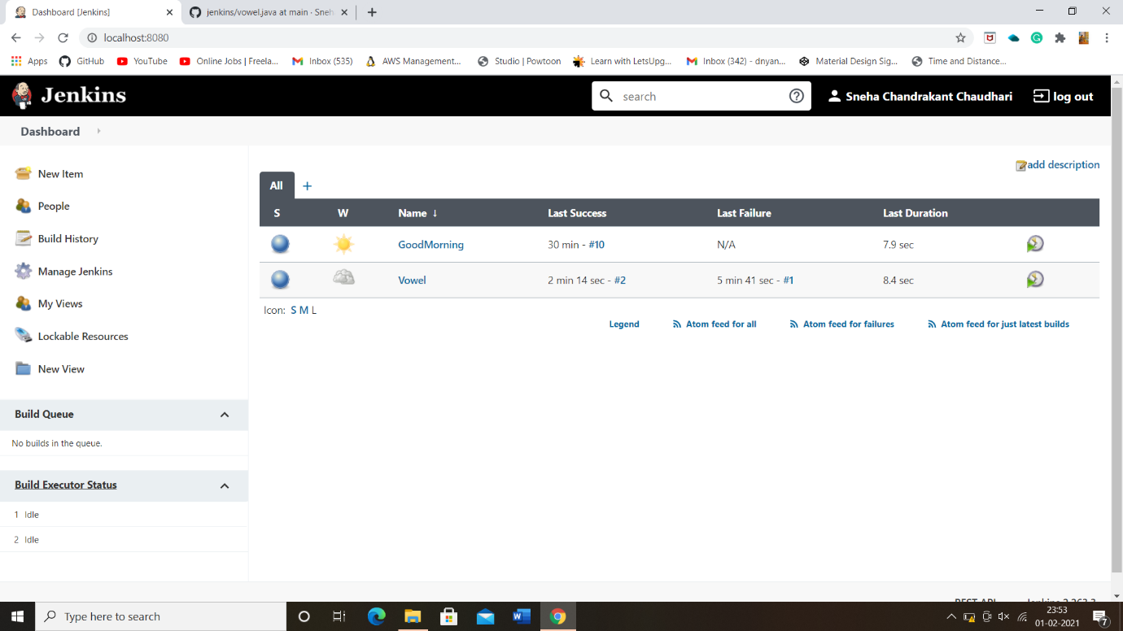

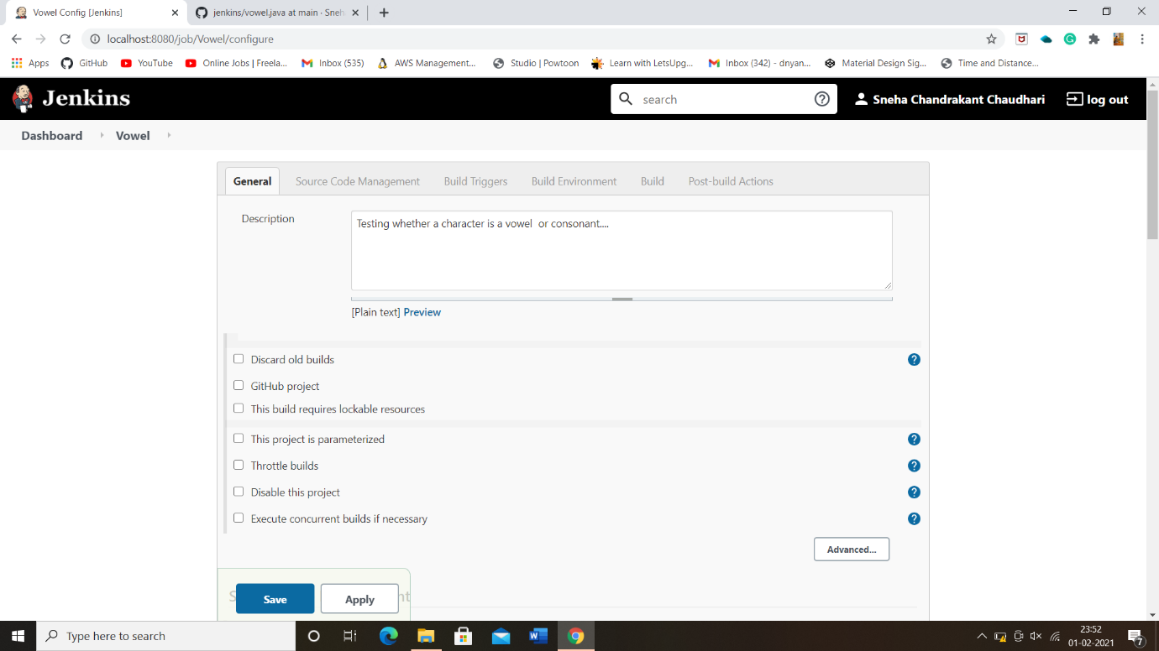

Task 2: -Configure git SCM:

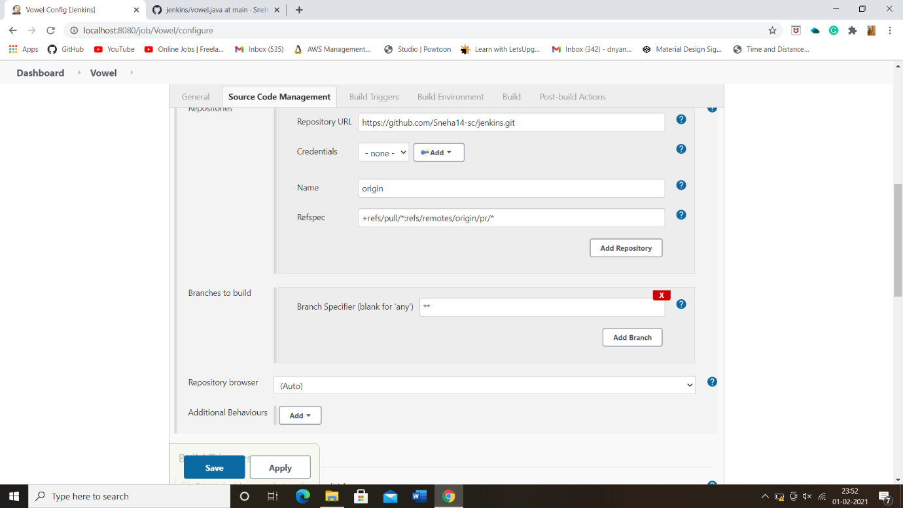

Task 3: -Build in step-java commands in execute window batch command.

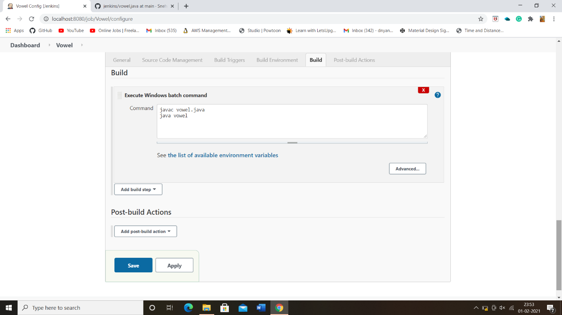

Task 4: - Run a Build and show a console output.

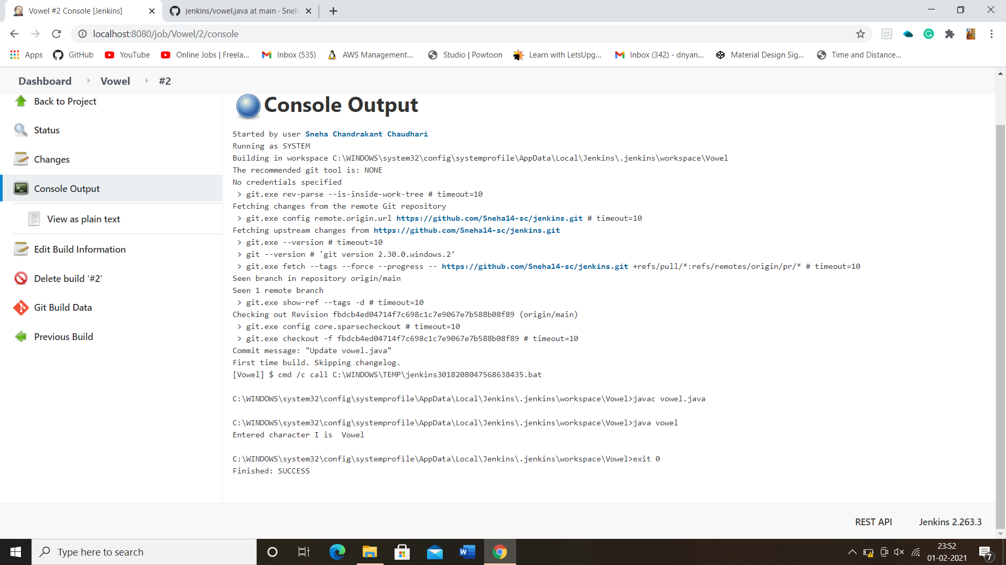

**THE END**