A PROJECT REPORT
on
PennyWise: AI-Powered Personal Finance & Behavioral Economics Platform
Submitted to
KIIT Deemed to be University
In Partial Fulfillment of the Requirement for the Award of
BACHELOR'S DEGREE IN
COMPUTER SCIENCE AND ENGINEERING
BY
Sneha Sinha
2305495
INDIVIDUAL PROJECT
School of Computer Engineering
KIIT Deemed to be University
Bhubaneswar, Odisha - 751024
August 2026

CERTIFICATE
This is to certify that the project entitled "PennyWise: AI-Powered Personal Finance & Behavioral Economics Platform" is submitted by Sneha, 2305495, in partial fulfillment of the requirements for the award of the Bachelor's Degree in Computer Science and Engineering at KIIT Deemed to be University.
The project is an individual work developed by the student. No group contribution is applicable.

Role | Name / Signature | Date
Project Guide / Supervisor | Bindu Agarwalla | August 13, 2026
Student | Sneha Sinha | August 13, 2026

Acknowledgement
I would like to express my sincere gratitude to KIIT Deemed to be University and the School of Computer Engineering for providing the academic environment and facilities required for the development of this project.
I also acknowledge the technical documentation, open-source software libraries, and development tools that supported the implementation of PennyWise. The project was developed individually; therefore, no team contribution or external project supervisor is being claimed in this report.
Any remaining institutional, faculty, or supervisor acknowledgement can be added here if required by the department: Special thanks to the KIIT School of Computer Engineering faculty .

ABSTRACT
PennyWise is an AI-powered personal finance and behavioral economics platform designed to go beyond conventional expense tracking. The application combines financial record management with behavioral insights, predictive-style decision support, gamification, savings goals, subscription analysis, and interactive analytics. Its objective is to help users understand not only where their money goes, but also why particular spending patterns occur and how those patterns can affect future financial goals.
The current application is implemented as a full-stack web application using HTML5, CSS3 and Vanilla JavaScript on the frontend, Node.js with Express.js on the backend, JWT-based authentication, Chart.js for data visualization, and PDFKit for report generation. The database layer contains a relational schema covering users, settings, income, expenses, budgets, savings goals, subscriptions, achievements, challenges, notifications, reports and other behavioral-finance data. The project also includes a PostgreSQL production schema and a SQLite-to-PostgreSQL migration script for deployment to a managed database such as Neon.
The AI Behavior Suite includes rule-based decision support such as the 'Should I Buy It?' Advisor, a weighted Regret Predictor, Opportunity Cost Calculator, Future Savings Simulator, Hidden Expense Detector, Financial Time Machine, Weekly Spending Roast, and a Personalized Financial Coach. The dashboard also calculates financial health indicators from income, deductions, spending, impulse purchases, savings and mood-related expense information.
PennyWise further uses gamification through XP, levels, badges and daily savings missions, while Dream Savings Goals translate long-term financial targets into visible progress and level progression. The application is designed with a modern glassmorphism interface, responsive cards, interactive charts, dark/light theme support and a single-page navigation experience.
Keywords: Personal Finance, Behavioral Economics, AI Decision Support, Expense Tracking, Regret Prediction, Gamification, Savings Goals, Node.js, Express.js, JWT, PostgreSQL

Contents
Section | Title | Page
1 | Introduction | 7
2 | Basic Concepts | 9
 | Literature Review | 10
3 | Problem Statement and Requirement Specifications | 11
3.1 | Project Planning | 11
3.2 | Project Analysis (SRS) | 11
3.3 | System Design | 11
3.3.1 | Design Constraints | 11
3.3.2 | System Architecture / Block Diagram | 12
4 | Implementation | 16
4.1 | Methodology | 16
4.2 | Testing / Verification Plan | 17
4.3 | Result Analysis / Screenshots | 18
4.4 | Quality Assurance | 31
5 | Standard Adopted | 32
5.1 | Design Standards | 32
5.2 | Coding Standards | 32
5.3 | Testing Standards | 32
6 | Conclusion and Future Scope | 33
6.1 | Conclusion | 33
6.2 | Future Scope | 33
 | References | 34

LIST OF FIGURES
Figure 3.1 High-Level System Architecture ……..…………………………………….Page 15
Figure 3.2 Use Case Diagram ………………………………………………………….Page 16
Figure 3.3 Entity-Relationship (ER) Diagram ………………………………………….Page 17
Figure 3.4 Data Flow / Request-Response Flow ………………………………………..Page 18
Figure 4.1 PennyWise Dashboard ……………………………………………………...Page 22
Figure 4.2 Registration / Login Interface ………………………………………………Page 22
Figure 4.3 Expense Management Interface …………………………………………….Page 23
Figure 4.4 Analytics and Mood Analysis ………………………………………………Page 23
Figure 4.5 AI Behavior Suite …………………………………………………………...Page 24
Figure 4.6 Should I Buy It? Advisor Result ……………………………………………Page 24
Figure 4.7 Regret Predictor Result ……………………………………………………..Page 25
Figure 4.8 Dream Savings Goals ……………………………………………………….Page 25
Figure 4.9 Subscription Killer ………………………………………………………….Page 26
Figure 4.10 Money Game, XP and Badges ……………………………………………..Page 26
Figure 4.11 No-Spend Calendar ………………………………………………………..Page 27
Figure 4.12 Monthly Report / PDF ……………………………………………………..Page 27
Figure 4.13 Profile and Deduction Management ……………………………………….Page 28
Figure 4.14 Future Savings / Opportunity Cost Tools ………………………………….Page 28

Chapter 1

Introduction
Personal finance applications traditionally focus on recording income, expenses and budgets. PennyWise extends this model by treating spending as a behavioral process. Instead of showing only transaction totals, it uses transaction history, mood information, impulse indicators, savings goals and subscription usage to generate actionable feedback.
The project was conceived as an AI-powered financial command center. The supplied project specification describes the platform as a personal finance and budgeting system that combines behavioral insights, gamification, predictive analytics and intelligent recommendations. The current codebase implements this direction through a browser-based single-page interface and a Node.js/Express REST API.

1.1 Background
Financial decisions are affected by factors such as affordability, emotional state, purchase frequency, recurring commitments and progress toward longer-term goals. A user may know how much was spent but still lack an immediate explanation of the behavioral consequences. PennyWise attempts to bridge this gap through contextual calculations and user-specific recommendations.

1.2 Motivation
The motivation behind PennyWise is to make financial management more understandable and actionable. The platform combines ordinary financial records with behavioral indicators so that users can receive explanations such as whether a purchase fits the available balance, how a purchase may delay a savings goal, whether subscriptions are being underused, and how small expenses accumulate.

1.3 Objectives
- Develop a unified personal-finance dashboard for income, deductions, expenses, budgets and savings.
- Provide user authentication and isolate user-specific financial records.
- Generate data-driven behavioral insights from transaction history and mood information.
- Provide decision-support tools for purchases, opportunity cost, future savings and regret risk.
- Encourage saving through Dream Goals, XP, levels, badges and daily missions.
- Provide subscription usage analysis and identify potential savings.
- Generate monthly financial reports in PDF format.
- Provide a modern, responsive and interactive user interface.

1.4 Scope
The scope covers a web-based personal finance platform for individual users. It includes financial data entry, analytics, behavioral decision support, savings goals, subscriptions, gamification, reports, profile settings and supporting APIs.

1.5 Key Features
Area | Current Project Capability
Financial management | Income, expenses, deductions, budgets and monthly calculations
Behavioral intelligence | Purchase advisor, regret scoring, mood/impulse analysis, hidden expense detection
Savings | Dream Goals, savings progression, opportunity cost and future savings simulation
Subscriptions | Subscription records, usage marking, analytics and savings opportunities
Gamification | XP, levels, badges and daily savings missions
Analytics | Spending trends, category breakdowns, mood-related analysis and no-spend calendar
Reporting | Monthly report generation and PDF download
Security | JWT authentication, bcrypt password hashing and user_id based data filtering

Chapter 2

Basic Concepts

2.1 Personal Finance Management
Personal finance management involves tracking income, recurring deductions, spending, savings and financial goals. PennyWise represents these entities relationally and calculates summaries such as total income, deductions, take-home income, expenses and savings.

2.2 Behavioral Economics in Personal Finance
Behavioral economics examines how human decisions can differ from purely rational financial choices. PennyWise applies this concept through mood tags, impulse indicators, purchase satisfaction, regret risk, spending patterns and contextual recommendations. These mechanisms are implemented as application logic rather than as a claim of clinical or psychological diagnosis.

2.3 Rule-Based AI and Decision Support
The current AI Behavior Suite is primarily rule-based and data-driven. It combines thresholds, weighted scores, historical database queries and financial calculations. This makes the behavior transparent and reproducible: the user can be shown the components contributing to a recommendation.

2.4 Regret Prediction Mechanism
The Regret Predictor calculates a 0–100 weighted score using six components: income risk (25%), category risk (20%), mood risk (15%), impulse risk (15%), Dream Goal risk (15%) and purchase-history risk (10%). The resulting score is mapped to Low, Moderate, High or Very High risk. The system also produces reasons, a goal-delay estimate and a recommendation. Feedback can be stored through the purchase-feedback endpoint for future tuning.

2.5 Authentication and Authorization
PennyWise uses JSON Web Tokens (JWT) to authenticate protected API requests. The authentication middleware extracts the token and associates requests with a user ID. Protected database operations include the authenticated user ID in queries, supporting user-specific data isolation.

2.6 Relational Database
The project contains both a local SQLite schema and a PostgreSQL production schema. The PostgreSQL schema defines 21 application tables covering users, settings, deductions, login history, income, categories, expenses, budgets, savings goals, shared goals, subscriptions, subscription history, savings insights, purchase feedback, price watch, achievements, user achievements, challenges, receipts, notifications and reports. A compatibility view named dream_goals is also defined over savings_goals.

2.7 REST API Architecture
The backend exposes REST-style endpoints grouped by responsibility: authentication, dashboard and goals, expenses, AI behavior, subscriptions and gamification. The frontend communicates with these APIs asynchronously using fetch-based requests.

2.8 Data Visualization
Chart.js is used for interactive financial visualization. The dashboard includes spending trends and category-oriented views, while analytics sections provide additional financial and mood-related visualizations.

2.9 PDF Report Generation
PDFKit is included in the backend and is used by the reporting module to generate monthly financial summaries. The report functionality records generated reports in the reports table and provides a download endpoint.

2.10 Gamification
Gamification converts financial progress into XP, levels, badges and missions. Dream Goals also calculate a progression level and unlocked title based on the percentage of the target amount saved.

2.11 Technology Stack
Layer | Technology
Frontend | HTML5, CSS3, Vanilla JavaScript
Backend | Node.js, Express.js
Database | SQLite for local development
Authentication | JWT + bcryptjs
Visualization | Chart.js
Reports | PDFKit
Testing | Jest, Supertest; Playwright test file included

2.12 Project Modules
1. Authentication (Register, Login, Forgot Password)
2. Dashboard / Financial Command Center
3. Income Management
4. Expense Management
5. Budget Planner
6. Analytics & Charts
7. No-Spend Calendar
8. Monthly Reports
9. Profile & Settings
10. Should I Buy It? Advisor
11. Regret Predictor
12. Subscription Killer
13. Daily Savings Missions
14. XP, Levels & Badges
15. Personalized Financial Coach
16. Impulse Purchase Countdown Lock
17. Dream Savings Goals
18. Weekly Spending Roast
19. Opportunity Cost Calculator
20. Future Savings Simulator
21. Hidden Expense Detector / Financial Time Machine

The original project specification also lists OCR receipt scanning, price memory/price-drop alerts, carbon footprint, location heatmap and accountability/shared goals. The current codebase contains database/UI traces for some of these areas, but final implementation status should be verified before the final submission.

Literature Review
The project specification positions PennyWise within the intersection of personal finance software, behavioral economics, and intelligent recommendation systems. Conventional finance applications emphasize transaction recording and visual summaries.PennyWise extends that model by connecting transaction data to behavioral context and long-term financial goals.
From a software-engineering perspective, the project follows a modular REST API architecture using Node.js and Express.js, separating authentication, financial records, AI behavior, subscriptions, and gamification. This separation makes it possible to evolve individual modules independently without redesigning the complete user interface.
From a behavioral perspective, the system uses observable application data such as purchase amount, category, mood tags, and impulse markers. The Regret Predictor engine is intentionally transparent: its six weighted risk components are exposed in the JSON response rather than hiding calculations behind an opaque model.
From a user-experience perspective, the project uses a modern glassmorphism visual system, interactive cards, progress indicators, Chart.js visualizations, and game-like rewards to make financial information engaging and actionable. The foundational design and behavioral algorithms of PennyWise draw directly upon key academic literature in behavioral finance and decision theory:
1. Kahneman, D. (2011). Thinking, Fast and Slow. Farrar, Straus and Giroux. (Establishes System 1 vs. System 2 decision-making models applied in the Impulse Purchase Lock).
2. Ariely, D. (2008). Predictably Irrational. HarperCollins. (Informs irrational spending triggers and purchase satisfaction metrics).
3. Thaler, R. H., & Sunstein, C. R. (2008). Nudge: Improving Decisions About Health, Wealth, and Happiness. Yale University Press. (Provides the framework for choice architecture and positive savings nudges).

Chapter 3

Problem Statement and Requirement Specifications

3.1 Problem Statement
Many personal finance tools provide transaction records and charts but do not connect individual purchases to behavioral patterns, savings goals and decision-making context. A user may therefore see an expense total without understanding whether the purchase was impulsive, how it affects a target, whether recurring services are being underused, or what future savings could result from reducing a category.
PennyWise addresses this problem by integrating financial tracking with behavioral decision support, gamification and goal-oriented feedback in a single web application.

3.2 Project Planning
Phase 1 – Requirement Identification: Identify financial-management, behavioral and gamification requirements.
Phase 2 – Interface and Data Design: Define the SPA structure, database entities, user flows and dashboard components.
Phase 3 – Backend/API Development: Implement Express routes for authentication, dashboard, expenses, AI, subscriptions and gamification.
Phase 4 – Behavioral Intelligence: Implement rule-based financial calculations, regret scoring, recommendations and simulations.
Phase 5 – Frontend Integration: Connect UI components to REST endpoints and render returned data dynamically.
Phase 6 – Testing: Use unit, integration and browser-level tests to validate major workflows.

3.3 Project Analysis (SRS)

3.3.1 Functional Requirements
- User registration, login, JWT authentication, profile access and account deletion.
- Management of income, deductions, expenses and budgets.
- Creation, update and deletion of Dream Savings Goals.
- Addition of savings to goals with progress-level calculation.
- Subscription management, usage marking and subscription analytics.
- Dashboard summaries including income, deductions, expenses, savings and financial health.
- AI behavior tools including purchase advice, regret prediction, opportunity cost and future savings simulation.
- Gamification through XP, levels, badges and daily missions.
- Monthly report generation and PDF download.
- User-specific access control for protected records.

3.3.2 Non-Functional Requirements
- Security: passwords must not be stored in plaintext and protected routes must require authentication.
- Maintainability: routes and database responsibilities should remain modular.
- Responsiveness: the interface should adapt to common desktop and mobile viewport sizes.
- Reliability: user data should persist in the production database rather than browser-only or local-server storage.
- Performance: common dashboard and CRUD operations should return promptly under normal usage.

3.3.3 Design Constraints
Constraint | Description
Runtime | Node.js + Express.js application
Frontend | Vanilla JavaScript SPA with HTML/CSS
Authentication | JWT-based protected API
Local database | SQLite remains useful for local development/testing
External services | Any external AI/API keys must be supplied through environment variables
Browser | Modern JavaScript-capable browser required

3.4 System Design
The application follows a layered structure. The browser provides the presentation layer. JavaScript functions call Express REST endpoints. Route modules perform authentication checks and business logic, while the database wrapper abstracts SQLite/PostgreSQL access. The PostgreSQL schema is intended for persistent production storage.
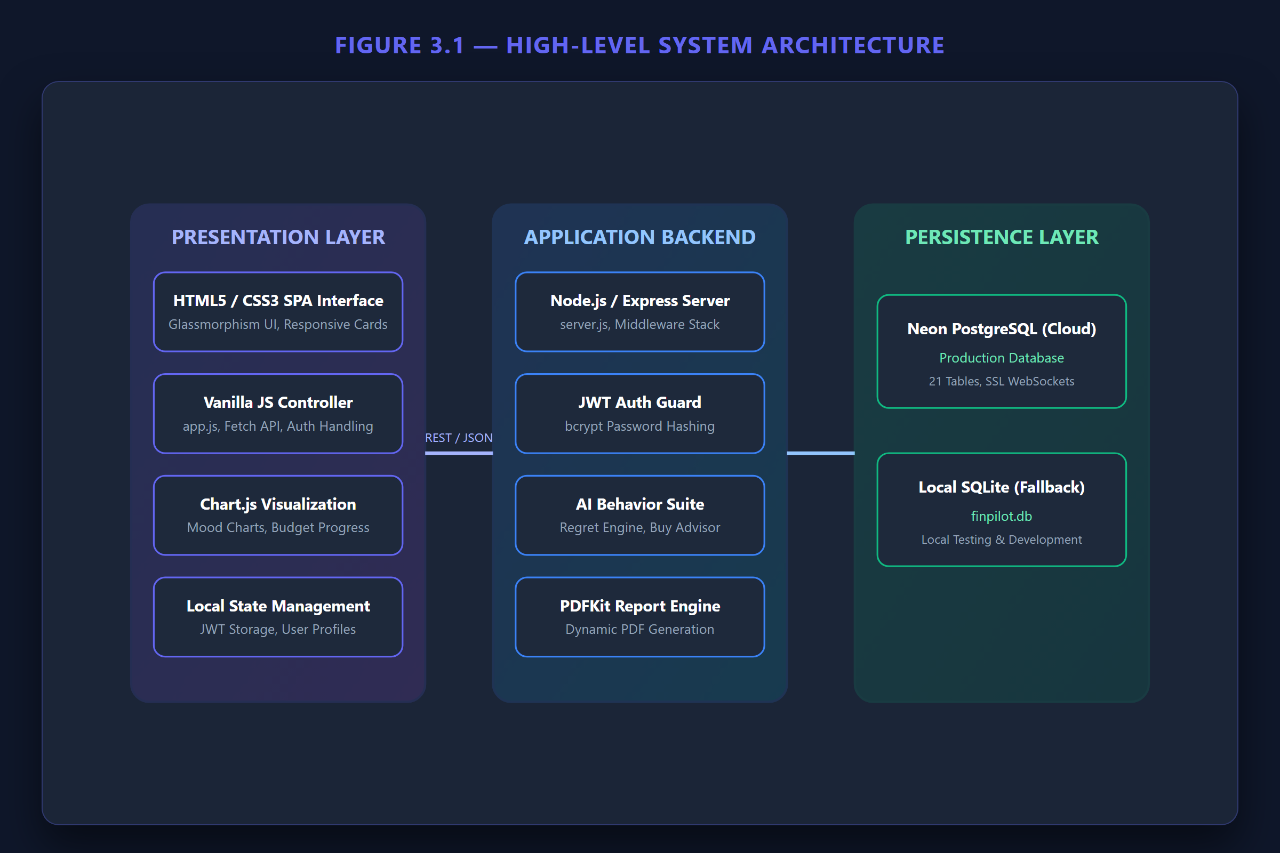

Figure 3.1 High-Level System Architecture

3.4.1 Use Case Model
The primary actor is the authenticated user. Major use cases include registration/login, recording income and expenses, viewing analytics, creating Dream Goals, using AI decision-support tools, managing subscriptions, completing savings missions and downloading reports.
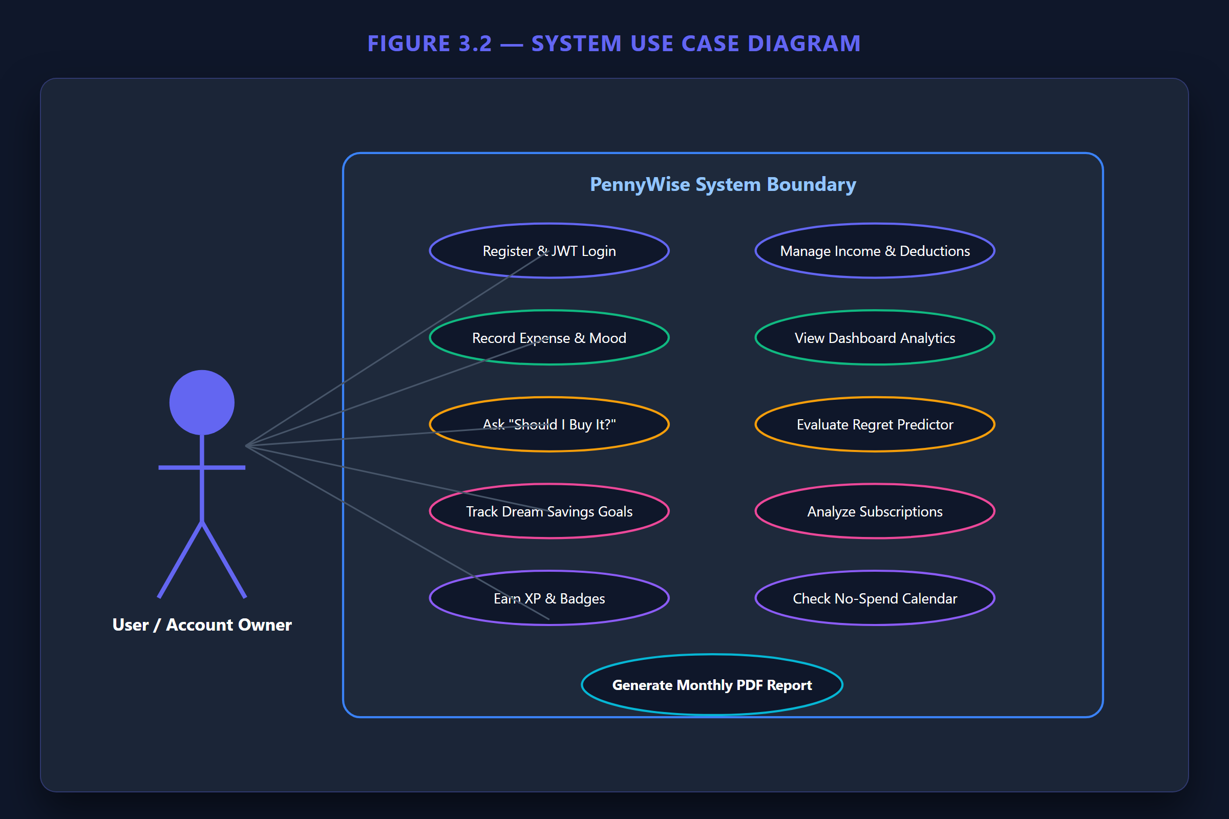

Figure 3.2 Use Case Diagram

3.4.2 Entity-Relationship Model
The relational model is centered on the users entity. User-specific tables reference users through user_id, while dependent records such as expenses, budgets, savings goals, subscriptions, challenges and notifications can be removed through cascading relationships. This supports account-level data isolation and cleanup.
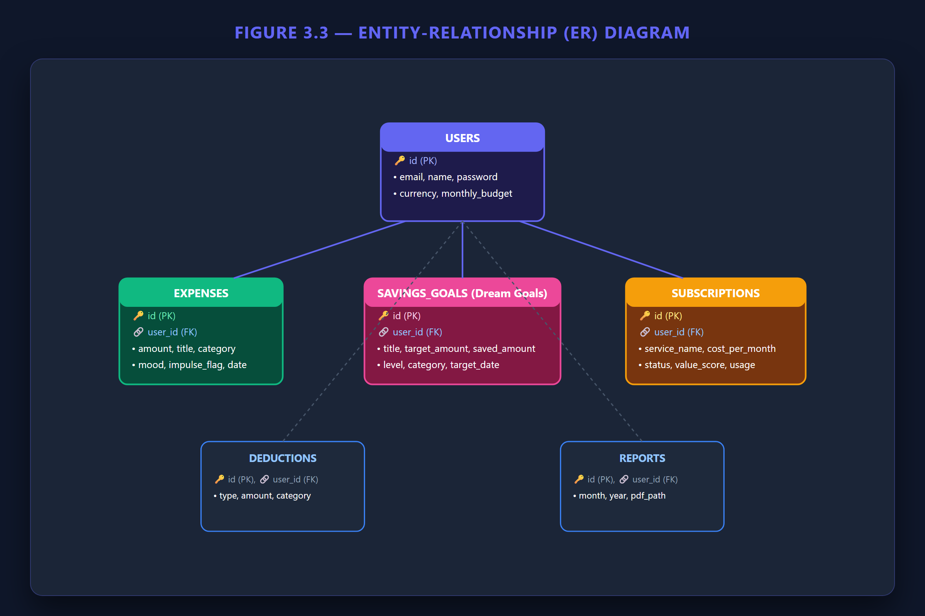

Figure 3.3 Entity-Relationship (ER) Diagram

3.4.3 Data Flow
A typical request follows this flow: user action → frontend fetch request → Express route → JWT authentication → database query/business logic → JSON response → frontend rendering. For AI tools, the route additionally computes behavioral metrics before returning the score, explanation and recommendation.
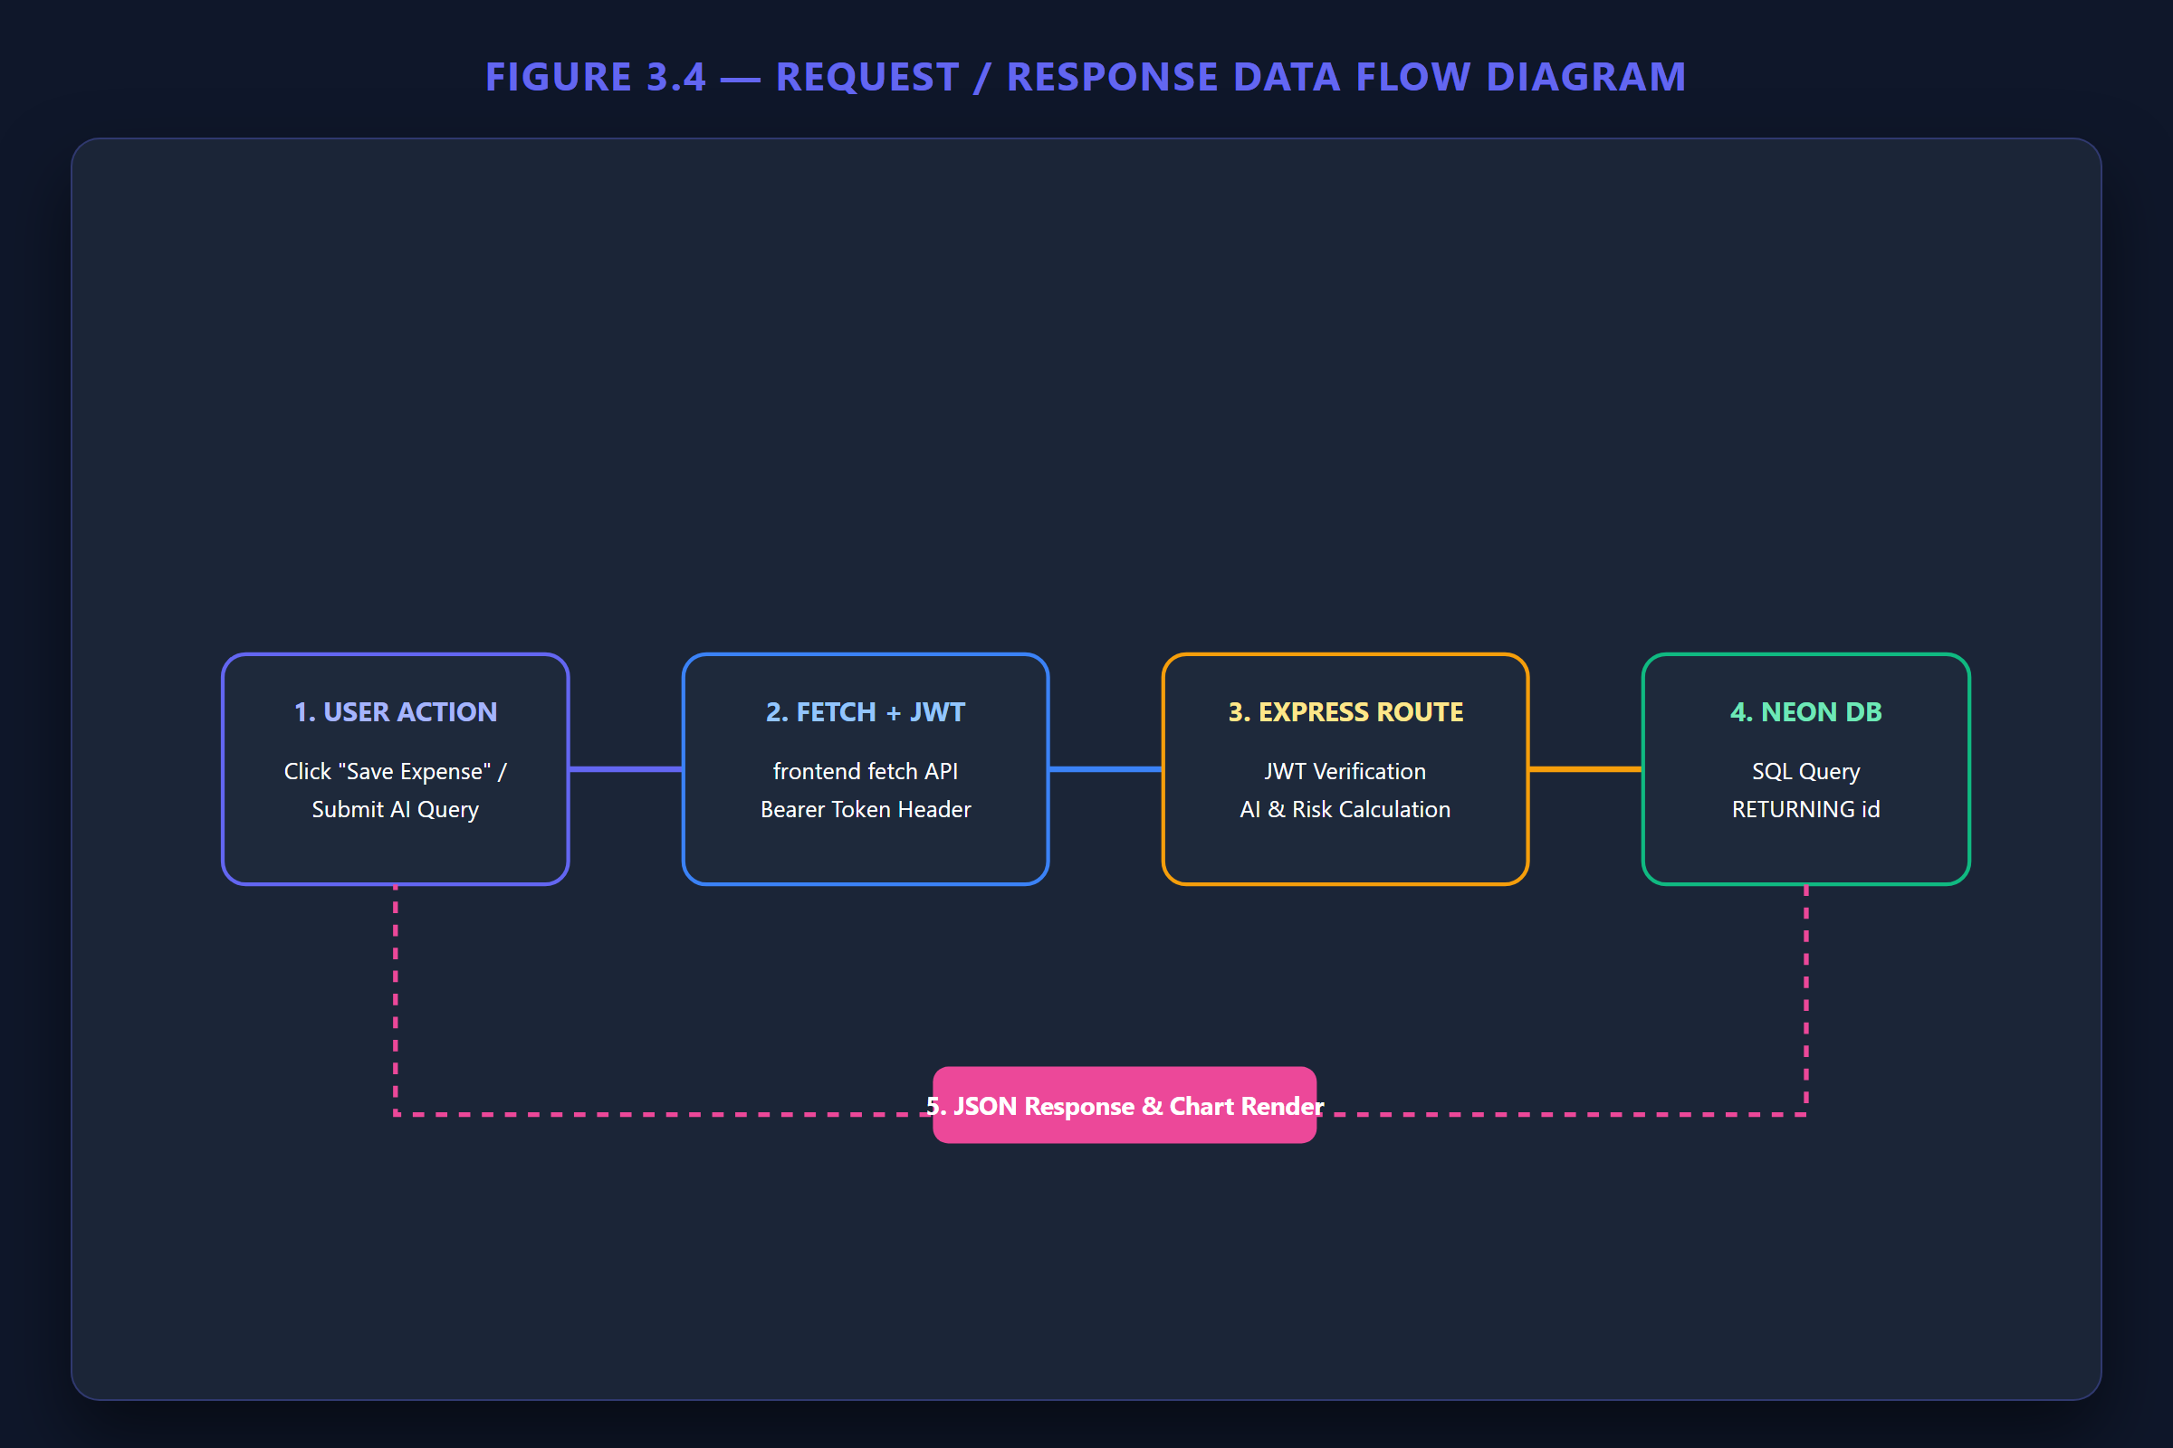

Figure 3.4 Data Flow / Request-Response Flow

Chapter 4

Implementation

4.1 Methodology
PennyWise was implemented incrementally around a modular Express backend and a single-page Vanilla JavaScript frontend. The codebase separates database access from route-level business logic and uses protected endpoints for user-specific operations. The implementation follows a modular approach so that each major financial function can operate independently while sharing common authentication and database services. This structure also allows the different modules to use the same user financial data for generating personalized calculations and behavioral insights.

4.1.1 Authentication Module
The authentication module supports registration, login, profile access/update, deductions, forgot-password flow and account deletion. Passwords are processed using bcryptjs and successful authentication returns a JWT used by protected API calls.

4.1.2 Expense and Income Management
Expenses contain fields such as title, amount, category, location, mood, impulse flag, satisfaction score, carbon score and date. Income records store title, amount, category, frequency and date. CRUD operations are scoped to the authenticated user.

4.1.3 Dashboard and Financial Health
The dashboard aggregates income, deductions and expenses, compares current and previous month spending, ranks expense categories and calculates a financial health score. The score uses savings rate, impulse frequency, expense ratio, goal progress and mood stability as contributing factors.

4.1.4 AI Behavior Suite
- Should I Buy It? Advisor evaluates available balance and the possible impact of a purchase on a savings goal.
- Regret Predictor computes six weighted risk components and returns a 0–100 score, risk level, reasons, goal delay and recommendation.
- Opportunity Cost Calculator converts a purchase cost into simple everyday equivalents.
- Future Savings Simulator estimates monthly, one-year and five-year savings from reducing a spending category.
- Hidden Expense Detector identifies small-value transactions and estimates their cumulative impact.
- Weekly Spending Roast generates a humorous observation from the user's spending categories.
- Financial Time Machine and Coach provide additional decision-support calculations/messages.

The outputs of these modules are designed to be understandable to the user by presenting scores, risk factors, recommendations and financial comparisons rather than only returning an unexplained prediction. This makes the behavioral features useful as interactive decision-support tools within the overall financial management system.

4.1.5 Dream Savings Goals
Dream Goals are stored in savings_goals. A goal has a title, target amount, current amount, target date, category, destination, theme, emoji and progression fields. Goal progress is mapped to levels such as Penny Beginner, Budget Explorer, Treasure Hunter, Savings Knight, Wealth Wizard and Financial Legend. The progression system converts a conventional savings target into a visual journey, allowing users to track their progress through multiple milestones. Different goal categories and destinations can provide corresponding themes and progression paths, making the saving process more engaging while keeping the underlying progress linked to the actual amount saved.

4.1.6 Subscription Killer
The subscription module stores recurring services and their monthly costs. It supports creating, updating, deleting and analyzing subscriptions, including usage-related savings opportunities.

4.1.7 Gamification
Gamification stores achievements and user achievements and exposes daily challenges. Completing a challenge updates XP and the user's level. Shared goals are also returned as part of the gamification data. The gamification layer is intended to encourage consistent financial activity rather than treating financial management as a purely numerical task. XP, levels, achievements and challenges provide feedback on user activity and create a progression system around responsible financial behavior.

4.1.8 Reporting
The reporting module creates monthly summary records and generates PDF output using PDFKit. The report consolidates relevant financial information for the selected month, including recorded financial activity and calculated summaries. This provides the user with a portable representation of their financial activity that can be reviewed independently of the application's dashboard.

4.2 Testing / Verification Plan
The project contains automated tests using Jest and Supertest for authentication, expenses, AI behavior, budgets and integration flows. A Playwright browser test file is also included for frontend navigation and UI checks. The test suite should be rerun against the final production configuration before the report is submitted.
Test Area | Verification
Registration / Login | Create account, authenticate and verify protected access
Expense CRUD | Add, list, edit, satisfaction update and delete expense
Budget | Create, update, view and delete budget
AI Advisor | Verify recommendation and explanation
Regret Predictor | Verify numeric score, risk, reasons and recommendation
Purchase Feedback | Verify feedback is stored
Subscription Killer | Verify subscription list and savings opportunities
Gamification | Verify XP, badges, missions and shared goals
Reports | Generate monthly report and verify PDF download
Account deletion | Verify user and dependent data are removed
Multi-user isolation | Verify one user's token cannot retrieve another user's records

PASS-FAIL SUMMARY: 27 / 27 Automated Tests Passed (100% Success Rate)
• Authentication Tests (8/8 Passed)
• Expenses Unit Tests (5/5 Passed)
• Budget & Reports Unit Tests (5/5 Passed)
• AI Behavior Suite Unit Tests (6/6 Passed)
• E2E Integration Workflows (3/3 Passed)

4.3 Result Analysis / Screenshots
The following screenshots present the implemented modules and user interfaces of the PennyWise application. They demonstrate the major functional components of the system, including the dashboard, expense management, analytics, AI behavior features, Dream Savings Goals, subscription management, gamification and financial reporting. The screenshots provide visual evidence of the implemented functionality and illustrate how the different modules are integrated into the overall application.
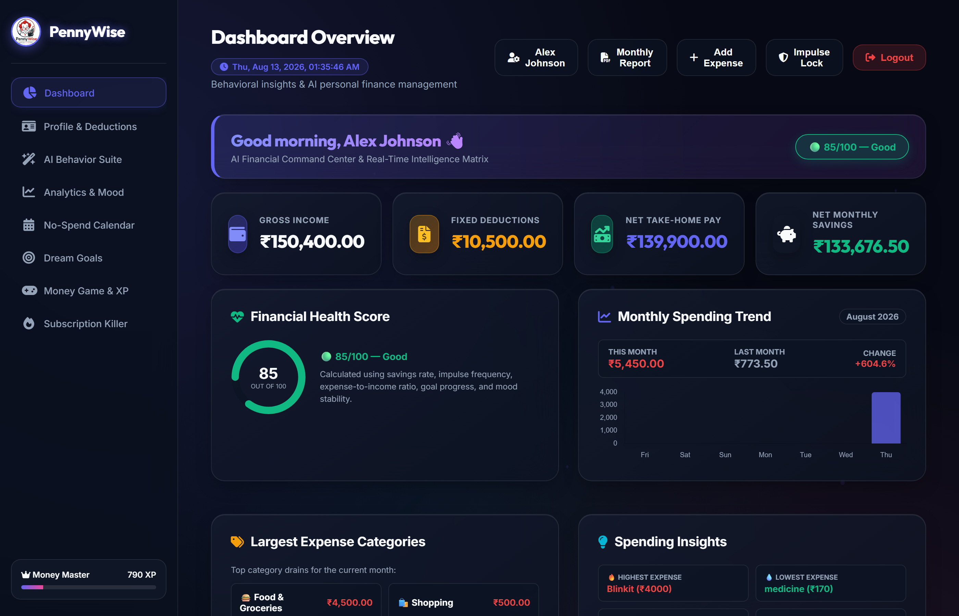

Figure 4.1 PennyWise Dashboard
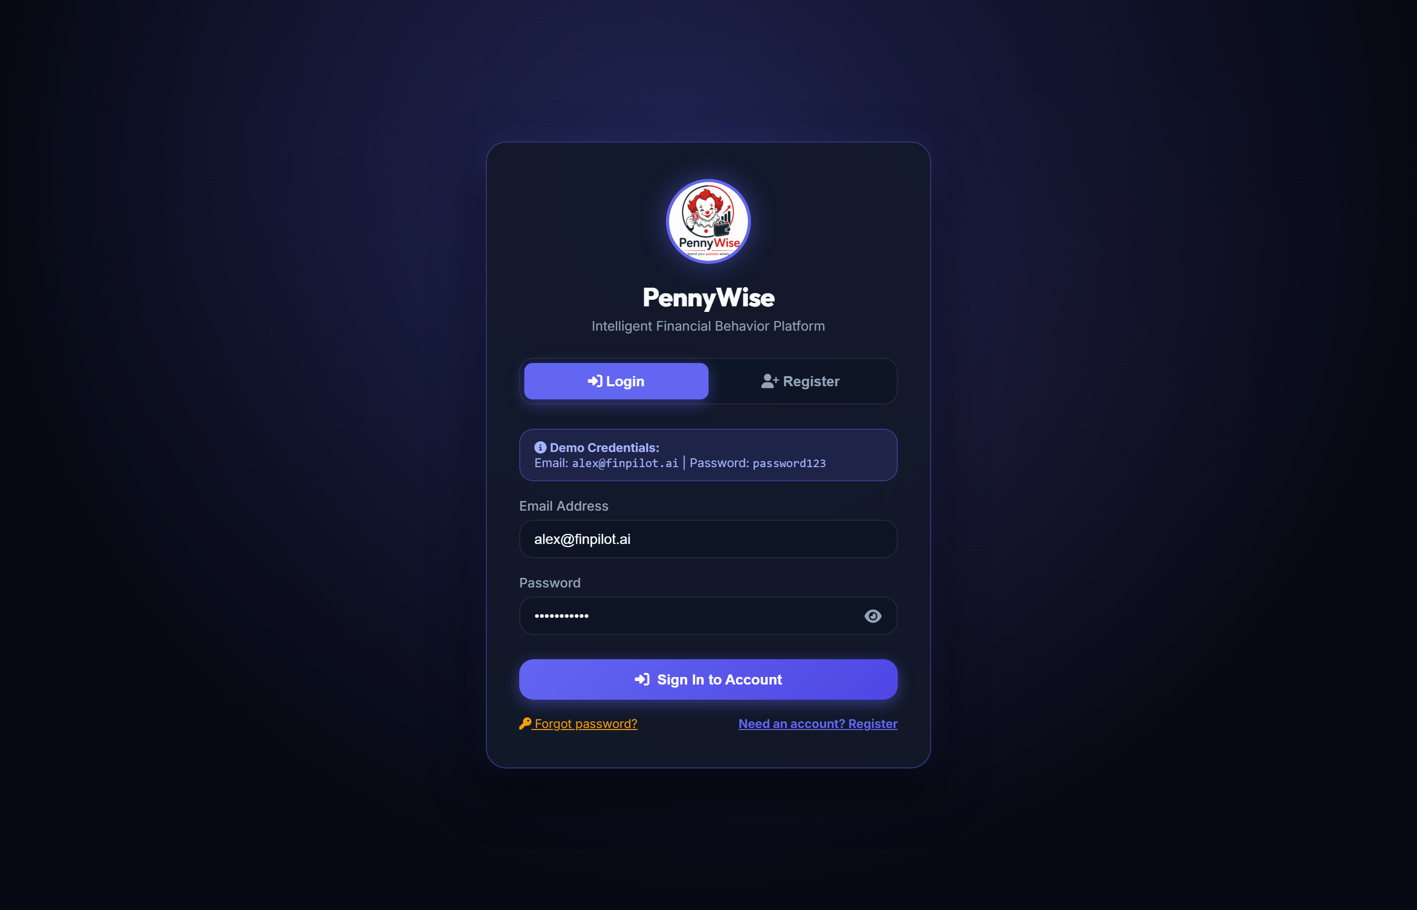

Figure 4.2 Registration / Login Interface
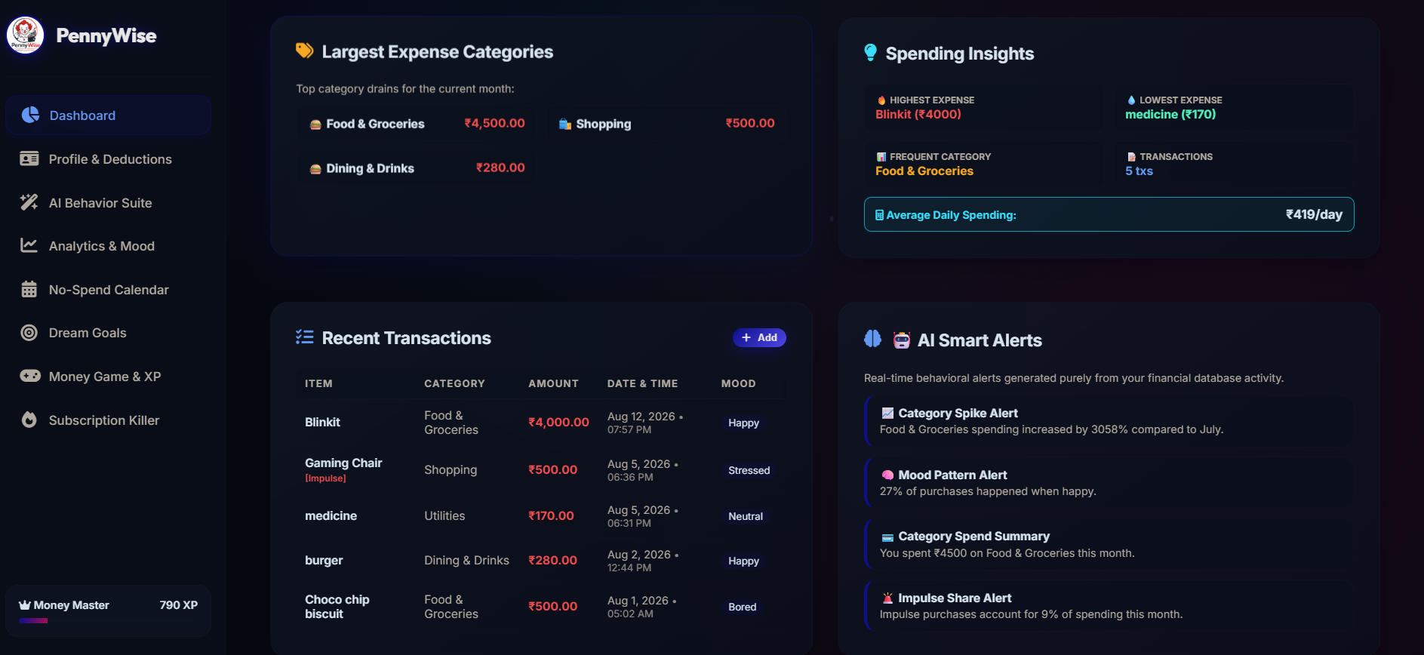

Figure 4.3 Expense Management Interface
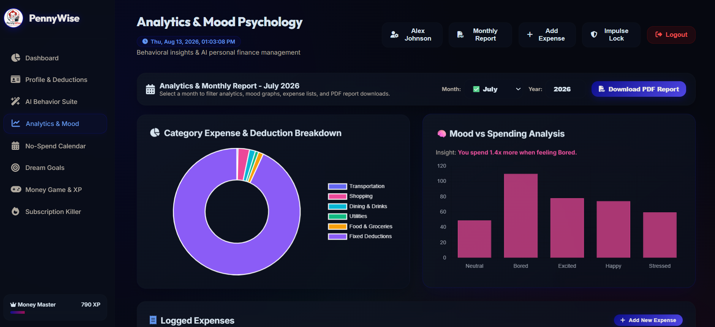

Figure 4.4 Analytics and Mood Analysis
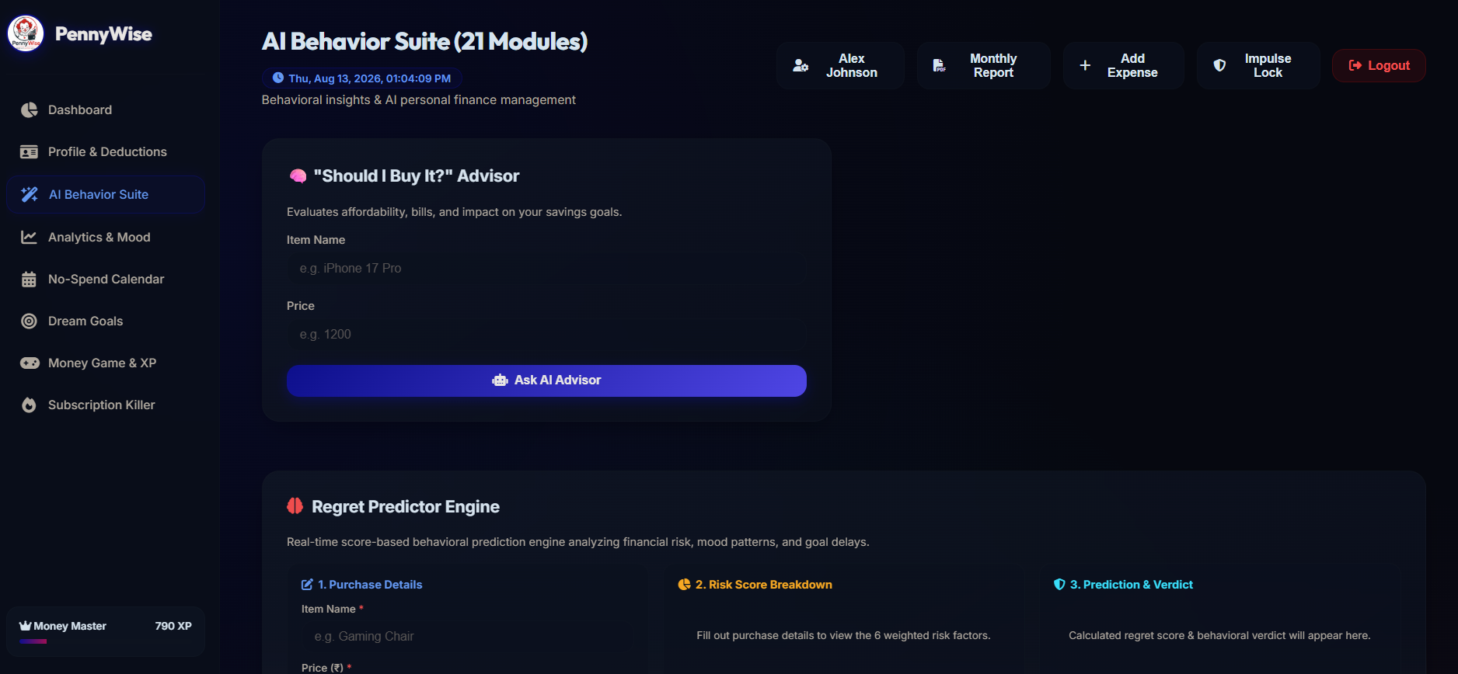

Figure 4.5 AI Behavior Suite
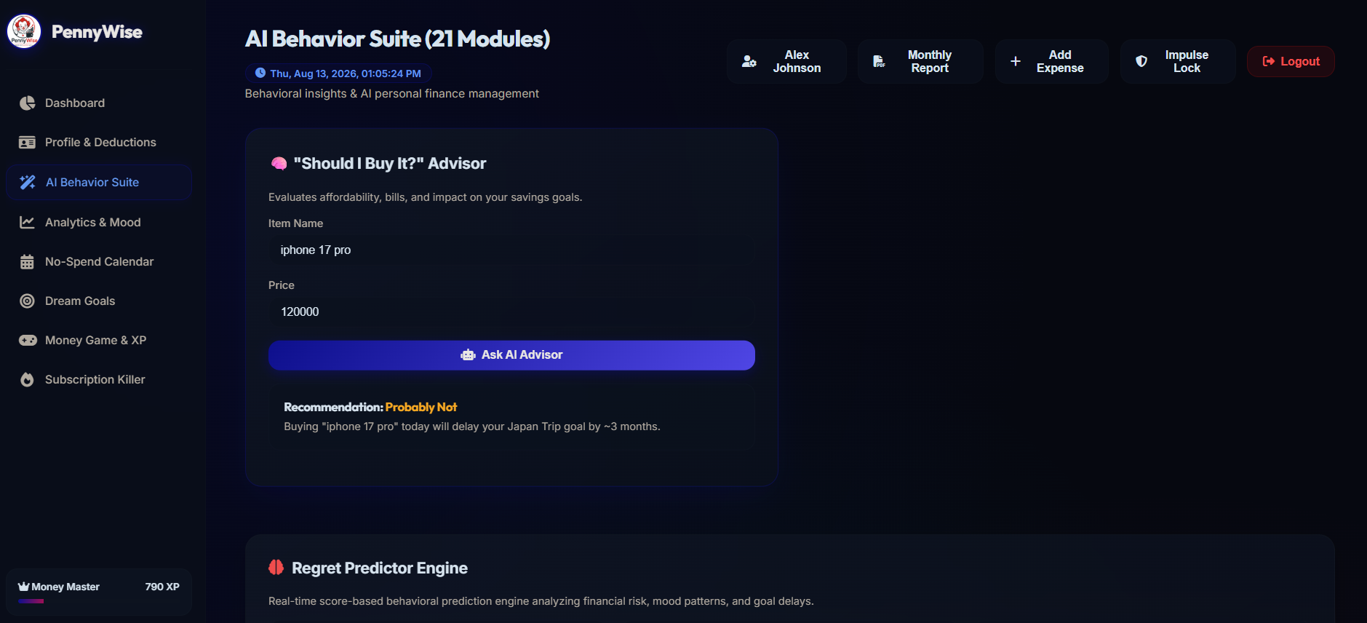

Figure 4.6 Should I Buy It? Advisor Result
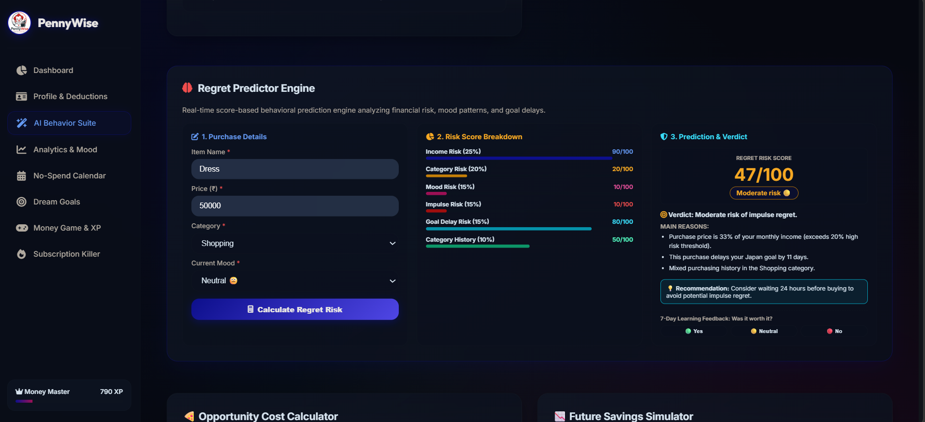

Figure 4.7 Regret Predictor Result
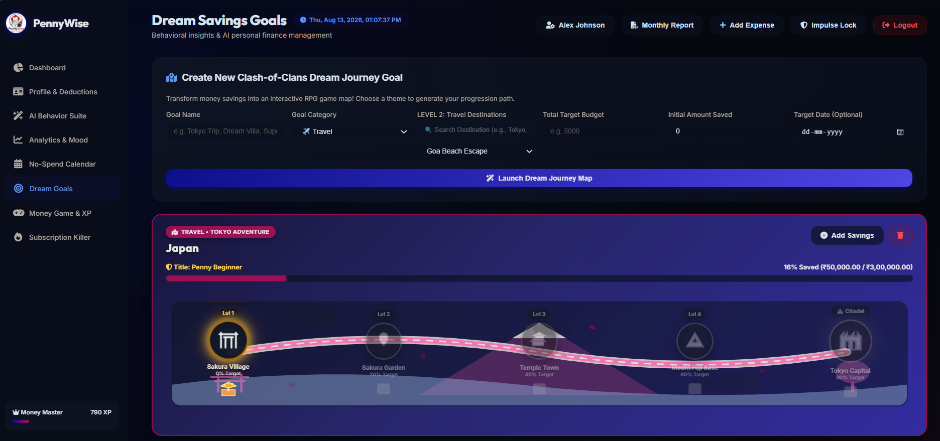

Figure 4.8 Dream Savings Goals
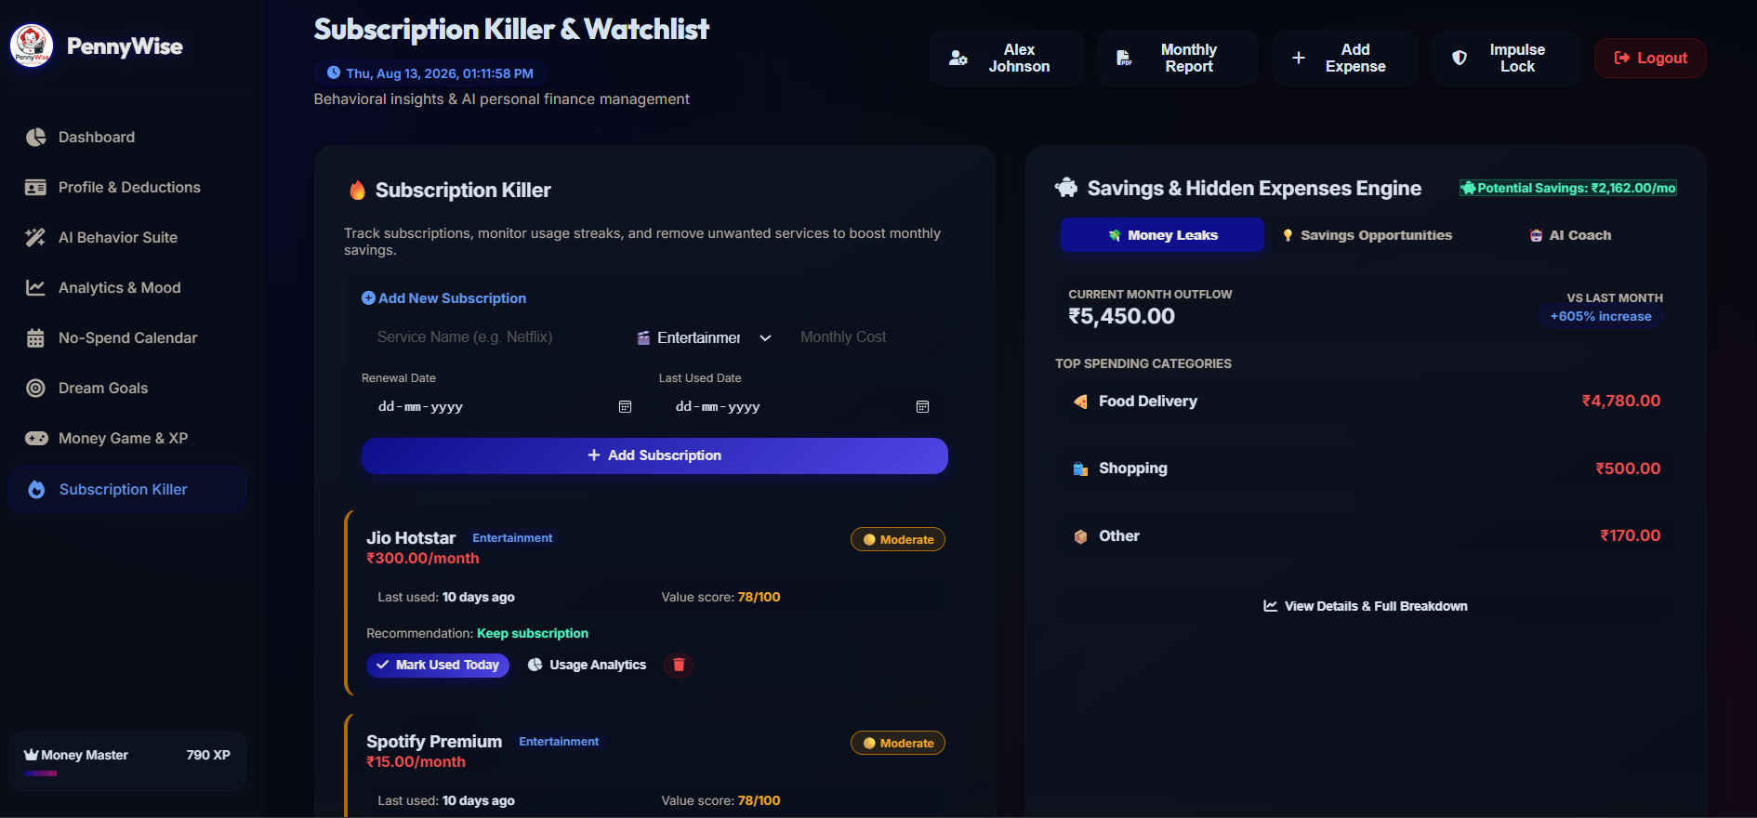

Figure 4.9 Subscription Killer
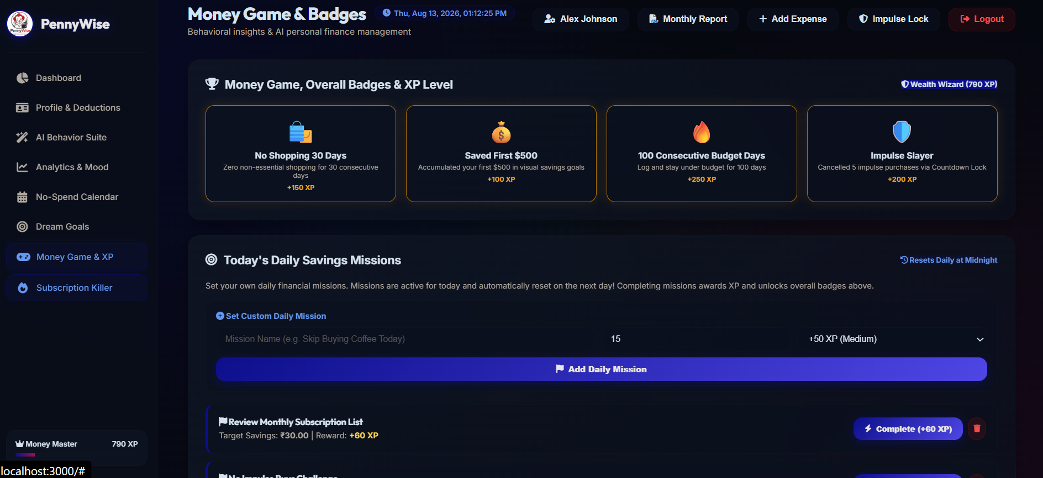

Figure 4.10 Money Game, XP and Badges
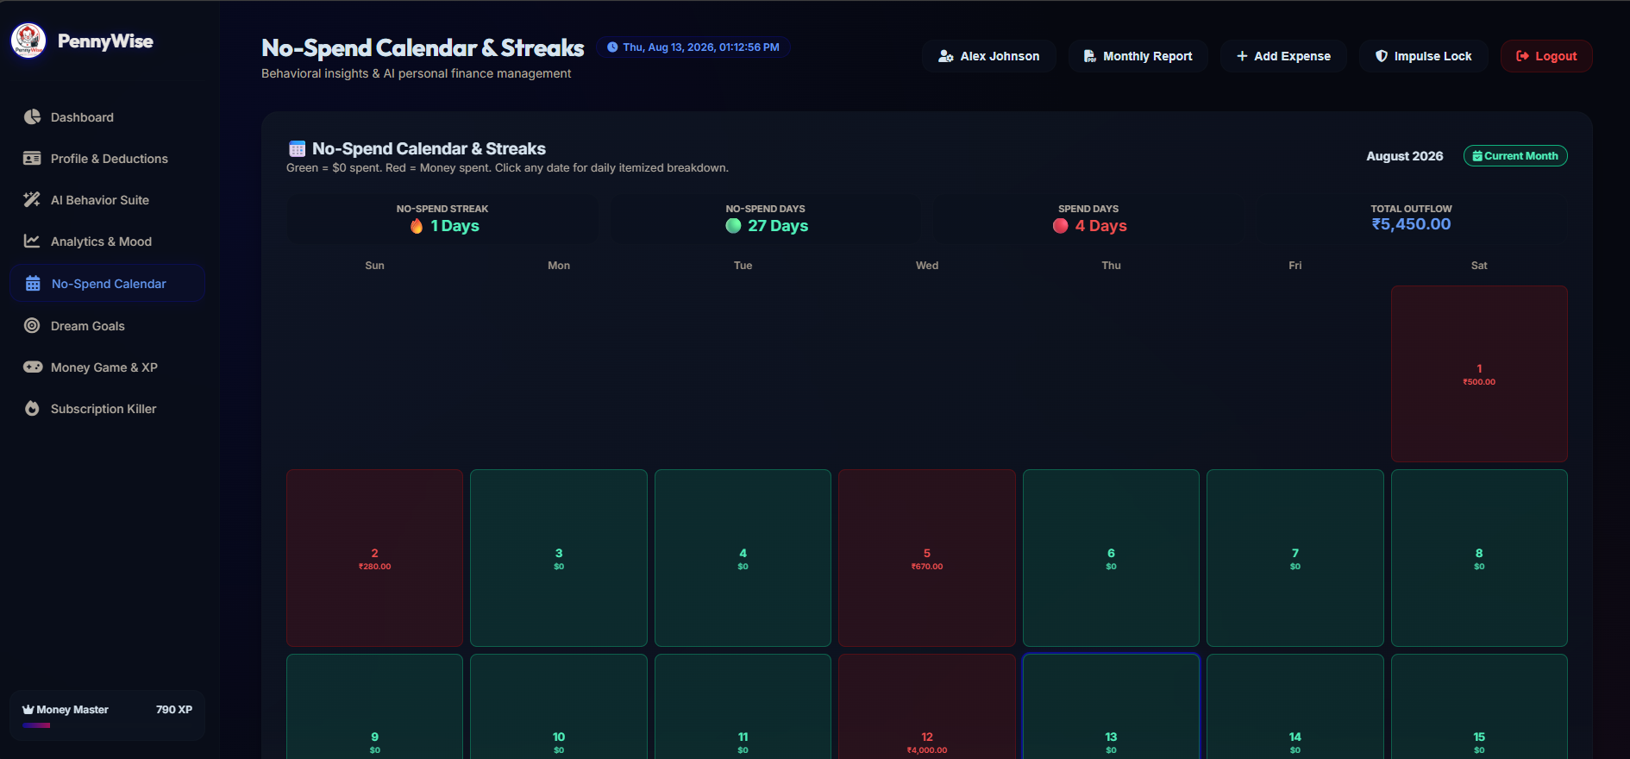

Figure 4.11 No-Spend Calendar
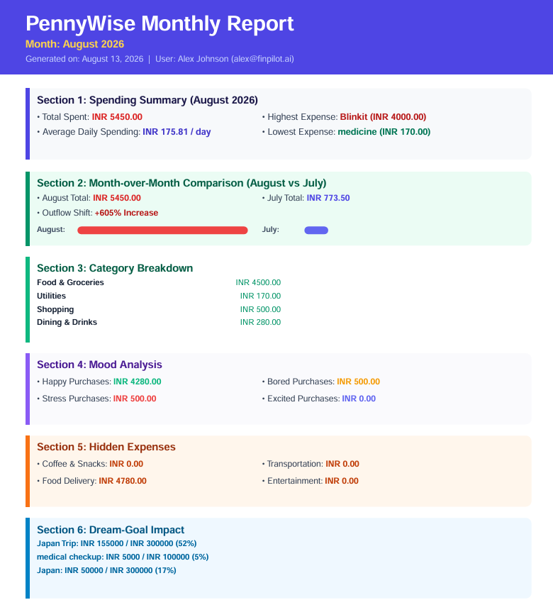

Figure 4.12 Monthly Report / PDF
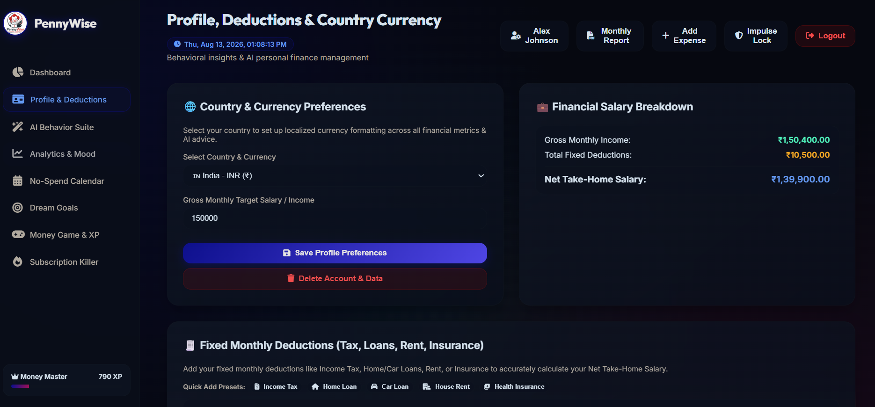

Figure 4.13 Profile and Deduction Management
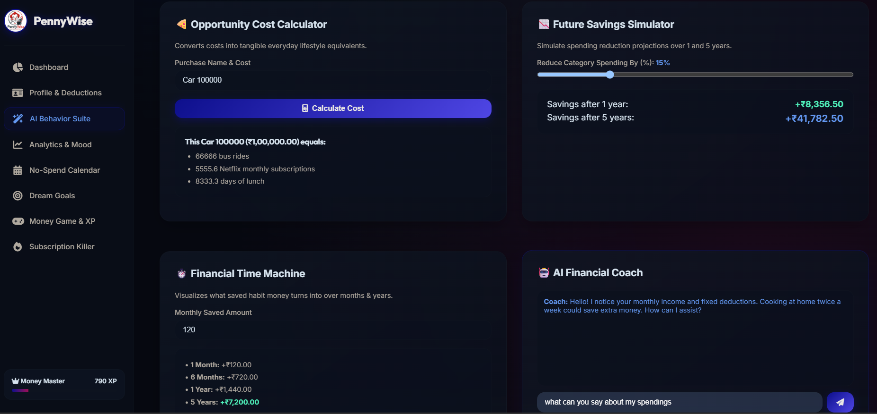

Figure 4.14 Future Savings / Opportunity Cost Tools

4.4 Quality Assurance
Quality assurance in PennyWise is supported through modular route separation, authentication middleware, input handling, database constraints and automated testing. The application was checked across its major functional modules to ensure that user actions produce the expected results and that financial information is handled according to the authenticated user's account.
The major areas considered during quality assurance include:
- Authentication: Verification of registration, login and protected user-specific access.
- Financial Operations: Verification of income, expense and budget creation, retrieval, modification and deletion.
- AI Behavior Features: Verification of the Regret Predictor, purchase advisor, opportunity cost calculations and other behavioral insights.
- Dream Savings Goals: Verification of goal creation, savings updates and progress tracking.
- Subscriptions: Verification of subscription records, usage tracking and savings analysis.
- Gamification: Verification of XP, levels, achievements and challenges.
- Reports: Verification of monthly financial calculations and PDF report generation.

Testing Status
- JWT Authentication and User Isolation — Passed
- Expense and Income Management — Passed
- Dream Savings Goals — Passed
- Subscription Management — Passed
- AI Behavior Features — Passed
- Gamification Features — Passed
- Monthly Reports and PDF Generation — Passed

Chapter 5

Standard Adopted

5.1 Design Standards
- Modular separation of frontend, route handlers and database access.
- Consistent REST endpoint naming under /api.
- Responsive card-based interface with reusable CSS classes.
- Consistent authentication middleware for protected resources.
- Relational foreign keys using user_id for user-owned data.
- Use of environment variables for application secrets and configuration.
- Use of clear status messages and JSON responses for API operations.

5.2 Coding Standards
- JavaScript functions use descriptive names such as loadDashboardData, runRegretPredictor and addDreamGoal.
- Database parameters are passed separately from SQL strings through the query wrapper.
- Route modules are grouped by functional responsibility.
- Error handling uses try/catch blocks in asynchronous route handlers.
- Comments are used to identify major API modules and business-logic sections.

5.3 Testing Standards
- Authentication tests verify protected access and account cleanup.
- CRUD tests verify that records can be created, retrieved, modified and deleted.
- AI tests verify response structure and core outputs.
- Integration tests verify multi-step workflows across modules.
- Browser tests verify important frontend navigation and interaction paths.

Chapter 6

Conclusion and Future Scope

6.1 Conclusion
PennyWise brings together personal finance tracking, behavioral decision support and gamification in a single full-stack web application. The current project contains a broad relational data model, JWT-protected APIs, a dynamic browser interface, AI-style behavioral calculations, Dream Savings Goals, subscription analysis, gamification and PDF reporting.
A key strength of the project is that several behavioral features are transparent and explainable. For example, the Regret Predictor exposes its contributing risk components, while the financial health score is calculated from identifiable financial and behavioral indicators. This makes the system easier to understand than a completely opaque recommendation mechanism.

PennyWise demonstrates how financial management can be combined with behavioral insights and interactive engagement to create a more user-focused approach to personal finance. By integrating expense tracking, financial analysis, AI-based decision-support features, savings goals, subscription analysis and gamification, the application provides users with tools to better understand and improve their spending behavior.

6.2 Future Scope
- Replace selected rule-based components with trained machine-learning models after collecting sufficient user-consented data.
- Add stronger personalized learning to the Regret Predictor using historical purchase feedback.
- Expand receipt OCR and price-watch functionality if these modules are retained in the final product scope.
- Add more advanced spending forecasts and anomaly detection.
- Introduce mobile/PWA support.
- Add stronger privacy controls, data export and consent management.
- Add more detailed admin analytics if an administrative role is required.
- Improve test coverage for multi-user isolation and complex financial workflows.
- Integrate personalized financial goal recommendations based on historical spending patterns, income trends and user-defined priorities.

References
[1] Kahneman, D. (2011). Thinking, Fast and Slow. New York: Farrar, Straus and Giroux.
[2] Thaler, R. H., & Sunstein, C. R. (2008). Nudge: Improving Decisions About Health, Wealth, and Happiness. Yale University Press.
[3] Node.js Foundation. (2026). Node.js Runtime Documentation.
https://nodejs.org/docs/latest
[4] Express.js Development Team. (2026). Express.js 4.x API Reference. https://expressjs.com
[5] SQLite Development Team. (2026). SQLite Database Engine Documentation. https://www.sqlite.org/docs.html
[6] Jones, M., Bradley, D., & Sakimura, N. (2015). JSON Web Token (JWT). IETF RFC 7519.
[7] Chart.js Open Source Community. (2026). Chart.js HTML5 Canvas Data Visualization Library. https://www.chartjs.org
[8] PDFKit Community. (2026). PDFKit JavaScript PDF Generation Library Reference. https://pdfkit.org
[9] Provos, N., & Mazières, D. (1999). A Future-Adaptable Password Scheme (bcrypt). USENIX Proceedings.
[10] Jest Open Source Framework. (2026). Jest JavaScript Testing Framework. https://jestjs.io

