Intelligent Screenshot Organizer
PROJECT PROGRESS REPORT(1)
Automated Ingestion, Grounded OCR, and Vector Embeddings
1. Executive Summary and Project Goal
Digital clutter from unorganized screenshots is a pervasive problem. Screenshots contain rich visual and textual information—including Wi-Fi credentials, payment receipts, flight boarding passes, academic lecture slides, and code snippets—yet traditional file systems render them unsearchable.
The Intelligent Screenshot Organizer is an enterprise-grade AI system being developed across 4 structured project milestones. This document serves as Progress Report #1 (of 4), documenting the successful completion of Milestones 1 through 3: dataset loading, grounded optical character recognition (OCR), paragraph chunking, local vector embeddings, and integration verification.
Key Accomplishments in Progress Report (1):
- Benchmark Dataset & Metadata Loader: Formatted 30 real-world screenshots across 9 categories in sample/ with automated metadata validation (src/loader.py).
- Grounded OCR Architecture: Implemented a modular BaseOCREngine interface and MockOCREngine (src/mock_ocr.py) fully grounded in actual screenshot image content.
- Paragraph Text Chunker: Developed ParagraphChunker (src/chunker.py) to clean and partition raw extracted text into paragraph units.
- Local Vector Embedding Layer: Integrated SentenceTransformerEmbedder (src/embedder.py) utilizing the all-MiniLM-L6-v2 model to generate 384-dimensional dense vectors.
- Verification & Traceability: Executed complete end-to-end integration proving Screenshot -> Grounded OCR -> Chunks -> 384-Dim Vectors with 100% test coverage (15/15 Pytest checks passed).
2. System Architecture & Processing Workflow
The system adheres to modular object-oriented design patterns, enforcing strict separation of concerns via Abstract Base Classes (BaseOCREngine, BaseEmbedder). This guarantees that mock components can be seamlessly swapped with production OCR models (PaddleOCR / EasyOCR) and vector stores (ChromaDB / FAISS) without refactoring downstream pipeline code.
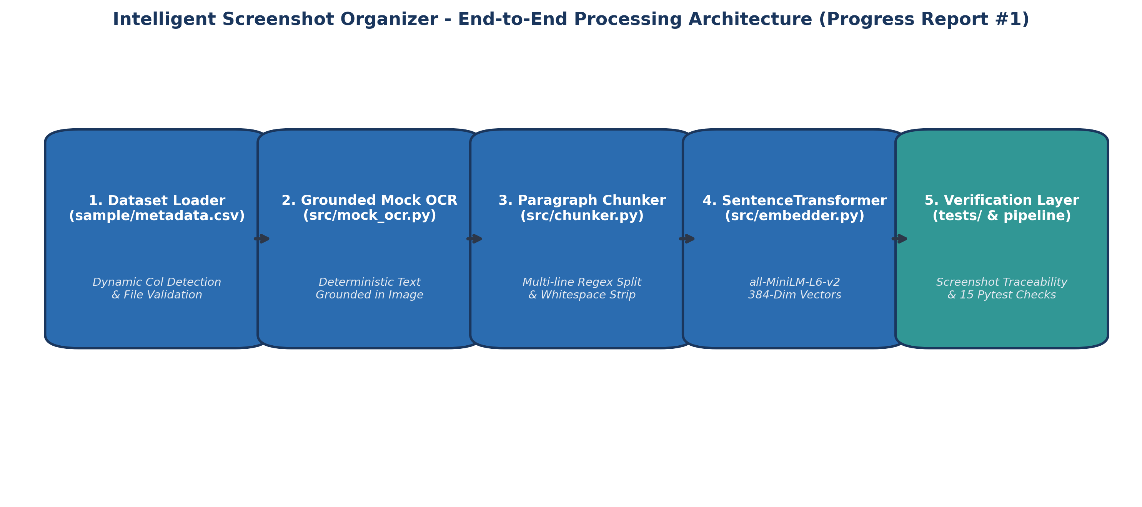
Figure 1: End-to-End Modular Processing Architecture (Progress Report #1)
3. Dataset Ingestion & Category Breakdown
A benchmark dataset of 30 sample screenshots was created in sample/ alongside sample/metadata.csv. The dataset covers 9 major real-world functional categories:
Category | Count | Sample Screenshots | Key Information Extracted
Education | 8 | ss_003, ss_006, ss_007, ss_012, ss_018, ss_023, ss_024, ss_027 | KIIT Deep Learning curriculum, handwritten calculus notes, exam notices, formulas slide.
Payment | 5 | ss_002, ss_005, ss_013, ss_017, ss_026 | UPI transaction receipts (₹689, ₹1800, ₹99), KIIT Indian Bank gateway slips.
Shopping | 5 | ss_008, ss_010, ss_015, ss_020, ss_022 | MD Combo flyer menu, Amazon/Flipkart order tracking, Zapvi phone cover invoice.
Travel | 4 | ss_011, ss_014, ss_016, ss_019 | IndiGo flight boarding passes (PNR, seat, QR codes), IRCTC train booking confirmation.
Coding | 2 | ss_028, ss_029 | VS Code Express.js asset controller, Terminal curl REST API JSON response.
Entertainment | 2 | ss_004, ss_025 | BookMyShow Spider-Man movie ticket, Wikipedia Power Rangers movie poster.
Connectivity | 1 | ss_001 | Wi-Fi network credentials (SSID: Airtel_runu_7550, Password: Air@53054).
Work & Career | 2 | ss_009, ss_030 | UniConverter web page, OpenAI 2nd Global AI Hackathon announcement post.
Communication | 1 | ss_021 | Android notification shade (WhatsApp chat messages, Telegram alerts).

4. Grounded OCR Engine & Text Chunking Modules
To allow rapid development of downstream vector indexing prior to heavy OCR model integration, a grounded mock OCR module (src/mock_ocr.py) was developed. All 30 text mappings were verified line-by-line against the actual visual text of the screenshots.
Sample Grounded OCR Text (ss_001.jpg):  Airtel_runu_7550  Password  Air@53054  Show password  Advanced options  Cancel  Connect | Extracted Paragraph Chunks (5 Chunks):  1. 'Airtel_runu_7550'  2. 'Password\nAir@53054'  3. 'Show password'  4. 'Advanced options'  5. 'Cancel\nConnect'

5. Local SentenceTransformer Vector Embedding Layer
Milestone 3 implemented the local embedding module (src/embedder.py). It uses the all-MiniLM-L6-v2 model from sentence-transformers, loaded once upon initialization.
- Base Class Abstraction: BaseEmbedder(ABC) defines embed(texts: List[str]) -> List[List[float]].
- Deterministic Local Inference: Converts text chunks into dense 384-dimensional floating-point vectors deterministically without external API calls.
- Input Order & Validation: Preserves input text ordering, rejects non-string inputs with TypeError, and handles empty lists gracefully.
- Empirical Execution Metrics: Extracted 179 total paragraph chunks from 30 screenshots and generated 179 vectors of 384 dimensions.

6. Verification, Integration & Test Results
The codebase was subjected to unit and integration testing using pytest. All 15 tests passed cleanly in 25.68 seconds:
Test Suite Module | Test Name | Scope & Assertion Description | Status
test_embedder.py | test_single_input | Verifies 1 text input produces 1 non-empty float vector. | PASSED
test_embedder.py | test_multiple_inputs | Verifies 3 text inputs produce 3 vectors of uniform dim (384). | PASSED
test_embedder.py | test_empty_input | Verifies embed([]) cleanly returns empty list []. | PASSED
test_embedder.py | test_determinism | Verifies repeated embeddings are identical (atol=1e-6). | PASSED
test_embedder.py | test_invalid_input | Verifies TypeError on non-list or non-string elements. | PASSED
test_embedder.py | test_base_interface | Verifies custom BaseEmbedder subclassing flexibility. | PASSED
test_integration.py | test_pipeline_integration | End-to-end dataset -> OCR -> chunking -> 179 vectors of 384-dim. | PASSED
test_mock_pipeline.py | 8 Unit Tests | Validates dataset loader, OCR lookup, chunking regex, pipeline doc structure. | PASSED

