Experiment -2.2

Student Name: Sneha Mehrotra UID: 22BDO10048

Branch: CSE (Devops) Section/Group: 22BCD-1\A

Semester: 4th Date of Performance: 21/02/24

Subject Name: Git and Git Hub Subject Code: 22CSH-293

**Aim/Overview of the practical**:

To create remote repositories and merge their contents in a single local repository followed by updating contents and pushing changes back to remote repository.

**Software Used:** Git Bash, Git-Hub.

**Steps** for experiment/practical:

1 Create a new local repository and initialize it using git init.

2 Add a file file1.java and edit it using the vi command.

3 Save the changes made to f1.java using git add and git commit.

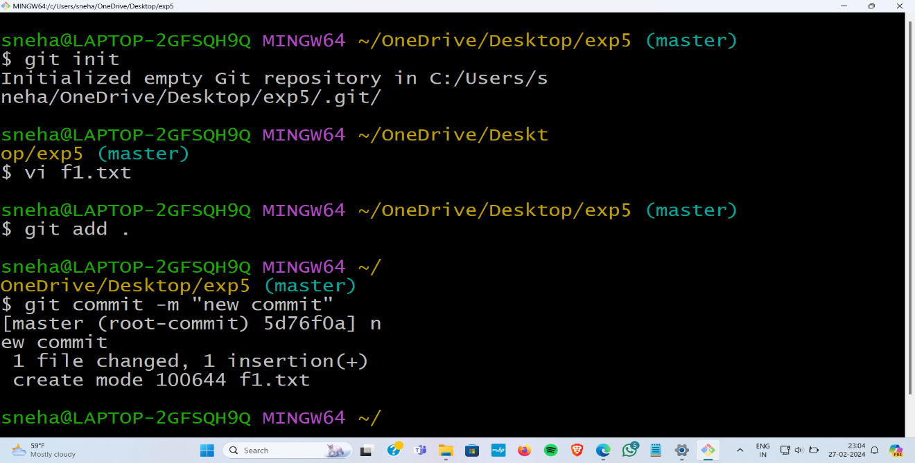

4 Create a remote repository on GitHub without including README.md.

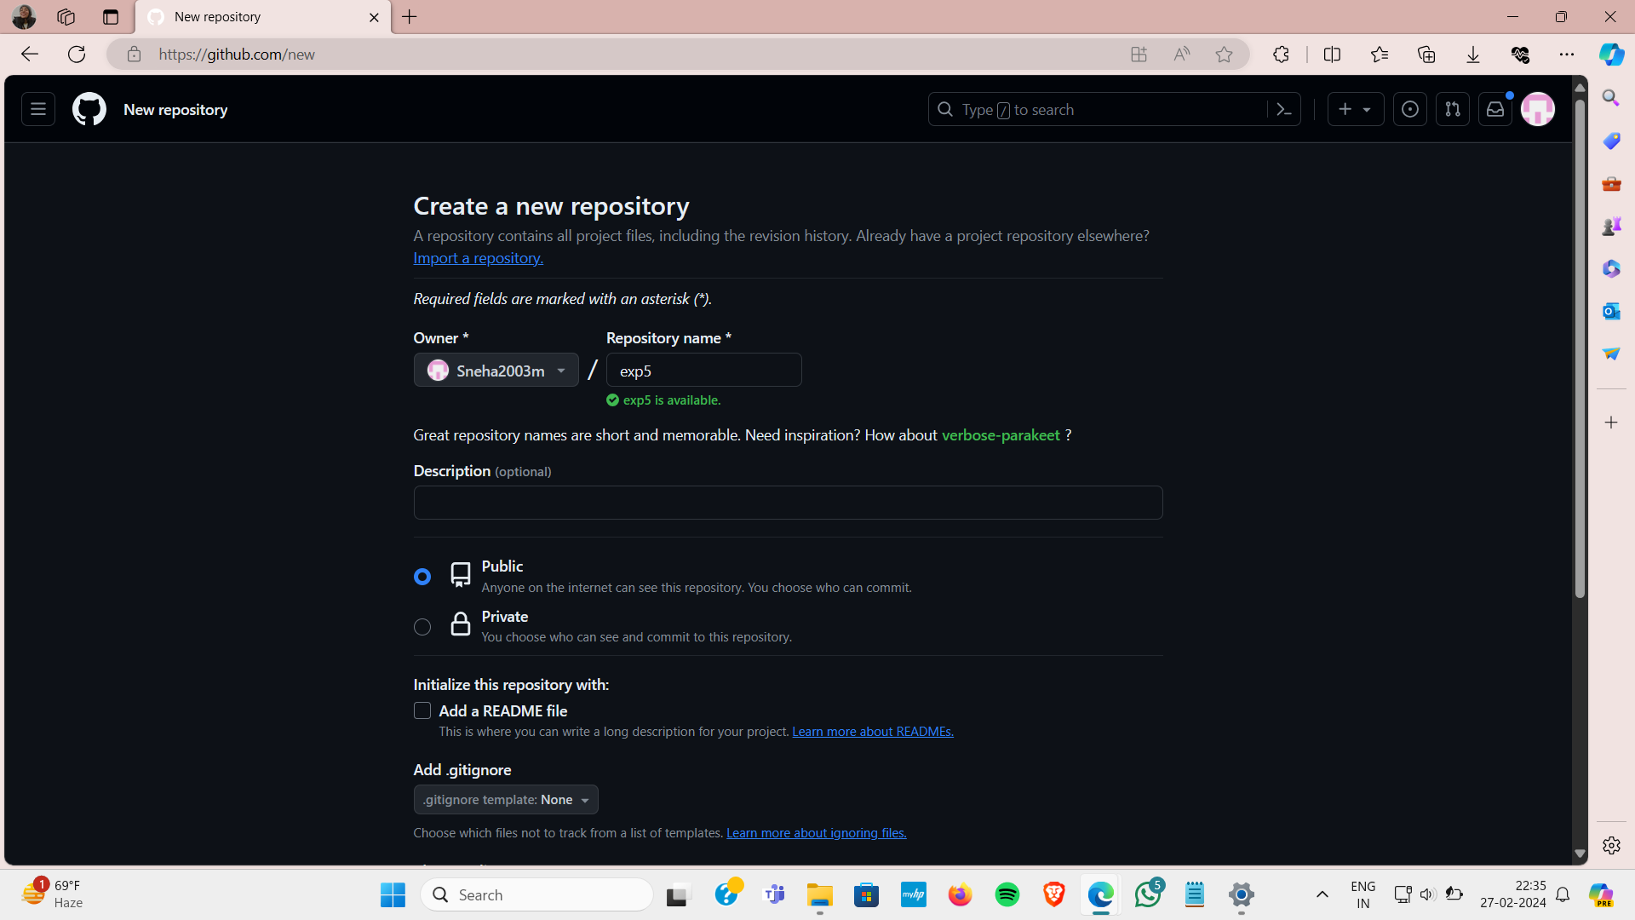

5 . Configure the GitHub repository as the new remote repository using git remote add origin <https link to the repository>.

1. Push the changes (the f1.java file) to the remote repository using git push -u origin main.

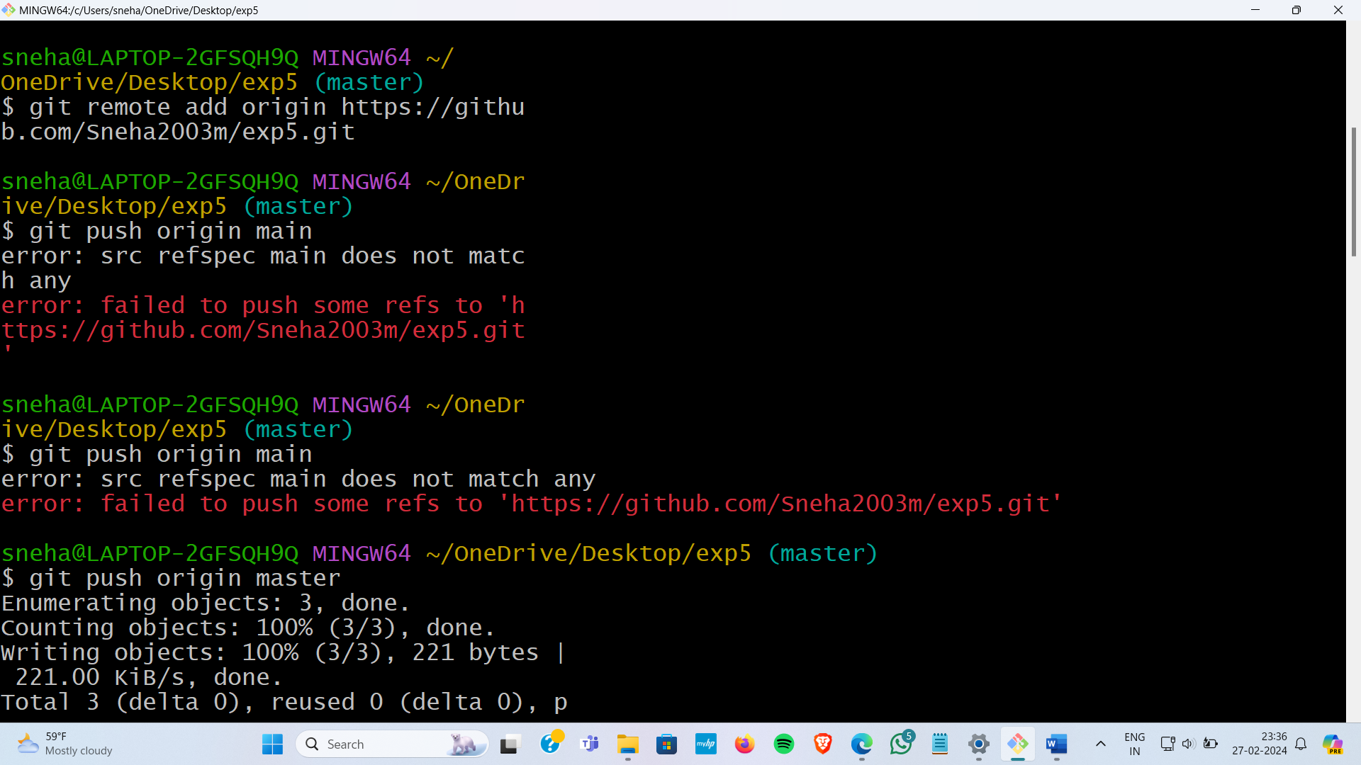

7 Verify the updated remote repository with f1.java.

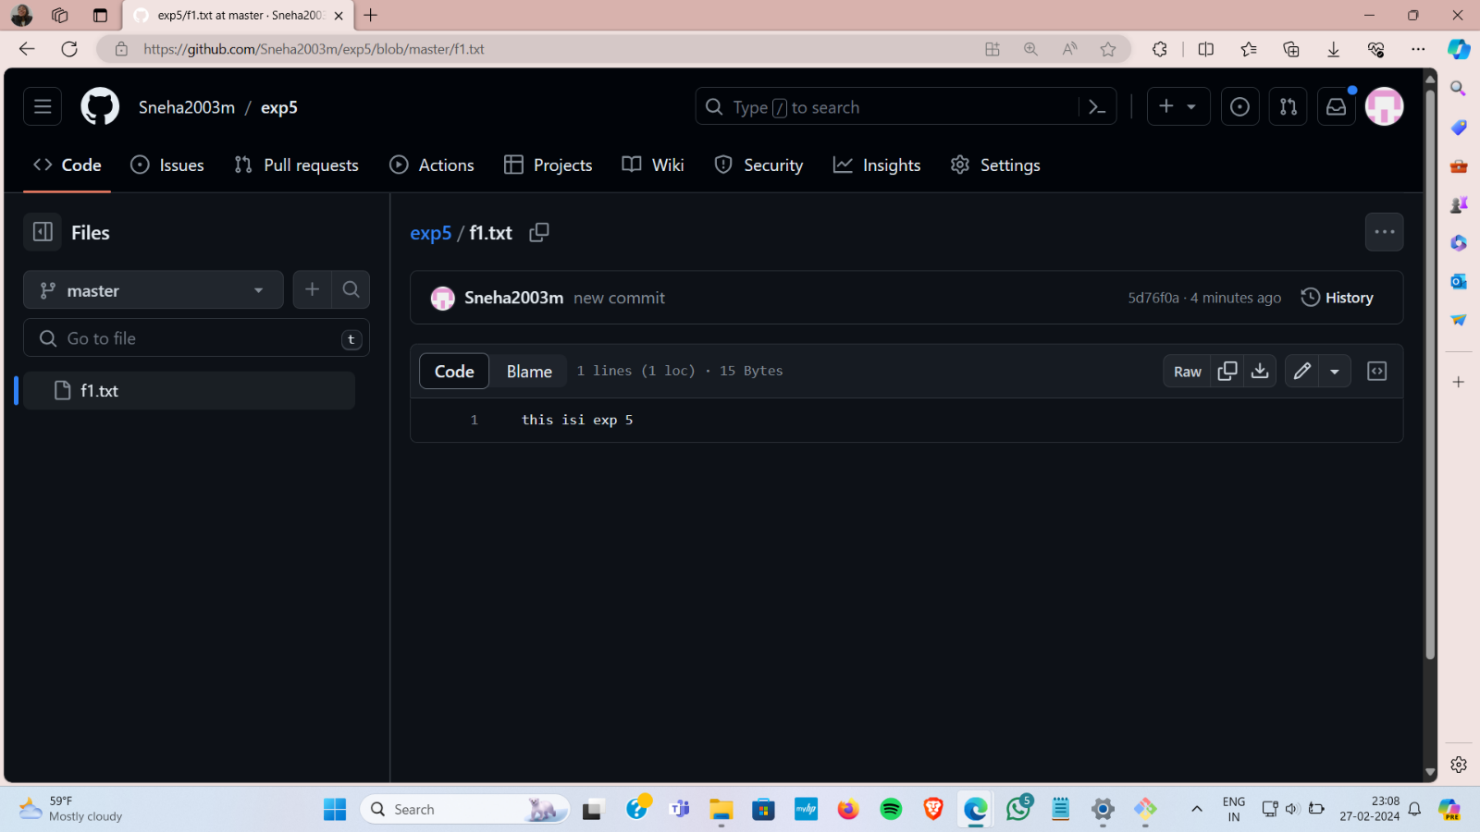

1. Create another repository on GitHub, this time with README.md.
2. Link this remote repository to our local repository using git remote add or2<url of the second repo>.
3. Check existing remote linked repositories using git remote -v command. 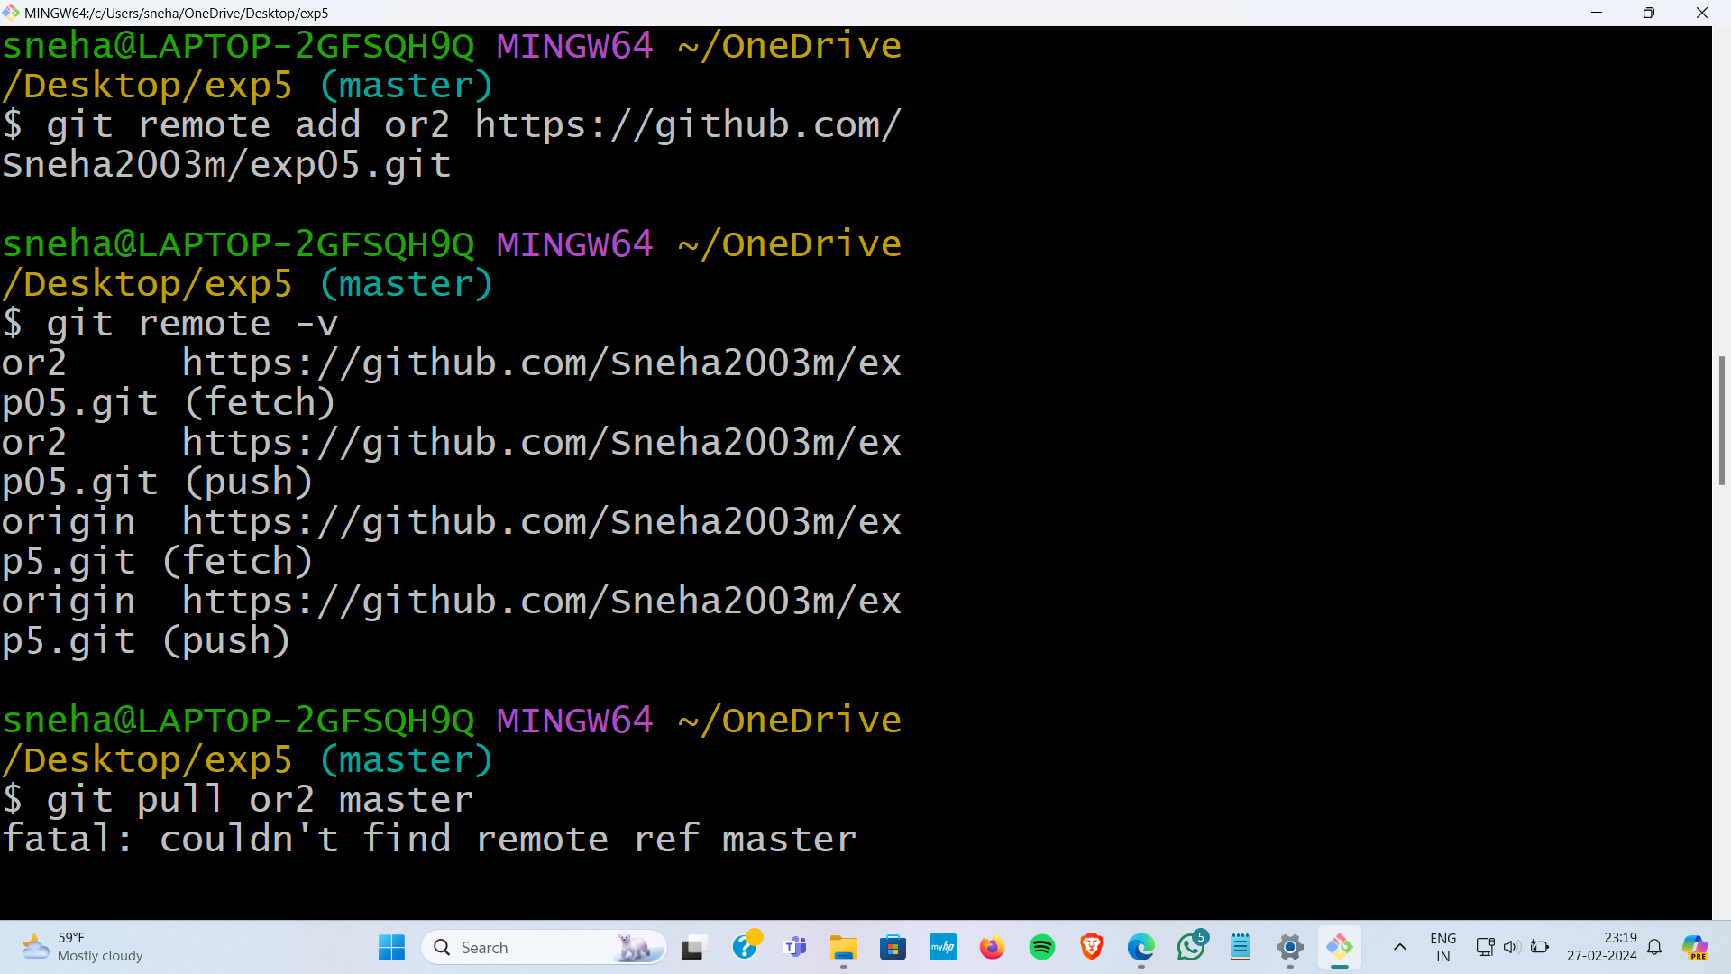

1. Attempt to update the local repository with the remote repository using git pull or2 main, which returns an error.
2. Merge the contents of both remote repositories with different commit histories into a single local repository using git pull or2 main --allow-unrelated-histories.
3. Change the contents of README.md file using vi command.
4. Push the changes back to the remote repository (new5.2) using git push dope main after adding the file to the staging area and committing the changes.

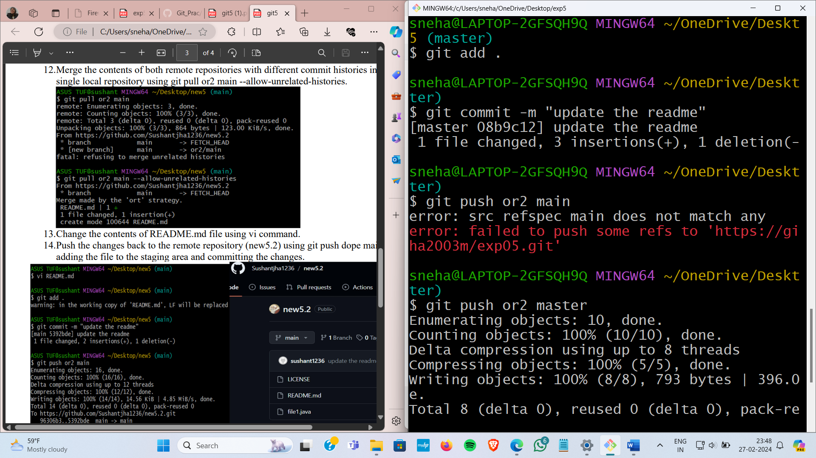

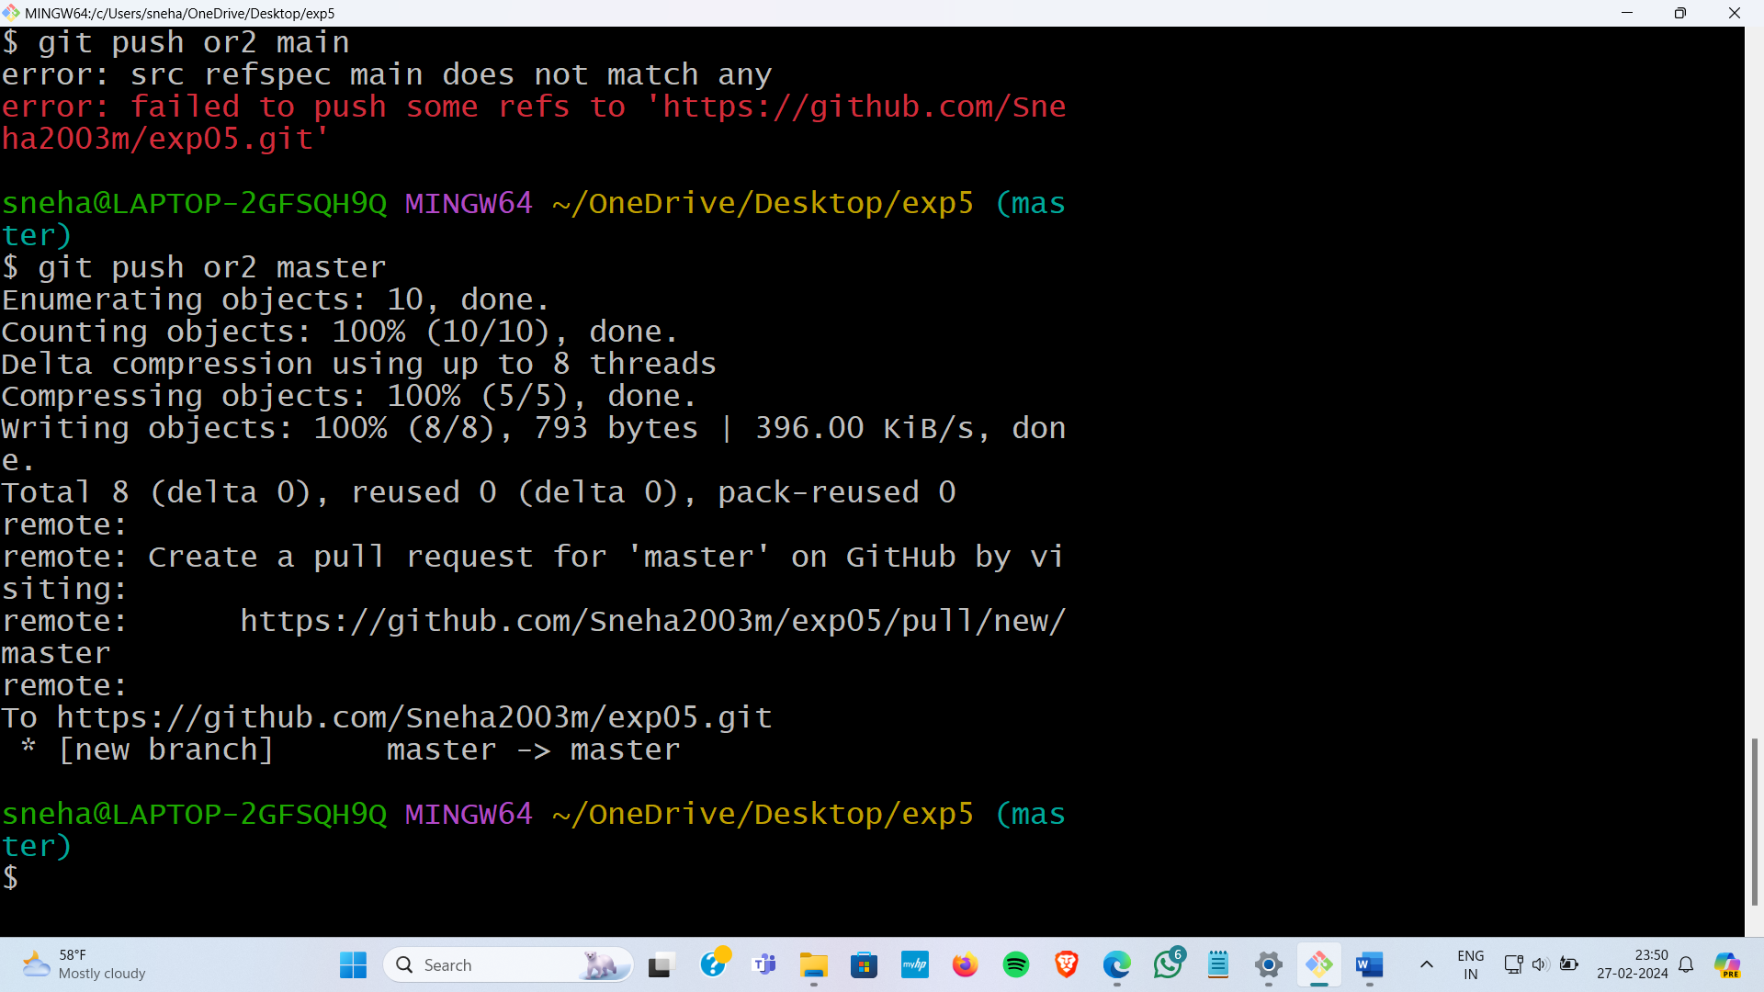

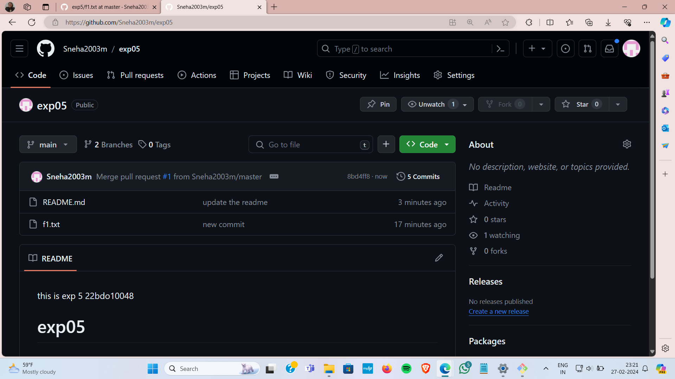

Learning outcomes (What I have learnt):

* 1. Understanding Git Workflow
  2. Learnt about commit, merge and add commands.
  3. Version Control Proficiency.
  4. Committing changes.
  5. Learnt about how to pull request and push in git bash.

Evaluation Grid (To be created as per the SOP and Assessment guidelines by the faculty):

|  |  |  |  |
| --- | --- | --- | --- |
| Sr. No. | Parameters | Marks Obtained | Maximum Marks |
| 1. |  |  |  |
| 2. |  |  |  |
| 3. |  |  |  |
|  |  |  |  |