**Experiment -1.2**

**Student Name: Sneha Mehrotra UID: 22BDO10048**

**Branch: CSE (Devops) Section/Group: 22BCD-1\A**

**Semester: 4th Date of Performance: 17/01/24**

**Subject Name: Git and Git Hub Subject Code: 22CSH-293**

1. **Aim/Overview of the practical:**

Creating branches with GitHub and merging with the main branch.

1. **Task to be done:**

Create branch of a repository and make changes and merge the file into main branch.

1. **Steps for experiment/practical:**

**1. Create a New Branch:**

Navigate to your GitHub repository on the web.

Click on the "Branch: main" button near the top left of the page.

In the text box that appears, type a name for your new branch and press Enter.

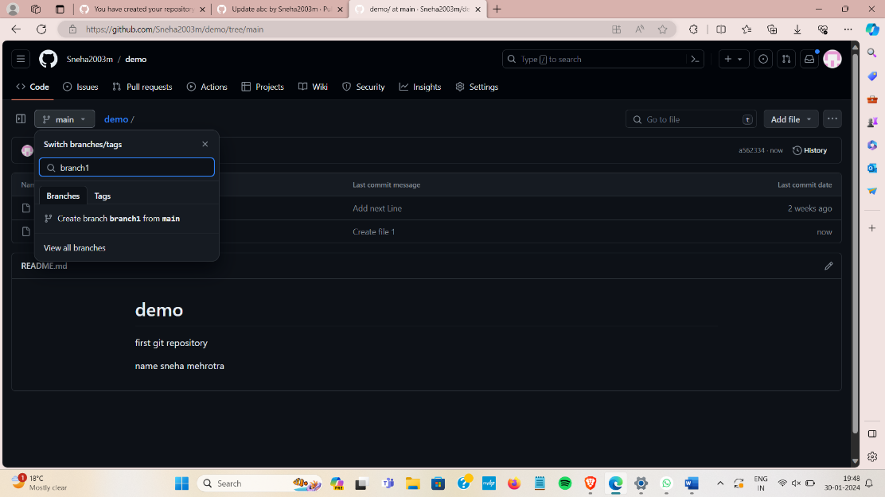 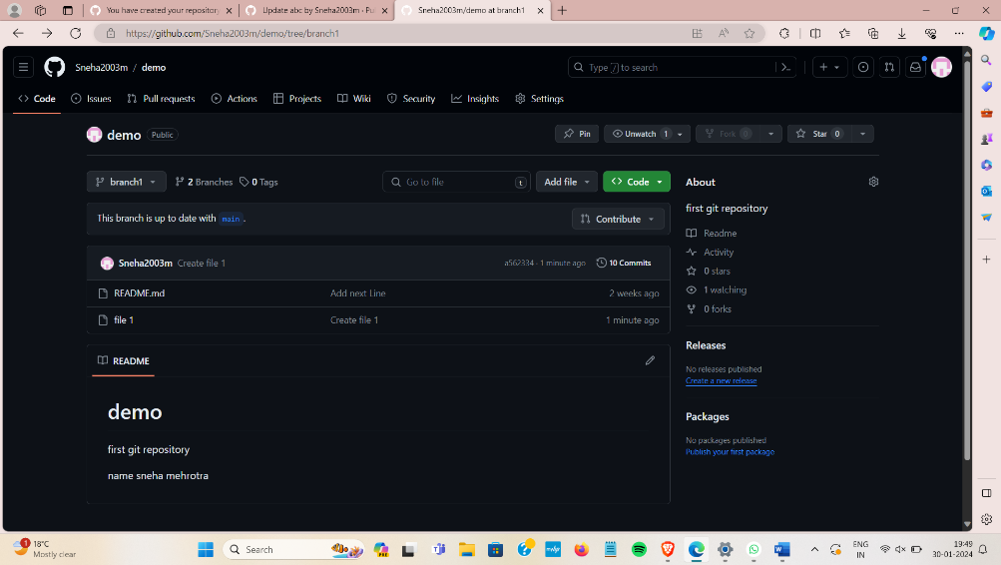

**2. Make Changes:**

Navigate to the newly created branch by clicking on the branch name dropdown and selecting your branch**.**

**3. Edit and Commit Changes:**

Make changes to your code or add new files.

Scroll down to the "Changes" section.

Enter a commit message in the "Commit changes" section.

Click on the "Commit changes" button.

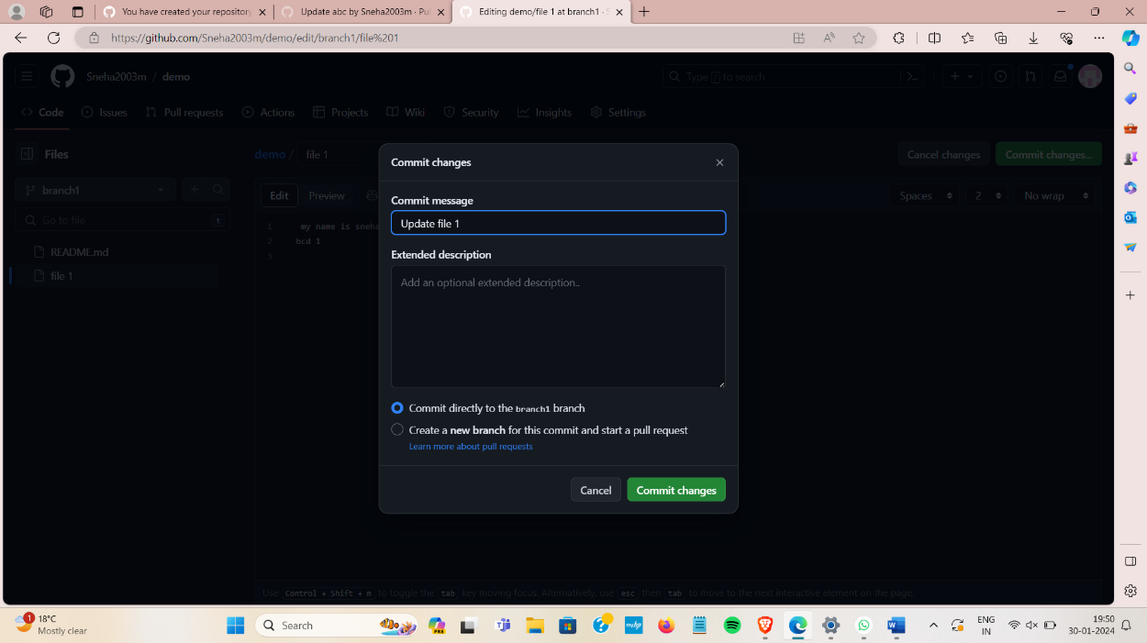

**4. Create a Pull Request:**

Once you've committed your changes to the new branch, GitHub will display a message with a "Compare & pull request" button.

Click on the "Compare & pull request" button.

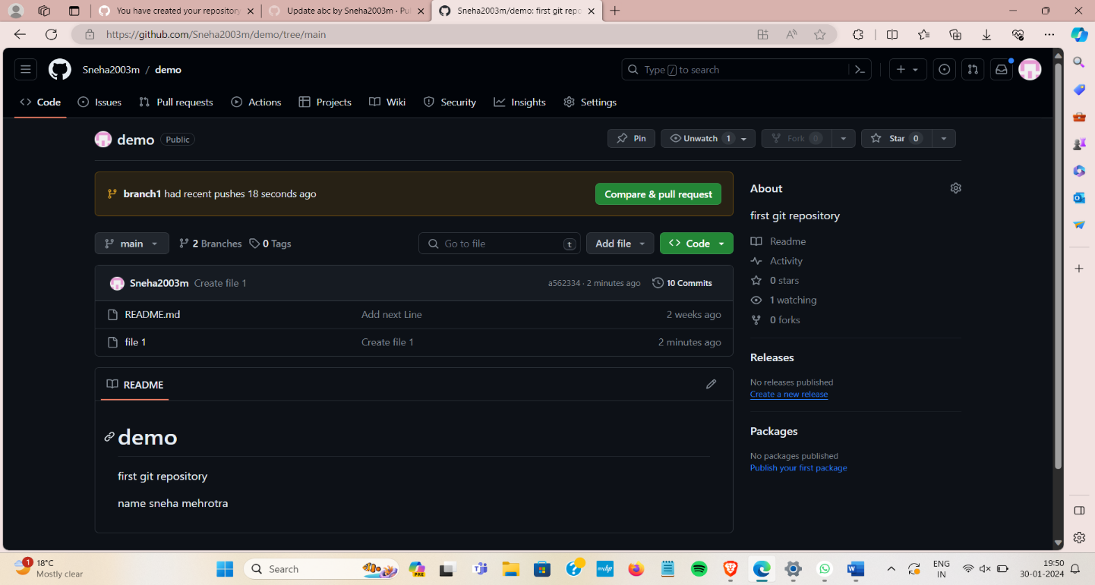

**5. Open a Pull Request:**

You'll be taken to a page where you can review your changes. Add any additional comments if needed.

Click on the "Create pull request" button.

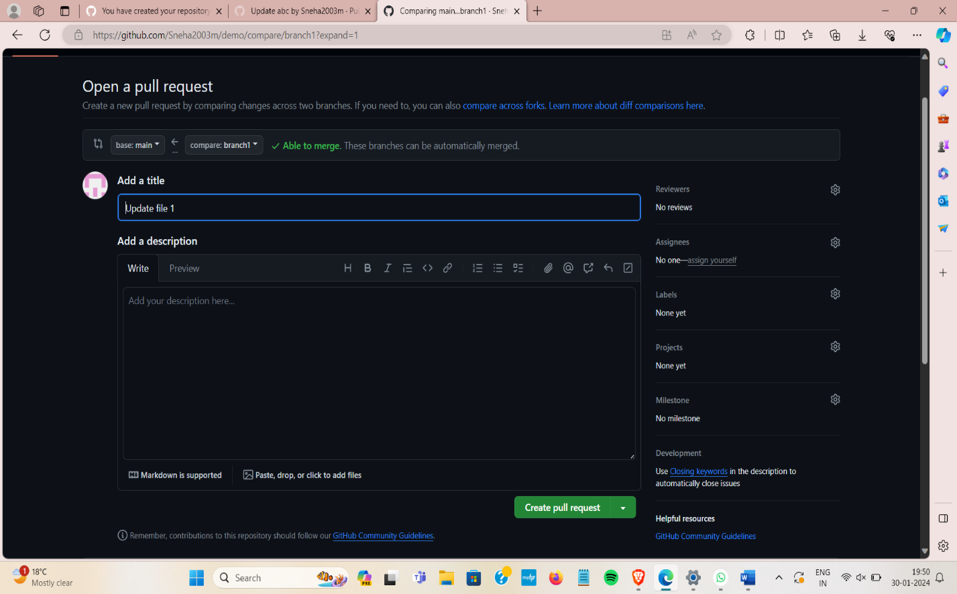

**6. Merge the Pull Request:**

After the pull request is reviewed and approved, you can merge it.

Click on the "Merge pull request" button.

Optionally, confirm the merge.

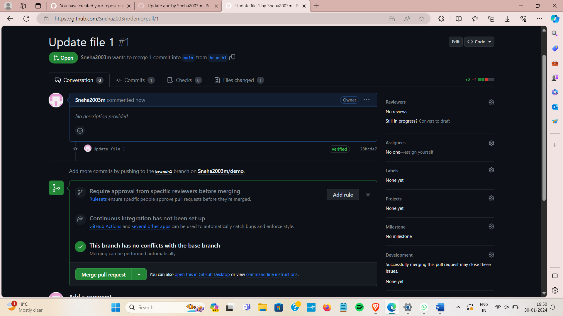

**7. Confirm the Merge:**

Once the pull request is merged, GitHub will prompt you to confirm the merge.

Confirm the merge.

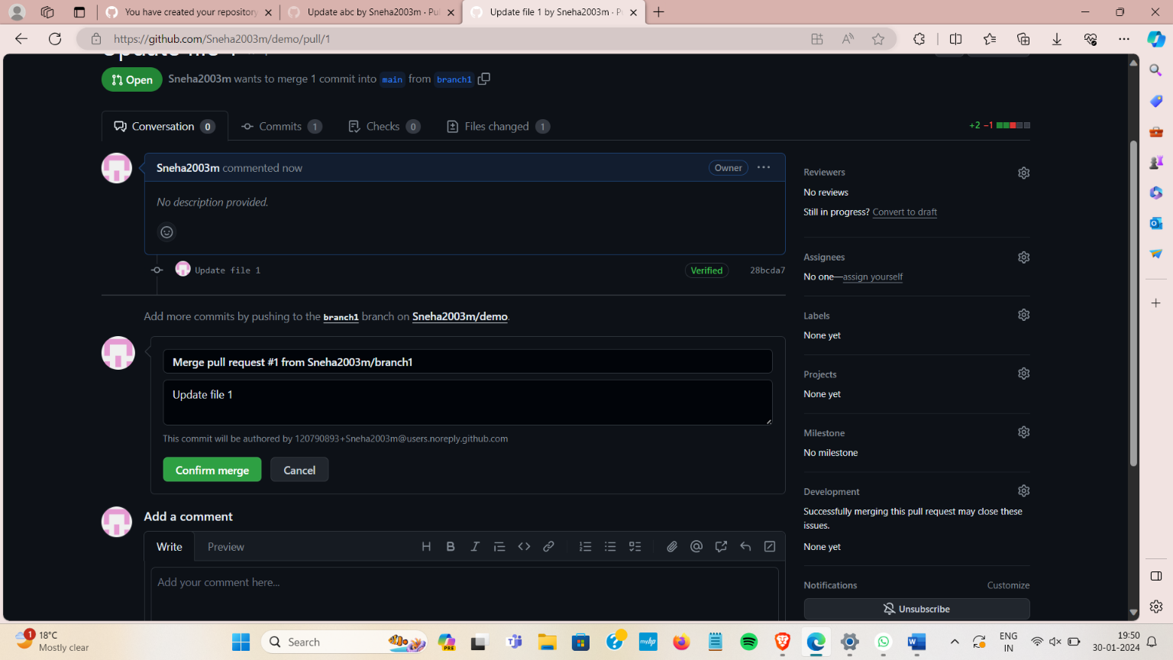

**8. Delete the Branch (optional):**

After merging, GitHub will give you the option to delete the branch.

Choose to delete the branch if you no longer need it.

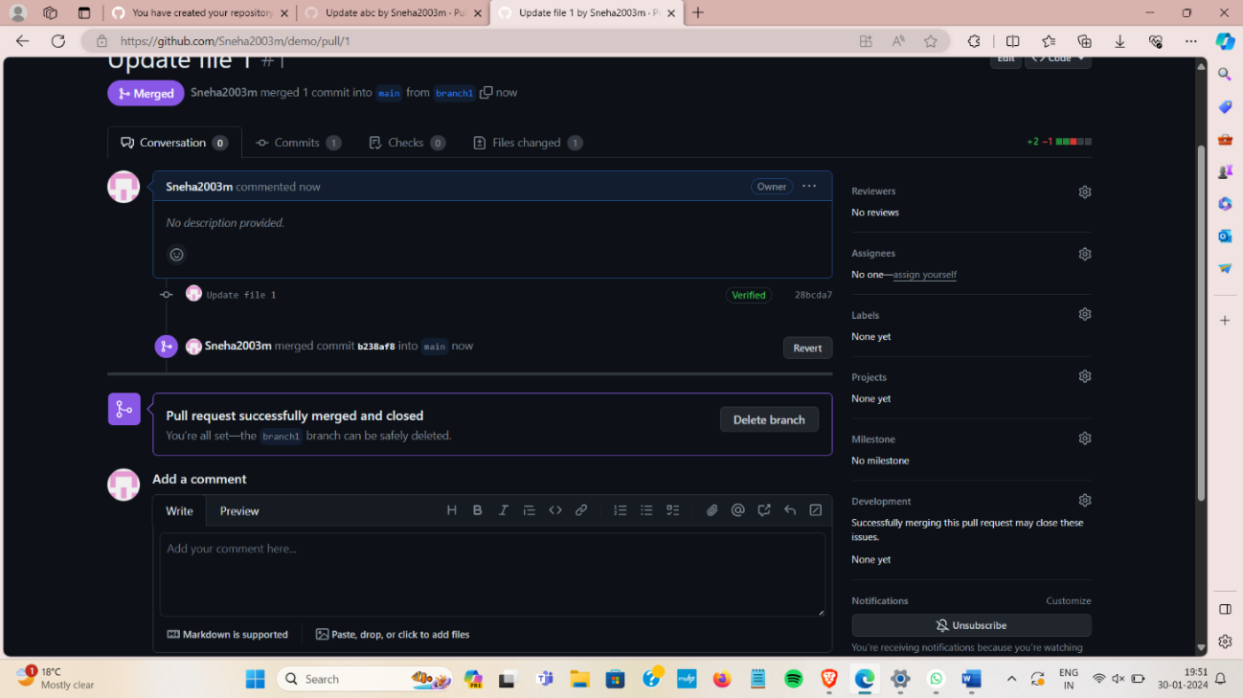

**From Creating Branch On GitBash:**

**1.** Create a new folder naming **“git”** on dextop.

**2.** Initialize the git using *“git init”*  command.

**3.** Create a new file using *“vi command”* Eg **“vi sneha.txt”**

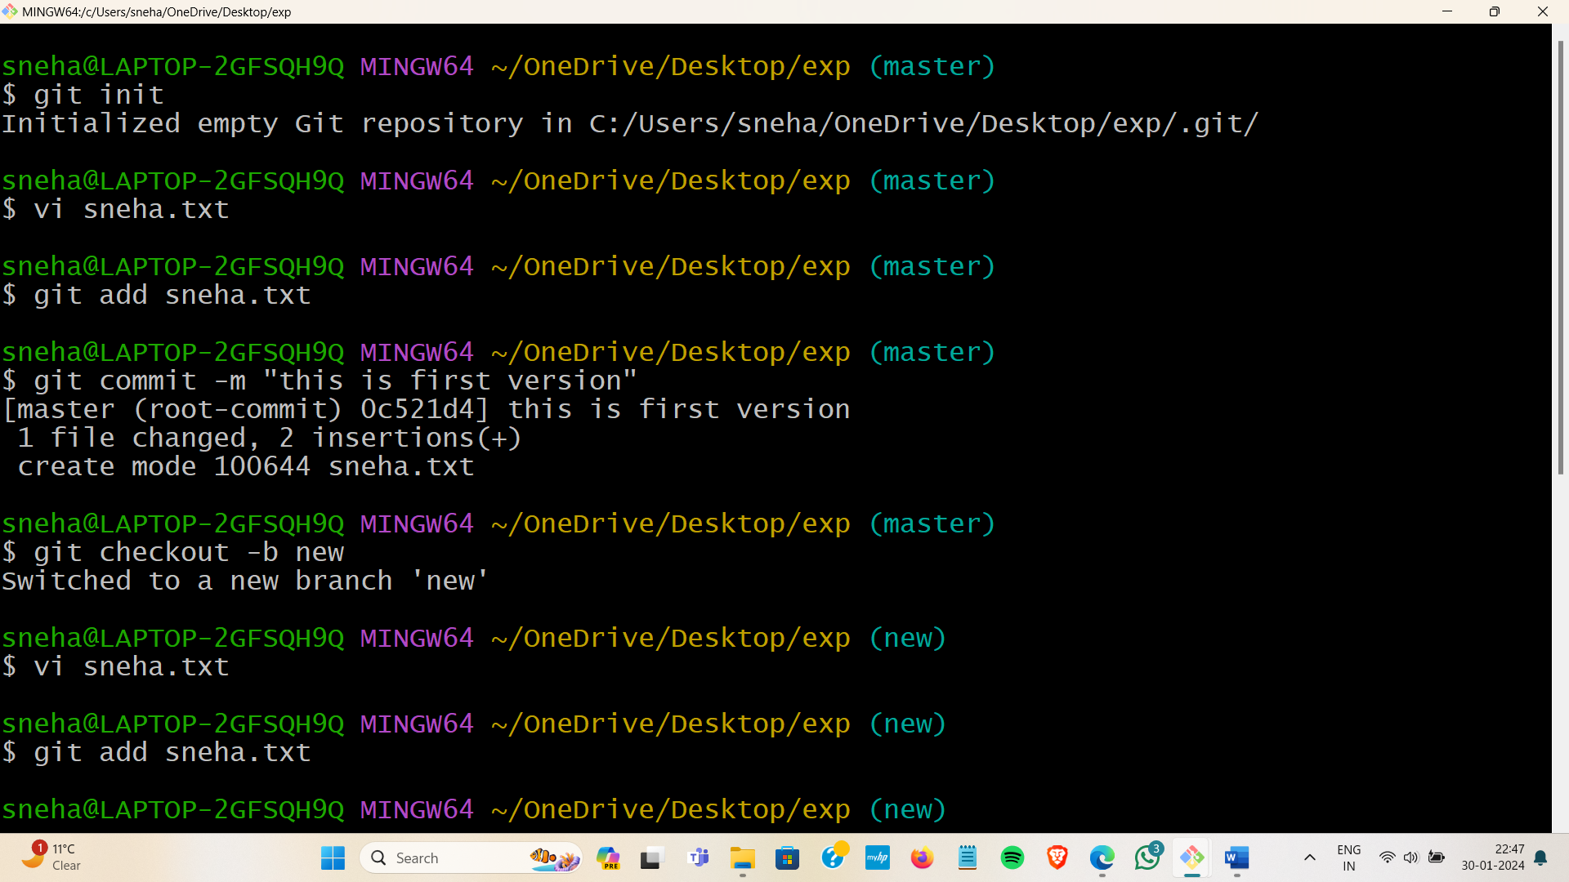

**4.** Edit file and add content to it.

**5.** Put the file in staging area using *“git add (file name)”* Eg **“git add sneha.txt”**

**6.** Commit this file using *“git commit -m “message””*

**7.** Create a new branch using code *“git checkout -b branch_name”*

**

**8.** Open and Edit file using *“vi file name”*  and add content to it.

**9.** Put the file in staging area using *“git add (file name)”* Eg **“git add sneha.txt”**

**10.** Commit this file using *“git commit -m “message””*

**11.** Move to master branch using *“git checkout master”*

**12.** Merge the branch using code *“ git merge new”*



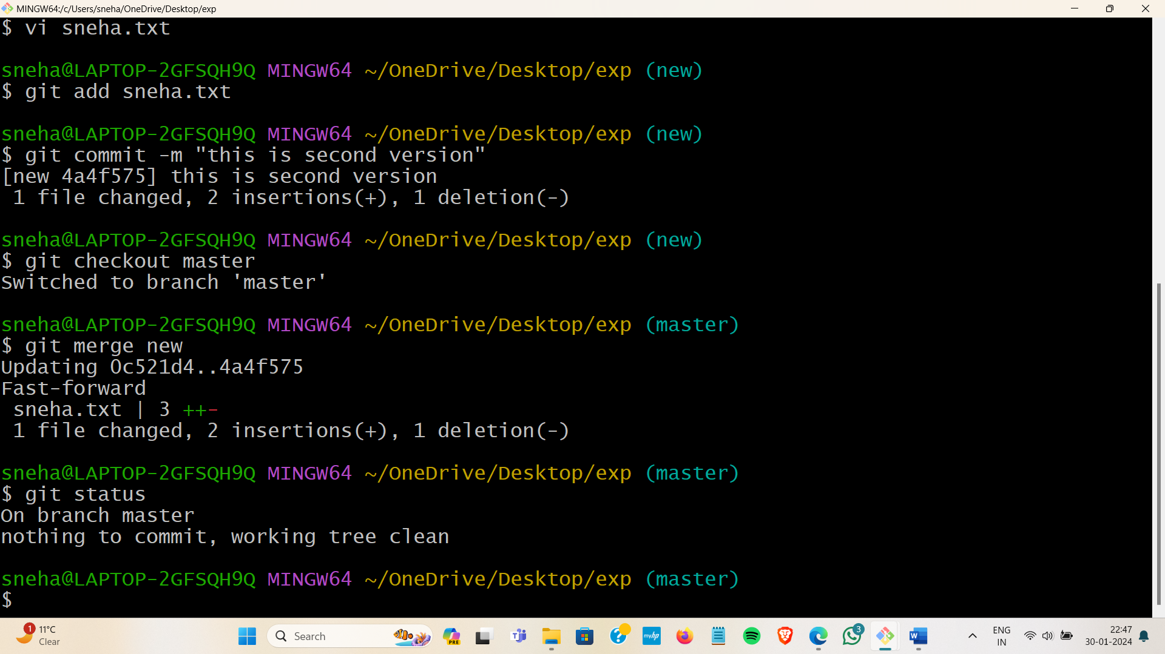

**13.** Show the status of file using *“git status”.*



**Learning outcomes (What I have learnt):**

**1.** Understanding Git Bash Commands

**2.** Use of GitHub Repository URL

**3**. Creating a Local Copy using Git bash.

**4.** Navigating Directories.

**5.** Connecting Local and Remote Repositories

**Evaluation Grid (To be created as per the SOP and Assessment guidelines by the faculty):**

|  |  |  |  |
| --- | --- | --- | --- |
| Sr. No. | Parameters | Marks Obtained | Maximum Marks |
| 1. |  |  |  |
| 2. |  |  |  |
| 3. |  |  |  |
|  |  |  |  |