Traffic Accident Analysis Dashboard

1. Introduction:
The Traffic Accident Analysis Dashboard is an interactive data visualization project developed using Power BI to analyze and interpret road accident data across various cities in India. Road accidents are a significant public safety issue, and understanding their patterns is crucial for effective prevention and policy-making.
This dashboard aims to transform raw and complex accident data into meaningful visual insights that are easy to understand and analyze. By using multiple visual elements such as charts, maps, and key performance indicators, the dashboard provides a comprehensive overview of accident trends, causes, and outcomes.
The project emphasizes not only data analysis but also user-friendly design, ensuring that users can interact with the data efficiently and gain valuable insights with minimal effort.

2. Problem Statement:
Road accidents are one of the leading causes of injuries and fatalities in India. Every year, thousands of lives are lost due to accidents caused by various factors such as road conditions, driver behavior, and vehicle types. However, the available accident data is often presented in raw tabular format, making it difficult to interpret and analyze.
The major challenges include:
- Lack of proper visualization tools to represent accident data clearly
- Difficulty in identifying major causes and trends
- Inability to quickly determine high-risk cities and accident-prone areas
- Limited accessibility of insights for decision-makers
Due to these challenges, it becomes difficult for authorities and analysts to take informed actions.
This project addresses these problems by developing an interactive dashboard that simplifies data interpretation and highlights key insights effectively.

3. Solution / Features:
To overcome the above challenges, a Power BI dashboard has been developed with multiple features that allow users to explore and analyze accident data efficiently.

Key Features:
- Total Accident Overview
Displays the total number of accidents using a KPI card, providing a quick summary of the dataset.
- Interactive Filters
Allows users to filter data based on accident outcomes such as minor injuries, total injuries, and fatalities, enabling customized analysis.
- Accident Outcomes Visualization
Uses donut charts to represent the distribution of accident outcomes, making it easier to understand the proportion of injuries and fatalities.
- Top Accident Causes
Highlights the most frequent causes of accidents, helping identify key contributing factors.
- City-wise Analysis
Displays the top cities with the highest number of accidents, enabling comparison across regions.
- Geographical Representation
Uses a map visualization to show accident hotspots across India, providing spatial insights.
- Key Insights Section
Summarizes important findings in a concise format, allowing users to quickly understand major trends without analyzing each visual.
The dashboard is designed with a modern dark theme and consistent color palette to enhance readability and visual appeal.

4. Screenshots:
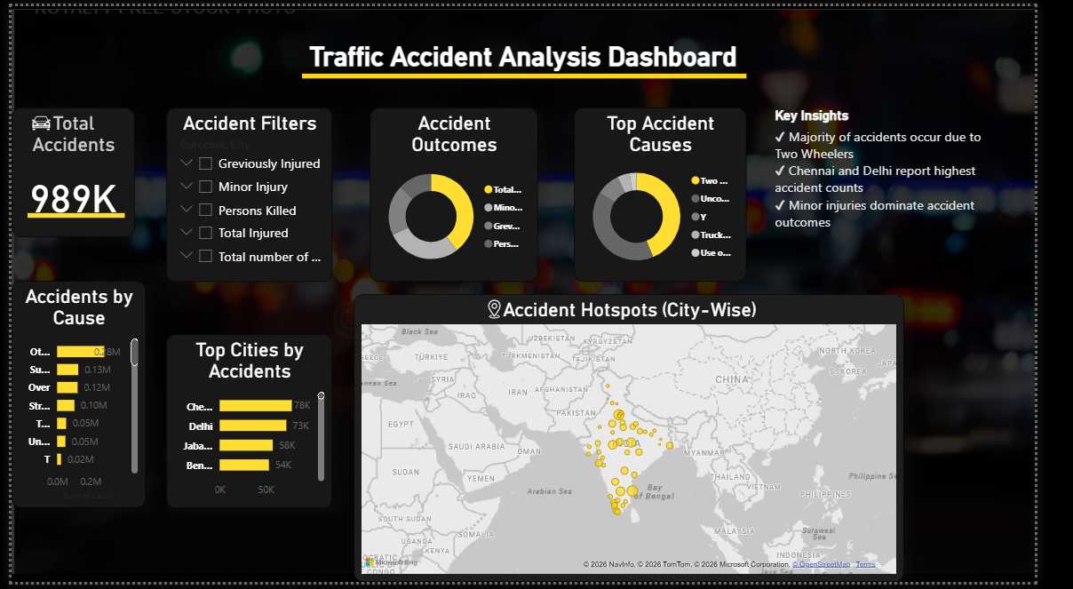
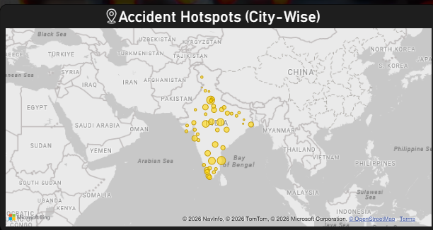
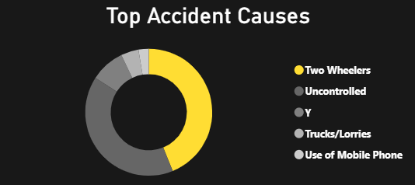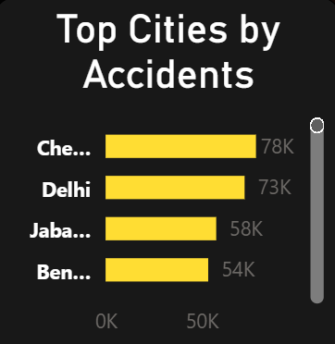

5. Tech Stack:
The project has been developed using the following tools and technologies:
- Power BI Desktop – Used for data visualization and dashboard creation
- Data Modeling – Used to structure and organize data for analysis
- Visualization Techniques:
  - Bar Charts for comparison
  - Donut Charts for distribution
  - Map Visualization for geographical insights
  - KPI Cards for summary metrics
- Design Elements:
  - Custom background image
  - Icons for better UI
  - Dark theme with yellow highlights
These tools helped in creating an interactive and visually appealing dashboard.

6. Unique Points:
This project stands out due to the following unique aspects:
- Modern UI Design
The dashboard uses a dark theme with a consistent color palette, giving it a professional and product-like appearance.
- Interactive Filtering
Users can dynamically filter data based on different outcomes, making the dashboard flexible and user-friendly.
- Insight-driven Approach
Instead of only displaying data, the dashboard highlights key insights to improve understanding.
- Combination of Multiple Visual Types
The use of maps, charts, and KPIs ensures comprehensive analysis from different perspectives.
- Geographical Analysis
The inclusion of a map helps identify accident hotspots across cities.

7. Future Improvements:
Although the current dashboard provides valuable insights, it can be further enhanced in the following ways:
- Time-based Analysis
Adding date-wise data to analyze trends over months or years.
- Predictive Analytics
Using machine learning models to predict future accident trends.
- Additional Data Integration
Including factors such as weather conditions, road types, and traffic density.
- Enhanced Interactivity
Adding drill-down and drill-through features for deeper analysis.
- Deployment
Publishing the dashboard online for real-time access and sharing.

8. Conclusion:
The Traffic Accident Analysis Dashboard successfully converts raw accident data into meaningful and actionable insights. It helps in identifying major accident causes, high-risk cities, and outcome distributions.
The project demonstrates strong skills in data visualization, UI design, and analytical thinking. It also highlights the importance of presenting data in a clear and structured manner to support decision-making.
Overall, the dashboard serves as an effective tool for understanding accident patterns and can be further extended for advanced analytics.

