IoT Device Authentication System using C++ and Octave

Abstract
This project presents a simple simulation of an Internet of Things (IoT) device authentication system implemented using C++ and GNU Octave. The system verifies IoT devices using encrypted tokens and restricts unauthorized access by limiting the number of authentication attempts. If a device fails authentication after three attempts, it is automatically blocked. The program logs authentication details and generates summary files for monitoring device activity. GNU Octave is used to visualize authentication results using a bar graph that shows the number of allowed and blocked devices. The project demonstrates a basic security mechanism used in IoT networks to prevent unauthorized access.

1. Introduction
The rapid growth of Internet of Things (IoT) devices has increased the importance of secure communication and authentication mechanisms. IoT devices often operate in distributed environments where security vulnerabilities can lead to unauthorized access or network attacks. Authentication is one of the most important steps in ensuring that only legitimate devices can access a network.
In this project, a simple authentication system is developed using C++. The system simulates how IoT devices authenticate themselves using encrypted tokens. Each device is allowed a maximum of three attempts to enter the correct token. If authentication fails, the device is marked as blocked. The authentication results are logged and visualized using GNU Octave.

2. Objectives
• To simulate an authentication system for IoT devices.
• To implement security by limiting authentication attempts.
• To log device authentication activities.
• To visualize authentication results using GNU Octave.

3. Tools and Technologies Used
Tool / Technology | Purpose
C++ | Implementation of device authentication logic
GNU Octave | Data visualization and graph plotting
Command Prompt / Terminal | Program execution
Text Files | Storage of logs and summary data

4. Methodology
1. The user enters the total number of IoT devices that will attempt authentication.
2. Each device provides a unique device ID.
3. The system asks the device to enter an encrypted authentication token.
4. A maximum of three attempts are allowed for entering the correct token.
5. If the correct token is entered, the device is marked as ALLOWED.
6. If the token is incorrect after three attempts, the device is marked as BLOCKED.
7. Authentication details are stored in log files.
8. Octave reads the authentication results and generates a bar graph showing the number of allowed and blocked devices.

5. Results and Output
The program successfully simulated an IoT device authentication system. Devices were classified into two categories: Allowed devices and Blocked devices. The authentication process generated logs and summary files, which can be used for monitoring and security analysis.
GNU Octave generated a graphical representation of the results in the form of a bar chart showing the number of allowed and blocked devices.

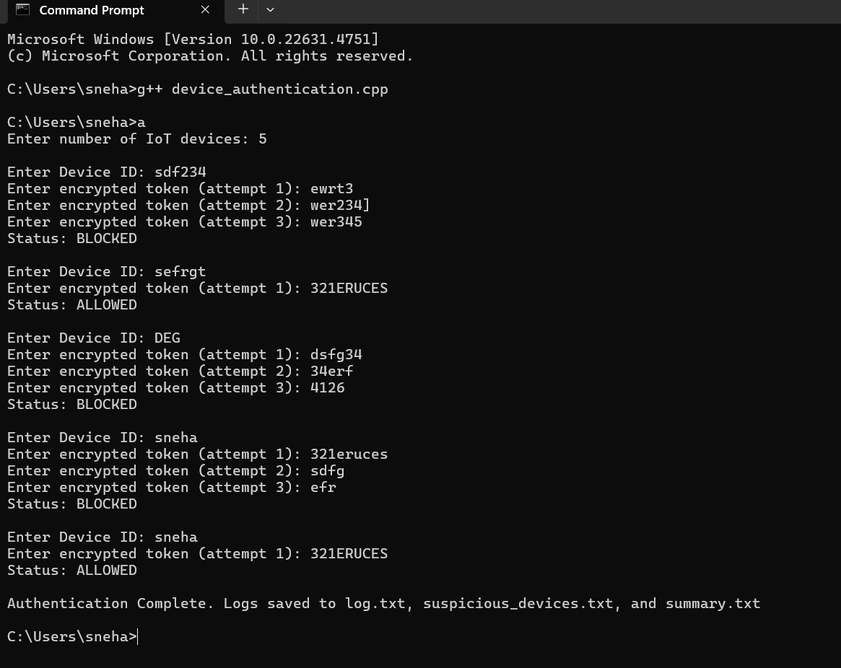
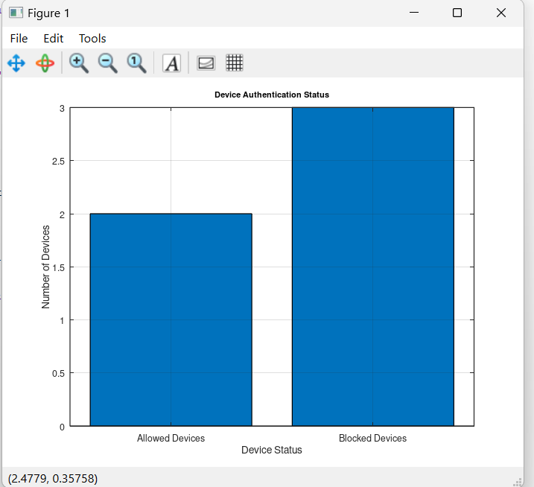

6. Applications
• IoT network security systems
• Smart home device authentication
• Access control in embedded systems
• Basic cybersecurity simulations for learning

7. Conclusion
This project demonstrates a basic authentication mechanism for IoT devices using C++ and GNU Octave. The implementation shows how security measures such as limited authentication attempts and activity logging can help protect IoT networks from unauthorized access. The use of visualization further helps in understanding the authentication results effectively. The project can be extended in the future by implementing real encryption algorithms, database integration, and real-time IoT device communication.

