AI Trial — Submission Document
Name: Sneha
Email: singhsneha115506@gmail.com
Brief: This document contains code excerpts, generation metadata, and the sample images produced for the 3-article trial task.

README (summary)
# AI-Powered Text-to-Image Generator
This project is a local text-to-image generation system built with an open-source Stable Diffusion model, a Streamlit web interface, and a PyTorch backend.
Given a natural-language prompt, the application generates one or more images, supports multiple visual styles, and includes basic safety mechanisms such as prompt filtering and visible watermarking.
---
## 1. Project Overview & Architecture
### High-level description
- **Goal**: Allow a user to type a text prompt and generate AI-created images locally.
- **Model**: Stable Diffusion v1.5, loaded via the `diffusers` library.
- **Interface**: Streamlit web app for easy interaction.
- **Backend**: PyTorch for model execution (GPU if available, otherwise CPU).
### Architecture components
1. **Frontend (Streamlit, `app.py`)**
- Collects user input:
- Prompt text
- Style (Photorealistic, Artistic / Painting, Cartoon / Anime, Concept Art)
- Number of images
- Guidance scale
- Diffusion steps
- Optional negative prompt
- Image resolution
- Displays:
- Progress and estimated completion time
- Generated images
- Download buttons for PNG and JPEG
- Uses a custom-styled layout with separate panels for controls and outputs.
2. **Model Layer (`model.py`)**
- Uses `StableDiffusionPipeline` from `diffusers`.
- Automatically detects hardware:
- **GPU (cuda)**: uses `float16` and autocasting for performance.
- **CPU**: uses `float32`, slower but still functional.
- Exposes a `generate()` method that receives prompts and generation parameters and returns PIL images.
3. **Utility Layer (`utils.py`)**
- **Content filtering**: simple keyword-based filtering for unsafe prompts.
- **Watermarking**: adds an “AI GENERATED” label to each final image using Pillow.
- **Saving & metadata**:
- Saves PNG and JPEG versions into an `outputs/` directory.
- Creates a JSON file with prompt, negative prompt, timestamp, parameters and file paths.
4. **Configuration (`config/model_config.json`)**
- Documents:
- Model name and framework
- Default image size
- Default generation parameters
- Safety and watermarking strategy
5. **Samples (`samples/`)**
- Contains example generated images and a `samples_metadata.json` file describing the prompts and styles used.
---
## 2. Setup & Installation
### 2.1. Prerequisites
- Python 3.9+ recommended
- Git
- (Optional but recommended) A GPU with at least 6–8 GB VRAM for faster generation
### 2.2. Create and activate a virtual environment
python -m venv venv
# Windows
venv\\Scripts\\activate
# Linux / macOS
source venv/bin/activate
### 2.3. Install dependencies
pip install -r requirements.txt
### 2.4. Model download instructions

Generated Images and Captions
Coastal village affected by rising sea levels — wide environmental view
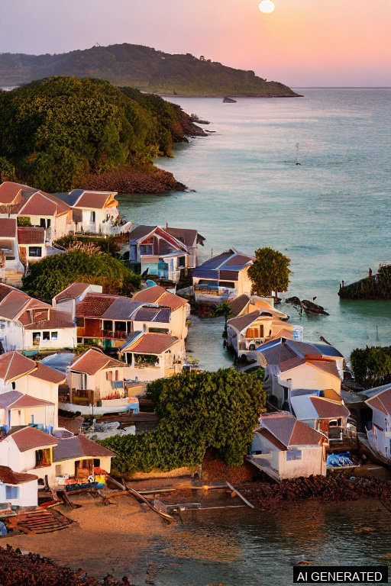
Caption: Wide environmental shot showing a coastal settlement with water encroaching on built structures at sunset. This image illustrates the scale and visual impact of sea-level rise described in Article 1.
Metadata: {
"prompt": "A high-resolution, photorealistic image of a coastal village at sunset where water laps at the foundations of simple houses; a family stands on a raised wooden platform watching rising sea levels, emotional expressions, warm golden light, wet reflective surfaces, detailed skin tones, cinematic composition, 8k, ultra realistic, depth of field, ultra realistic, 8k, professional photography, sharp focus, high dynamic range",
"negative_prompt": "low quality, blurry, deformed limbs, extra fingers, watermark, text, cartoon",
"steps": 30,
"guidance": 8.0,
"size": "768x512",
"article": 1
}

Renewable energy in rural communities / solar electrification
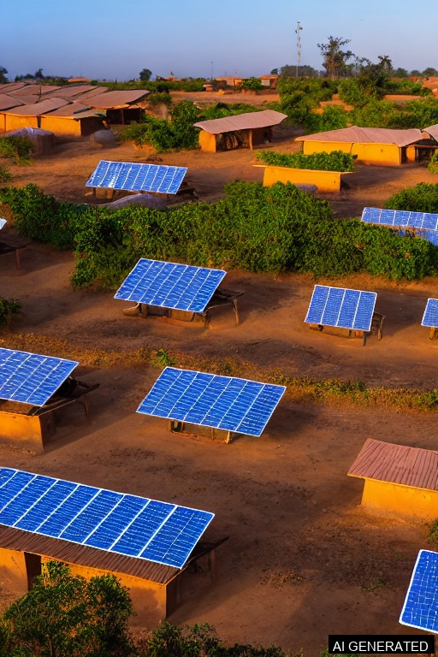
Caption: Photorealistic scene of a small African village at sunrise with rooftop solar panels and children studying under electric lights inside a classroom and a smiling teacher.
Metadata: {
"prompt": "Photorealistic scene of a small African village at sunrise with rooftop solar panels and children studying under electric lights inside a classroom; smiling teacher, solar microgrid battery unit in the background, warm morning colors, high detail, 4k, documentary photography style\n, ultra realistic, 8k, professional photography, sharp focus, high dynamic range",
"negative_prompt": "blurry, distorted faces, extra limbs, cartoonish, text, watermark",
"steps": 30,
"guidance": 8.5,
"size": "768x512",
"article": 1
}

Offshore wind farm with maintenance vessel — renewable energy transition
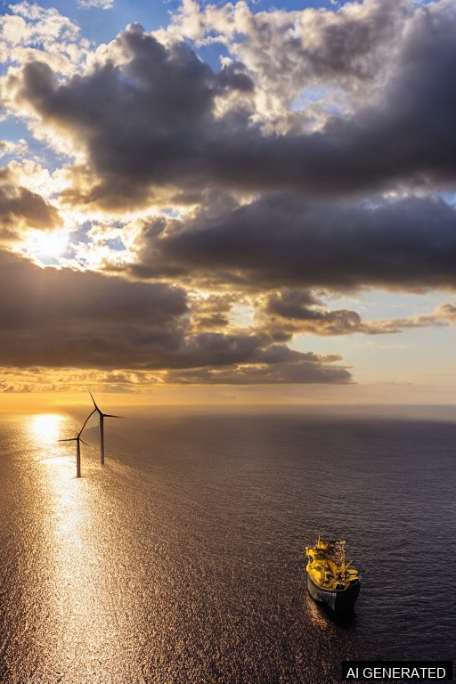
Caption: Cinematic sunrise scene of offshore wind turbines with a maintenance vessel in view. This image represents investment in renewable infrastructure and the operational reality of the energy transition.
Metadata: {
"prompt": "A photorealistic offshore wind farm at sunrise with multiple turbines arranged naturally; a yellow maintenance ship in the foreground with technicians in safety gear, realistic reflections on the ocean, dramatic clouds, sense of scale, cinematic 8k realism",
"negative_prompt": "duplicate turbines, warped blades, floating objects, surreal elements, cartoon",
"steps": 35,
"guidance": 8.0,
"size": "768x512",
"article": 1
}

Mass youth-led protest crossing a city bridge — collective mobilization
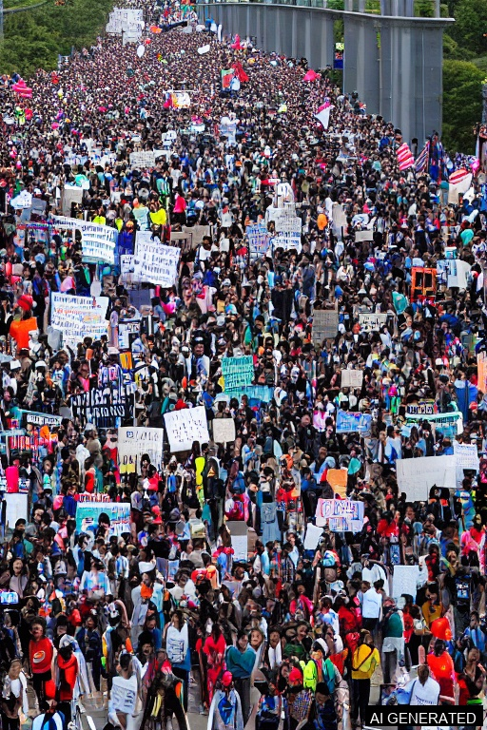
Caption: High-density crowd scene that captures the scale, diversity, and urgency of youth-led street mobilizations. Useful for illustrating mass action and political engagement described in Article 2.
Metadata: {
"prompt": "Ultra-realistic, high-resolution image of a densely packed youth protest crossing a large city bridge (daytime); protest signs, diverse faces, banners waving, documentary photo style, depth of field, 4k cinematic",
"negative_prompt": "gore, explicit violence, faces severely deformed, extra limbs, text overlays",
"steps": 35,
"guidance": 8.0,
"size": "768x512",
"article": 2
}

Portrait of a young activist — personal cost of protest
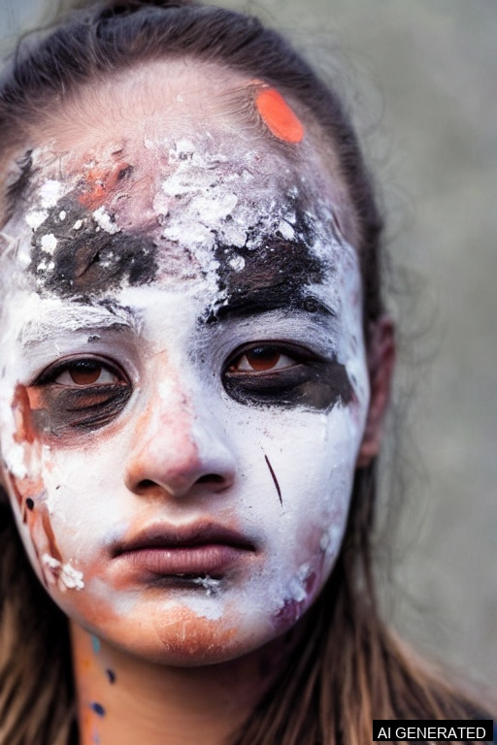
Caption: Close-up portrait conveying exhaustion, resolve, and symbolic face paint. This image highlights the personal and emotional dimension of participation in protests.
Metadata: {
"prompt": "Hyper-realistic close-up portrait of a young activist with protest face paint and a slight tear, determined eyes, soft dramatic lighting, shallow depth of field, highly detailed skin texture, editorial photograph",
"negative_prompt": "blur, low detail, cartoon, gore",
"steps": 35,
"guidance": 8.0,
"size": "768x512",
"article": 2
}

Youth candlelight vigil — peaceful solidarity and reflection
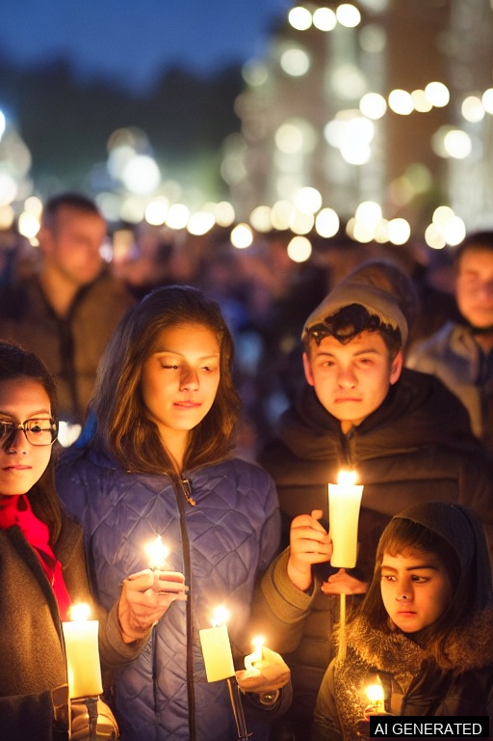
Caption: Evening scene showing young people holding candles in a vigil. It communicates themes of solidarity, mourning, and the quieter forms of protest that accompany mass mobilizations.
Metadata: {
"prompt": "High-resolution image of an evening candlelight vigil with young activists holding candles, soft warm glows, reflective faces, somber mood, cinematic bokeh, high detail, photorealistic",
"negative_prompt": "blurry, noisy, gore, chaotic background",
"steps": 35,
"guidance": 8.0,
"size": "768x512",
"article": 2
}

Human face with digital mesh overlay — identity & AI reconstruction
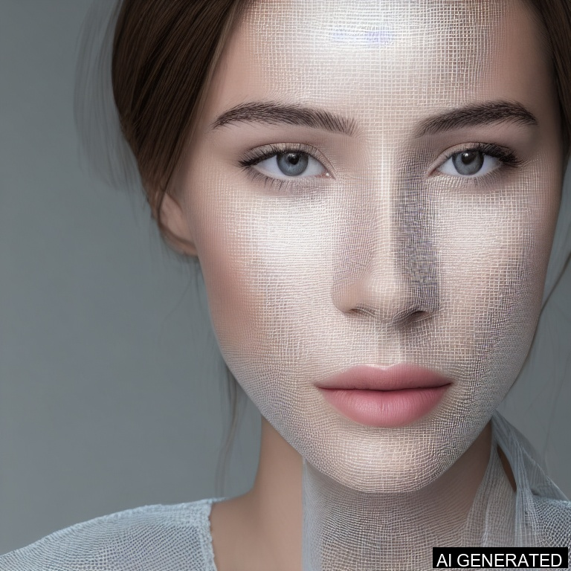
Caption: Photorealistic portrait where half the face transitions into a subtle digital mesh. This symbolizes the blending of human identity and machine interpretation explored in Article 3.
Metadata: {
"prompt": "A photorealistic portrait of a person looking into the camera, with half of their face subtly transitioning into a digital wireframe or holographic mesh. Soft lighting, clean minimal background, detailed skin texture, gentle AI augmentation effects that symbolize the blending of human identity with artificial intelligence.",
"negative_prompt": "distorted faces, melted features, multiple eyes, duplicated noses, horror effects, surreal deformities",
"steps": 35,
"guidance": 8.0,
"size": "768x768",
"article": 3
}

Hand holding device with neural network cloud — AI-assisted creativity
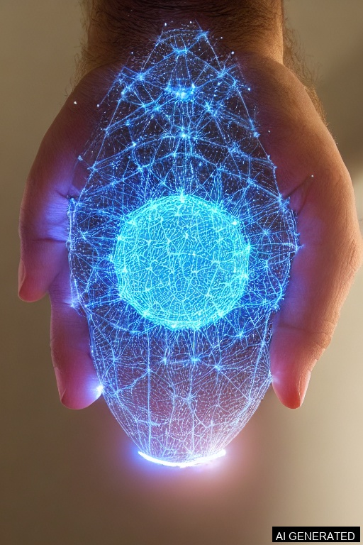
Caption: A hand holding a device beneath a glowing neural-network cloud representing AI assistance. This image depicts how AI can augment idea generation and creative workflows.
Metadata: {
"prompt": "A hyper-realistic image of a human hand and an advanced robotic hand touching fingertips, with a glowing AI neural-network pattern forming between them; dramatic lighting, futuristic laboratory background, sharp reflections on the robotic metal, air particles illuminated by blue and white lights, symbolic composition showing the merging of humanity and artificial intelligence., ultra realistic, 8k, professional photography, sharp focus, high dynamic range",
"negative_prompt": "cartoon, plastic hands, mannequin, melted fingers, deformed joints, blurry hologram, messy patterns, abstract backgrounds, floating disembodied hands",
"steps": 35,
"guidance": 8.0,
"size": "768x512",
"article": 3
}

Person using a tablet with AI-assisted UI — Human AI collaboration
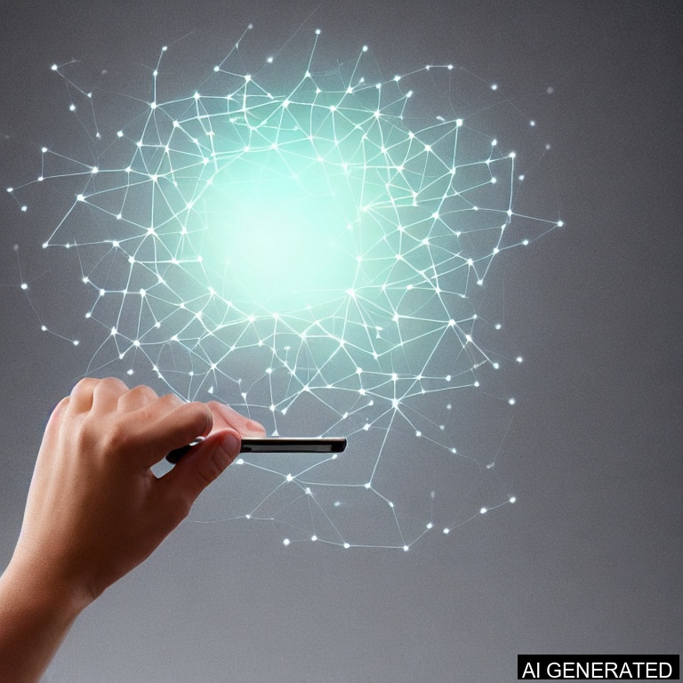
Caption: A glowing neural-network pattern emerging from a smartphone, symbolizing AI-generated ideas and digital intelligence.
Metadata: {
"prompt": "A photorealistic image of a person working on a digital tablet, with a softly glowing layer of AI-generated elements appearing above the screen. The AI augmentation looks like subtle holographic shapes, light neural-network lines, or floating translucent icons that represent creative suggestions. Minimalistic modern workspace, soft lighting, focus on human hand and UI.",
"negative_prompt": "many monitors, chaotic screens, distorted hands, broken text, surreal elements, heavy holograms",
"steps": 35,
"guidance": 8.0,
"size": "768x768",
"article": 3
}

Included code files
File: app.py
# app.py
import os
import streamlit as st
from model import Text2ImageGenerator
from utils import is_prompt_allowed, add_watermark, save_image_with_metadata
# ---------- PAGE CONFIG ----------
st.set_page_config(
page_title="AI-Powered Text-to-Image Generator",
page_icon="🖼️",
layout="wide"
)
# ---------- CUSTOM STYLES ----------
st.markdown(
"""
<style>
/* Global background */
.stApp {
background: radial-gradient(circle at top, #111827 0, #020617 45%, #000000 100%);
color: #e5e7eb;
font-family: "Inter", system-ui, -apple-system, BlinkMacSystemFont, sans-serif;
}
/* Main container padding */
.block-container {
padding-top: 2rem;
padding-bottom: 2rem;
padding-left: 2.5rem;
padding-right: 2.5rem;
}
/* Card style */
.glass-card {
background: rgba(15, 23, 42, 0.9);
border-radius: 18px;
padding: 1.2rem 1.4rem;
border: 1px solid rgba(148, 163, 184, 0.2);
box-shadow: 0 18px 45px rgba(0, 0, 0, 0.55);
}
.glass-header {
background: linear-gradient(135deg, #1e293b, #020617);
border-radius: 18px;
padding: 1.5rem 1.8rem;
border: 1px solid rgba(148, 163, 184, 0.5);
box-shadow: 0 25px 55px rgba(0, 0, 0, 0.75);
}
.section-title {
font-size: 1rem;
font-weight: 600;
letter-spacing: 0.08em;
text-transform: uppercase;
color: #9ca3af;
margin-bottom: 0.35rem;
}
.prompt-label {
font-weight: 600;
font-size: 0.95rem;
color: #e5e7eb;
}
.tip-text {
font-size: 0.85rem;
color: #9ca3af;
}
.footer-text {
font-size: 0.8rem;
color: #6b7280;
text-align: center;
margin-top: 1.5rem;
}
/* Hide Streamlit default menu/footer/logo */
#MainMenu {visibility: hidden;}
footer {visibility: hidden;}
header {visibility: hidden;}
</style>
""",
unsafe_allow_html=True
)
# ---------- MODEL (CACHED) ----------
@st.cache_resource
def load_generator():
return Text2ImageGenerator()
generator = load_generator()
# ---------- HEADER ----------
st.markdown(
"""
<div class="glass-header">
<div style="display:flex; align-items:center; gap:1rem; flex-wrap:wrap;">
<div style="
width: 52px;
height: 52px;
border-radius: 18px;
background: radial-gradient(circle at 30% 30%, #22d3ee, #6366f1);
display:flex;
align-items:center;
justify-content:center;
font-size: 1.7rem;
">
🖼️
</div>
<div style="flex:1; min-width:200px;">
<h1 style="margin:0; font-size:1.9rem; color:#f9fafb; font-weight:700;">
AI-Powered Text-to-Image Generator
</h1>
<p style="margin:0.3rem 0 0; color:#9ca3af; font-size:0.9rem;">
Transform plain text into high-quality images using an open-source Stable Diffusion pipeline.
</p>
</div>
<div style="text-align:right; min-width:170px;">
<div style="font-size:0.75rem; text-transform:uppercase; letter-spacing:0.12em; color:#9ca3af;">
Runtime Device
</div>
<div style="font-weight:600; color:#e5e7eb; font-size:0.95rem;">
{device}
</div>
<div style="font-size:0.8rem; color:#6b7280;">
Auto-detected (GPU if available)
</div>
</div>
</div>
</div>
""".format(device=generator.device),
unsafe_allow_html=True
)
st.markdown("") # spacer
# ---------- LAYOUT ----------
left_col, right_col = st.columns([1.1, 1.2])
# ========== LEFT: CONTROLS ==========
with left_col:
st.markdown('<div class="glass-card">', unsafe_allow_html=True)
st.markdown('<div class="section-title">Prompt</div>', unsafe_allow_html=True)
st.markdown('<div class="prompt-label">Describe the scene you want to generate</div>', unsafe_allow_html=True)
prompt = st.text_area(
label="",
value="a futuristic city at sunset, highly detailed, 4K, cinematic lighting",
height=110,
placeholder="Example: a cozy study room with warm lights, cinematic, ultra detailed"
)
st.markdown(
'<div class="tip-text">💡 Tip: Add mood, lighting, and style keywords for better results.</div>',
unsafe_allow_html=True
)
st.markdown("---")
# Style & core sliders
st.markdown('<div class="section-title">Style & Quality</div>', unsafe_allow_html=True)
style = st.selectbox(
"Artistic style",
["Photorealistic", "Artistic / Painting", "Cartoon / Anime", "Concept Art"],
help="Choose the overall look & vibe of the output image."
)
c1, c2 = st.columns(2)
with c1:
num_images = st.slider(
"Number of images",
min_value=1,
max_value=4,
value=1,
help="Generate multiple variations for the same prompt."
)
with c2:
guidance_scale = st.slider(
"Guidance scale",
min_value=3.0,
max_value=15.0,
value=7.5,
step=0.5,
help="Higher values follow the text more strictly but can reduce creativity."
)
steps = st.slider(
"Diffusion steps",
min_value=10,
max_value=50,
value=30,
step=5,
help="More steps = slower but sharper & more detailed images."
)
with st.expander("Advanced controls", expanded=False):
negative_prompt_input = st.text_area(
"Negative prompt",
value="low quality, blurry, distorted, extra limbs",
height=80,
help="Describe what you want to avoid in the image."
)
c3, c4 = st.columns(2)
with c3:
height = st.selectbox("Image height", [512, 640, 768], index=0)
with c4:
width = st.selectbox("Image width", [512, 640, 768], index=0)
# Generate button
st.markdown("")
generate_button = st.button(
"🚀 Generate Images",
use_container_width=True,
type="primary"
)
st.markdown('</div>', unsafe_allow_html=True) # close glass-card
# ========== RIGHT: OUTPUT & STATUS ==========
with right_col:
st.markdown('<div class="glass-card">', unsafe_allow_html=True)
st.markdown('<div class="section-title">Output</div>', unsafe_allow_html=True)
status_box = st.empty()
progress_text = st.empty()
progress_bar = st.empty()
output_dir = "outputs"
# Style prompt enhancement
def apply_style(prompt_text: str, style_choice: str) -> str:
style_prompts = {
"Photorealistic": "ultra realistic, 8k, professional photography, sharp focus, high dynamic range",
"Artistic / Painting": "oil painting, brush strokes, rich texture, artstation, highly detailed",
"Cartoon / Anime": "anime style, clean lines, cell shading, vibrant colors",
"Concept Art": "concept art, matte painting, dramatic lighting, highly detailed, cinematic"
}
return f"{prompt_text}, {style_prompts.get(style_choice, '')}"
# Handle generation
if generate_button:
if not prompt.strip():
status_box.error("Prompt cannot be empty.")
elif not is_prompt_allowed(prompt):
status_box.error("Prompt violates content guidelines. Please enter a safer description.")
else:
styled_prompt = apply_style(prompt, style)
status_box.info("Generation started. This may take some time depending on your hardware.")
progress_bar = st.progress(0)
if generator.device == "cuda":
est = "a few seconds per image (GPU)"
else:
est = "around 30–60 seconds per image (CPU, slower)"
progress_text.markdown(
f"**Estimated completion:** `{est}` &nbsp;&nbsp;•&nbsp;&nbsp; "
f"Steps: `{steps}` &nbsp;|&nbsp; Guidance: `{guidance_scale}`"
)
params = {
"num_images": num_images,
"guidance_scale": guidance_scale,
"steps": steps,
"height": height,
"width": width,
"device": generator.device,
"style": style
}
progress_bar.progress(10)
progress_text.markdown("🔧 Preparing model & pipeline...")
images = generator.generate(
prompt=styled_prompt,
negative_prompt=negative_prompt_input,
num_images=num_images,
guidance_scale=guidance_scale,
num_inference_steps=steps,
height=height,
width=width
)
progress_bar.progress(70)
progress_text.markdown("✨ Post-processing: adding watermark & saving images...")
cols = st.columns(num_images)
saved_paths = []
for idx, img in enumerate(images):
wm_img = add_watermark(img)
png_path, jpg_path, metadata_path = save_image_with_metadata(
wm_img,
base_dir=output_dir,
prompt=styled_prompt,
negative_prompt=negative_prompt_input,
params=params,
index=idx
)
saved_paths.append((png_path, jpg_path, metadata_path))
with cols[idx]:
st.image(
wm_img,
caption=f"Variant {idx+1}",
use_container_width=True
)
st.download_button(
label="Download PNG",
data=open(png_path, "rb").read(),
file_name=os.path.basename(png_path),
mime="image/png",
key=f"png_{idx}"
)
st.download_button(
label="Download JPG",
data=open(jpg_path, "rb").read(),
file_name=os.path.basename(jpg_path),
mime="image/jpeg",
key=f"jpg_{idx}"
)
progress_bar.progress(100)
progress_text.markdown("✅ Generation completed.")
status_box.success("Images generated, watermarked, and saved with metadata.")
else:
st.markdown(
'<div class="tip-text">Generate an image to see results here. '
'Use the left panel to craft your prompt and tweak quality settings.</div>',
unsafe_allow_html=True
)
st.markdown('</div>', unsafe_allow_html=True) # close glass-card
# ---------- FOOTER ----------
st.markdown(
'<div class="footer-text">Built with Stable Diffusion, Streamlit, and a slightly overworked brain.</div>',
unsafe_allow_html=True
)

File: model.py
# model.py
import torch
from diffusers import StableDiffusionPipeline
class Text2ImageGenerator:
def __init__(self, model_name: str = "runwayml/stable-diffusion-v1-5"):
# Detect device
self.device = "cuda" if torch.cuda.is_available() else "cpu"
print(f"Using device: {self.device}")
# Load pipeline
dtype = torch.float16 if self.device == "cuda" else torch.float32
self.pipe = StableDiffusionPipeline.from_pretrained(
model_name,
torch_dtype=dtype,
safety_checker=None # simple manual filtering will be used instead
)
self.pipe = self.pipe.to(self.device)
def generate(
self,
prompt: str,
negative_prompt: str = "",
num_images: int = 1,
guidance_scale: float = 7.5,
num_inference_steps: int = 30,
height: int = 512,
width: int = 512
):
# Autocast for GPU to save memory and speed up
if self.device == "cuda":
with torch.autocast(self.device):
result = self.pipe(
prompt=[prompt] * num_images,
negative_prompt=[negative_prompt] * num_images if negative_prompt else None,
guidance_scale=guidance_scale,
num_inference_steps=num_inference_steps,
height=height,
width=width
)
else:
result = self.pipe(
prompt=[prompt] * num_images,
negative_prompt=[negative_prompt] * num_images if negative_prompt else None,
guidance_scale=guidance_scale,
num_inference_steps=num_inference_steps,
height=height,
width=width
)
images = result.images
return images

File: utils.py
# utils.py
import os
import json
from datetime import datetime
from PIL import Image, ImageDraw, ImageFont
# Simple banned words list for content filtering
BANNED_KEYWORDS = [
"nude", "naked", "nsfw", "gore", "bloody", "violence", "sex"
]
def is_prompt_allowed(prompt: str) -> bool:
lowered = prompt.lower()
for word in BANNED_KEYWORDS:
if word in lowered:
return False
return True
def add_watermark(image: Image.Image, text: str = "AI GENERATED"):
img = image.copy()
draw = ImageDraw.Draw(img)
width, height = img.size
font_size = int(width * 0.03)
try:
font = ImageFont.truetype("arial.ttf", font_size)
except:
font = ImageFont.load_default()
# NEW: use textbbox instead of textsize
bbox = draw.textbbox((0, 0), text, font=font)
text_width = bbox[2] - bbox[0]
text_height = bbox[3] - bbox[1]
padding = 10
x = width - text_width - padding
y = height - text_height - padding
# Semi-transparent rectangle
rect_x0 = x - 5
rect_y0 = y - 5
rect_x1 = x + text_width + 5
rect_y1 = y + text_height + 5
draw.rectangle((rect_x0, rect_y0, rect_x1, rect_y1), fill=(0, 0, 0, 128))
draw.text((x, y), text, font=font, fill=(255, 255, 255))
return img
def save_image_with_metadata(
image: Image.Image,
base_dir: str,
prompt: str,
negative_prompt: str,
params: dict,
index: int = 0
):
os.makedirs(base_dir, exist_ok=True)
timestamp = datetime.now().strftime("%Y%m%d_%H%M%S")
filename_base = f"img_{timestamp}_{index}"
png_path = os.path.join(base_dir, filename_base + ".png")
jpg_path = os.path.join(base_dir, filename_base + ".jpg")
image.save(png_path, format="PNG")
image.convert("RGB").save(jpg_path, format="JPEG", quality=95)
metadata = {
"prompt": prompt,
"negative_prompt": negative_prompt,
"timestamp": timestamp,
"parameters": params,
"files": {
"png": png_path,
"jpg": jpg_path
}
}
metadata_path = os.path.join(base_dir, filename_base + ".json")
with open(metadata_path, "w", encoding="utf-8") as f:
json.dump(metadata, f, indent=4)
return png_path, jpg_path, metadata_path

Manifest (full metadata)
[
{
"file": "article1/coastal_wide.jpg",
"article": 1,
"title": "Coastal village affected by rising sea levels — wide environmental view",
"prompt": "A high-resolution, photorealistic image of a coastal village at sunset where water laps at the foundations of simple houses; a family stands on a raised wooden platform watching rising sea levels, emotional expressions, warm golden light, wet reflective surfaces, detailed skin tones, cinematic composition, 8k, ultra realistic, depth of field, ultra realistic, 8k, professional photography, sharp focus, high dynamic range",
"negative_prompt": "low quality, blurry, deformed limbs, extra fingers, watermark, text, cartoon",
"steps": 30,
"guidance": 8.0,
"size": "768x512",
"notes": "Wide environmental view — no people in this version"
},
{
"file": "article1/coastal_family.jpg",
"article": 1,
"title": "Renewable energy in rural communities / solar electrification",
"prompt": "Photorealistic scene of a small African village at sunrise with rooftop solar panels and children studying under electric lights inside a classroom; smiling teacher, solar microgrid battery unit in the background, warm morning colors, high detail, 4k, documentary photography style\n, ultra realistic, 8k, professional photography, sharp focus, high dynamic range",
"negative_prompt": "blurry, distorted faces, extra limbs, cartoonish, text, watermark",
"steps": 30,
"guidance": 8.5,
"size": "768x512",
"notes": "Human-centered narrative image for Article 1"
},
{
"file": "article1/offshore_wind.jpg",
"article": 1,
"title": "Offshore wind farm with maintenance vessel — renewable energy transition",
"prompt": "A photorealistic offshore wind farm at sunrise with multiple turbines arranged naturally; a yellow maintenance ship in the foreground with technicians in safety gear, realistic reflections on the ocean, dramatic clouds, sense of scale, cinematic 8k realism",
"negative_prompt": "duplicate turbines, warped blades, floating objects, surreal elements, cartoon",
"steps": 35,
"guidance": 8.0,
"size": "768x512",
"notes": "Symbolizes renewable energy infrastructure and operation"
},
{
"file": "article2/protest_wide.jpg",
"article": 2,
"title": "Mass youth-led protest crossing a city bridge — collective mobilization",
"prompt": "Ultra-realistic, high-resolution image of a densely packed youth protest crossing a large city bridge (daytime); protest signs, diverse faces, banners waving, documentary photo style, depth of field, 4k cinematic",
"negative_prompt": "gore, explicit violence, faces severely deformed, extra limbs, text overlays",
"steps": 35,
"guidance": 8.0,
"size": "768x512",
"notes": "Wide crowd image to represent mass mobilization"
},
{
"file": "article2/portrait_activist.jpg",
"article": 2,
"title": "Portrait of a young activist — personal cost of protest",
"prompt": "Hyper-realistic close-up portrait of a young activist with protest face paint and a slight tear, determined eyes, soft dramatic lighting, shallow depth of field, highly detailed skin texture, editorial photograph",
"negative_prompt": "blur, low detail, cartoon, gore",
"steps": 35,
"guidance": 8.0,
"size": "768x512",
"notes": "Emotional portrait capturing the personal impact of activism"
},
{
"file": "article2/candle_vigil.jpg",
"article": 2,
"title": "Youth candlelight vigil — peaceful solidarity and reflection",
"prompt": "High-resolution image of an evening candlelight vigil with young activists holding candles, soft warm glows, reflective faces, somber mood, cinematic bokeh, high detail, photorealistic",
"negative_prompt": "blurry, noisy, gore, chaotic background",
"steps": 35,
"guidance": 8.0,
"size": "768x512",
"notes": "Peaceful solidarity scene"
},
{
"file": "article3/ai_hand_mesh.jpg",
"article": 3,
"title": "Human face with digital mesh overlay — identity & AI reconstruction",
"prompt": "A photorealistic portrait of a person looking into the camera, with half of their face subtly transitioning into a digital wireframe or holographic mesh. Soft lighting, clean minimal background, detailed skin texture, gentle AI augmentation effects that symbolize the blending of human identity with artificial intelligence.",
"negative_prompt": "distorted faces, melted features, multiple eyes, duplicated noses, horror effects, surreal deformities",
"steps": 35,
"guidance": 8.0,
"size": "768x768",
"notes": "Symbolic representation of identity and AI reconstruction"
},
{
"file": "article3/ai_network_on_device.jpg",
"article": 3,
"title": "Hand holding device with neural network cloud — AI-assisted creativity",
"prompt": "A hyper-realistic image of a human hand and an advanced robotic hand touching fingertips, with a glowing AI neural-network pattern forming between them; dramatic lighting, futuristic laboratory background, sharp reflections on the robotic metal, air particles illuminated by blue and white lights, symbolic composition showing the merging of humanity and artificial intelligence., ultra realistic, 8k, professional photography, sharp focus, high dynamic range",
"negative_prompt": "cartoon, plastic hands, mannequin, melted fingers, deformed joints, blurry hologram, messy patterns, abstract backgrounds, floating disembodied hands",
"steps": 35,
"guidance": 8.0,
"size": "768x512",
"notes": "Symbolic, editorial depiction of AI assisting creativity"
},
{
"file": "article3/ai_collab_tablet.jpg",
"article": 3,
"title": "Person using a tablet with AI-assisted UI — Human AI collaboration",
"prompt": "A photorealistic image of a person working on a digital tablet, with a softly glowing layer of AI-generated elements appearing above the screen. The AI augmentation looks like subtle holographic shapes, light neural-network lines, or floating translucent icons that represent creative suggestions. Minimalistic modern workspace, soft lighting, focus on human hand and UI.",
"negative_prompt": "many monitors, chaotic screens, distorted hands, broken text, surreal elements, heavy holograms",
"steps": 35,
"guidance": 8.0,
"size": "768x768",
"notes": "Controlled Human AI collaboration scene"
}
]

