EXTRA LAB PRACTISE FOR DATABASE CONCEPTS
1. Introduction to SQL LAB EXERCISES:
• Lab 3: Create a database called library_db and a table books with columns: book_id, title, author, publisher, year_of_publication, and price. Insert five records into the table.
Ans-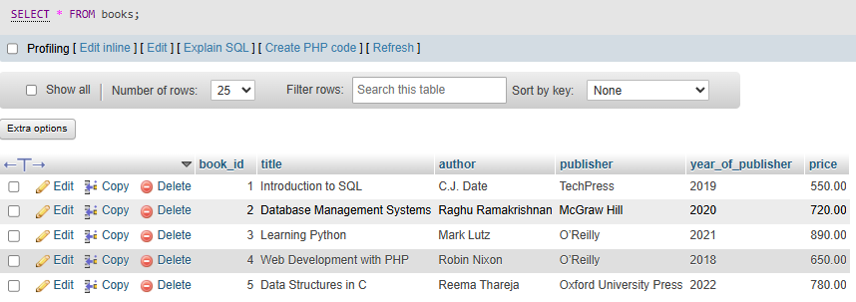
• Lab 4: Create a table members in library_db with columns: member_id, member_name, date_of_membership, and email. Insert five records into this table.
Ans-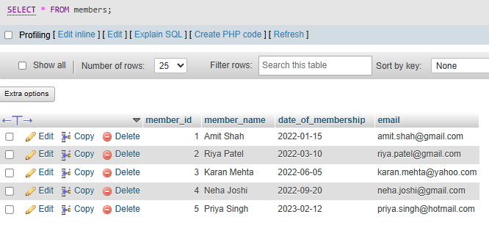
2. SQL Syntax LAB EXERCISES:
• Lab 3: Retrieve all members who joined the library before 2022. Use appropriate SQL syntax with WHERE and ORDER BY.
Ans-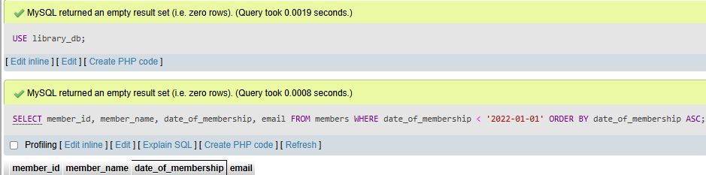

3. SQL Constraints
LAB EXERCISES:
• Lab 3: Add a CHECK constraint to ensure that the price of books in the books table is greater than 0.
Ans- 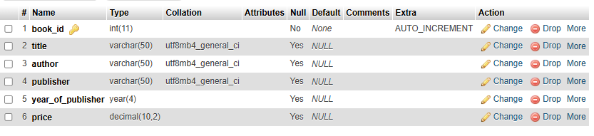
• Lab 4: Modify the members table to add a UNIQUE constraint on the email column, ensuring that each member has a unique email address.
Ans-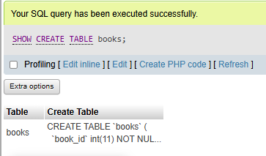
4. Main SQL Commands and Sub-commands (DDL)
LAB EXERCISES:
• Lab 3: Create a table authors with the following columns: author_id, first_name, last_name, and country. Set author_id as the primary key.
Ans-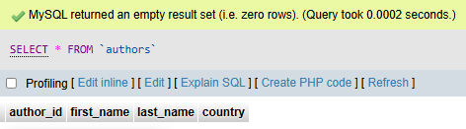
• Lab 4: Create a table publishers with columns: publisher_id, publisher_name, contact_number, and address. Set publisher_id as the primary key and contact_number as unique.
Ans-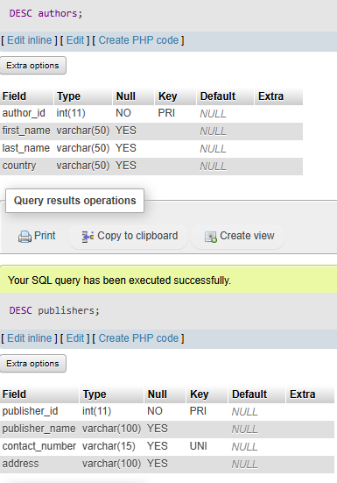
5. ALTER Command
LAB EXERCISES:
• Lab 3: Add a new column genre to the books table. Update the genre for all existing records.
Ans-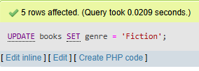
• Lab 4: Modify the members table to increase the length of the email column to 100 characters.
Ans-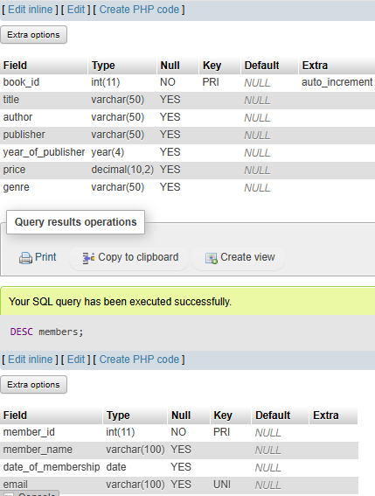
6. DROP Command
LAB EXERCISES:
• Lab 3: Drop the publishers table from the database after verifying its structure.
Ans-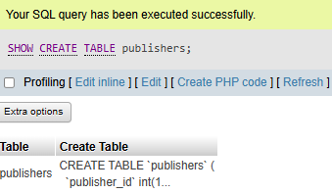
• Lab 4: Create a backup of the members table and then drop the original members table.
Ans-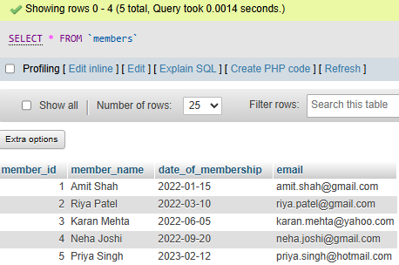
7. Data Manipulation Language (DML)
LAB EXERCISES:
• Lab 4: Insert three new authors into the authors table, then update the last name of one of the authors.
Ans-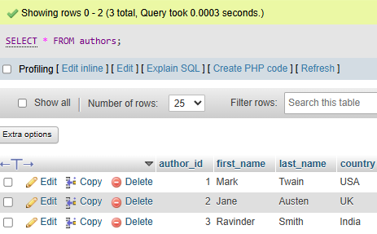
• Lab 5: Delete a book from the books table where the price is higher than $100.
Ans-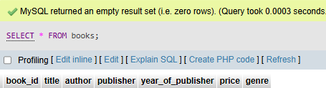
9. DELETE Command
LAB EXERCISES:
• Lab 3: Remove all members who joined before 2020 from the members table.
Ans-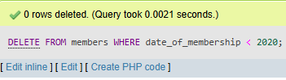
• Lab 4: Delete all books that have a NULL value in the author column.
Ans-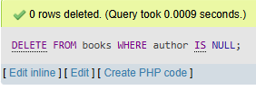

10. Data Query Language (DQL)
LAB EXERCISES:
• Lab 4: Write a query to retrieve all books with price between $50 an d $100.
Ans-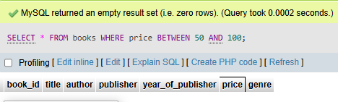
• Lab 5: Retrieve the list of books sorted by author in ascending order and limit the results to the top 3 entries.
Ans-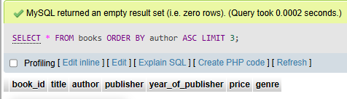
11. Data Control Language (DCL)
LAB EXERCISES:
• Lab 3: Grant SELECT permission to a user named librarian on the books table.
Ans-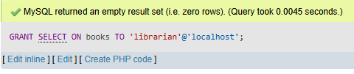
• Lab 4: Grant INSERT and UPDATE permissions to the user admin on the members table.
Ans-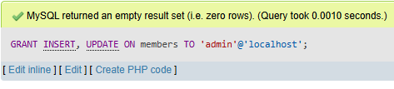

12. REVOKE Command
LAB EXERCISES:
• Lab 3: Revoke the INSERT privilege from the user librarian on the books table.
Ans-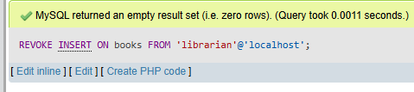
• Lab 4: Revoke all permissions from user admin on the members table.
Ans-