Assisment

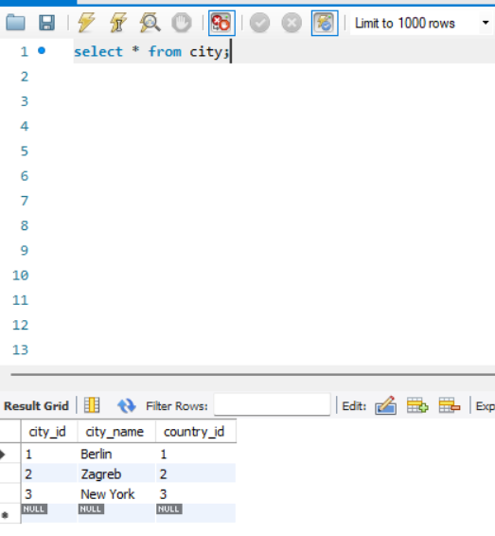

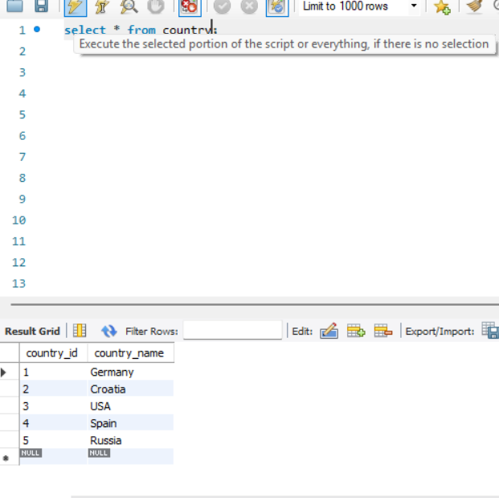
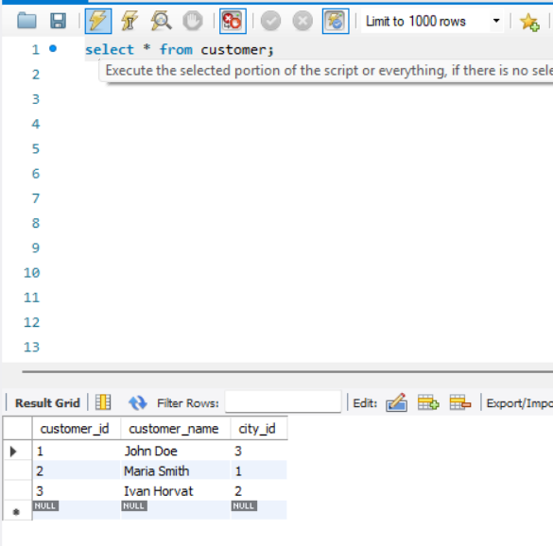
Task : 1 (join multiple tables using left join) List all Countries and customers related to these countries. For each country displaying its name in English, the name of the city customer is located in as well as the name of the customer. Return even countries without related cities and customers.
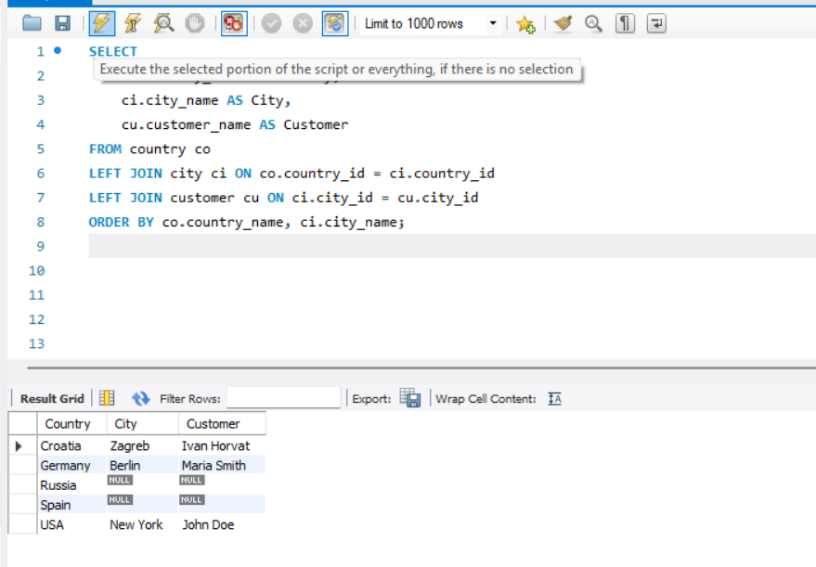

Task : 2 (join multiple tables using both left and inner join) Return the list of all countries that have pairs(exclude countries which are not referenced by any city). For such pairs return all customers. Return even pairs of not having a single customer
