1) MongoDB:

2. Implement MongoDB queries for the following operations:

**a. Insert a new event into the database.**



**b. Retrieve events within a specific time range, filtered by event type.**

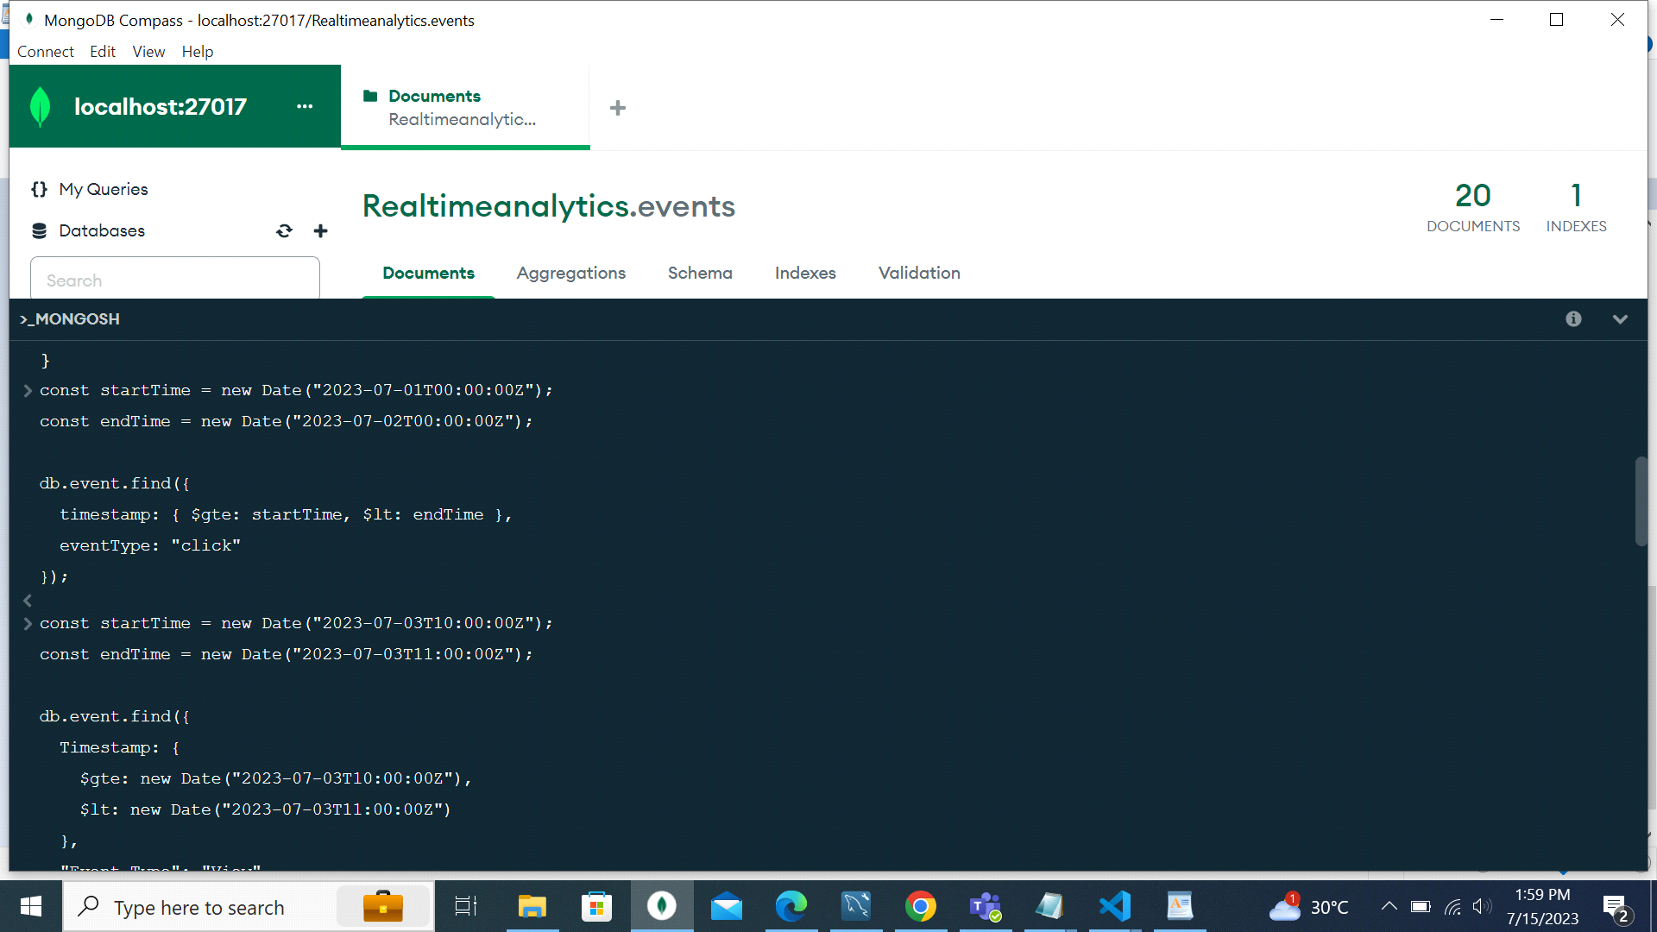

**d. Retrieve the top N users based on the number of events generated.**



**---------------------------------------------------------------------------------------------------------------------------**

**3. Discuss the benefits of using MongoDB's flexible schema for handling diverse event data.**

MongoDB's flexible schema provides several benefits for handling diverse event data:

1)Schema Evolution: MongoDB's flexible schema allows you to adapt and evolve your data model over time without requiring extensive schema migrations. This flexibility is particularly useful when dealing with evolving event data structures, as you can easily add or modify fields as needed without disrupting existing data.

2)Dynamic Fields: MongoDB allows the insertion of dynamic fields within documents, meaning each event can have different fields based on its specific characteristics. This flexibility accommodates the variability of event data, where different events may have different properties or additional data specific to their type. It avoids the need for a predefined, rigid schema that may not capture all the possible variations.

3)Reduced Data Transformation: With a flexible schema, you can store events directly as they arrive, eliminating the need for extensive data transformation before storing it in the database. This simplifies the data ingestion process and reduces the processing overhead, allowing faster and more efficient data ingestion for real-time analytics.

4)Agile Development: MongoDB's flexible schema promotes agile development practices, as it allows developers to quickly iterate and experiment with new event structures or data fields. It supports faster development cycles and enables easy iteration and testing of new features without disrupting the existing data model.

5)Query Flexibility: MongoDB's flexible schema enables flexible querying capabilities. You can easily query and filter events based on specific fields or criteria, including both common fields and dynamic fields. This flexibility makes it easier to extract valuable insights from event data and perform complex aggregations or analyses on the diverse data.

6)Horizontal Scalability: MongoDB's flexible schema supports horizontal scalability, allowing you to distribute event data across multiple nodes or shards. This scalability ensures high performance even with high volumes of diverse event data, enabling efficient handling of real-time analytics workloads.

---------------------------------------------------------------------------------------------------------------------------

**4. Explain how MongoDB's replica sets and automatic failover can ensure high availability and data durability in the analytics system.**

4. MongoDB's replica sets and automatic failover mechanism are designed to ensure high availability and data durability in the analytics system.

Here's an explanation of how these features work:

**Replica Sets:**

Replica sets in MongoDB are a group of MongoDB instances that maintain the same data set.A replica set consists of a primary node and one or more secondary nodes.

The primary node receives all write operations and replicates the changes to the secondary nodes asynchronously.

Replica sets provide data redundancy and fault tolerance. If the primary node fails, one of the secondary nodes automatically becomes the new primary to continue serving read and write operations.

**Automatic Failover:**

Automatic failover is a key feature of replica sets that ensures high availability in case of primary node failure.

When the primary node becomes unavailable due to a crash, network issues, or maintenance, the replica set elects a new primary node automatically.

The election process involves a majority vote among the remaining healthy nodes in the replica set.

Once a new primary is elected, the replica set continues to serve read and write operations without interruption.

**Data Durability**:

MongoDB ensures data durability by persistently storing data on disk and providing options for data replication.

Write operations are acknowledged by the primary node only after the data is durably written to the primary's disk journal.

The primary node then replicates the data to the secondary nodes, ensuring that the data is replicated and durable across multiple nodes.

By default, MongoDB uses write concern "majority" to ensure that write operations are acknowledged by a majority of the replica set members.

This means that write operations are durable and considered successful once they are acknowledged by the majority of the replica set members.

**High Availability:**

Replica sets provide high availability by enabling continuous service even in the event of primary node failures.

If the primary node fails, one of the healthy secondary nodes is automatically promoted as the new primary, ensuring uninterrupted service.

Clients can connect to the replica set using the replica set connection string, which automatically directs them to the current primary node.

By combining replica sets and automatic failover, MongoDB ensures high availability and data durability in the analytics system. It provides fault tolerance, data redundancy, and automatic recovery in case of node failures, minimizing downtime and ensuring continuous access to data for analytics and reporting purposes.