A

Project REPORT

ON

“AIRTRACK”



**Submitted To**

**Shivaji University, Kolhapur**

**In Partial Fulfillment of S.E. (Computer Science & Engineering)**

**Submitted By**

**Name of Students Roll No**

**1) Ms.Cheke Sneha Prabhakar 02**

**2) Ms.Mohite Gauri Uttam 04**

**3) Ms.Patil Varsha Vikas 06**

**Under the Guidance of**

**Asst. Prof. P. S. Jadhav**



**Computer Science & Engineering**

**D.Y.Patil Technical Campus Talsande Kolhapur.**

**2017-2018**



**Department of Computer Science & Engineering**

***CERTIFICATE***

*This is to certify that undersigned students of S.E. (Computer sci. & Engineering) has satisfactory completed Project work entitled* ***“AIRTRACK”*** *towards the partial fulfillment of SE Computer sci. course as per the rules laid down by Shivaji University, Kolhapur, for year 2017 - 2018. This report represents the bonafied work carried out by the students.*

**Guide HOD**

(Asst. Prof. P. S. Jadhav) (Asst. Prof. U. A. Patil)

**Director**  (Dr. S. R. Pawaskar)

### DECLARATION BY STUDENT

We hereby certify that the work which is being presented in the project entitled **“AIRTRACK ”** in partial fulfillment of requirements for the SE Computer, submitted in the Department of Computer Sci.& Engineering D. Y. Patil Technical Campus Talsande, Kolhapur, Maharashtra; is an authenticate record of our own work carried out during period from 2017 to 2018 under the supervision of Asst. Prof. P. S. Jadhav.

The matter presented in this mini project has not been submitted in any other University/Institute.

**Place:**

**Date:**

**Name of Students Roll No Signature**

1) Ms.Cheke Sneha Prabhakar 02

2) Ms.Mohite Gauri Uttam 04

3) Ms.Patil Varsha Vikas 06

**ACKNOWLEDGMENT**

For a strong tree a strong root is a prime requirement. Similarly for any project to be a great success a good guidance is required. We would like to express our deep gratitude towards our Guide **Asst. Prof. P. S. Jadhav** & Head of the Department **Asst.**.**Prof. U.A.Patil** for his valuable guidance and constant motivation.

We would like to thank **Dr. S. R. Pawaskar,** Director of D.Y. Patil Technical Campus Faculty of Engineering & Faculty of Management Talsande Kolhapur, for their encouragement & motivating us for this project work. We are grateful about them for providing necessary facilities for completion of this project work.

We would also like to thank our family member for support & encouraging us, and my friends & colleagues.

Lastly we thank all the persons who have guided and helped us directly or indirectly.

**INDEX**

|  |  |  |
| --- | --- | --- |
| **Sr.No** | **Chapter** | **Page No.** |
| **1** | **Problem Statement** |  |
| **2** | **Introduction** |  |
| **3** | **Objective** |  |
| **4** | **Scope of project** |  |
| **5** | **Flow chart** |  |
| **6** | **Result** |  |
| **7** | **Conclusion** |  |
| **8** | **Future scope** |  |
| **9** | **Reference** |  |

**Chapter 1**

**Problem statement :**

To compute the length of the longest landing strip that can be built on the island.

**Objective:**

To construct the Airtrack on polygon shape island .

**Introduction:**

In our project named Airtrack we have referred ACM International Collegiate Programming Contest problem from said material we found various problem out of which we design Airtrack system such way that we use the maximum surface area with respect to available area.

For our project we use distance formula to calculate the maximum distance among two points.

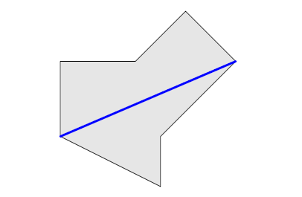

Fig A : the island modeled as a polygon

Given this polygon we need to compute the length of lonest landing strip (i.e. straight line segment) that can be built on the island . The landing strip must not intersect the sea, but it may touch or run along the boundary of the island.

**Chapter 2**

**Scope of project:-**

To design Airtrack on the polygon shape island .

**Flowchart:-**

Start

Initialized a variable & co-ordinate

Enter co-ordinates of points

Compare the co-ordinates sides

If length is higher

Print the higher length

Compare next higher length strip

Print the length

Calculate higher length strips

YES

Stop

NO

**Chapter 3**

**Result :**

**Sample Input/output:-**

|  |  |
| --- | --- |
| Sample input | Output |
| 3  0 2017  -2017 -2017  2017 0 | 4510.15 |

**Snapshot:** 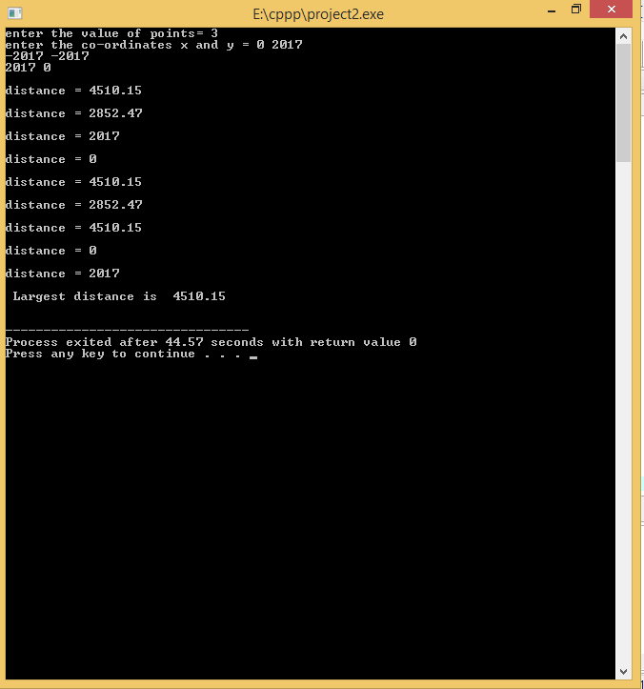

**Chapter 4**

**Software/Hardware Requirement:-**

**Software requirement**

Operating system: Windows 7 or later versions

Programming Language used: C++

**Hardware requirement**

Processor: Intel core i3 or above

Hard disk: 500 GB

RAM: 2GB

**Chapter 5**

**Conclusion:**

Polygon shape which is not suitable for airport construction by this mini project it is possible to construct the air track on polygon shape island.

**Future Scope :**

* To design the airtrack on any shape island.

**Reference :**

* ACM ICPC Problem –A 2017
* www.acmicpc.com
* www.mathc.com