In [1]: import numpy as np import pandas as pd import matplotlib.pyplot as plt import seaborn as sns

In [2]:
df = pd.read_csv(r"C:\Users\Owner\Downloads\data.xlsx - Sheet1.csv") df.head()
Out[2]: Unnamed:
ID Salary DOJ DOL Designation JobCity Gender DOB 10percentage ... ComputerScience MechanicalEngg Electr

0
senior
6/1/12 2/19/90
- train 203097 420000.0 present quality Bangalore f 84.3 ... -1 -1
0:00 0:00 engineer
9/1/13 assistant 10/4/89
- train 579905 500000.0 present Indore m 85.4 ... -1 -1 0:00 manager 0:00
6/1/14 systems 8/3/92
- train 810601 325000.0 present Chennai f 85.0 ... -1 -1 0:00 engineer 0:00
senior
7/1/11 12/5/89
- train 267447 1100000.0 present software Gurgaon m 85.6 ... -1 -1
0:00 0:00 engineer
3/1/14 3/1/15 2/27/91
- train 343523 200000.0 get Manesar m 78.0 ... -1 -1 0:00 0:00 0:00
- rows × 39 columns
In [3]:
df.shape
Out[3]:(3998, 39)
In [4]:
df.info()
<class 'pandas.core.frame.DataFrame'>
RangeIndex: 3998 entries, 0 to 3997
Data columns (total 39 columns):
# Column Non-Null Count Dtype
--- ------ -------------- -----
- Unnamed: 0 3998 non-null object
- ID 3998 non-null int64
- Salary 3998 non-null float64 3 DOJ 3998 non-null object
- DOL 3998 non-null object
- Designation 3998 non-null object
- JobCity 3998 non-null object
- Gender 3998 non-null object
- DOB 3998 non-null object
- 10percentage 3998 non-null float64
- 10board 3998 non-null object
- 12graduation 3998 non-null int64
- 12percentage 3998 non-null float64
- 12board 3998 non-null object
- CollegeID 3998 non-null int64
- CollegeTier 3998 non-null int64
- Degree 3998 non-null object
- Specialization 3998 non-null object
- collegeGPA 3998 non-null float64
- CollegeCityID 3998 non-null int64
- CollegeCityTier 3998 non-null int64
- CollegeState 3998 non-null object
- GraduationYear 3998 non-null int64
- English 3998 non-null int64
- Logical 3998 non-null int64
- Quant 3998 non-null int64
- Domain 3998 non-null float64
- ComputerProgramming 3998 non-null int64
- ElectronicsAndSemicon 3998 non-null int64
- ComputerScience 3998 non-null int64
- MechanicalEngg 3998 non-null int64
- ElectricalEngg 3998 non-null int64
- TelecomEngg 3998 non-null int64
- CivilEngg 3998 non-null int64
- conscientiousness 3998 non-null float64
- agreeableness 3998 non-null float64
- extraversion 3998 non-null float64
- nueroticism 3998 non-null float64 38 openess_to_experience 3998 non-null float64 dtypes: float64(10), int64(17), object(12) memory usage: 1.2+ MB
In [5]:
date_columns = ['DOJ' , 'DOL', 'DOB'] for col in date_columns:
df[col] = pd.to_datetime(df[col], errors= 'ignore' , format= '%m/%d/%y %H:%M')
df.info() <class 'pandas.core.frame.DataFrame'>
RangeIndex: 3998 entries, 0 to 3997
Data columns (total 39 columns):
# Column Non-Null Count Dtype
--- ------ -------------- -----
- Unnamed: 0 3998 non-null object
- ID 3998 non-null int64
- Salary 3998 non-null float64
- DOJ 3998 non-null datetime64[ns]
- DOL 3998 non-null object
- Designation 3998 non-null object
- JobCity 3998 non-null object
- Gender 3998 non-null object
- DOB 3998 non-null datetime64[ns]
- 10percentage 3998 non-null float64
- 10board 3998 non-null object
- 12graduation 3998 non-null int64
- 12percentage 3998 non-null float64
- 12board 3998 non-null object
- CollegeID 3998 non-null int64
- CollegeTier 3998 non-null int64
- Degree 3998 non-null object
- Specialization 3998 non-null object
- collegeGPA 3998 non-null float64
- CollegeCityID 3998 non-null int64
- CollegeCityTier 3998 non-null int64
- CollegeState 3998 non-null object
- GraduationYear 3998 non-null int64
- English 3998 non-null int64
- Logical 3998 non-null int64
- Quant 3998 non-null int64
- Domain 3998 non-null float64
- ComputerProgramming 3998 non-null int64
- ElectronicsAndSemicon 3998 non-null int64
- ComputerScience 3998 non-null int64
- MechanicalEngg 3998 non-null int64
- ElectricalEngg 3998 non-null int64
- TelecomEngg 3998 non-null int64
- CivilEngg 3998 non-null int64
- conscientiousness 3998 non-null float64
- agreeableness 3998 non-null float64
- extraversion 3998 non-null float64
- nueroticism 3998 non-null float64 38 openess_to_experience 3998 non-null float64 dtypes: datetime64[ns](2), float64(10), int64(17), object(10) memory usage: 1.2+ MB
In [6]: df.describe()
^{Out[6]:}
 | ID | Salary | 10percentage | 12graduation | 12percentage | CollegeID | CollegeTier | collegeGPA | CollegeCityID | CollegeCityTier
count | 3.998000e+03 | 3.998000e+03 | 3998.000000 | 3998.000000 | 3998.000000 | 3998.000000 | 3998.000000 | 3998.000000 | 3998.000000 | 3998.000000
mean | 6.637945e+05 | 3.076998e+05 | 77.925443 | 2008.087544 | 74.466366 | 5156.851426 | 1.925713 | 71.486171 | 5156.851426 | 0.300400
std | 3.632182e+05 | 2.127375e+05 | 9.850162 | 1.653599 | 10.999933 | 4802.261482 | 0.262270 | 8.167338 | 4802.261482 | 0.458489
min | 1.124400e+04 | 3.500000e+04 | 43.000000 | 1995.000000 | 40.000000 | 2.000000 | 1.000000 | 6.450000 | 2.000000 | 0.000000
25% | 3.342842e+05 | 1.800000e+05 | 71.680000 | 2007.000000 | 66.000000 | 494.000000 | 2.000000 | 66.407500 | 494.000000 | 0.000000
50% | 6.396000e+05 | 3.000000e+05 | 79.150000 | 2008.000000 | 74.400000 | 3879.000000 | 2.000000 | 71.720000 | 3879.000000 | 0.000000
75% | 9.904800e+05 | 3.700000e+05 | 85.670000 | 2009.000000 | 82.600000 | 8818.000000 | 2.000000 | 76.327500 | 8818.000000 | 1.000000
max | 1.298275e+06 | 4.000000e+06 | 97.760000 | 2013.000000 | 98.700000 | 18409.000000 | 2.000000 | 99.930000 | 18409.000000 | 1.000000
8 rows × 27 columns
In [7]:
df.isnull().sum()
Out[7]:Unnamed: 0 0
ID 0
Salary 0
DOJ 0
DOL 0
Designation 0
JobCity 0
Gender 0
DOB 0
10percentage 0
10board 0
12graduation 0
12percentage 0
12board 0
CollegeID 0
CollegeTier 0
Degree 0 Specialization 0 collegeGPA 0
CollegeCityID 0
CollegeCityTier 0
CollegeState 0
GraduationYear 0 English 0
Logical 0
Quant 0
Domain 0
ComputerProgramming 0
ElectronicsAndSemicon 0
ComputerScience 0
MechanicalEngg 0
ElectricalEngg 0
TelecomEngg 0 CivilEngg 0 conscientiousness 0 agreeableness 0 extraversion 0 nueroticism 0
openess_to_experience 0 dtype: int64
Exploratory Data Analysis and Visualization
In [8]:
df.columns
Out[8]:Index(['Unnamed: 0', 'ID', 'Salary', 'DOJ', 'DOL', 'Designation', 'JobCity',
'Gender', 'DOB', '10percentage', '10board', '12graduation',
'12percentage', '12board', 'CollegeID', 'CollegeTier', 'Degree',
'Specialization', 'collegeGPA', 'CollegeCityID', 'CollegeCityTier',
'CollegeState', 'GraduationYear', 'English', 'Logical', 'Quant',
'Domain', 'ComputerProgramming', 'ElectronicsAndSemicon',
'ComputerScience', 'MechanicalEngg', 'ElectricalEngg', 'TelecomEngg',
'CivilEngg', 'conscientiousness', 'agreeableness', 'extraversion',
'nueroticism', 'openess_to_experience'], dtype='object')
DATA VISUALIZATION
In [9]:
plt.figure(figsize=(10,8)) sns.set_style("darkgrid") sns.boxplot(df['Quant']) Out[9]:<Axes: >
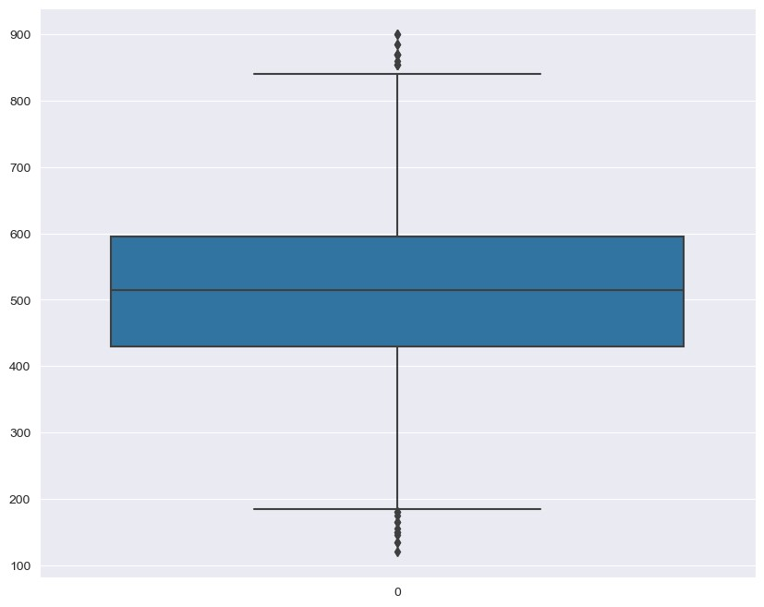
In [10]: # Outliers df['Quant'][(df['Quant']<190) | (df['Quant']>850)].reset_index()
Out[10]: index Quant
0 195 | 870
1 522 | 165
2 564 | 180
3 698 | 860
4 783 | 180
5 899 | 870
6 1148 | 175
7 1310 | 870
8 1661 | 870
9 1815 | 135
10 2007 | 855
11 2134 | 145
12 2155 | 870
13 2411 | 885
14 2437 | 120
15 2490 | 900
16 2616 | 135
17 2932 | 165
18 2957 | 900
19 2988 | 885
20 3165 | 855
21 3239 | 855
22 3258 | 150
23 3283 | 150
24 3544 | 185
25 3616 | 155
In [11]: plt.figure(figsize=(10,8)) sns.set_style("darkgrid") sns.boxplot(df['Domain']) plt.show()
In [12]:
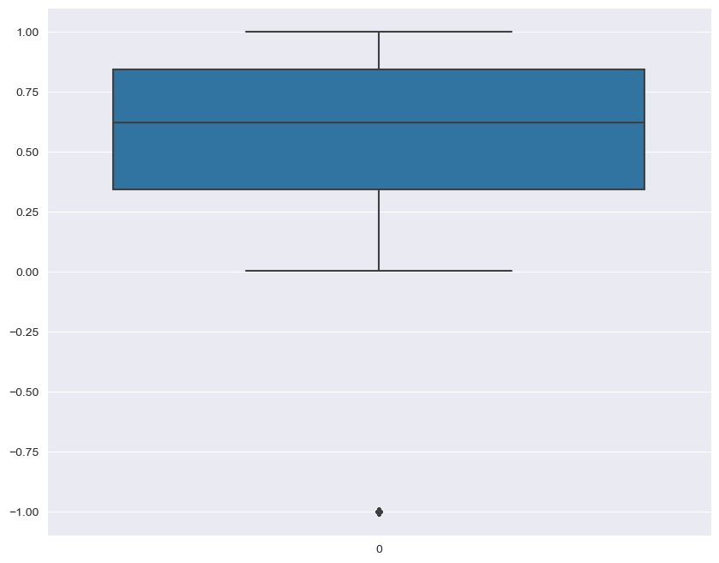
sns.set_style("darkgrid") plt.figure(figsize=(8,6)) sns.distplot(df['Salary']) plt.title("Pdf distribution of Salary")
C:\Users\Owner\AppData\Local\Temp\ipykernel_6792\186139634.py:3: UserWarning:
`distplot` is a deprecated function and will be removed in seaborn v0.14.0.
Please adapt your code to use either `displot` (a figure-level function with similar flexibility) or `histplot` (an axes-level function for histograms).
For a guide to updating your code to use the new functions, please see https://gist.github.com/mwaskom/de44147ed2974457ad6372750bbe5751
sns.distplot(df['Salary'])
Out[12]:Text(0.5, 1.0, 'Pdf distribution of Salary')
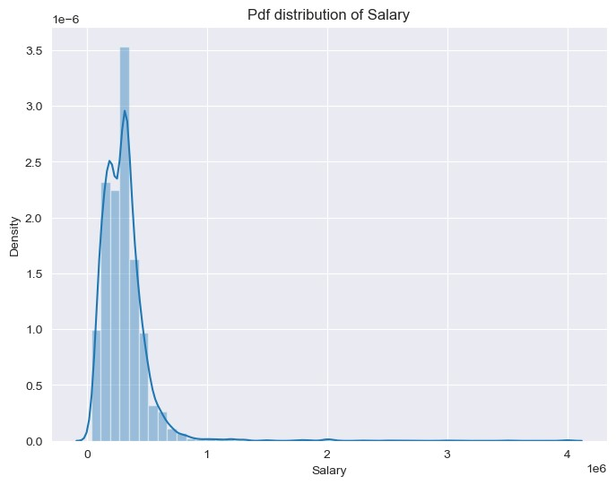
sns.set_style("darkgrid") plt.figure(figsize=(8,6)) sns.distplot(df['10percentage'])
"Pdf distribution of 10percentage") C:\Users\Owner\AppData\Local\Temp\ipykernel_6792\680487440.py:3: UserWarning:
`distplot` is a deprecated function and will be removed in seaborn v0.14.0.
Please adapt your code to use either `displot` (a figure-level function with similar flexibility) or `histplot` (an axes-level function for histograms).
For a guide to updating your code to use the new functions, please see https://gist.github.com/mwaskom/de44147ed2974457ad6372750bbe5751
sns.distplot(df['10percentage'])
Out[13]:Text(0.5, 1.0, 'Pdf distribution of 10percentage')
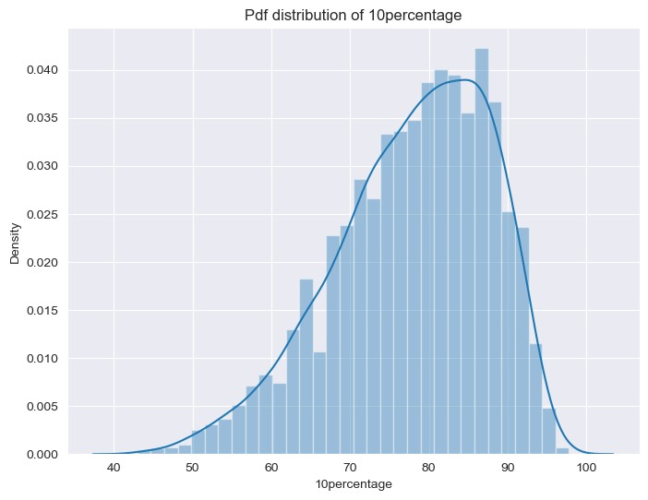
sns.set_style("darkgrid") plt.figure(figsize=(8,6)) sns.distplot(df['12percentage'])
"Pdf distribution of 12percentage") C:\Users\Owner\AppData\Local\Temp\ipykernel_6792\835645539.py:3: UserWarning:
`distplot` is a deprecated function and will be removed in seaborn v0.14.0.
Please adapt your code to use either `displot` (a figure-level function with similar flexibility) or `histplot` (an axes-level function for histograms).
For a guide to updating your code to use the new functions, please see https://gist.github.com/mwaskom/de44147ed2974457ad6372750bbe5751
sns.distplot(df['12percentage'])
Out[14]:Text(0.5, 1.0, 'Pdf distribution of 12percentage')
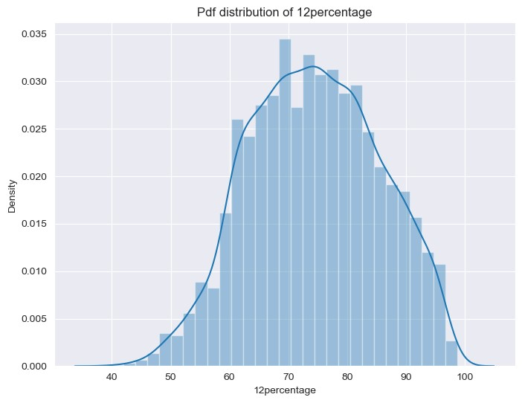
sns.set_style("darkgrid") plt.figure(figsize=(8,6)) sns.distplot(df['collegeGPA'])
"Pdf distribution of collegeGPA")
C:\Users\Owner\AppData\Local\Temp\ipykernel_6792\457740276.py:3: UserWarning:
`distplot` is a deprecated function and will be removed in seaborn v0.14.0.
Please adapt your code to use either `displot` (a figure-level function with similar flexibility) or `histplot` (an axes-level function for histograms).
For a guide to updating your code to use the new functions, please see https://gist.github.com/mwaskom/de44147ed2974457ad6372750bbe5751
sns.distplot(df['collegeGPA'])
Out[15]:Text(0.5, 1.0, 'Pdf distribution of collegeGPA')
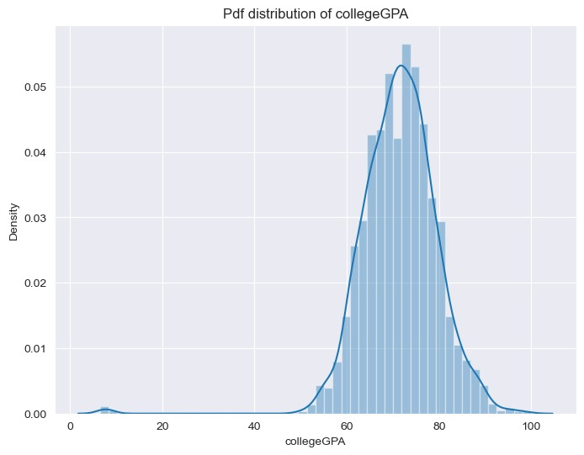
Designation offered in the job and it's count:
In [16]:
df['Designation']
Out[16]:0 senior quality engineer
- assistant manager
- systems engineer
- senior software engineer
- get
...
- software engineer
- technical writer
- associate software engineer
- software developer
- senior systems engineer
Name: Designation, Length: 3998, dtype: object
In [17]:
designations = df['Designation'].unique() len(designations)
Out[17]:419
In [18]:
designation_count = df['Designation'].value_counts() designation_count
Out[18]:software engineer 539 software developer 265 system engineer 205 programmer analyst 139 systems engineer 118
...
cad drafter 1 noc engineer 1 human resources intern 1 senior quality assurance engineer 1
jr. software developer 1
Name: Designation, Length: 419, dtype: int64
In [19]:
# Taking the most frequent designation
designation_count[:15]
Out[19]:software engineer 539 software developer 265 system engineer 205 programmer analyst 139 systems engineer 118 java software engineer 111 software test engineer 100 project engineer 77 technical support engineer 76 senior software engineer 72 java developer 67 test engineer 57 web developer 54 application developer 52 assistant manager 52
Name: Designation, dtype: int64
In [20]:
# plotting the most frequent designation sns.set_style("darkgrid") plt.figure(figsize=(12,10)) designation_count[:15].plot(kind='bar', width=0.9) plt.xlabel('Designation') plt.ylabel('count') plt.title('Job Designation of a CSE Fresher')

Out[20]:Text(0.5, 1.0, 'Job Designation of a CSE Fresher')
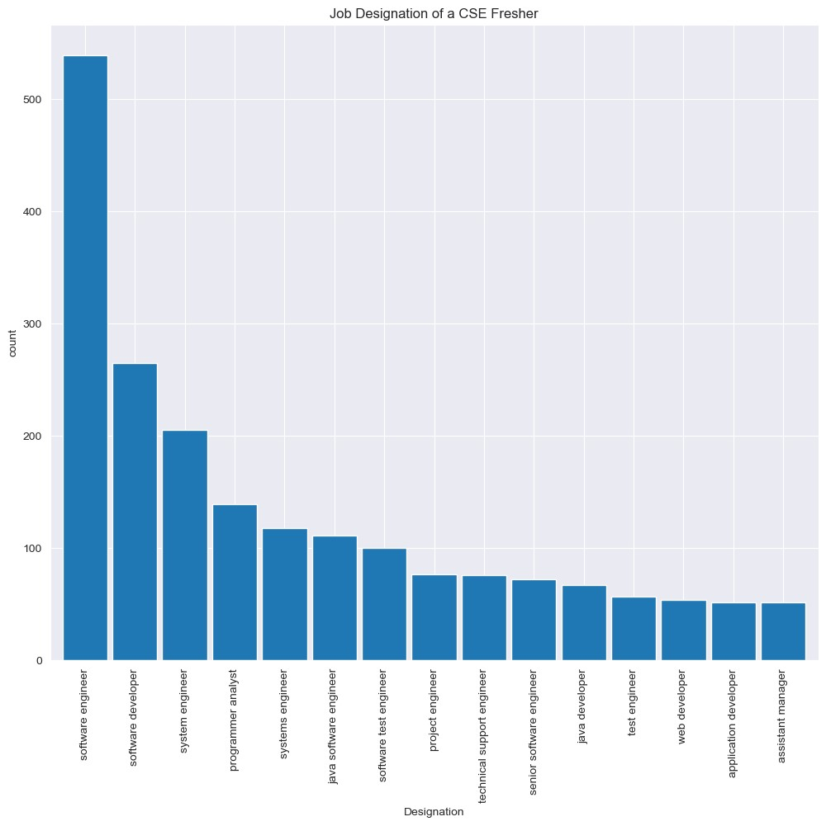
Degree obtained/pursued by the candidate and it's count
In [21]:
df['Degree']
Out[21]:0 B.Tech/B.E.
- B.Tech/B.E.
- B.Tech/B.E.
- B.Tech/B.E.
- B.Tech/B.E.
...
- B.Tech/B.E.
- B.Tech/B.E.
- B.Tech/B.E.
- B.Tech/B.E.
- B.Tech/B.E.
Name: Degree, Length: 3998, dtype: object
In [22]:
uniq_degree = df['Degree'].unique() len(uniq_degree)
Out[22]:4
In [23]:
degree_count = df['Degree'].value_counts()
degree_count
Out[23]:B.Tech/B.E. 3700
MCA 243
M.Tech./M.E. 53 M.Sc. (Tech.) 2
Name: Degree, dtype: int64
In [24]:
# plotting the most frequent Degree sns.set_style("darkgrid") plt.figure(figsize=(12,10)) degree_count.plot(kind= 'bar', width=0.7,logy=True) plt.xlabel('Degree') plt.ylabel('count') plt.title('Degree obtained/pursued by the candidate') Out[24]:Text(0.5, 1.0, 'Degree obtained/pursued by the candidate')
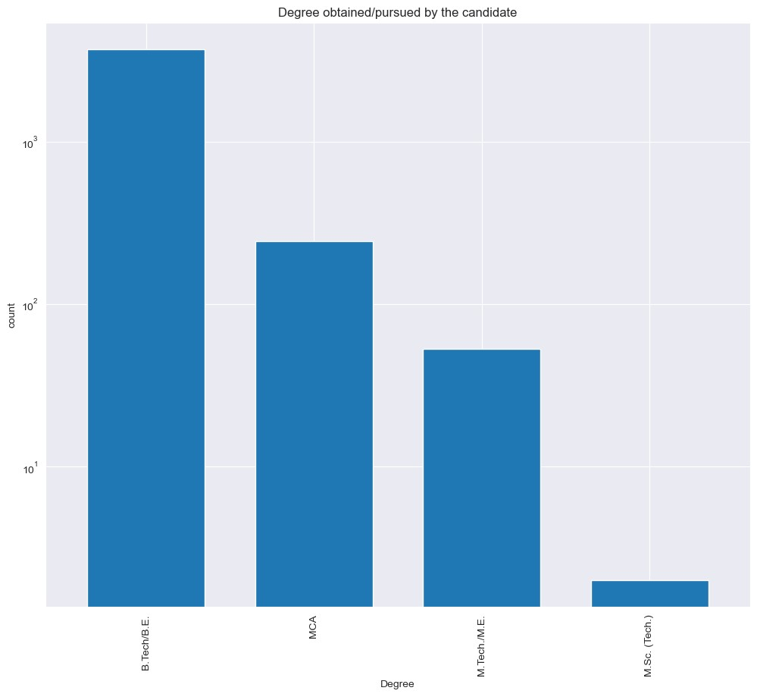
In [25]:
df['Specialization']
Out[25]:0 computer engineering
- electronics and communication engineering
- information technology
- computer engineering4 electronics and communication engineering
...
- information technology
- electronics and communication engineering
- computer engineering
- computer science & engineering
- information technology
Name: Specialization, Length: 3998, dtype: object
In [26]:uniq_specialization = df['Specialization'].unique() len(uniq_specialization)
Out[26]:46
In [27]:
specialization_count = df['Specialization'].value_counts() specialization_count
Out[27]:electronics and communication engineering 880 computer science & engineering 744 information technology 660 computer engineering 600 computer application 244 mechanical engineering 201 electronics and electrical engineering 196 electronics & telecommunications 121 electrical engineering 82 electronics & instrumentation eng 32 civil engineering 29
electronics and instrumentation engineering 27 information science engineering 27 instrumentation and control engineering 20 electronics engineering 19 biotechnology 15 other 13
industrial & production engineering 10 applied electronics and instrumentation 9 chemical engineering 9 computer science and technology 6 telecommunication engineering 6 mechanical and automation 5 automobile/automotive engineering 5 instrumentation engineering 4 mechatronics 4 aeronautical engineering 3 electronics and computer engineering 3 electrical and power engineering 2 biomedical engineering 2 information & communication technology 2
industrial engineering 2 computer science 2 metallurgical engineering 2 power systems and automation 1 control and instrumentation engineering 1 mechanical & production engineering 1 embedded systems technology 1 polymer technology 1 computer and communication engineering 1
information science 1 internal combustion engine 1 computer networking 1 ceramic engineering 1
electronics 1
industrial & management engineering 1
Name: Specialization, dtype: int64
In [28]:
specialization_count[:6]
Out[28]:electronics and communication engineering 880 computer science & engineering 744 information technology 660 computer engineering 600 computer application 244 mechanical engineering 201
Name: Specialization, dtype: int64
In [29]:
# plotting the most frequent Specialization sns.set_style("darkgrid") plt.figure(figsize=(12,10)) specialization_count[:6].plot(kind= 'bar', width=0.9) plt.xlabel('Specialization') plt.ylabel('Count') plt.title('Specialization pursued by the candidate') Out[29]:Text(0.5, 1.0, 'Specialization pursued by the candidate')
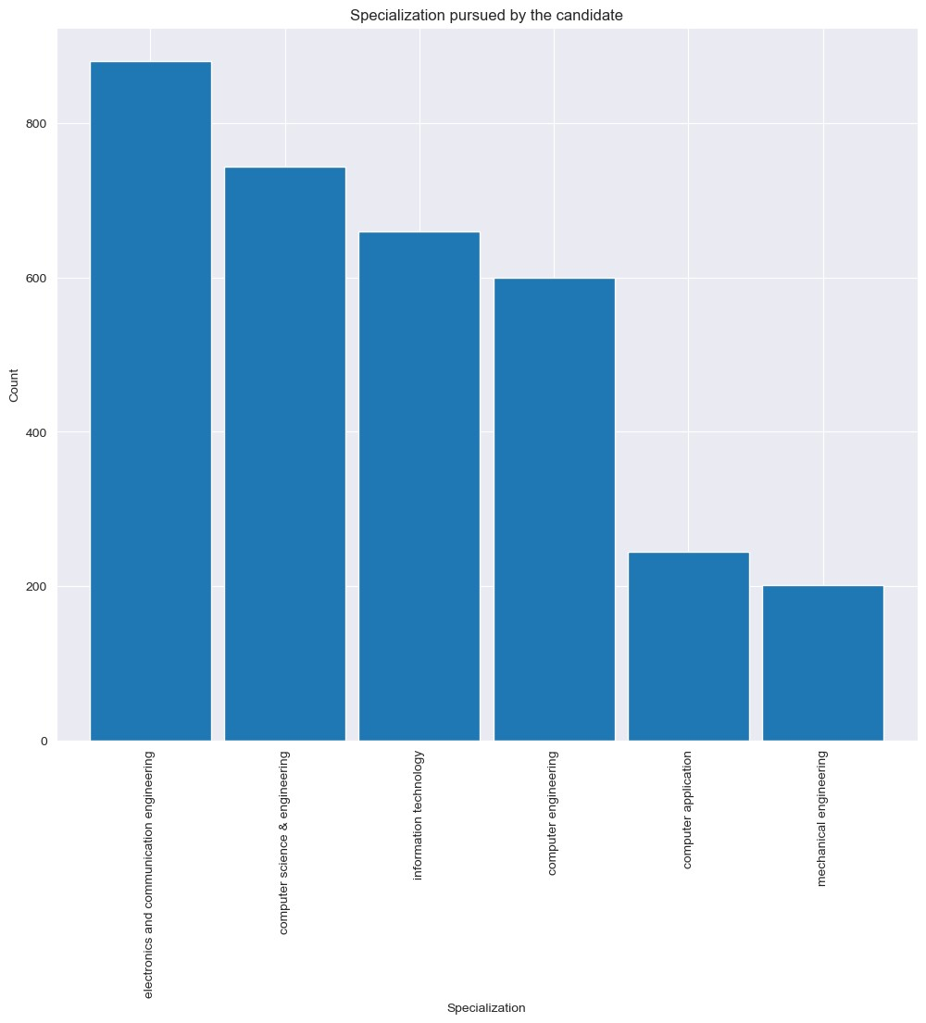
In [30]:
df['CollegeState']
Out[30]:0 Andhra Pradesh
- Madhya Pradesh
- Uttar Pradesh
- Delhi
- Uttar Pradesh
...
- Haryana
- Telangana
- Orissa
- Karnataka
- Tamil Nadu
Name: CollegeState, Length: 3998, dtype: object
In [31]:
uniq_collegestate = df['CollegeState'].unique() len(uniq_collegestate)
Out[31]:26
In [32]:
college_state_count = df['CollegeState'].value_counts() college_state_count
Out[32]:Uttar Pradesh 915
Karnataka 370
Tamil Nadu 367
Telangana 319
Maharashtra 262
Andhra Pradesh 225
West Bengal 196
Punjab 193
Madhya Pradesh 189
Haryana 180
Rajasthan 174
Orissa 172
Delhi 162
Uttarakhand 113
Kerala 33
Jharkhand 28
Chhattisgarh 27
Gujarat 24
Himachal Pradesh 16
Bihar 10
Jammu and Kashmir 7
Assam 5
Union Territory 5
Sikkim 3

Meghalaya 2
Goa 1
Name: CollegeState, dtype: int64
In [33]:
sns.set_style("darkgrid") plt.figure(figsize=(12,10)) college_state_count[:15].plot(kind= 'bar', width=0.9) plt.xlabel('College_State') plt.ylabel('Count') plt.title('College State Distribution')

Out[33]:Text(0.5, 1.0, 'College State Distribution')
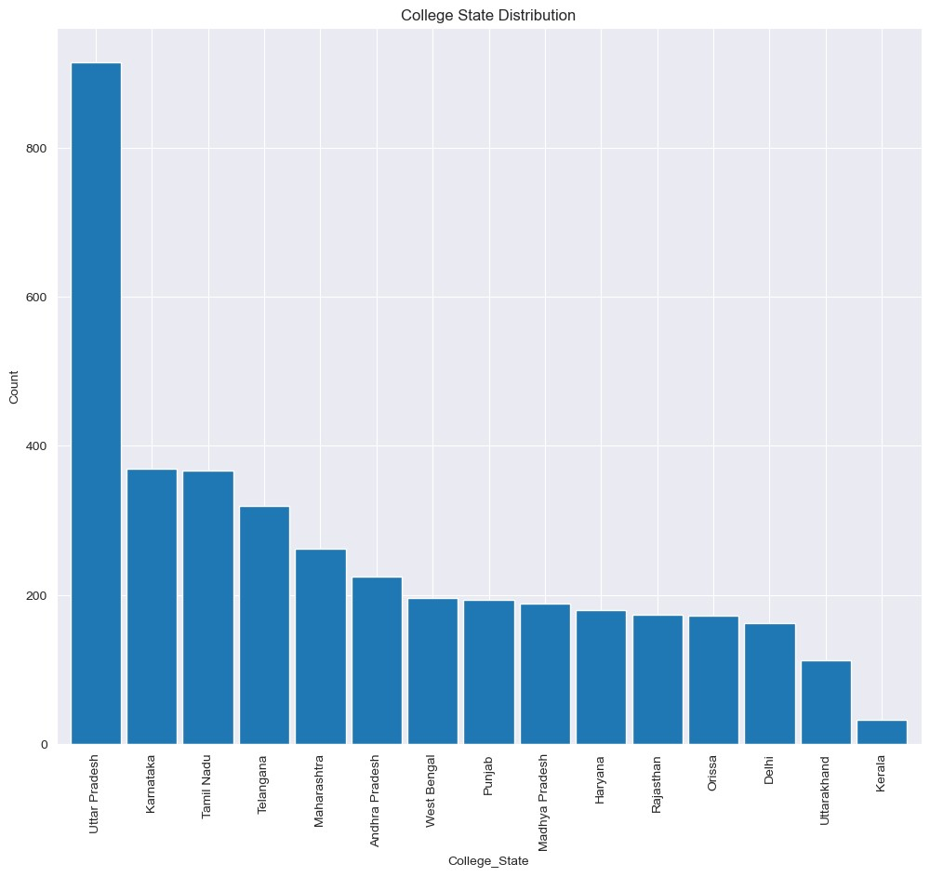
Yearwise Employment groupby Gender
In [34]:
sns.catplot(x = "GraduationYear", hue="Gender",data = df,kind='count') plt.xticks(rotation=90) plt.show()
Detect the Outliers in each numerical column
In [35]:
df.columns
Out[35]:Index(['Unnamed: 0', 'ID', 'Salary', 'DOJ', 'DOL', 'Designation', 'JobCity',
'Gender', 'DOB', '10percentage', '10board', '12graduation',
'12percentage', '12board', 'CollegeID', 'CollegeTier', 'Degree',
'Specialization', 'collegeGPA', 'CollegeCityID', 'CollegeCityTier',
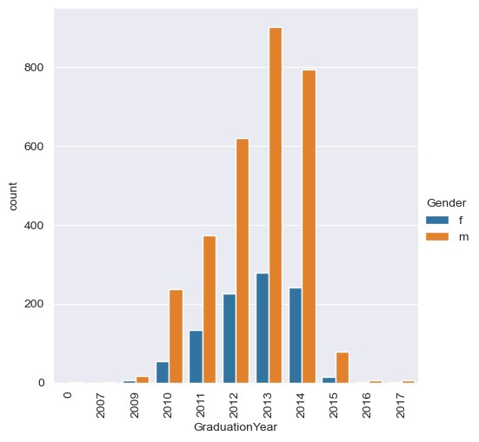
'CollegeState', 'GraduationYear', 'English', 'Logical', 'Quant',
'Domain', 'ComputerProgramming', 'ElectronicsAndSemicon',
'ComputerScience', 'MechanicalEngg', 'ElectricalEngg', 'TelecomEngg',
'CivilEngg', 'conscientiousness', 'agreeableness', 'extraversion',
'nueroticism', 'openess_to_experience'], dtype='object')
In [36]:
#Finding the outliers in 10percentage column plt.figure(figsize=(10,8)) sns.set_style("darkgrid") sns.boxplot(df['10percentage'])
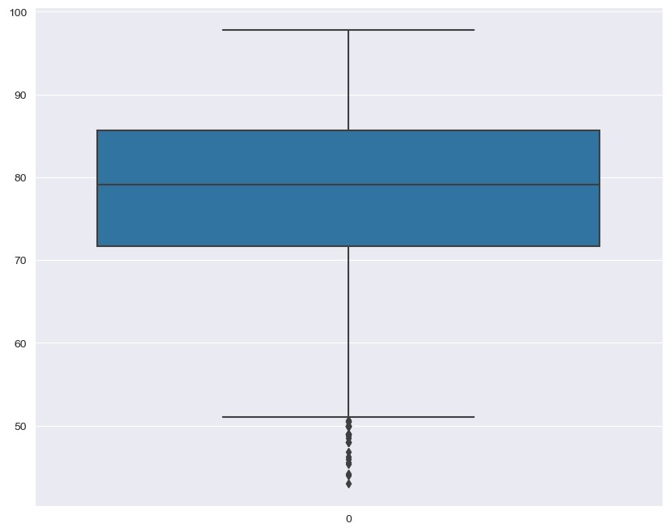
In [37]: #Outliers df['10percentage'][df['10percentage']<52].reset_index()
index 10percentage
0 108 | 51.00
1 245 | 50.60
2 466 | 44.16
3 490 | 44.00
4 491 | 45.60
5 502 | 48.00
6 600 | 49.00
7 613 | 48.00
8 887 | 51.20
9 898 | 49.00
10 919 | 48.80
11 1064 | 49.00
12 1102 | 49.00
13 1169 | 48.50
14 1193 | 48.00
15 1235 | 50.60
16 1334 | 43.00
17 1838 | 50.00
18 1845 | 49.00
19 1955 | 45.33
20 1976 | 46.24
21 2024 | 51.36
22 2037 | 48.00
23 2123 | 51.00
24 2215 | 50.50
25 2217 | 51.00
26 2292 | 50.00
27 2432 | 50.00
28 2563 | 51.60
29 2655 | 50.66
30 2885 | 46.80
31 2982 | 50.00
32 3284 | 50.00
33 3425 | 50.00
34 3507 | 51.83
35 3525 | 51.42
36 3690 | 46.00
37 3743 | 49.90
In [38]:
#Finding the outliers in 12percentage column plt.figure(figsize=(10,8)) sns.set_style("darkgrid") sns.boxplot(df['12percentage'])
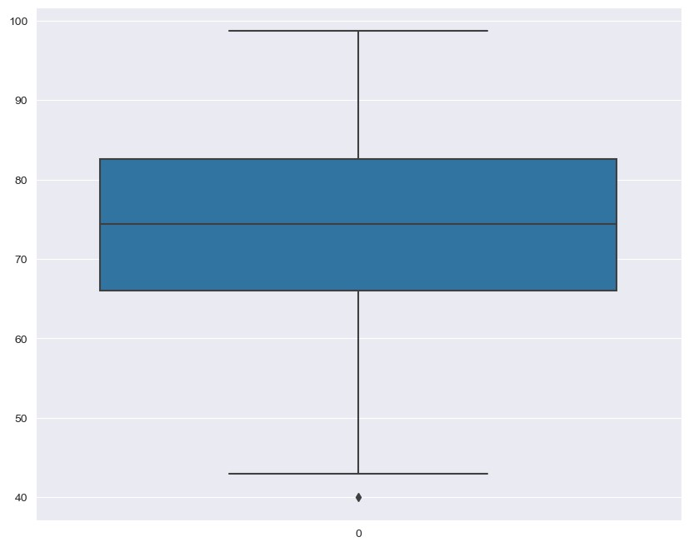
In [39]: #Outliers df['12percentage'][df['12percentage']<52].reset_index()
^{Out[39]:} index 12percentage
- 23 43.42
- 50 49.50
- 59 49.00
- 99 50.80
- 108 48.00
... ... ...
- 3678 51.23
- 3754 50.00
- 3806 48.00
- 3925 50.00
- 3955 49.00
- rows × 2 columns
In [40]:
#Finding the Outliers in Salary column plt.figure(figsize=(10,8)) sns.set_style("darkgrid") sns.boxplot(df['Salary'])
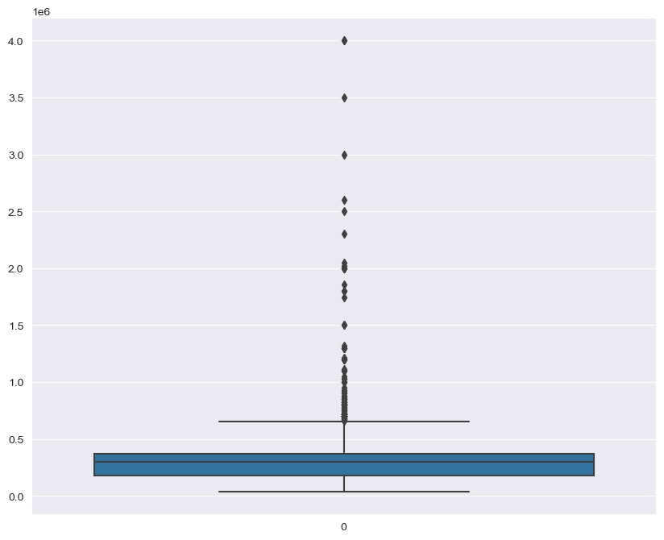
In [41]: plt.figure(figsize=(10,8)) sns.set_style("darkgrid") sns.boxplot(df['collegeGPA'])
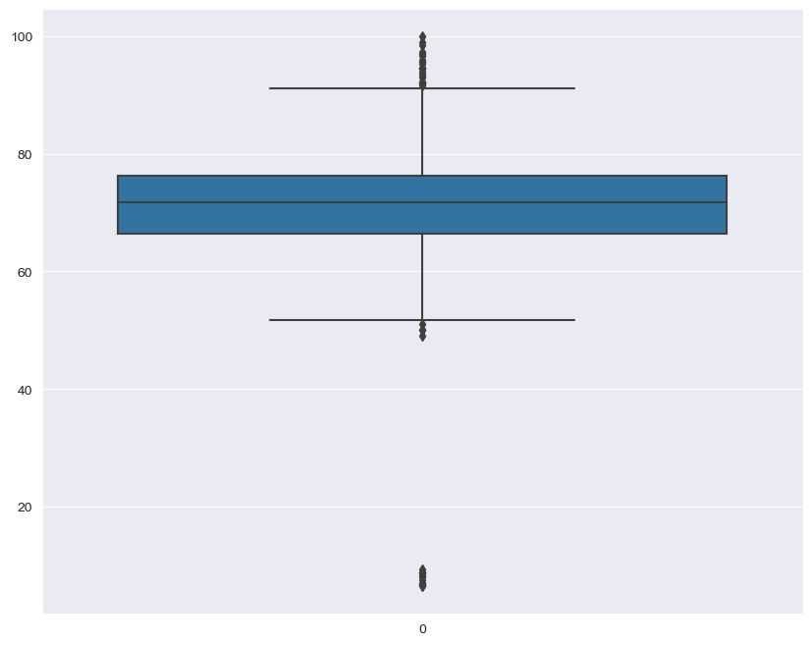
In [42]: #Outliers df['collegeGPA'][(df['collegeGPA']<53) | (df['collegeGPA']>93)].reset_index()
index collegeGPA
0 7 | 8.58
1 138 | 6.63
2 324 | 52.00
3 614 | 93.60
4 690 | 99.93
5 788 | 6.80
6 874 | 94.50
7 907 | 50.00
8 968 | 52.00
9 1134 | 96.00
10 1264 | 97.30
11 1345 | 93.30
12 1400 | 51.80
13 1419 | 6.85
14 1439 | 8.07
15 1510 | 96.70
16 1685 | 94.70
17 1767 | 7.56
18 2125 | 52.00
19 2151 | 6.95
20 2152 | 95.30
21 2229 | 8.13
22 2293 | 9.30
23 2410 | 52.00
24 2662 | 8.88
25 2691 | 8.89
26 2703 | 94.00
27 2836 | 49.07
28 2988 | 94.60
29 3151 | 98.40
30 3276 | 95.70
31 3293 | 51.00
32 3308 | 6.45
33 3323 | 96.90
34 3448 | 50.00
35 3590 | 52.00
36 3850 | 99.00
In [43]: plt.figure(figsize=(10,8)) sns.set_style("darkgrid") sns.boxplot(df['English'])
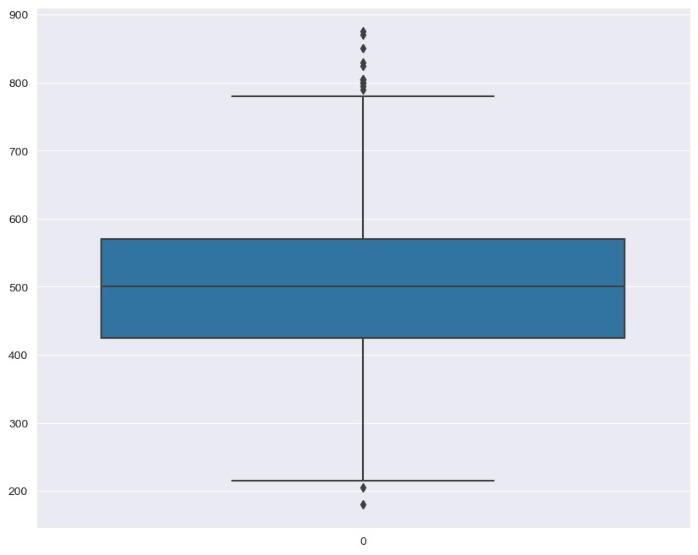
In [44]: #Outliers df['English'][(df['English']<220) | (df['English']>790)].reset_index()
^{Out[44]:} index English
- 275 875
- 444 825
- 624 215
- 668 870
- 847 800
- 935 205
- 1183 805
- 1217 180
- 1450 830
- 1519 795
- 2077 800
- 2122 800
- 2273 215
- 2385 805
- 2596 805
- 3044 850
In [45]:
plt.figure(figsize=(10,8)) sns.set_style("darkgrid") sns.boxplot(df['Quant'])
In [46]: #Outliers df['Quant'][(df['Quant']<190) | (df['Quant']>850)].reset_index()

index Quant
0 195 | 870
1 522 | 165
2 564 | 180
3 698 | 860
4 783 | 180
5 899 | 870
6 1148 | 175
7 1310 | 870
8 1661 | 870
9 1815 | 135
10 2007 | 855
11 2134 | 145
12 2155 | 870
13 2411 | 885
14 2437 | 120
15 2490 | 900
16 2616 | 135
17 2932 | 165
18 2957 | 900
19 2988 | 885
20 3165 | 855
21 3239 | 855
22 3258 | 150
23 3283 | 150
24 3544 | 185
25 3616 | 155
In [47]: plt.figure(figsize=(10,8)) sns.set_style("darkgrid") sns.boxplot(df['Domain'])
In [48]: #Outlier df['Domain'][df['Domain'] <= -1].value_counts().reset_index()
^{Out[48]:} index Domain
0 -1.0 246
In [49]:
plt.figure(figsize=(10,8)) sns.set_style("darkgrid") sns.boxplot(df['ComputerProgramming'])
Out[49]:
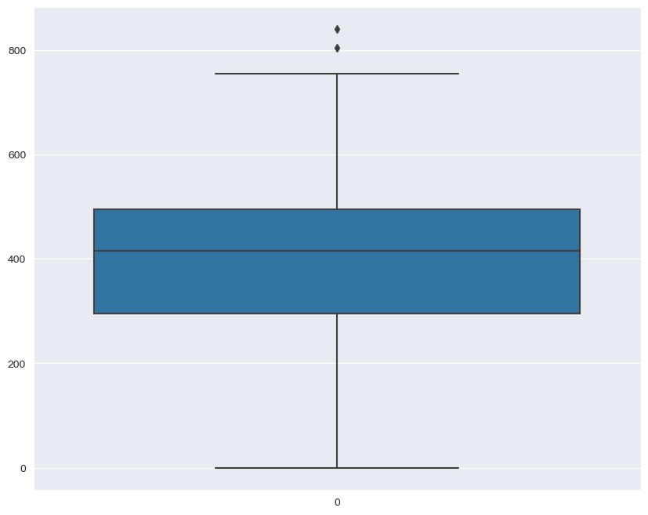
In [50]: #Outlier df['ComputerProgramming'][df['ComputerProgramming'] <= 800].reset_index()
^{Out[50]:} index ComputerProgramming
- 0 445
- 1 -1
- 2 395

3 3 615
4 4 -1
... ... ...
- 3993 345
- 3994 325
- 3995 405

3994 3996 445

3995 3997 435
3996 rows × 2 columns
In [51]:
plt.figure(figsize=(10,8)) sns.set_style("darkgrid") sns.boxplot(df['ElectronicsAndSemicon']) Out[51]:
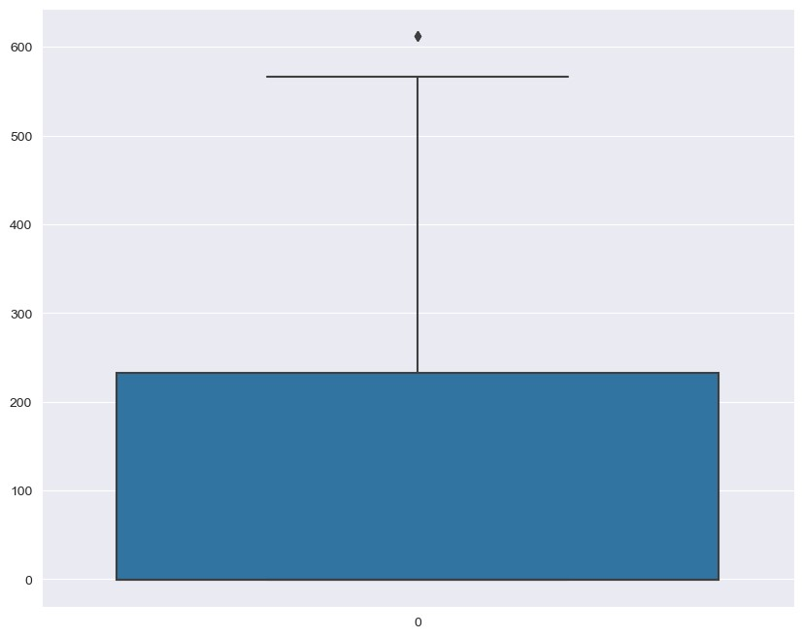
In [52]: #Outlier df['ElectronicsAndSemicon'][df['ElectronicsAndSemicon'] <= 600].reset_index()
^{Out[52]:} index ElectronicsAndSemicon
- 0 -1
- 1 466
- 2 -1
- 3 -1
- 4 233
... ... ...
- 3993 -1
- 3994 420
- 3995 -1
- 3996 -1
- 3997 -1
- rows × 2 columns
In [53]:
plt.figure(figsize=(10,8)) sns.set_style("darkgrid") sns.boxplot(df['ComputerScience']) Out[53]:
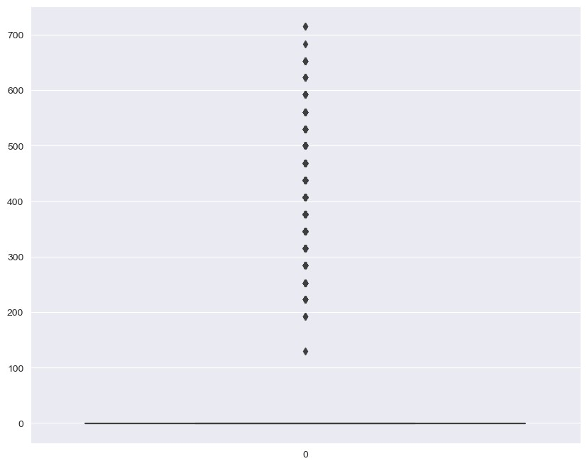
In [54]: #Outlier df['ComputerScience'][df['ComputerScience'] <= 100].value_counts().reset_index()
^{Out[54]:} index ComputerScience
0 -1 3096
In [55]:
plt.figure(figsize=(10,8)) sns.set_style("darkgrid") sns.boxplot(df['MechanicalEngg']) Out[55]:
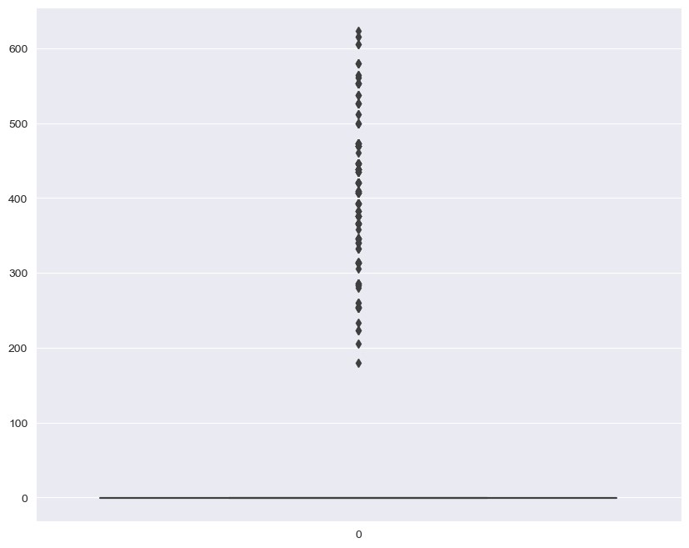
In [56]: #Outlier df['MechanicalEngg'][df['MechanicalEngg'] <= 179].value_counts().reset_index()
^{Out[56]:} index MechanicalEngg
0 -1 3763
In [57]:
plt.figure(figsize=(10,8)) sns.set_style("darkgrid") sns.boxplot(df['ElectricalEngg']) Out[57]:
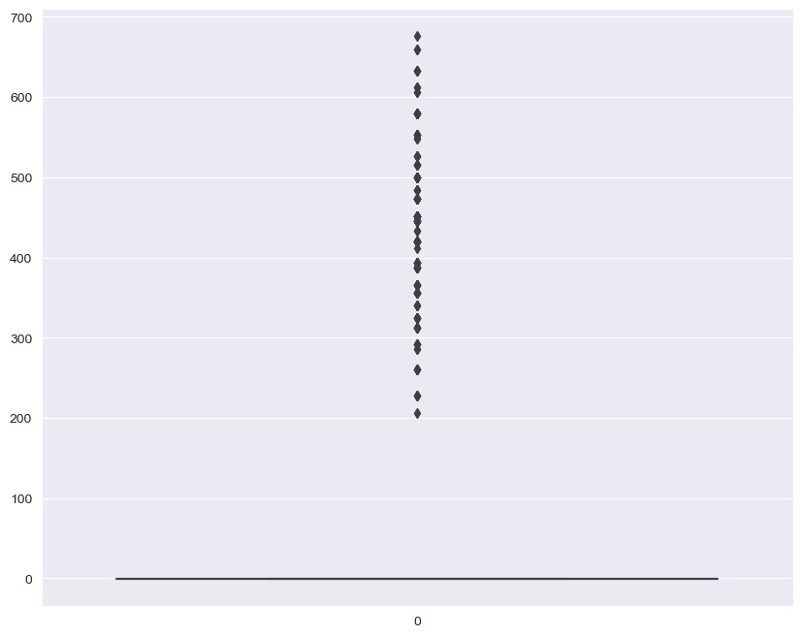
In [58]: #Outlier df['ElectricalEngg'][df['ElectricalEngg'] <= 200].value_counts().reset_index()
^{Out[58]:} index ElectricalEngg
0 -1 3837
In [59]:
plt.figure(figsize=(10,8)) sns.set_style("darkgrid") sns.boxplot(df['TelecomEngg']) Out[59]:
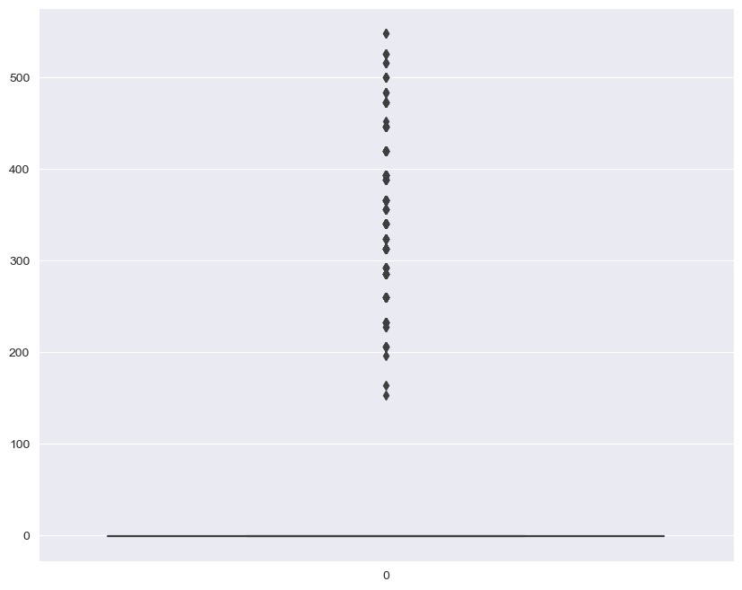
In [60]: #Outlier df['TelecomEngg'][df['TelecomEngg'] <= 150].value_counts().reset_index()
^{Out[60]:} index TelecomEngg
0 -1 3624
In [61]: df.corr()
C:\Users\Owner\AppData\Local\Temp\ipykernel_6792\1134722465.py:1: FutureWarning: The default value of numeric_only in DataFrame.corr is deprecated.
In a future version, it will default to False. Select only valid columns or specify the value of numeric_only to silence this warning.
df.corr() ^{Out[61]:}
 | ID | Salary | 10percentage | 12graduation | 12percentage | CollegeID | CollegeTier | collegeGPA | CollegeCityID | CollegeCityT
ID | 1.000000 | -  0.247294 | 0.044547 | 0.673102 | 0.007069 | 0.284540 | 0.035160 | 0.047144 | 0.284540 | -0.035
Salary | -  0.247294 | 1.000000 | 0.177373 | -0.161383 | 0.170254 | -0.118690 | -0.179332 | 0.130103 | -0.118690 | 0.015
10percentage | 0.044547 | 0.177373 | 1.000000 | 0.269957 | 0.643378 | 0.021082 | -0.126042 | 0.312538 | 0.021082 | 0.116
12graduation | 0.673102 | -  0.161383 | 0.269957 | 1.000000 | 0.259166 | 0.254021 | 0.027691 | 0.086001 | 0.254021 | -0.003
12percentage | 0.007069 | 0.170254 | 0.643378 | 0.259166 | 1.000000 | 0.022336 | -0.100771 | 0.346137 | 0.022336 | 0.130
CollegeID | 0.284540 | -  0.118690 | 0.021082 | 0.254021 | 0.022336 | 1.000000 | 0.067054 | 0.017240 | 1.000000 | 0.007
CollegeTier | 0.035160 | -  0.179332 | -0.126042 | 0.027691 | -0.100771 | 0.067054 | 1.000000 | -0.086781 | 0.067054 | -0.101
collegeGPA | 0.047144 | 0.130103 | 0.312538 | 0.086001 | 0.346137 | 0.017240 | -0.086781 | 1.000000 | 0.017240 | 0.017
CollegeCityID | 0.284540 | -  0.118690 | 0.021082 | 0.254021 | 0.022336 | 1.000000 | 0.067054 | 0.017240 | 1.000000 | 0.007
CollegeCityTier | -  0.035977 | 0.015384 | 0.116707 | -0.003016 | 0.130462 | 0.007757 | -0.101494 | 0.017471 | 0.007757 | 1.000
GraduationYear | 0.027539 | -  0.010053 | -0.013799 | 0.014457 | -0.012933 | -0.000172 | -0.005557 | 0.008706 | -0.000172 | 0.008
English | 0.135505 | 0.178219 | 0.350780 | 0.147925 | 0.212888 | -0.022792 | -0.183843 | 0.106478 | -0.022792 | 0.050
Logical | 0.102215 | 0.179275 | 0.316014 | 0.105887 | 0.243571 | -0.047094 | -0.182811 | 0.196610 | -0.047094 | 0.020
Quant | -  0.055134 | 0.230627 | 0.317640 | 0.001379 | 0.312413 | -0.114672 | -0.251103 | 0.217380 | -0.114672 | 0.007
Domain | -  0.125639 | 0.104656 | 0.078563 | -0.034163 | 0.074099 | -0.073857 | -0.061436 | 0.107252 | -0.073857 | 0.009
ComputerProgramming | 0.018859 | 0.115665 | 0.053600 | -0.047995 | 0.080818 | -0.033760 | -0.073644 | 0.136596 | -0.033760 | 0.064
ElectronicsAndSemicon | -  0.115601 | 0.000665 | 0.085179 | -0.005891 | 0.117112 | -0.020438 | -0.031573 | 0.029855 | -0.020438 | 0.041
ComputerScience | 0.482626 | -  0.100720 | -0.018933 | 0.293439 | -0.043534 | 0.102303 | 0.001053 | 0.007601 | 0.102303 | -0.010
MechanicalEngg | -  0.026147 | 0.018475 | 0.050364 | 0.035459 | 0.037635 | -0.009291 | -0.021548 | -0.031765 | -0.009291 | -0.052
ElectricalEngg | 0.104454 | -  0.047598 | 0.074419 | 0.123751 | 0.064001 | 0.022933 | 0.002594 | 0.052258 | 0.022933 | 0.010
TelecomEngg | -  0.049272 | -  0.022691 | 0.049378 | 0.023470 | 0.044201 | 0.025620 | 0.000007 | -0.005226 | 0.025620 | 0.049
CivilEngg | -  0.017871 | 0.037639 | 0.030002 | -0.004727 | 0.005910 | 0.005749 | -0.033722 | -0.018950 | 0.005749 | -0.033
conscientiousness | 0.175557 | -  0.064148 | 0.067657 | 0.103329 | 0.058299 | 0.076432 | 0.055174 | 0.069582 | 0.076432 | 0.014
agreeableness | 0.024837 | 0.057423 | 0.136645 | 0.041182 | 0.103998 | -0.005264 | -0.038055 | 0.068282 | -0.005264 | 0.005
extraversion | 0.120979 | -  0.010213 | -0.004679 | 0.061956 | -0.007486 | 0.005917 | 0.009970 | -0.032684 | 0.005917 | -0.008
nueroticism | -  0.146289 | -  0.054685 | -0.132496 | -0.074369 | -0.094369 | -0.008973 | 0.023778 | -0.074859 | -0.008973 | 0.004
openess_to_experience | 0.031359 | -  0.011312 | 0.036692 | -0.015069 | 0.006332 | -0.010678 | -0.019179 | 0.028071 | -0.010678 | -0.016
27 rows × 27 columns
In [62]: plt.figure(figsize=(20,15)) sns.heatmap(df.corr() , annot=True) plt.show() C:\Users\Owner\AppData\Local\Temp\ipykernel_6792\1400349996.py:2: FutureWarning: The default value of numeric_only in DataFrame.corr is deprecated.
In a future version, it will default to False. Select only valid columns or specify the value of numeric_only to silence this warning. sns.heatmap(df.corr() , annot=True)
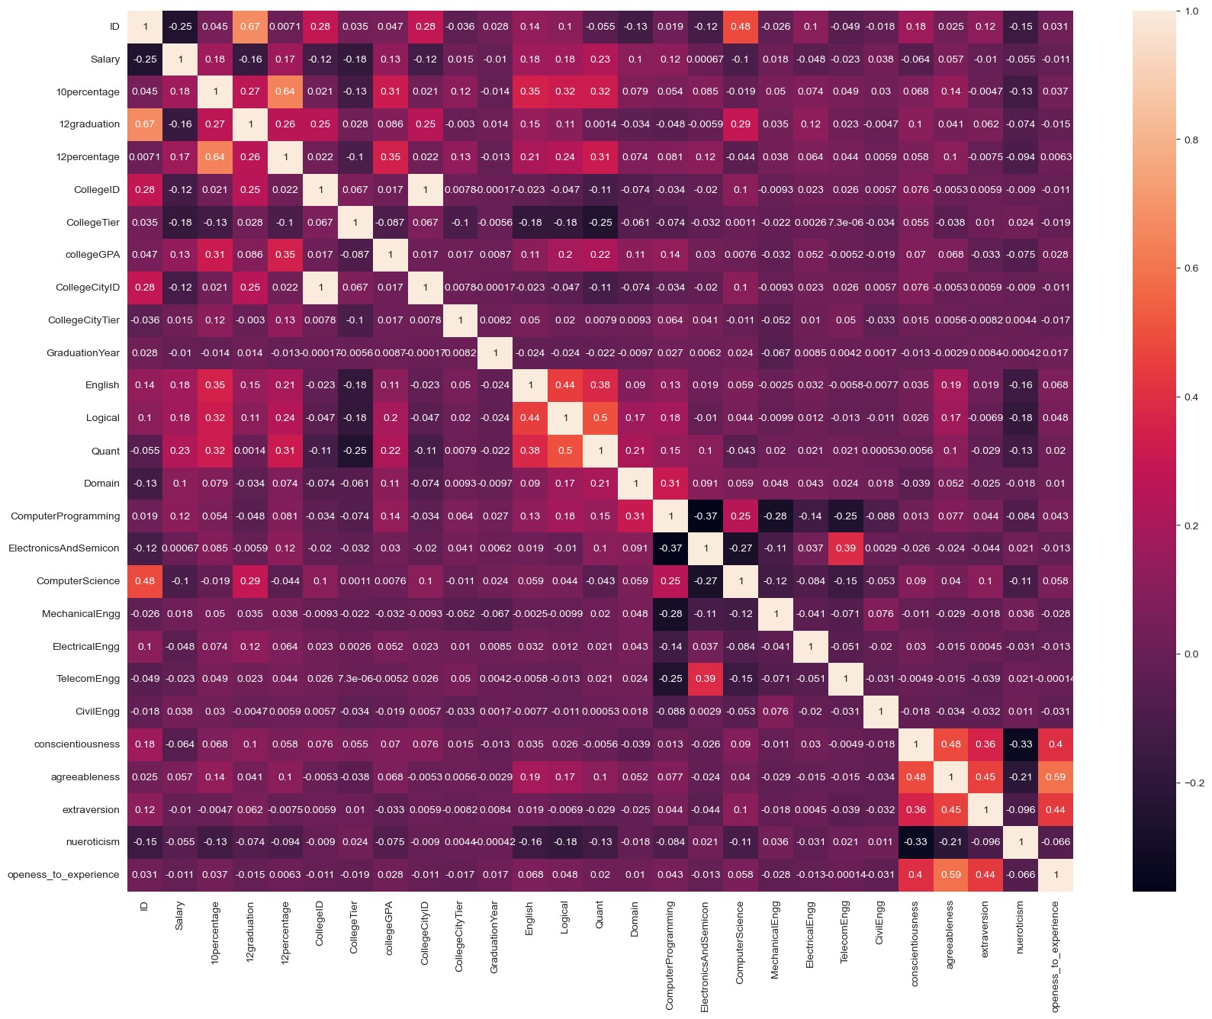
Bivariate Analysis
Discover the relationships between numerical columns using Scatter plots, hexbin plots, pair plots, etc..
In [63]: plt.figure(figsize=(20,15)) data = df[['Salary','10percentage','12percentage','collegeGPA','conscientiousness','agreeableness','extraversion','nueroticism','openess_to_experience sns.pairplot(data) plt.show()
<Figure size 2000x1500 with 0 Axes>
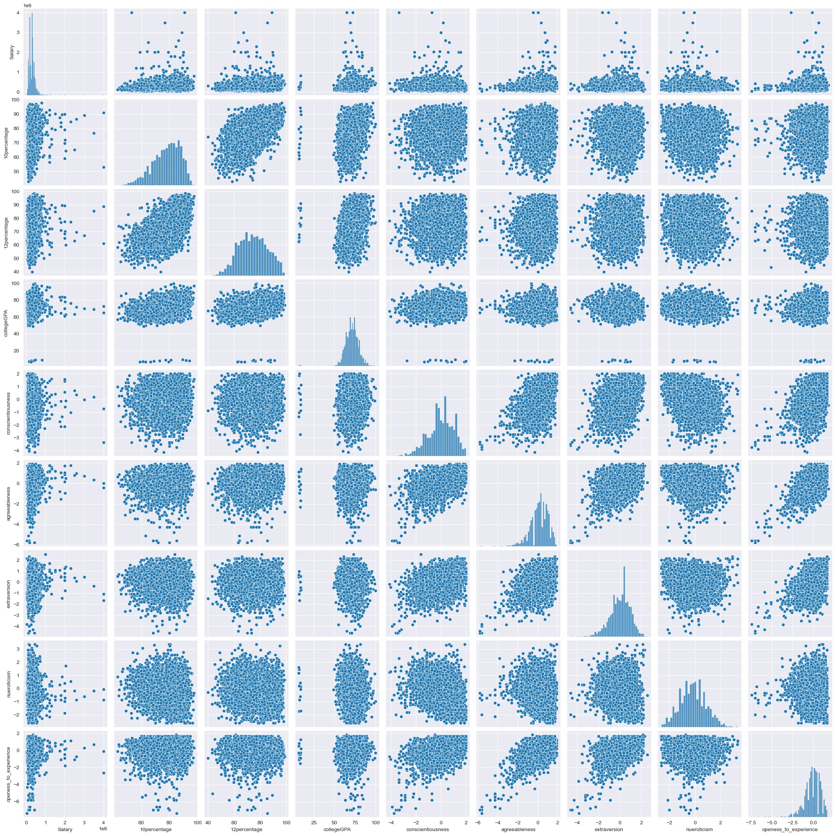
In [64]:
plt.figure(figsize=(10,8)) sns.set_style("darkgrid") sns.scatterplot(data=df, x="10percentage",y="12percentage",hue="Gender") Out[64]:<Axes: xlabel='10percentage', ylabel='12percentage'>
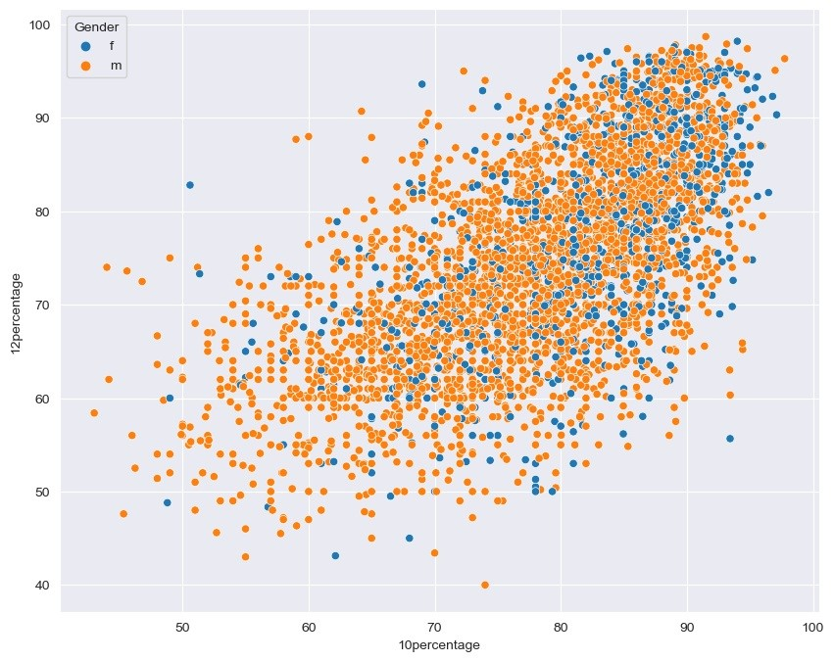
Hexbinplot on Salary, collegeGPA
In [65]:
fig = plt.subplots(figsize=(10,8)) plt.hexbin(x='Salary', y='collegeGPA', data=df, cmap ='icefire_r') Out[65]:<matplotlib.collections.PolyCollection at 0x1c2e664a410>
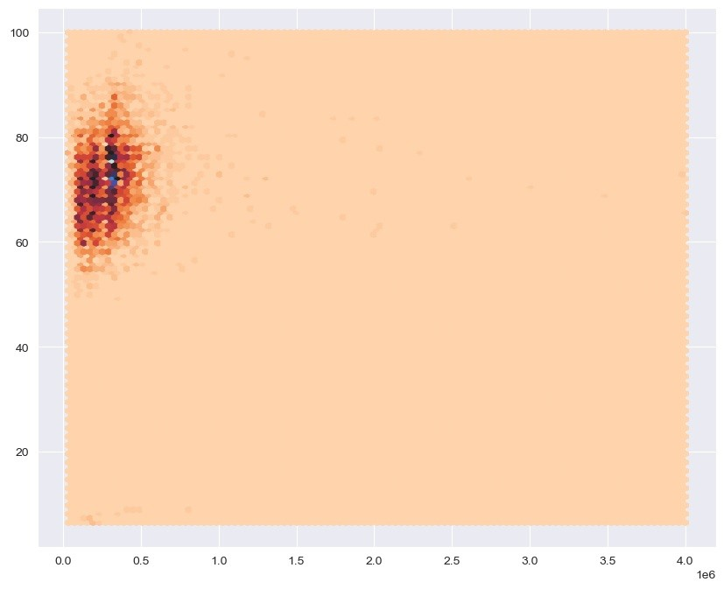
In [66]:
# Salary by Specialization plt.figure(figsize=(10,8)) sns.set_style("darkgrid") sns.boxplot(x=df['Salary'].iloc[:15], y=df['Specialization'].iloc[:15]) plt.suptitle('Salary by specialization') plt.show()
categorical and numerical columns
In [67]:
plt.subplots(figsize=(12,6)) sns.set_style("darkgrid") sns.boxplot(x="Degree", y="collegeGPA", data=df)
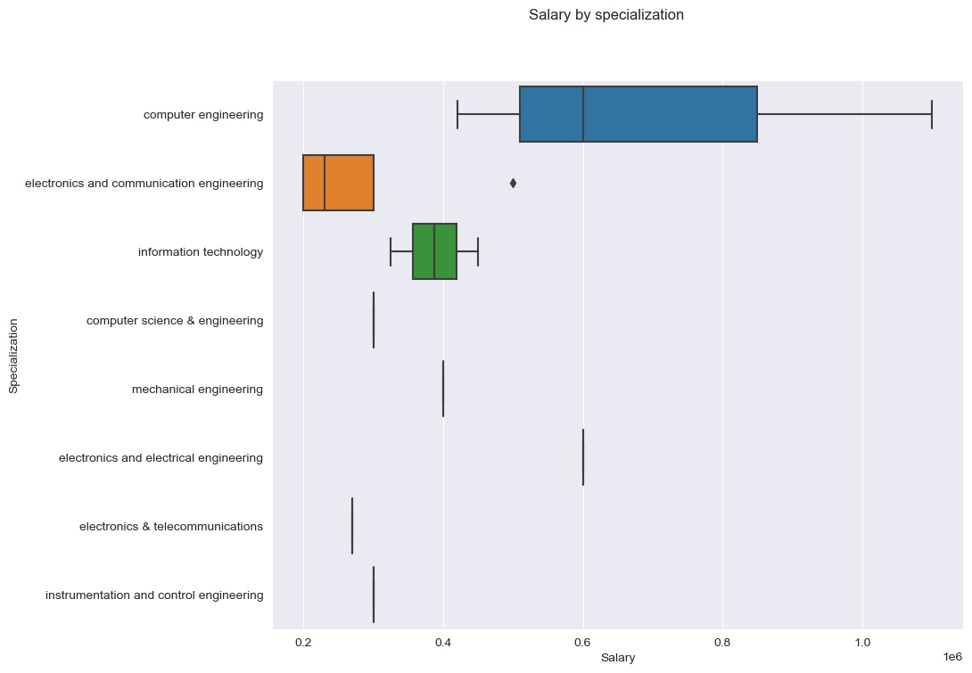
Out[67]:<Axes: xlabel='Degree', ylabel='collegeGPA'>
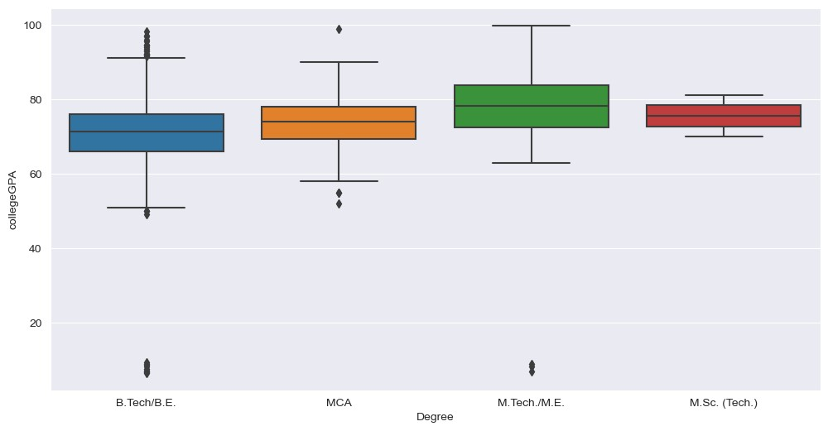
In [68]:
fig=plt.subplots(figsize=(10,7)) sns.set_style("darkgrid") sns.barplot(data=df, x="Degree", y="Salary") Out[68]:<Axes: xlabel='Degree', ylabel='Salary'>
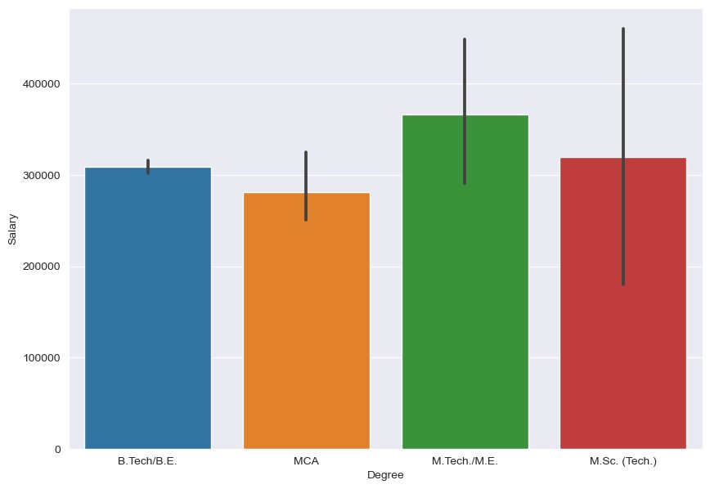
In [74]:
fig=plt.subplots(figsize=(10,7)) sns.set_style("darkgrid") sns.swarmplot(data=df, x='Degree', y='collegeGPA')

C:\Users\Owner\Desktop\a\Lib\site-packages\seaborn\categorical.py:3544: UserWarning: 79.6% of the points cannot be placed; you may want to decrease th e size of the markers or use stripplot. warnings.warn(msg, UserWarning)
Out[74]:<Axes: xlabel='Degree', ylabel='collegeGPA'>
C:\Users\Owner\Desktop\a\Lib\site-packages\seaborn\categorical.py:3544: UserWarning: 82.6% of the points cannot be placed; you may want to decrease th e size of the markers or use stripplot. warnings.warn(msg, UserWarning)
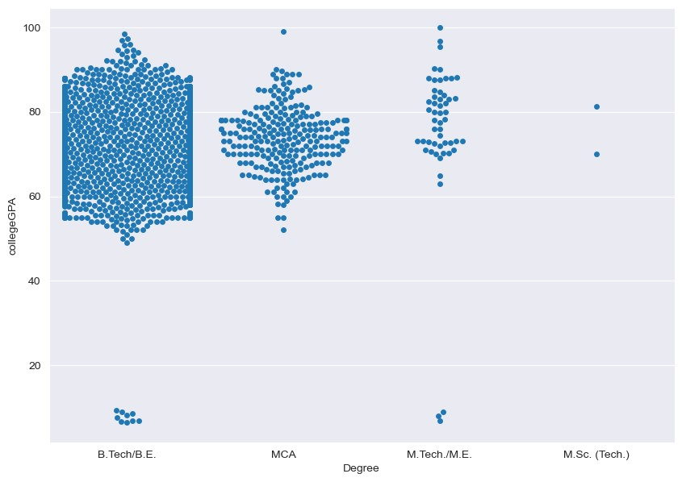
Research Questions
Times of India article dated Jan 18, 2019 states that “After doing your Computer Science Engineering if you take up jobs as a Programming Analyst, Software Engineer, Hardware Engineer and Associate Engineer you can earn up to 2.5-3 lakhs as a fresh graduate.” Test this claim with the data given to you. Is there a relationship between gender and specialization? (i.e. Does the preference of Specialisation depend on the Gender?)
In [ ]:

In [79]: df_R=df[(df["Designation"]=="programmer analyst")|(df["Designation"]=="software engineer")|(df["Designation"]=="hardware enginner")|(df["Designatio df_R
Out[79]: Unnamed:
ID Salary DOJ DOL Designation JobCity Gender DOB 10percentage ... ComputerScience MechanicalEngg Ele
0
2014- software 1990-
- train 466888 325000.0 present Pune f 79.00 ... -1 -1
09-01 engineer 11-30
2010- 9/1/12 software 1988-
- train 140069 320000.0 Bangalore f 91.20 ... -1 -1
11-01 0:00 engineer 07-25
2012- 12/1/13 software 1991-
- train 339689 200000.0 -1 f 75.67 ... -1 -1
08-01 0:00 engineer 08-20
2014- 6/1/15 programmer 1993-
24 train 963123 335000.0 Hyderabad m 88.00 ... 346 -1
06-01 0:00 analyst 06-28
2014- 4/1/15 software 1992-
31 train 1094324 340000.0 Bangalore m 77.20 ... 407 -1
08-01 0:00 engineer 10-23
... ... ... ... ... ... ... ... ... ... ... ... ... ...
2013- 4/1/14 software 1989-
3979 train 212055 550000.0 Bangalore m 69.16 ... -1 -1
07-01 0:00 engineer 07-22
2014- software 1991-
3981 train 1077872 220000.0 present Gurgaon m 53.40 ... 530 -1
09-01 engineer 12-17
2011- software 1990-
3984 train 305041 480000.0 present Gurgaon f 89.80 ... -1 -1
12-01 engineer 01-18
2014- software 1991-
3989 train 1204604 300000.0 present Bangalore m 74.88 ... 346 -1
09-01 engineer 11-23
2011- 10/1/12 software 1987-
3993 train 47916 280000.0 New Delhi m 52.09 ... -1 -1
10-01 0:00 engineer 04-15
678 rows × 39 columns
In [80]: df_R["Salary"]
Out[80]:19 325000.0
- 320000.0
- 200000.0
24 335000.0
31 340000.0
...
3979 550000.0
3981 220000.0
3984 480000.0
3989 300000.0
3993 280000.0
Name: Salary, Length: 678, dtype: float64
In [81]: ab=df_R["Salary"] bc=[] for i in ab: bc.append(i) print(bc)
[325000.0, 320000.0, 200000.0, 335000.0, 340000.0, 270000.0, 380000.0, 390000.0, 400000.0, 250000.0, 120000.0, 305000.0, 300000.0, 800000.0, 325000 .0, 450000.0, 310000.0, 340000.0, 640000.0, 330000.0, 305000.0, 500000.0, 315000.0, 300000.0, 325000.0, 340000.0, 305000.0, 335000.0, 375000.0, 2350
00.0, 450000.0, 300000.0, 410000.0, 440000.0, 305000.0, 325000.0, 360000.0, 300000.0, 300000.0, 550000.0, 310000.0, 300000.0, 265000.0, 275000.0, 17
0000.0, 245000.0, 425000.0, 300000.0, 395000.0, 305000.0, 250000.0, 560000.0, 390000.0, 305000.0, 315000.0, 300000.0, 320000.0, 785000.0, 300000.0,
240000.0, 315000.0, 330000.0, 210000.0, 380000.0, 405000.0, 460000.0, 320000.0, 275000.0, 320000.0, 425000.0, 240000.0, 180000.0, 300000.0, 310000. 0, 300000.0, 475000.0, 300000.0, 240000.0, 335000.0, 335000.0, 390000.0, 310000.0, 385000.0, 300000.0, 385000.0, 310000.0, 400000.0, 300000.0, 3450
00.0, 250000.0, 500000.0, 300000.0, 450000.0, 500000.0, 330000.0, 450000.0, 370000.0, 310000.0, 445000.0, 305000.0, 220000.0, 405000.0, 335000.0, 30
0000.0, 180000.0, 265000.0, 300000.0, 315000.0, 360000.0, 335000.0, 100000.0, 420000.0, 400000.0, 300000.0, 240000.0, 440000.0, 335000.0, 480000.0,
300000.0, 400000.0, 400000.0, 320000.0, 375000.0, 345000.0, 400000.0, 420000.0, 215000.0, 350000.0, 300000.0, 315000.0, 305000.0, 180000.0, 300000. 0, 310000.0, 350000.0, 325000.0, 350000.0, 350000.0, 300000.0, 340000.0, 200000.0, 315000.0, 480000.0, 310000.0, 335000.0, 325000.0, 360000.0, 3350
00.0, 435000.0, 360000.0, 350000.0, 310000.0, 345000.0, 350000.0, 240000.0, 400000.0, 110000.0, 340000.0, 400000.0, 170000.0, 430000.0, 85000.0, 330
000.0, 305000.0, 200000.0, 240000.0, 350000.0, 550000.0, 420000.0, 335000.0, 380000.0, 515000.0, 350000.0, 275000.0, 260000.0, 300000.0, 395000.0, 2
40000.0, 445000.0, 240000.0, 300000.0, 315000.0, 450000.0, 335000.0, 500000.0, 800000.0, 370000.0, 325000.0, 300000.0, 300000.0, 300000.0, 350000.0
, 350000.0, 450000.0, 280000.0, 350000.0, 320000.0, 240000.0, 345000.0, 200000.0, 335000.0, 350000.0, 350000.0, 400000.0, 415000.0, 420000.0, 30000
0.0, 90000.0, 140000.0, 120000.0, 340000.0, 300000.0, 505000.0, 320000.0, 300000.0, 310000.0, 305000.0, 440000.0, 375000.0, 375000.0, 335000.0, 2750
00.0, 335000.0, 350000.0, 430000.0, 305000.0, 335000.0, 275000.0, 240000.0, 400000.0, 290000.0, 60000.0, 400000.0, 335000.0, 275000.0, 400000.0, 450
000.0, 350000.0, 385000.0, 335000.0, 300000.0, 360000.0, 305000.0, 350000.0, 330000.0, 120000.0, 305000.0, 320000.0, 375000.0, 360000.0, 430000.0, 1
65000.0, 320000.0, 610000.0, 190000.0, 350000.0, 550000.0, 300000.0, 510000.0, 335000.0, 300000.0, 355000.0, 230000.0, 475000.0, 120000.0, 240000.0
, 305000.0, 315000.0, 450000.0, 475000.0, 120000.0, 560000.0, 360000.0, 180000.0, 320000.0, 320000.0, 450000.0, 240000.0, 300000.0, 305000.0, 24000
0.0, 620000.0, 320000.0, 350000.0, 120000.0, 450000.0, 280000.0, 410000.0, 400000.0, 480000.0, 310000.0, 330000.0, 350000.0, 95000.0, 120000.0, 4200
00.0, 330000.0, 300000.0, 225000.0, 430000.0, 240000.0, 405000.0, 280000.0, 480000.0, 450000.0, 335000.0, 300000.0, 325000.0, 200000.0, 300000.0, 88
0000.0, 200000.0, 120000.0, 300000.0, 300000.0, 330000.0, 145000.0, 200000.0, 240000.0, 415000.0, 335000.0, 310000.0, 340000.0, 215000.0, 100000.0,
400000.0, 300000.0, 180000.0, 325000.0, 290000.0, 350000.0, 350000.0, 820000.0, 70000.0, 400000.0, 180000.0, 300000.0, 450000.0, 315000.0, 310000.0
, 180000.0, 325000.0, 325000.0, 320000.0, 400000.0, 300000.0, 605000.0, 600000.0, 440000.0, 195000.0, 200000.0, 315000.0, 325000.0, 335000.0, 10500
0.0, 335000.0, 590000.0, 275000.0, 300000.0, 330000.0, 325000.0, 280000.0, 400000.0, 305000.0, 600000.0, 240000.0, 140000.0, 450000.0, 310000.0, 200
000.0, 240000.0, 300000.0, 450000.0, 310000.0, 460000.0, 300000.0, 310000.0, 545000.0, 340000.0, 360000.0, 230000.0, 500000.0, 100000.0, 375000.0, 1
20000.0, 305000.0, 240000.0, 240000.0, 360000.0, 470000.0, 180000.0, 325000.0, 350000.0, 335000.0, 240000.0, 380000.0, 330000.0, 350000.0, 350000.0
, 265000.0, 720000.0, 400000.0, 465000.0, 200000.0, 350000.0, 300000.0, 490000.0, 180000.0, 335000.0, 210000.0, 140000.0, 520000.0, 430000.0, 32500
0.0, 550000.0, 420000.0, 220000.0, 350000.0, 300000.0, 375000.0, 335000.0, 505000.0, 930000.0, 350000.0, 345000.0, 400000.0, 310000.0, 325000.0, 680
000.0, 305000.0, 620000.0, 315000.0, 335000.0, 340000.0, 225000.0, 455000.0, 290000.0, 1000000.0, 335000.0, 180000.0, 530000.0, 570000.0, 400000.0,
205000.0, 320000.0, 245000.0, 205000.0, 335000.0, 360000.0, 350000.0, 360000.0, 250000.0, 120000.0, 150000.0, 390000.0, 300000.0, 430000.0, 300000. 0, 240000.0, 355000.0, 460000.0, 240000.0, 300000.0, 300000.0, 180000.0, 485000.0, 85000.0, 350000.0, 400000.0, 320000.0, 820000.0, 315000.0, 32500
0.0, 120000.0, 500000.0, 345000.0, 305000.0, 110000.0, 225000.0, 310000.0, 220000.0, 440000.0, 305000.0, 330000.0, 135000.0, 370000.0, 310000.0, 300
000.0, 330000.0, 420000.0, 400000.0, 200000.0, 360000.0, 335000.0, 505000.0, 300000.0, 220000.0, 350000.0, 365000.0, 325000.0, 350000.0, 335000.0, 3
00000.0, 250000.0, 340000.0, 450000.0, 355000.0, 200000.0, 300000.0, 210000.0, 350000.0, 300000.0, 325000.0, 420000.0, 325000.0, 420000.0, 630000.0
, 300000.0, 450000.0, 300000.0, 400000.0, 240000.0, 420000.0, 430000.0, 405000.0, 345000.0, 400000.0, 100000.0, 500000.0, 230000.0, 150000.0, 32500
0.0, 240000.0, 360000.0, 350000.0, 180000.0, 375000.0, 180000.0, 300000.0, 305000.0, 530000.0, 300000.0, 330000.0, 405000.0, 240000.0, 325000.0, 650
000.0, 310000.0, 325000.0, 565000.0, 120000.0, 250000.0, 420000.0, 200000.0, 460000.0, 380000.0, 145000.0, 480000.0, 1500000.0, 350000.0, 320000.0,
300000.0, 455000.0, 195000.0, 320000.0, 280000.0, 500000.0, 360000.0, 550000.0, 415000.0, 600000.0, 570000.0, 360000.0, 110000.0, 335000.0, 590000. 0, 325000.0, 315000.0, 325000.0, 300000.0, 400000.0, 310000.0, 180000.0, 480000.0, 240000.0, 380000.0, 640000.0, 290000.0, 400000.0, 330000.0, 1800
00.0, 335000.0, 380000.0, 400000.0, 550000.0, 300000.0, 145000.0, 315000.0, 360000.0, 220000.0, 500000.0, 455000.0, 475000.0, 90000.0, 310000.0, 550
000.0, 310000.0, 310000.0, 315000.0, 925000.0, 320000.0, 400000.0, 325000.0, 300000.0, 280000.0, 240000.0, 335000.0, 200000.0, 300000.0, 445000.0, 7
00000.0, 400000.0, 615000.0, 240000.0, 400000.0, 225000.0, 700000.0, 95000.0, 390000.0, 325000.0, 420000.0, 95000.0, 295000.0, 180000.0, 180000.0, 5
00000.0, 300000.0, 400000.0, 300000.0, 450000.0, 350000.0, 405000.0, 145000.0, 300000.0, 240000.0, 335000.0, 315000.0, 160000.0, 300000.0, 330000.0
, 260000.0, 400000.0, 300000.0, 600000.0, 335000.0, 145000.0, 370000.0, 390000.0, 290000.0, 340000.0, 105000.0, 240000.0, 100000.0, 300000.0, 28000
0.0, 410000.0, 310000.0, 390000.0, 360000.0, 310000.0, 335000.0, 415000.0, 320000.0, 550000.0, 220000.0, 480000.0, 300000.0, 280000.0]
In [82]: import random n=40 cd=random.sample(bc,n)
print(cd)
[350000.0, 225000.0, 330000.0, 145000.0, 220000.0, 325000.0, 300000.0, 400000.0, 230000.0, 600000.0, 400000.0, 550000.0, 350000.0, 320000.0, 550000 .0, 280000.0, 315000.0, 240000.0, 400000.0, 450000.0, 300000.0, 315000.0, 240000.0, 300000.0, 200000.0, 350000.0, 480000.0, 450000.0, 415000.0, 3850 00.0, 350000.0, 820000.0, 450000.0, 305000.0, 300000.0, 300000.0, 310000.0, 490000.0, 335000.0, 300000.0]
In [83]: def t_score(sample_size, sample_mean, pop_mean, sample_std):
numerator = sample_mean - pop_mean denomenator = sample_std / sample_size**.5 return numerator / denomenator
In [84]:
import numpy as np import statistics import matplotlib.pyplot as plt import numpy as np from scipy.stats import t,norm
In [85]: sum(cd)/len(cd)
Out[85]:359375.0
In [86]:
statistics.stdev(cd)
Out[86]:124355.71136348322
In [88]: sample_size = 100 sample_mean = 332250.0 pop_mean = 300000 sample_std = 89621.3
In [89]: t_value = t_score(sample_size, sample_mean, pop_mean, sample_std)
print(t_value)
3.59847491611927
In [90]:
confidence_level = 0.95
alpha = 1-confidence_level t_critical = t.ppf(1-alpha/2,df=99) print(t_critical)
1.9842169515086827
In [92]:
x_min=-200000 x_max= 800000 mean = pop_mean std = sample_std x = np.linspace(x_min, x_max, 100) y = norm.pdf(x, mean, std) plt.xlim(x_min, x_max) plt.plot(x,y) t_critical_left = pop_mean + (-t_critical * std) t_critical_right = pop_mean + (t_critical * std) x1 = np.linspace(x_min, t_critical_left, 100) y1 = norm.pdf(x1, mean, std) plt.fill_between(x1, y1, color='blue') x2 = np.linspace(x_min, t_critical_right, 100) y2 = norm.pdf(x2, mean, std) plt.fill_between(x2, y2, color='blue') plt.scatter(sample_mean, 0) plt.annotate("x_bar", (sample_mean, 0.7))
Out[92]:Text(332250.0, 0.7, 'x_bar')
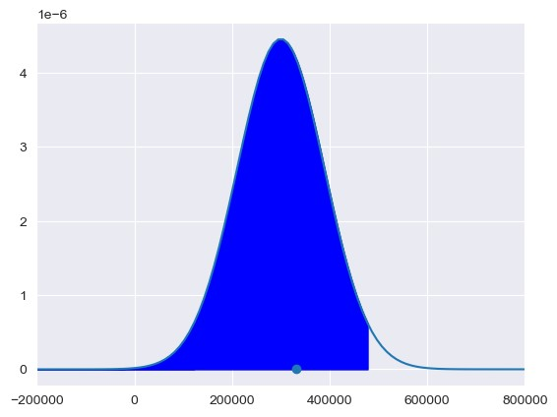
In [ ]:

In [ ]:

In [ ]:

In [ ]:

In [ ]:

In [ ]:

In [ ]:

In [ ]:

In [ ]:

In [ ]:

