Login: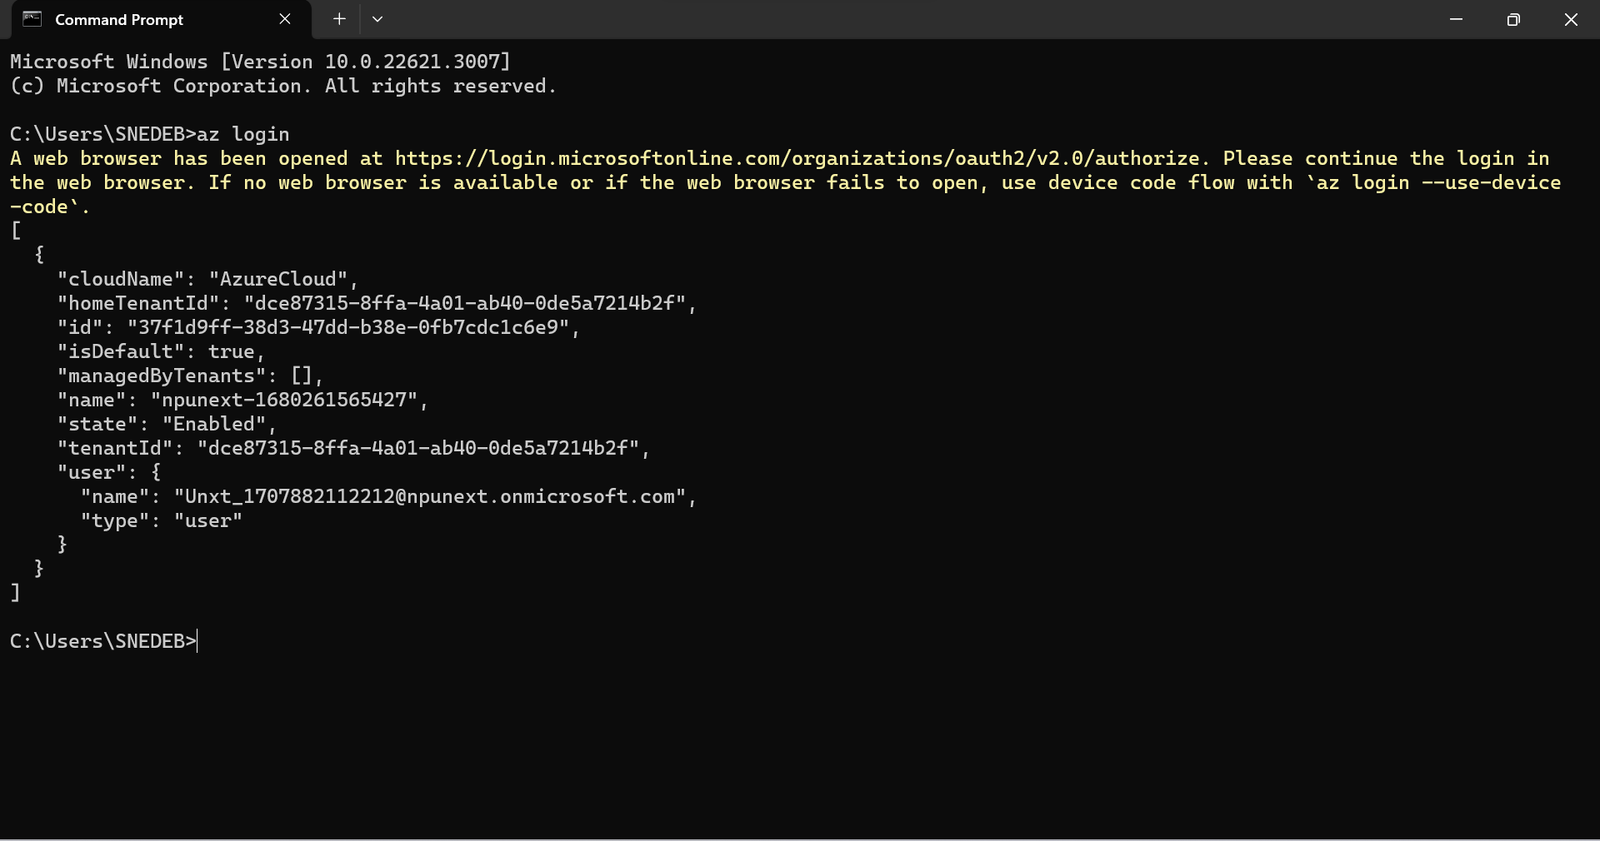

Creating new Resource:

List of all Resource Groups:

Creating VM

Entering The VM:

Updating all packages:

Add inbound Security

The in build HTML page:

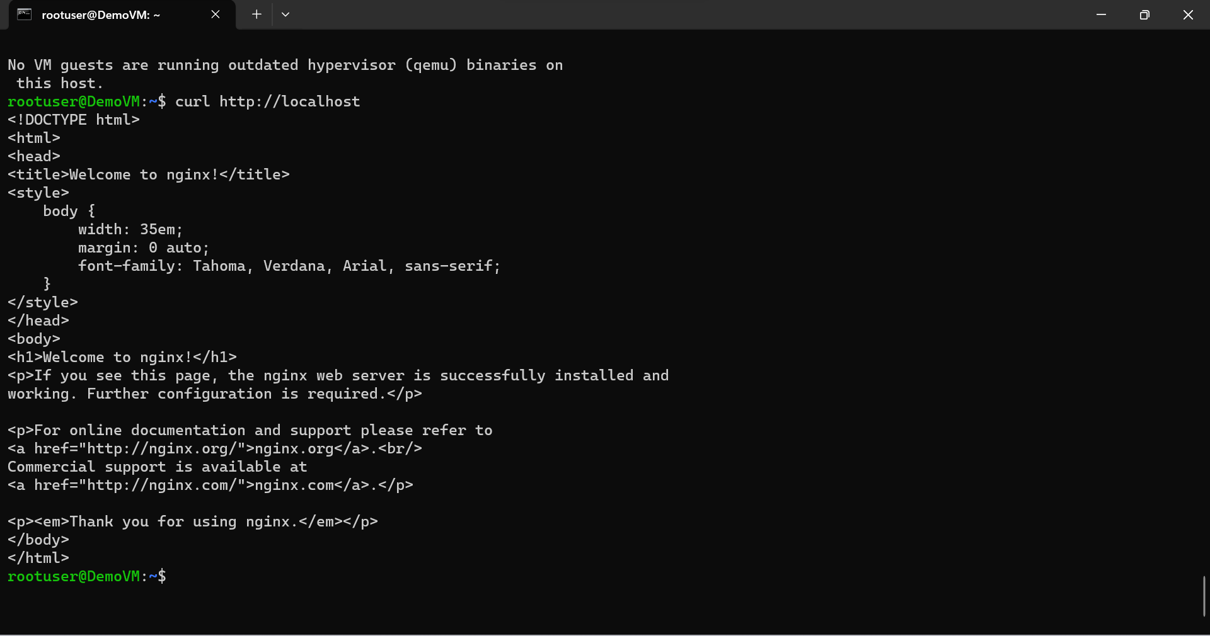

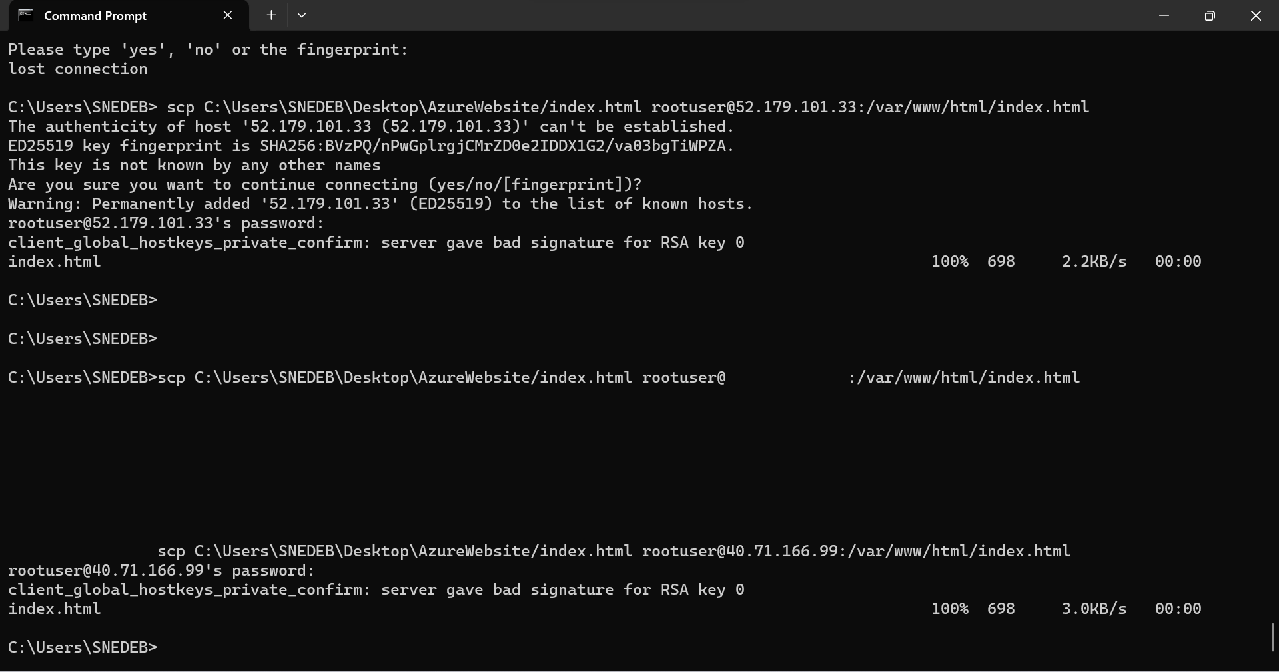

Visual Studio Code:

<!DOCTYPE html>

<html lang="en">

<head>

    <meta charset="UTF-8">

    <meta http-equiv="X-UA-Compatible" content="IE=edge">

    <meta name="viewport" content="width=device-width, initial-scale=1.0">

    <link rel="stylesheet" href="a.css">

    <title>Good Bye</title>

    <p>Lorem ipsum dolor sit amet consectetur adipisicing elit. Dolorem magnam possimus debitis accusamus minus

        reiciendis unde voluptas accusantium officiis, iusto incidunt atque nulla illo ad excepturi alias adipisci aut

        deserunt.</p>

    <img src="https://th.bing.com/th/id/OIP.NZzmdImCU2b9pQomly_AYAHaJf?rs=1&pid=ImgDetMain"

        alt="No image found">

</head>

<body>

</body>

</html>

body {

  background-color: lightblue;

}

h1 {

  color: white;

  text-align: center;

}

p {

  font-family: verdana;

  font-size: 20px;

}

img {

  border-radius: 80px;

}

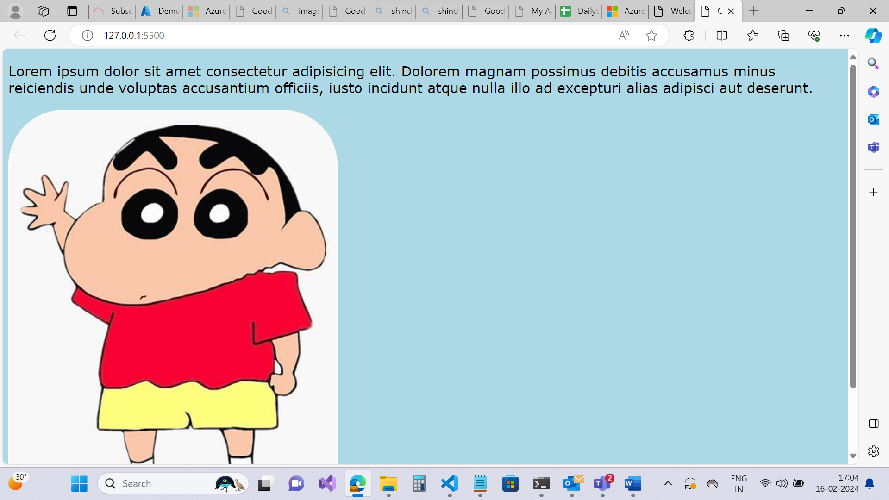

Hosting server of the VM on our local machine

Hosted :

