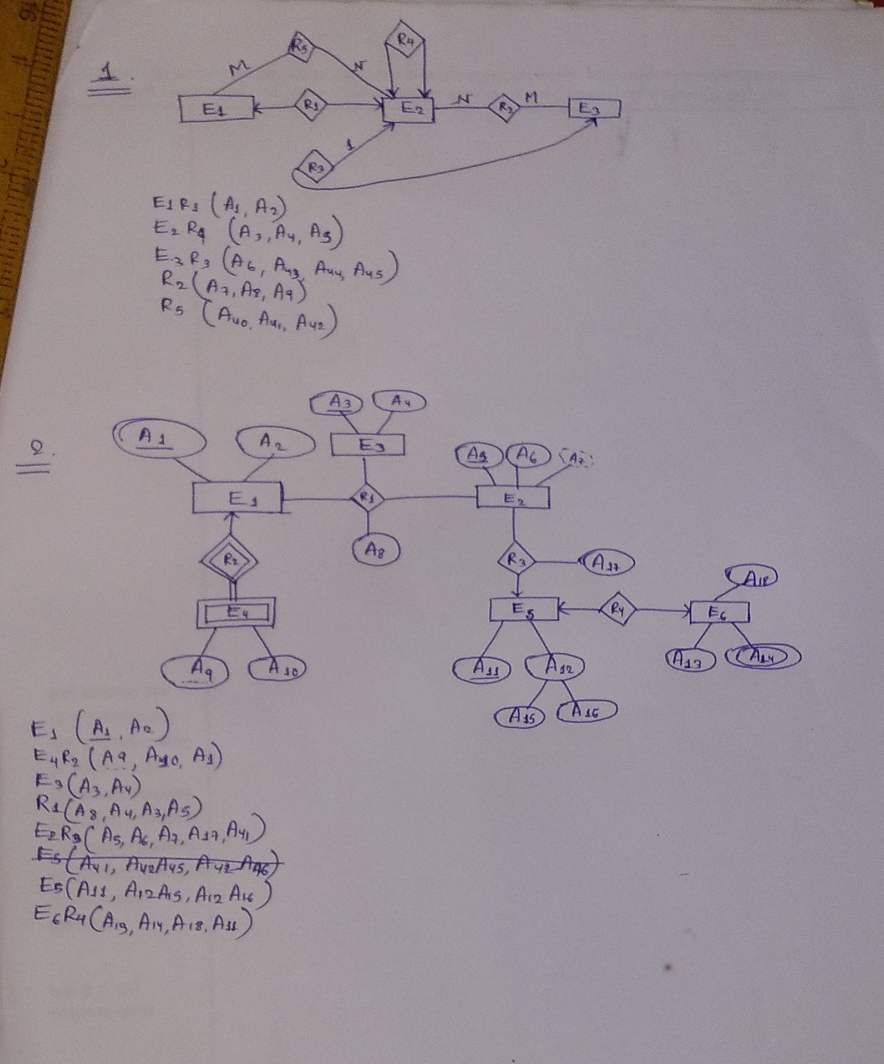

use sjsms;

select \* from student as s

inner join studentdetels as sd on s.studentbetelsid = sd.id

inner join session as se on s.sessionId = se.id

inner Join cwst cw on s.id = cw.studentId

inner join clas as c on c.id = cw.clasId

where se.name like '2020-2021' and c.name not like 'class 1'

select \* from student as s

inner join studentdetels as sd on s.studentDetelsId = sd.id

inner join session as se on s.sessionId = se.id

inner join cwst cw on s.id = cw.studentId

where se.name like '2020-2021' and cw.clasId in (select id from clas where name not like

'%1' and id != 1)

select \* from student as s

inner join studentdetels as sd on s.studentDetelsId = sd.id

inner join session as se on s.sessionId = se.id

inner join cwst cw on s.id = cw.studentId

inner join clas as c on c.id = cw.clasId

where se.name like '2020-2021' and

not exists (select id, name from clas where name not like '%1' and id != 1 and c.id = id

and c.name = name)

select \* from student as s

inner Join studentdetels as sd on s.studentDetelsid = sd.id

inner Join session as se on s.sessionId = se.id

inner Join cwst cw on s.id = cw.studentId

inner join clas as c on c.id = cw.clasId

where se.name like '2020-2021' and (c.id, c.name) in (select id, name from clas where name

not like '%1')

select \* from student as s

inner Join studentdetels as sd on s.studentDetelsId = sd.id

inner join session as se on s.sessionId = se.id

inner join cwst cw on s.id = cw.studentId

inner join clas as c on c.id = cw.clasId

where se.name like '2020-2021' and (c.id, c.name) in (select id, name from clas where name

like '%1')

union all select \* from student as s

inner join studentdetels as sd on s.studentDetelsId = sd.id

inner join session as se on s.sessionId = se.id

inner Join cwst cw on s.id = cw.studentId

inner join clas as c on c.id = cw.clasId

where se.name like '2020-2021' and (c.id, c.name) in (select id, name from clas where name

like '%2')