CASE STUDY

**Scenario:** You have been hired as a data analyst by an e-commerce company to analyse their sales data. The company wants to understand their sales performance over the past year to make informed business decisions.

TASKS

1. Data Cleaning and Preparation:

* Sum of with nulls values and missing values from data

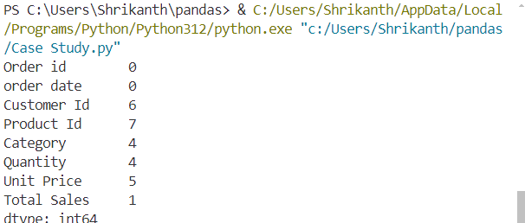

* Cleaned data

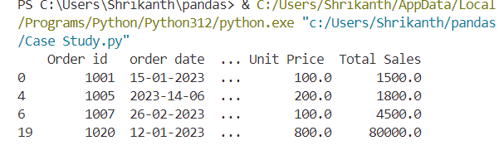

* Fill the values from missing the value (0)

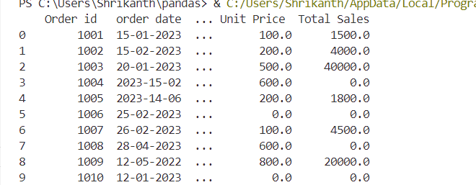

* Data field with proper date format

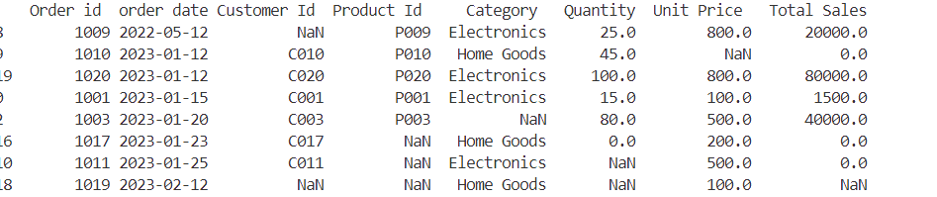

* Creating extra columns i.e. year and month from date field

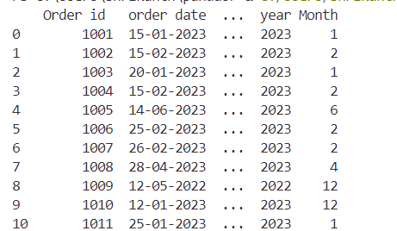

1. EDA

* Calculate basic statistics for numerical columns (Quantity, Total Sales).

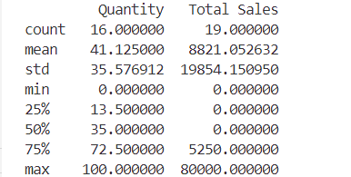

* Determine the total sales and number of orders for each month.

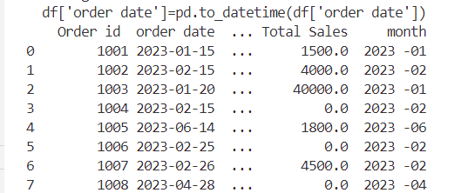

* Identify the top 5 products and categories based on total sales.

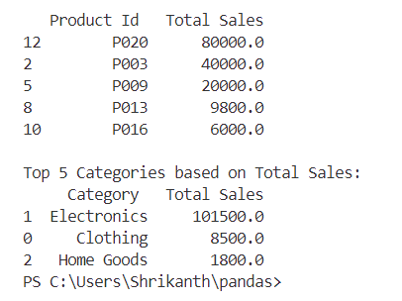

3. STATISTICAL ANALYSIS

* Compute the average order value and total sales per customer.

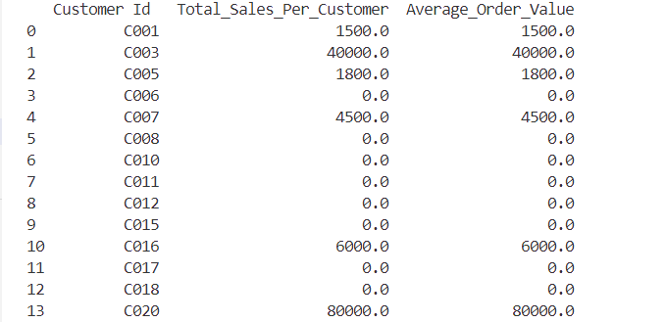

* Perform a hypothesis test to determine if there is a significant difference in average sales between two product categories (e.g., Electronics vs. Clothing). Use a t-test for this analysis.



5. DATA VISUALIZATION

* Create a line chart showing the trend of total sales over the months of the past year.

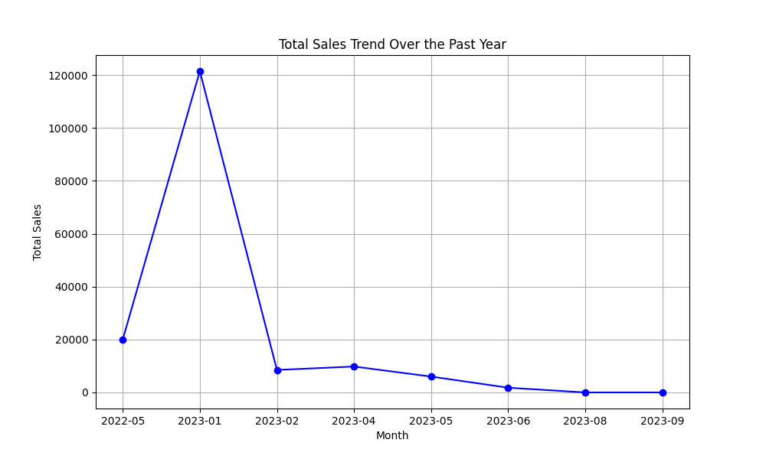

* Create a bar chart to compare total sales across different product categories.

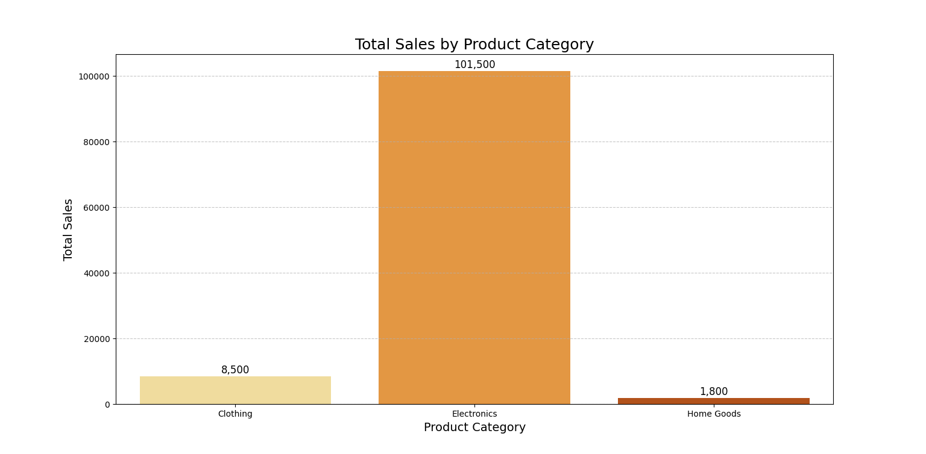

* Use a pie chart to show the proportion of total sales contributed by each category.

