BCSE307P – Compiler Design Lab
Project Review II – Progress Report
Compiler-Based Automatic Test Case Generation Using AST and Program Analysis
Implemented as BranchLab – an AST-based targeted test generator for Python, Java and C
Name | Register No. | Course | Review
Sneha Geevargis | 24BCB0149 | BCSE307P – Compiler Design Lab | Project Review II

Team member: Sneha Geevargis – 24BCB0149
Repository: [GitHub link]

1. Abstract
Random and hand-written tests often miss boundary values and leave program branches unexercised. This project builds a lightweight, explainable test generator that works from the compiler's view of a program. It parses the source into an Abstract Syntax Tree (AST), extracts the conditions that decide each branch, derives boundary values for them, executes the generated tests, and measures branch coverage, statement coverage and fault-detection rate (mutation score). The tool, BranchLab, supports C (the language committed to in Review I) as well as Python and Java, through one pipeline with a web interface.
In an evaluation on 9 programs against random testing with the same number of tests, the AST-targeted suites reached an average branch coverage of 94.2% versus 58.5%, statement coverage of 96.6% versus 67.8%, and detected 94.4% of injected boundary faults versus 23.7%, with an average generation time of 6.3 ms per program.

2. Problem Statement
Most faults sit at decision points: a condition written as >= instead of >, or a threshold off by one. Random inputs rarely land exactly on such boundaries, and hand-written tests are slow to produce and give no measure of which paths were never executed. Heavy-weight techniques (symbolic execution, search-based optimisation, LLM-based generation) improve coverage but need constraint solvers, long searches or external models, and their tests are hard to trace back to the code. There is a need for a lightweight approach that reads the program's structure directly, targets its branches and boundaries, and reports exactly what it did and did not cover.

3. Objectives and Status
Objectives as stated in Review I, with their status at Review II:
# | Objective (Review I) | Status at Review II
1 | Parse C programs and construct an AST | Done – C via Tree-sitter; extended to Python (ast module) and Java
2 | Identify branches, conditions and boundary cases from the AST | Done – if / else-if / while / do-while / switch-case; &&, ||, !; reversed operands; signed, hex and suffixed literals
3 | Generate targeted test cases for those branches and boundaries | Done – boundary values per condition, combined within a test budget; plus invalid-input and fuzz tests
4 | Evaluate with branch coverage, statement coverage and fault-detection rate | Done – all three measured for C, Java and Python; fault detection by mutation testing
5 | Compare with random generation on coverage, number of tests and generation time | Done – evaluation script and results in Section 9

Work added beyond the Review I plan:
- Multi-language: Java and Python support through the same pipeline as C.
- Prototype UI: a React web interface (BranchLab) backed by a FastAPI service.
- Path-aware input delivery: each generated value is delivered to the variable it belongs to, following the program's own reads and branches.
- Verified suggestions: for every missing outcome a test is suggested, executed once, and marked verified only if it really reaches that outcome.

4. Literature Survey and Research Gap
The Review I survey grouped prior work into four families:
Family | Representative work | Strength | Limitation addressed here
Random / feedback-directed | DART (2005); Feedback-directed random testing (2007) | Fully automatic, cheap | Rarely hits exact boundaries; no structural targeting
Symbolic / concolic execution | CUTE (2005); EXE (2006); KLEE (2008) | High coverage of feasible paths | Constraint solving cost; path explosion
Search-based | AUSTIN study (2010); EvoSuite (2011); DynaMOSA (2018) | Optimises whole suites for coverage | Many iterations; mostly Java-focused
LLM-assisted | CodaMOSA (2023); ChatUniTest (2024); STRUT (2025) | Strong on complex code | Depends on large models; tests need validation and repair

Gap: a lightweight, explainable generator that uses only compiler-level structure (the AST) to target branches and boundaries, needs no constraint solver, search or language model, links every test to the condition it targets, and measures its own effectiveness honestly.

5. Novelty
- Explainable, structure-derived tests: every test comes from a named condition (for example age >= 18 on line 3 gives 17, 18, 19), so each test can be explained.
- Multi-language from one design: one pipeline serves C, Java and Python; each language plugs in through a small adapter (parse, analyze, execute).
- Probe-based coverage for C and Java: compiled languages cannot be traced like Python, so each condition and statement is wrapped in a probe that records its outcome and returns the value unchanged; outcomes survive exit(), crashes and timeouts.
- Path-aware input delivery: a read map built from the AST answers each test's reads (scanf, Scanner, input()) along the path its own values take, including switch cases, fall-through and helper functions.
- Verified, honest reporting: suggestions for missing outcomes are executed before they are shown, and coverage never hides what it does not measure.
- Lightweight: analysis and generation take about 6 ms per program on average; no solver, search or model is involved.

6. System Design
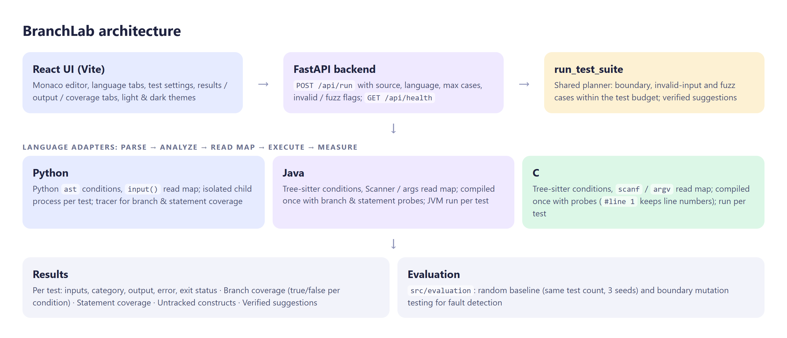
Figure 1. BranchLab architecture

6.1 Processing stages
Stage | What happens
Parse | Python: built-in ast module. C and Java: Tree-sitter grammars produce a concrete syntax tree.
Analyze | Collect variable-vs-number comparisons in if/while/do conditions and switch/match cases (case 2 means choice == 2).
Generate | Boundary values per condition (c-1, c, c+1; nearest floats for float constants), combined across variables within the budget; optional invalid and fuzz inputs.
Deliver | A read map (reads in order + the branches deciding them) gives each test exactly the answers its path reads, on stdin, argv/args, or as Python globals.
Execute | Python: a fresh process per test, killed after 3 s. C/Java: compiled once per run, each test run with a 10 s limit.
Measure | Branch coverage (true/false per condition), statement coverage, untracked constructs, verified suggestions.

6.2 Key algorithms
Boundary selection. For x op c with integer c the candidates are c-1, c and c+1, ordered so that the second always satisfies the condition. This lets combined rows reach nested branches.
Combination within a budget. When all combinations exceed the maximum number of tests, rows are chosen in priority order: diagonal rows (every variable at its k-th value), then rows that change one variable at a time, then evenly spaced rows of the full product.
Probe instrumentation (C/Java). if (x > 5) becomes if (__probe(3, (x > 5))) and each statement gets __line(n); before it. A single-statement body is wrapped as { probe; stmt }. In C, #line 1 keeps compiler messages on the original line numbers.
Mutation operators (evaluation). At each comparison: the operator off by one (> to >=, < to <=, == to !=), the constant plus one, and the constant minus one.

7. Implementation
Component | Technology | Size
Analysis, generation, execution, coverage, evaluation | Python 3.13 | 4,380 lines
C and Java parsing | Tree-sitter 0.25.2 (C and Java grammars) | –
Backend API | FastAPI + Uvicorn | –
Web interface | React 19, Vite, Monaco editor | 2,253 lines
Automated tests | pytest | 242 tests, 3,435 lines

7.1 Prototype
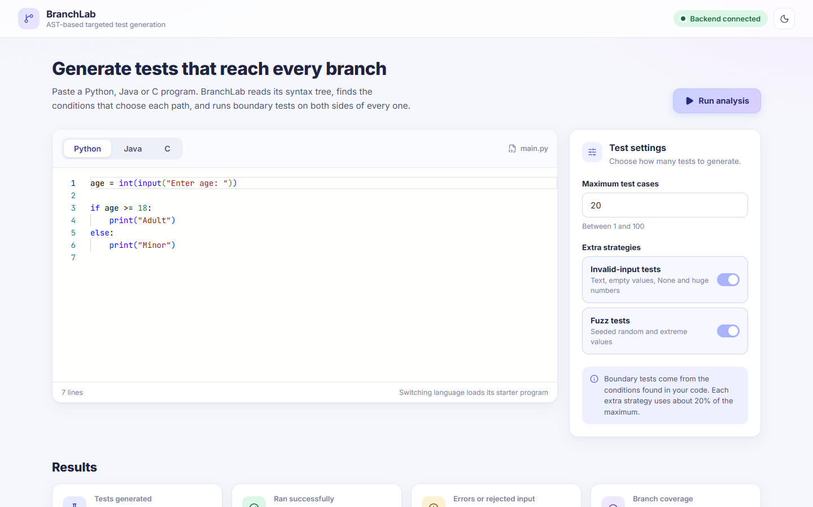
Figure 2. Workspace: language tabs, code editor and test settings
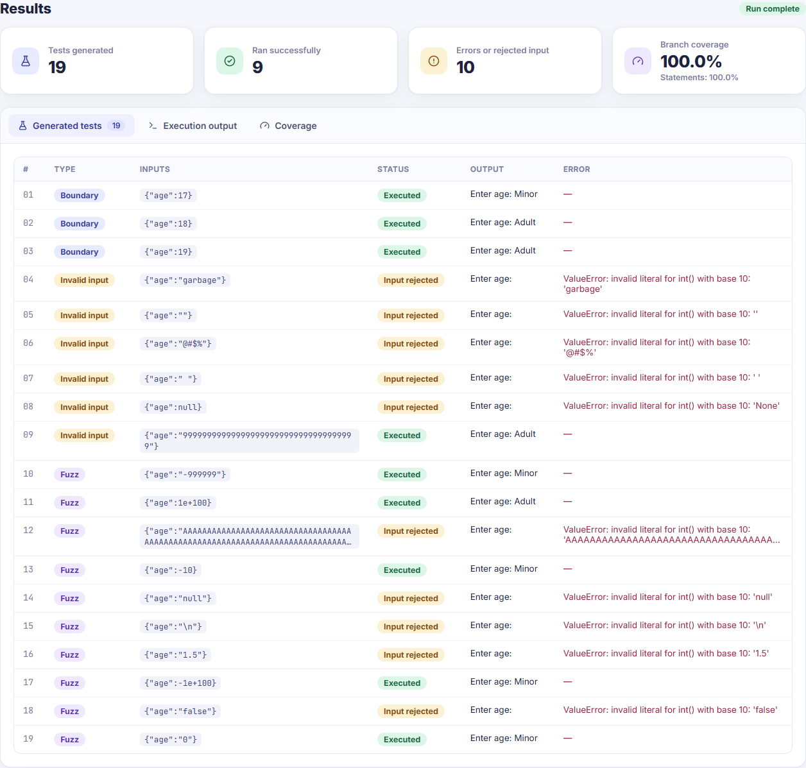
Figure 3. Generated tests with category, inputs, status and output
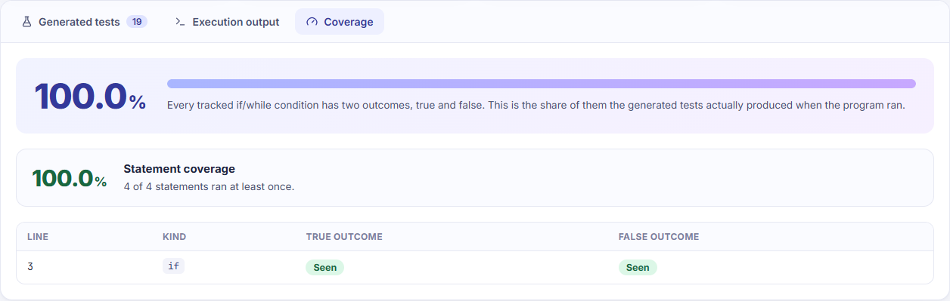
Figure 4. Branch and statement coverage for the Python starter program

8. Validation of the Tool
The tool is checked by 242 automated tests. Coverage figures are never trusted on their own: every program output is compared with a reference implementation, and the expected true/false outcomes are recomputed independently from the actual generated inputs. Every change was made test-first (a failing test, then the fix). These checks found real defects during development:
Defect found | Fix
Python input values were swapped between variables | Read order taken from the AST
Java Scanner programs hung until the timeout on every test | Standard input always supplied
C scanf programs read uninitialised memory yet were reported as executed | Values delivered on stdin per path
Reads of values no condition uses shifted later values into the wrong variable | Typed placeholder answers
Tree-sitter 0.26.0 returned corrupted nodes and crashed the process | Pinned 0.25.2; crash regression test

9. Results: AST-Targeted vs Random Testing
Setup: BranchLab's targeted suite (at most 20 tests) is compared with random suites of the same size, drawing uniform integers in [-1000, 1000] for the same input variables; random results are the mean of three fixed seeds. Fault detection uses 81 boundary mutants in total. The evaluation is reproducible with: python -m src.evaluation.evaluate
Program | Tests | Branch AST | Branch Rand. | Stmt AST | Stmt Rand. | Faults AST | Faults Rand. | Gen. ms
python/grade.py | 15 | 100.0% | 29.2% | 100.0% | 43.3% | 100.0% | 0.0% | 0.5
python/thermostat.py | 6 | 100.0% | 75.0% | 100.0% | 83.3% | 100.0% | 0.0% | 0.6
python/countdown.py | 3 | 100.0% | 100.0% | 100.0% | 100.0% | 100.0% | 100.0% | 1.4
python/nested_login.py | 9 | 100.0% | 83.3% | 100.0% | 90.5% | 100.0% | 0.0% | 0.6
java/Grade.java | 15 | 100.0% | 29.2% | 100.0% | 43.3% | 100.0% | 2.2% | 19.1
java/Thermostat.java | 6 | 100.0% | 75.0% | 100.0% | 85.7% | 100.0% | 0.0% | 4.6
c/grade.c | 15 | 100.0% | 29.2% | 100.0% | 48.5% | 100.0% | 0.0% | 5.8
c/countdown.c | 3 | 100.0% | 100.0% | 100.0% | 100.0% | 100.0% | 100.0% | 1.7
c/bank.c | 20 | 48.0% | 6.0% | 69.7% | 15.2% | 50.0% | 11.1% | 22.4
Average |  | 94.2% | 58.5% | 96.6% | 67.8% | 94.4% | 23.7% | 6.3

9.1 Discussion
- Fault detection: with the same number of tests, AST-targeted suites detected 94.4% of injected boundary faults against 23.7% for random inputs, because random values almost never land on c-1, c or c+1.
- Coverage: average branch coverage 94.2% vs 58.5%; statement coverage 96.6% vs 67.8%.
- Case study: on the menu-driven bank system (examples/c/bank.c) the targeted suite reached 48.0% branch and 69.7% statement coverage versus 6.0% and 15.2% for random inputs, which rarely pick a valid menu option. Remaining branches need several actions in one run (create an account, then deposit), which neither approach generates.
- Generation time: analysis and generation took 6.3 ms per program on average; random generation is cheaper, but its tests are far less effective.
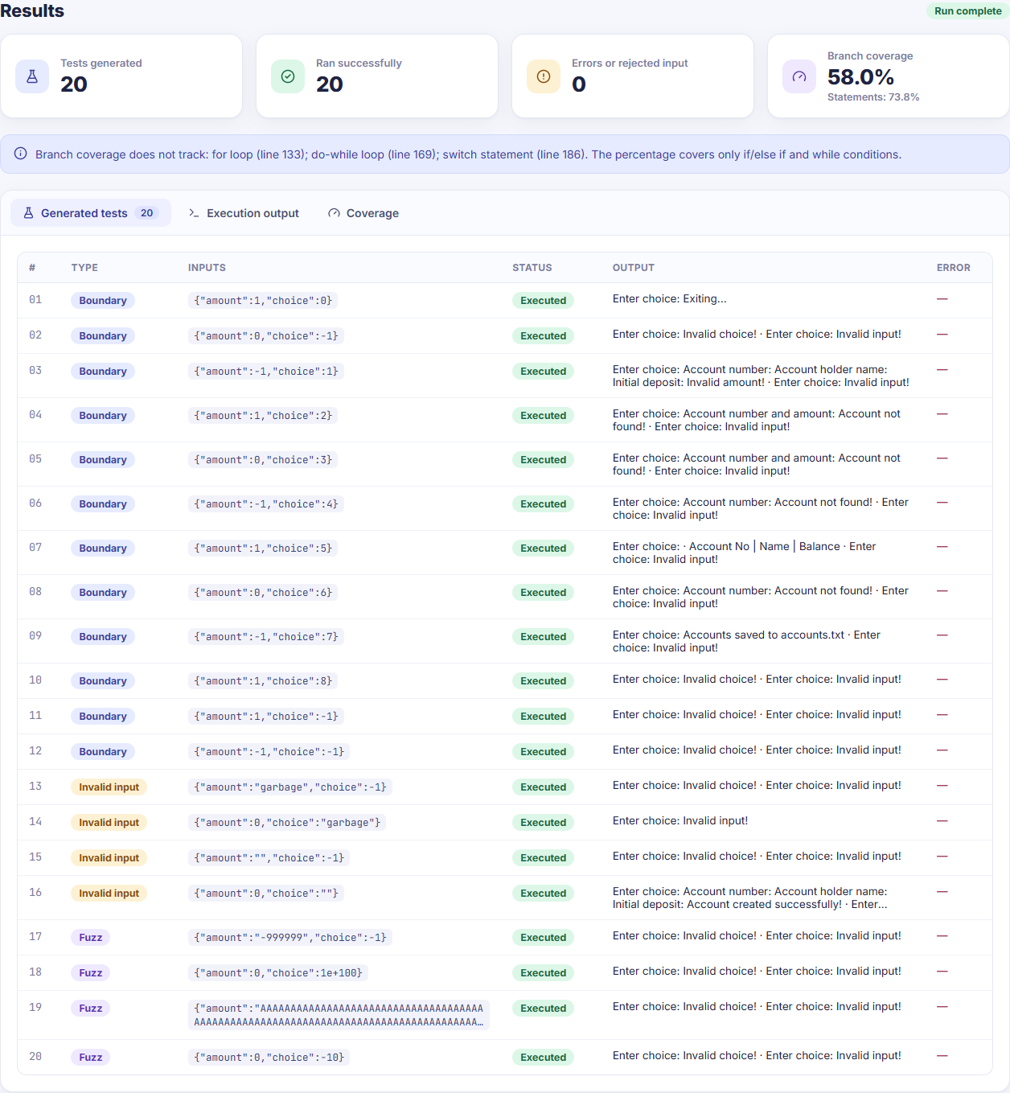
Figure 5. The C bank system in BranchLab: every menu option is exercised. This run also includes invalid-input and fuzz tests (58.0% branch, 73.8% statement); the evaluation above uses targeted tests only.

10. Implementation Progress
Module | Progress
AST parsing and condition analysis (C, Java, Python) | Complete
Targeted, invalid-input and fuzz test generation | Complete
Execution with input delivery and time limits | Complete
Branch and statement coverage; verified suggestions | Complete
Evaluation: random baseline and mutation testing | Complete
Web interface (BranchLab) | Complete
Larger benchmark programs; final report | In progress (Review III)

Overall, the planned implementation is complete and demonstrable as a working prototype; the remaining work is a wider evaluation and the final report.

11. Limitations and Future Work
- Single-run tests: each test is one run with one set of values; behaviour that needs a sequence of actions is not generated.
- Condition forms: only comparisons between a variable and a numeric constant produce targeted values (not x > y or strlen(s) > 5).
- Coverage scope: for loops, switch statements and ?: run normally but are not counted in branch coverage; the interface lists them.
- Isolation: processes contain hangs and crashes but are not a security sandbox.
Future work: input sequences for stateful programs, lightweight constraint handling for variable-to-variable conditions, coverage of loops and switch cases, container sandboxing, and evaluation on standard benchmark programs.

12. Conclusion
The project meets all objectives set in Review I. It parses programs into ASTs, identifies branch conditions and boundaries, generates targeted tests, and measures branch coverage, statement coverage and fault detection. Compared with random testing at equal test counts, the AST-based approach achieves higher coverage and detects far more injected boundary faults, while staying lightweight and explainable. BranchLab presents all of this in a working web prototype for C, Java and Python.

References
- P. Godefroid, N. Klarlund, K. Sen, “DART: Directed Automated Random Testing,” 2005.
- K. Sen, D. Marinov, G. Agha, “CUTE: A Concolic Unit Testing Engine for C,” 2005.
- C. Cadar, V. Ganesh, P. Pawlowski, D. Dill, D. Engler, “EXE: Automatically Generating Inputs of Death,” 2006.
- C. Pacheco, S. Lahiri, M. Ernst, T. Ball, “Feedback-Directed Random Test Generation,” 2007.
- C. Cadar, D. Dunbar, D. Engler, “KLEE: Unassisted and Automatic Generation of High-Coverage Tests for Complex Systems Programs,” 2008.
- K. Lakhotia, P. McMinn, M. Harman, “An Empirical Investigation into Branch Coverage for C Programs Using CUTE and AUSTIN,” 2010.
- G. Fraser, A. Arcuri, “Evolutionary Generation of Whole Test Suites,” 2011.
- A. Panichella et al., “Automated Test Case Generation as a Many-Objective Optimisation Problem with Dynamic Selection of the Targets,” 2018.
- C. Lemieux, J. P. Inala, S. Lahiri, S. Sen, “CodaMOSA: Escaping Coverage Plateaus in Test Generation with Pre-trained Large Language Models,” 2023.
- Y. Chen, Z. Hu, C. Zhi, J. Han, S. Deng, J. Yin, “ChatUniTest: A Framework for LLM-Based Test Generation,” 2024.
- J. Liu, C. Li, R. Chen, S. Li, B. Gu, M. Yang, “STRUT: Structured Seed Case Guided Unit Test Generation for C Programs using LLMs,” 2025.

