JDK – java dev kit

JRE – java run time env – env to run the code

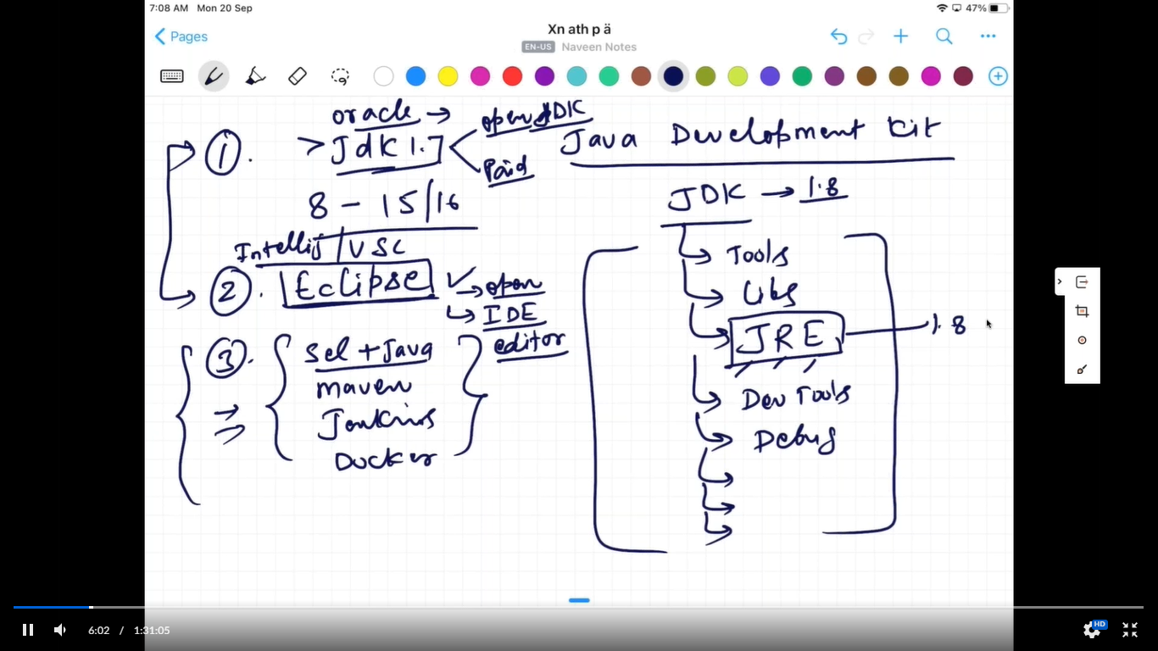

JVM will check for main() method. If we don’t have main(). We can’t run that class

Data Types-

