**Static Array –** Static array will occupy only 1 type of data.

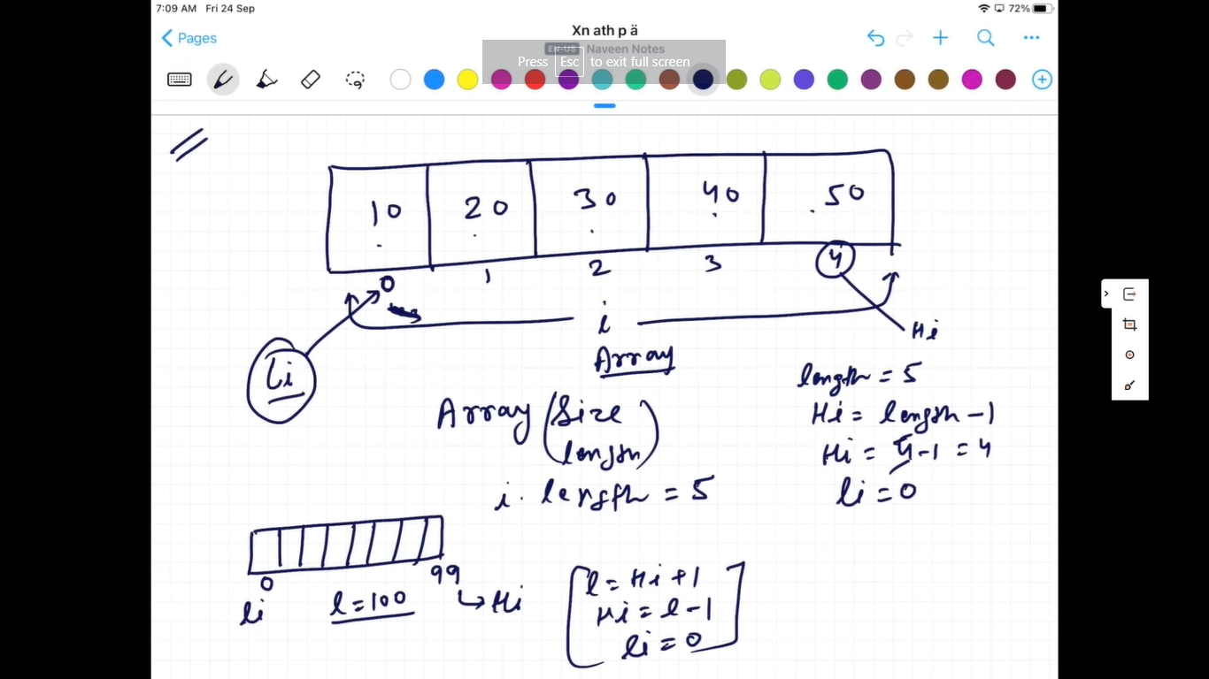

//1. int array:

int i[] = new int[4];

i[0]=10;

i[1]=20;

i[2]=30;

i[4]=40;

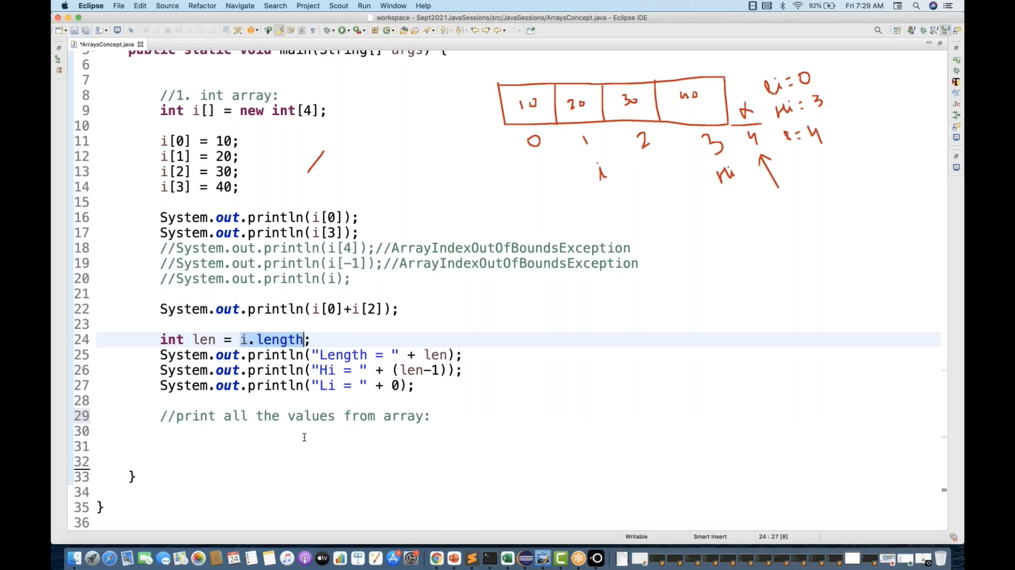

For each loop –

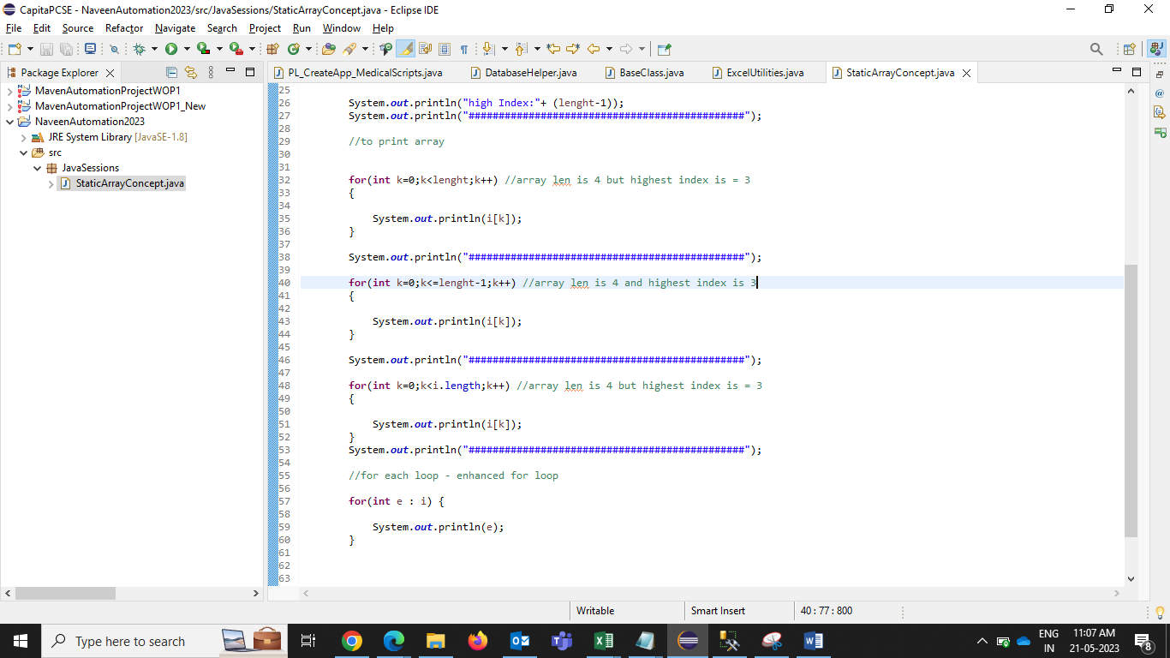

Output –

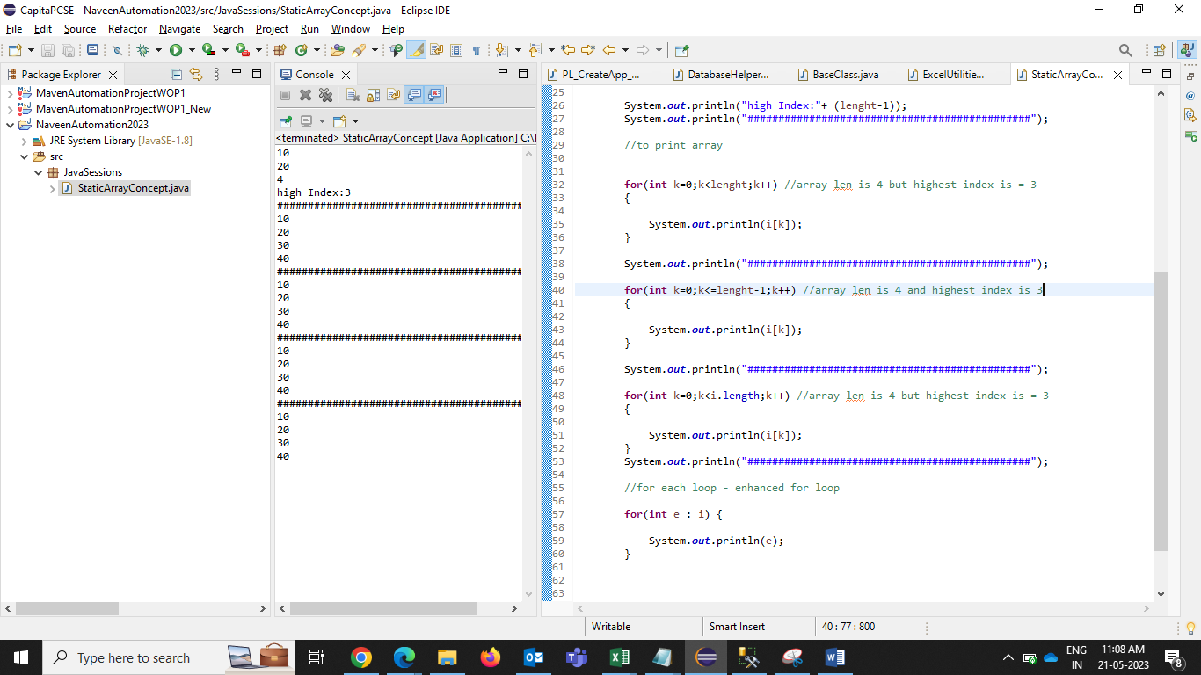

Char and double array –

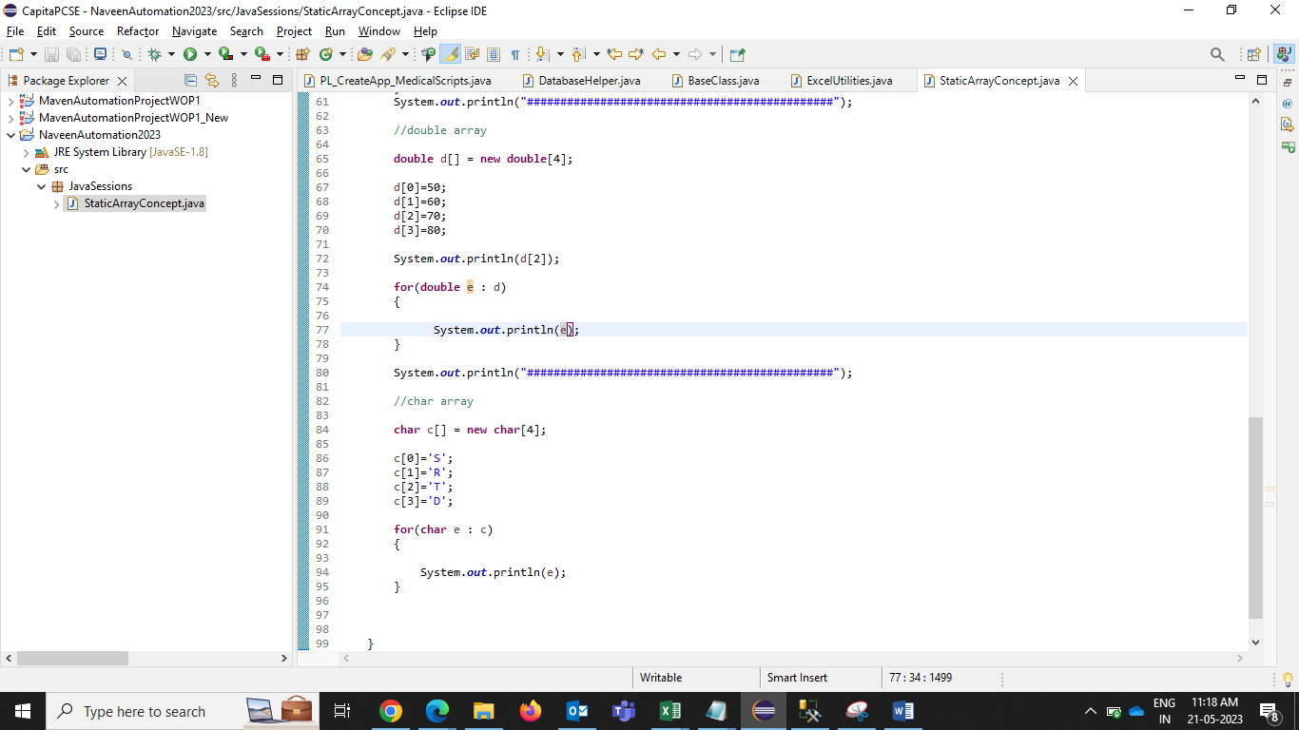

Output –

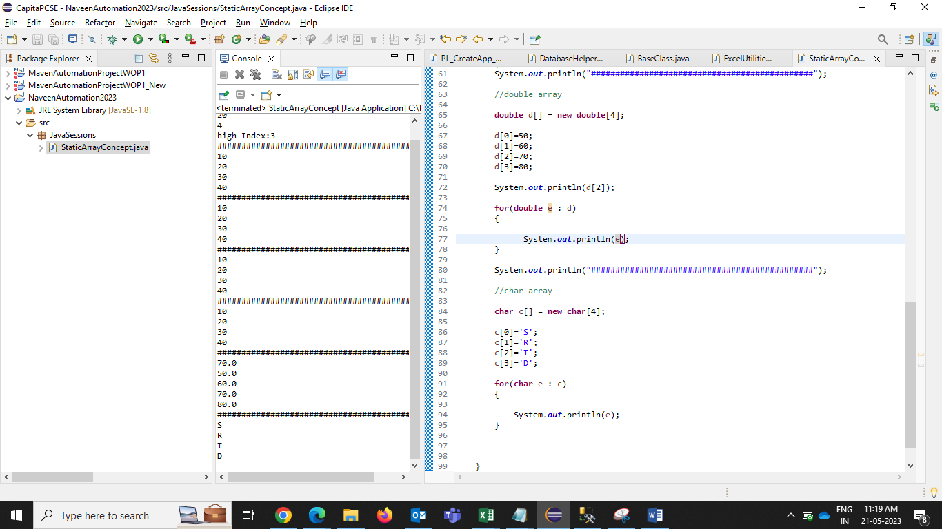

String array –

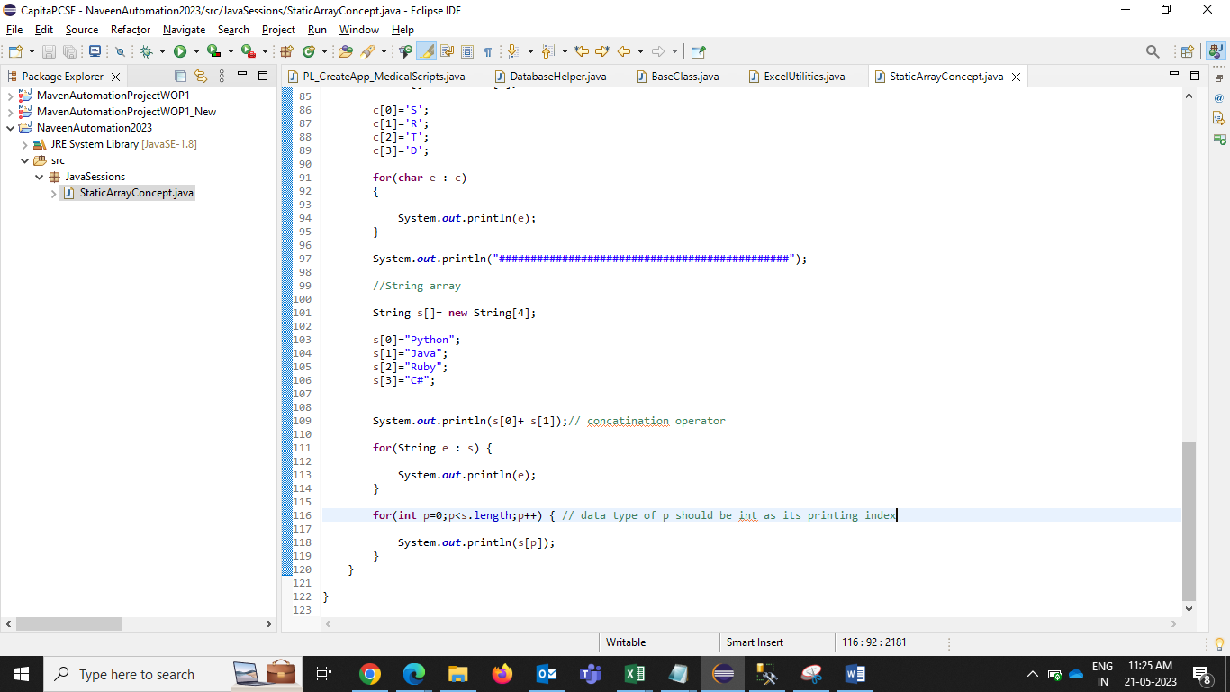

Output =

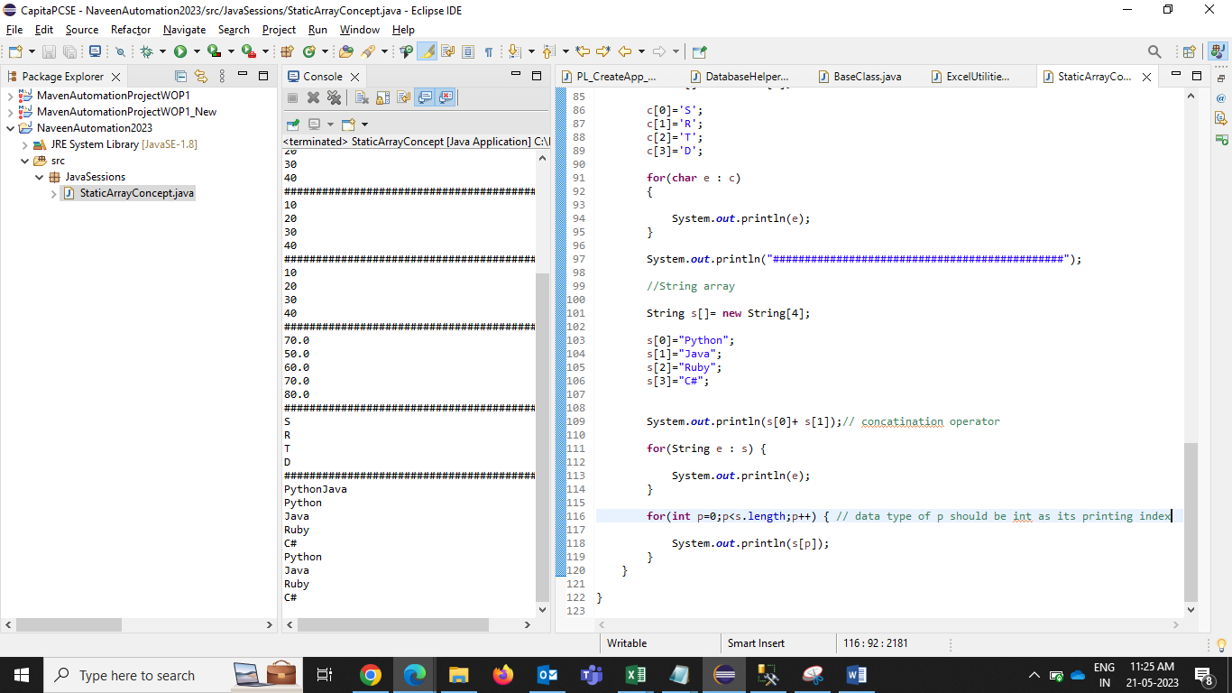

Printing index –

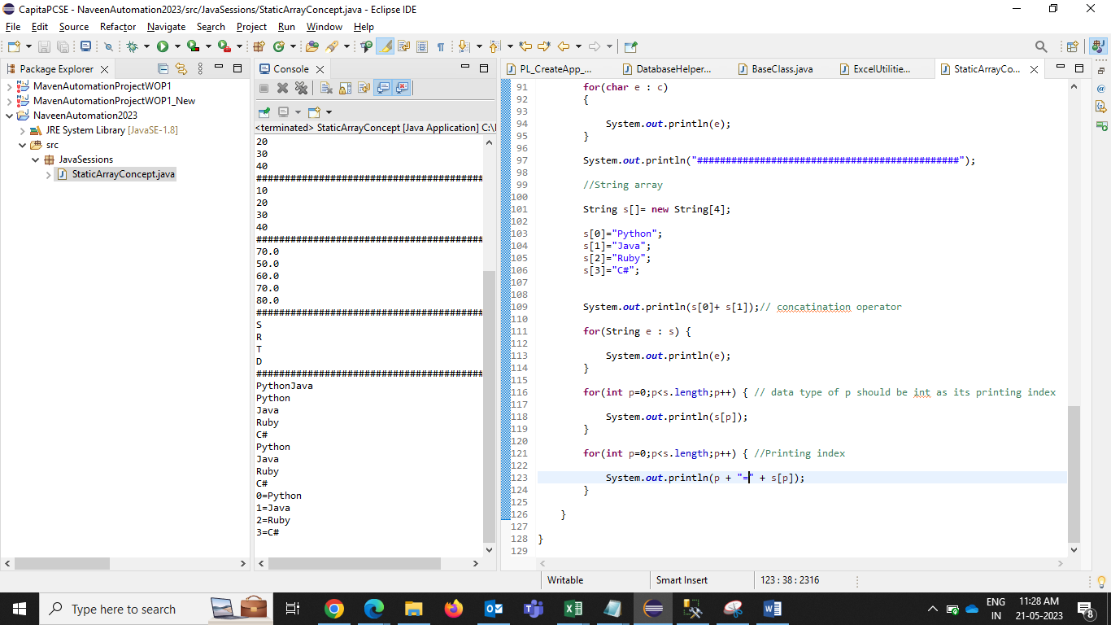

Disadvantage/limitations of static array –

1. Size is always fix - to overcome this problem, use dynamic array- **ArrayList**
2. Arrays will store similar type of data – to overcome this problem, use dynamic array- **ArrayList / Static Object array**

// user cases for static array –

1. total no. of months in year

2.Total days in a week

1. **Static Object array – its static array only but we can store diff type of data.**

Object is in built class in java.

