**Use cases for dynamic array –**

1.Ecommerce website – product size is not fix/ no. of users

2. Uber app – total no. of bookings at any time.

**Use cases for static array –**

1. DOB dropdown

**ArrayList** –

1. it’s a default class in java and need to create the object.
2. ArrayList maintain the index/order
3. To get size of ArrayList = ar.size(); [ in array it’s a .lenght()]

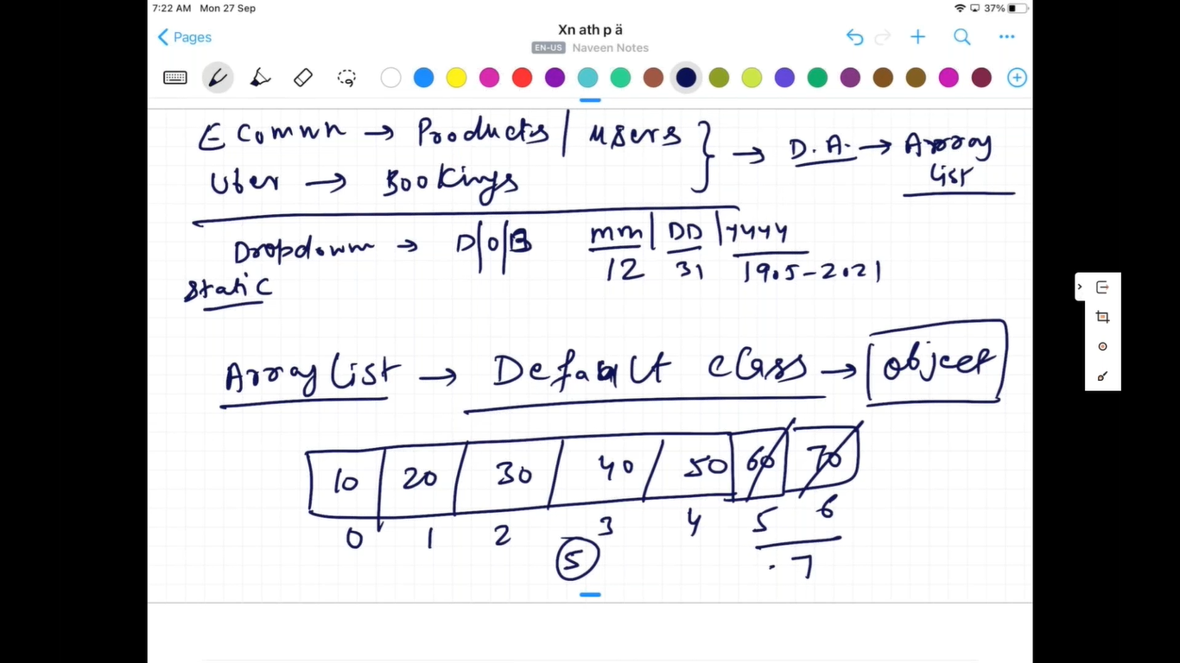

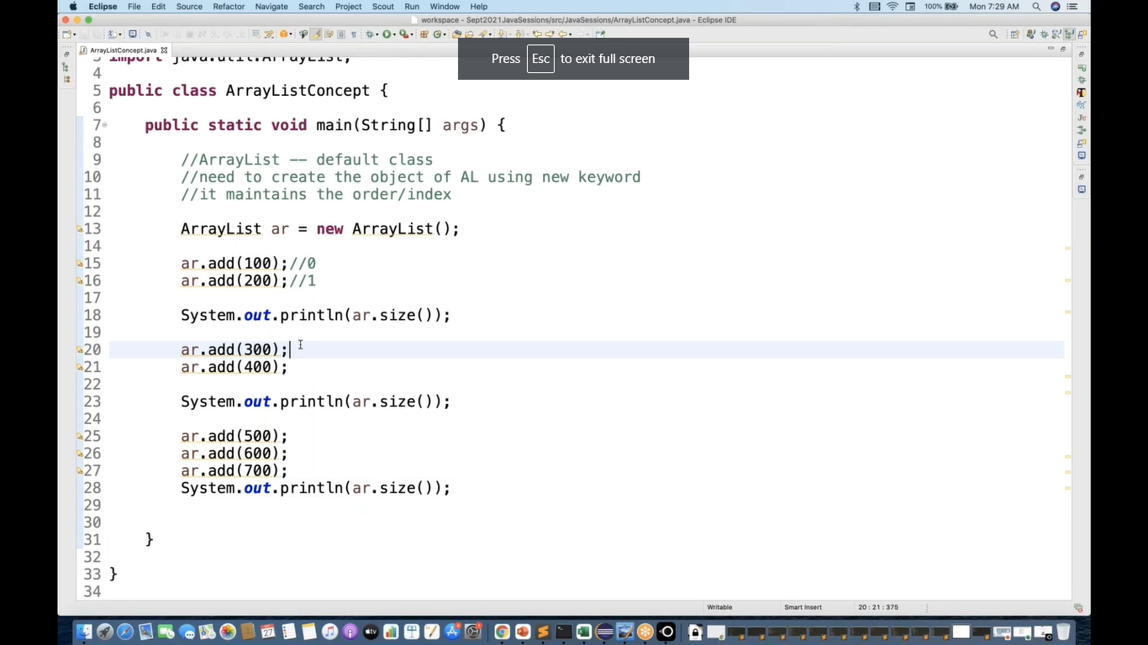

Output –

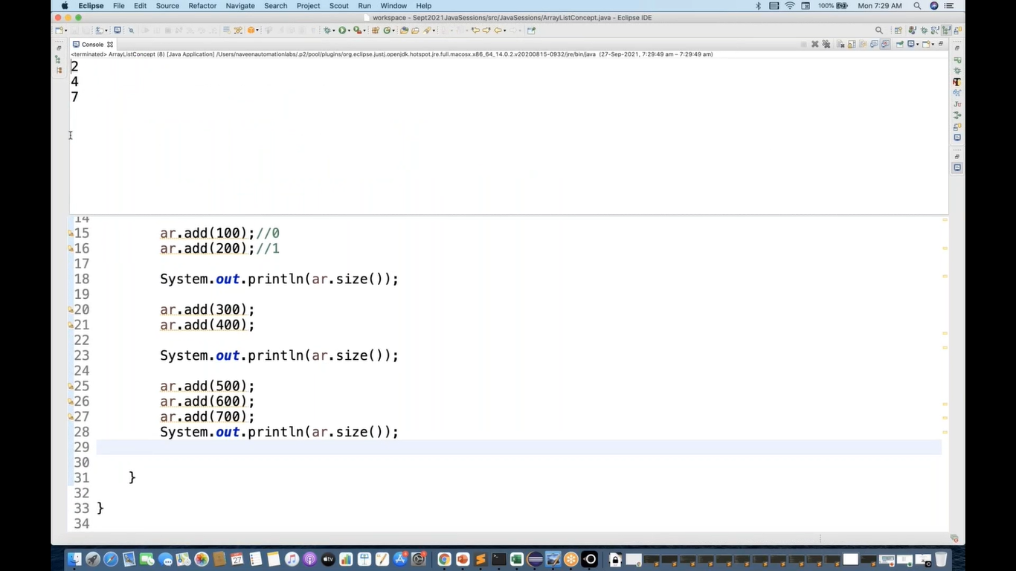

Default virtual capacity (Vc) of ArrayList = 10 cells will be created as soon as we initialize the ArrayList.

Physical capacity = no. of cells occupied in the ArrayList.

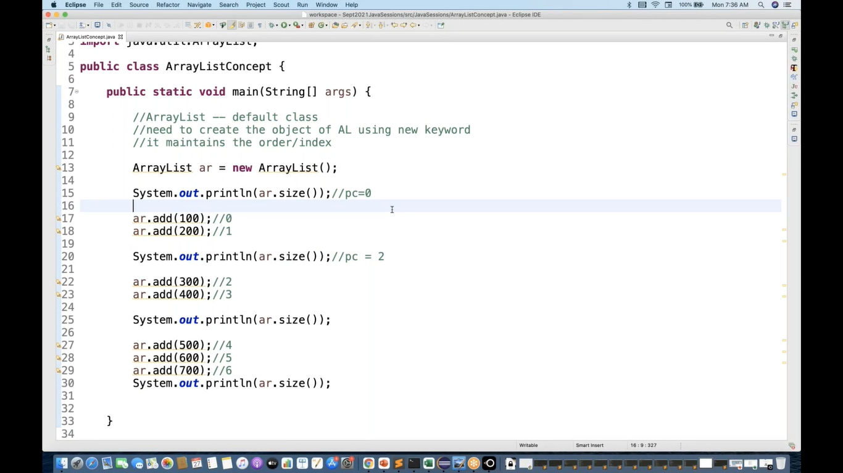

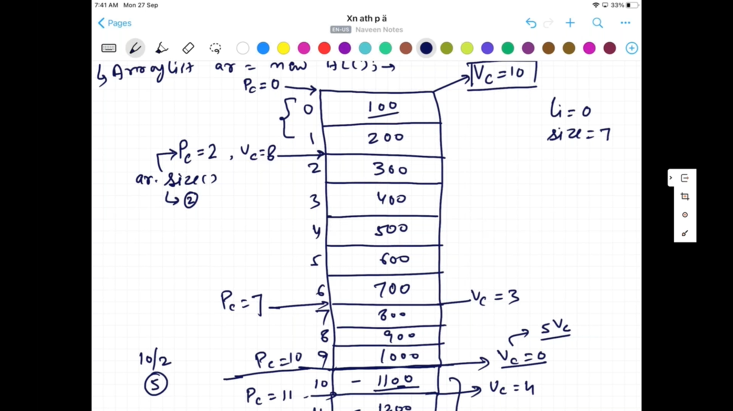

To check value at specific index – ar.get(0);

To remove element from ArrayList = ar.remove();

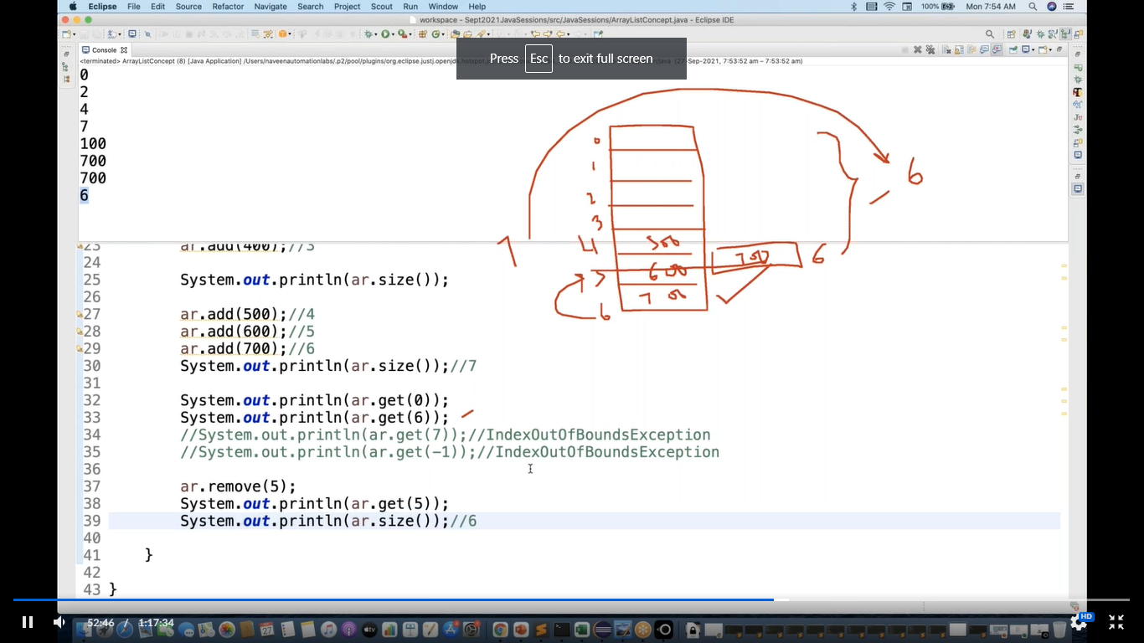

Printing data of ArrayList –

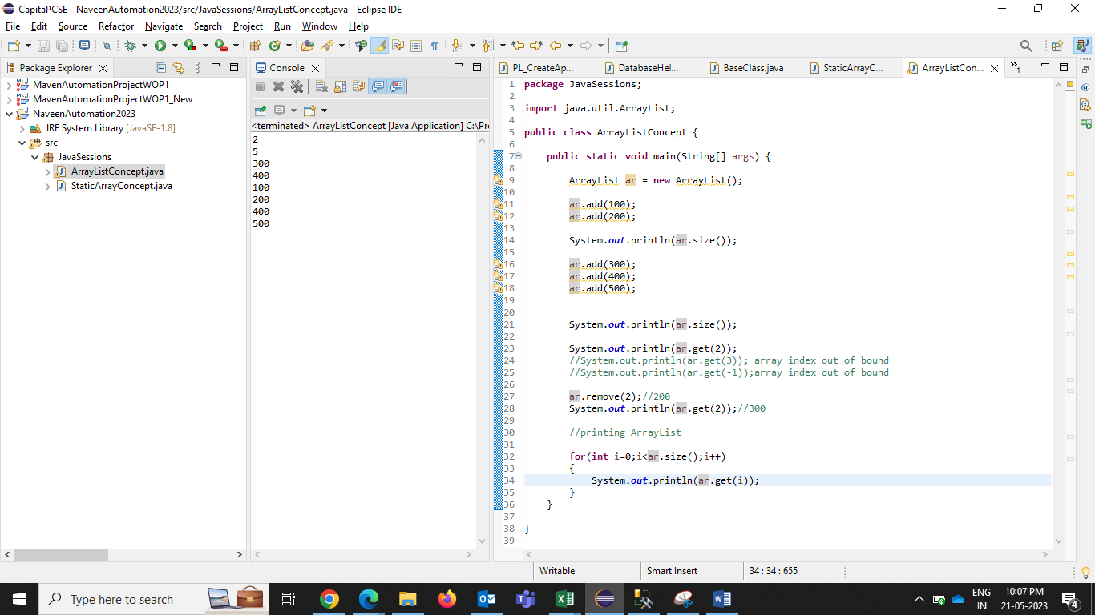

# We can add duplicate values.

# We can add diff type of data in ArrayList at a time– int, string, char etc

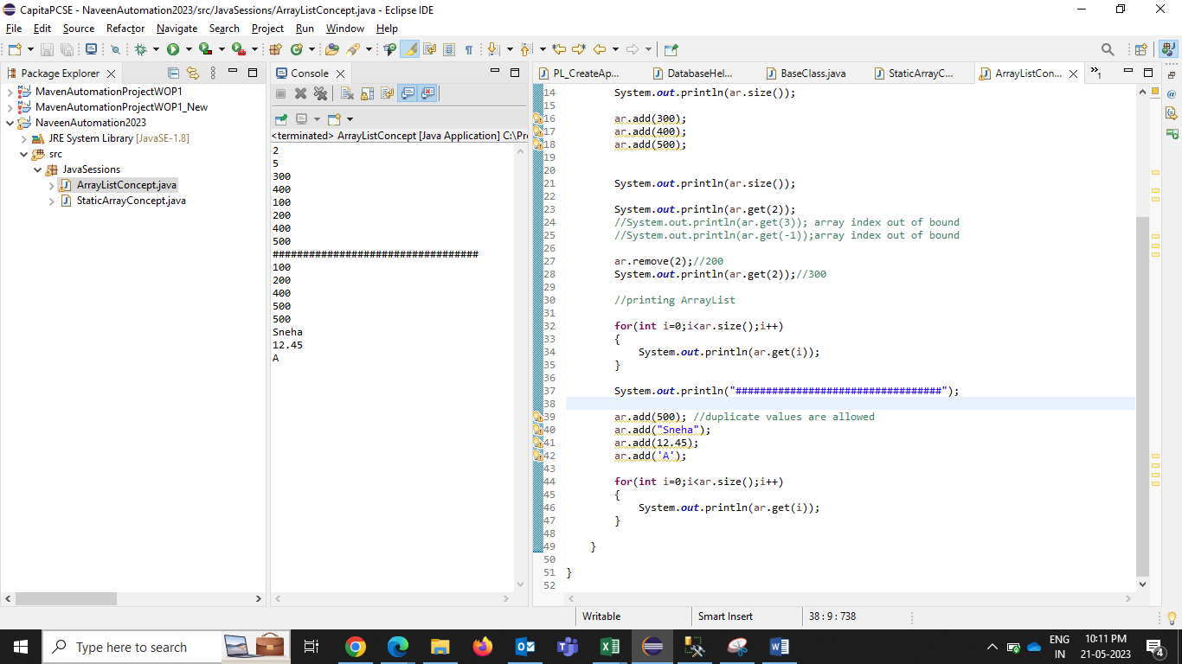

Generics –

On all int type, there is Integer class , wrapper class.

Interger – is a class and its non-primitive

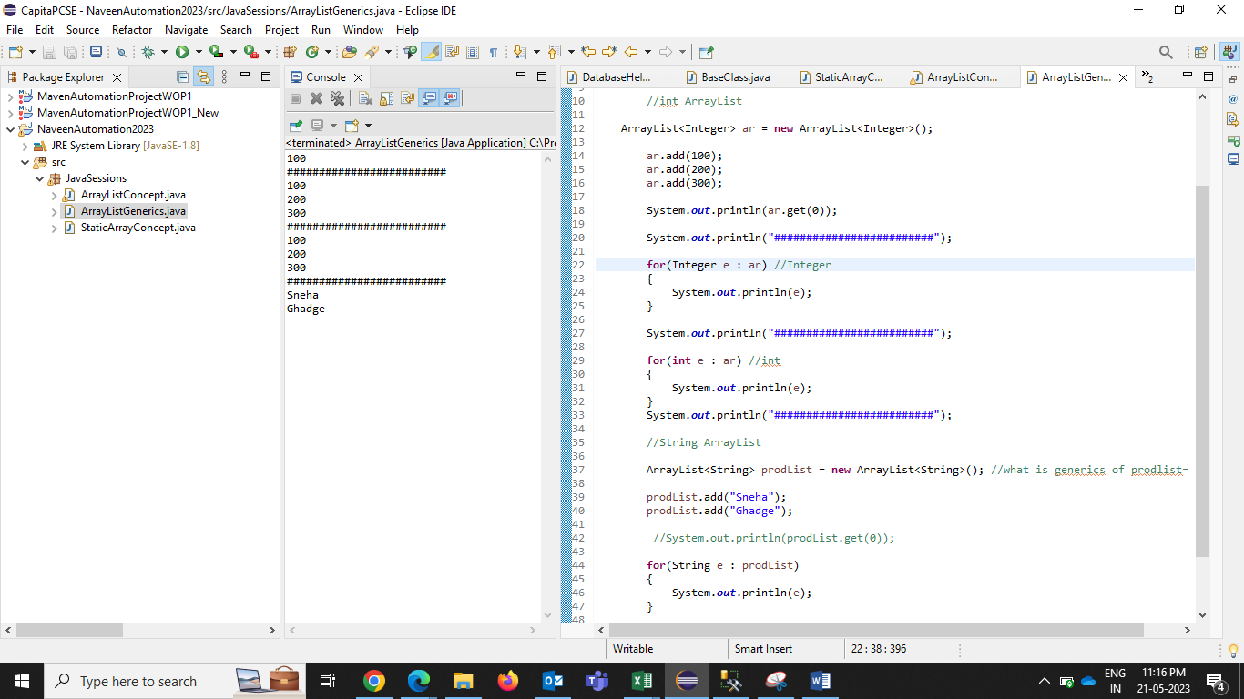

Object ArrayList – To store diff type of data

ArrayList<Object> emp = new ArrayList<Object>();

