**Functions in Java –**

# can not create function inside a function.

# can call function inside a function.

#JVM will go to main method always when we run the program

//1. No input, No return

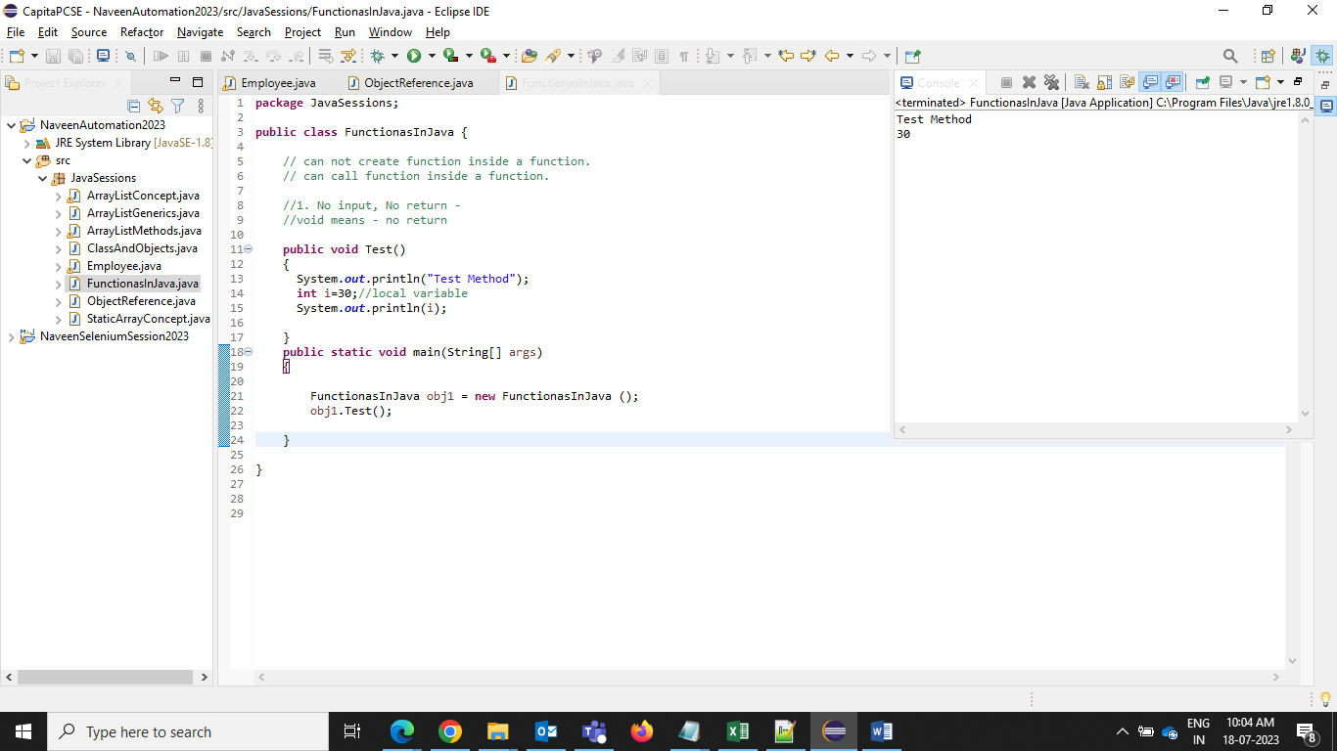

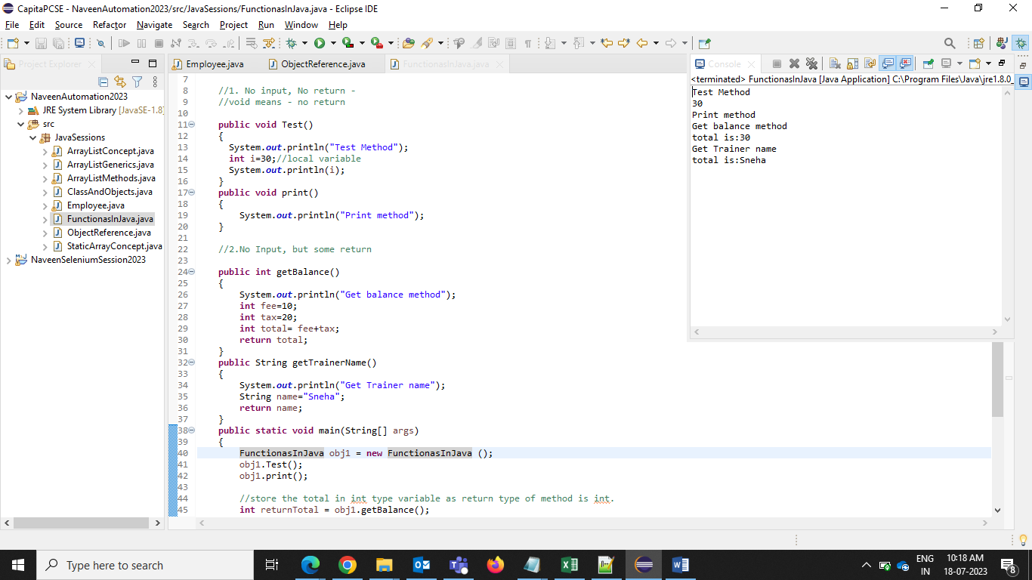

//2. No input, but some return

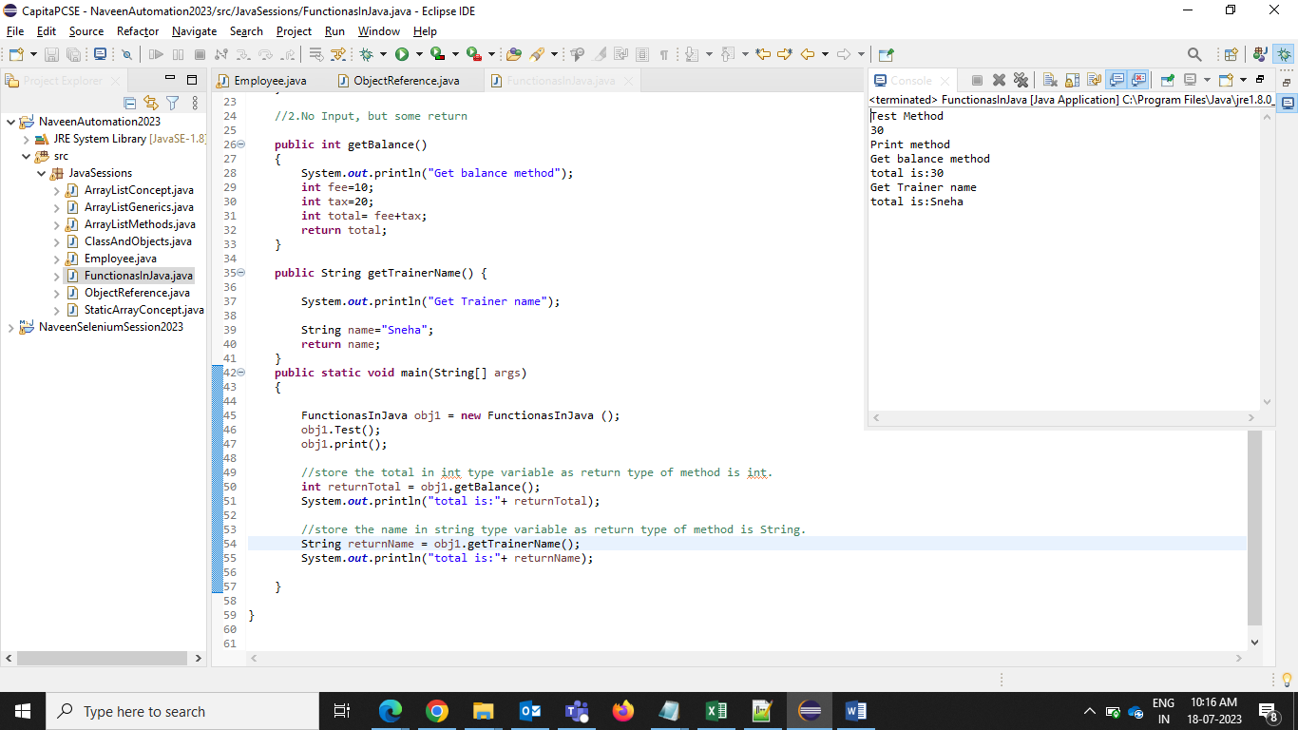

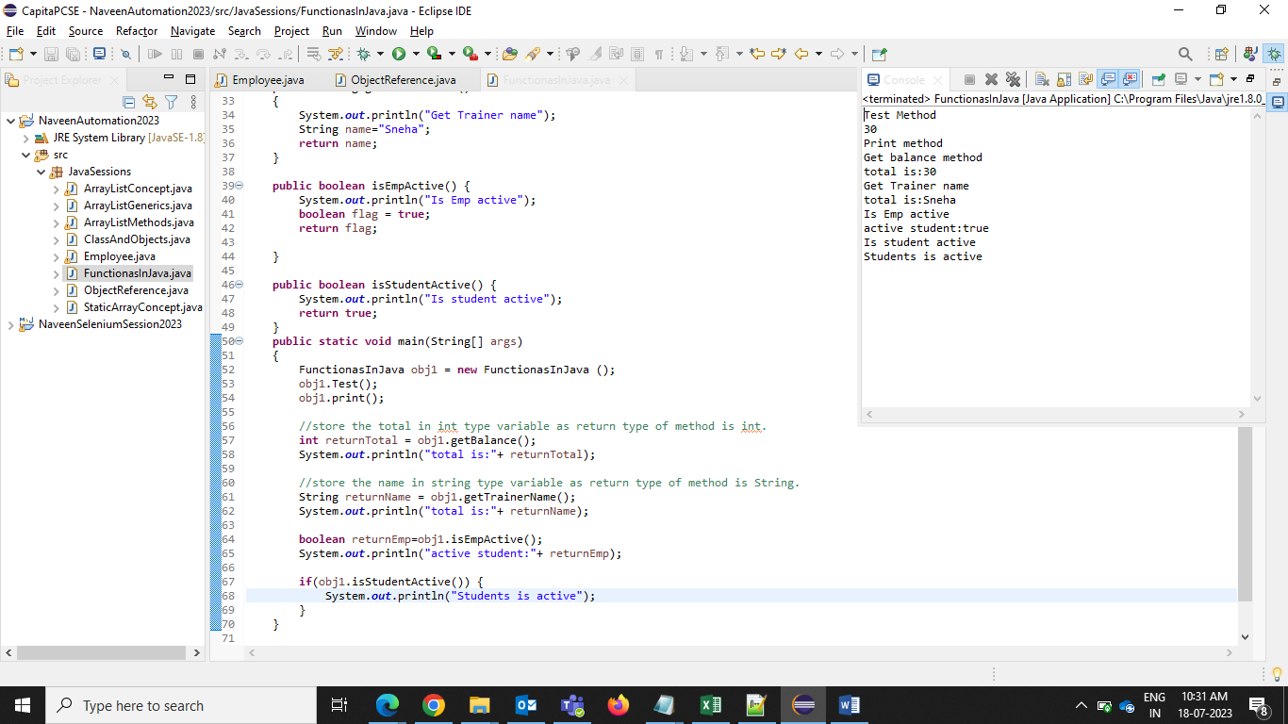

//3. Some input, some return

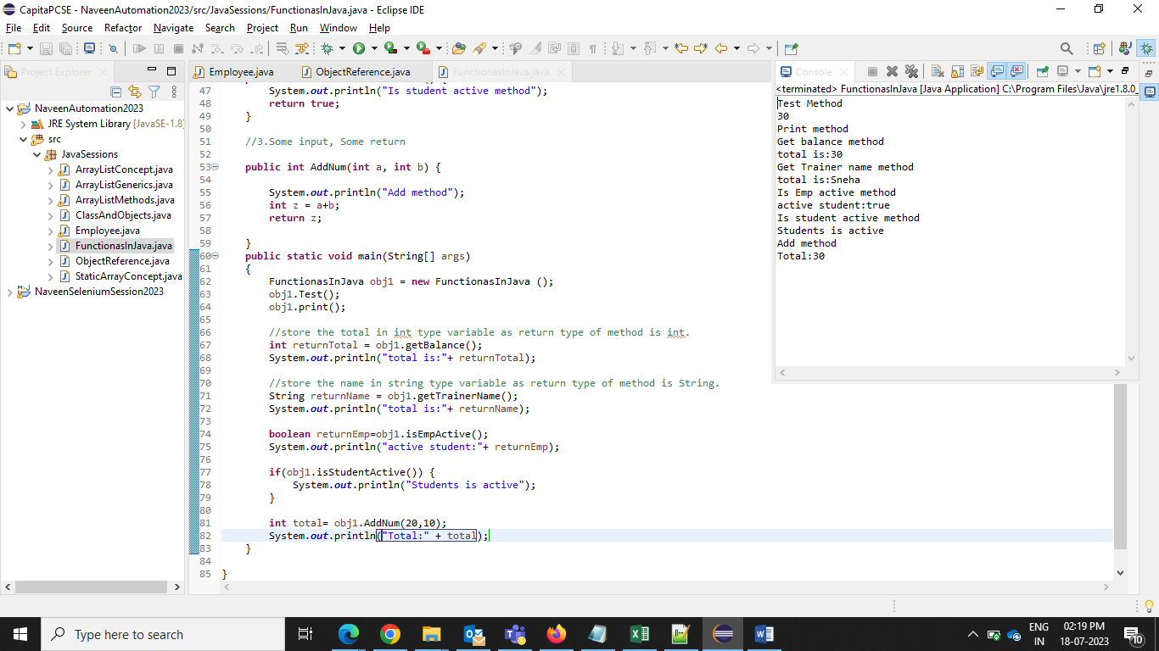

// input string, return int

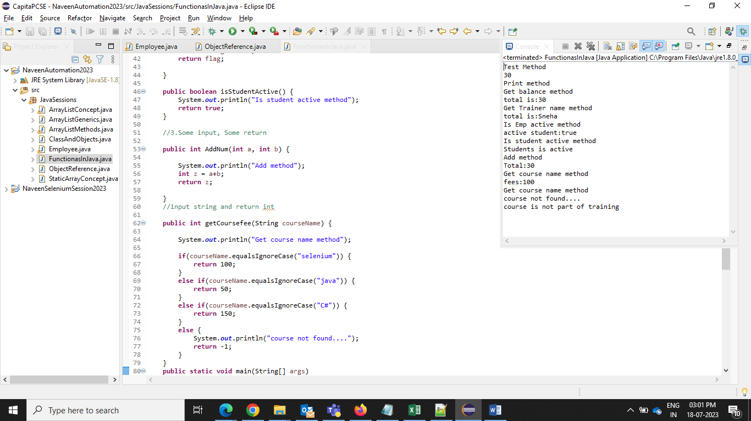

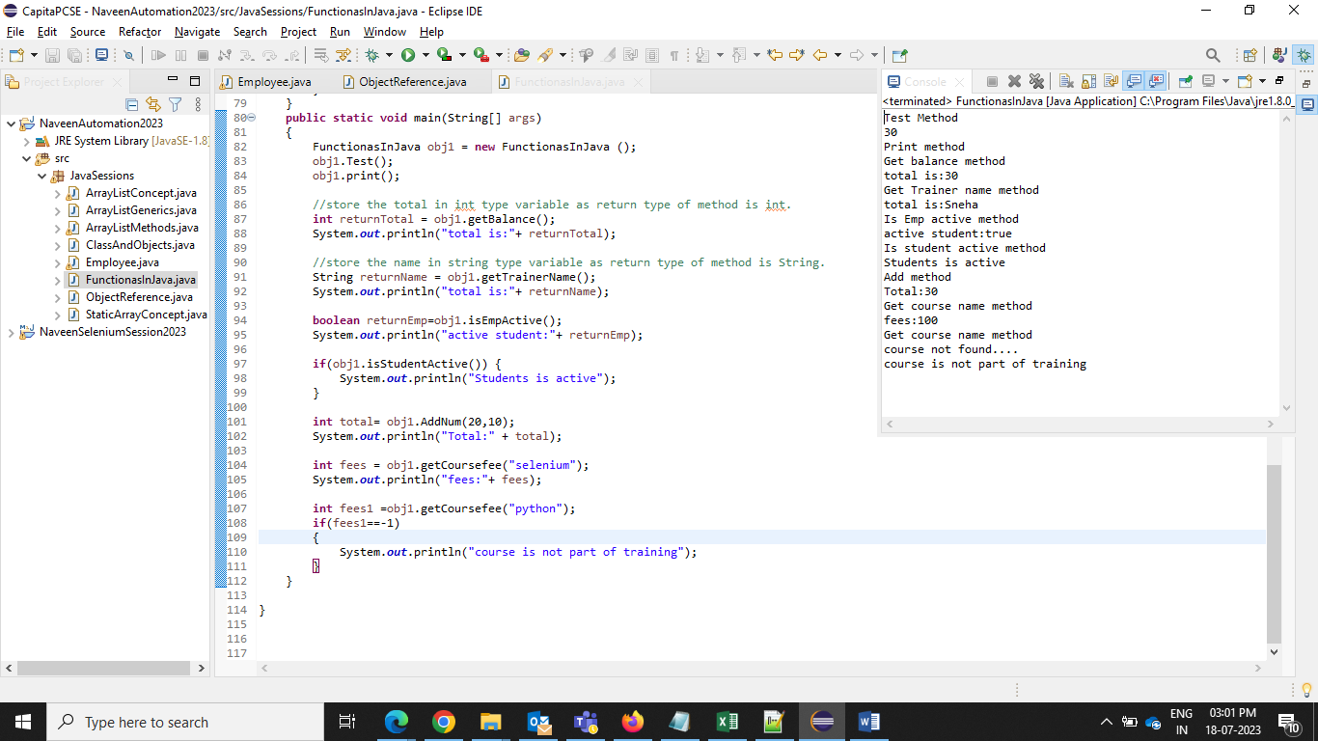

// variables are defining the properties of the object.

// methods are defining the behavior of the object

Properties of employee – age, name, city, salary

Feature of employee – employee can write the code, can travel, emp can talk to cust, emp can generate the.

Human is class – every human class object has following -

Object Properties – 2 hands, 1 nose, 2 legs, 2 ears

Object Feature – humane can write, can sing , can drive

Customer behavior on e-commerce website – cust can search prod, can do login, can add prod in the cart.

