We never pass more than 5 parameters to method. If we want to pass more than 5 para then we pass class object.

// we cant create duplicate function - same method, same no. of parameter.

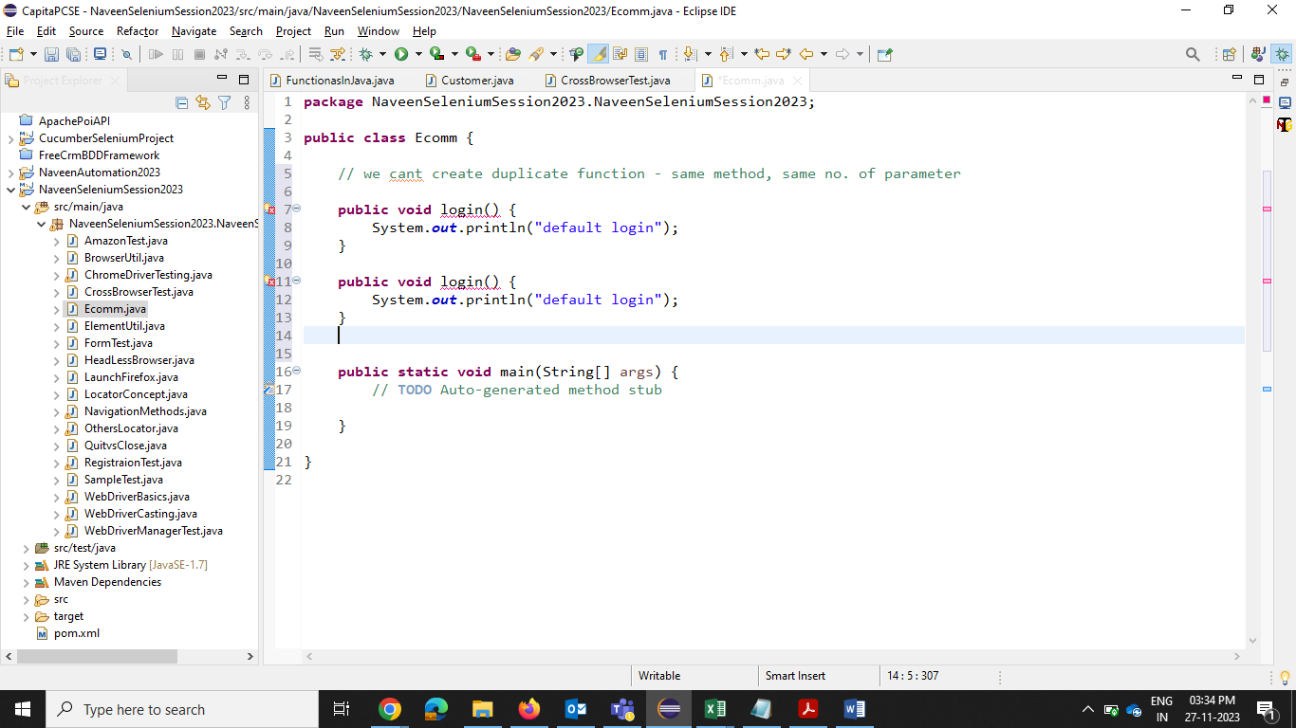

Method overloading –