

PROJECT AND TEAM INFORMATION

Project Title

HerSuraksha - Women Safety and Emergency App

Student/Team Information

Team Name:  Team ID | CoDevis  FS-VI-TO76
Team member 1 (Team Lead) | Goyal , Sneha - 2023934  goyalsneha405@gmail.com  
Team member 2 | Singhal , Nandini - 2024074  nandinisinghal2004@gmail.com
Team member 2 | Priya - 2023785  somaypriya@gmail.com  
Team member 2 | Pundir , Urvee – 2023686  urvee2004@gmail.com  

PROJECT PROGRESS DESCRIPTION

Project Abstract

- HerSuraksha is a responsive women safety web application built for quick emergency access on both mobile and laptop browsers. The current project combines SOS response, live tracking, contact management, nearby safety assistance, and emergency utility tools inside a single Firebase-hosted interface.
- When the user triggers SOS, the app shows a 5 second cancel countdown, captures GPS coordinates, starts an 8 hour live tracking session with 30 second Firestore updates, emails the location and tracking link to saved emergency contacts through EmailJS, and attempts a call to the highest priority contact. The dashboard also includes quick helplines, an emergency siren with a flashing warning screen, and a safety timer that automatically escalates to the top 4 contacts after the travel timer and 10 minute grace period.
- The current build further includes scheduled fake calls, nearby police stations, hospitals, and ATMs with saved backup places, voice trigger for SOS and siren phrases while the app is open, emergency notes, a stealth calculator screen, profile and contact management, feedback collection, and English/Hindi language support. Firebase Anonymous Authentication is used for instant access, while Firestore stores user profiles, emergency contacts, saved places, feedback, notes, and live tracking sessions.

Updated Project Approach and Architecture

- Frontend:
- HTML entry files in the project root provide separate screens for login, dashboard, contacts, add/edit contact, fake call, nearby places, notes, help, account, stealth calculator, and live tracking.
- CSS is organized into page level and shared component styles for responsive layouts on mobile and laptop screens.
- JavaScript is modularized into js/pages, js/firebase, js/utils, and js/components for page logic, Firebase access, timers, location helpers, translations, and UI behavior.
- Firebase backend:
- Firebase Anonymous Authentication is used for quick sign in, and Cloud Firestore stores users, emergencyContacts, savedNearbyPlaces, feedback, and liveLocations data.
- Deployment and integrations:
- Firebase Hosting deploys the web app at https://hersuraksha.web.app and serves the public live tracking page.
- EmailJS is used for SOS alert emails, the Geolocation API is used for live coordinates, the Web Speech API is used for voice trigger, HTML audio is used for ringtone and siren playback, tel: and sms: deep links are used for calling and messaging, Overpass API is used for nearby place discovery, and Leaflet is used to display the live tracking map.
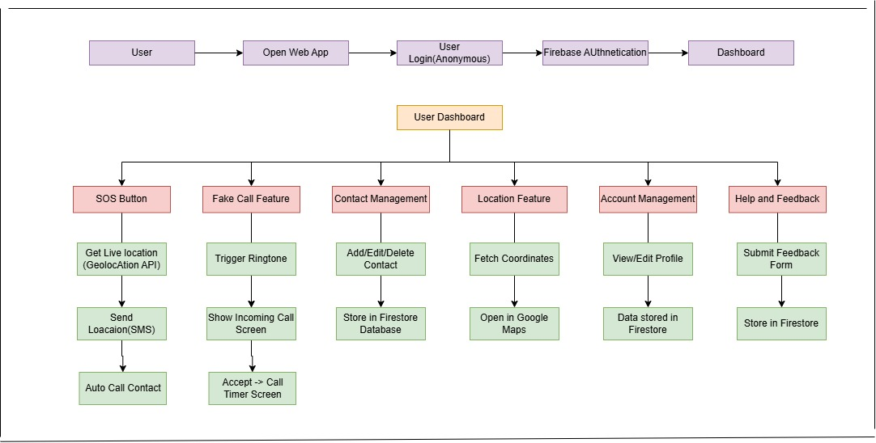

Tasks Completed

Task Completed | Team Member
Firebase Hosting, Firebase Authentication, and Firestore integration  Anonymous sign in with stored user profile and persistent session  Responsive dashboard with SOS, Fake Call, Nearby Places, Safety Timer, and Emergency Siren cards  SOS flow with 5 second cancel window, live tracking link, EmailJS alerts, and priority contact auto-call  Emergency contact add, edit, delete, call, SMS, and priority ordering  Fake call scheduling with caller customization, ringtone, accept/decline, and call screen timer  Nearby police stations, hospitals, ATMs, plus saved backup places  Travel safety timer with automatic SOS escalation after grace period  Voice trigger for SOS phrases and siren phrases  Quick helplines for 112, 100, 1091, 181, and 102  Emergency notes storage in the user account  Account management with profile edit, photo upload, language selection, logout, and account deletion  Help page with FAQs, support details, and Firestore feedback form  Public live tracking page for shared SOS links  English and Hindi language support | Integrated collaboratively by Sneha, Nandini, Priya, and Urvee in the current build.

Challenges/Roadblocks
Firebase SDK module loading issues were resolved using type="module" script tags and import maps.
OTP based onboarding was not reliable for emergency use, so the project shifted to anonymous authentication with stored profile details for faster access.
Firestore permission rules and deployed data consistency had to be corrected so users can access only their own records safely.
Browser permissions for location, microphone, and audio required explicit handling and fallbacks across SOS, nearby places, voice trigger, fake call, and siren features.
Nearby place search depends on network access and third party Overpass responses, so saved backup places were added for reliability.
Real SMS delivery and direct police system integration would need additional paid or backend supported services, so the current build uses EmailJS, priority calling, helplines, and police discovery instead.
Mobile responsiveness required repeated UI refinement to prevent footer overlap, card breaking, and layout issues on smaller screens.
Cross page timers and emergency state were stabilized using localStorage and sessionStorage.

Tasks Pending
Task Pending | Team Member (to complete the task)
Real SMS alert delivery through a production gateway or backend service  Direct police or authority escalation workflow beyond helpline dialing and nearby police discovery  Broader PWA or background support for alerts when the app is not actively open  Additional compatibility hardening for voice trigger outside supported browsers | Next iteration by the full team.

Project Outcome/Deliverables
Women Safety Web Application
Deployed at: https://hersuraksha.web.app
Responsive design working on mobile and laptop browsers
Dashboard safety hub with SOS, Fake Call, Nearby Places, Safety Timer, Emergency Siren, Quick Helplines, Notes, and the Change stealth calculator
SOS module: 5 second cancel countdown, live location, EmailJS alerts, 8 hour live tracking, public tracking page, and priority contact auto-call
Fake Call module: scheduled incoming call with customizable caller details, ringtone, accept/decline flow, and call timer screen
Nearby Places module: live nearby police stations, hospitals, and ATMs with saved backup places
Safety Timer module: trip check in with automatic SOS escalation after the 10 minute grace period
Voice Trigger module: in app speech phrases for SOS and siren with separate toggles
Contact Management: add, edit, delete, reorder, call, and SMS emergency contacts
Account Management: edit profile, update photo, fake call settings, language preference, logout, and delete account
Support and documentation: help cards, FAQ, feedback form, and support contact details
Multi-language support: English and Hindi translation system

Progress Overview
Completed tasks: the core web app and extended safety feature set are integrated in the current build.
Dashboard integration: the dashboard now contains a greeting header, Notes and Change shortcuts, five primary safety cards, quick helplines, voice trigger controls, and live travel status handling.
Contacts page: stored emergency contacts can be prioritized and used directly for call, SMS, edit, and delete actions.
Nearby Places page: live nearby police, hospital, and ATM results are fetched using Overpass API, with saved custom places as fallback.
Notes page: users can store and delete quick emergency notes such as vehicle numbers, location clues, or suspect descriptions in their account.
Account page: profile edit, photo upload, fake call customization, language toggle, logout, and account deletion are implemented.
Fake Call integration: users can schedule a fake incoming call for 30 seconds, 1 minute, or a custom delay and launch a realistic incoming call screen.
SOS integration: the SOS flow now includes a 5 second countdown, live tracking session creation, alert emails, and a call attempt to the top priority contact.
Shared tracking page: contacts can open the live tracking link and view real time updates on a map.
Overall status: the project scope has moved beyond the original report and now includes siren, voice trigger, safety timer, helplines, notes, nearby places, and bilingual UI support.

Codebase Information
Deployed web app: https://hersuraksha.web.app
GitHub Repository Link: https://github.com/SnehaGoyal15/HerSurakha---Women-Security-Application
Main HTML entry files in the project root: index, login, dashboard, contacts, add-contact, edit-contact, fake-call, call-screen, nearby-places, notes, help, account, stealth, and track
assets: image and audio assets such as logos, icons, ringtone, and siren
css/components and css/pages: shared and page specific responsive styles
js/firebase: Firebase configuration, auth helpers, and Firestore helpers
js/pages: page specific feature logic for each screen
js/utils: language translations, geolocation, fake call scheduler, live tracking, safety timer, and storage helpers
firebase.json and firestore.rules: hosting and database security configuration

Testing and Validation Status
Test Type | Current Status | Notes
UI and navigation flow  Firebase Authentication and Firestore integration  User profile and account management  Emergency contacts CRUD and priority ordering  SOS alert flow with live tracking and email delivery  Fake Call scheduling and incoming call screen  Nearby Places live lookup and saved fallback places  Safety Timer and auto SOS escalation  Emergency Siren and flashing alert screen  Voice Trigger for SOS and siren phrases  Help page and feedback submission  Language switch between English and Hindi  Firestore security rules review  Offline or low connectivity behavior  Cross browser and manual device validation | Implemented  Implemented  Implemented  Implemented  Implemented  Implemented  Implemented  Implemented  Implemented  Implemented  Implemented  Implemented  Implemented  Partial  Partial | Root pages are connected through the dashboard and footer navigation.  Anonymous auth is used for instant entry and user scoped Firestore data.  Profile edit, photo update, fake call settings, language preference, logout, and delete account are present.  Contacts can be added, edited, deleted, reordered, called, and messaged.  SOS now includes a 5 second cancel window, 8 hour tracking link, EmailJS alerts, and priority contact auto-call.  Fake call can be scheduled for preset or custom delay and opens a realistic incoming call flow.  Nearby police stations, hospitals, and ATMs are fetched live; saved places act as fallback.  Travel timer escalates to SOS for the top 4 contacts after the grace period if the user does not check in.  Dashboard siren starts loud audio and a flashing emergency overlay.  Voice trigger works while the app is open and browser speech recognition is supported.  Feedback form stores submissions in Firestore and the help page documents all major features.  English and Hindi translations are wired through the shared language utility.  Rules restrict users to their own profile, contacts, and saved places; feedback is write only and live tracking is public read.  Fake call and the calculator are the most offline friendly pieces; Firebase backed features and live place discovery need connectivity.  The web app is designed for mobile and laptop browsers, but broader browser and device regression testing can continue in future iterations.

Deliverables Progress
Completed:
Firebase hosted HerSuraksha web app with a responsive dashboard
Anonymous sign in plus stored user profile
SOS with live tracking, EmailJS alerts, and priority contact auto-call
Emergency contacts CRUD and priority ordering
Fake Call scheduling and customization
Nearby Places with live police, hospital, and ATM lookup plus saved places
Safety Timer with automatic escalation
Emergency Siren, Quick Helplines, and Voice Trigger
Notes page and Change stealth calculator
Account page with photo upload, fake call settings, language preference, logout, and deletion
Help and FAQ page with feedback collection
English and Hindi support
Pending / Next:
Real SMS gateway integration
Direct police or authority escalation workflow
Deeper offline or PWA behavior and notification support
Additional compatibility hardening for voice trigger outside supported browsers

