Studies on Stress Management: A Case Study of Avatar Steel Industries, Chennai, India

Abhishekh Bharati 8

Varun Berry 6

Shubham Berry 56

Geeta Kumari and K. M. Pandey

***A*bstract—In this work the analysis has been done on stress management of Avtar steel indudtries, Chennai.Asample size of 100 is taken for the purpose of analysis made from primary and secondary data. Out of the total sample most of the respondents are male and many are between 50 and above. Most of the respondents are under graduate and have professional qualification. Most of the respondents have 10-15 years of long association with the organization. Almost all the respondents are satisfied with the physical and psychological working condition of the organization, and only fewer respondents are dissatisfied with the psychological working condition of the organization. The opinion about the training programs conducted by the organization is almost better, according to majority of the respondents.**

***Index Terms*—Working condition, stress management, work pressure, reaction**

I. INTRODUCTION AND REVIEW OF LITERATURE

A review on the previous studies on stress among the employees is necessary to know the areas already covered. This will help to find our new areas uncovered and to study them in depth. The earlier studies made on stress among the employees are briefly reviewed here. The research study of Jamal. M [1] finds that job stressors were significantly related to employees’ psychosomatic problems, job satisfaction, unproductive time at the job, and absenteeism. Type A behavior was found to be an important moderator of the stress outcome relationship. Brief. A. P. and J. M. Atieh [2] argues that it is not safe to assume that job conditions that have an adverse impact on affective reactions to the job will also have a negative impact on overall subjective wellbeing.

Fienmann [3] views stress as a psychological response state of negative effect characterized by a persistent and a high level of experienced anxiety or tension. Recent research into the interaction between the mind and body shows that we may place our body on stress ‘alert’ quite unconsciously, because of our psychological and emotional attitudes to stress. Anticipatory emotions like impatience, anxiety, and anger can produce the same nerve impulses and chemical reactions as being faced with a concrete challenge. So when faced with a stressful situation, we must either use up the energy created by the body to challenge or learn how to “turn off”, the response using a conscious relaxation technique [2]. Hans Seyle, the endocrinologist, whose

Manuscript received May 13, 2011; revised August 28, 2011. Geeta Kumari - Geeta Kumari is with the Department of Management Since August 2008 at Gurgaon College of Engineering, Gurgaon, India.

K.M.Pandey is with the Department of Mechanical Engineering at National Institute of Technology, Silchar, Asam, India.

research on General Adaptation Syndrome (GAS), for the first time, revealed how human beings adapt themselves to emotional strives and strains in their lives. According to him emotional stress occurs in three important stages. 1. Alarm reaction stage 2. Resistance stage 3. Exhaustion stage. Alarm reaction is caused by physical or psychological stressors. Resistances are brought about by Aprinocorticotropic hormone (ACTH) of the body. Exhaustion follows when ACTH dwindles as a result of continual stress. According to Stephen .P. Robbins, “stress related headaches are the leading cause of loss of work time in U. S. industry”. Cooper and Marshall* visualize stress as characteristics of both the focal individual and his environment. They designate the internal and external convulsive forces as ‘pressures’ or ‘stressors’ and the resulting stalk of the organism on stress. Geeta Kumari and K.M.Pandey[4] worked on Job Satisfaction in Public Sector and Private Sector: A Comparison.Their main findings are given below : Public Sector versus Private Sector comparisons are a debate which seems to be a never ending topic. It is very difficult to take stand for either of these two forms of administration. The reason behind that is not unknown but obvious as both provide scopes in different ways. Job satisfaction describes how content an individual is with his or her job. The happier people are within their job, the more satisfied they are said to be. This paper surveys both the sectors in most of the aspects of analysis.. As the current findings show, jobholders vary regarding the extent of ambivalence experienced with respect to their attitude toward their job. The current findings also open up opportunities for further research regarding the consequences of job ambivalence. For instance, the present findings imply that job performance of individuals with high versus low job ambivalence may fluctuate such that job performance is comparatively high when positive beliefs and affective experiences are salient and thus predominate at a certain point in time but that their performance may be comparatively low at other times when negative beliefs and affective experiences are salient and predominate. In this respect, research could, for instance, collect manager perceptions of performance consistency. Future research should aim to replicate the present findings with larger and more diverse samples as well as profit from the use of multiple-item scales to measure job performance.

II. RESEARCH METHODOLOGY

Research is defined as human activity based on intellectual application in the investigation of matter. The primary purpose for applied research is discovering, interpreting, and the development of methods and systems for the advancement of human knowledge on a wide variety of scientific matters of our world and the universe. Research can use the scientific method, but it is not necessary all the time to have a scientific approach. Scientific research relies on the application of the scientific method and provides scientific information and theories for the explanation of the nature and the properties of the world around us. It makes practical applications possible. Research methodology is a way to systematically solve the research problem. The research methodology in the present study deals with research design, data collection methods, sampling methods, survey, analysis and interpretations. Descriptive approach is one of the most popular approaches these days. In this approach, a problem is described by the researcher by using questionnaire or schedule. This approach enables a researcher to explore new areas of investigation. A research design is the arrangement of conditions for collection and analysis of data in a manner that aims to combine relevance to the research purpose with economy in procedure.  A well structured questionnaire is framed.

* Data is collected from the employees in AVTAR STEELS.  Findings are made and necessary suggestions and recommendations are given on the basis of primary data and secondary data collected and analysed.

* Bars & charts  Pie diagrams

STATISTICAL TOOLS USED

* Chi-square  Weighted average

IV. RESULTS AND DISCUSSIONS

The various data that were collected during the survey are tabled below. Table 1 records the data of the age of the employees and their percentage among the respondents.

TABLE 1: DATA ANALYSIS AND INTERPRETATIONS

|  |  |  |
| --- | --- | --- |
| Age in Years | Number of respondents | Percentage |
| (21-30) | 69 | 23 |
| (31-40) | 75 | 25 |
| (41-50) | 72 | 24 |
| 50 & Above | 84 | 28 |
| Total | 300 | 100 |

Chart .1.Age wise classification of employees

|  |
| --- |
| III. A DATA COLLECTION METHOD Inference: |

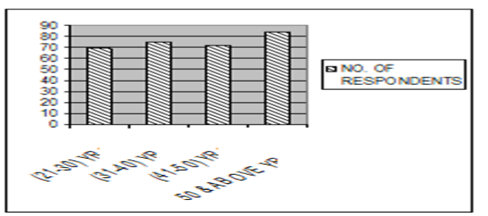

The data collection method used in this research is survey method. Here the data are systematically recorded from the

respondent

RESEARCH TOOL.

A structured questionnaire has been prepared to get the relevant information from the respondents. The questionnaire consists of a variety of questions presented to the respondents for their response. The various types of questions used in this survey are:  Open ended questions

* Closed ended questions
* Multiple choice questions

The employees of AVTAR STEELS are the sample unit in the survey.

The sample size chosen for this study is 100.

HR - 15

CIV - 10

ELECTRICAL - 10 STEEL - 35

ACCOUNTS - 25 COMMERCIAL - 5

………….

100

The sampling type is non-probability which involves deliberating selections of particular units constituting a sample, which represents the universe.

STRATIFIED SAMPLING:

Stratum means a layer population from which samples are to be selected may contain a number of layers from each layer a few samples are selected that is why this method is called stratified sampling.

STATISTICAL METHODS USED

 Percentage analysis

It is observed from the survey that 25% of the respondents are between (31-40) yrs, 24% of the respondents are between (41-50) yrs, 28% of the respondents are above 50 years and 23% of the respondents are between (21-30) yrs.

TABLE 2: GENDER WISE CLASSIFICATION OF EMPLOYEES

|  |  |  |
| --- | --- | --- |
| Gender | No. Of respondents | PERCENTAGE |
| Male | 171 | 57 |
| Female | 129 | 43 |
| Total | 300 | 100 |

Chart2: Gender wise classification of employees

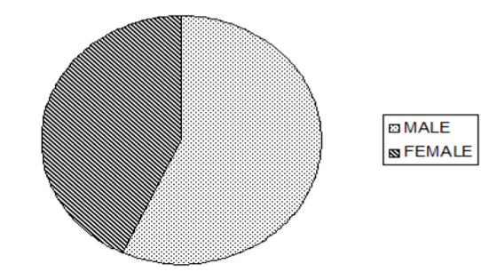

Inference:

It is found from the survey that 57% of the respondents are male and 43% of the respondents are female.

Chart.3: Classification on educational qualification

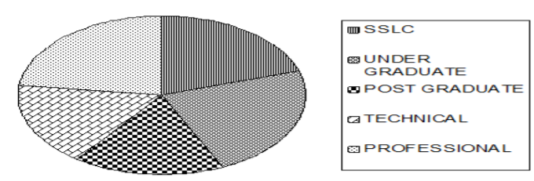

Inference:

It is evident from the survey that 69% of the respondents are professionally qualified, 23% of the respondents have graduation, 17% of the respondents have post graduation and technically qualified, 20% of the respondents have only done finished SSLC.

TABLE 3: WORK EXPERIENCE WITH AVTAR STEELS

|  |  |  |
| --- | --- | --- |
| Attributes | No. Of respondents | Percentage |
| <5yrs | 75 | 25 |
| (5-10)yrs | 69 | 23 |
| (10-15)yrs | 84 | 28 |
| >15yrs | 72 | 24 |
| Total | 300 | 100 |

Chart 4: Work experience with avtar steels

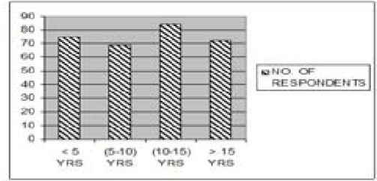

Inference:

It is found from the survey that 24% of the respondents have more than 15 years of experience, 23% of the respondents have (5-10) yrs of experience and 28% of the respondents have their experience between (10-15) yrs remaining 24% of the respondents have less than 5 years of experience.

TABLE 4: PHYSICAL WORKING CONDITION OF THE ORGANIZATION

|  |  |  |
| --- | --- | --- |
| Satisfaction | No. Of respondents | Percentage |
| Highly satisfied | 69 | 23 |
| Satisfied | 84 | 28 |
| Neutral | 72 | 27 |
| Highly dissatisfied | 51 | 17 |
| Dissatisfied | 24 | 8 |
| Total | 300 | 100 |

Chart 5: Opinion about the pay package

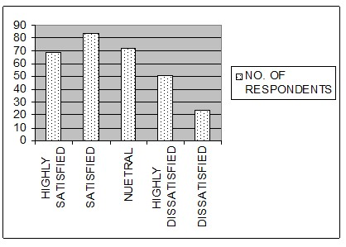

It is found from the survey that more than half of the respondents (28%) are satisfied with the physical working Inference:

It is evident from the survey that 28% of the employees are highly satisfied with the pay scale provided, 24% of the respondents are satisfied with their pay scale, 23% of them are neither satisfied nor dissatisfied, 8% of them are highly dissatisfied, and 17% of the respondents are dissatisfied with the pay scale provided.

TABLE 6: OPINION ABOUT THE JOB

|  |  |  |
| --- | --- | --- |
| Particulars | No. Of respondents | Percentage |
| Challenging | 24 | 8 |
| Interesting | 84 | 28 |
| Routine | 51 | 17 |
| Boring | 72 | 24 |
| Monotonous | 69 | 23 |
| Total | 300 | 100 |

Chart 6: Opinion about the job

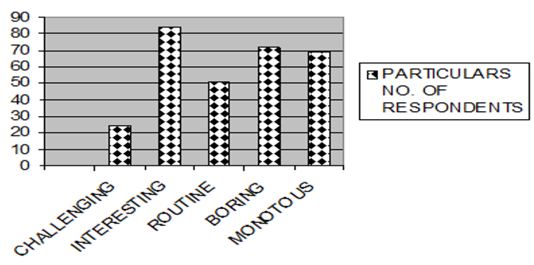

Inference:

It is observed from the survey that 28% of the respondents feel the job interesting, 24% of them feel it boring, 17% of the respondents feel it routine, while for 23% amongst the respondents the job is a monotonous one and 8% of them feel the same job challenging.

TABLE 7: OPINION ABOUT THE COMPLETION OF THE WORK WITHIN THE

SPECIFIED TIME

|  |  |  |
| --- | --- | --- |
| Satisfaction | No. of respondents | Percentage |
| Strongly agree | 69 | 23 |
| Agree | 24 | 8 |
| Undecided | 72 | 24 |
| Strongly disagree | 84 | 28 |
| Disagree | 51 | 17 |
| Total | 300 | 100 |

|  |  |  |  |  |  |  |  |  |  |  |  |  |  |  |  |  |  |  |  |  |  |  |  |
| --- | --- | --- | --- | --- | --- | --- | --- | --- | --- | --- | --- | --- | --- | --- | --- | --- | --- | --- | --- | --- | --- | --- | --- |
| |  |  |  | | --- | --- | --- | | Satisfaction | No. Of respondents | Percentage | | Highly satisfied | 84 | 28 | | Satisfied | 72 | 24 | | Neutral | 69 | 23 | | Highly dissatisfied | 24 | 8 | | Dissatisfied | 51 | 17 | | Total | 300 | 100 |   condition of the organization. Among all the respondents 27% are neither satisfied nor dissatisfied with the physical       |  |  | | --- | --- | | working condition of the organization, 23% of the respondents are highly satisfied with the physical working condition of the organization, 17% of the respondents are highly dissatisfied with physical condition provided and 8% respondents are dissatisfied with physical working condition of the organization.    TABLE 5: OPINION ABOUT THE PAY PACKAGE PROVIDED BY THE ORGANIZATION | Inference:  It is clear from the survey that 23% of them strongly agree that they can complete the work at time, 8 % of them agree that they can complete work at time, 24% of them have no idea, 28% of them strongly disagree that they cannot complete the work in time, 17% of them disagreed the completion of job in time.  Chart 8: Work overload |   Inference: |

Chart 7: Opinion about the completion of work within the specified time

It is observed from the survey that 17% of the respondents are overloaded with work, 24% left it undecided and 23% of the respondents say that they are not overloaded with work.

TABLE 8: WORK OVERLOAD

|  |  |  |
| --- | --- | --- |
| Satisfaction | No.of respondents | Percentage |
| Strongly agree | 51 | 17 |
| Agree | 84 | 28 |
| Undecided | 72 | 24 |
| Strongly disagree | 69 | 23 |
| Disagree | 24 | 8 |
| Total | 300 | 100 |

TABLE 9: STRESS IN JOB

|  |  |  |
| --- | --- | --- |
| Preference | No. of respondents | Percentage |
| Yes | 183 | 61 |
| No | 119 | 39 |
| Total | 300 | 100 |

Chart 9: Stress in job

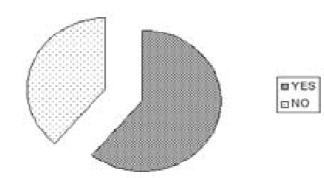

Inference:

It is evident from the survey that 61% of the respondents suffer stress and 31% of the respondents do not suffer stress.

TABLE 10: STRESS CAUSING FACTORS AMONG DIFFERENT LEVELS OF

EMPLOYEES

|  |  |  |
| --- | --- | --- |
| Factors | No. of respondents | Percentage |
| Role overload | 120 | 40 |
| Role underload | 93 | 31 |
| Interpersonal relationship | 87 | 29 |
| TOTAL | 300 | 100 |

Chart 10: Stress causing factors among different levels of employees

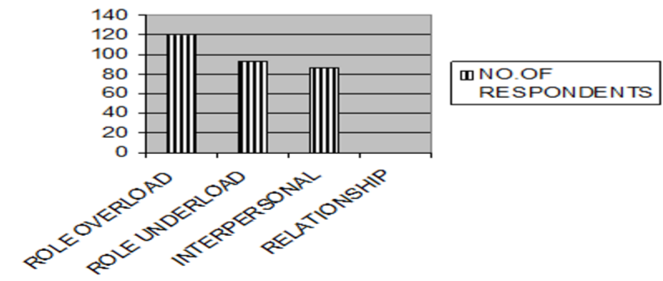

Inference**:**

It is observed from the survey that for most of the respondents of all the level of employees role overload is the major stress causing factor; the second place goes to the role under load and then comes the inter personal relationship.

TABLE 11: KIND OF STRESS IN JOB AMONG DIFFERENT AGE GROUP

|  |  |  |
| --- | --- | --- |
| Particulars | No. Of respondents | Percentage |
| Physical | 93 | 31 |
| Mental | 87 | 29 |
| Both | 120 | 40 |
| Total | 300 | 100 |

Chart 11: Kind of stress among different age group

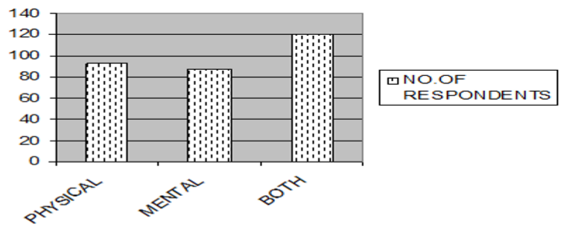

Inference:

It is found from the survey that 31% of the respondents suffer physical stress, 29% of them suffer mental stress and the remaining of them suffers from both the stress.

TABLE 12: LEVEL OF STRESS

|  |  |  |
| --- | --- | --- |
| Level of stress | No. Of respondents | Percentage |
| Very high | 72 | 24 |
| High | 69 | 23 |
| Moderate | 51 | 17 |
| Low | 72 | 24 |
| Very low | 36 | 12 |
| Total | 300 | 100 |

Chart 12: Level of stress

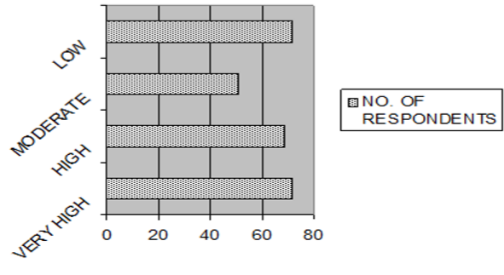

Inference:

It is found from the survey that 17% of the respondents have moderate level of stress, 24% of the respondents have high level of stress, and only 12% of the respondents have very low level of stress.

TABLE 13: PHYSICAL INCONVENIENCE DUE TO STRESS

|  |  |  |
| --- | --- | --- |
| Preference | No. Of respondents | Percentage |
| Yes | 156 | 52 |
| No | 144 | 48 |
| Total | 300 | 100 |

Chart 13: Physical inconvenience due to stress

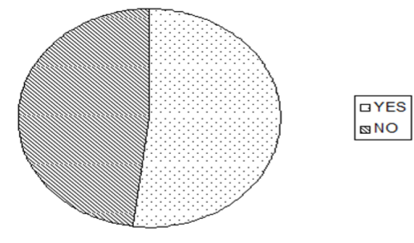

Inference:

It is evident from the survey that 52% of the respondents suffer from physical inconvenience due to stress and the remaining 48% responded “NO” to the same question.

Chart 14: Kind of inconvenience

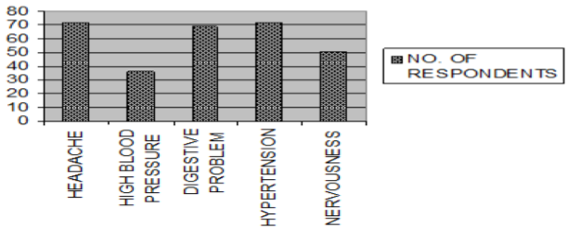

Inference:

It is observed from the survey that most of the respondents (24%) suffer from headache and hypertension and the digestive problem due to stress comes next, then comes the nervousness and only less % of the respondents suffers from high blood pressure.

TABLE 14: KIND OF INCONVENIENCE

|  |  |  |
| --- | --- | --- |
| Inconvenience | No. of respondents | Percentage |
| Headache | 72 | 24 |
| High blood pressure | 36 | 12 |
| Digestive problem | 69 | 23 |
| Hypertension | 72 | 24 |
| Nervousness | 51 | 17 |
| Total | 300 | 100 |

TABLE.15: ORGANIZATION STEPS TO MANAGE STRESS

|  |  |  |
| --- | --- | --- |
| Preference | No. Of respondents | Percentage |
| Yes | 153 | 51 |
| No | 147 | 49 |
| Total | 300 | 100 |

Chart 15: Organization steps to Manage stress

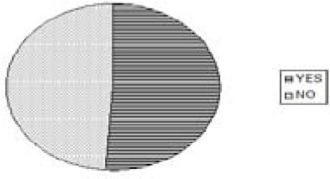

Inference:

It is evident from the survey that 51% of the respondents agrees that their organization is helping them in overcoming stress, and the 49% of them are not satisfied with the help provided by the organization to overcome stress.

Inference:

It is observed from the survey that 24% of them recommend employee counseling, 12% of them need effective training, 23% need work groups, 24% need health groups, and the remaining need transport subsidy.

TABLE 17: OPINION ABOUT COUNSELING TO REDUCE THE STRESS

|  |  |  |
| --- | --- | --- |
| Particulars | No. Of respondents | Percentage |
| Strongly agree | 51 | 17 |
| Agree | 84 | 28 |
| Neutral | 72 | 24 |
| Disagree | 69 | 23 |
| Strongly disagree | 24 | 8 |
| Total | 300 | 100 |

Chart 17: Opinion about counseling to reduce the stress

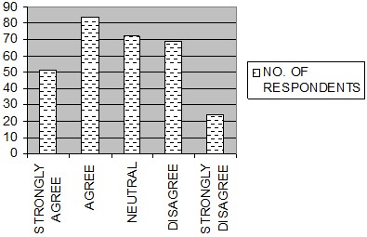

Inference:

From the above data we can find that 17% of the respondents strongly agree that counseling can overcome stress, 28% of them agree that they can overcome stress through counseling, 24% of them don’t have any idea whether counseling will help in overcoming the stress, 28% disagree to the same fact while the remaining 8% strongly denies the fact that counseling will help in overcoming stress.

|  |  |  |
| --- | --- | --- |
| Particulars | No. Of  respondents | Percentage |
| Employee counseling | 72 | 24 |
| Effective & training |  |  |
| development program | 36 | 12 |
| Work groups | 69 | 23 |
| Health clubs | 72 | 24 |
| Autonomous | 0 | 0 |
| Transport subsidy | 51 | 17 |
| Total | 300 | 100 |

TABLE 16: PROGRAMS THAT COULD BE ADOPTED TO MANAGE STRESS TABLE 18: ORGANIZATION POLICIES AND PROCEDURES ARE STRESS FREE

|  |  |  |
| --- | --- | --- |
| Particulars | No. Of respondents | Percentage |
| Highly accepted | 51 | 17 |
| Accepted | 84 | 28 |
| Not accepted | 72 | 24 |
| Highly not accepted | 93 | 31 |
| Total | 300 | 100 |

Chart 18: Organization policies and procedures are stress free

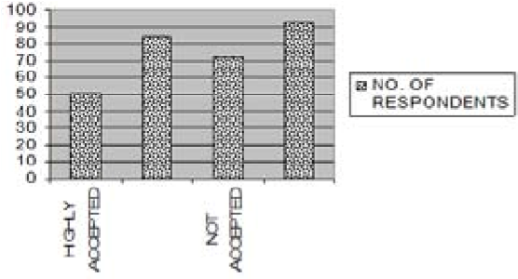

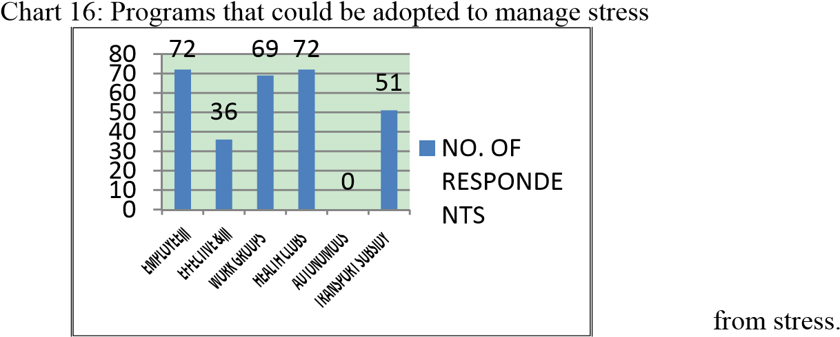Inference:

It is observed from the survey that most of the respondents accept that the company’s policies are stress free, 28% of them have accepted that organization policies are stress free, 24% of them have not accepted it, 31% of them have not accepted that their organization policy is free TABLE 19: BEST INTERVENTION TO REDUCE STRESS Chart 21: Opinion about stress level in night shift compared

|  |  |  |
| --- | --- | --- |
| Particulars | No. Of respondents | Percentage |
| Relaxation technique | 93 | 31 |
| Time management | 84 | 28 |
| Training & development | 72 | 24 |
| Working | 51 | 17 |
| Total | 300 | 100 |

Chart 19: Best intervention to reduce stress

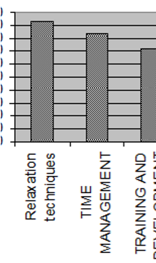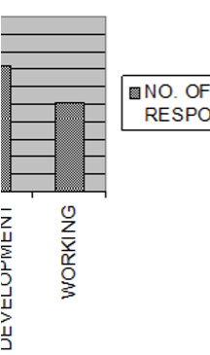

Inference:

It is observed from the survey that to overcome stress most of the respondents (31%)opined relaxation as one of the best techniques, 28% of them need more time management techniques,24% said that training is the best intervention,17% said working intervention is the best thing to overcome st ress.

TABLE 20: OPINION ABOUT INTERPERSONAL RELATIONSHIP

|  |  |  |
| --- | --- | --- |
| Particulars | No. Of respondents | Percentage |
| Strongly agree | 51 | 17 |
| Agree | 84 | 28 |
| Neutral | 72 | 24 |
| Disagree | 69 | 23 |
| Strongly disagree | 24 | 8 |
| Total | 300 | 100 |

Chart 20: Opinion about interpersonal relationship

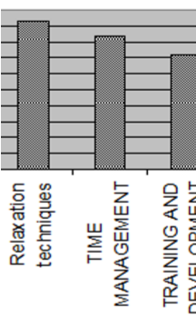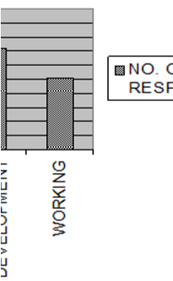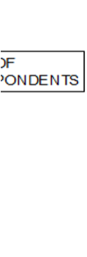

Inference:

From the above we can find that 17% of the respondents strongly agree that they have strained interpersonal relationship, 28% of them agree that they have strained interpersonal relationship stress, 24% of them don’t have any idea, 28% disagree that they have strained interpersonal relationship.

TABLE 21: OPINION ABOUT STRESS LEVEL IN NIGHT SHIFT COMPARED TO DAY SHIFT

|  |  |  |
| --- | --- | --- |
| Particulars | No. Of respondents | Percentage |
| Very high | 51 | 17 |
| High | 84 | 28 |
| Moderate | 72 | 24 |
| Low | 69 | 23 |
| Very low | 24 | 8 |
| Total | 300 | 100 |

0

10

20

30

40

50

60

70

80

90

to day

shif

t

NO.

RES

TS

OF

P

ONDEN

Inference:

From the above we can find that17% of them strongly agree that they have stress in night shift, 28% of them agree that they have stress in night shifts,24% of them don’t have any idea, 28% disagree that they do not have any stress in night shift.

TABLE 22: SPENDING THE WEEKEND

|  |  |  |
| --- | --- | --- |
| Particulars | No. Of respondents | Percentage |
| Going to movies | 84 | 28 |
| Get together | 51 | 17 |
| Visit friends/relatives | 72 | 24 |
| Music classes | 69 | 23 |
| Any other(specify) | 24 | 8 |
| Total | 300 | 100 |

Ch

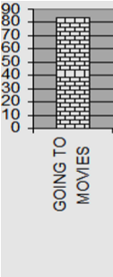

a

rt22: S

p

endi

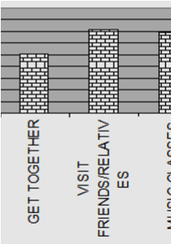

n

g the weeke

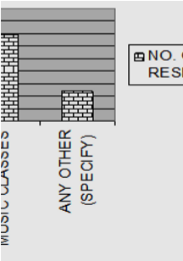

nd

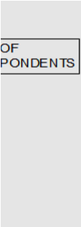

Inference:

From the above data we can find that 28% of the respondents would like to go to movies in the weekend, 17% would like a get together, 24% would like to visit friends/relatives, and 23% would like to go to music class, while the remaining 8% would prefer to go any other place/thing of their choice.

TABLE 23:FAMILY FACTOR WHICH INFLUENCE STRESS

|  |  |  |
| --- | --- | --- |
| Particulars | No. Of respondents | Percentage |
| Dependent | 93 | 31 |
| Illness | 87 | 29 |
| Financial problem | 60 | 20 |
| Other problems | 60 | 20 |
| Total | 300 | 100 |

Chart 23: F

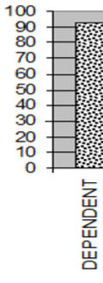

a

mily factor

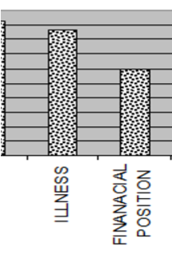

w

hich influenc

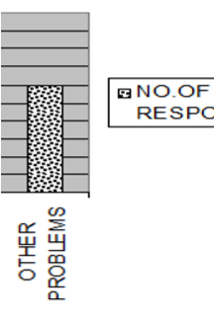

e

stress



Inference:

It is found from the survey that 31% of them said dependency influences stress, 29% said that illness influences stress, 20% of them said that financial as well as other family oriented problems influence stress.

TABLE 24: PERSONAL FACTOR INFLUENCING STRESS

|  |  |  |
| --- | --- | --- |
| Particulars | No. of respondents | Percentage |
| Perception | 60 | 20 |
| Attitude | 87 | 29 |
| Health condition | 60 | 20 |
| Personality | 93 | 31 |
| Total | 300 | 100 |

Chart 24: Personal factor influencing stress

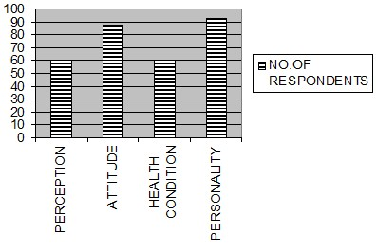

Inference:

It is found from the survey that 20% of them said perception influence stress, 29% said that attitude influence stress, 20% of them said that health condition influence stress, and the remaining said that personality influence stress.

TABLE 25: STRATERGY TO REDUCE STRESS

|  |  |  |  |  |  |  |  |
| --- | --- | --- | --- | --- | --- | --- | --- |
| Factors | high  ly satis fied | sat isf ie d | ne utr al | dissatisfi d | highly  dissatisfi ed | to ta l | per  cen tag e |
| yoga | 10 | 10 | 10 | 10 | 11 | 5  1 | 17 |
| meditatio n | 10 | 11 | 11 | 17 | 20 | 6  9 | 23 |
| motivati on | 11 | 11 | 10 | 20 | 20 | 7  2 | 24 |
| counseli ng | 0 | 0 | 0 | 9 | 0 | 9 | 3 |
| indoor  games | 11 | 20 | 20 | 11 | 11 | 7  2 | 24 |
| others | 2 | 10 | 6 | 10 | 0 | 2  8 | 9 |

TABLE 26: CROSS TABULATION FOR SPENDING WEEKEND VS STRATEGY TO REDUCE STRESS

|  |  |  |  |  |  |  |  |
| --- | --- | --- | --- | --- | --- | --- | --- |
| Strategy    Spending weekend | Y  o g  a | Med  itatio n | Motiv  ation | Couns  eling | Ind oor ga mes | Ot  her | Row  total |
| Going to |  |  |  |  |  |  |  |
| movies | . | . | 4 |  |  |  | 4 |
| Get |  |  |  |  |  |  |  |
| together | 4 | 16 | 8 | 2 |  |  | 30 |
| Visit to |  |  |  |  |  |  |  |
| friends/rel atives | 8 | 22 | 10 | 10 |  |  | 50 |
| Music |  |  |  |  |  |  |  |
| classes |  | 4 | 4 | 2 |  |  | 10 |
| Any other |  |  | 6 |  |  |  | 6 |
| Column  total | 1  2 | 42 | 32 | 14 |  |  | 100 |

Chart 25: Stratergy to reduce stress

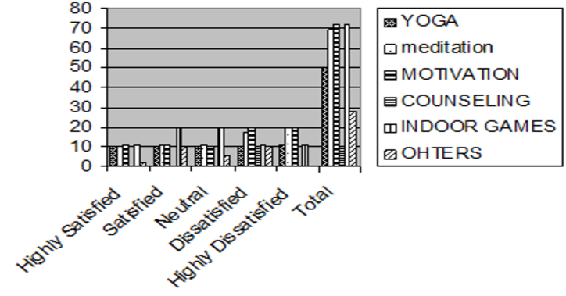

Inference:

It is found from the above table that 17% prefer yoga;  majority of the respondents (24%) prefers both indoor games and motivation to others (counseling or meditation).

Chi-square test on spending weekend vs strategy to reduce stress

(theory part is given beforehand in the same paper)

Null Hypothesis (H0): There is no significant relation between spending weekend and strategy to reduce stress Alternate Hypothesis (H1): There is a significant relation between spending weekend and strategy to reduce stress

Calculations based on theory

Degrees of freedom = 12

Calculated value = 27.497

For 12 degrees of freedom at 5% level of significance, the chi-square table value is 5.226.

Inference:

Calculated value > Tabulated value.

Hence H0 is rejected and H1 is accepted.

V. FINDINGS  Out of the total sample most of the respondents are male and many are between 50 and above. Most of the respondents are under graduate and have

professional qualification.  Most of the respondents have 10-15 years of long association with the organization.  Almost all the respondents are satisfied with the physical and psychological working condition of the organization and only fewer respondents faces physcological problem in the existing environment.

* The opinion about the training programs conducted by the organization is almost better, according to majority

of the respondents.

* Almost all the respondents are satisfied with the pay package provided by the organization and nearly half of the respondents feel that they do a routine job.  Most of the respondents agree that they can complete their work within the specified time and some of the respondents are undecided.
* Nearly half of the respondents agree that they are overloaded with work.
* More than half of the respondents suffer stress in their job.
* Among all other factors, role overload causes more stress according to most of the respondents.
* Most of the respondents from steels department suffer from physical stress; most of the respondents from accounts department suffer from mental stress, and most of the respondents from civil department suffer from both physical and mental stress.  Most of the respondents feel only moderate level of stress and some of the respondents feel high level of stress in their job.
* More than half of the respondents have physical inconvenience due to stress and most of the respondents suffer from headache and high blood

pressure.

* Almost all the respondents prefer to follow coping strategies personally, to manage stress and they prefer

to do meditation and yoga to reduce stress. Suggestions  The employees must give importance to time management techniques thereby they can complete their work within the specified time.

* Many tasks can be delegated to subordinates without losing effectiveness so that we can reduce the overload of work. Adopt the work to home transition strategy. It means instead of carrying the pressures of the work to home, the suggestion is to start the unwinding process during  the work day and enter the home in a relaxed and peaceful mind. Giving counseling to the employees when they are in stressed condition or face problems, because counseling is the discussion of a problem (physical/mental/social) that usually has emotional/financial co-relation with an employee, in order to help him to cope within better.
* The organization must introduce Employee Assistance Programmes (EAPs) and stress control workshops according to the level of employees, because there is a strong relation between the level of stress and level of employees. EAP includes counseling employees who seek assistance on how to deal with alcohol and drug  abuse, managing personal finances, handling conflicts at the work place, dealing with marital and other family problems, and coping with health problems.

VI. CONCLUSIONS

Stress in the work place has become the black plague of the present century. Much of the stress at work is caused not only by work overload and time pressure but also by lack of rewards and praise, and more importantly, by not providing individuals with the autonomy to do their work as they would like. Most of the employees were not satisfied with the grievance handling procedure of the organization which was found by the unstructured interview. Organization must begin to manage people at work differently, treating them with respect and valuing their contribution. If we enhance the psychological well being and health of the employees, in the coming future the organization would make more revenue as well as employee retention. Because it is said that, **“A Healthy Employee is a Productive Employee”**

REFERENCES

1. Jamal M., “Job Stress-Prone Type A behavior and personal and organizational consequences”, Canadian Journal of Administrative.
2. Brief A.P. and Atieth J.M., “Studying Job Stress: Are we making mountains out of mole Hills?” Journal of occupational behavior,

1987.

1. Finemann- “A Psychological Model of Stress and its application to managerial unemployment”, Human relations, 1979.
2. Geeta Kumari and K. M. Pandey, "Job Satisfaction in Public Sector and Private Sector: A Comparison," *International Journal of*

*Innovation, Management and Technology* vol. 2, no. 3, pp. 222-228, 2011.

1. Business line, “The stress is beginning to show”, Financial Express published by Hindu, Trivandrum, 1989.
2. Dr.Satish Chandra Pandy, “Indian ways of winning Stress”, The Journal of Indian Management and Strategy, 1997.
3. Ahuja. K.K- “Industrial psychology and organizational behavior”, Khanna publishers, New Delhi, 1991.
4. Biswanath Ghosh- “A new look organizational behavior”, Himalaya Publishing House New Delhi, 1994.
5. Ghosh P.K. and Ghorpade M.B. - “Industrial and Organizational Psychology”, Himalaya Publishing House, Bombay 1991.
6. Kapur S.K, Punia B.K.-“Organizational Behavior and Management”, S.K.Publishers, New Delhi.
7. Laurie J. Mullins – “Organizational Behavior”, Pitman’s publishing Ltd, London, 1990.
8. www.avtarsteel.com



**Geeta Kumari** was awarded MBA in 2007and M.Phil in Business Administration in 2010. She is serving as Assistant Professor in Department of Management Since August 2008 at Gurgaon College of Engineering, Gurgaon, India. She has got 20 research publications to her credit in International and National Conferences and International Journals.

**K. M. Pandey** is serving as Professor in Department of Mechanical Engineering at National Institute of Technology, Silchar, Asam, India.

