Airline Analysis:
Q1. Which airlines operated the highest number of flights during January 2015?
Answer: Southwest Airlines Co.
Q2. Which airlines experienced the highest average departure delays during January 2015?
Answer: American Eagle Airlines Inc.
Q3. Which airlines experienced the highest average arrival delays during January 2015?
Answer: American Eagle Airlines Inc.
Airport Analysis:
Q4. Which airports handled the highest volume of departing flights during January 2015?
Answer: ATL
Q5. Which origin airports experienced the highest average departure delays?
Answer: ILG
Time-Based Analysis:
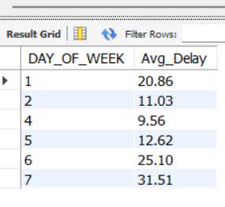
Q6. How did average departure delays vary across different days of the week?
Answer:

Flight Operations Analysis:
Q7. Which flight routes covered the greatest distances during January 2015?
Answer: HNL TO HFK

Delay Cause Analysis:
Q8. What were the primary factors contributing to flight delays?
Answer: Air System Delay
Q9. How many flight records were analyzed in this study?
Answer: 77,914 flights
Q10. What was the average departure delay across all flights?
Answer: 34.66 Hours
Q11. What was the average arrival delay across all flights?
Answer: 42.01 Hours
Q12. Were any flights cancelled or diverted in the analyzed dataset?
Answer: No.

