l

Requirement Document- Hundred Media Advertising

LLC
This requirement document has been prepared Hundred Media Advertising LLC in Al Quoz Industrial Area 4, UAE. With over 10 years of experience in the UAE, Hundred Media Advertising LLC is the company which services Exhibitions, Events, Advertising, Interiors and Retail Kiosks. Hundred Media is specialized in creating and organizing Exhibitions event.

PROJECT NAME | Customized ERP Software
JOB LOCATION | Al Quoz Industrial Area 4
EST. START DATE: | 30-Dec-2023 | EST. FINISH  DATE: | 31-July -2024
INQUIRY NUMBER: | C3P-INQ-2023-07-052 | LAST UPDATED  DATE: | 26-June-2025
CUSTOMER  NAME: | Mr. Musammil  Managing Director | SALES CONTACT: | Reeba Mathew
CUSTOMER CONTACT: | +971 55 108 3100  musammil@hundredmedia.ae | TECHNICAL CONTACT: | Mr. Siddharth Bhosle Chief Technical Officer
SCOPE: | - Customized ERP Software  - Sales and Estimation Module  - Project Module  - HR Management Module  - Accounts | DEVELOPMENT  STATUS: | Software requirement collection was over.Software Development going on.
REVISION: | 58 | INQUIRY RECEIVED DATE: | 08-Jul-2023

1 | Modules required | - Sales and Estimation Module  - Project Module  - HR Management Module  - Accounts
2 | Special requirements in above modules, if any?
3 | Number of users in data entry and top Management | 15
4 | Total employees | 100
5 | Current existing software | Customized ERP Software

6 | When this company started? | 2010
7 | No: of branches in UAE? | 1
8 | No: of branches outside UAE?
9 | Expected date and timeline for this project? | 6 months starting from Dec 2023
10 | Project Coordinator – Name, Designation, E-mail id and Phone Number | Mr. Musammil Managing Director  +971 55 108 3100  musammil@hundredmedia.ae operations@hundredmedia.ae
11 | Decision maker – Name, Designation, E-mail id and Phone number | Mr. Musammil Managing Director  +971 55 108 3100  musammil@hundredmedia.ae
12 | Is this software installation will be done at customer server or C3P server? | Initially it will be at C3P server.
13 | What is the most important purpose the customer is expecting from the software? | They need to track project using customized ERP.

Scope | Customized ERP Software
Module 1 | A. Sales Module | Any Additional Requirements
Sub-Headings | - Customer Information Management  - Sales Management  - Customer credit management  - Email Integration  - Calendar Integration  - Reporting and Analysis  - Sales Loss Tracking module  - Various Reports
Module 2 | B. Inventory Management Module
Sub-Headings | - Receipt  - Storage  - Records  - Verification  - Goods Received Note  - Stock List  - Material Issued  - Service Order List  - Order Management  - Inventory Management via multiple channel  - Warehouse Management  - Hundred Media required department vise entering needed.

Module 3 | C. Purchase Module
Sub Headings | - Purchase Indent  - Purchase Requisition  - Request for Quotation  - Purchase Quotation List  - Comparison Statement  - Purchase Order list  - PO from Multiple PR
Module 4 | E. Project Module
- Project Materials Planning and Allocation
- Project Cost Tracking
- Project-specific Inventory Management
- Project Reporting and Analytics
Hundred media specializes in Exhibitions Projects. Here is an overview of their process:
  - When an inquiry is received, Hundred media prepares a quotation for the customer. This quotation likely includes details about the products or services requested, along with pricing information. If the customer requests a discount or seeks modifications to the initial quotation, Hundred Media will provide a revised quotation.
  - Once the customer is satisfied with the quotation and terms, they will confirm the purchase by issuing a Purchase Order (PO).
  - After receiving the confirmed PO, Hundred media will prepare and send a Performa invoice to the customer.
  - Once the PO is confirmed in the sales module, the data is transferred to the Project module
  - In the Project Module, there is an estimation team responsible for estimating design hours, carpentry work, electrical work, and other infrastructure requirements for projects. Additionally, they allocate work to subcontractors. The work progress is tracked, mainly by comparing the planned versus actual progress based on total cost and time. For each project, inventory, purchases, and employee man-hours should be tracked in this project module
  - Hundred media need to track sub-contracting work in the software.
  - Hundred Media also performs specific tasks, such as design work, carpentry works and electrical
works, which need to be tracked in the software

 | as individual projects.
Module 5 | F. Accounting Module
Sub-Headings | - Profit/Loss Tracking (General Ledger)  - Accounts Payable  - Accounts Receivable  - Financial Reporting  - Tax Management  - Multi- currency Management  - Budgeting and Forecasting  - Reports  - Hundred Media required multiple login for  accounts.(Gym)
Module 6 | G. Human Resource Management (HRM) Module
Sub-Headings | - Accommodation  - Insurance  - Vehicles  - Salary Calculation  - Employee Details  - Salary advance  - Job Role Assignment  - Compensation & Benefits  - Time Slot
 | 10. Over Time
Revision 1(As per meeting on 14-Oct-2023)

- C3P initially submitted a proposal with separate modules, but it didn't fit within their budget. Therefore, we proposed a project-based solution, considering their status as a project-based company.

- Currently, HM using standalone software like Tally and QuickBooks for accounting and HRM respectively. So, C3P consolidated the four modules—sales, purchase, inventory, and project—into a single complete project module, labeled as Scope 1. The remaining two modules Accounting and HRM were placed into Scope 2. They agreed to this arrangement, and as a result, we were able to reduce the price. It's likely that they plan to initiate both Scope 1 and Scope 2 simultaneously.

Revision 2(As per meeting on 31-Oct-2023) ATTENDEES
  - Mr.Musammil(Managing Director, Hundred media)
  - Mr. Nataraj Marulaiah, Ms. Sonam Phade, Mr. Ashwin S, ,Mr. Syam V.S., Ms. Reeba Mathew (C3P Team)
As requested by Hundred Media, the C3P team presented a demo of our previous works. Hundred Media expressed satisfaction with our previous work demos and engaged in discussions about the results with their consultancy group.
Next Plan:
Hundred Media's Consultancy Group has expressed interest in meeting with C3P's Senior ERP Consultant on 9- Dec- 2023.

Revision 3(As per meeting on 9-Dec-2023) Time Duration: 1pm to 2pm
ATTENDEES
  - Mr.Musammil(Managing Director, Hundred media),Mr.Abin C.Pascal (Consultant, Hundred Media)
  - Mr.Siddharth Bhosle, Mr. Joby Varghese, Mr. Ashwin S, ,Mr. Syam V.S (C3P Team)
As discussed earlier, the meeting involved the C3P team and the consultant from Hundred Media. C3P presented their company profile, and when technical queries arose regarding the software, C3P's program director addressed all concerns.

Next Plan

Hundred Media management will confer with the consultant group to evaluate C3P's performance in the meeting. The final decision will be communicated by the upcoming week.

Revision 4(18-Dec-2023)

To ascertain Hundred Media's final decision, C3P's senior consultant and sales engineer contacted them. However, they mentioned not having discussed matters further since the previous meeting.
On December 20, 2023, when our Project Coordinator contacted Hundred Media, they conveyed that the consultant is satisfied with our Customized Software. Although expressing interest in continuing with our software, they requested a discount in the payment and C3P revised the proposal.
C3P has enhanced its modules to cater specifically to Hundred Media's needs, introducing the 'Drawing Tracking Module,' 'Internal Production Module,' 'Subcontract Management Module,' and 'Fit-out and Installation Module.' These modifications aim to provide exclusive benefits through the ERP software tailored for Hundred Media. The details of the 'Internal Production Module' will be deliberated upon in the software requirement collection meetings.

The modified modules in the revised Customized ERP Software proposal are as follows

Sales & Estimation Module
    - Customer Registration
    - Enquiry Registration
    - Estimation
    - Quotation
    - Payment Terms
    - Delivery Terms
    - Order Confirmation
    - Order Acceptance
    - Performa Invoice
    - Various Reports

Project Module
    - Project Materials Planning and Allocation

    - Project Cost Tracking
    - Project-specific Inventory Management
    - Project Reporting and Analytics
Project module which Includes following module:
    - Drawing Tracking Module
      - Drawing documentation
      - Version control for design changes
      - Design approval work flows
    - Inventory and Store Management Module
      - Good Received Note
      - Storage
      - Retrieval
      - Issue
      - Records
      - Surplus Stock
      - Verification
      - Stock List
      - Material Issued
      - Batch Tracking
      - FIFO & LIFO
      - Just-In-Time Inventory
      - Materials Requirements Planning
    - Purchase Module
      - Purchase Indent
      - Purchase Requisition
      - Request for Quotation
      - Purchase Quotation List
      - Comparison Statement
      - Purchase Order list
      - PO from Multiple PR

    - Internal Production Module
(Subheadings need to be discussed)

    - Subcontract Management Module
      - Supplier and Subcontractor Management
      - RFQ (Request for Quotation) Management
      - Progress Tracking
      - Invoicing and Payments
    - Fit-out and Installation Module
      - Site Planning and scheduling
      - Resource allocation for fabrication teams
      - Site progress tracking
      - Logistics and transportation management

Human Resource Management Module
    - Corporate Files
    - Accommodation
    - Insurance
    - Vehicles
    - Salary Calculation
    - Leave Application
    - Recruitment Details
    - Employee Details
    - Salary Advance
    - Job Role Assignment
    - Employee Trainings
    - Compensation and Benefits
    - Time Slot
    - Over Time

Accounting Module
    - Profit/Loss Tracking
    - Accounts Payable
    - Accounts Receivable
    - Tax Management
    - Multi- Currency Management

Next Plan
    - Credit Notes
    - Debit Notes

C3P management will initiate internal discussions concerning pricing and payment terms. Following internal agreement, the quoted amount will be promptly presented to Hundred Media. Upon their acceptance, a formal quote will be prepared and submitted before 22 -Dec-2023, ensuring the timely processing of the initial payment. Acknowledging the busy nature of January for Hundred Media, C3P is committed to fulfilling all software requirements by the end of December.

Revision 5 (30-Dec-2023) Time: 9.30am-11.30am ATTENDEES
      - Mr.Musammil (Managing Director, Hundred media)
      - Mr.Siddharth Bhosle, Ms. Sonam Phade, Mr. Joby Varghese, Ms. Reeba Mathew, Mr. Ashwin Padmanabhan T, Mr. Syam V.S (C3P Team)
This meeting marked the commencement of the software requirement collection phase for Hundred Media Advertising after awarding the project to C3P. The Managing Director of Hundred media provided an overview of the company's profile to the C3P members, followed by a detailed explanation of their company's workflow, outlined as follows:

      - Hundred Media primarily engages in engineering works for customizing exhibition booths according to customer specifications.

      - The company boasts a dedicated marketing and sales team, leveraging an extensive customer list to generate inquiries.

      - Customers engage through digital marketing, cold calls, and cold emails to generate inquiries.

      - Email push marketing and WhatsApp marketing options should be available. Additional subscription payments will be processed by Hundred Media.

      - Company name format should be “Hundred Media”

      - They engage in B2B services, tailoring their work to meet customer requirements. They are prepared to develop designs and provide technical drawings, specializing in carpentry, painting, electrical, and metal and glass works, all conducted in their own workshop.

      - In a separate division, signage and graphics, furniture and special deco, AV (trussing, screen, light and sound), logistics works will be done.

      - Inquiries to be categorized to 5 Main, signage and graphics, furniture and special deco, AV (trussing, screen, light and sound), logistics (transportation).
      - In B2C scenarios, Hundred Media offers comprehensive services, providing customers with full conceptualization, including design and production, when they approach them.

      - In B2B situations, customers can engage Hundred Media to bring their ideas to reality based on the documents (Designs and drawings) they provide for the design process.
      - For both B2B and B2C, they use a common format, and there is a design brief form for inquiry registration. B2C customers use the brief form, while B2B customers begin with estimation.

      - Hundred Media plans to appoint an estimation engineer responsible for conducting basic-level estimations, subject to approval by the Managing director.

      - The primary categories are B2B and B2C, each comprising three customer types:
        - Economic
        - Standard
        - Premium.

      - Hundred Media provides the design created by a design engineer, which is then approved by the director along with quotation for customer approval.
      - The quotation includes payment terms, delivery terms, and a timeline. Quotations are prepared by the accounts department.

      - There are exclusion, notes, terms & condition to be included in the quotation.

Note*
*C3P can take notes from the sample quotes provided by Hundred Media. Check box option can be provided at the initial stage.
      - Hundred Media estimates costs and then provides an option to enter the total margin.

      - Before preparing the quotation, Hundred Media discusses with suppliers to ensure that the stock is ready before submitting it to the customer. They have existing suppliers, and if any special item is required, they search for new suppliers.

      - Hundred Media maintains an inventory with a list of items, including their quantity, details, and prices.
      - Inventory list to be collected from Hundred Media. (Received)
      - ​
      - The inventory remains consistent for all customer types, but premium customers predominantly utilize new items. Additionally, upon project award, the execution team must be provided with the Bill of Materials (BOM), and relevant information regarding the customer type should be included.

      - Sometimes, customers provide a signed quotation or purchase order (PO).
      - After the PO is confirmed, and the design is approved, the design engineer shares all documents with the project manager, who then initiates the production process.

      - After the approval of PO, Hundred Media provides a proforma invoice.

      - Terms include advance payment, mock-up payment, and final payment. The proforma invoice, along with the first tax invoice, is provided upon receiving the PO.

The payment terms in the proforma invoice are typically 70% (advance), 20% (mockup), and 10% (final), with the due amount specified in the tax invoice. For international customers, an advance payment of 100% or sometimes 70-80% is received.

      - A project manager checks each division, including carpentry, painting, electrical, metal, and glass, to ensure that everything is in order for the project. He also decide the works should be done in house

      - The materials for the exhibition are categorized into two types:
        - Consumables
        - Returnable.

Consumables refer to items used during the project, while returnables pertain to items that are returned after the project is completed.
      - ​
The quality of returnable items will be assessed by each divisional head.

The following are the important details needed for the initial development of software. Kindly provide these details.
- Provide and explain the process flow (work flow) diagram.
- Provide Name, Address, Contact Details, TRN No., Bank details (bank name, Bank accounts, Bank Branch,Bank IBAN, Bank SWIFT).(Received on 25-Jan-24)
- Details of offices in multiple locations (if any).
- Provide the logo of company.(Received)
- Minimum 5 Copies of Customer registration form, Enquiry Registration Form.(Brief format Received)
- Minimum 5 copies of existing quotations for study.(Received)
- Formats of Invoices, Purchase Orders, Delivery Notes, any reports available. .(Received)
- Minimum 5 Copies of Cost/Estimation Sheets for study(Received)
- Master Item List/Inventory List in excel format (Very important). (Received)
- Any formats of Certifications available.
- Provide Employee details, salary calculation details, leave forms, leave handover forms and any other formsavailable in HR.(Will provide on 21-Feb-24)

The following provides an overview of the standard forms or information required in each module. Please share any existing templates or forms relevant to the modules listed below.
Kindly inform us which ones are necessary for your use and specify any that are not required. These standard forms are not available in the software; however, the necessary formats for a Hundred Media request can be created using the software.

Sales & Estimation Module:
  - Customer Registration:
    - Customer Information Form (Name, Contact Details, etc.)
  - Enquiry Registration:
    - Enquiry Form (Enquiry Details, Source, etc.)
  - Estimation:
    - Estimation Form (Cost Estimation Details)
  - Quotation: (Received)
    - Quotation Form (Detailed Quote, Pricing, Terms)
  - Payment Terms:
    - Payment Terms Form (Payment Details)(Received)
  - Delivery Terms:
    - Delivery Terms Form (Delivery Information)
  - Order Confirmation:
    - Order Confirmation Form
  - Order Acceptance:
    - Order Acceptance Form
  - Performa Invoice: (Tax Invoice received)
    - Performa Invoice Form
  - Various Reports:
    - Report Generation Interface

Project Module:
  - Brief Format (Received)
  - Project Materials Planning and Allocation:
    - Material Planning Form
    - Allocation Form
  - Project Cost Tracking:
    - Cost Tracking Form
  - Project-specific Inventory Management:
    - Inventory Management Interface
  - Project Reporting and Analytics:
    - Reporting and Analytics Dashboard
  - Drawing Tracking Module:
    - Drawing Documentation Form
    - Version Control Form
    - Design Approval Workflow Form

  - Inventory and Store Management Module:
    - Good Received Note Form
    - Storage Form
    - Retrieval Form
    - Issue Form
    - Surplus Stock Form
    - Batch Tracking Form
    - FIFO & LIFO Form
    - Just-In-Time Inventory Form
    - Materials Requirements Planning Form
  - Purchase Module:
    - Purchase Indent Form
    - Purchase Requisition Form
    - Request for Quotation Form
    - Purchase Quotation List Form
    - Comparison Statement Form
    - Purchase Order List Form (Received)
    - PO from Multiple PR Form
  - Internal Production Module:
    - (Subheadings need specific forms, e.g., Production Plan Form)
  - Subcontract Management Module:
    - Supplier and Subcontractor Management Form
    - RFQ Management Form
    - Progress Tracking Form
    - Invoicing and Payments Form
  - Fit-out and Installation Module:
    - Site Planning and Scheduling Form
    - Resource Allocation Form
    - Site Progress Tracking Form
    - Logistics and Transportation Management Form

Human Resource Management Module:
  - Corporate Files:
    - File Upload Interface
  - Accommodation:
    - Accommodation Details Form
  - Insurance:
    - Insurance Details Form
  - Vehicles:
    - Vehicle Details Form
  - Salary Calculation:
    - Salary Calculation Form
  - Leave Application:
    - Leave Application Form
  - Recruitment Details:
    - Recruitment Details Form
  - Employee Details:
    - Employee Details Form
  - Salary Advance:
    - Salary Advance Form
  - Job Role Assignment:
    - Job Role Assignment Form
  - Employee Trainings:
    - Employee Trainings Form
  - Compensation and Benefits:
    - Compensation and Benefits Form
  - Time Slot:
    - Time Slot Form
  - Over Time:
    - Over Time Form

Accounting Module:
  - Profit/Loss Tracking:
    - Profit/Loss Tracking Form
  - Accounts Payable:
    - Accounts Payable Form
  - Accounts Receivable:
    - Accounts Receivable Form
  - Tax Management:
    - Tax Management Form
  - Multi-Currency Management:
    - Multi-Currency Management Form
  - Credit Notes:
    - Credit Notes Form
  - Debit Notes:
    - Debit Notes Form
  - Reports:

    - Financial Reports Interface

Next Plan
C3P is scheduled to provide this Software Requirements Specification (SRS) to Hundred Media on 10-Jan-24. Upon receipt, Hundred Media will thoroughly review the document. Any corrections or modifications suggested by Hundred Media will be communicated to C3P.
Subsequently, C3P will incorporate the recommended changes into the SRS and transmit the updated document to their Indian Team for a comprehensive study. Following the review by the C3P Indian Team, the C3P UAE team will coordinate with Hundred Media to organize a meeting. This meeting will serve as a platform for further discussion and clarification regarding the software requirements, ensuring alignment between the proposed solution and the needs of Hundred Media.
After the Hundred Media and C3P Indian team agree, the next requirement collection meeting can be planned for either the 12th or 13th of January 2024.

Accounting module and HR module will be developed according to UAE standard modules and after demo any customization required, C3P will provide.

Revision 6 (13-Jan-2024)

Time: 2.00pm-3.30pm
ATTENDEES
- Mr.Musammil (Managing Director, Hundred media)
- Mr. Joby Varghese, Mr. Syam V.S (C3P Team)

On 13 -Jan- 2024, a senior consultant from C3P visited Hundred Media to review the requirement sheet. During the discussion, Managing Director suggested a few changes. We have documented the modifications and are indicated in red color in the Revision 5 (Pages 8 to 13). With these the first level review of SRS by Hundred Media is over.

Next Plan

C3P will send this SRS document to our C3P Indian team as well as Hundred Media for their review on 25 -Jan -2024.Will update the corresponding changes in this SRS accordingly.

For the initial development of software, Hundred Media has to provide

- Master item list or inventory list in excel format
- Minimum 5 copies of estimation/cost sheet.
- Send all documents for single project you have done.

Revision 7 (27-Jan-2024)

After an internal meeting between C3P UAE and C3P Indian teams, it has been identified that there is a need to discuss the sub-modules within the Human Resource Management (HRM) Module.

Next Plan:

Hundred Media will furnish the job order, estimation, divisional order, mock-up form, cash payment request, buildup schedule, and handover form on 29-Jan-2024.(Received)
C3P is scheduled to visit Hundred Media on 2-Feb-2024. The main purpose of this visit is to gather the required forms and formats that Hundred Media intends to integrate into the HRM system.
When C3P conducted an internal review of this project's progress, there may be chances for revising the timeline to accommodate the completion of data collection from Hundred Media. C3P will discuss this timeline revision with Hundred Media once they provide the above-requested inputs.

Revision 8 (15-Feb-2024)
Time: 11.30pm-12.00pm

ATTENDEES

- Mr.Musammil (Managing Director, Hundred media)
- Ms.Neethu (Acting HR Manager)
- Mr.Siddahrth Bhosle (Chief Technical Officer)
- Ms. Harsha T. (Software Developer Trainee)
- Ms. Reeba Mathew (Sales and Marketing Admin)

On 15-Feb-2024, C3P conducted the software requirement collection for the HR module of Hundred Media. The details gathered for the HR module are as follows:

  - Upon an employee's joining, the HR department of Hundred Media (HM) will collect passport and visa details,followed by the issuance of the offer letter.

  - Upon joining, employees receive only department and designation information; no ID card is issued.

  - Employees are required to report to their respective departments upon joining.

  - Attendance is recorded in Excel sheets, and Sunday is the only paid leave.

  - Annual leave entitlement is 30 days after 12 months for all employees and laborers. Sick leave is subject to a
doctor’s prescription.
  - For a one-day leave, one day's salary will be deducted from the monthly salary.

  - Salary deductions are made for absences or violation charges. Deductions for late attendance and early leaving are

currently not implemented but are under consideration.

  - Overtime is applicable only for laborers, with a fixed OT pay per hour. The minimum working hours depend on the nature of the work, sometimes extending up to 12 or 13 hours.

  - A labor card, a monthly paper record of overtime, is maintained by the Warehouse In-Charge.

  - For other employees, no overtime is applicable.

  - Upon an employee's departure, laborers must return tools, while other employees must return laptops. The Warehouse In-Charge and HR Manager will supervise the return process, sign a small paper document after the return, and final approval will be provided by MD.

  - Hundred Media requested C3P to add some standard formats in HR department.
  - Company vehicles details to be monitored by HR department.

Next Plan

  - C3P UAE will collect all HR-related documents and other pending documents from Hundred Media (HM) by 21-Feb- 2024. After reviewing the documents, C3P Pune will decide whether to follow any standard format.
  - C3P plans to finalize the SRS on 12-Mar-2024, followed by payment collection. Afterward, C3P intends to conduct an initial demo of the setup on 18-Mar-2024.

Revision 9 (23-March-2024)
Time: 11.30pm-12.00pm

ATTENDEES

- Mr.Musammil (Managing Director, Hundred media)
- Ms.Neethu (Acting HR Manager)
- Ms. Sonam (Chief Technical Officer)
- Ms. Reeba Mathew (Sales and Marketing Admin)
- Mr. Ashwin Padmanabhan T (Project Coordinator)

During this meeting, Sonam Madam, C3P’s Senior Software Developer, delivered a comprehensive presentation covering the
following aspects:
  - Login Creation
  - Setup: We will guide you through the setup process, covering various details such as:

    - Company details
    - Customer details
    - Supplier details
- Item Main Category
- Warehouse Master

- Item Master list
- VAT details
- Terms and Conditions
- Currency Details
- Unit Master
- Access Control
  - HR Module: explained how to add employee details, departments, and use user access control.
  - ​
    - User/Employee
    - User access
    - Departments

Note: Based on the HM's past response on the document submission, priority on their customer projects, and decision makers' availability, C3P revised the plan as below.
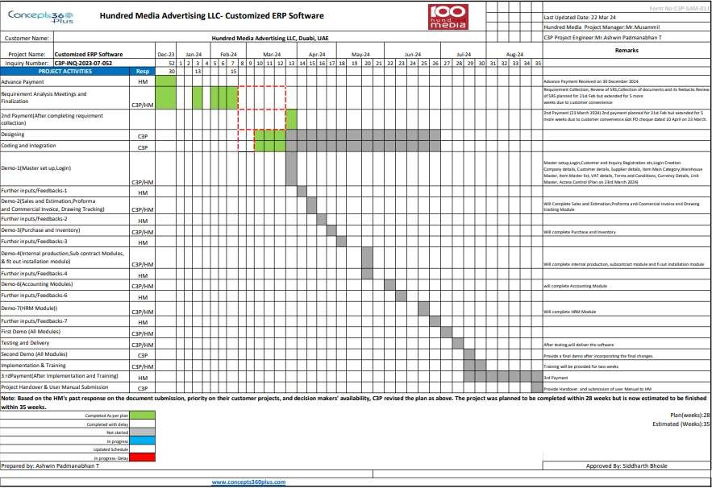

Next Plan:

Note: As discussed, On 17 April 2024, C3P has extended the plan by an additional two weeks due to a busy schedule with Hundred Media’s projects. The revised plan is outlined below:
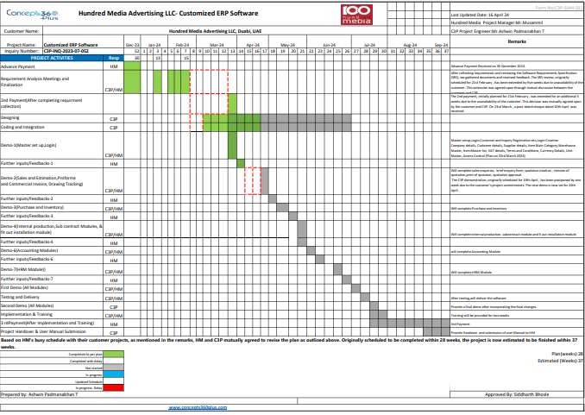

C3P needs to follow up for the feedback and in next demo on 26th April, C3P is planning to discuss Sales Module:
      - Enquiry registration
      - Customer registration
      - Estimation
      - Quotation

Revision 10(11-May-2024)

Time:12pm-2:45pm

ATTENDEES

- Mr.Musammil(ManagingDirector,Hundredmedia)
  - Ms.Neethu (ActingHRManager)
- Ms. Sonam, Mr. Ashwin Padmanabhan T ,Mr.Joby Varghese,Ms.Jomy Mary George (C3P Team)

During this meeting Ms.Sonam presented the HR and Sales Module covering the following headings to Hundreds Media team:
  - HR Module
- Designation master as per client request
- Documents upload in Employee Registration
- Leave application and approval
- Joining Process
- Allowances and Deduction Master
- Salary Calculation
- Overtime calculation
- Employee Attendance
- Resignation
- Passport Release
- Corporate file
- Vehicle details
  - Sales
- Enquiry
- Quotation
- Sales Invoice

Changes Needed

- Approval for leave application
  - For labors, only one approval
  - For other employees, application should follow the below approval flow
    - Operation Head
    - HR Manager
    - Managing Director
  - Show who approved the leave like ‘Approved by HR’, ‘Approved by MD’
  - Overtime calculation for temporary/outside staff Per hour and Per day needed

- Approval for Resignation
  - Labour ->Department Head
- Sales flow

  - Enquiry > Estimate > Quotation > Sales

- Enquiry
  - Image upload option in Project Details table

Next Plan

C3P will present Purchase module along with estimation, quotations, and Quotation approval from Sales module.

Document Needed

Detailed Estimation Sheet

Revision 11 (19-June-2024)

Time: 4pm-6pm

ATTENDEES

- Mr. Sooraj (Acting Sales Manager)
- Ms. Neethu (Acting HR Manager)
- Ms. Sonam, Mr. Ashwin Padmanabhan T (C3P Team)

During the meeting, Ms. Sonam planned to present the Sales Module, Purchase Module, and Inventory Module. However, the discussion focused solely on the Sales Module, covering the following headings for the Hundreds Media team:
  - Sales Module:
    - Add New Prospective- In this they required an option to upload the excel sheet of prospective list.
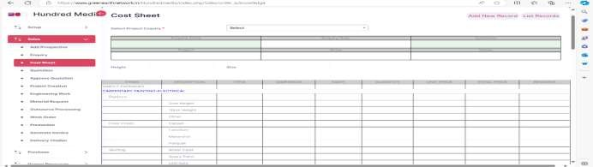
    - Cost sheet- In the cost sheet they will provide the changes required in brief enquiry form. They required multiple line to add the details in the item column.

Note* the cost material sheet provided on 25 June 2024. In this the cost is not mentioned, that details

will provide on 28 June 2024

Next Plan:
After mutual discussion Hundred media agreed to conduct meeting on 21 June 2024. So C3P agreed to present rest of the modules (Sales, Purchase, Inventory and HR)

Approved By,
Mr. Nataraj Marulaiah
Techno-Commercial Director



Revision 12 (21-June-2024)

Time: 10.15am-12pm

ATTENDEES

- Mr. Musammil (Managing Director, Hundred media)
  - Ms.Neethu (ActingHRManager)
  - Sooraj (Acting Sales Manager)
- Ms. Sonam, Mr. Ashwin Padmanabhan T (C3P Team)

During this meeting, Sonam Madam, C3P’s Senior Software Developer, delivered a comprehensive presentation covering
the following aspects:

  - Sales Module:
    - Cost sheet
    - Quotation- Hundred media required comparison statement in the quotation
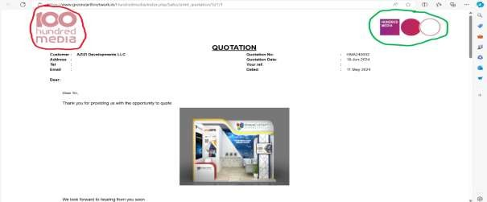
In this quotation format they doesn’t required logo (which one is marked red) left side any more in the software.
They required logo which one is in right side (which is marked in green)

    - Approve Quotation
    - Project creation- In project creation C3P shown Assign Project team, edit project
  - Purchase Module and Inventory Module:
    - Purchase Requisition
    - RFQ To Supplier- Multiple supplier selection for RFQ
    - Quote From Supplier
    - Purchase Order
    - Goods Received
    - Direct GRN
    - Stock Adjustment
    - Stock Allocation

  - HR Module

    - Probation period with from date to date
    - Advance salary form

In this meeting we also discussed the Accounting module, which we shown to the finance head- he suggested that C3P accounting is resembling with the Tally software, so they doesn’t have any suggest at that time. Sonam ma’am suggested that need to collect following documents for Accounting from Hundred media:
    - Account Group
    - Ledger
    - HR link format to accounts
    - Sales link format to accounts
    - Purchase link format to accounts
Document:

Collected | Pending
Updated costing  sheet | Brief enquiry form
DO
Mock up form

Corrections  requested | Completed | Working on | Waiting for input | Clarification  required | Repeated  requests
15 | 13 | 2 | 0 | 0 | 0

Updated Plan:
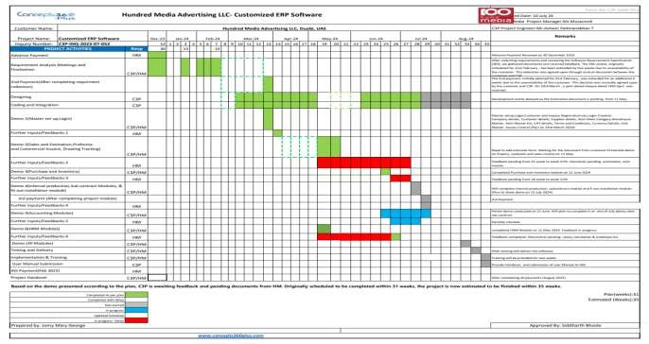

Next Plan:

C3P will present complete Project module by the mid of July (15 July 2024) and after the demo C3P planning to collect the third payment.

Revision 13 (19-July-2024)

Time: 3.30pm-6pm

ATTENDEES

- Mr. Musammil (Managing Director, Hundred media)
- Ms. Neethu (Acting HR Manager)
- Mr. Sooraj (Acting Sales Manager)
- Ms. Fadheela (Acting Accounts Head
- Mr. Nephin (Acting Project Engineer)

- Ms. Sonam, Mr. Siddharth Bhosle, Mr. Ashwin Padmanabhan T (C3P Team)

During this meeting, Sonam Madam, C3P’s Senior Software Developer, delivered a comprehensive presentation covering
the following aspects:
  - Project module
    - Project Creation
    - Engineering Work
    - Material Request
    - Outsource Processing
    - Work Order
    - Handover
    - Generate Invoice
    - Fit out & Installation (HM need to discuss internally and will provide work flow to C3P.)
    - Payment Request
    - Mockup Form
  - Accounting Module
    - Account Group
    - Ledger Account
    - Receipts Entry
    - Payment Entry
During the meeting HM mentioned some additional requirements each modules in the software. Following are the additional requirements:

- Sales module:
During our last meeting (Rev 11, 19 June 2024), Mr. Suraj mentioned that the costing sheet did not need to be connected to the inventory or item master and stated they had their own format. We developed the software based on these instructions and presented it on 19 July. However, during this presentation, Ms. Fadheela, who was not present in previous meetings, stated that the costing sheet must be connected to the live item master list.

- Accounting module:
Earlier HM told us that they accounting module exactly like tally but now Ms. Fadheela and Anjo told they want the project wise cost.

- Purchase module:
In the purchase module, HM needs alerts or visibility for previous prices. C3P requires clarification on how to handle situations where the price changes multiple times.

- HR module
HM required to integration Biometric scanner to our software.

During the meeting C3p asked HM to provide following documents related to software.
Documents:
- Updated brief enquiry form
- Material Requisition link with inventory (work flow)
- Returnable material form
- Site installation, fit out form and workflow
- Cost sheet approval steps

HM needs to provide only final formats for following:
- Quotation print format
- Tax invoice format

- Performa invoice
- Purchase order
- Quotation request to supplier
- Purchase request
- Payments and receipts formats from accounts
- All the HR related formats, joining letter, leave application, salary slips etc.
- Dash board formats for all departments

These are the percentages of each module tested by HM so far:

MODULE | PERCENTAGE (TESTING)
Sales Module | 70-80%
Purchase and inventory  Module | 20-30%
Accounting Module | 50%
HR Module | 50%
Project Module | 0% (Demo was shown to  them on 19 July 2024)

Next Plan:
C3P needs to check the availability of the technical team to conduct a meeting. C3P also needs to discuss the additional requirements with the technical team and HM. HM has requested a demo of the software, so C3P should check the
availability of Sonam Ma’am to conduct a demo session. For this meeting, HM’s entire team needs to attend.

UPDATED TIMELINE
This updated timeline will be made because new additional requirement mentioned in above, so it require additional on month to complete it.
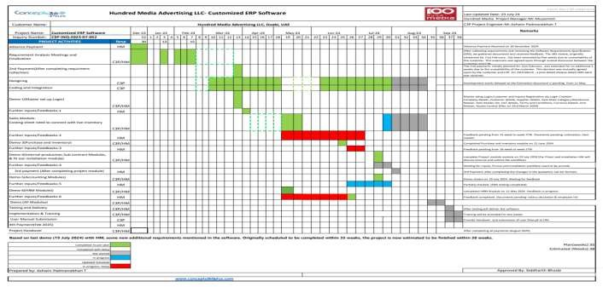

Revision 14 (24-July-2024)

Time: 1pm-4pm

ATTENDEES

- Ms. Fadheela (Acting Accounts Head)
- Ms. Sonam, Mr. Ashwin Padmanabhan T (C3P Team)

The meeting was primarily held to demonstrate each software module to Fadheela ma’am and the HM team.
However, only Fadheela ma’am attended, and she was not present during the initial requirement collection and module-wise demo. This meeting was therefore dedicated to discussing the modules and receiving suggestions and additional requirements.
Fadheela ma’am will monitor the HM workflow in the software. So that ma’am can explain to them about the
developed software hereafter.

  - Setup:
    - In employee corner need to add a link company handbook and policy procedure. When new employee joins the company they need to aware of company policy. HM have 2 policy one for office employee and other for warehouse labor.
    - In supplier registration the payment terms should be added and reflect in PO.

  - Sales Module:
    - In the new prospective need to add the salesperson name.-Done
    - In Prospective, they required a filter to check each salesperson prospective report.-Done
    - They required sort by option in prospective list (today, this week, month and year)-done
    - In new prospective any option for to add show/exhibition name. Done
    - In sales department need to check only prospective and enquiry. Done

  - Enquiry:
    - In category- add option Agency.-Done
    - In brief details- inquiry number need to be add and wanted revision.

  - Cost sheet/Estimation:
    - Cost sheet is very important in HM ERP software.
    - Quotation editing or deletion, quotation approval, and estimation fall under the responsibilities of the Estimation department.
    - Cost sheet is linked with to every department.
    - Cost sheet must rename to Estimation.-renamed to cost estimation.
    - Cost sheet must be connected to Item master.-Done
    - Cost sheet required approval and revision.-Done
    - Cost sheet must be under project department.-Done
    - Labor cost and expense must be include in cost sheet.
    - After the revision and approved, the cost sheet must be lock mode. -Done
    - Quotation approval required from project manager.-Done
    - Quotation is combination of cost sheet and enquiry.-Done
    - HM required to send the quotation by email. So we ask HM to provide the email credentials- email configuration, email id, port number and server number (NEW REQUIREMENT).

  - Project:
    - Operation manager will create project details.
    - Operation manager will assign the works to the project manager.
    - Then the project manager will create project creation in the software.
    - When the quotation is approved by the customer, the accounts department, purchase department must be alert about the project. When the quotation is approved the accounts department will create proforma invoice to the customer and accounts team will collect the first payment.
    - In project creation, add creation they need to add the performa invoice number.

Here we covered the Setup, Sales module (till project creation)

Next Plan
Meeting will be continue on 25 July 2024, to discuss the remaining module.

Revision 15 (25-July-2024)

Time: 1pm-4pm

ATTENDEES

- Ms. Fadheela (Acting Accounts Head)
- Ms. Sonam, Mr. Ashwin Padmanabhan T (C3P Team)

Last meeting we covered the setup, sales module (till project creation) and today will covered the project module and purchase module.

Continuation of project module,
- In project creation, work is distributed among the following departments: Design, Furniture, Warehouse (Production), and Signage and Graphics. Within the Warehouse department, tasks are further divided into carpentry, electrical, painting, and glass & metal.
- Each department operates independently but is connected to the parent company (HM).
- HM requires detailed reports of expenses, labor costs, and material calculations for each department individually.
- The Project Manager will send detailed work orders to each department.
- HM will issue purchase requests to each department, and the departments will provide HM with quotations, after which HM will issue LPOs.
- In project scheduling, HM requires alerts for start and end dates to coordinate with other ongoing projects.
- Project creation and engineering works should be consolidated on one page.
- For the production report, they require the schedule and engineering works.-Done
- There is a need for updates in the project schedule.
- The Project Manager will approve or reject once the project creation is complete.
- After the PI, the approved quotation is given to the different department project managers.
- When the quotation is accepted and the PI is received, the Operation Manager will assign the Project Manager, and the PM will create the project. (C3P needs to add a step where the Operation Manager assigns the Project Manager.)

- Project creation will be done by the Operation Manager and project scheduling by the Project Manager.

- In the work order, departments can accept or reject tasks. There should be permission to upload attachments.
- When the Project Manager selects a project, they need to see the project schedule, project mock-up, and project engineering, and they can add details to it. After adding all details, the approve button will display.
- The Operation Manager will also want to check all details and can approve what the Project Manager has entered into the project.
- There should be no separate button for the mock-up form; it can be included on one page.
- After this, they need to create all job orders for the respective departments. (HM needs to discuss with the production team).
- The parent company (HM) will provide one work order number, and each department needs to get a notification about the work order provided by HM.
- In the department session, a checkbox should be provided to add tasks under the warehouse department.
- In the work order, when the Project Manager selects the project, all the basic details will appear, including the scope of work. Below, they can add the department-wise scope. When the department head logs in and checks the project, they can create work orders.
- There is a need to collect department-wise work orders.
- Departments can reject or accept the work order. If rejected, the parent company will outsource and find another company for the work. Attachments should be allowed.
- A department-wise module is required. When the CEO logs in, each department-wise module needs to be visible so they can check individual expenses, income, profit, sales, and revenue.
- All department-wise quotations are the same, but the title needs to change to the department name.
- When the work order is created, the material requisition form will be sent to the department. Each department purchase manager will create a material request.
- When department-wise quotations are received, including price, if accepted, they will check the inventory section. If the quantity is not available, they will create a material requisition for the purchase department.
- The quotation will be approved by the Operation Manager and will go to the accounts department. The department will issue the invoice to accounts.
- They need to see expenses project-wise and department-wise.(NEW REQUIREMENT)
- In outsourcing, include the supplier name, number of laborers, working hours, and cost per hour, department, and total amount.
- In handover, after project completion, the handover option should appear. The Project Manager needs to attach the customer signature in a PDF format. C3P will provide three options for attachments.
- Upon handover, the software should show the end date of the project.
- After handover, the final invoice must be ready.
- At the time of handover, if there is any additional amount, the accounts department must be informed.
- Provide fit-out and installation formats and workflow.
- In invoice generation, every invoice should resemble the proforma invoice and quotations. If there is any additional amount, it should be added to the final invoice.

  - Purchase Module:
    - In dashboard, pending revisions must be seen.
    - They required Mockup date alerts.
    - In purchase requisition, need approval from respective department head.
    - HR will approve the PR and create a list and send to purchase manager.
    - In RFQ, need to create category wise item list.
    - While generating PO, the operation manager needs to be approved and send copies to accounts departments.
    - Inventory also needs to connect with accounts.

Next Plan:

For all these checks will require additional time, next demo for HM will be conduct on 29 July to discuss Accounting and HR module.
After all demos C3P will update the timeline and present it to HM.

Corrections requested | Completed | Working on | New requirements | Waiting for input | Clarification required | Repeated requests
69 | 6 | 63 | 6 | 5 | 0 | 0

Revision 16 (29-July-2024)

Time: 1pm-4pm

ATTENDEES

- Ms. Fadheela (Acting Accounts Head)
- Ms. Sonam, Mr. Ashwin Padmanabhan T (C3P Team)

During the meeting C3P explain about the HR module and Accounting module, here is the suggestion suggested by HM,

  - HR Module
    - In department creation, a department is created, and under the department comes the department head, followed by the employees.
    - HM needs to provide a joining letter and a company handbook to new employees.
    - There are two types of company policies: one for employees and one for laborers.
    - The company policy for employees is attached in the software, while the policy for laborers is in print format and listed in the employee corner.
    - When an employee joins the company, HR will provide a joining letter and handbook. The joining letter needs to be signed by the employee and uploaded to the software.
    - To register attendance, HM needs to connect the biometric scanner to the software. (NEW REQUIREMENT)
    - C3P needs to suggest the model and configuration related to the biometric scanner. (needs internal discussion)
    - If HR does not provide the biometric scanner, the software's attendance registration section should include an Excel sheet for all employees with checkboxes for attendance.
    - The Excel sheet should include the date, a list of all employees and laborers, and the in and out times.
    - HR needs to provide office time setup and overtime options for employees and laborers.
    - There are 2 overtime options: normal OT and weekend OT.
    - C3P needs to provide a setup that includes office timings, overtime, and holidays.
    - For overtime, different project employees and laborers have different rates.
    - HR needs to provide the overtime policy with examples for both an employee and a laborer (needs to be

provided in an Excel sheet).
    - HM suggested an option for compensatory leave. When an employee or laborer works on a Sunday or holiday, they can take leave on a working day.
    - Compensatory leave will be available in the employee corner.
    - When an employee requests allowances (leave salary, ticket allowance, etc.) after not taking leave and working on a holiday, it will be listed in the employee corner.
    - In the allowance request process, once HR approves the request, it will be included in the monthly salary.
    - Only one month's salary can be provided in advance, and it will be deducted from the same month's salary.
    - In the case of an advance salary, the same month's salary is provided. For employee loans, the amount will be deducted periodically from the monthly salary.
    - HR provides salary advances, medical allowances, and loan allowances.
    - An employee can submit a resignation, which goes to HR and is processed as a termination. For laborers, the department head can fill out the resignation form.
    - The term "resignation" is changed to "termination."
    - HR needs to provide the format for experience certificates. Employees need to apply for an experience certificate.
    - In vehicle details, there are two types: vehicle assets and maintenance (services, current kilometers).
    - Fuel consumption details will be connected to the accounts department.
    - Fuel consumption and kilometers will be uploaded daily into the system by HR or an accountant.
    - Vehicle details are first connected to the accounts module and then to HR.
    - Vehicles registered under accounts will be categorized into two types: fixed assets and expenses.
    - The driver's name must also be added.
    - In the employee registration form, HR needs to track items provided to the employee, such as laptops (including serial number), SIM cards (including SIM card number), mobile phones (including IMEI number), and vehicles (including number plate).
    - Accommodation details need to be provided.
    - HR needs to provide office staff details.

  - Account module

- In receipt entry, the customer name is required. Once the customer is selected, all related invoices should appear in a dropdown menu, with the amount automatically populated.
- Add fields for cheque number, PDC (Post-Dated Cheque) date, and CDC (Current Dated Cheque) date.
- Enable multiple invoice entry.
- Once a quotation is approved by the customer, an alert should be sent to the operation manager and accountant. The accountant should then create a proforma invoice.
- Allow partial creation of tax invoices, with the ability to generate two or more invoices from one proforma invoice.
- The C3P module should be able to complete both proforma and tax invoices within the software.
- In payment entry, the cheque date should appear, and multiple invoices should be selectable.
- Include fields for debit notes and credit notes.
- Two types of journal entries are required: project expense and general expense.
- Allow multiple selections in journal entry.
- HM will provide account data in QuickBooks format.
- Include a button for contra entry in the journal entry module.
- Move the creation of proforma and tax invoices to the accounts module.

Corrections requested | Completed | Working on | New requirements | Waiting for input | Clarification required | Repeated requests
115 | 6 | 109 | 25 | 15 | 0 | 0

Documents to be collected from HM:
- Company handbook and policy procedure (employee and labor)
- Department-wise work order format
- Fit-out and installation format and workflow
- Joining letter format (HR)
- Office timing setup, overtime setup, and holidays for employees and labor
- Accommodation details
- Office staff details

UPDATED TIMELINE:
We plan to complete the software by August. We share module-wise demos and are awaiting feedback; however, HM has not yet provided any. Fadheela Ma’am has suggested a total of 115 changes to the existing scope, which have been discussed over the last four meetings. Consequently, we will need an additional 2 months to implement these changes. Please find the updated timeline below.
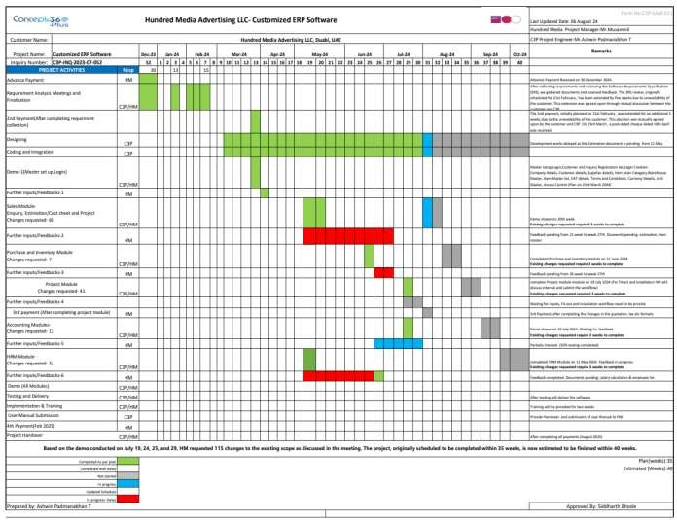

Next Plan:
Next week, we will schedule a meeting to discuss the timeline and cost for the additional or new requirements. We will also provide updates on the progress of the 115 existing changes during this discussion.

Additional/ New Requirements
Following points are Additional/New requirements from Hundred Media received on 19, 24, 25 and 29 July. So to compete additional requirement require additional time and cost required. C3P still working on the proposal and will present by next week.
- Sales Module-
  - Cost sheet connect to live inventory list. (Done)
  - Brief form updates (hold)
  - Cost sheet linked with every departments(hold)
  - E-mail configuration
  - Sales module only needs enquiry and prospective. Done
  - In aspects of user access project team will be executing the cost sheet. Done
- Project Module
  - Need to create department wise status updates in project module by single supervisor.
  - In project module, Departments enter actuals based on the work order. Separate purchase request required. In actual if any additional materials required it should show separately.
  - HM needs to see departments wise reports of expenses, labor costs, and material calculations.
  - Project creation and engineering works should be consolidated on one page.
  - Project schedule, project mock-up, and project engineering should be in one page. Done
  - Department wise scope of work need to be create
  - When the CEO logs in, each department-wise module needs to be visible so they can check individual expenses, income, profit, sales, and revenue. (hold except sales report)
  - They need to see expenses project-wise and department-wise.
  - When quotation approved by customer need to send alert to accounts department and purchase department
  - Invoice should resemble the proforma invoice and quotations. If there is any additional amount, it should be added to the final invoice.
- Purchase module
  - In purchase module there should be a user access to connection to inventory.
- HR Module
  - To register attendance, HM needs to connect the biometric scanner to the software. (C3P needs to give HM the specifications)
  - HM suggested an option for compensatory leave.
  - Changes in allowance.
  - Changes in vehicle details, needs to connect with accounts department and then HR

- Accounts Module
  - Cheque printing option requested
  - HM needs to provide QuickBooks data
  - Include a button for contra entry in the journal entry module. Done
  - Move the creation of proforma and tax invoices to the accounts module.

Revision 17 (07-August-2024)

Time: 11am-11.30am

ATTENDEES

- Ms. Fadheela (Acting Accounts Head)
- Mr. Nataraj M, Mr. Ashwin Padmanabhan T (C3P Team)

Todays discuss need a clarification based on the additional/new requirements in biometric scanner and department wise invoice.

  - In biometric scanner, HM required weekly wise attendance report needed to upload in the software. C3P agreed to do it.
  - In the department-wise invoice, for Hundred Media which has four departments—Design, Furniture, Warehouse (Production), and Signage and Graphics—Nataraj Sir inquired with Fadheela Ma’am about having separate invoices for each department. This means that sales, purchase, inventory, and accounting should be distinct for each department, unlike Hundred Media, which is focused solely on production. Nataraj Sir suggested that department-wise software would be required for this purpose.

So Fadheela ma’am told tomorrow they will discuss with HM and will share feedback on Friday.

Next Plan:

Next week, we will present the progress on the 115 existing changes.

Regarding the additional scope (25 points) mentioned above, once Fadheela Ma’am confirms the details by this Friday
or Saturday (August 9 or 10), C3P will inform HM of the next steps.

Revision 18 (24-Aug-2024)

Time: 10.30am-1.30pm

ATTENDEES

- Mr. Musammil, Ms. Fadheela (Hundred Media team)
- Ms. Sonam, Mr. Ashwin Padmanabhan T (C3P Team)

During the meeting, Ms. Sonam, C3P's Senior Software Developer, presented the changes suggested in previous meetings and gave a detailed presentation covering the sales module and the initial part of the project module. The key points discussed were:
- Sales Module:
  - In the 'Prospective' section:
    - Add the ability to filter reports by day, month, and year.-Done
    - Include the salesperson's name.-Done

  - In the 'Enquiry' section:
    - Add a revision number when edits are made.-Done
    - Add an 'Agency' category.-Done
  - In the 'Quotation' section:
    - Adjust the alignment to ensure Arabic writing is aligned with English writing. Done
    - Add a job number when a client provides a purchase order or approves a quotation.
    - Only approved quotations will be shown in the Performa invoice.-Done
    - Ensure one Performa invoice corresponds to one quotation.-Done
  - Cost Sheet Module:
    - Remove the edit and approval buttons.-Done
    - Ensure that once an enquiry is created, the associated cost sheet is generated, and the enquiry details are not duplicated in the cost sheet.
    - Descriptions in the cost sheet should be sourced from the item master.
  - Invoice Module:
    - A tax invoice will be created from the Performa invoice.-Done
    - Allow the invoice to be deleted from the software.-Done
    - The project name and exhibition name should be included in the Performa invoice.-Done
    - In the module's dashboard, ensure that in the Performa invoice option, the list's action column displays the same job number but with a new PI number.
- Project Module:
- Add an alert in the project team selection process to notify whether a person has already been assigned to another project team.
- Rename the 'Project Department' module to the 'Operation' module.-Done
- In the module's dashboard, the following changes will be made:-Done 4.


Sales and
Marketing

Add Prospective
Enquiry
Client Quote
Accept
Operation Module
Cost
Estimation
Quotation
Project
Creation
Project work
Material
request

Outsourcing process
Work order
Handover
Fitout and
Installation

Payment request

Mockup form

Documents need to be collect from Hundred Media-
- Inventory List (Item Code, Item Description, Stock Quantity and Price)
- Fit out and installation workflow

Next Plan

We plan to complete the changes in the Sales and Operations modules by Monday, 9th September 2024. Following this, the payment milestone will be due. Next, we will finalize the Project module, and once the changes are completed, the C3P technical team will notify the group.

Rev 19 (09 September 2024)

C3P has been completed the changes as per requested. Following are the done by C3P:
- Payment term option added to supplier master, and it available in the PO report according to the workflow.
- Labor and office staff have also been added to the employee types in the employee registration.
- A 'Project Complete' radio button has been added to the handover section.
- File attachments option provided in Handover form.
- The 'Generate Invoice' option has been implemented and can also be printed.
- The Proforma invoice has been completed and can also be printed.

- The 'Department' and 'Designation' fields have been enabled in the employee registration edit.
- Revision and approval have been completed for the cost estimates.
- The running project reports have been completed, including printing and exporting to Excel, with filters applied for date ranges and customer-specific data.
- In department master option provided to select main department or sub department.
- In outsourcing material form calculation for no of labor and working hours and total amounts are provided.
- Multiple payments terms you can add in quotation, and that will automatically reflect in Proforma invoice.
- Print format for quotation is updated.
Next Plan
Sales and operations module are completed and use for live test. Now we are working on changes from purchase and HR. Once completed we will update again.

Rev 20 (27 September 2024)
C3P has been completed the changes as per requested. Following are the done by C3P:

  - Purchase module:-
- The purchase requisition has been added to the employee corner and is accessible only to the logged-in user.
- Purchase requisition approval is now handled by the department, with approvals from users within the same department.
- As per your changes, we added a category in the RFQ, and data is now automatically reflected based on the selected category.
- We have added a payment terms option in the supplier section of the setup module. When selecting a quoted supplier in the purchase order, the associated payment term will automatically reflect in the purchase order form.

  - Operation Module -:
- In the operations module, a new feature has been added for payment terms. You can now add a new row to specify a payment term name and payment percentage. These payment terms are reflected on the proforma invoice, and once the proforma is generated, the payment terms are shown on the generated invoice.
- Quotation payment terms have been included in the print format.
- In project creation, we have added an alert for the start date, end date, and employee-related notifications.
  - Account Module :-
- If a proforma is generated, an entry will be automatically inserted into the project creation.
- A filter has been added to exclude proforma invoices from the dropdown list once a proforma has been generated.
- If a pro forma invoice is created, it will appear in the generated invoice dropdown, allowing for the generation of multiple invoices. Additionally, you can select the payment term as 'yes' or 'no,' and the calculations for the payment will be printed based on the 'yes' selection.
- In the generate invoice, we have provided the option to specify amounts credited and debited.

Next Plan:
C3P is currently working on the remaining points of the HR module and the purchase module. We will inform you once it is complete.

Corrections requested | Completed | Working on | New requirements | Waiting for input | Clarification required | Repeated requests
135 | 51 | 84 | 17 | 8 | 0 | 0

Rev 21 (04 Oct 2024 )

Date
Time: 3:30 PM – 7:00 PM
Attendees:
- Ms. Fadheela, , Mr. Jain Hyder (Hundred Media team)
Mr.Joby K Varghese ,Mr. Ashwin Padmanabhan T, Mr.Ganesh Ravindra, Ms.Harsha (C3P Team)

During the meeting with the Hundred Media team, they informed us that they are currently testing the software. They have tested the enquiry and customer generation features, but encountered difficulties with the cost estimation. Previously, all cost estimates were consolidated, making it difficult for them to analyze costs by category or department.

The Hundred Media team provided an updated cost estimation format, which was presented during the meeting. This format breaks down the costs department-wise, allowing them to better understand the pricing for each department.

Both the Hundred Media and C3P teams reviewed the points outlined in the SRS and verified the completion of several key items. Many features were successfully demonstrated, and the Hundred Media team expressed satisfaction with the progress.

Before concluding, both parties agreed to proceed with live testing of the software. Ms. Fadheela mentioned that once the new cost estimation format is finalized, they will schedule a session for live testing.

Next Plan :
C3P is currently doing the cost estimation format and will present it by 20 Oct 2024

Rev 22 (24 Oct 2024 )

During the initial demo of the Sales module on June 19, 2024, C3P completed and presented the costing sheet based on the format initially provided by Hundred Media. During the meeting, Mr. Suraj requested some adjustments to the estimations, which were implemented accordingly. C3P revised the estimations and presented them again to the customer on July 19, 2024. At this meeting, Ms. Fadheela, who had been absent previously, requested further changes to the estimation format. The sample format for these changes was received on October 4, 2024.
Since C3P has already revised the estimations twice based on customer feedback, any more changes will incur additional charge.

Next Plan :
Based on the latest format from Hundred media, C3P implemented estimation and plans to present a phase 1 demo of the software on 24 October 2024.
Rev 23
Date:25 Oct 2024
Time: 11:30 AM – 12:30 PM
Attendees:
- Ms. Fadheela , Mr. Fazil (Hundred Media team) Mr.Ganesh Ravindra, Ms.Harsha (C3P Team)
During the meeting, C3P presented the cost estimation form to the customer to obtain the confirmation.
The following changes were required during the meeting:
- It should have a subtotal and margin field before the grand total.
- Another section for overhead/indirect expenses need to be added with provision to add multiple rows with fields for cost description and amount.
- Enquiry items must be fetched to estimation form.
- The titles in the detailed estimation table must be editable.
- Remove ‘used’ column for painting category.
- In Labor Salary, selection of a type must fetch the cost details from db.
- In Detailed estimation for subcontractor cost, each row should have fields for subcontractor name, cost, markup.
- For entry pass, there are currently 3 options: Abu Dhabi, Dubai, Outside UAE with fixed costs. There must be provision to add new options also.
- For logistics, cost calculation is based on number of tons, destinations, number of trips.
- Overtime should be calculated by the system on the entry of start and end time for each category of labors.
- Trashing should be renamed as trashing/dismantling.
- In Food & Beverages, there should be 5 options with fixed costs: Breakfast, Lunch, Dinner, Mid-day BF, Mid-day Snack.

Next Plan :
After the discussion with their project team, hundred media will give confirmation of the estimation format.

Rev 24
Date:26 Oct 2024
Time: 3:30 PM – 4:30 PM
Attendees:
- Ms. Fadheela (Hundred Media team) Ms.Sonam Phade, Ms.Harsha (C3P Team)
After discussion with the project team, Hundred Media raised following requirements during the meeting:
  - Software theme has to be based on vibrant colours.
  - Subcategory details have to be hidden by default.
  - Change labor cost to Labor cost/Manpower
  - Remove used, buy and % columns for all subcategory under material cost except Carpentry and Electrical.
  - Search option for item selection.
  - Item selection for each subcategory.
  - Before total project cost there should be :
    - Total direct expenses

    - Total indirect expenses
    - Subtotal
    - Margin
  - Under Operations, they want a new menu for production.
  - Provision to add new type of cost in estimation.
Next Plan :
Hundred Media need to provide the excel sheets for production module implementation.C3P will complete the required changes in estimation by second week of November and after that will schedule a live testing.
During live testing, customer should duplicate an actual enquiry in the software and confirm they are able to take a printout of the quotation after estimation which marks the next payment milestone.
Following this, a discussion has to be made with customer regarding the pending works to be completed in the software and C3P will submit a revised plan covering all the points from the discussion.
Rev 25(09 Nov 2024)
Time: 3:30 PM – 4:30 PM
Attendees:
Mr. John, Mr. Suraj,Mr. Fazil (Hundred Media team) Mr. Joby, Ms.Harsha (C3P Team)
The objective of the meeting was to give training to the customer for Sales & Operations module. But the customer had some confusions regarding the format of the estimation they provided to C3P for implementation. Customer agreed to discuss internally and give C3P a final decision regarding the format to be followed in estimation at the earliest.
During the meeting following changes and corrections were required by the customer:
- Alerts should be given for all mandatory fields.
- The previous designer field should be a select list. Customer should provide the possible options for the same.
- When uploading a file in the enquiry, it gives an error. Customer will have to upload larger sizes of files during enquiry registration.
- Provision to view the file uploaded in enquiry in the estimation form.
- In enquiry type field, ’main’ option should be removed and following options should be added:
  - Exhibitions
  - Events
  - Kiosk
  - Corporate gifts
  - Interiors
  - Others

Next Plan:
The customer agreed they want to revise their current SOP and will submit a revised SOP by 15 November 2024.During the time the customer finalize the SOP, C3P plans to schedule live training sessions of the completed modules to the corresponding users and take feedbacks from them. The schedule for the same will be communicated accordingly.
Also the customer has to provide the detailed requirements along with document formats from internal production module and fit out and installation module.

Rev 26(14 Nov 2024)
Time: 11:15 AM – 12:15 PM
Attendees:

Mr. Shafeek, Mr. Fazil (Hundred Media team) Ms.Harsha, Ms.Reeba, Ms. Vijisha (C3P Team)
The meeting was intended for training of the purchase module. Following requirements/corrections were suggested by the customer during the meeting:
- Each requisition must be linked to a project. Storekeeper must also be able to make requisition for stock purpose without mentioning any project.
- Once a PO is generated, it must be approved by CEO to send to customer. Along with generated PO, the approving person must be able to see other quotations from suppliers as supporting documents.
- The terms and conditions in PO must be reviewed by accounting department.
- Provision to upload supplier invoice in GRN.
- In Direct GRN also provision for uploading supplier invoice and project selection must be there.
Next Plan:
C3P will complete the changes from the purchase module by 27 November 2024.

Rev 27(25 Nov 2024)
Time: 4:30 PM – 6:00 PM
Attendees:
Ms. Rajinsha, Mr. Fazil (Hundred Media team) Mr.Joby, Ms.Harsha, Ms.Reeba (C3P Team)
The meeting was intended for discussing the updated SOP document of HundredMedia. It was agreed to submit a revised SOP by 15 November but it was delayed till 25 November as there was a delay in finalizing the document by hundred media. The discussion is summarized as follows:
- Document Coordinator(Ms. Angelica) uploads the database of the prospects into the ERP system.
- Sales Tele Caller (Ms. Christina) contacts the prospects and categorizes them. If found any interest, it is converted to enquiry.
- Other sources of enquiries are Digital Marketing, Sales Consultants, Sales team and existing customers.
- Enquiries by Sales team are registered by themselves. Remaining are done by Sales tele-caller and Digital Marketing executive (Mr. Safwan) and a sales person is assigned to each enquiry.
- The assigned Sales person will submit enquiry brief form to customer.
- After receiving the filled enquiry brief form, sales person will assign the enquiry to one of the designer in the company based on their availability. Sales person shall be able to see the available dates of each designers.(Designer: Mr Anwar)
- Once assigned to a designer, the designer must prepare a design and upload it to the system.
- Sales team will review the design and cross check with enquiry brief form. Once approved, will forward to estimator.(Estimator: Mr. John)
- At this stage, the estimation, BoQ, Quotation is prepared.
- Once the quotation is approved internally, it is send to client.
- If the quotation is rejectected, there must be provision to revise the quotation.
- If the quotation is approved, sales team must update the status of the enquiry as LPO received and asks the corresponding designers to submit 3D designs and technical drawings which is then forwarded to client.
- After the client approves the design and drawings, a meeting is held between Sales and Project team during which the project team take over the work
- After the meeting, the minutes of meeting must be prepared and uploaded to ERP system, so all concerned person can access it.
- The work starts after the meeting, and the project team is responsible for preparing project progress reports for sales team during the course of work.
- When a date is fixed for any project milestone(eg:mockup,handover), a notification must be sent to accounts department so they can prepare the payment follow up.

Next Plan:
Hundred Media must give confirmation for the following points by 29/11/2024:
- Who will be assigning sales person to each enquiry.
- To whom will be quotations reverted for revision when rejected from customer.

The following documents also should be provided by 29/11/2024:
- Sample Estimation formats- Estimation format should be sent after finalizing with all concerned officials. Since we already changed the estimation thrice, no more changes can be tolerated.
- Sample BOQ documents.
- Format for project progress reports- created by project team for sales team.
- Mockup declaration form.
- Mockup confirmation form.
- Finalised Project SOP document

C3P is planning to conduct the live testing of Purchase Module by 07/12/2024 and HR module by 11/12/2024.

C3P must also submit a revised timeline to Hundred media.

Rev 28(27 Nov 2024)

Through Whatsapp message, Hundred Media confirmed the following points:
  - Enquiries will be assigned to sales person by the Sales Director.
  - The quotation when rejected, must go the estimator along with reason and the cycle will follow

The following documents were also provided:
- Sample Estimation documents
- Format for project progress reports- created by project team for sales team.
- Finalised Project SOP document

Next Plan:
Hundred Media must give confirmation for the following points by 07/12/2024:
- The current fields in the enquiry brief form have to be retained or not.
- The format and number of design files.
The changes in the sales module will be discussed internally and will update the date of completion after the above points have been confirmed.

Rev 29(04 Dec 2024)
Through whatsapp, Hundred media confirmed the following points in sales module:
  - Design file will be single and in pdf format.
  - Enquiry brief form should replicate the google form. Following are the additional fields:
    - Orientation
    - Floor Plan attachment
    - Option to choose logo types
    - Previous stand photo attcahment
    - Shelves qty
    - Website
    - Other requirements.
  - The fields marked in the provided document shall be removed.

Next Plan:
C3P will complete the points by 20 December 2024.

Rev 30(09 Dec 2024)
Time: 4:00 PM – 5:00 PM
Attendees:
Ms. Rajinsha (Hundred Media team) Ms.Harsha, Ms.Reeba (C3P Team)
During the meeting HR module was tested, following changes were suggested:
- Error in calculation of number of days in leave application.
- Joining date from last leave field in leave application doesn’t allow to select older dates.
- Rename joining application as rejoining application.
- Provision to input overtime amount of each employee in salary structure.
- Rename Passport release as ‘Passport release Request’.
- In vehicle details, provision to input mulkiya expiry date

Next Plan:
Hundred Media must share the following documents:
- Additional forms in HR module.
- Updated salary sheet
After sharing the documents, if any clarification is required C3P will schedule a meeting to discuss the
same.
Rev 31(10 Dec 2024)
Time: 5:00 PM – 6:00 PM
Attendees:
Mr. Muzammil, Mr. Fazil (Hundred Media team) Mr. Joby Ms.Harsha, Ms.Reeba (C3P Team)
During the meeting, the current status of the ERP project was discussed. The summary of the discussion was:
- Sales module is undergoing the changes as per the latest SOP discussed.
- Purchase module is undergoing the changes mentioned in Revision 26. Once completed its training will be planned.
- Project module SOP is still pending from hundred media.
- HR module was tested by Ms. Rajinsha(Rev 30).It has to be tested with actual records.
- Accounting module can be tested only after all other modules have been finalized as it is linked with all others.

Next Plan:
Hundred media suggested to start the testing of Sales module by 11/12/2024 as the initial part does not have any major changes .

Rev 32(13 Dec 2024)
Time: 11:00 AM – 12:00 PM
Attendees:
Mr. Phinto, Mr. Sooraj (Hundred Media team) Ms.Harsha, Ms.Reeba (C3P Team)

The testing scheduled for 11/12/2024 was postponed to 13/12/2024 as hundred media team was not available. During the meeting, sales module was tested from prospect entry to enquiry brief form and following feedbacks were recorded:
- In enquiry form, on selecting a prospect sales person must be automatically selected.
- The previously allocated designer must be renamed as allocated designer and should be a drop down.
- Work details are not given in the enquiry part.(No need of table in the enquiry form).
- In enquiry brief form:
  - In dimension field input is given as 3 x 4. Currently ‘x’ is not getting input.
  - Main platform size should be renamed as platform height.
  - Remove No. of sides open field and rename orientation as number of sides open
  - Removes Shelves quantity from ‘key stand details’ to ‘basic info’
  - Rename colour scheme to colour theme.
  - Add the option to choose logo type.
  - In graphics section, the options should be : TV Screen 50’’, TV Screen 55’’, TV Screen
65’’, TV Screen 75’’, TV Screen 85’’.These options should have a default value of 0.
  - Change Ipads/Tablets to Ipad/Tablets/LED video Tile.
  - Give the preview of attached floorplan and previous stand photo.
  - Remove the Previously allocated Designer field and add sales officer field.

Next Plan:
As there were different opinions during the meeting, Hundred Media should confirm the above feedbacks and also give clarity regarding the following points by 18/12/2024:
- How to decide the availability of designers?
- How to handle the updation in enquiry brief forms?

Rev 33(18 Dec 2024)
Time: 12:30 PM – 1:15 PM
Attendees:
Mr. Phinto, Mr. Sooraj,Mr. Fazil (Hundred Media team) Ms.Harsha, Ms.Reeba (C3P Team)
During the meeting the clarifications for the points in Rev 32 was given as:
- Designers are kept engaged from the date of assigning the enquiry to the design deadline date.
- Enquiry brief form handling will be managed by hundred media team. Also, for seperate enquiry,separate brief form links has to be sent to customer which will be provided by the system when registering an enquiry.

Next Plan:
C3P will complete the points and provide a training by 20/12/2024.

Rev 34(21 Dec 2024)
Time: 2:30 PM – 4:30 PM
Attendees:
Mr. Phinto, Mr. Sooraj,Mr. Fazil (Hundred Media team) Mr.Joby,Ms. Sonam,Ms.Harsha, Ms.Reeba (C3P Team)
During the meeting, the testing of Sales module was done until BOQ.A discussion was held regarding the

BOQ format as HM was having different formats for BOQ and cost estimation currently C3Ps senior consultant expressed the contradictories regarding that. Following that, it was decided that C3P will propose a BOQ format which will align with cost estimation.

Next Plan:
HM will share BOQ and cost estimation format of a same project for C3P to study and propose a new BOQ format.

Rev 35(27 Dec 2024) Time:4:00 PM – 4:30 PM
Attendees:
Mr. Fazil,Mr. John (Hundred Media team) Ms.Harsha (C3P Team)
During the meeting, the finalized BOQ format was discussed with HM team. With the following points agreed:
- BOQ section title can be added and deleted from the setup menu which can be selected from a dropdown in BOQ form.
- BOQ details need not be edited from quotation form.

Next Plan:
C3P will complete the BOQ part in the software by 06/01/2025.

Rev 35(02 Jan 2025) Time:11:00 AM – 12:30 PM
Attendees:
Mr. Fazil (Hundred Media team) Ms. Sonam, Ms.Harsha (C3P Team)
During the meeting, the Project SOP was discussed. And following points to be clarified after further discussion between HM and C3P:
  - Payment Request for multiple Projects.
  - Work order
  - Quote from subdivisions

Next Plan:
Senior consultant from C3P will visit HM office for further clarification.
Rev 35(03 Jan 2025) Time:11:00 AM – 12:30 PM
Attendees:
Mr. Fazil (Hundred Media team) Mr. Joby, Ms.Harsha (C3P Team)
During the meeting, the Project SOP was re-discussed. And following points have been clarified as:
- Payment Request for multiple Projects.-Total amount will be divided based on stand size- Stand size should be mandatory when registering enquiry.
- Work order – will be renamed as BOQ work order and BOQ will be renamed as BOQ estimation.
- Quote from subdivisions-minimal forms can be provided if required. Otherwise separate

ERP will be required for each subdivision to keep track of their inventory and stock.

Other points discussed in the meeting were:
- There should be a project status chart in the dashboard of project department employees for the projects they are a part of: the milestones in the chart can be :checklist creation, Project meeting etc

- Even after the project start there can be changes in BOQ and variation quotes may have to be sent. C3P has to internally discuss whether sending Proforma Invoice is feasible instead of Variation quote.

- Need to finalise how the Signage & Graphics team can communicate with sales team if the provided logos,HQ artwork files are not appropriate for the work.

- The furniture subdivision must be able to upload a final furniture list required for the project.

Next Plan:
C3P will internally discuss the point no. 2 . and will update HM team with the solution.HM should share their current stock list, pricelist, HR SOP before 08 Jan 2025..The project SOP discussion will be continued on 07/01/2025.
After receiving HR SOP, C3P will submit a revised plan of the project to HM.

Rev 36(03 Jan 2025) Time:3:00 PM – 3:45 PM
Attendees:
Mr. Shafeek (Hundred Media team) Ms. Teena, Ms.Harsha (C3P Team)
During the meeting, the purchase module training was done.Following suggestions were raised from client side:
  - Provision to attach drawing files with RFQ(maximum 2 files in PDF format).
  - Service items need not be entered in GRN.
  - RFQ not listing the details of multiple REQ.
  - When PO is created from comparison PO is created for all suppliers, also payment terms are not coming in PO.

Next Plan:
C3P will complete the points after internal discussion.

Rev 37(07 Jan 2025)
Time:2.30 pm - 3.40 pm Attendees:
Mr. Fazil (Hundred Media team)
Mr. Sonam mam, Teena VI (C3P Team)

During the meeting, the Project SOP was discussed(operation module). And following points have been clarified:
    - Payment Request for multiple Projects: The total amount will be split up automatically based on Stand size. Stand size is the key to split the total amount. The value should be in the ‘sqm’ unit. If 2 projects have the same stand size, it will split equally. This item is

mainly for the general item purchase for all the projects under the same event. There should be other project-specific purchases.
    - In Purchase, expenses are mainly 2 kinds – 1. purchase for the project 2. food/transport/miscellaneous. Here also consider stand-size as the key to split-up the project expenses.
    - Work order – Remove the work order. Instead, use BOQ from the start of the process till the end.
    - In the future HM team will think about keeping supplier bills in the ERP – but not for now.
    - The production process starts with the BOQ and technical drawing.
    - Detailed description of Operation Module
      - Project Executive – Submit BOQ and Technical drawings to the Production Manager.
      - Production Manager – work on the production schedule and team plan which includes
        - Timeline
        - Material arrangements
        - Mockup update
        - Dismantling schedule
Then create a production Quotation for project costing and assign it to the project Executive.
- Project Executive – Plans the outsourcing team and manpower required and informs HR. Then prepare the purchase list form and passes to the Procurement Officer/Store
- Procurement Officer/Store – will check the available products, if not available, they will purchase and give them to the Production Manager.
- Production Manager – Once they get the products, he will pass products, BOQ, technical drawings, and deadline to the Production Supervisor.
- Production Supervisor – will allocate to 8 sections like Electricians, Carpenter, Painter, etc. These people will update the project status to the Project Executive.
- Project Executive – Once completed, he will arrange a mock-up show. During the time of mock-up revisions/additions can happen. And these amendments will pass to the Production Manager or Supervisor.
- Production Manager/Supervisor – will report the amendments to the Accounts team.
- Accounts Team – will generate a Proforma Invoice for payment confirmation. As of now, we have a single proforma invoice for a project and we can generate multiple tax invoices for a single proforma invoice. Proforma Invoice is not connected to inventory or accounts.
- Operation Supervisor – will execute the changes and arrange the buildup once completed. So he request the Procurement team for logistics and manpower.
- Procurement Team – will arrange loading, unloading, and dismantling.
    - After discussing the operation-SOP, discuss the Project-SOP.
      - In mockup form – plan to add an attachment field to upload the mock-up photos.
      - Places where Quotation is created or updated –
        - Depending on the drawing, create the first Quotation and BOQ
        - When client meetup – amendments can happen and update BOQ, it will automatically update the Quotation.
        - During the mockup show – will create a proforma Invoice for their amendments.
        - During buildup time – may have amendments. So will create a Proforma Invoice with these amendments. A final invoice with additions.

      - Invoicing Stages – 1. Advance payment 2. Mockup payment 3. Final payment
      - Entry Pass – It is also part of payment. This is considered for the show, not for the project. Here also split the cost among projects.
      - While scheduling the build-up, the Project Executive will prepare a checklist for loading and unloading products – Will be provided from client side
      - Prepare Handover/delivery report and get a sign from the client by the project Executive.
      - We plan to Edit the Proforma Invoice and add the title ‘Work Addition’ and provide 2 fields ‘tile’ and the amount for incorporating the additional amendments during mockup and buildup. Otherwise, we have to create multiple Proforma invoices. Now we can edit on a single Proforma invoice.

Next Plan:
- HM should provide a checklist for loading and unloading products during the buildup process.
- HM should organize all required forms, including Form 1, Form 2, and Form 3 (as specified in the SOP), in a folder.
- HM will share further updates after testing with live data.
- The HM team has confirmed live training on 08 January 2025.

Rev 38(15 Jan 2025)
Time:2.00 pm – 4.15 pm Attendees:
Mr. Phinto, Mr. John, Mr. Suraj (Hundred Media team) Mr. Joby Vargheese, Teena VI (C3P Team)
As per the initial plan, live training was conducted for the Hundred Media team. Originally scheduled for January 8th, it was later postponed to January 15.
Three team members from Hundred Media and two members from the C3P team attended the session. Despite limited staff availability, we successfully provided comprehensive training.

Also, C3P shared a message in the WhatsApp group to encourage them to use the Sales module, Otherwise, HM team encounters problems when the Sales Module is integrated with Accounts, Purchase, and Operations. Identifying and resolving problems will become more challenging. So C3P requests them to continue using the ERP system for the Sales Module as part of your regular workflow.

The following points were noted for correction:

- Add Attachment Support for Word Documents in Create Enquiry
  - Update the file upload functionality to allow .doc and .docx files in addition to existing formats.
- Fix Missing value Venue Display in 'Brief Link'
  - Ensure the venue value is visible when viewing the "Brief Link" section.
- Remove Redundant Questions in 'Brief Link’
  - Eliminate repetitive questions such as "Do you need a reception counter?"
  - Replace it with a single question: "How many reception counters do you need?"
- BOQ Print View Formatting
  - Ensure that quantity, price, and total amount fields in the BOQ print view are formatted with comma separators for better readability (e.g., 1,000 instead of 1000).

- Enable Print Button in Quotation Listing Page
  - Allow the Print button to be active once a quotation is created, regardless of approval status.
  - Previously, the button was enabled only when the quote was approved.
- Fix the Missing Approve Button for User 'Suraj'
  - Investigate and correct the missing Approve button for the user Suraj in relevant workflows.
- Add Website URL Field in the 'Exhibitor Portal Credentials' Section
  - Include a field to input the website URL under the Exhibitor Portal Credentials section on the client quote accept page.
- There are a few corrections in the Quotation Template like
- Add the designer's name.
- Add the salesperson's name.
- Remove the 'Project Management and Logistics' section.
- The value for 'Amount in Words' is missing in some templates, and the value for 'Grand Total' is also missing.
- Rename the table header 'Remark' to 'Total'. Below 'Total', display the total amount for each item.
- The template currently displays only the price. The HM team needs the quantity to be displayed as well.
- The HM team will provide the actual text for the Terms and Conditions.
- Some text regarding the International Currency Exchange Policy is missing from this template, although it is present in the original provided template.
- Move the HM seal to the left-hand side, and add a provision for the client's signature on the right- hand side.

Next Plan:
  - The C3P Team will update the corrections and share it with the HM team by the end of this week.
  - C3P is Continuing the development work with the production module.
  - HM should provide the checklist for loading and unloading products during the buildup process.
  - HM should organize all required forms, including Form 1, Form 2, and Form 3 (as specified in the SOP), in a folder.
  - The completion of the ERP will mainly depend on input from the HM team.

Rev 39(20 Jan 2025)
Time:9.15 am – 9.45 pm Attendees:
Mr. Fazil (Hundred Media team)
Mr. Siddharth Bhosle ,Ms Reeba,Ms Teena (C3P Team)

As per the discussion during the phone call regarding Bio-metric system integration, a meeting was conducted between Fazil from HM and Siddharth from C3P. And finally, conclude to set up a meeting with Bio-metric system provider.

Next Plan:
  - HM will contact the Bio-metric System Provider.

Rev 40(30 Jan 2025)
Time:2.00 pm – 4.30 pm Attendees:
Mr. Phinto, Mr. John, Mr. Fasil (Hundred Media team) Mr. Suraj, Ms.Sonam, Ms. Teena VI (C3P Team)
The meeting with HM was conducted as previously communicated via the WhatsApp group.

Agenda

- Discussion on CRP points:
  - Lead and prospect management (bulk data uploading, social media leads)
  - Contact and client database
  - Task and activity tracking
  - Automated follow-up reminders and follow-up status updates
  - Sales pipeline management
- Project Module Demo

Discussion Summary

  - The HM team reviewed our current sales module and confirmed that only the third point on CRM points "Task and Activity Tracking" is pending, which was not part of the initial scope.
  - As a goodwill gesture, we agreed to implement this by developing a dashboard for each user that includes:
    - The total number of calls attended today
    - The number of rejected and proceeded leads
    - The number of follow-ups required
Feedback Points

- Prospective Listing Page – Need a provision to change the status to "Interested" or "Not Interested."
- BOQ Total – Should be comma-separated.
- BOQ Tab Key Issue – When using the Tab key to navigate fields, the total (Price * Quantity) is not displaying.
- Backspace Issue – The form is submitting when using the Backspace key.
- BOQ Templates – Two versions:
  - With price
  - Without price (for production)
- Quotation Page(Create & Edit) – BOQ should not be editable.
- New Quotation Template – To be designed as per the sample by HM(not provided).
- Price Decimals – Remove decimals from the quotation template.
- Dashboard Enhancement – Add a dropdown for "Interested" and "Not Interested" leads.
- Proforma Invoice – Split amount should display as per the sample provided by HM.
- Label Change – Change "Cost Estimation" to "Project Cost Estimation."
- Module Relocation – Move the Quotation section from the Operations module to the Sales module.

Points Clarified

- First, the mock-up declaration form which is under production ,then mock-up form will come which is under the project module.
- Details regarding Material request, Outsourcing material that comes under the production module, collected from the team HM

Findings and Agreements

- The HM team acknowledged and agreed that these changes are causing an extension of our schedules.
- The HM team also acknowledged and agreed that changes in template formats, such as the quotation, which was previously approved but is being revised again, will cause delays in the overall process and development completion.
- C3P needs 4 days to complete all the changes. The cost for the changes is approximately AED 3000, based on the hours spent on them.

Sl. No | Description | Qty | Price In AED | Amount In AED
1 | Changes in the Customized ERP Software  - Dashboard changes  - Quotation Template changes | 1 |  | 3,000
Grand Total |  |  |  | 3,000
Discount |  |  |  | 3,000
Nil

- But we will implement these changes at no additional charge, in accordance with our previous agreement with Mr. Musammil . However, if the changes exceed the agreed limit, we will track the cumulative hours and charge payment for tasks such as rework on previously agreed tasks.

Next Plan:

  - We will re-schedule a meeting with the project team after February 22nd as they are busy.
  - We planned to work on certain forms like Mock-up declaration form,mock-up form and certain forms under production.
  - Mean while we can re-schedule a meeting and complete project module.
  - HM team agreed to provide certain documents

Rev 41(14 Feb 2025)
Time:10.00 am – 10.30 am Attendees:
Mr. Phinto, Mr. Fasil (Hundred Media team) Mr. Ms.Sonam, Ms. Teena VI (C3P Team)
A meeting was scheduled based on the discussion over whatsapp.

Agenda

    - Demo for Dashboard and Prospective Bulk Import

Discussion Summary
    - A demo was conducted for the Dashboard and Prospective Bulk Import features.
    - HM's Feedback:
      - Suggested listing the names of exhibitions in the "Prospective Listing" page.
      - When clicking on an event/exhibition, the relevant imported contacts should be displayed.
    - Dashboard Review:
      - The sales team will review the dashboard, and feedback will be shared via WhatsApp after their evaluation.
Next Plan:

    - HM agreed to provide the pending documents.
    - A follow-up meeting will be scheduled after February 22nd.
    - Update the Prospective Listing page as per HM's suggestion.

Rev 42(24 Feb 2025)
Time:10.00 am – 11.30 am Attendees:
Ms. Fadheela , Mr. Fasil (Hundred Media team) Mr. Ms.Sonam, Ms. Teena VI (C3P Team)
A meeting was scheduled based on the discussion over WhatsApp.

Agenda

    - Demo for Project Module and Feedback Point (Prospective Listing)

Discussion Summary

    - A demo was conducted for the Project Module, but the HM team requested another meeting after internally clarifying their requirements. They also agreed to provide form templates for the Operation Module.
    - The HM team suggested moving Project and Production under the Operation Menu (Side Menu).

Next Plan:

    - HM agreed to provide the pending form templates for Operation.

    - 24/02/2025 – A meeting is planned for the same day evening with HM-HR. HM will update the time via WhatsApp.
    - HM team requested another meeting after internally clarifying their requirements.

Rev 44(25 Feb 2025)
Time:5.30 pm – 6.30 pm Attendees:
Ms. Fadheela , Mr. Fasil (Hundred Media team) Mr. Ms.Sonam, Ms. Teena VI (C3P Team)
Key Discussion Points:

- Overview of the Operation Module:
  - The Operation Module consists of two sub-modules:
    - Project Module
    - Production Module
  - Both modules will work parallelly once the Quotation is approved and the Project is initiated.
- Discussion on Project Module:
  - Project Manager will lead the Project Module, while the Production Manager will lead the
Production Module.
  - Main Responsibilities of the Project Manager:
    - Schedule the Project
    - Create Work Order
      - In the Work Order, the Project Manager will assign tasks to different departments listed in the BOQ (e.g., Carpentry, Electrical, Flooring).
      - The Work Assigning section will include:
        - A dropdown for selecting the department
        - A text area for work details (fetched from BOQ)
    - Cost Estimation:
      - Each Project Department Head will create a Cost Estimation based on assigned work.
- Checklist & Dashboard Visibility:
  - HM emphasized the need for a checklist that should be visible to all assigned users within the project.
  - The checklist should be accessible by users from three departments:
- Accounting
- Sales
- Operations
  - This will help in tracking the project status effectively.
  - The checklist should be displayed on the dashboard for better visibility and monitoring.

Next Steps:

- C3P will discuss this points internally and update HM on the meeting which is
planned for tomorrow(25/02/2025).
- HM agreed to provide a relationship document which defines the title and Category(department)

Rev 45(28 Feb 2025)
Time: 11.10 pm – 12.00 pm Attendees:
Ms. Mr. Fasil (Hundred Media team)
Mr.Siddharth Bhosle(CTO), Ms.Sonam, Ms. Teena VI (C3P Team)

Meeting Discussion Points
- Project Module Workflow Overview
  - The HM team explained the project module workflow to the C3P team to ensure clarity in execution.
- BOQ Creation & Approval
  - BOQ (Bill of Quantities) will be created at the start of the project.
  - Upon BOQ approval, a Quotation will be generated from the BOQ.
  - Revisions may occur in the quotation if required.
  - Once the Quotation is approved, a Proforma Invoice will be generated from the Accounts Module.
- Project Initiation
  - The project will be initiated only after receiving the advance payment.
  - Project Head will create the project.
    - The Project Head will assign the project to the Project Manager (PM).
- Project Execution
  - The Project Manager (PM) will be responsible for the entire project execution.
  - Checklist Creation: The PM will create a checklist at the start of the project.
  - Cost Estimation: The PM will prepare the cost estimation and get it approved by the Project Head.
- Work Order Assignment & Progress Tracking
  - The PM will assign the project to different departments by creating a Work Order.
  - Each BOQ Title will be assigned to a department.
  - Rules for Work Order Assignments:
    - A single department can handle multiple BOQ Titles.
    - A single BOQ Title cannot be assigned to multiple departments.
  - Each Work Order will have a deadline.
- Daily Progress Updates
  - The assigned team must update daily progress with remarks.
  - Updates are required for both internal and outsourced work.
  - Progress % must be entered for each BOQ Title (this reflects the overall progress of the Work Order).
  - Project tracking should be visible to all assigned users.
- Job Order & Reporting
  - Once a Job Order is created, department personnel must be able to view it project-wise.
  - The Job Order Report will include:
    - Project Name
    - Department Name
    - Job Order
    - Progress (%)
    - Deadline
- Project Completion & Handover
  - The project is ready for delivery when all departments achieve 100% progress.
  - Checklist Updates During Final Stages:
    - Mock-Up

    - Build-Up
    - Dismantling
- During Dismantling, the customer must sign a report confirming that everything is completed as expected.
- Project Closure & Review
  - After dismantling, the PM will create a Completion Report.
  - A Review Meeting will be conducted after project completion.

Next Steps:

- C3P will discuss internally and come with the updates in the next meeting. The date is not yet confirmed.

Rev 46(05 Mar 2025)
Time: 9.30 am – 10.00 am Attendees:
Ms. Mr. Fasil (Hundred Media team) Ms. Teena VI (C3P Team)
Agenda:
- Presentation of the On-site Attendance Design
Proposed Plan:
- Each employee will be assigned a 6-digit OTP upon registration with the company.
- During on-site projects, the supervisor will first mark their own attendance using the OTP, then mark attendance for each employee by entering their respective OTPs.
- Employee ID, geo-coordinates, start time, and end time will be recorded.
Review Points:
- Entering the OTP is complicated for employees; this step should be skipped.
- Supervisors need a simplified view showing all employees under the production department, allowing them to press a start button next to each employee and submit attendance.
- Attendance data should integrate seamlessly with office-based employee attendance, and HR needs to see live attendance data (on-site + off-site) within the ERP system.
Next Steps:
- Schedule a meeting on the HR module on 06/03/2025.
- Plan a meeting regarding the Project Module, Cheque Printing, and biometrics on Friday at 10 AM.
- HM suggested that C3P start the attendance tracking task after discussing the bio-metric system with the entire team.
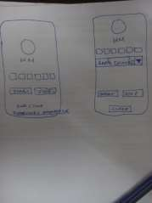

Rev 47(10 Mar 2025)
Time: 12.30 pm – 2.30 pm Attendees:
Ms. Mr. Fasil (Hundred Media team)
Mr.Siddharth Bhosle(CTO), Ms.Sonam, Ms. Teena VI (C3P Team)

Agenda:
  - Cheque Printing
  - Door Access/Biometric System
  - HR SOP
Discussion Points:
- Cheque Printing:

  - The cheque printing feature is almost complete, but the cheque size is varying.
  - The printing needs to be dynamic, so settings are required. Currently working on this.
  - HM will print a cheque and share a picture with us for review.

- Door Access/Biometric System:

  - Two possibilities for attendance were discussed: onsite attendance and a biometric system.
  - It was decided to move forward with onsite attendance tracking for employees.
  - For office staff, attendance tracking will be enabled by installing a separate door access system, capturing only the first entry and last exit.
  - HM needs to automate the process of integrating the door access report with the ERP.
  - Sidhardh Sir will review the Door Access Application (Data Sheet/Specification) tomorrow (11/03/2025) and finalize the attendance process afterward.

- HR SOP:

  - HM reviewed the existing HR module, discussed its features, and compared it with the new forms.
Points Noted:

- Data Backup Option:
  - Access will be granted to the Senior Accountant or personnel from the Finance Department.
- Onsite Attendance System:
  - Sidhardh Sir explained the workings of the onsite attendance system to HM.
- HR Module:
  - The development of the HR module needs to start soon.
- Employee List & Policies:
  - HM agreed to provide the employee list, including overtime details and leave cover policies.
- Salary Generation, Review, and Approval:
  - After generating the monthly salary, it should be reviewed and approved:
  - Review Process: Finance will review the salary but are not permitted to edit. They can add a note and mark it as "Reviewed."
  - Approval Process: During approval, select employees, add a single note, and mark as "Approved."

- Asset Tracking:
  - All assets (e.g., mouse, laptop, desktop) with serial numbers need to be added to the Asset Form.
  - HM agreed to start with minimal requirements, adding complexity later as needed.
Next Steps:
- Follow up on the cheque printing settings.
- Review the Door Access Application and finalize the attendance process on 11/03/2025.
- Start working on HM onsite attendance.
- Initiate the HR module development.
- Obtain employee list and policies from HM.
- HM agreed to provide the Data sheet or specification of the existing Door Access System.

Rev 48(11 Mar 2025)
Time: 9.30 am – 11.00 am Attendees:
Ms. Mr. Fasil (Hundred Media team)
Mr.Siddharth Bhosle(CTO), Ms.Sonam, Ms. Teena VI (C3P Team)

Agenda:
- Cheque Printing Review
- Operation Module Discussion
- Biometric Specification Check

Discussion Points
- Cheque Printing Review
  - HM suggested removing the Cheque Number field. However, it will be retained for tracking purposes.
- Operation Module Discussion
  - The checklist will be different for the Production and Project modules.
  - Different departments under Production (e.g., Carpentry, Electrical) will update their status to the Production Manager, who will then update the checklist.
  - The Project Manager will update the Project Checklist.
  - BOQ items will be listed as sub-titles under Cost Estimation.
  - When creating a cost estimation, users will add products, and the stock availability should be displayed for reference.
  - The Production Department will submit a Material Requisition Form to the Storekeeper, who will generate a report of all required products for the project.
  - The Storekeeper will issue available products through a Material Issue Form.
  - The Storekeeper will select unavailable products (with the option to add other products irrespective of the project) and create a purchase request for purchase. In the purchase request, the storekeeper can order more products than the project's immediate requirement.
  - Stock will decrease upon submitting the Material Issue Form, and the Operations Manager
must approve the stock reduction.
  - When products are returned, the Storekeeper must approve the return, and stock will increase accordingly.
- Biometric Specification Check

  - Verification is done, but more software installation is required to check the db. So once the software is installed, HM will inform us. Then, C3P will continue the data collection process.

Findings and Agreements

- The HM team acknowledged and agreed that these changes are causing an extension of our schedules.
- The HM team also acknowledged and agreed that changes in workflow, such as BOQ and Cost Estimation, the connection between work order and BOQ, and the HR module, which was previously approved but is being revised again. Additional features like Cheque Printing and on-site attendance Tracking will cause delays in the overall process and development completion.
- C3P requires around 10 days to complete the Project Module, which will be completed by April 4th. The Production Module requires around 18 days to complete, and it will be completed by April 30th. We will work on the revised HR module in parallel, which will take around 4 weeks and will probably be completed by April 30th. The cost for the changes is approximately AED 13000, based on the hours spent on them.

Sl. No | Description | Qty | Price In AED | Amount In AED
1 | Changes in the Customized ERP Software  - Cheque printing and Attendance Tracking  - Revised HR module as per the new SOP  - Multiple Changes on BOQ + Cost Estimation
 |  | 1 | 3000
 |  |  | 5000  5000 | 13,000
CarryForward (Based on SRS Rev - 40) |  |  |  | 3000
Grand Total |  |  |  | 16,000
Discount |  |  |  | 16,000

- We will implement these changes at no additional charge, as per our previous agreement with Mr. Musammil. However, any further changes, re-work, or new feature implementations will be discussed and mutually agreed upon. After the discussion, we will track the cumulative hours and charge payment accordingly for the tasks.

Next Plan

- The Accounting Module discussion will be planned after receiving updates on Production.
- Operation Module development will continue.
- Onsite employee attendance tracking implementation will begin.

Rev 49(17 Mar 2025)
Time: 10.00 am – 11.45 am Attendees:
Ms. Mr. Fasil, Ms Rajinsha (Hundred Media team)
Mr.Siddharth Bhosle(CTO), Ms.Sonam, Ms. Teena VI (C3P Team)

As planned earlier, we conducted a meeting to discuss the following points:

- Software Installation - Attendance Automation
- Work Order
- HR Module

- Data Backup Automation Discussion Points
- Software Installation - Attendance Automation
  - HM was not able to install the attendance tracking software as per our requirement for attendance automation.
  - Sidharth Sir will try using their attendance software from our end and check by tomorrow.
- Work Order
  - The quantity and price are editable in the Work Order section.
  - BOQ and Work Order are common documents for all departments, but the cost sheet is a department-specific document.
  - They do not have any existing Job Order as of now but are planning to implement it.
  - HM agreed to provide a dummy work order document.
- HR Module
  - As discussed earlier, we will reuse existing features and add new ones as required.
- Data Backup Automation
  - Discussed the importance of taking backups from their side.
  - C3P confirmed the backup process across multiple servers from our side.
  - The admin can grant a person/department privileges to access the data backup.

Next Plan

- Software Installation: Sidharth Sir will connect with the HM team to install the software on March 18, 2025.
- HM has to provide a dummy work order document and BOQ-WOrkOrder-Cost Estimation of a single project to study the data flow.
- HR Module: Planning to start development by Wednesday, March 19, 2025.
- Module Progress: Share the module progress document in the group today (March 17, 2025).
- Attendance Tracking: HM plans to release the attendance tracking feature by March 20, 2025.

Rev 50(05 Apr 2025)
Time: 11.00 am – 11.20 am
Attendees: Ms Rajinsha (Hundred Media team), Ms.Reeba, Ms. Teena VI (C3P Team)

As planned, we conducted a meeting to update the status of HR forms and make sure the workflow is in the right direction and also for the requirement collection:

Feedback Points

- Interview Assessment form – EID is not mandatory. Add an option ‘Resident Visa Cancel’ in the ‘Visa status’ field and replace ‘EID expiry’ with ‘Visa Expiry’.
- HM confirmed that there would be slight changes in the offer letter according to the designation. So, C3P has to modify the offer letter accordingly, and HM will provide the details
- As a part of requirement collection, C3P discussed the leave application form. The production team has no direct access to ERP, so after discussion, they will let us know their plan.
- ​

Next Plan

  - Update the feedback points on 05/04/225
  - The delay in providing the requested document (dated 18/03/2025) is impacting our production and project module development. As a result, the release date, initially set for April 30, 2025, will be extended according to the availability of the document. Currently, there has been a delay of 3 weeks, and the delivery date may be pushed to the end of May.
  - HM will provide the documents which is listed below soon

Awaiting Response(new)
    - Offer letter templates for different positions
    - Confirmation for the leave form for the production team.

Awaiting Documents(old)
- Checklist for production and project
- Work Order

Rev 51(22 Apr 2025)
Time: 11.00 am – 12.30 pm
Attendees: Ms Rajansha, Mr. Fasil (Hundred Media team), Ms. Teena VI (C3P Team)

A meeting was scheduled without prior notice to present the Leave Records and gather feedback. Before the Leave Records demo, Fasil Sir requested a complete walkthrough of the HR Module.

Forms Presented:
- Work Requisition Form
- Interview Assessment Form
- Asset Request Form
- Employee Checklist Form
Feedback Points:

Work Requisition Form
- Add fields for:
- Roles and Responsibilities
- Budgeted Salary
- ​
Shortlisted CVs Form (New Form to be Created)
- Fields to include:
- WFR ID
- Resume Upload/Link

Interview Assessment Form
- Add a dropdown to select the Code for Shortlisted CV
- Approvals Required: HR, HOD, and CEO

Offer Letter Form
- Make the form dynamic
- Include the Salary Structure for each employee in the offer letter
- ​
Joining Application Form
- Remove the bottom section of the page
- Reduce the text size

Updated Workflow for Selection Process:
  - Once an employee is selected:
  - Offer Letter and Joining Application will be sent via email
  - Upon receiving the filled Joining Application, the Employee Profile will be created
  - Signed copies of the Offer Letter and Joining Application will be stored in the employee's profile

Asset Request Form
- An approval signature is required

Employee Checklist Form
- Signature not required
- No print required

Leave Application Form
- CEO approval not required
- No print required

Additional Discussion:

- HM discussed the importance of completing Biometric Attendance Integration and emphasized that C3P should prioritize this task.C3P recommended that HM contact the biometric vendor for integration with MySQL.

- HM is planning to go live in August.
- We require around another 3 days to integrate these additional features. After completing the remaining forms, C3P will work on the feedback points.

Next Plan

Planning for a meeting with HM on April 24th regarding the Work Order Form in production.

Rev 52(24 Apr 2025)
Time: 9.30 am – 11.30 pm
Attendees: Mr John, Mr. Fasil (Hundred Media team),
Mr.Siddharth Bhosle(CTO), Ms.Sonam, Ms. Reeba , Ms. Teena VI (C3P Team)

Agenda Items:
- Biometric
- Cheque Printing
- Work Order

- Biometric
  - C3P recommended using Hikvision support for biometric integration to prevent data loss. Even if something happened, they can recover.
- Cheque Printing
  - Sidhardh Sir will review the printer model and configuration.
  - Further steps will be determined after his review.

- Work Order
  - HM shared a sample Work Order.
  - The Work Order will include BOQ (Bill of Quantities) titles, along with budgeted prices.
  - The entire Work Order will be visible to all departments, but only the concerned department can edit it (adding remarks and entering prices).
  - If the entered price exceeds the allocated budget, a confirmation pop-up will appear before submission:
"Do you really want to submit as it is out of budget?"
- This allows the concerned person to consult and confirm before final submission.
  - Once submitted, the Work Order will be loaded into the Cost Estimation system.
  - In Cost Estimation, the concerned department can still view and revise the price if needed.
  - In Cost Estimation, the Project Executive can set deadlines and mark the % of progress.

Summary Points:
- A Work Order is essentially a copy of the Cost Estimation.
- Work Order = BOQ with editable fields and cost per item.
- After submitting the Work Order, it appears in Cost Estimation, where it can be modified and approved.
- In Cost Estimation:
  - The Project Executive can set deadlines and update the progress percentage.
- Of the total budget:
  - 50% is allocated to procurement.
  - Of this 50%:
    - 70% goes to production.
    - The remaining 30% is shared among other departments.
- The BOQ:
  - Includes price for the Accounts team.
  - Excludes price for the Production team.
- BOQ is used in three modules:
  - Estimation, Quotation, and Work Order.
- Estimation is used in:
  - Pre-Quotation, Work Order, and Detailed Cost Estimation.
- There are two types of Cost Estimation:
  - BOQ Cost Estimation
  - Production Cost Estimation
  - After BOQ approval by the customer, before assigning a work order, the finance/accounts executive will assign a budget for production and overheads as a %age of the total BOQ cost estimation.
Next Plan
1. Planning for a Sales Training on 25th April.

Rev 53(25 Apr 2025)
Time: 10.30 am – 2.15 pm
Attendees: Sales Team,Mr. Fasil, Mr.Suraj (Hundred Media team), Mr.Suraj , Ms. Teena VI (C3P Team)
- Enquiry Creation
  - All fields from the Excel/Prospective page (e.g., Exhibition Name, Stand Name, Country Name, Location, etc.) should auto-fill in the Enquiry Page when a prospect is selected.
  - Change label: "Project Location / Venue" → "Venue"
  - Add the following new fields:

    - Country
    - Remark 2
    - 4 Image Upload Options
  - Project Name and Stand Name should be identical (auto-filled from Excel).
  - Remove mandatory restriction from fields.
  - Add a new dropdown: "Design Provided" (Yes/No)
    - If Yes: Design is provided by the client → Enquiry directly sent to Estimator
    - If No: Enquiry assigned to Designer for processing
    - Upload field based on the selection:
      - If Yes: Upload for client-provided image
      - If No: Upload for sales team's reference image
  - Ensure the reference image (uploaded by Sales/Client) is visible to Designers based on the
Brief Link.

- Enquiry List
  - Display Stand Name and Exhibition Name instead of Client Name.

- Enquiry Edit
  - Refer to the Designer Schedule document (provided by HM) to identify designer availability (free or busy).
- Brief Link
  - URL Format: ExhibitionName/HundredMedia
  - The Brief Link form should be editable by both the Customer and HM.
  - Add Platform Height field with options:
- No Platform, 5 cm, 10 cm, Above 10 cm
- Add the Remark field on the right-hand side
  - Add the Remark field next to Logo Type. If "Other" is selected, the user must specify.
  - Under Basic Information, add the field Height with options:
- 2.5, 3, 4, Above 4
- Add the Remark field
  - Change label: "Graphics" → "Signage & Graphics"
  - Move Logo under Signage & Graphics
  - Move the TV Screen under Audio Visuals
  - After the TV Screen, add:
- Field: TV LED Wall with options T1, T2, T3
- Remark field
  - Add new section: Furniture & Planters
1. HM will provide structure (Dropdown: Yes/No + Remark)
  - Add:
- Catalog Image Link
- Textarea: Catalog Details

- Access Control & Permissions
  - Restrict Listing Pages (Enquiry/Quotation/Prospective List):
- Salespersons see only their records
- Open access for Accounts, Estimator, and Designer
  - Ensure Brief Link is viewable by:
- Designer, Enquiry Team, Client, Estimator
- Confirm Designer has access (not yet available—check needed)

- Design Upload Listing

  - Change label: "Design Required By" → "Design Deadline"
  - Add Brief Link field.
  - If the design is not completed by the deadline, the designer should receive an alert from the Salesperson.
  - Add Revision Tracking:
1. Include: Start Date, Deadline
- Multiple submissions (15–20 designs) before final approval possible
- Design Approval Section
  - Along with View Document button, display uploaded image inline.
  - Add approval tracking:
- Approval by Sales Team
- Approval by Client
(Currently only one approval tracked — update required)

- BOQ (Bill of Quantities)
  - Once the design is approved, it should be forwarded to Estimator.
  - Provide a view option for Estimators to see all Client-Approved Enquiries.

- Side Menu
  - Reorder Side Menu:
- Place Client Quote Accept after Quotation

- Quotation Listing Page
  - Add option to "Send Quotation Print to Customer" under Action column (next to Delete button).

- Quotation Edit
  - Add option to attach the signed quotation.
  - Give Accounts Team access to print the signed quotation.

- Client Quote Accept
  - Change label: "Remark for Approval" → "Remark"
  - Add Status Options:
- Accept, Reject, Revise
  - If Revise is selected → Allow editing of the quotation.
  - Once approved by the client:
- Accounts Team receives an intimation to generate the invoice.

- Accounts Team
  - After invoice is generated by Accounts → Sales Team should follow up.
  - Add provision for Multiple Invoices, including:
- "Additional Invoice" (Details to be provided by HM)

Next Plan

C3P is planning the next steps based on the following points:

- HM is required to provide the updated CSV file for prospect import.
- HM is required to share the latest production checklist.

HM needs to update the HR Module with department details, employee-wise information, designations, and approval setup.

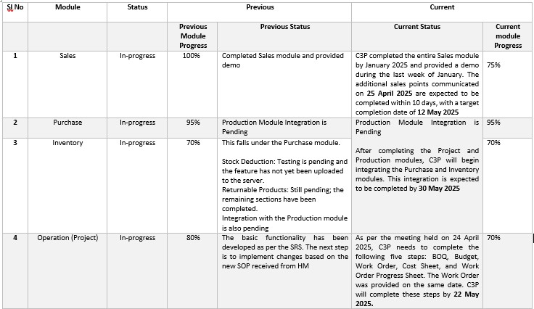

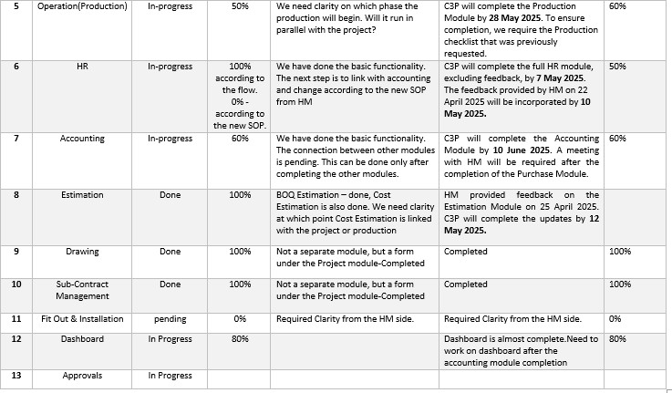

Rev 54(15 May 2025)

Time: 11 am – 11.45 am

Attendees: Ms. Mr.Fasil (Hundred Media)
Sonam Phade,Reeba Mathew (C3P)

C3P have conducted the demo for the Accounting Module, and the following feedback was received:

- They do not want each employee to be created as a separate ledger.
- The HM can handle the creation of groupings and subgroupings in the chart of accounts.
- The term "Payable Salary" should be renamed to "Salary Payments".

HM is required to provide the following formats/reports for implementation:

- Balance Sheet
- Profit and Loss Statement
- Trial Balance
- Annual Report
- Cash Flow Format
- Monthly Sales Report
- Dashboard requirements for accounts

Time: 12.30 – 2.15 pm

Attendees: Ms. Rajansha, Mr.Fasil (Hundred Media) Teena VI (C3P)
- HR Demo Overview
  - The scheduled HR demo took place as planned.
  - HM reviewed all forms except the payroll system.
    - Pending Forms : Leave Form, Compensatory Form, Monthly Salary, Holiday Master, etc.
- Corporate File
  - Implement a notification system and dashboard alert when a corporate file is nearing its expiry date to ensure timely renewal or action.
- Sub Menu
  - Rearrangement of the sub-menu is required.
  - Note: HM will provide a document specifying the new names and desired order.
- Employment Application Form

  - Changes Required:
- Remove the signature field from both the printable and web versions.
- The form link should be accessible via the HM website for external job seekers.
- Offer Letter
  - Workflow Update:
1. Previously: Profile creation → Offer letter
Now: Signed Offer Letter & Joining Application Form → Then create Employee Profile
  - Additional Fields Needed:
    - Department Name
    - Reporting Person
    - Office Location
    - Incentive details (should display if available)
- Joining Application
  - Changes Required:
- Provide a separate link for new employees to fill in their details before joining.
  - These details will be used to create the employee profile.
- Remove HR signature field from the form.
- Employee Profile
  - Enhancement: Auto-fill employee profile fields based on the submitted joining application data.
- Vehicle Handover
  - Change Required: Display the full user list in the Driver Name dropdown field.
- Final Settlement
  - HM agreed to share their current format. Further development will proceed based on that document.

Next Plan

HM is required to share the following documents and complete the corresponding actions.

  - Sample copy of Balance Sheet
  - Profit and Loss Statement
  - Trial Balance
  - Cash Flow Format
  - Annual Report
  - Additional Invoice Format (please provide a clear reference)
  - Monthly Sales Report (including the columns and filters you require)
  - Outstanding Report
  - Complete documents related to each project (minimum 2 projects)

  - Full details for at least two projects for in-depth review
  - Dashboard sketches or requirements for each department
  - Update Supplier List, Customer List, and Employee List
  - Names and positions of the side menus in the HR Module (please provide as a document)
  - Production Checklist
  - Reports prepared by the estimator for ERP reference (We would prefer if the details of reports could be shared in the WhatsApp group or through a meeting, as it allows for quicker communication and saves time.)
  - Kindly ensure that each employee’s details—such as department and designation—are accurate
  - Please provide user access details for each employee, along with the approval setup for each form under User Access Control and Approval Setup in the HR module (If you need any assistance or would prefer a meeting to discuss this, please feel free to reach out — we’ll be happy to support you.)
  - Kindly inform the availability of HR for the payroll demo.
  - Provide the preferred email subject line and body content for the automated quotation email functionality.

Kindly share the above at the earliest, as timely submission is crucial for us to proceed with internal testing and ensure smooth module completion. Any delay in receiving these inputs may affect the overall timeline

REV 55( 15 May 2025) Thursday
Attendees: Rahul, Business Development Manager, C3P
Purpose: Testing of Sales Module

Rahul conducted a test of the sales module in collaboration with the team at Hundred Media. Noted Issues:
1.Incorrect Total Amount Calculation during Quotation Creation 2.Unnecessary Preview Section Appears When No Image is Uploaded
When creating a quotation without uploading an image, an empty preview layout box still appears. This is not needed and should be hidden. The preview section should only be displayed if an image is uploaded.
3. Alignment Issue in Quotation Print View
– The printed version of the quotation has alignment issues. Content is not properly structured or spaced, affecting the readability and professional appearance of the document. (Correct print format is needed from the client to ensure proper alignment.)
Next Plan:
Rahul is scheduled to visit on Thursday (29-05-2025) to present a demo of the Project and HR modules.

REV 56 31 May 2025 Friday
Attendees: : Ms. Rajansha, Mr.Fasil, Project Team, Production Manager (Hundred Media)
Rahul, Sneha (C3P)
Time: 10.00 AM – 5.00 PM
Purpose: Presentation of HR ,Project Module Feedback Points HR Module
- Menu Arrangement General:
->Corporate Files
->Vehicle Details

- Payroll:
->Basic Salary
->Employee Overtime (Employee Attendence (From Biometric)
-> Paid Leave
->Monthly Salary (Master file---list only)
- Onboarding:
->Workforce Requisition
->Interview Assessment
->Employment Application
->Offer Letter
- Employee Details:
->User/Employee
->Joining record (Not needed.)
->Asset Handover Form
->CheckList
->Vehicle Handover
->Leave Records
->Employee Request
->Performance Review
- Off Boarding:
->Termination/Resignation
->Clearance Form
->Passport Release
  - Make dashboard icons responsive
  - Basic Salary- Add Pension as an option in the Allowance Type dropdown --Setup→Allowance& Deduction-> Pension( Added)
  - Show Combo Off in monthly salary (Employee Corner->Employee request->Apply for combo Off—Then it reflects on Monthly salary)
  - HR Approval—Rajansha Raju (In Rajansha’s absence, Fasil will provide approval) (To be Default)
  - CEO Approval-Musammil ) -- (To be Default)
Purchase Module

  - Make dashboard icons responsive
  - Hide all miscellaneous fields from Purchase Order
  - Purchase Order print format
When creating a new purchase order, the serial number is not displaying

Corrections requested | Completed | Working on | New requirements | Waiting for input | Clarification required | Repeated requests
9 | 9 | 0 | 0 | 0 | 0 | 0

REV 57 04 June 2025 Wednesday
Attendees: Rahul , Sneha (C3P), Fasil, Production team(Hundred Media)
Time: 3.00 PM- 5.30 PM
Purpose: Presentation of Production Module
Feedback Points of Production Module
- Outsource Processing-> Rename material name to Scope of work
- Rename Product checklist details to Production Checklist Details
- Production checklist – show all BOQ items and option to add extra item (Documents needed)

Corrections requested | Completed | Working on | New requirements | Waiting for input | Clarification required | Repeated requests
12 | 11 | 0 | 1 | 1 | 0 | 0

REV 58 21 June 2025 Saturday
Attendees: Harsha, Sneha. Sonam conducted accounting module demo, Fasil, Rajansha, Faiz (Hundred Media)
Time: 10.00 AM-3.00 PM

Accounting Module Requirements
The Accounts team needs an option to add both customers and suppliers.
- In the General Ledger form, provide an option to add sub-groups.
- Edit and Delete options should be accessible only to the Accounts Manager.
- Add a gap between the Print and Delete buttons across all forms.
- In the Profit and Loss report - color change is needed
- After creating a GRN, there should be an option to upload the invoice and send it for approval by Accounts.
- In the Journal Entry form, add an option for LPO selection.
- Payment Entry should be linked to cheque printing.
- In the Payment Entry print, display the Cheque Date and Cheque Number.
Project Payment Approval should support multi-level approval:
  - First by Production Manager
  - Then by Finance Manager
  - If the amount exceeds a specific limit, final approval by the CEO is required.
- In Project → Payment Request, add a Priority field.
- Based on the selected priority, highlight the request with corresponding colors in the Payment Approval screen.
- A tracking option is required for Post-Dated Cheques (PDCs).
- Report – Individual Ledger Details – Add Balance Column

Sales Perspective:

- Mandatory fields to be highlighted in red so sales can easily identify which fields need to be filled.
- The design upload feature in the enquiry section should allow multiple file uploads.
- Rename "Prospective" to "Prospects"
- In the Sales Dashboard, display interested prospects along with their Contact Number and Email ID.
- Make dashboard compatible with tablet (This will do after the completion of dashboard)

BOQ Estimation Section:
  - BOQ Print : Units (e.g., cm, LS, RM, etc.) should be displayed either in all uppercase or all lowercase.
  - Provide option for choosing multiple currency (USD, etc)
  - Add Redo and Undo buttons Not Practical in web format( Edit and delete options also provided)
  - BOQ is reviewed by the Operations Director and Sales Director

Project
After project creation, currently there are 2 levels of approval. Require only one approval – (By Operations Director - Shanavas)

Production
In the Production Dashboard, provide visibility into the expected sales closures along with their expected closure dates.(Based on approved Quotation)
This will help the Production team plan resources based on upcoming confirmed orders.
HR

- Workforce Requisition – Provide this form to all HODs (employee corner)
When HOD submit workforce requisition, hr can see requested by that HOD’s name instead of all employee name.

- HR Dashboard – Show all requests like leave, workforce requisition submitted by HODs ,etc
- Currently, both active and inactive employees are displayed together in the Employee/User List. Add a separate section or filter to view active and inactive employees independently.
- Add penalty in deduction type- Done

Next Plan

- C3P will complete Accounting Module changes on 09th July 2025
- C3P will complete Sales Module changes on 26th June 2025
- C3P will complete BOQ changes on 28th June 2025
- C3P will complete Project changes on 28th June 2025
- C3P will complete HR changes on 02 July 2025

- C3P will complete dashboard in the following dates:
Dashboards

1. Sales Dashboard | - 08/07/2026
2. Estimator Dashboard | - 08/07/2026
3. Designer Dashboard | - 28/06/2025
4. Purchase Dashboard | - 03/07/2025
5. Project Dashboard | - 07/07/2025
6. Production Dashboard | - 02/07/2025
7. Accounts Dashboard | - 09/07/2025
8. HR Dashboard | - 03/07/2025
9. Finance & HR Manager | Dashboard -15/07/2025
10. CEO Dashboard -21/07/2025

- HM is required to share the following documents:
  - Trial balance copy
  - One month’s salary slip
  - Production Checklist
  - Item details with price
  - Report from Estimator
  - Annual Report
Module | Corrections requested | Completed | Working on | New requirements | Waiting for input | Clarification required | Repeated requests
Sales | 9 | 7 | 0 | 1 | 0 | 0 | 0
Project | 1 | 1 | 0 | 0 | 0 | 0 | 0
Production | 1 | 1 | 0 | 0 | 0 | 0 | 0
HR | 4 | 4 | 0 | 0 | 0 | 0 | 0
Accounting | 14 | 14 | 0 | 0 | 0 | 0 | 0
Total | 41 | 39 |  | 2

REV 59 02 July 2025 Wednesday

C3P Completed the following points:

Sales Perspective
- Mandatory fields are now highlighted in red outer
- The design upload feature in the enquiry section should allow multiple file uploads – Already available
- "Prospective" renamed to "Prospects".
- Sales Dashboard now displays interested prospects with Contact Number and Email ID.

BOQ Estimation Section
- BOQ print format: Units (cm, LS, RM, etc.) now appear consistently in lowercase.
- Multiple currency option (e.g., USD) is now available.
- BOQ approval flow involving Operations Director and Sales Director has been implemented.
Project
- Project approval workflow updated to require only one approval – by Operations Director (Shanavas).
Production
- Production dashboard – Displays Total Upcoming Orders (based on approved quotations) to assist in production planning.
HR
- Workforce Requisition form: The "Requested By" field is defaulted to the HOD’s name automatically when the form is submitted (instead of listing all employees).
- Employee/User List now includes a filter to view active and inactive employees separately.
Dashboard
1. Designer dashboard
2. Production dashboard
3. Project Dashboard
4. Estimator Dashboard
5. HR Dashboard
6. Purchase Dashboard

Next Plan
- C3P will complete Accounting Module changes on 09th July 2025

C3P will complete dashboard in the following dates:
1.Sales Dashboard - 08/07/2025
2. Accounts Dashboard - 17/07/2025
3. Finance & HR Manager Dashboard - 15/07/2025
4. CEO Dashboard - 11/07/2025
5.Sales Head Dashboard -14/07/25

REV 60 03 July 2025 Thursday

Attendees: Sneha, Jyothish (C3P), Fasil, Rajansha, Nephin Antony, Faiz( Hundred Media)
Time : 10.00 AM – 2.00 PM

- Discussed HR module modifications
- Discussed dashboard changes (Sales, Designer, Production, Project)
- Checked cheque printing issue (Alignment issue to be fixed)
- Checked Biometric configuration
- Checked payroll calculation
- Support Project manager for testing

Project Module changes:

  - Payment request- Add new column – Quantity
  - Project Checklist (Check dropdown need to show in diff color)
  - Project Checklist – provide option for add additional document
  - Project Cost Sheet – Provide option for adding extra item in each section like carpentry, paint etc under material cost
  - Project Cost Sheet –Provide option for adding category under Sub contract cost
  - Project Cost Sheet –In salary category under Labor cost/ man power the dropdown needs to show Painters, Electrician, Carpenters, Helpers
  - Add uploading file option in mock-up form
  - Modify Handover print – Include comment section and sign option

Sales:

- Enquiry: Show Next Available slot in Check designer availability table
- Sales Daily Report : Add new report

Date | Show | No.of Interested Calls | No.of Local calls | No,. Of answer | No.of Email | No.of Enquiries | Total Signed
25-Jun-25 | Beauty World | 10 | 50 | 45 | 19 | 5 | 0

Production dashboard:

- Show Total upcoming order as first
- Show project wise budget in Operation Director’s (Shanavas) dashboard

HR:

- Payroll Calculation issue

HM is required to share the following documents:

- Production Checklist
- Item details with price
- Report from Estimator
- Annual Report

Corrections requested | Completed | Working on | New requirements | Waiting for input | Clarification required | Repeated requests
53 | 51 | 0 | 11 | 0 | 0 | 0

Next Plan
- C3P will complete Project Module Points 12 July 2025
- C3P will complete Sales Module Points on 17 July 2025
- C3P will do cheque print issue on 11 July 2025

C3P will complete dashboard in the following dates:

1.Sales Dashboard - 11/07/2025
2. Accounts Dashboard - 17/07/2025
3. Finance & HR Manager Dashboard - 15/07/2025
4. CEO Dashboard - 11/07/2025
5.Sales Head Dashboard -14/07/25

REV 61 10 July 2025 Thursday

Attendees: Jyothish , Sneha(C3P), Fasil, Rajansha, John, Anwar,Mohammad Fayas, Faiz( Hundred Media)
Time : 10.00 AM – 4.00 PM

• The C3P team presented demos of the Estimator, Designer, and Production dashboards to the respective team members. They expressed satisfaction with the demos.
• The C3P team presented the requested changes for the Sales and Estimation sections to John.
• Supported Rajansha in testing the onboarding and offboarding processes.
• Provided support for biometric configuration.

Feedback Points:
HR
1.Joining Application Form: Remove the ‘Filled by HR’ section and implement validation across the form.
2. Interview Assessment: Display the notice period as a dropdown selection
3. Resignation Form: Provide a row-wise delete option in the upload section.
4. Resignation Form: Add a ‘Not Approved’ option alongside the existing ‘Approved’ option, and include a remark
field.
5.Linking Resignation Form to Clearance Form:
  - After resignation approval, provide a link to the Clearance Form from the Resignation List.
  - Add an approval process for the Clearance Form.
6.Training & Development: To be considered for future implementation.
BOQ
7.Instead of undo-redo, give a warning popup option when deleting sales order line

Corrections requested | Completed | Working on | New requirements | Waiting for input | Clarification required | Repeated requests
60 | 57 | 0 | 12 | 1 | 0 | 0

Next Plan
- C3P will complete HR module points(except training and development ) on 21 July 2025
REV 62 15 July 2025 Tuesday

Attendees: Sonam, Jyothish , Sneha(C3P), Faiz (Hundred Media)
Time : 12.30 PM– 1.15 PM

C3P conducted online accounting meeting and presented accounting dashboard.

REV 63 21 July 2025 Monday

Attendees : Jyothish, Sneha (C3P), Fahim, Suraj, John, Faiz

Time: 10.00 AM- 5.00PM

HM conducted user level testing of sales module with the presence of C3P team

Requirements:

1. BOQ Estimation- Requires access to view the uploaded design.
2. Enquiry : If the client has provided the design, designer allocation should not be displayed.
3.Quotation: Based on the categories of Hundred Media (Exhibition, Events, Sign & Graphics, Kiosks,
Interiors), different notes such as exclusions, cancellation policies, and storage details need to be shown.

- Quotation : If VAT is not selected in the quote, it should not be displayed in the print version either.
- The proforma invoice should be generated according to the agreed payment terms.

Corrections requested | Completed | Working on | New requirements | Waiting for input | Clarification required | Repeated requests
65 | 62 | 0 | 14 | 0 | 1 | 1

REV 64 26 July 2025 Saturday

Attendees : Sneha (C3P), Rajansha, Shabanas, Ashaar

Time :10.00 AM -10.45 AM, 3.00 PM-4.00PM

Meeting Summary:
- Presented HM Module feedback changes to Ms. Rajansha
- Conducted testing of the Monthly Salary module; identified some calculation issues — C3P will resolve the issue
- Conducted a demo of the Project and Production modules
- Collected the Production Checklist

REV 65 22 August 2025 Friday

C3P Completed the following points:

- Payroll issue has been fixed, tested, and verified with actual data
- Production checklist completed.
- Finance & HR dashboard

Pending Points:

- Payment terms need to be added to all forms in the Purchase module.
- Accounting module changes
- Accounting dashboard

REV 66 28 August 2025 Thursday

Attendees : Mr. Joby Vargheese, Mr. Jyothish (C3P), Mr.Fasil (Hundred Media)

Time: 5.30 PM -9.00 PM

Review Meeting conducted.

1. Dashboard – Optimization and Design modification. (Instead of a summary box, use a round shape design (to match
with HM logo).
2. Prospect Form – Add an option to choose a company (for printing view only).
3. Quotation Print
- Provide a version without price (similar to BOQ).
- When an image is uploaded during quotation creation, display the image instead of the text section (Dear… ……… Thanks & Regards).
- Adjust the header alignment. Currently all other table contents are on diff page.so need to correct alignment
4. Rename Sales Report to Enquiry Report.
5. Project Checklist Report – Replace background color with font color.
6. Sales Dashboard – Format as per the provided sample.

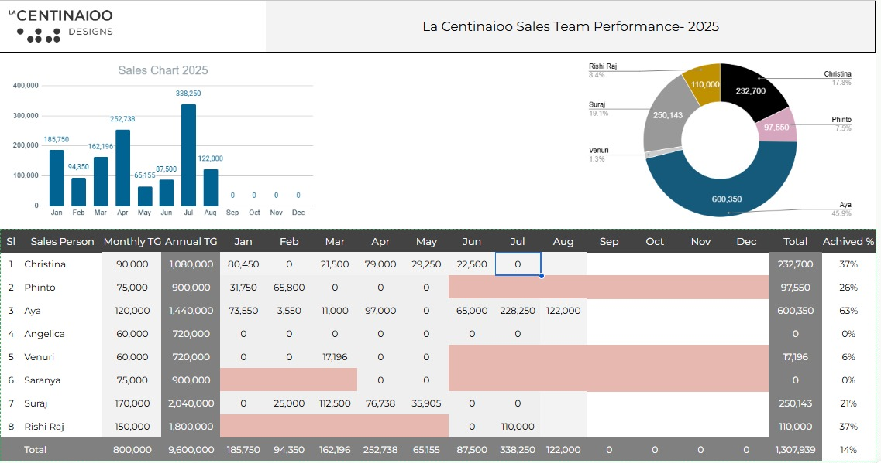

  - All Forms and Prints – General beautification and layout optimization.

  - Sales Report – Format as per the provided sample.

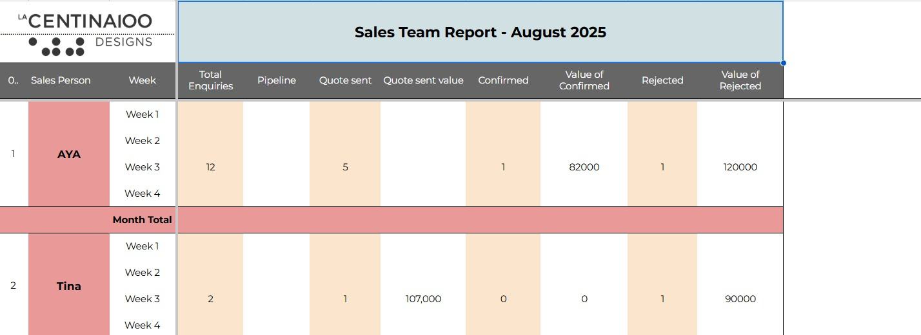

Corrections requested | Completed | Working on | New requirements | Waiting for input | Clarification required | Repeated requests
73 | 70 | 0 | 14 | 0 | 0 | 0

REV 67 01 September 2025 Monday

Attendees : Mr. Jyothish, Ms.Sneha (C3P), HM Team

Time: 11.00 AM 5.30 P.M

A meeting was conducted with all ERP users to demonstrate the overall functionalities and workflow of the system. The process
was tested up to the stage of quotation approval.

Feedback Points:
- In the BOQ, display the name of the salesperson.
- In the Brief Details section, resolve the navigation issue.
- In the Sales Dashboard, display the BOQ for quotation creation.
- For Design and Quotation Approval, only a single level of approval is required.
Corrections requested | Completed | Working on | New requirements | Waiting for input | Clarification required | Repeated requests
77 | 74 | 0 | 14 | 0 | 0 | 0

REV 68 06 September 2025 Saturday
Attendees : Mr. Jyothish, Ms.Sneha (C3P), Mr. Fasil (HM)

Time: 4.00 PM- 5.00 PM

An online meeting was conducted to present all completed points, during which Fasil Sir provided some content changes and feedback
on the prints.

REV 69 13 September 2025 Saturday
Attendees : Ms.Sneha , Ms.Manju(C3P), Mr. Fasil (HM)
Time :3.00 PM- 4.30 PM

Conducted the review meeting and completed testing up to the Project–Work Order stage.

- The ERP workflow was verified and confirmed to be functioning properly.

- We presented the completed Phase 1 points (Rev 66 & 67) , along with the Phase 2 Sales Report (both individual and Sales Head reports) and the Sales Head dashboard.

- The summary box in the Sales Dashboard was modified to a round shape, which was reviewed and approved.

- Print alignments were verified and found to be satisfactory.

Next Action Points:

- Update all dashboards to use round-shaped summary boxes.

- Apply modifications to the Sales Report.

- Implement project tracking based on the checklist.

- Provide report access for designers (new requirement).

- In the Project Dashboard, display the confirmed projects list along with a BOQ viewing option (new requirement).

- In the Sales Dashboard, show total sales, targets, and achieved sales (new requirement).

Corrections requested | Completed | Working on | New requirements | Waiting for input | Clarification required | Repeated requests
83 | 80 | 0 | 17 | 0 | 0 | 0

Note:
Fasil Sir needs to test the entire workflow with actual data. Kindly inform once the testing is completed.

REV 70 19 September 2025 Friday
Attendees : Ms.Sneha , Mr.Jyothish, Mr. Fasil (HM)
Time :4.30 PM – 5.15 PM

Presented Updates
1. Dashboard Modifications
- Reviewed all recent changes made to the dashboards.
- Included layout adjustments and updates to the summary boxes.
2. Designer Report
- Demonstrated the Designer Report functionality.
- Included options for printing and exporting to Excel.
3. Sales Report Changes
- Showed updates in the individual and Sales Head reports.
- Incorporated modifications suggested during the previous review.
4. Project Dashboard
- Displayed the confirmed project list.
- Provided the BOQ viewing option for improved project tracking.
5. Project Progress Tracking
- Reviewed project tracking based on checklist items.
- Ensured effective monitoring of project progress.

Feedback and Next Steps

- Fasil Sir reviewed all the updates and was satisfied with the progress.
- He suggested some content changes in the dashboards for better clarity and presentation.
- Fasil Sir will begin testing the entire workflow with actual data on Sep 20
- We requested that feedback be provided after the testing is completed.
REV 71 24 September 2025 Wednesday
Attendees :Mr.Musammil, Mr.Jinshad , Mr. Fasil (HM), Mr.Jyothish, Ms.Sneha (C3P)
- Fixed cheque printing alignment issue.
- Conducted a review meeting for the sales module up to quotation creation.

REV 72 26 September 2025 Thursday

Attendees : Mr. Fasil (HM), Mr.Jyothish, Ms.Sneha (C3P)
Time :3.30 PM – 4.30 PM

Conducted an online review meeting of the project module and verified the dashboard and sales report changes.

REV 73 1 October 2025 Wednesday

Attendees :Mr.Musammil, Mr.Jinshad , Mr. Fasil (HM), Mr.Jyothish, Ms.Sneha (C3P)

Time :4.30 PM – 6.00 PM

Conducted a review meeting of project module

REV 74 2 October 2025 Thursday

Attendees : Mr. Fasil , Mr. Nephin, Mr. Ashhar , Mr. Shafeeq (HM), Mr.Jyothish, Ms.Sneha (C3P)

Time :3.00 PM – 5.00 PM

Conducted live testing of the Project, Production, and Purchase modules.

Feedback Points:

Split Project Progress and Production Progress separately.

Establish a connection between Work Order and Cost Estimation.

In Technical Drawings, display the uploaded design document.

Corrections requested | Completed | Working on | New requirements | Waiting for input | Clarification required | Repeated requests
86 | 83 | 0 | 19 | 0 | 0 | 0

REV 75 4 October 2025 Saturday

Attendees : Mr. Fasil (HM), Mr. Joby K Varghese, Mr.Jyothish Kumar, Ms. Sneha Kuriakose (C3P)

Time :3.00 PM – 5.00 PM

Conducted online meeting to confirm

1.Project and Production Progress

• Show Project Progress and Production Progress separately on the Project Dashboard.
• Project Progress Report is not required.
• Instead of checklists, create milestones with planned dates for tracking
project progress. (Some milestone dates will be defaulted automatically based on ERP completion data.)
• HM will provide the weightage for each item, and progress will be calculated accordingly.

2. Work Order Access for Purchase Team

No need to provide access to the Purchase team. For Graphics and Furniture, the item dropdown is
not required — only the description from the BOQ needs to be displayed.

3.Purchase RFQ Requirement

In the RFQ, add an option for item-wise supplier selection. (Need clarity)

Additional Points:

• Proforma Invoice – Variation Quotation
• Project Completion Report (HM will provide the sample format)

Corrections requested | Completed | Working on | New requirements | Waiting for input | Clarification required | Repeated requests
88 | 84 | 1 | 20 | 0 | 0 | 0

REV 76 06 October 2025 Monday

Attendees : Mr. Fasil , Mr. Faiz (HM), Ms. Sonam, Mr. Jyothish, Ms. Sneha
Time: 2.00 PM – 4.00 PM
A demo session of the Accounting Module was conducted, and the final changes on the dashboard were discussed.
Feedback points:
- Tax invoice print format - content and alignment to be revised. A sample format will be provided by HM.
- Tax invoice - Miscellaneous Amount – to be removed
- Tax Invoice Account Entry – needs to be read-only to prevent manual editing.
- Cash flow statement required
- Salary Payable – should appear on the Credit (CR) side in the Monthly Account Salary
- Account dashboard- Replace Project payment approval with Pending approval

Corrections requested | Completed | Working on | New requirements | Waiting for input | Clarification required | Repeated requests
94 | 89 | 2 | 20 | 0 | 0 | 0

REV 77 09 October 2025 Friday

Sl. No | Description | Qty | Price In AED | Amount In AED
1 | Changes in the Customized ERP Software  1.Project and production checklist  2. Project Progress
 |  | 1 | 2000
 |  |  |  | 2,000
Carry Forward (Based on SRS Rev - 48) |  |  |  | 16,000
Grand Total |  |  |  | 18,000
Discount |  |  |  | 18,000

REV 78 13 October 2025 Monday
Attendees : Ms.Rajansha (HM), Mr.Sidharth, Ms. Sonam, Mr.Suraj, Ms. Sneha, Mr.Jyothish
Time:11.00 AM- 12.00 PM
Conducted an online meeting to discuss and gain clarity on integrating the biometric system with the payroll.

HR mentioned the need for a mispunch option with the following workflow:
An employee submits a request → HR verifies it → HR either approves or rejects it.
If approved, the record is updated in the employee’s attendance.

Corrections requested | Completed | Working on | New requirements | Waiting for input | Clarification required | Repeated requests
95 | 90 | 2 | 21 | 0 | 0 | 0

REV 79 15 October 2025 Wednesday
Attendees : Mr. Fasil , Ms. Sonam, Ms. Sneha
Conducted an online meeting to discuss the cash flow statement.
1. A separate form needs to be created for entering the estimated budget.
- Extra Proforma – Instead of using quotation variation, a separate extra proforma needs to be created against the
same quotation at any stage of the project.
- Work Order – The item dropdown should display items based on the selected category.

REV 80 21 October 2025 Tuesday

Feedback changes:
1.Dashboard appearance – HM Team has provided the font style and color for Centina. We need to apply a
different color theme when logging in as Centina and Hundred Media. The following dashboards need
these changes: Sales Dashboard, Designer Dashboard, and Estimator Dashboard.
- Quotation: In bank dropdown need to show 2 bank details.
- Quotation terms, period, and payment terms should be set as default but editable if needed.
- Client Design Accept: The list page should display the Client Name.
- Client Brief Form: Remove the logo.
- Enquiry- Design Document Upload section need multiple upload options
- Sales Dashboard – Need Sales Report

Corrections requested | Completed | Working on | New requirements | Waiting for input | Clarification required | Repeated requests
102 | 97 | 2 | 21 | 0 | 0 | 0

REV 81 29 October 2025 Wednesday
Attendees : Mr. Fasil , Ms. Rajansha (HM), Ms. Sneha(C3P)
Time: 10.30 AM- 12.30 PM
Conducted live testing of the HR module, and the feedback points are as follows:
1. Dashboard Summary Boxes:
- Total Employees – show daily Present and Absent count
- Document Expiry – display both Corporate and Vehicle files expiring within one month
- Recruitment Status – include Workforce and Interview counts
- Visa Status
2. Birthday Reminder:
- Display birthday daily basis instead of monthly
3. Offer Letter:
- Salary Structure: When entering a monthly salary, the annual amount should auto-calculate
- Incentive Structure: Salary, Target = Salary × 30%, Incentive = 3%, Magical Figures
4. Payroll:
- In Employee Request, replace “Paid Leave” with Leave Salary and Ticket Allowance
5. Offboarding Process:
- Add an Exit Interview Form
6. Employee Master Report:
- Include Salary, Overtime
7.In leave application need to show total and remaining leave
- Purchase Requisition – IF Loggined person is HR, then no need to show project details.
9. CEO Dashboard:
Sales - Sales Value, Enquiries , Quotes, Pipeline
Finance- Proforma Invoices, Receivables, Payables,
Procurement & Store- PRF's, PO's, Inventory
Projects - projects started, Completed,
Production -Production started, Completed,
HR& Admin- HC, Attendance,
10.Finance & HR Dashboard
11.Department Head dashboard need to show leave request
12. Project Progress Report

Corrections requested | Completed | Pending | Working on | New requirements | Waiting for input | Clarification required | Repeated requests
112 | 110 | 2 | 0 |  | 1 | 1 | 0

REV 81 29 October 2025 Wednesday

Attendees : Mr. Fasil , Mr.Faiz, Ms. Rajansha (HM), Mr. Sidharth Mr.Jyothish, Mr. Akshay,
Ms. Sneha(C3P)
Time: 9.00 AM- 12.00 PM
Visit Summary

- Reconfigured the biometric system; reports are now generating correctly.
- Checked cheque printing; noted a minor alignment issue.
- Demonstrated updated Finance & HR dashboards, CEO Dashboard, and HR Dashboard changes
to Fasil sir.

Pending Documents:
Exit Interview Format
Overtime related excel sheet

REV 82 24 November 2025 Monday

Attendees : Mr. Fasil , Mr.John, Ms. Cristina, Ms. Aya (HM), Mr.Jyothish , Ms. Amisha(C3P)
The HM team demonstrated the Sales Module and shared the following feedback points :

1. BOQ Revision After Approvals
- HM team requested the ability to create BOQ revisions even after the approval process is completed.
- Current system restricts revisions post-approval; needs enhancement to allow controlled revision creation with proper tracking.

2. BOQ Add Page – Decimal Support
- Quantity field on BOQ Add Page should support decimal values.
- Similar decimal support is required on the BOQ Edit Page as well.
- This is required for accurate measurements and costing in sales estimation.

3. Client Approval Page – Document Not displayed
- Uploaded documents above 15MB are displayed in the Client Approval section.

Corrections requested | Completed | Pending | Working on | New requirements | Waiting for input | Clarification required | Repeated requests
115 | 111 | 3 | 2 |  | 1 | 1 | 0

REV 83 27 Nov 2025
Attendees : Mr. Fasil , Mr.Ashaar, Mr.Shabnas, Mr.Shafeeq (HM), Ms.Sneha, Ms.Amisha (C3P)
Time : 10.00 AM-12.30 PM

Conducted an online meeting and demonstrated the Project, Purchase, and Production modules. Initiated
live testing.
Feedback points are as follows:
  - The mockup date on the project creation form should be automatically updated once the mockup
is created.
  - In the Purchase Requisition list, the project name needs to be displayed.
  - Quote from supplier- an upload option is required.
  - Quote from supplier- the price should be defaulted from the item master
  - In the Production Dashboard, a progress report needs to be displayed.
  - In the Purchase Dashboard, the material request list needs to be displayed
  - The Project Dismantling option should appear as a menu under Project. Currently, it is displayed under the Handover list.
  - After project approval, any necessary updates should be allowed.
  - A dismantling schedule (including project details and assigned dismantling team) needs to be added in Project Work.
  - Implement same-tab navigation, so that links open in the same page instead of a new tab.
  - In the Progress Report, data should be displayed exhibition-wise on a monthly basis.
  - An Outsource Contract Agreement needs to be added.----(New requirement, Future enhancement)
  - Service Request (New Requirement)

Corrections requested | Completed | Pending | Working on | New requirements | Waiting for input | Clarification required | Repeated requests
128 | 126 | 2 | 0 | 2 | 1 | 0 | 0

REV 84 06 Dec 2025
Attendees : Mr. Fasil (HM), Ms.Sneha(C3P)
Time : 11.00 AM-11.45 AM

1. BOQ Variance Feature Requirement ( NEW Requirement)
In the BOQ section, a Variance option is required with Low and High dropdowns. The user manually enters the
variance amount and selects High, which adds it to the Total BOQ Amount; if Low is selected, it is deducted.

Requirements:
- Entered variance amounts must be displayed on the BOQ print with price.
- In the Quotation and Proforma, the final grand total should reflect the added or deducted variance.

Corrections requested | Completed | Pending | Working on | New requirements | Waiting for input | Clarification required | Repeated requests
129 | 128 | 1 | 0 | 2 | 1 | 0 | 0

Pending Points:
      - In the RFQ, add an option for item-wise supplier selection.
      - Exit Interview – Future enhancement
      - An Outsource Contract Agreement needs to be added - Future enhancement

REV 85 12 Dec 2025
Attendees : Mr. Jyotjish, Mr.Akshay, Ms.Amisha(C3P), HM team
Time : 9.00 AM-12.30 PM
During today’s visit, we met with the respective team members and collected the following
feedback and requirements:

1. Meeting with Cristina
• Clarified her doubts related to the Quotation flow.
• Feedback: In the Quotation list page, the Signed Document Upload section needs an
option to delete the uploaded document.
2. Meeting with John
• He shared several feedback points for the BOQ Estimation and dashboard.
• Dashboard Changes Requested:
• Remove Total Prospects and Approved Designs.
Show only: Approved Total,Total Enquiry, Pending BOQ
Estimation Requirement:
While entering item details in BOQ estimation, he wants a suggestion list dropdown. We
informed him that we will check the feasibility with the team.
3. Meeting with Fayas
Suggested updates in the Work Order.
Feedback Points:
• Work Order print is not showing item list and stand size.
In Project creation, separate fields are needed for:
• Stand Number
• Stand Size (Currently combined as stand number/size)
4. Meeting with Fahim
He shared multiple feedback points:
• Project Checklist Document: Sub-heading formatting needs better spacing/size.
• Quotation Page:
➢ If currency = USD, the Grand Total should be editable (not read-only).
➢ Quotation print should show Grand Total (Inclusive VAT) for USD selections.
• Dashboard Progress Bar: Issue showing 102% progress.
• Remove all test data from Work Order item description dropdown.
5. Meeting with Rizwan and Bhasim
They did not have any feedback now.
6. Meeting with HR -Rejinsha
They shared several points which need further discussion with Fasil Sir before final confirmation.
So we listed some points:
• In Employee Request, when selecting Comp Off, a field is needed to input leave date. (Compensatory allowance)
• In Purchase Request, the item dropdown should show only HR-related items, not the full
list.
• Salary slip list are currently showing empty.
• In Workforce Request, the Budget Salary field needs to be enlarged.
• Workforce requests are not appearing in Manager approval dashboard.
• In Joining Application, resigned employees should be removed from the dropdown.
• Reject remarks given in Employee Request are not showing in edit page.

Next Plan: C3P will complete the pending points by December 20.

Corrections requested | Completed | Pending | Working on | New requirements | Waiting for input | Clarification required | Repeated requests
144 | 139 | 5 | 0 | 0 | 0 | 0 | 0

Prepared By,
Reeba Mathew (Rev 01-03, 06-08)
Ashwin Padmanabhan T. (Rev 04-05, 09, 11, 12, 13, 14, 15, 16, 17, 18.19.20,21)
Jomy Mary George (Rev 10) Harsha(Rev 22-Rev36) Teena VI(Rev 37-55)
Sneha(Rev 56-84)
Amisha(Rev 85)

.
ANNEXURE
- Preferred Template Color
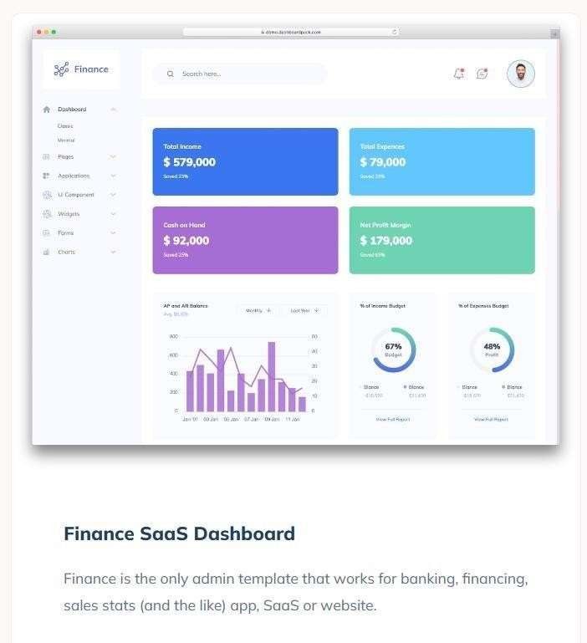

- Logo



- Background



Quotation:
Page1
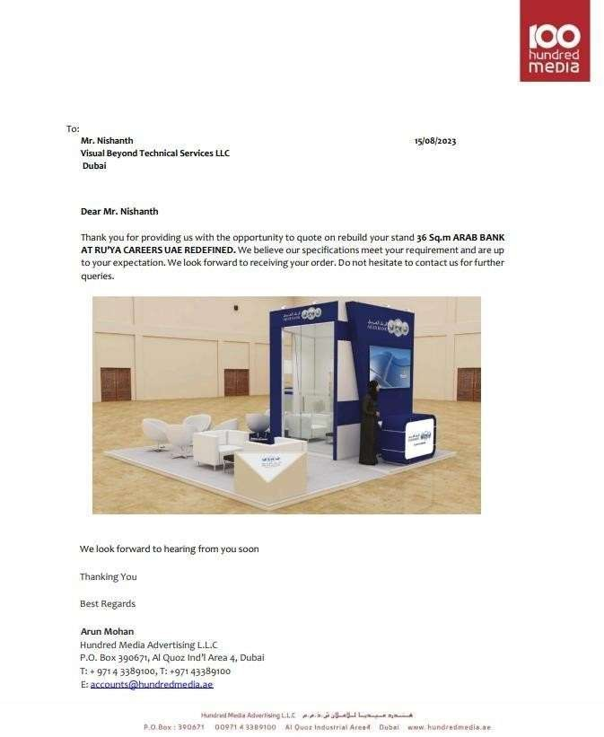

Page 2
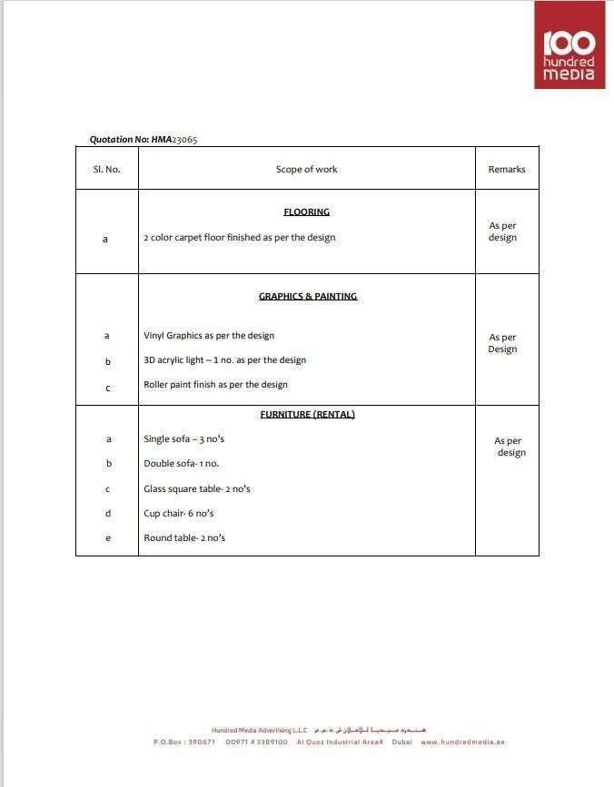

Page 3
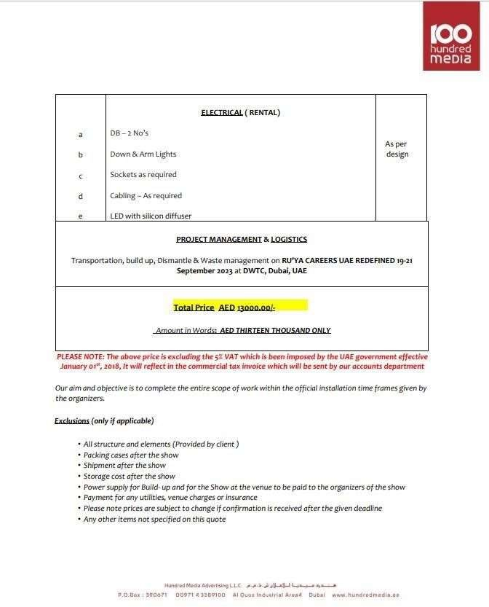

Page 4
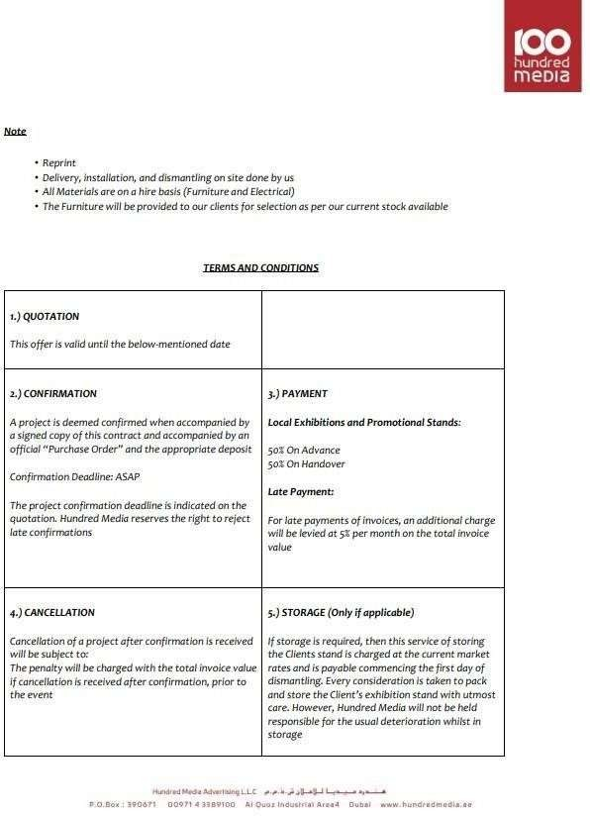

Page 5
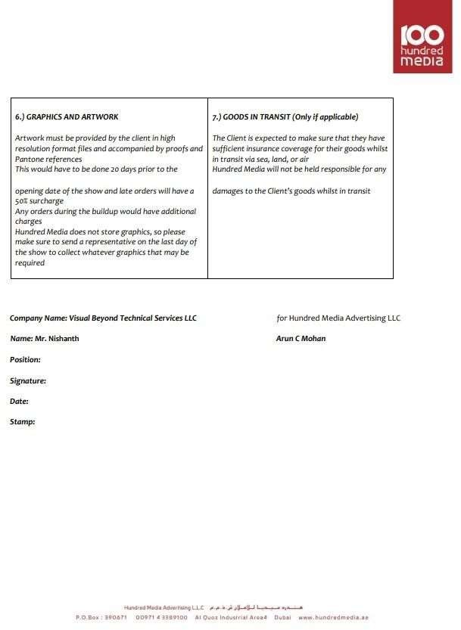

Tax Invoice

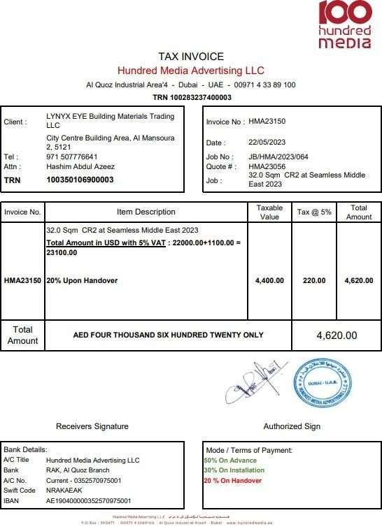

Purchase order
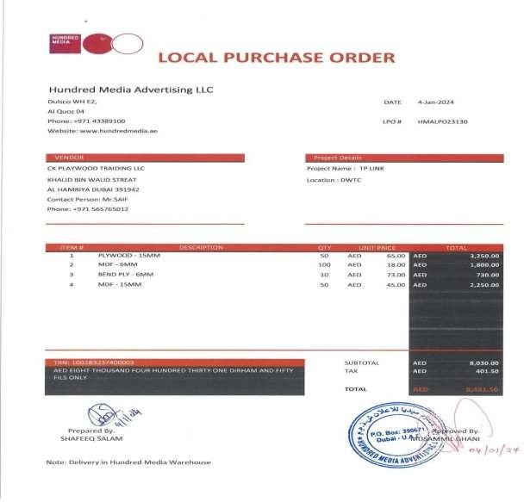

Design Brief Format

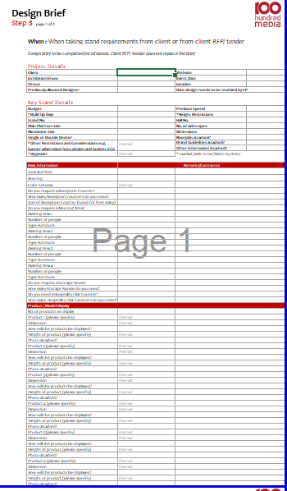
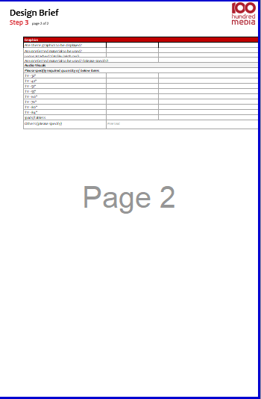
Page 1 Page 2

Mock-Up Format
