**Prescription drug claims analysis**

**Contributor: Prakash Vaka (RxSavings) <prakashkvau@gmail.com>**

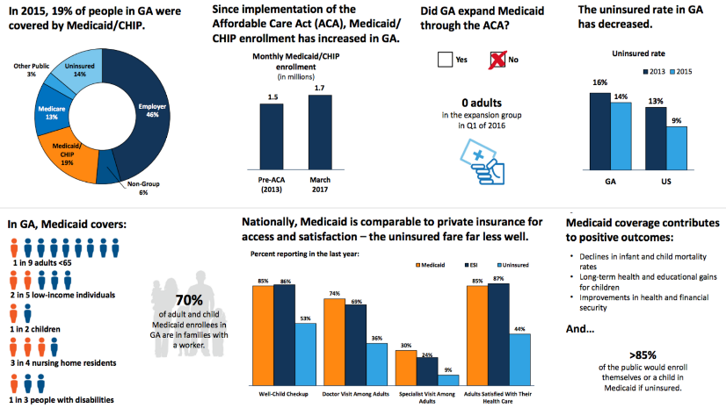

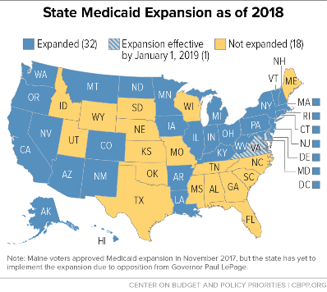

Dataset 1: Statistics of Medicaid claims from previous years.

Current Expansion of Medicaid

Dataset 2: Patient’s existing diagnosis and prescription formation

Forecast, Trends and Analysis Medicaid Drugs

***Reference:*** [***https://bit.ly/2Jx54qF***](https://bit.ly/2Jx54qF)

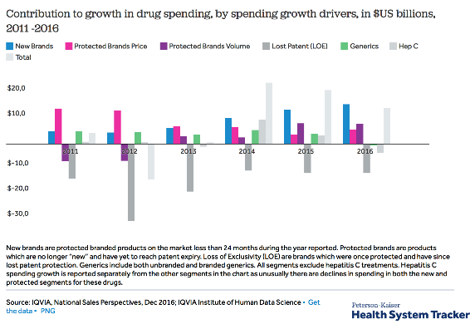

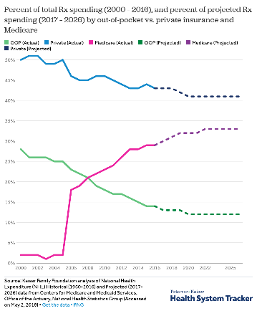

**Description:**

To understand and predict prescription drug usage of medic-aid population, which will enable the local government and health plans to reduce spend.

**Requirements**

* Combine datasets for analysis.

* Analyse and visualize interesting patterns in the data.

**Examples:**

Costliest disease per zip code, based on prescription claim cost.

Future prediction of prescription usage by state/zip.

Extra points if you can use add demographic information.

**Datasets :**

* Medicaid claims. (https://www.medicaid.gov/medicaid/prescription-drugs/state-drug-utilization-data/index.html)
* Zip code information (https://www.census.gov/geo/maps-data/data/zcta_rel_download.html)
* Disease mapping with drug (https://www2a.cdc.gov/vaccines/iis/iisstandards/ndc_tableaccess.asp)
* Prescriber(Doctor) information: (http://download.cms.gov/nppes/NPI_Files.html)