Team: 14  
Professor: Yugyung Lee

Name: Sneha Mishra  
Class ID: 19  
Email: [smccr@mail.umkc.edu](mailto:smccr@mail.umkc.edu)  
[MyGitHub](https://github.com/SnehaMishra28/Python-DeepLearning_Fall2018/wiki/Module-1:-Lab-%231)

Technical Partner:  
Name: Raju Nekadi  
Class ID: 20  
Email: [rn8mh@mail.umkc.edu](mailto:rn8mh@mail.umkc.edu)  
[GitHub](https://github.com/rnekadi/CSEE5590_PYTHON_DEEPLEARNING_FALL2018)

Source code for this lab work can be found [here](https://github.com/SnehaMishra28/Python-DeepLearning_Fall2018/tree/master/Mod1_Lab1/Source)

# Objective

This Lab work is divided into 5 parts, to get familiar with python and understand the basic topics. Few of the topics covered in this lab are:

* Loop structures, Conditional statements, Functions, Tuples
* Complex datatypes, Dictionary, Sets, Python Functions, Web Scraping
* Classes, Object Oriented Concepts, Inheritance, instances, Scientific packages
* Data types, Operators, Conditional Statements

# Features

## Part 1:

### Problem Statement:

Search in a string and find the first non-repeated characters in that string.  
Example-  
Input: Deep data structure.  
Output: p  
(hint: if there is space in the string you need to consider the whole as one string. In the above example Deepdatastructure).

### Solution:

1. Ask user to input a string of choice.
2. Convert the string to lower case (can go for upper case if you want) to make it case in-sensitive.
3. Form a dictionary of each character in the string with its count of occurrences.
4. Loop through this list to get the first character which does not repeat.

Code snippet is attached below:  
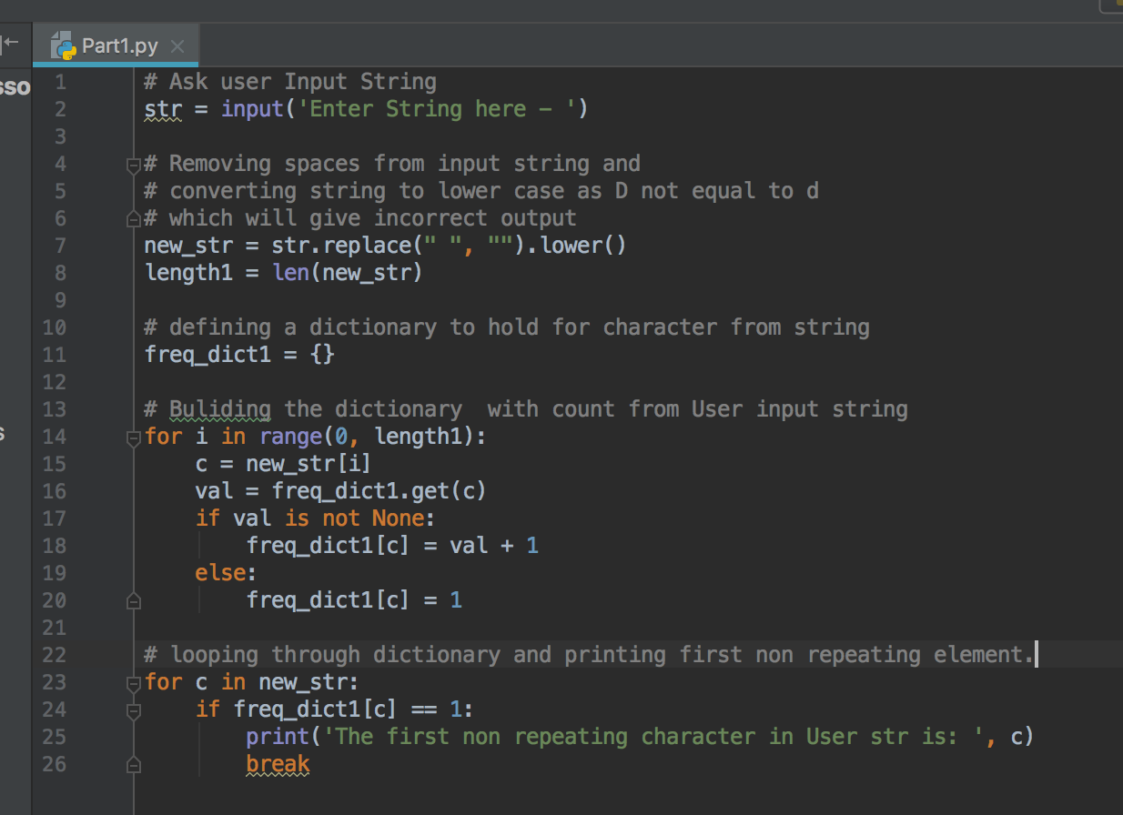

The output after running the code is below:  
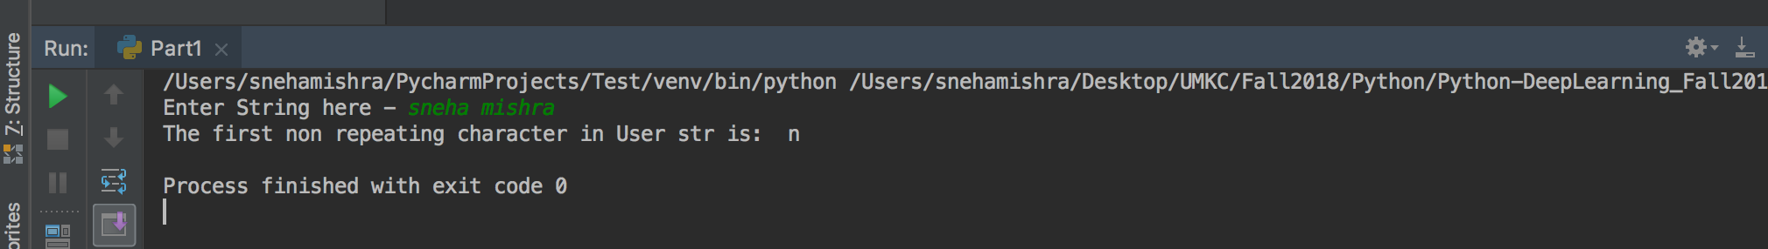

## Part 2:

### Problem Statement:

Suppose you have two files:  
File1:“This time, we are going to learn how to write programs that recognize objects in images using deep learning. In other words, we are going to explain the black magic that allows Google Photos to search your photos based on what is in the picture”  
File2:“this we to are in the that your on based what is how other”  
Program a code such that you remove everything in the File1 which is inside File2.  
The output of File1 will be: “time, going learn write programs recognize objects images using deep learning. words, going explain black magic allows Google Photos search photos picture".

### Solution:

1. Open both the input files in read mode (since these files are never updated, just read).
2. Check if the opened files are empty or not, if empty then display appropriate user messages.
3. When file not empty, Open a result file in write mode to update the File 1 contents.
4. Create a list of words from second file, which needs to be discarded from file 1.
5. Check if the word in file 1 is not in the above mentioned list of words, then only write the words in result file.

Code snippet is attached below:

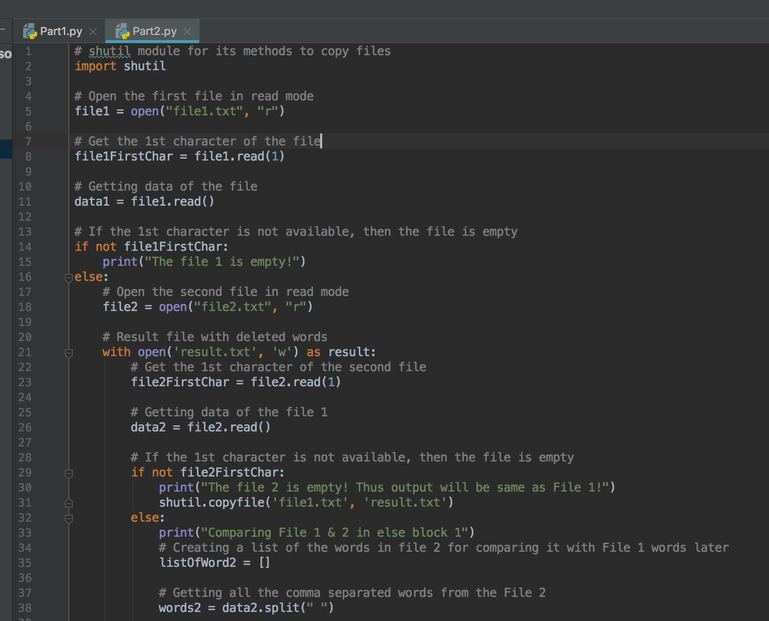

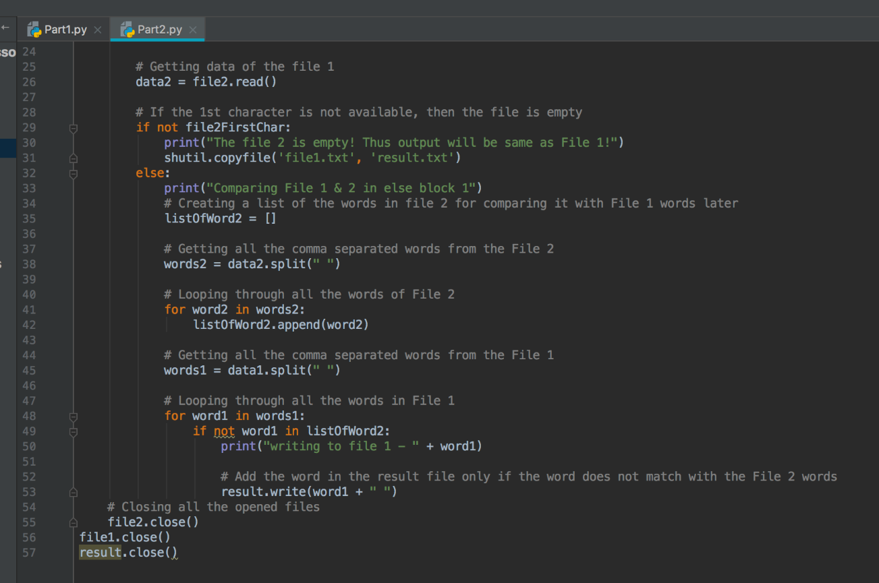

Snippet of the Input file to the code:  
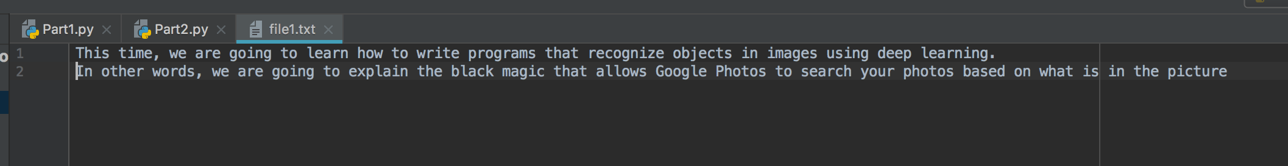

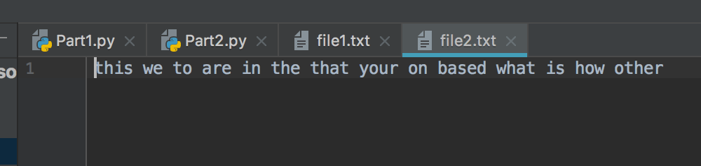

The output after running the code is below:  
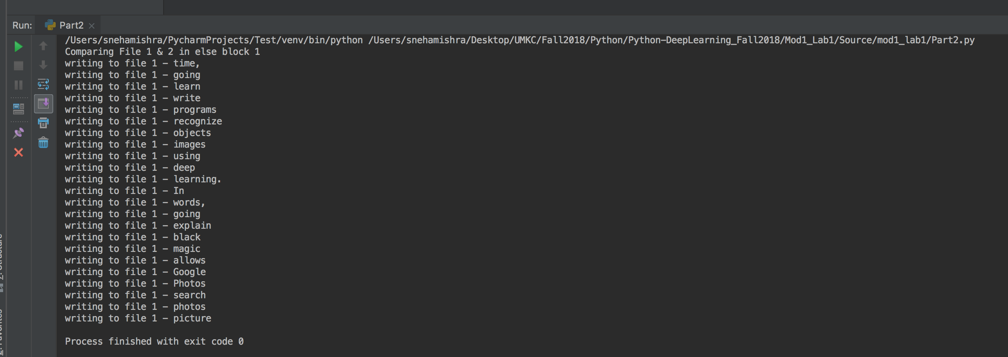

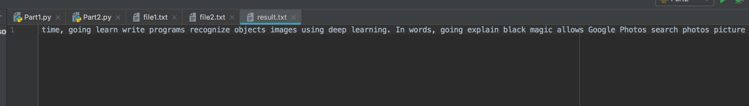

When input file is empty, output will be: 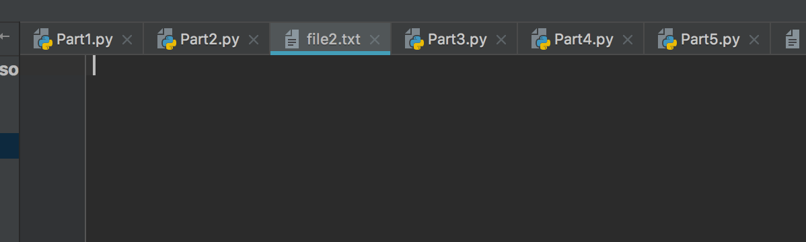

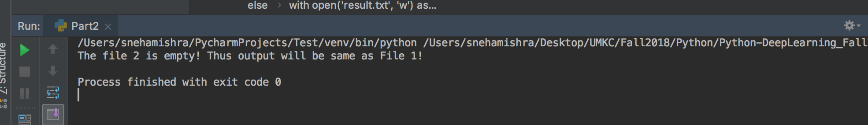

## Part 3:

### Problem Statement:

Consider the following scenario. You have a list of students who are attending class "Python" and another list of students who are attending class "Web Application". Find the list of students who are attending “python” classes but not “Web Application”.

### Solution:

1. Create two lists of students for the two courses mentioned in the above problem.
2. Create a third list which contains the list of students enrolled in first course but not in the 2nd course.
3. Run the loop for the students in list one, and put the names of only those students who are not in the second list.
4. Print the third list.

Code snippet is attached below:  
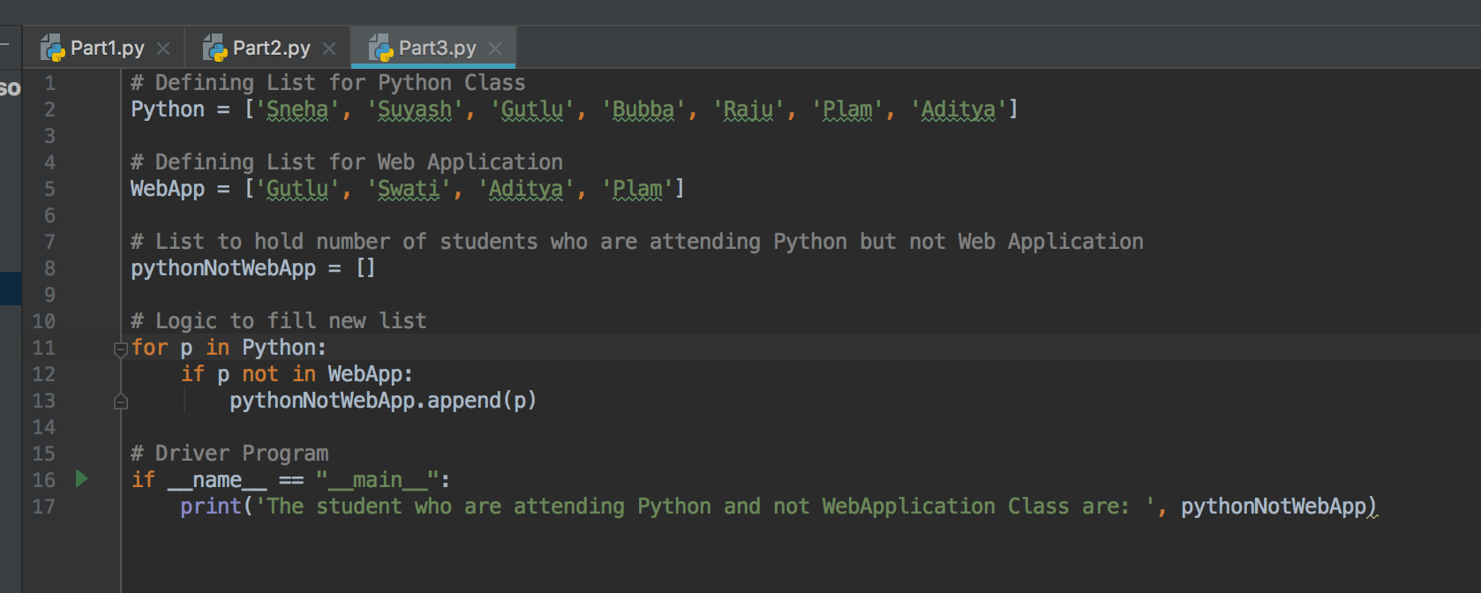

The output after running the code is below:  
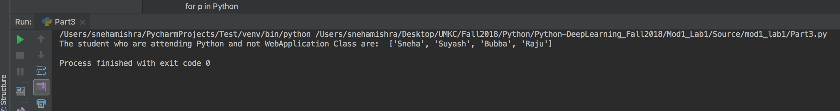

## Part 4:

### Problem Statement:

Write a python program to create a Hospital admission System (e.g. classes Patient, Doctor, Medical Admission Clerk, Book, Nurse, etc.)  
Prerequisites:  
a. Your code should have at least five classes  
b. Your code should have init constructor in all the classes  
c. Your code should show inheritance at least once  
d. Your code should have one super call  
e. Use of self is required  
f. Use at least one private data member in your code  
g. Use multiple Inheritance at least once  
h. Create instances of all classes and show the relationship between them  
Comment your code appropriately to point out where all these things are present

### Solution:

1. Create Classes called Hospital, Procedure, Patient, Staff, Nurse and Doctor.
2. Define the attributes and getter/setter for each class as required.
3. For multiple inheritance, class Patient inherits properties from two classes Hospital and Procedure.
4. Class Staff inherits from class Hospital, while class Doctor and Nurse inherit from class Staff.
5. Create objects of the classes and print them out.

Code snippet is attached below:  
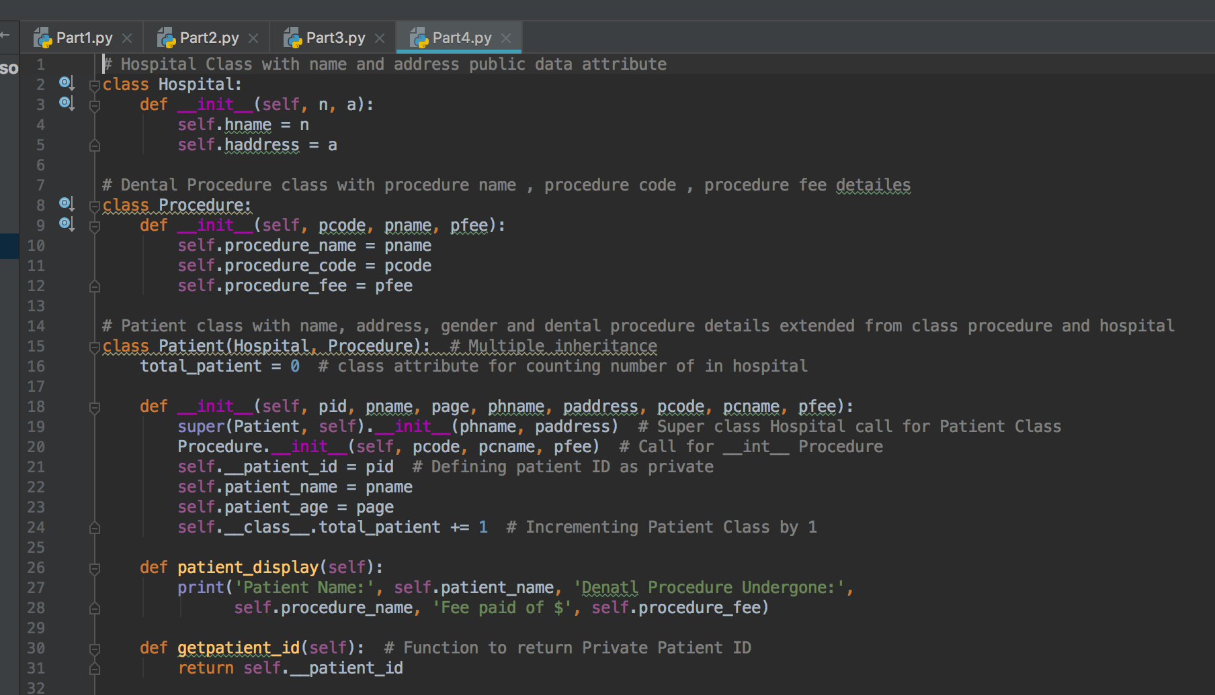

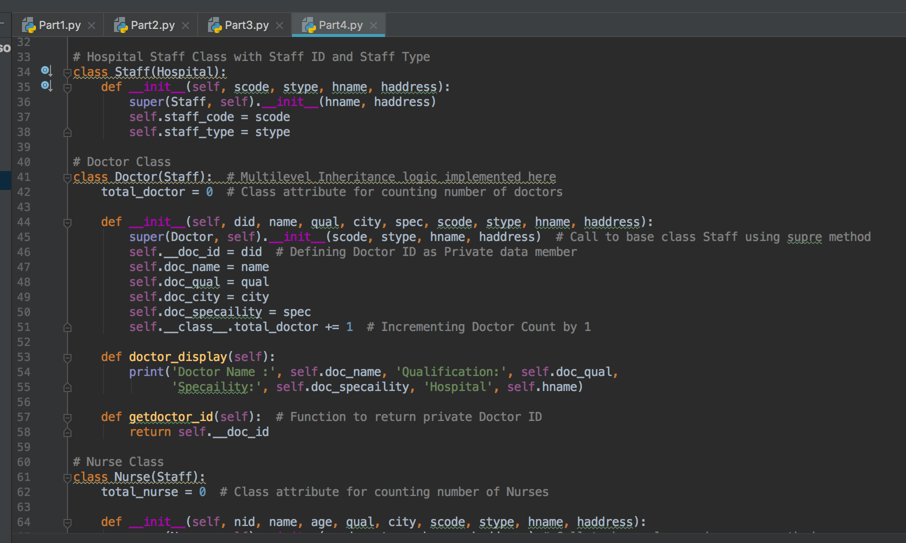

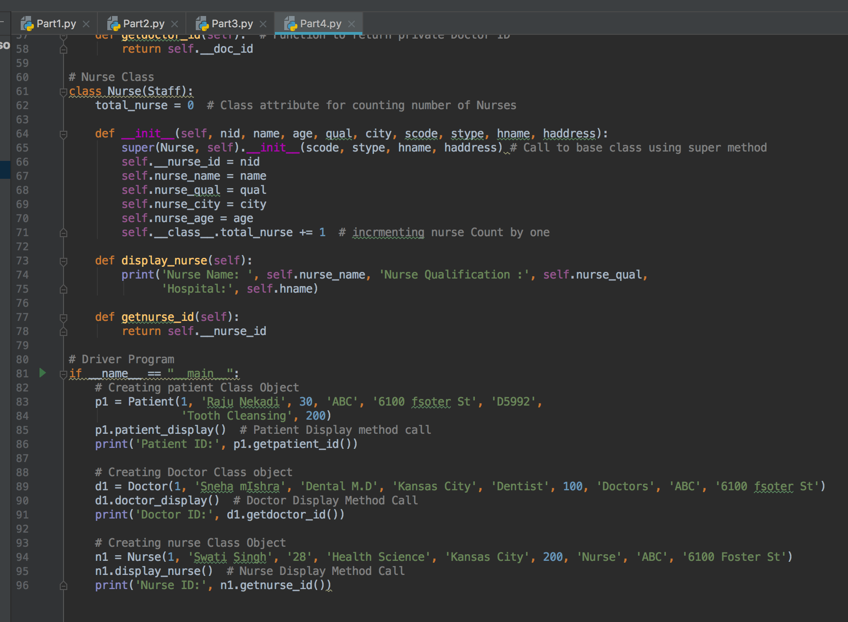

The output after running the code is below:  
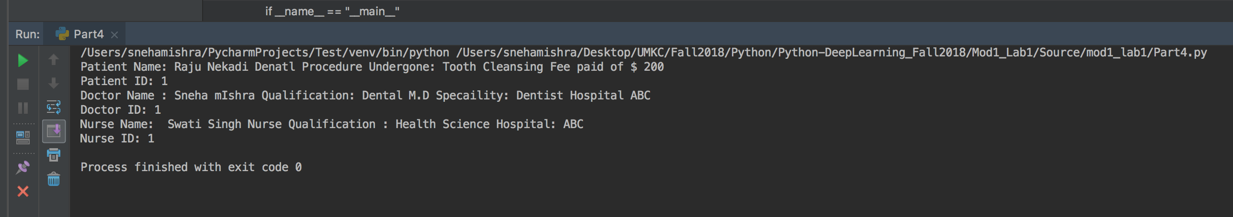

## Part 5:

### Problem Statement:

Program a code which download a webpage contains a table using Request library, then parse the page using Beautifusoup library. You should save all the information of the table in a file.  
Sample input: <https://www.fantasypros.com/nfl/reports/leaders/qb.php?year=2015>  
Sample output: Save the table in this link into a file

### Solution:

1. Get the url and fetch the contents of that web page.
2. The html is parsed using the BeautifulSoup libraries.
3. Open another text file as output to save the contents parsed from this web page.
4. Extract the data from the given url using the inbuilt functions and write them to the output text file.

Code snippet is attached below:  
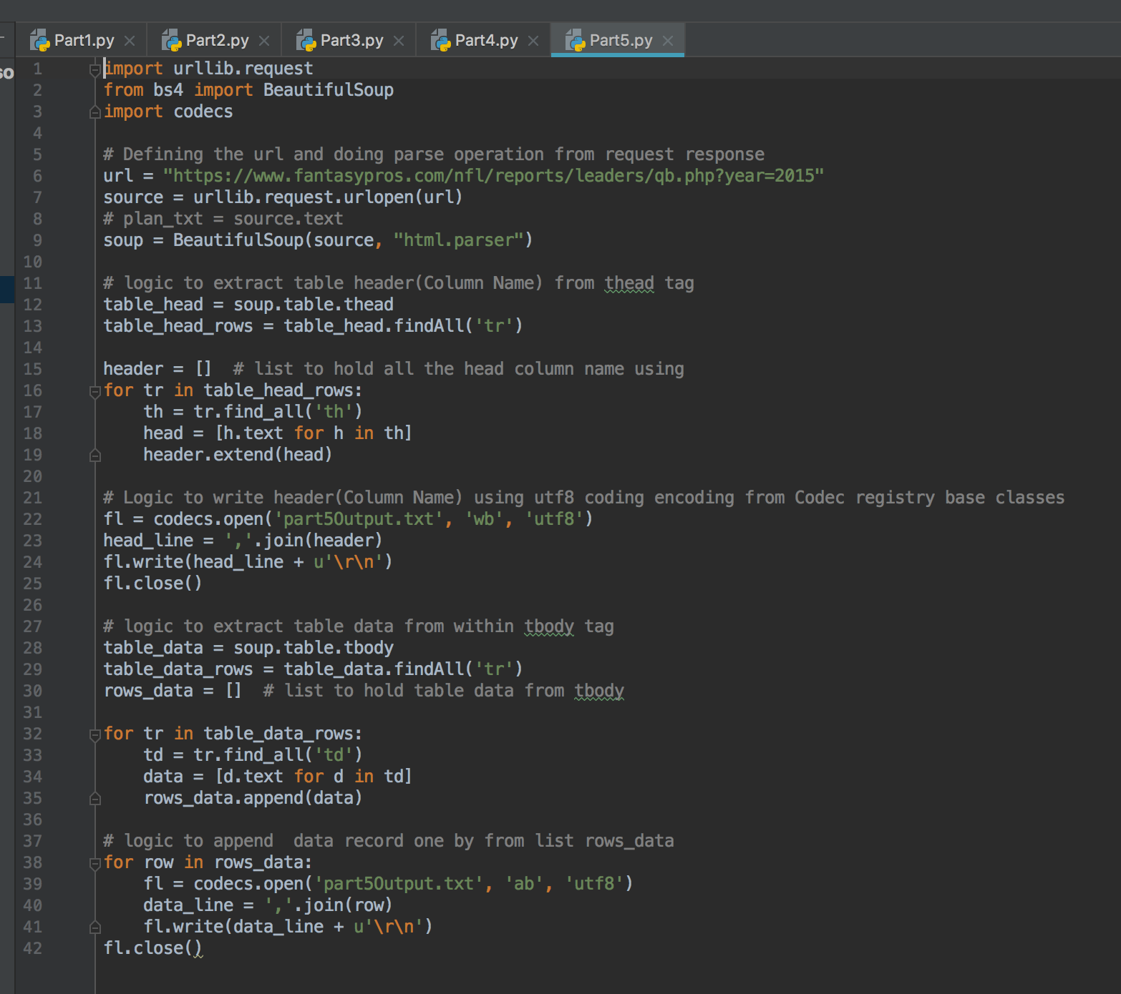

The output after running the code is below:  
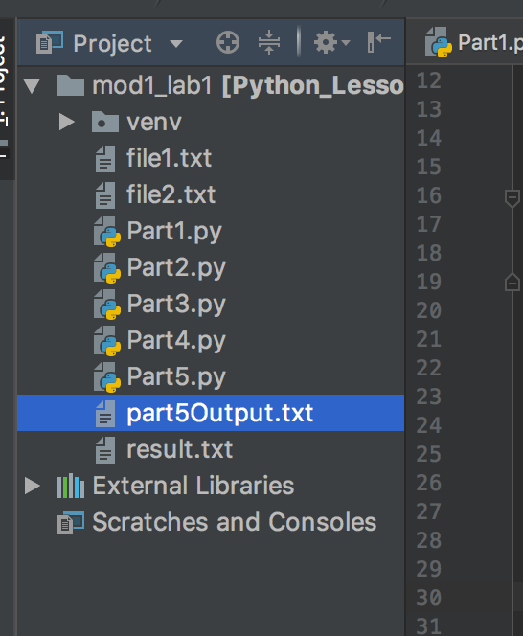

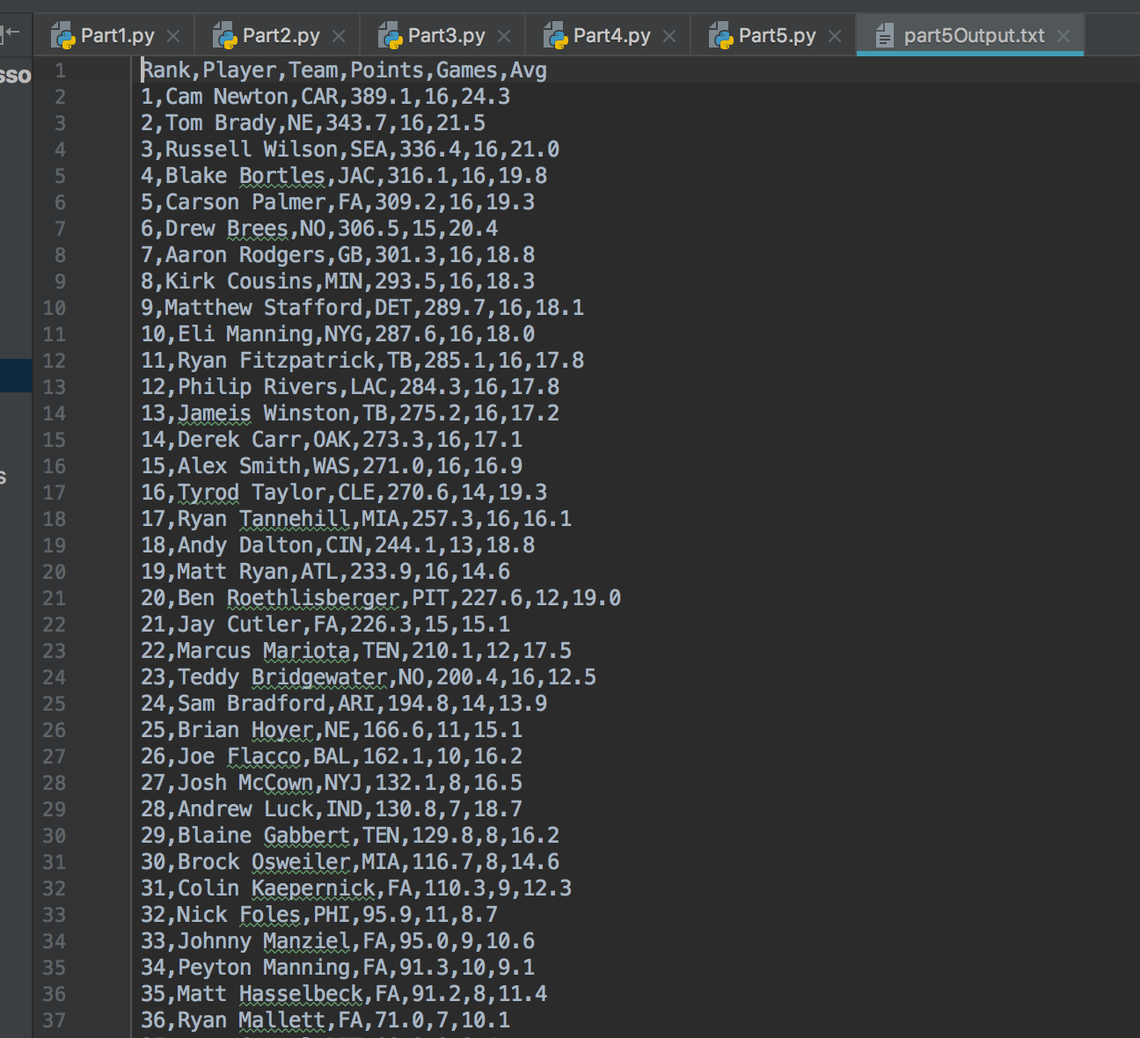

# References:

* <https://stackoverflow.com/questions/15137769/how-to-delete-same-words-from-different-text-file-using-python>
* <https://stackabuse.com/how-to-copy-a-file-in-python/>
* <https://docs.python.org/2/library/shutil.html>
* <https://www.sanfoundry.com/python-program-copy-contents-file-another/>
* <https://www.journaldev.com/14408/python-read-file-open-write-delete-copy>
* <https://unix.stackexchange.com/questions/145079/remove-all-lines-in-file-a-which-contain-the-strings-in-file-b>